    Joint Collaborative Team on Video Coding (JCT-VC)  of ITU-T SG16 WP3 and ISO/IEC JTC1/SC29/WG11  3rd Meeting: Guangzhou, CN, 7-15 October, 2010 | Document: JCTVC-C097  WG11 Number: m18120

Title: | TE1：Huawei report on DMVD improvements in TMuC
Status: | Input Document to JCT-VC
Purpose: | Tool Experiment Report
Author(s) or  Contact(s): | Mingyuan Yang, Sixin Lin, Dong Wang, Jiantong zhou, Haoping Yu  Huawei Technologies Co., Ltd.  Section B1, Huawei Industrial Base,  Bantian Longgang Shenzhen, China | Tel:  Email: | +86 755 28567191  myyang@huawei.com  linsx@huawei.com  wangdong1210@huawei.com  haopingyu@huawei.com
Source: | Huawei Technologies Co., Ltd.
_____________________________

Abstract
The goal of this Tool Experiment (TE1) is to prove the performance of Decoder-side Motion Vector Derivation (DMVD) techniques in TMuC software. There are two categories in the TE1, one is TE.1a (DMVD Inter Prediction) and the other is TE.1b (DMVD Direct Mode). This contribution continues the work in [1][2], including the Template Matching based DMVD (TM-DMVD) and the Spatial and Temporal Direct Mode (STDM) techniques. STDM and TM-DMVD work together in the TE.1a and STDM works alone in the TE.1b. Both techniques have been implemented into the TMuC 0.7 software and tested following the common test conditions in JCTVC-B300 and JCTVC-B301. This document describes these techniques in details, which includes algorithm description, software implementation, coding performance, and complexity evaluation and analysis. According to the test results, a combined performance gain of XXX% over the TE1 anchor bistreams is observed.
- Algorithm Description

TM-DMVD
Currently, TM-DMVD is integrated into inter coding modes 2Nx2N, 2NxN, Nx2N and all asymmetric partition modes in the TMuC software. A Coding Unit (CU) level rate-distortion (RD) evaluation is performed to decide whether the TM-DMVD mode is used. The motion vectors and the selection of the reference pictures are derived as described below.
- Template composition
The current template is created by the reconstructed pixels nearby the current block as shown in Fig. 1, where an L-shaped symmetric region around the upper-left corner of the target block is selected as the template whose maximum size is 16. However, when TM-DMVD is used in a Prediction Unit (PU), in order to make parsing and decoding process separated, the prediction instead of the unavailable reconstruction from the other motion partitions is used to construct the current template as illustrated in Fig. 2.
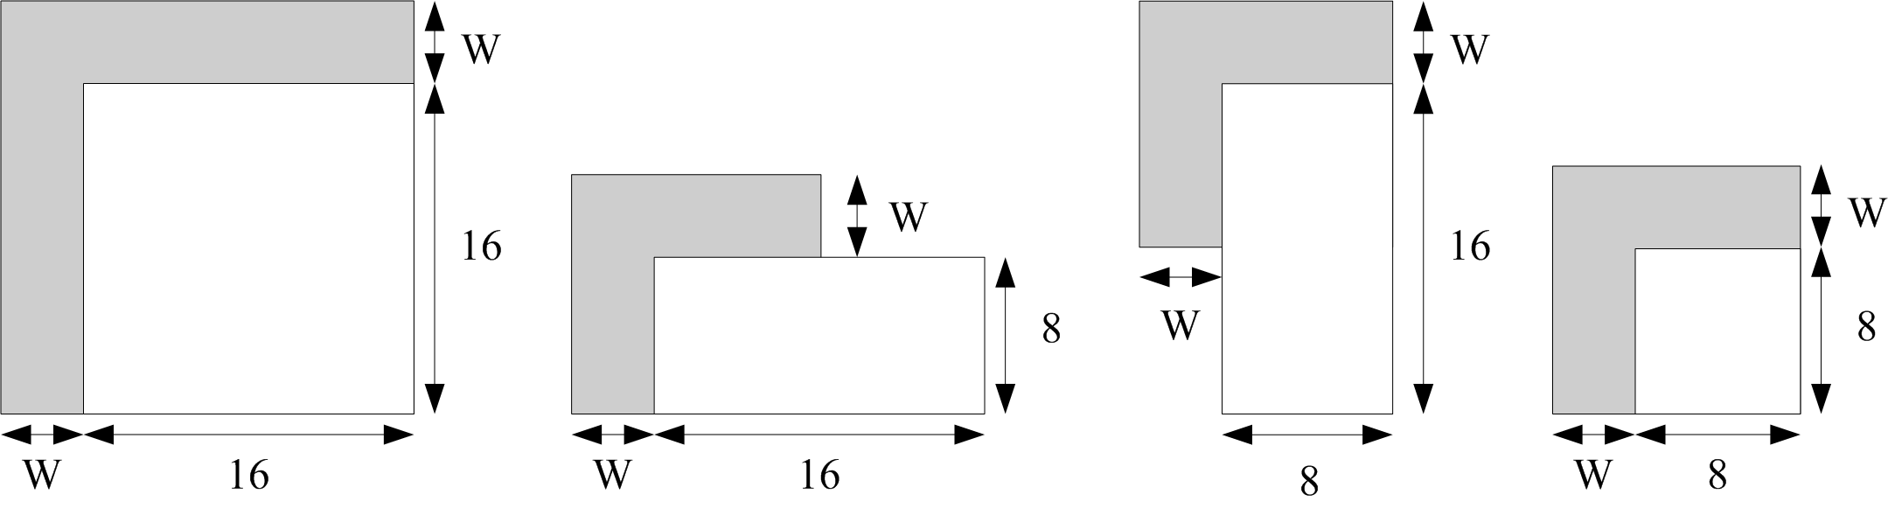
Fig. 1 Template composition for block partitions with different size
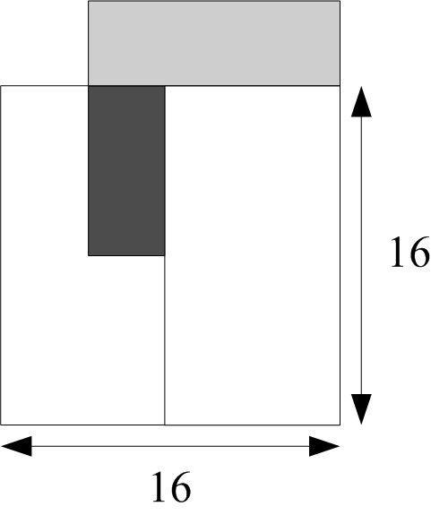
Fig. 2 Template composition when a part of the template is not available
- Candidate based template matching
The motion information candidates from the first available inter mode blocks on left and up are achieved from the neighbor blocks as shown in Fig. 3. In order to refine the motion estimation, the neighborhood of those in sub-pixel range could also be used.
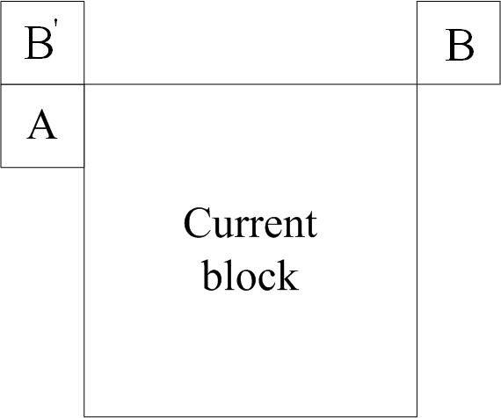
Fig. 3 Composition of candidate motion vector set

- Multiple reference pictures and multi-hypothesis prediction
By scaling these motion vectors in the candidate set according to the temporal distance of the current frame and every reference frame, a candidate set of motion vectors pointing to each reference frame (pair) can be derived. Template matching is used based on the distortion cost function (Equation. 1) between the current template and the reference template. Not only the positions pointed by the candidate motion vectors but also the positions nearby are checked. Consequently, N motion vectors which produce the minimal distortion costs are achieved to predict the current coding block. In our implementation template matching is applied to find two optimal motion vectors out of the new candidate set, and then multi-hypothesis prediction is performed.
(1)

STDM
Here the algorithm process is depicted and the flowing chart is shown as below.

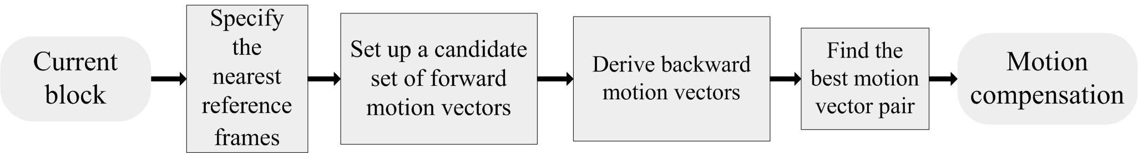
Fig. 4 Procedures of STDM
The procedure of STDM is shown in Fig. 4 and it is applied in the skip and direct mode. Firstly two reference frames should be specified for the current encoding block. In B slice, the two reference frames are the nearest forward and backward reference frames in List0 and List1. In P slice the two reference frames are the nearest and the second nearest forward references in List0. The corresponding position of the two reference frames is illustrated in Fig. 5. In the following chapters the nearest forward reference frame is called the forward reference frame, and the nearest backward reference frame in B slice and the second nearest forward reference frame in P slice is called the corresponding reference frame.
Fig. 5 The positions of the two reference frames
The forward motion vectors of neighboring blocks are scaled to get the corresponding motion vectors. The forward motion vector of the co-located block is scaled to get both the forward motion vector and the corresponding motion vector. The calculation of the corresponding motion vectors is based on the assumption that the motion of objects is simple translation. After the candidate set of motion vector pairs is set up, each of motion vectors in the set will be checked. The one that minimize the following spatial-temporal cost function is selected as the final motion vector of current macroblock.
(2)
In equation (2), calculates the sum of absolute difference of two blocks and , and are the corresponding reference blocks in the forward and the corresponding reference frames, respectively. , and are the templates around , and the current coding block, respectively. The weighting factor is set to 1 in the current implementation.
- Software Implementation
In TMuC software recursive coding unit structure is used and every coding unit can be SKIP (skip or direct mode), INTRA or INTER. In this contribution STDM mode competes with TMuC SKIP mode in every coding unit depth. One flag is needed to indicate whether STDM mode is used in the SKIP mode.
TM-DMVD is implemented in the inter modes (2Nx2N, 2NxN, Nx2N and all asymmetric partition modes) in TMuC software. For 2Nx2N mode only one flag is used to indicate whether TM-DMVD mode is used. For other modes two flags are need to indicate which PU uses the TM-DMVD modes.
CU-level rate-distortion (RD) evaluation is performed to decide whether STDM and TM-DMVD are chosen.
- Syntax and Semantic Change
New syntax elements “STDM_Flag” and “DMVD_Flag” are added as follows in TMuC software. (The green part is modification of new syntax elements.)
Prediction unit syntax
prediction_unit( x0, y0, currPredUnitSize ) { | C | Descriptor
if( slice_type != I )
skip_flag
if( skip_flag ) {
if( (slicetype==B && !slice_is_P_or_GPB && STDM_Validate) ||
(slice_is_P_or_GPB && STDM_Validate && num_ref_idx_l0_active_minus1 > 0) )
STDM_flag | 2 | ue(v) | ae(v)
if( mv_competition_flag ) {
if( inter_pred_idc != Pred_L1 && NumMVPCand( L0 ) > 1 )
mvp_idx_l0 | 2 | ue(v) | ae(v)
if( inter_pred_idc != Pred_L0 && NumMVPCand( L1 ) > 1 )
mvp_idx_l1 | 2 | ue(v) | ae(v)
}
}
else {
if(!entropy_coding_mode_flag)
mode_table_idx |  | vlc(n,v)
else {
if( slice_type != I )
pred_mode | 2 | u(1) | ae(v)
}
if( PredMode == MODE_INTRA ) {
planar_flag | 2 | u(1) | ae(v)
if(planar_flag) {
planar_delta_y = getPlanarDelta()
planar_delta_uv_present_flag | 2 | u(1) | ae(v)
if(planar_delta_uv_present_flag) {
planar_delta_u = getPlanarDelta()
planar_delta_v = getPlanarDelta()
}
} else {
if(entropy_coding_mode_flag)
intra_split_flag | 2 | ae(v)
combined_intra_pred_flag | 2 | u(1) | ae(v)
for( i = 0; i < ( intra_split_flag ? 4 : 1 ); i++ ) {
prev_intra_luma_pred_ flag | 2 | u(1) | ae(v)
if( !prev_intra_pred_luma_flag )
rem_intra_luma_pred_mode | 2 | ue(v) | ae(v)
if( adaptive_intra_smoothing_flag )
intra_luma_filt_flag | 2 | u(1) | ae(v)
}
}
if( chroma_format_idc != 0 )
intra_chroma_pred_mode | 2 | ue(v) | ae(v)
}
}
else if( PredMode == MODE_INTER ) {
if(entropy_coding_mode_flag)
inter_partitioning_idc | 2 | ue(v) | ae(v)
for( i= 0; i < NumPuParts( inter_partitioning_idc ); i++ ) {
if( NumMergeCandidates > 0 ) {
merge_flag[ i ] | 2 | ue(1) | ae(v)
if( merge_flag[ i ] && NumMergeCandidates > 1 )
merge_left_flag[ i ] | 2 | ue(1) | ae(v)
}
if( !merge_flag[i] ) {
if(DMVD_validate && PredMode !=MODE_SKIP)
DMVD_flag | 2 | ue(v) | ae(v)
if( slice_type == B && !dmvd_flag_validate
&& !slice_is_P_or_GPB)
inter_pred_idc[ i ] | 2 | ue(v) | ae(v)
if( inter_pred_idc[ i ] != Pred_L1 ) {
if( entropy_coding_mode_flag ) {
if( num_ref_idx_l0_active_minus1 > 0 && !dmvd_flag_validate )
ref_idx_l0[ i ] | 2 | ue(v) | ae(v)
mvres_l0 [ i ] | 2 | ue(1) | ae(v)
}
else {
if(!dmvd_flag_validate)
ref_idx_mvres_l0[ i ] | 2 | ue(v) | ae(v)
}
if(!dmvd_flag_validate)
mvd_l0[ i ][ 0 ] | 2 | se(v) | ae(v)
if(!dmvd_flag_validate)
mvd_l0[ i ][ 1 ] | 2 | se(v) | ae(v)
if( mv_competition_flag &&
NumMVPCand( L0, i ) > 1 )
mvp_idx_l0[ i ] | 2 | ue(v) | ae(v)
}
if( inter_pred_idc[ i ] != Pred_L0 ) {
if( entropy_coding_mode_flag ) {
if( num_ref_idx_l1_active_minus1 > 0 && !dmvd_flag_validate)
ref_idx_l1[ i ] | 2 | ue(v) | ae(v)
mvres_l1 [ i ] | 2 | ue(1) | ae(v)
}
else {
if(!dmvd_flag_validate)
ref_idx_mvres_l1[ i ] | 2 | ue(v) | ae(v)
}
if(!dmvd_flag_validate)
mvd_l1[ i ][ 0 ] | 2 | se(v) | ae(v)
if(!dmvd_flag_validate)
mvd_l1[ i ][ 1 ] | 2 | se(v) | ae(v)
if( mv_competition_flag &&
NumMVPCand( L1, i ) > 1 )
mvp_idx_l1[ i ] | 2 | ue(v) | ae(v)
}
}
}
}
else if( PredMode == MODE_DIRECT ) {
if( (slicetype==B && !slice_is_P_or_GPB && STDM_Validate) ||
(slice_is_P_or_GPB && STDM_Validate && num_ref_idx_l0_active_minus1 > 0) )
STDM_flag | 2 | ue(v) | ae(v)
if( slice_type == B &&
!(slice_is_P_or_GPB && stdm_flag_validate) )
inter_pred_idc | 2 | ue(v) | ae(v)
if( mv_competition_flag ) {
if( inter_pred_idc != Pred_L1 &&
NumMVPCand( L0 ) > 1 )
mvp_idx_l0 | 2 | ue(v) | ae(v)
if( inter_pred_idc != Pred_L0 &&
NumMVPCand( L1 ) > 1 )
mvp_idx_l1 | 2 | ue(v) | ae(v)
}
}
}
stdm_flag specifies the approach to derive the motion information in Skip and Direct modes.
- If stdm_flag is equal to 1, STDM derivation method is used.
- Otherwise TMuC original derivation method is used.
dmvd_flag specifies the approach to derive the motion information in inter modes
- If dmvd_flag is equal to 1, TM-DMVD derivation method is used.
- Otherwise TMuC original derivation method is used.

Decoding Process Conditions
slice_is_P_or_GPB specifies whether current slice is GPB or P Slice
- If slice_is_P_or_GPB is true, current slice is P slice or B slice and the POC numbers of reference slices in List 1 is smaller than the POC number of the current slice
- Otherwise current slice is B slice and the POC numbers of reference slices in List 1 is bigger than the POC number of the current slice.
STDM_Validate specifies whether current coding unit can be coded by STDM
- If STDM_Validate is true, current coding unit can be coded by STDM
- Otherwise current coding unit cannot be coded by STDM
stdm_flag_validate specifies whether current prediction unit is coded by STDM
- If stdm_flag_Validate is true, current prediction unit iscoded by STDM
- Otherwise current prediction unit is not coded by STDM
DMVD_Validate specifies whether current coding unit can be coded by TM-DMVD
- If DMVD_Validate is true, current coding unit can be coded by STDM
- Otherwise current coding unit cannot be coded by STDM
dmvd_flag_validate specifies whether current prediction unit is coded by TM-DMVD
- If dmvd_flag_Validate is true, current prediction unit is coded by TM-DMVD
- Otherwise current prediction unit is not coded by TM-DMVD
- Compression Performance and Complexity analysis in TE.1a
In TE.1a TM-DMVD and STDM are enabled in the TMuC 0.7 software platform.
In the tables below, all of the data are measured on the same computer: MS Windows Server 2003R2, Enterprise x64 Edition, SP2. Inter® Xeon® CPU E5650 @2.67GHz, 24 GB of RAM. And the source code is written in C++ language based on TMuC, without any optimization through assembly language, such as MMX or SSE2 instruction, etc.
The simulation complies with the common test conditions defined in JCTVC-B301. Detailed test conditions are available in attached configure files.
The accompanied spreadsheets show the detailed test results.

Compression Performance Discussion
In the tables below, average BDRATE saving is used. BD-rate Y represents the bit rate saving corresponding to luma space. BD-rate U and BD-rate V represent the bit rate saving corresponding to each chroma space.

Test Results for Random Access High Efficiency Configuration Relative to TE1 Anchor
Video Sequence | TM-DMVD+STDM
Video Sequence | BD-rate Y(%) | BD-rate U(%) | BD-rate V(%)
Class A
Class B
Class C | -3.93 | -3.50 | -3.75
Class D | -3.93 | -3.08 | -2.32
Total average
Table 1. RD Performance in random access high efficiency Configuration
From Table 1 the total gain from the proposed techniques is about xxx% bitrate saving and xxx dB PSNR increasing.

Test results for Low Delay High Efficiency Configuration Relative to TE1 Anchor
Video Sequence | TM-DMVD+STDM
Video Sequence | BD-rate Y(%) | BD-rate U(%) | BD-rate V(%)
Class B
Class C | -2.5 | -1.1 | -0.7
Class D | -1.9 | 0.9 | 0.8
Class E
Total average
Table 2. RD Performance in low delay high efficiency Configuration
Compared with TE1 anchor, the average gain from the proposed techniques is about xxx% bitrate saving and xxx dB PSNR increasing.

Complexity Analysis
In the tables below, the data means the percentage of decoding time compared with TE1 anchor. The data in the tables are the average decoding time for each sequence at all rate points.

Random Access High Efficiency Configuration Relative to TE1 Anchor

Video Sequence | TM-DMVD+STDM (%)
Class A
Class B
Class C
Class D
Total Average
Table 3. Complexity Analysis in random access high efficiency Configuration
From Table 3, it can be seen that TM-DMVD_STDM is about XXX times slower than TE1 anchor.

Low Delay High Efficiency Configuration Relative to TE1 Anchor
Video Sequence | TM-DMVD+STDM (%)
Class B
Class C
Class D
Class E
Total average
Table 4. Complexity Analysis in low delay high efficiency Configuration
From Table 4 , it can be seen that TM-DMVD_STDM is about XXX times slower than TE1 anchor.
Note: In the last meeting we proposed another technique named SMDDT with a simplified interpolation filter which can significantly reduce the TM-DMVD and STDM decoding complexity without sacrificing compression performance and even slightly better than STDM for some cases. However we do not have enough time to implement this technique this time, we will present the data with this technique later.
- Compression Performance and Complexity analysis in TE.1b
In TE.1b only STDM is enabled in the TMuC 0.7 software platform.
In the tables below, all of the data are measured on the same computer: MS Windows Server 2003R2, Enterprise x64 Edition, SP2. Inter® Xeon® CPU E5650 @2.67GHz, 24 GB of RAM. And the source code is written in C++ language, without any optimization through assembly language, such as MMX or SSE2 instruction, etc.
The test conditions in the simulation comply with the common test conditions (JCTVC-B301). Detailed test conditions are available in attached configure files.
Detailed test results are available in attached Excel files.

Compression Performance Discussion
In the tables below, average BDRATE saving is used. BD-rate Y represents the bit rate saving corresponding to luma space. BD-rate U and BD-rate V represent the bit rate saving corresponding to each chroma space.

Test Results for Random Access High Efficiency Configuration Relative to TE1 Anchor
Video Sequence | STDM
Video Sequence | BD-rate Y(%) | BD-rate U(%) | BD-rate V(%)
Class A | -3.6 | -3.8 | -3.8
Class B | -3.0 | -2.4 | -2.4
Class C | -2.5 | -2.5 | -2.5
Class D | -2.7 | -2.3 | -2.5
Total average | -2.9 | -2.6 | -2.6
Table 5. RD Performance in random access high efficiency Configuration
From Table 5 the average gain for proposed technique is about 2.9% bit rate saving compared with TE1 anchor.

Test results for Low Delay High Efficiency Configuration Relative to TE1 Anchor
Video Sequence | STDM
Video Sequence | BD-rate Y(%) | BD-rate U(%) | BD-rate V(%)
Class B | -0.6 | 1.0 | 0.9
Class C | -0.6 | 0.1 | 0.4
Class D | -0.1 | 0.8 | 1.1
Class E | -0.8 | 0.2 | -0.2
Total average | -0.5 | 0.6 | 0.6
Table 6. RD Performance in low delay high efficiency Configuration
Compared with TE1 anchor, the average gain for proposed technique is about 0.5% bit rate saving.

Complexity Analysis
In the tables below, the data means the percentage of decoding time compared with TE1 anchor. The data in the tables are the average decoding time for each sequence at all rate points.

Random Access High Efficiency Configuration Relative to TE1 Anchor
Video Sequence | STDM (%)
Class A | 122.80%
Class B | 119.90%
Class C | 114.17%
Class D | 118.95%
Total average | 118%
Table 7. Complexity Analysis in random access high efficiency Configuration
From Table 7 STDM is about 1.18 times slower than TE1 anchor.

Low Delay High Efficiency Configuration Relative to TE1 Anchor
Video Sequence | STDM (%)
Class B | 133.76%
Class C | 139.71%
Class D | 122.30%
Class E | 118.67%
Total average | 129%
Table 8. Complexity Analysis in low delay high efficiency Configuration
From Table 8 STDM is about 1.29 times slower than TE1 anchor.
- Conclusion
In this proposal we present the brief description of TM-DMVD and STDM together with the analysis of the coding performance and complexity. From the simulation results, we can see that the coding performance of TE1 anchor can be much improved by the proposed techniques.
We suggest that JCTVC adopts the decoder side motion vector derivation techniques into the Test Model for further investigation.
- Reference
[1] Sixin Lin, Mingyuan Yang, Jiantong Zhou, Jin Song, Dong Wang, Haitao Yang, Jiali Fu, Haoping Yu, Wang Yue, Li Zhang, Siwei Ma, Wen Gao, “TE1: Huawei report on DMVD improvements”, JCTVC-B037, 2nd Meeting: Geneva, CH, 21-28 July, 2010;
[2]Haitao Yang, Jiali Fu, Sixin Lin, Jin Song,Dong Wang, Mingyuan Yang, Jiantong Zhou, Haoping Yu, Changcai Lai, Yongbin Lin, Lingzhi Liu,Jianhua Zheng, Xiaozhen Zheng, JCTVC-A111, “Description of video coding technology proposal by Huawei Technologies & Hisilicon Technologies”, 1st Meeting: Dresden, DE, 15-23 April, 2010;

Patent rights declaration(s)
(NOTE – Activities in the JCT-VC and contributions to the JCT-VC are subject to the common patent policy for ITU-T/ITU-R/ISO/IEC. A statement of that policy can be found at
http://www.itu.int/ITU-T/dbase/patent/patent-policy.html, with further information available at http://www.itu.int/ITU-T/ipr/index.html and in the ISO/IEC Directives. The form to be used for the formal reporting of patent rights to ITU-T/ITU-R/ISO/IEC can be found at http://www.itu.int/ITU-T/ipr/index.html. Contributions to the JCT-VC proposing normative technical content shall contain a non-binding informal notice of whether the submitter may have patent rights that would be necessary for implementation of the resulting standard. The provided informal notice shall indicate the category of anticipated licensing terms according to the ITU-T/ITU-R/ISO/IEC patent statement and licensing declaration form. This obligation to provide an informal notice is supplemental to, and does not replace, any existing obligations of parties with technology included in a final or draft standard to submit formal IPR declarations to ITU-T/ITU-R/ISO/IEC. An example of an informal IPR notification statement for a contribution is provided below.)

Huawei Technologies may have IPR relating to the technology described in this contribution and, conditioned on reciprocity, is prepared to grant licenses under reasonable and non-discriminatory terms as necessary for implementation of the resulting ITU-T Recommendation | ISO/IEC International Standard (per box 2 of the ITU-T/ITU-R/ISO/IEC patent statement and licensing declaration form).

