    Joint Collaborative Team on Video Coding (JCT-VC)  of ITU-T SG16 WP3 and ISO/IEC JTC1/SC29/WG11  3rd Meeting: Guangzhou, CN, 7-15 October, 2010 | Document: JCTVC-C089

Title: | TE7: Results for mode-dependent residual reordering for intra prediction residual
Status: | Input Document to JCT-VC
Purpose: | Proposal
Author(s) or  Contact(s): | Xin Zhao, Li Zhang, Siwei Ma, Wen Gao  Institute of Digital Media, Peking University  Beijing, China | Tel:  Email: | +86-010-62753424  xzhao@jdl.ac.cn  zhanglili@jdl.ac.cn  swma@jdl.ac.cn
Source: | Peking University
_____________________________

Abstract
In this contribution, the Peking Univ. results in response to the Tool Experiment TE7 [1] on MDDT simplification are presented, with both tool description and simulation results. Simulation results are obtained under the test conditions specified in TE7, and the detailed rate-distortion measurements using BD-rate values are provided in the accompanying spreadsheets.

- Introduction
In the 2nd JCT-VC meeting held in Geneva, the Tool Experiment TE7 is set up for a further investigation on MDDT simplification. At the Geneva meeting, the Peking Univ. contribution JCT-VC B102 [2] is included as a tool under test. In this contribution, an implementation of the proposed method on Test Model under Consideration (TMuC) 0.7 [3] is described, with simulation results obtained under the TE7 defined test conditions.

- Algorithm description
To further simplify the mode-dependent directional transform (MDDT), a mode-dependent residual reordering (MDRR) method is proposed. In the proposed MDRR, between the prediction and transform stages, a certain kind of reordering is implemented on the residual samples for each mode in spatial. The reordering is manipulated in a way that the distribution statistics of reordered residual samples present less mode-dependent characteristic. After the reordering, the 34 intra prediction modes will be assigned into two groups (directional, DC), and only one transform matrix is assigned for each group. In the proposed algorithm, orthogonal column and row transforms are used as,
F=DXD^{T},
where D indicates the transform matrix, X denotes the input residual block and F represents the output transform coefficient matrix.
In the proposed algorithm, as shown in Figure 1, there are four reordering methods for both 4x4 and 8x8 intra prediction residual blocks. And the mapping between intra prediction mode and reordering method is shown in both Table 1 and Figure 2.
(a) (b) (c) (d)
Figure 1 Residual reordering methods for 4x4 blocks

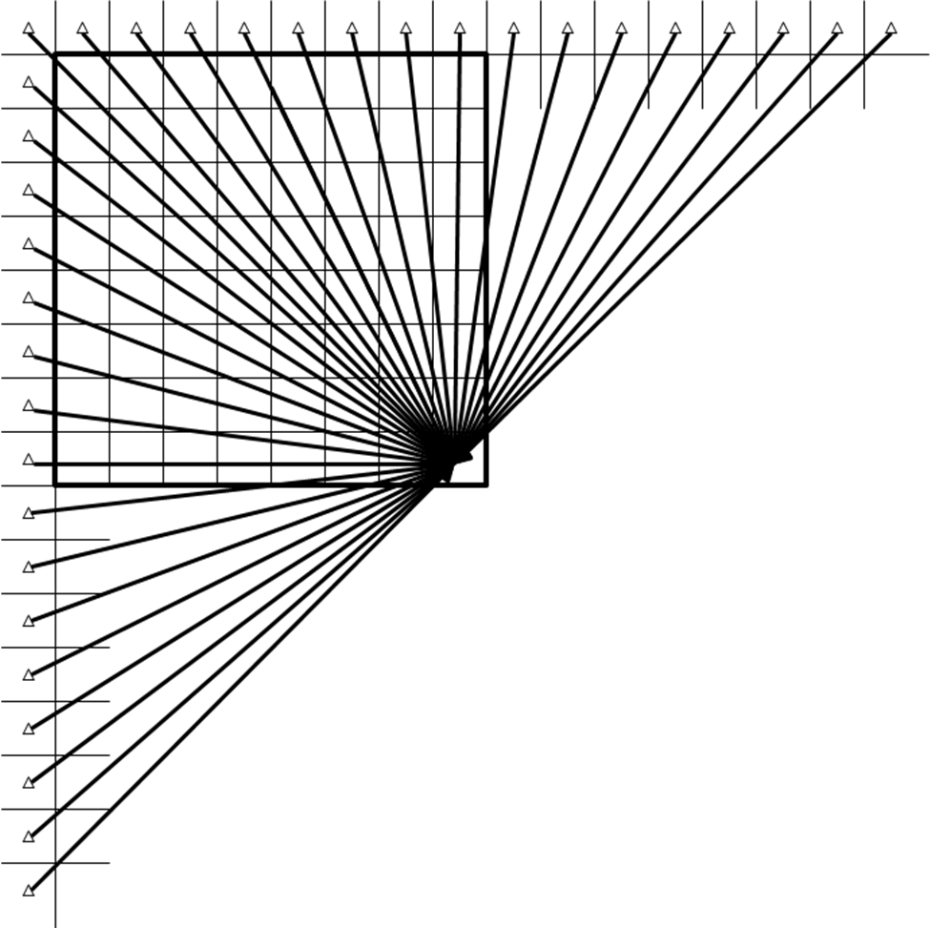
c
a

b

d
Figure 2 Mapping from 33 prediction directions to residual reordering method in the angular mode of Intra 8x8 macroblocks.

After reordering, only one transform matrix is assigned for the 33 directional intra prediction modes, and one for DC mode, as shown in Table 2.
Table 1 Mapping from logical intra prediction order to residual reordering method

residual reordering method | a | b | c | d
logical intra prediction order | 1~9 | 18~25 | 10~17 | 26~33

Table 2 Prediction modes grouping in different Intra modes

 | Group 1 | Group 2
Intra 4x4 predicition (0~33) | 2(DC) | Others
Intra 8x8 predicition (0~33) | 2(DC) | Others
The conventional DCT and quantization in H.264/AVC is retained for DC mode (Group 1 in Table 2), and for other directional modes (Group 2 in Table 2), the following transform matrices are used for intra 4x4 and intra 8x8, respectively.
Intra 4x4:
Klt4x4[4][4]={
{ 20, 33, 38, 34},
{ 36, 32, -11, -41},
{ -41, 17, 34, -31},
{ 28, -41, 37, -18},
}
Intra 8x8:
klt8x8[8][8]={
{ 12, 18, 21, 23, 25, 26, 26, 25},
{ 22, 30, 27, 17, 1, -15, -27, -28},
{ -24, -25, -3, 25, 34, 15, -14, -27},
{ -29, -11, 25, 26, -12, -31, -5, 26},
{ -31, 10, 29, -13, -23, 21, 21, -25},
{ -26, 28, 2, -28, 22, 7, -30, 20},
{ -18, 31, -27, 9, 14, -29, 29, -14},
{ 9, -19, 27, -31, 31, -26, 17, -7},
}

- Simulation results

Rate-Distortion Performance
The rate-distortion performance compared to the original MDDT in terms of BD_Rate for Y, U and V components are shown in Table 3. As Table 3 shows, for “Intra High Efficiency” test condition, the proposed algorithm results in average 0.3%, 0.4% and 0.3% BD-Rate increase for Y, U and V components, respectively. For “Random Access, High Efficiency” test condition, the proposed algorithm results in average 0.1%, 0.0% and 0.1% BD-Rate increase for Y, U and V components, respectively.
Table 3 Coding performance in terms of BD_Rate

Sequence name | All-intra High Efficiency |  |  | Random Access High Efficiency
Sequence name | BD_YRate | BD_URate | BD_VRate | BD_YRate | BD_URate | BD_VRate
Traffic | 0.5 | 0.5 | 0.5 | 0.2 | 0.2 | 0.1
PeopleOnStreet | 0.7 | 0.9 | 0.7 | 0.4 | 0.0 | -0.2
Kimono1 | 0.2 | 0.1 | 0.2 | 0.1 | -0.1 | 0.0
ParkScene | 0.2 | -0.1 | 0.0 | 0.0 | 0.2 | 0.0
Cactus | 0.2 | 0.3 | 0.0 | 0.0 | 0.0 | -0.1
BasketballDrive | 0.2 | 0.4 | 0.3 | 0.1 | 0.1 | -0.1
BQTerrace | 0.4 | 0.5 | 0.4 | 0.2 | -0.1 | -0.4
BasketballDrill | 0.3 | 0.5 | 0.6 | 0.1 | 0.2 | 0.3
BQMall | 0.4 | 0.5 | 0.4 | 0.2 | -0.1 | 0.4
PartyScene | -0.1 | 0.1 | 0.1 | 0.0 | 0.0 | 0.1
RaceHorses | 0.4 | 0.0 | 0.0 | 0.2 | -0.2 | 0.2
BasketballPass | 0.4 | 0.2 | 0.3 | 0.2 | 0.1 | 0.1
BQSquare | 0.3 | 0.2 | 0.3 | 0.1 | 0.5 | 0.6
BlowingBubbles | 0.0 | 0.1 | 0.1 | 0.2 | -0.2 | 0.2
RaceHorses | 0.3 | 0.3 | 0.2 | 0.1 | 0.2 | 0.2
vidyo1 | 0.8 | 0.9 | 0.7
vidyo3 | 0.3 | 0.5 | 0.6
vidyo4 | 0.7 | 0.7 | 0.5
Class A avg | 0.6 | 0.7 | 0.6 | 0.3 | 0.1 | -0.1
Class B avg | 0.2 | 0.2 | 0.2 | 0.1 | 0.0 | -0.1
Class C avg | 0.2 | 0.3 | 0.3 | 0.1 | 0.0 | 0.2
Class D avg | 0.2 | 0.2 | 0.2 | 0.1 | 0.1 | 0.3
Class E avg | 0.6 | 0.7 | 0.6
All average | 0.3 | 0.4 | 0.3 | 0.1 | 0.0 | 0.1

Complexity
To measure the complexity, the proposed algorithm is compared to the original MDDT in the Table 4.
Table 4 Complexity comparisons between original MDDT and proposed method

 | 4x4 Transform |  | 8x8 Transform
Complexity Metric | Original MDDT | Proposed Algorithm | Original MDDT | Proposed Algorithm
operation counts | 128 mul, 96 add | 128 mul, 96 add | 1024 mul, 896 add | 1024 mul, 896 add
memory requirements for transforms | 2048 bits | 112 bits | 8192 bits | 448 bits
minimum bit-precision (9-bit input) | 16-bit (DC)  25-bit (others) | 16-bit (DC)  23-bit (others) | 21-bit (DC)  26-bit (except DC) | 21-bit (DC)  24-bit (except DC)
Other operations and memory requirements | None | Additional residual reordering process (can be absorbed with other processing) | None | Additional residual reordering process (can be absorbed with other processing)

Conclusion
Based on the above simulation results, it is observed that the complexity of MDDT can be significantly reduced with slight degradation of coding gain. Therefore, it is suggested to incorporate MDDT simplification to the development of Test Model.

References
[1] Robert Cohen, Chuohao Yeo, Rajan Joshi, Wenpeng Ding, Siwei Ma, Akiyuki Tanizawa, Haitao Yang, Xin Zhao, Li Zhang, “Tool Experiment 7: MDDT Simplification”, Doc. JCTVC-B307_r4, Joint Collaborative Team on Video Coding (JCT-VC) of ITU-T SG16 WP3 and ISO/IEC JTC1/SC29/WG11, Geneva, CH, 21-28 July, 2010.
[2] Xin Zhao, Li Zhang, Siwei Ma, Wen Gao, “Mode-dependent residual reordering for Intra prediction residual”, Doc. JCTVC-B102, Joint Collaborative Team on Video Coding (JCT-VC) of ITU-T SG16 WP3 and ISO/IEC JTC1/SC29/WG11, Geneva, CH, 21-28 July, 2010.
[3] JCT-VC. Test Model under Consideration (TMuC). JCTVC-A204, Dresden, Germany. Apr, 2010.

Patent rights declaration(s)
Peking University may have IPR relating to the technology described in this contribution and, conditioned on reciprocity, is prepared to grant licenses under reasonable and non-discriminatory terms as necessary for implementation of the resulting ITU-T Recommendation | ISO/IEC International Standard (per box 2 of the ITU-T/ITU-R/ISO/IEC patent statement and licensing declaration form).

