    Joint Collaborative Team on Video Coding (JCT-VC)  of ITU-T SG16 WP3 and ISO/IEC JTC1/SC29/WG11  3rd Meeting: Guangzhou, CN, 7-15 October, 2010 | Document: JCTVC-C055

Title: | Performance report of TMuC for Super Hi-Vision
Status: | Input Document to JCT-VC
Purpose: | Information
Author(s) or  Contact(s): | Kazuhisa Iguchi  Atsuro Ichigaya  Yoshiaki Shishikui  NHK  Science & Technology Research Laboratories  1-10-11, Kinuta, Setagaya-ku, Tokyo, JAPAN  Shun-ichi Sekiguchi  Akira Minezawa  Information Technology R&D Center, Mitsubishi Electric Corporation  5-1-1, Ofuna, Kamakura, JAPAN | Tel:  Email:  Tel:  Email: | +81-3-5494-3354  iguchi.k-eq@nhk.or.jp  ichigaya.a-go@nhk.or.jp  shishikui.y-hw@nhk.or.jp  +81-467-41-2463  Sekiguchi.Shunichi@eb.MitsubishiElectric.co.jp  Minezawa.Akira@ds.MitsubishiElectric.co.jp
Source: | [Name of sourcing organization, AHG, etc.]
_____________________________

Abstract
This contribution reports the performance of TMuC 0.7.0 for Super Hi-Vision (SHV) sequences. While TMuC achieves substantial coding gain relative to H.264 CfP anchor, it took from to times encoding time than JM encoding with CfP anchor condition.

Introduction
HEVC is required to support wide variety of picture size ranging at least from QVGA to 8Kx4K [1]. This contribution reports the performance of TMuC software [2] for Super Hi-Vision (SHV) sequences those have been donated for HEVC standardization [3]. As a result of our simulation, while TMuC achieved significant improvement from JM for SHV sequences, its encoding took from to times computation time than JM.

Simulation results
Figure 1 and 2 illustrate simulation results of SHV sequences "steam locomotive train (SL)" and "nebuta festival (nebuta)" [3], respectively. Both sequences have 7680x4320 pixels in a frame and 300 frames (60 frames per second). The results of TMuC are obtained by TMuC 0.7.0 with random access condition described in JCTVC-B300 [4]. The results of AVC/H.264 are produced using JM16.1 with CfP Constraint Set 1 condition. Additionally, we also plot the experimental data of A107 codec [5] for the same SHV sequences [6] in the both figures .
Figure 1 "SL" Luma R-D performance

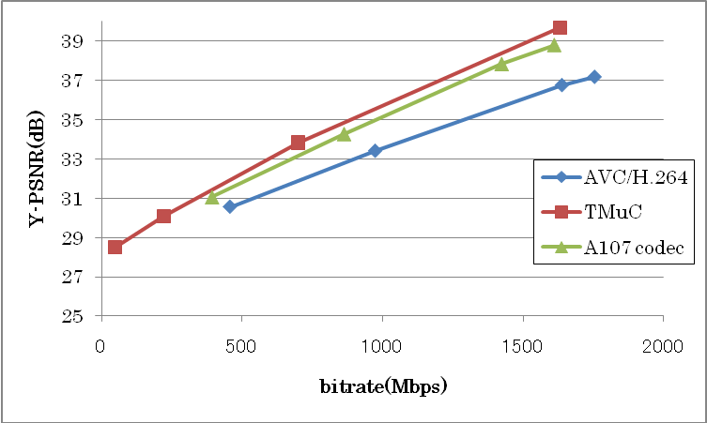
Figure 2 "nebuta" Luma R-D performance
While TMuC achieved significant improvements from AVC/H.264, it took about from 15 days to XX days to complete encoding. Table 1 and 2 shows the simulation environments and encoding time.

Table 1 Simulation Environments
 | PC type A | PC type B | PC type C
CPU | Xeon X5680  3.33GHz | Xeon W5590  3.33GHz | Xeon X5482  3.20GHz
Memory | 24GB | 48GB | 32GB
OS | Windows XP Professional x64 Edition 2003 SP2

Table 2 Encoding Time
Sequence | QP | time(seconds) | time(days) | PC type
SL | 37 |  |  | B
SL | 32 |  |  | C
SL | 27 |  |  | B
SL | 22 |  |  | A
nebuta | 37 | 1337954.781 | 15.5 | A
nebuta | 32 | 1586497.906 | 18.4 | A
nebuta | 27 | 2137862.016 | 24.7 | A
nebuta | 22 | 2608223 | 30.2 | A

We also used JM16.1 (modified to deal with SHV resolution) to encode “nebuta” sequence at QP=22 (the most complex condition). It took 4.6 days to encode for whole sequence. As JCTVC-B066[6] reported that JM encoding required 5 days, the simulation environment of this contribution should be faster than that used for JCTVC-B066. B066 also reported A107 codec required 8days for its encoding. Considering the performance and encoding time trade-off that can be seen in Figure 1, 2 and Table 2, the current TMuC software should careful be assessed on both tool configuration including encoding method and implementation efficiency.

Simulation results for cropped sequences
As discussed in the previous section, the current status of the TMuC software makes it difficult to evaluate and optimize coding tools for SHV sequences. To make simulation time to be practical length to conduct various performance evaluations, we also encoded SHV sequences cropped into Class A size. It took between 2.7 days and 3.8 days to encode whole frames using the same TMuC 0.7.0 software. The results are illustrated in the column named as "Crop before encode" in Table 3. The "Crop after encode" is calculated from the results in section 2. Before calculating PSNR, the decoded frames were cropped into Class A size. Both columns are the same for all color components and it is observed that the subjective coding quality is also the same. From the results, it can be said that cropped SHV sequences to Class A size shows the similar ability to evaluate codec and coding tools.
Table 3 PSNR of SHV and cropped SHV
Sequence | QP | crop after encode |  |  | crop before encode
Sequence | QP | Y(dB) | U(dB) | V(dB) | Y(dB) | U(dB) | V(dB)
SL | 37 | 37.1727 | 43.6988 | 43.8107 | 37.1851 | 43.9070 | 44.1289
SL | 32 |  |  |  | 38.8536 | 44.4956 | 44.4812
SL | 27 |  |  |  | 40.0931 | 45.1099 | 44.9196
SL | 22 |  |  |  | 41.5049 | 45.8045 | 45.5059
nebuta | 37 | 28.0020 | 35.2387 | 34.0070 | 27.9985 | 35.2871 | 34.0637
nebuta | 32 | 29.7843 | 36.5096 | 35.2117 | 29.8025 | 36.5201 | 35.2535
nebuta | 27 | 33.6135 | 37.6487 | 36.2584 | 33.7015 | 37.6566 | 36.3041
nebuta | 22 |  |  |  | 39.5277 | 38.8480 | 37.5510

Conclusion
The results of encoding SHV sequences using TMuC 0.70 are reported. It has been confirmed that TMuC achieves significant coding efficiency compared with JM for SHV sequences but, it takes from 15 days to days while JM required days using up-to-date computing environment.
This high coding complexity of TMuC encoder should be a practical issue for optimizing HEVC standard to UHDTV sources, which should also affect quality of standard compliant UHDTV codec. We recommend to pay attention to encoding complexity, as well as decoding complexity, of the current TMuC tools in the evaluating process of TMuC such as TE12 for defining Test Model.
We also note that SHV sequences cropped into Class A size have the same coding degradation as that of full-resolution SHV sequences in the cropped area.

References
[1] "Vision, Applications and Requirements for High-Performance Video Coding (HVC) ", ISO/IEC JTC1/SC29/WG11 document N11096, Jan. 2010.
[2] "Test Model under Consideration", JCTVC-B205, July 2010.
[3] S.Sakaida, Y.Shishikui, A.Ichigaya, Y.Matsuo, K.Iguchi and T.Toyoda, "7680 × 4320 format test sequences for JCT-VC", JCTVC-A023, April 2010.
[4] Frank Bossen, "Common test conditions and software reference configurations", JCTVC-B300, July 2010.
[5] K.Sugimoto, Y.Itani, Y.Isu, N.Hiwasa and S.Sekiguchi, "Description of video coding technology proposal by Mitsubishi Electric", JCTVC-A107, April 2010.
[6] S.Sekiguchi, K.Sugimoto, S.Yamagishi and Y.Yamada, "Report of Super Hi-Vision coding performance", JCT-VC-B066, July 2010.

