    Joint Collaborative Team on Video Coding (JCT-VC)  of ITU-T SG16 WP3 and ISO/IEC JTC1/SC29/WG11  2nd Meeting: Geneva, CH, 21-28 July, 2010 | Document: JCTVC-B118

Title: | Angular intra prediction and ADI simplification
Status: | Input Document to JCT-VC
Purpose: | Proposal
Author(s) or  Contact(s): | Madhukar Budagavi  Texas Instruments Inc., USA | Tel:  Email: | +1-214-480-1861  madhukar@ti.com
Source: | Texas Instruments Inc.
_____________________________

Abstract
In HEVC TMuC Intra prediction, pixels in current block are predicted from their neighboring left and top pixels. Two different types of Intra prediction mechanisms are defined: Angular intra prediction and Arbitrary Direction Intra (ADI). In both these techniques, the reference pixels used for Intra prediction at a particular pixel location in the predicted block are determined by solving an equation for line which involves calculation of slope. Slope calculation involves division which is expensive to implement in both hardware and software. This contribution proposes modified versions of Intra prediction equations that involve additions/multiplications with simple factors instead of expensive divisions.

Introduction
In HEVC TMuC [1] Intra prediction, pixels in current block are predicted from their neighboring left and top pixels. The following types of Intra prediction are currently defined:
- For blocks of size 64x64 : 33 Directions (ADI+Planar)
- For blocks of size 32x32 : 33 Directions (ADI+Planar)
- For blocks of size 16x16 : 33 Directions (ADI+Planar)
- For blocks of size 8x8 : 33 directions (Angular+Planar)
- For blocks of size 4x4: 9 directions (AVC)
In both Angular intra prediction and ADI, the reference pixels used for Intra prediction at a particular pixel location in the predicted block are determined by solving an equation for line which involves calculation of slope. Slope calculation involves division which is expensive to implement in both hardware and software. This contribution proposes modified versions of Intra prediction equations that involve multiplications with simple factors instead of expensive divisions

Angular intra prediction simplification
Angular intra prediction is defined for block sizes 8x8 in HEVC TMuC [1]. Figure 1 shows the angular intra prediction process (modified from figure in JCTVC-A119). A total of 33 Intra prediction directions are defined in angular intra prediction too. Intra prediction angle is given by displacement of the bottom row of the block and the reference row above the block in case of vertical prediction or displacement of rightmost column of the block and reference column left from the block in case of horizontal prediction. In the case of vertical prediction, the reference row above the block is called the main reference and the reference column to the left of the block is called the side reference. In the case of horizontal prediction, the reference column to the left of the block is called the main reference and the reference row above the block is called the side reference. When intra prediction angle is negative, the side reference gets used requiring the calculation of the y-intercept and hence a division by the slope. The y-intercept (integer and fractional parts respectively are calculated using the following equations):
deltaIntSide = (8*8*(l+1)/absAng) >> 3;
deltaFractSide = (8*8*(l+1)/absAng) % 8;
where absAng is abs(Intra prediction angle) and l is pixel x/y location for vertical/horizontal prediction. Divsion by absAng is a computationally complex operation. This contribution proposes replacing the above equations with the following equations:
deltaIntSide = (absAngInvTable[absAng]*(l+1)) >> 3;
deltaFractSide = (absAngInvTable[absAng]*(l+1)) % 8;
where absAngInvTable = [64 32 21 16 12 10 9 8];

Since l increments linearly, the modified equation requires only one addition per pixel. If multiplication with absAngInvTable[] is required, then the multiplication factors are very simple requiring two additions is most cases but for value of 21).

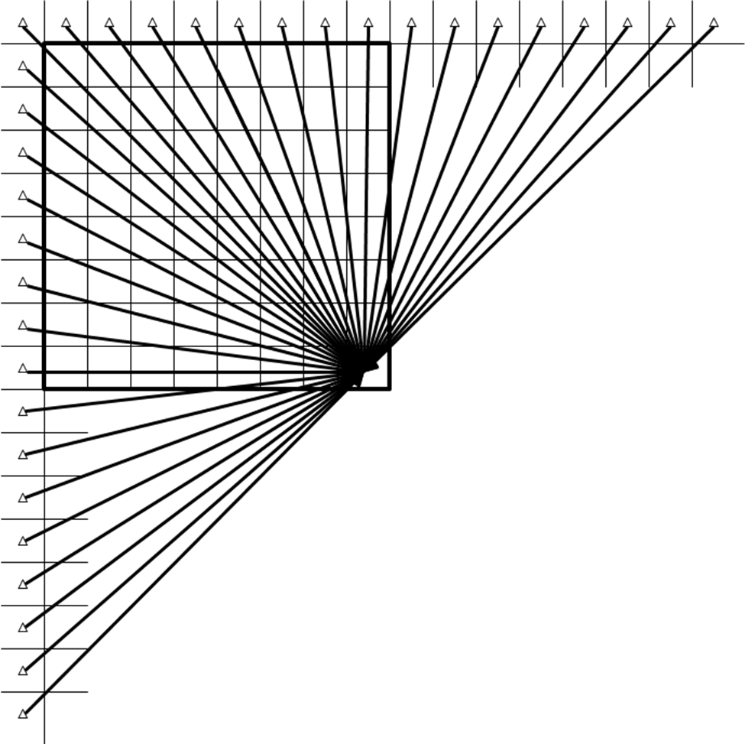
Direction = horizontal 4
Direction = vertical 2
Direction = horizontal -3
Figure 1: Angular intra prediction.

Above optimization was integrated into TMuC-04-bugfix. A total of 20 frames were encoded using the scripts in cfg\cfp-fast and Alpha.bat with –ip 1 (All Intra coding). BD-Rate results are provided below. There is no loss in coding efficiency.

 | Fast angular prediction
 |  | BD-Rate increase
S01 | Traffic | -0.01
S02 | PeopleOnStreet | -0.01
S03 | Kimono | -0.03
S04 | ParkScene | -0.02
S05 | Cactus | 0.01
S06 | BasketballDrive | -0.04
S07 | BQTerrace | 0.00
S08 | BasketballDrill | 0.00
S09 | BQMall | -0.01
S10 | PartyScene | -0.04
S11 | RaceHorses | -0.08
S12 | BasketballPass | 0.05
S13 | BQSquare | 0.01
S14 | BlowingBubbles | 0.05
S15 | RaceHorses | -0.02
 | All Seq Avg | -0.01
 | All Seq Min | -0.08
 | All Seq Max | 0.05

ADI (Arbitrary Direction) intra prediction simplification
The overall idea of ADI is similar to Angular intra prediction, but the differences are in the details. A total of 33 Intra prediction directions are defined [1]. The Intra prediction direction is determined by the tuple (dx, dy) which defines the line to be used to calculate the pixels to be used for prediction of the current pixel. An example (extracted from JCTVC-A124) is shown in Figure 2 below. The red colored pixel is the pixel being predicted. Green colored pixels are neighboring pixels which are used for predicting pixels in current block. E.g. the pixels used for predicting the red pixel are the “Context pixel” in Figure 2 and its neighbor.

Figure 2: Arbitrary direction intra prediction (JCTVC-A124).

The key operation in the calculation of context pixel location in the source code provided in [2] as follows:
ContextPixelLocation=dx*CurrentPixelLocation/dy;
Division is a computationally expensive operation in both hardware and software. This contribution proposes storing dx/dy in a table at fixed precision. Since dx and dy are fixed for an Intra prediction mode, this table continues to be 1D table. ContextPixelLocation can be calculated as:
ContextPixelLocation=(DxDivDyTable[IntraMode]*CurrentPixelLocation) >> DxDivDyShiftTable[IntraMode];
Similar idea can be applied to simplify the following operations involving division and modulo operations:
- ContextPixelLocation=dy*CurrentPixelLocation/dx
- (dx*CurrentPixelLocation)%dy
- (dy*CurrentPixelLocation)%dx

Simulation runs for calculating the BD-Rate impact of these simplifications are currently ongoing using TMuC-0.4. The results will be uploaded in the contribution once the simulations complete.

References
- JCT-VC, “Test Model under Consideration”, JCTVC-A205, Joint Collaborative Team on Video Coding meeting, 15-23 April 2010, Dresden, Germany.
- JCT-VC, TMuC-0.1 Reference Software, https://hevc.hhi.fraunhofer.de/svn/svn_TMuCSoftware/tags/0.1/ and http://hevc.kw.bbc.co.uk/git/w/jctvc-tmuc.git.

Patent rights declaration(s)
Texas Instruments Inc. may have IPR relating to the technology described in this contribution and, conditioned on reciprocity, is prepared to grant licenses under reasonable and non-discriminatory terms as necessary for implementation of the resulting ITU-T Recommendation | ISO/IEC International Standard (per box 2 of the ITU-T/ITU-R/ISO/IEC patent statement and licensing declaration form).

