    Joint Collaborative Team on Video Coding (JCT-VC)  of ITU-T SG16 WP3 and ISO/IEC JTC1/SC29/WG11  2nd Meeting: Geneva, CH, 21-28 July, 2010 | Document: JCTVC-B107

Title: | Intra Coding with Directional DCT and Directional DWT
Status: | Input Document to JCT-VC
Purpose: | Proposal
Author(s) or  Contact(s): | Cheung Auyeung  1730 N. First Street  San Jose, CA, USA  Ali Tabatabai  1730 N. First Street  San Jose, CA, USA | Tel:  Email:  Tel:  Email: | +1-408-352-4725  cheung.auyeung@am.sony.com  +1-408-352-4715  ali.tabatabai@am.sony.com
Source: | Sony Corp.
_____________________________

Abstract
The Mode Dependent Directional Transform (MDDT) is an option in KTA2.6r1 for the coding of intra block residue. To reduce complexity of MDDT, two types of transforms are proposed to replace MDDT for the transform coding of intra block residuals: Directional Discrete Cosine Transforms (DDCT) and Directional Discrete Wavelet Transform (DDWT). They are applied along and perpendicular to the direction of the intra prediction mode on either 4x4 or 8x8 blocks. In addition, fixed scanning pattern, which is a function of QP and prediction direction, for scanning of the transform coefficients is also proposed. DDCT results in BD-Rate of -1.78% and BD-PSNR of 0.067 dB relative to DCT for CS1. In contrast, MDDT results in BD-Rate of -2.33% and BD-PSNR of 0.087 dB relative to DCT for CS1.
This document proposes to conduct experiment with DDCT as a part of the Transform Tool Experiment of HEVC.

Introduction
The Mode Dependent Directional Transform (MDDT) is an option in KTA2.6r1 for the encoding of intra block residue. The MDDT in KTA2.6r1 includes mode dependent KLT and adaptive scanning of the transform coefficients. To speedup the computation of MDDT, this contribution propose (1) to replace the mode dependent KLTs by Directional DCT or Directional DWT and (2) to replace the adaptive scanning by QP based fixed scanning.
Since there are fast algorithms for DCT and DWT, the computation of the transform can be reduced relative to MDDT. Furthermore, unlike adaptive scanning in MDDT, QP based fixed scanning in this proposal does not require tracking of statistics in the picture, therefore computation can be further reduced.

Directional discrete cosine transform (DDCT)
The Directional Discrete Cosine Transforms (DDCT) is a set of transform to apply to the intra prediction errors in the video compression framework AVC. In this section, description and properties of DDCT will be described.

Intra coding in AVC and where DDCT fits in
Intra coding predicts the image content based on the value of previously decoded pixels. It has 9 prediction modes for 4x4 blocks, 9 prediction modes for 8x8 blocks, and 4 prediction modes for 16x16 blocks. For each intra prediction mode, an intra prediction algorithm is used to predict the image content in the current block based on decoded neighbors. The intra prediction errors are transformed using a DCT-like transform. The transform coefficients are then quantized, scanned into a 1D signal, and entropy coded using CAVLC or CABAC.
In this framework, DDCT is to replace the AVC transforms by a set of transforms that taking into account the prediction mode of the current block. Hence, DDCT provides 9 transforms for 4x4, 9 transforms for 8x8, and 4 transforms for 16x16, although many of them are the same or can be simply inferred from a core transform. For each transform, the DDCT also provides a fixed scanning pattern based on the QP and the intra prediction mode to replace the zigzag scanning pattern of DCT coefficients in AVC.

Directional discrete cosine transform (DDCT)
Transforms: DDCT provides 9 transforms for 4x4, 9 transforms for 8x8, and 4 transforms for 16x16. For each intra prediction mode, DDCT transform consists of two stages:
- Stage 1 – along the prediction direction: pixels that align along the prediction direction are grouped together and feed into a DCT transform. Note that, in cases of prediction modes that are neither horizontal nor vertical, the DCT transforms used are of different sizes.
- Stage 2 – across the prediction direction: another stage of DCT is applied to the transform coefficients resulted in the first stage. Again, the DCT transforms may be of different sizes.
To make the transform sizes more balanced, the DDCT transforms group pixels in the corners together in order to use DCT of longer size, hence more efficient in terms of compression. For example, in Error: Reference source not found, for 8x8 intra prediction mode 4, six pixels at the bottom-left corner and upper-right corner are grouped together for a 6-point DCT. Note that the pixel order as numbered in the figure is important for the effectiveness of the DCT. Error: Reference source not found to Error: Reference source not found show the DDCT transforms for other block size and prediction modes.
Fixed scanning: Once the transforms are applied to the prediction errors a fixed scanning pattern based on the QP and the intra prediction mode is used to order the transform coefficients into a 1D signal, similar to the role of zigzag scanning of DCT coefficients in AVC.

mode 4, stage 1
1
mode 4, stage 1
1
2
3
5
6
1
2
3
4
5
6
mode 4, stage 2

Figure 1: DDCT for 8x8 intra prediction mode 4 (diagonal down right). Left – the first stage, and right – the second stage. Each component transform is a DCT transform, may be of different size.
mode 5, stage 1
mode 5, stage 2
1
2
3
4
5
6
1
2
3
4
5
6

Figure 2: DDCT for 8x8 intra prediction mode 5 (down down right). Left – the first stage, and right – the second stage. Each component transform is a DCT transform, may be of different size.
mode 4, stage 1
mode 4, stage 2
Figure 3: DDCT for 4x4 intra prediction mode 4 (down right). Left – the first stage, and right – the second stage. Each component transform is a DCT transform, may be of different size.

mode 5, stage 1
mode 5, stage 2
Figure 4: DDCT for 4x4 intra prediction mode 5 (down down right). Left – the first stage, and right – the second stage. Each component transform is a DCT transform, may be of different size.

The DDCT possesses the following properties: adaptivity, directionality, symmetry, and complexity (to the order of separable transforms).
Adaptivity:
Unlike AVC in which the same DCT-like transform is applied at the intra prediction errors for all intra prediction modes of the same block size (4x4, 8x8, or 16x16), DDCT assigns a different transform and scanning pattern to each intra prediction mode. These transforms and scanning pattern are designed taking into account the intra prediction direction.
Directionality:
Since the intra prediction mode is known, the DDCT transform is designed with the knowledge of the intra prediction direction. By first applying the transform along the prediction direction, DDCT has the potential to minimize the artifact around the object boundaries.
Symmetry:
Although there are 22 DDCT transforms for 22 intra prediction modes (9 modes for 4x4, 9 modes for 8x8, and 4 modes for 16x16), these transforms can be derived, using simple operators such as rotation and/ or reflection, from only 7 different core transforms:
- 16x16: one transform for all 16x16 modes
- 8x8 and 4x4:
  - Modes 0, 1: same transform similar to AVC, DCT is used, first horizontally, then vertically,
  - Modes 3 and 4: the DDCT transform for mode 4 can be obtained from the transform for mode 3 using a reflection on the vertical line at the center of the block
  - Modes 5 to 8: the DDCT transforms for mode 6-8 can be derived from one of mode 3 using reflection and rotation.

Implementation

Matrix implementation of DCT
For simplicity of implementation, the basis DCT transforms in DDCT are implemented as matrix operators whose matrix entries are quantized to 7 bit precision. For future work, fast implementation and integer arithmetic can be used to replace the current implementation to obtain better performance as well as smaller dynamic range [1,2].
The transform matrices $D_{N}$for DCT of size N and its inverse $D_{N}^{−1}$are given as follows.
$$D_{2}=\left[\begin{matrix}\text{91} & \text{91} \\ \text{91} & −\text{91}\end{matrix}\right]$$
$$D_{2}^{−1}=\left[\begin{matrix}\text{90} & \text{90} \\ \text{90} & −\text{90}\end{matrix}\right]$$
$$D_{3}=\left[\begin{matrix}\text{74} & \text{74} & \text{74} \\ \text{90} & 0 & −\text{90} \\ \text{52} & −\text{104} & \text{52}\end{matrix}\right]$$

$$D_{3}^{−1}={\left[\begin{matrix}\text{74} & \text{74} & \text{74} \\ \text{91} & 0 & −\text{91} \\ \text{52} & −\text{104} & \text{52}\end{matrix}\right]}^{T}$$
$$D_{4}=\left[\begin{matrix}\text{64} & \text{64} & \text{64} & \text{64} \\ \text{84} & \text{34} & −\text{34} & −\text{84} \\ \text{64} & −\text{64} & −\text{64} & \text{64} \\ \text{34} & −\text{84} & \text{84} & −\text{34}\end{matrix}\right]$$
$$D_{4}^{−1}=D_{4}^{T}$$
$$D_{5}=\left[\begin{matrix}\text{57} & \text{57} & \text{57} & \text{57} & \text{57} \\ \text{77} & \text{48} & 0 & −\text{48} & −\text{77} \\ \text{66} & −\text{25} & −\text{81} & −\text{25} & \text{66} \\ \text{48} & −\text{77} & 0 & \text{77} & −\text{48} \\ \text{25} & −\text{65} & \text{81} & −\text{65} & \text{25}\end{matrix}\right]$$
$$D_{5}^{−1}={\left[\begin{matrix}\text{57} & \text{58} & \text{57} & \text{58} & \text{57} \\ \text{77} & \text{48} & 0 & −\text{48} & −\text{77} \\ \text{65} & −\text{25} & −\text{80} & −\text{25} & \text{65} \\ \text{48} & −\text{77} & 0 & \text{77} & −\text{48} \\ \text{25} & −\text{66} & \text{82} & −\text{66} & \text{25}\end{matrix}\right]}^{T}$$
$$D_{6}=\left[\begin{matrix}\text{52} & \text{52} & \text{52} & \text{52} & \text{52} & \text{52} \\ \text{71} & \text{52} & \text{19} & −\text{19} & −\text{52} & −\text{71} \\ \text{64} & 0 & −\text{64} & −\text{64} & 0 & \text{64} \\ \text{52} & −\text{52} & −\text{52} & \text{52} & \text{52} & −\text{52} \\ \text{37} & −\text{74} & \text{37} & \text{37} & −\text{74} & \text{37} \\ \text{19} & −\text{52} & \text{71} & −\text{71} & \text{52} & −\text{19}\end{matrix}\right]$$
$$D_{6}^{−1}=D_{6}^{T}$$
$$D_{7}=\left[\begin{matrix}\text{48} & \text{48} & \text{48} & \text{48} & \text{48} & \text{48} & \text{48} \\ \text{67} & \text{53} & \text{30} & 0 & −\text{30} & −\text{53} & −\text{67} \\ \text{62} & \text{15} & −\text{43} & −\text{68} & −\text{43} & \text{15} & \text{62} \\ \text{53} & −\text{30} & −\text{67} & 0 & \text{67} & \text{30} & −\text{53} \\ \text{43} & −\text{62} & −\text{15} & \text{68} & −\text{15} & −\text{62} & \text{43} \\ \text{30} & −\text{67} & \text{53} & 0 & −\text{53} & \text{67} & −\text{30} \\ \text{15} & −\text{43} & \text{62} & −\text{68} & \text{62} & −\text{43} & \text{15}\end{matrix}\right]$$
$$D_{7}^{−1}=D_{7}^{T}$$

$$D_{8}=\left[\begin{matrix}\text{45} & \text{45} & \text{45} & \text{45} & \text{45} & \text{45} & \text{45} & \text{45} \\ \text{63} & \text{53} & \text{36} & \text{12} & −\text{12} & −\text{36} & −\text{53} & −\text{63} \\ \text{59} & \text{24} & −\text{24} & −\text{59} & −\text{59} & −\text{24} & \text{24} & \text{59} \\ \text{53} & −\text{12} & −\text{63} & −\text{36} & \text{36} & \text{63} & \text{12} & −\text{53} \\ \text{45} & −\text{45} & −\text{45} & \text{45} & \text{45} & −\text{45} & −\text{45} & \text{45} \\ \text{36} & −\text{63} & \text{12} & \text{53} & −\text{53} & −\text{12} & \text{63} & −\text{36} \\ \text{24} & −\text{59} & \text{59} & −\text{24} & −\text{24} & \text{59} & −\text{59} & \text{24} \\ \text{12} & −\text{36} & \text{53} & −\text{63} & \text{63} & −\text{53} & \text{36} & −\text{12}\end{matrix}\right]$$
$$D_{8}^{−1}=D_{8}^{T}$$
$$D_{9}=\left[\begin{matrix}\text{43} & \text{43} & \text{43} & \text{43} & \text{43} & \text{43} & \text{43} & \text{43} & \text{43} \\ \text{59} & \text{52} & \text{39} & \text{21} & 0 & −\text{21} & −\text{39} & −\text{52} & −\text{59} \\ \text{57} & \text{30} & −\text{10} & −\text{46} & −\text{60} & −\text{46} & −\text{10} & \text{30} & \text{57} \\ \text{52} & 0 & −\text{52} & −\text{52} & 0 & \text{52} & \text{52} & 0 & −\text{52} \\ \text{46} & −\text{30} & −\text{57} & \text{10} & \text{60} & \text{10} & −\text{57} & −\text{30} & \text{46} \\ \text{39} & −\text{52} & −\text{21} & \text{59} & 0 & −\text{59} & \text{21} & \text{52} & −\text{39} \\ \text{30} & −\text{60} & \text{30} & \text{30} & −\text{60} & \text{30} & \text{30} & −\text{60} & \text{30} \\ \text{21} & −\text{52} & \text{59} & −\text{39} & 0 & \text{39} & −\text{59} & \text{52} & −\text{21} \\ \text{10} & −\text{30} & \text{46} & −\text{57} & \text{60} & −\text{57} & \text{46} & −\text{30} & \text{10}\end{matrix}\right]$$
$$D_{9}^{−1}=D_{9}^{T}$$
$$D_{\text{11}}=\left[\begin{matrix}\text{39} & \text{39} & \text{39} & \text{39} & \text{39} & \text{39} & \text{39} & \text{39} & \text{39} & \text{39} & \text{39} \\ \text{54} & \text{50} & \text{41} & \text{30} & \text{15} & 0 & −\text{15} & −\text{30} & −\text{41} & −\text{50} & −\text{54} \\ \text{52} & \text{36} & 8 & −\text{23} & −\text{46} & −\text{55} & −\text{46} & −\text{23} & 8 & \text{36} & \text{52} \\ \text{50} & \text{15} & −\text{30} & −\text{54} & −\text{41} & 0 & \text{41} & \text{54} & \text{30} & −\text{15} & −\text{50} \\ \text{46} & −8 & −\text{52} & −\text{36} & \text{23} & \text{55} & \text{23} & −\text{36} & −\text{52} & −8 & \text{46} \\ \text{41} & −\text{30} & −\text{50} & \text{15} & \text{54} & 0 & −\text{54} & −\text{15} & \text{50} & \text{30} & −\text{41} \\ \text{36} & −\text{46} & −\text{23} & \text{52} & 8 & −\text{55} & 8 & \text{52} & −\text{23} & −\text{46} & \text{36} \\ \text{30} & −\text{54} & \text{15} & \text{41} & −\text{50} & 0 & \text{50} & −\text{41} & −\text{15} & \text{54} & −\text{30} \\ \text{23} & −\text{52} & \text{46} & −8 & −\text{36} & \text{55} & −\text{36} & −8 & \text{46} & −\text{52} & \text{23} \\ \text{15} & −\text{41} & \text{54} & −\text{50} & \text{30} & 0 & −\text{30} & \text{50} & −\text{54} & \text{41} & −\text{15} \\ 8 & −\text{23} & \text{36} & −\text{46} & \text{52} & −\text{55} & \text{52} & −\text{46} & \text{36} & −\text{23} & 8\end{matrix}\right]$$
$$D_{\text{11}}^{−1}=D_{\text{11}}^{T}$$

The above transform matrices are obtained by scaling the DCT transform by 2^7 = 128. Since the DDCT transforms are two-stage transforms, the transform coefficients are scaled by 2^14 overall. Hence, it is necessary to scale back the transform coefficients. In the implementation of DDCT, this process is done by integrating the scaling factor 2^14 into the quantization process.

Special implementation of mode 2
For simplicity of implementation, in 4x4 and 8x8 cases, the intra prediction mode 2 (the DC mode) uses the original implementation of AVC. Their corresponding transforms are DCT-like with integer arithmetic. However, the transforms for mode 0 and 1, although theoretically being the same, use matrix implementation instead of fast implementation as in mode 2. The performance of DDCT hence can be slightly improved by using the AVC implementation.

Directional discrete wavelet transform (DDWT)

DDWT and its relation to DDCT
DDWT can be considered as a variation of DDCT, designed to improve the visual quality by choosing basis functions that have compact spatial supports.

Intra coding in AVC and where DDWT fits in
In this framework, DDWT is to replace the AVC transforms by a set of transforms that taking into account the prediction mode of the current block. Hence, DDWT provides 9 transforms for 4x4, 9 transforms for 8x8, and 4 transforms for 16x16, although many of them are the same or can be simply inferred from a core transform. For each transform, the DDWT also provides a fixed scanning pattern based on the QP and the intra prediction mode to replace the zigzag scanning pattern of DCT coefficients in AVC.

DDWT
DDWT are two-stage transforms, with the first stage conducted along the prediction direction and the second stage applied across the prediction direction (please refer to Error: Reference source not found to ).
Transforms: DDWT provide 9 transforms for 4x4, 9 transforms for 8x8, and 4 transforms for 16x16. For each intra prediction mode, DDWT transform consists of two stages:
- Stage 1 – along the prediction direction: pixels that align along the prediction direction are grouped together and feed into an intermediate transform derived from the Haar wavelet. Note that, in cases of prediction modes that are neither horizontal nor vertical, the intermediate transforms used are of different sizes.
- Stage 2 – across the prediction direction: another stage of intermediate transforms is applied to the transform coefficients resulted in the first stage. Again, the intermediate transforms may be of different sizes.
Fixed scanning: Once the transforms are applied to the prediction errors a fixed scanning pattern based on the QP and the intra prediction mode is used to order the transform coefficients into a 1D signal, similar to the role of zigzag scanning of DCT coefficients in AVC.

mode 4, stage 1
mode 4, stage 2
Figure 5: DDWT for 8x8 intra prediction mode 4 (diagonal down right). Left – the first stage, and right – the second stage. Each intermediate transform is derived from the Haar wavelet transform, and may be of different size. At the second stage, pixels of the same color go through the same intermediate transform.

mode 5, stage 1
mode 5, stage 2
Figure 6: DDWT for 8x8 intra prediction mode 5 (down down right). Left – the first stage, and right – the second stage. Each intermediate transform is derived from the Haar wavelet transform, and may be of different size. At the second stage, pixels of the same color go through the same intermediate transform.

mode 4, stage 1
mode 4, stage 2
Figure 7: DDWT for 4x4 intra prediction mode 4 (down right). Left – the first stage, and right – the second stage. Each intermediate transform is derived from the Haar wavelet transform, and may be of different size. At the second stage, pixels of the same color go through the same intermediate transform.

mode 5, stage 1
mode 5, stage 2
Figure 8: DDWT for 4x4 intra prediction mode 5 (down down right). Left – the first stage, and right – the second stage. Each intermediate transform is derived from the Haar wavelet transform, and may be of different size. At the second stage, pixels of the same color go through the same intermediate transform.
The DDWT possesses the following properties: localization, adaptivity, directionality, symmetry, and complexity (to the order of separable transforms).
Localization:
The basis vectors of the intermediate transforms have compact spatial support; hence the effect of quantization tends not to spread out around the edges. This helps to preserve the visual quality of the reconstructed images.
Adaptivity:
Unlike AVC in which the same DCT-like transform is applied at the intra prediction errors for all intra prediction modes of the same block size (4x4, 8x8, or 16x16), DDWT assigns a different transform and scanning pattern to each the intra prediction mode. These transforms and scanning pattern are designed taking into account the intra prediction direction.

Directionality:
Since the intra prediction mode is known, the DDWT transform is designed with the knowledge of the intra prediction direction. By first applying the transform along the prediction direction, DDWT has the potential to minimize the artifact around the object boundaries.
Symmetry:
Although there are 22 DDWT transforms for 22 intra prediction modes (9 modes for 4x4, 9 modes for 8x8, and 4 modes for 16x16), these transforms can be derived, using simple operators such as rotation and/ or reflection, from only 7 different core transforms:

- 16x16: one transform for all 16x16 modes
- 8x8 and 4x4:
  - Modes 0, 1: same transform
  - Modes 3 and 4: the DDWT transform for mode 4 can be obtained from the transform for mode 3 using a reflection on the vertical line at the center of the block
  - Modes 5 to 8: the DDWT transforms for mode 6-8 can be derived from that of mode 3 using reflection and/or rotation.

Implementation

Matrix implementation of intermediate transform
For simplicity of implementation, the intermediate transforms in DDWT are implemented as matrix operators whose matrix entries are quantized to 7 bit precision. For future work, fast implementation and integer arithmetic can be used to replace the current implementation to obtain better performance as well as smaller dynamic range.
The transform matrices $W_{N}$for the intermediate transform of size N and its inverse $W_{N}^{−1}$are given as follows.
$$W_{1}=W_{1}^{−1}=\text{128}$$
$$W_{2}=\left[\begin{matrix}\text{91} & \text{91} \\ \text{91} & −\text{91}\end{matrix}\right]$$
$$W_{2}^{−1}={\left[\begin{matrix}\text{90} & \text{90} \\ \text{90} & −\text{90}\end{matrix}\right]}^{T}$$
$$W_{3}=\left[\begin{matrix}\text{74} & \text{74} & \text{74} \\ −\text{104} & \text{52} & \text{52} \\ 0 & −\text{91} & \text{91}\end{matrix}\right]$$
$$W_{3}^{−1}={\left[\begin{matrix}\text{74} & \text{74} & \text{74} \\ −\text{104} & \text{52} & \text{52} \\ 0 & −\text{90} & \text{90}\end{matrix}\right]}^{T}$$

$$W_{4}=\left[\begin{matrix}\text{64} & \text{64} & \text{64} & \text{64} \\ \text{64} & \text{64} & −\text{64} & −\text{64} \\ \text{91} & −\text{91} & 0 & 0 \\ 0 & 0 & \text{91} & −\text{91}\end{matrix}\right]$$
$$W_{4}^{−1}={\left[\begin{matrix}\text{64} & \text{64} & \text{64} & \text{64} \\ \text{64} & \text{64} & −\text{64} & −\text{64} \\ \text{90} & −\text{90} & 0 & 0 \\ 0 & 0 & \text{90} & −\text{90}\end{matrix}\right]}^{T}$$
$$W_{5}=\left[\begin{matrix}\text{57} & \text{57} & \text{57} & \text{57} & \text{57} \\ −\text{47} & −\text{47} & −\text{47} & \text{70} & \text{70} \\ −\text{104} & \text{52} & \text{52} & 0 & 0 \\ 0 & −\text{91} & \text{91} & 0 & 0 \\ 0 & 0 & 0 & −\text{91} & \text{91}\end{matrix}\right]$$
$$W_{5}^{−1}={\left[\begin{matrix}\text{57} & \text{57} & \text{57} & \text{57} & \text{57} \\ −\text{47} & −\text{47} & −\text{47} & \text{70} & \text{70} \\ −\text{104} & \text{52} & \text{52} & 0 & 0 \\ 0 & −\text{90} & \text{90} & 0 & 0 \\ 0 & 0 & 0 & −\text{90} & \text{90}\end{matrix}\right]}^{T}$$
$$W_{6}=\left[\begin{matrix}\text{52} & \text{52} & \text{52} & \text{52} & \text{52} & \text{52} \\ −\text{74} & −\text{74} & \text{37} & \text{37} & \text{37} & \text{37} \\ 0 & 0 & −\text{64} & −\text{64} & \text{64} & \text{64} \\ −\text{91} & \text{91} & 0 & 0 & 0 & 0 \\ 0 & 0 & −\text{91} & \text{91} & 0 & 0 \\ 0 & 0 & 0 & 0 & −\text{91} & \text{91}\end{matrix}\right]$$
$$W_{6}^{−1}={\left[\begin{matrix}\text{52} & \text{52} & \text{52} & \text{52} & \text{52} & \text{52} \\ −\text{74} & −\text{74} & \text{37} & \text{37} & \text{37} & \text{37} \\ 0 & 0 & −\text{64} & −\text{64} & \text{64} & \text{64} \\ −\text{90} & \text{90} & 0 & 0 & 0 & 0 \\ 0 & 0 & −\text{90} & \text{90} & 0 & 0 \\ 0 & 0 & 0 & 0 & −\text{90} & \text{90}\end{matrix}\right]}^{T}$$

$$W_{7}=\left[\begin{matrix}\text{48} & \text{48} & \text{48} & \text{48} & \text{48} & \text{48} & \text{48} \\ −\text{56} & −\text{56} & −\text{56} & \text{42} & \text{42} & \text{42} & \text{42} \\ −\text{104} & \text{52} & \text{52} & 0 & 0 & 0 & 0 \\ 0 & 0 & 0 & \text{64} & \text{64} & −\text{64} & −\text{64} \\ 0 & −\text{91} & \text{91} & 0 & 0 & 0 & 0 \\ 0 & 0 & 0 & −\text{91} & \text{91} & 0 & 0 \\ 0 & 0 & 0 & 0 & 0 & −\text{91} & \text{91}\end{matrix}\right]$$

$$W_{7}^{−1}={\left[\begin{matrix}\text{48} & \text{48} & \text{48} & \text{48} & \text{48} & \text{48} & \text{48} \\ −\text{56} & −\text{56} & −\text{56} & \text{42} & \text{42} & \text{42} & \text{42} \\ −\text{104} & \text{52} & \text{52} & 0 & 0 & 0 & 0 \\ 0 & 0 & 0 & \text{64} & \text{64} & −\text{64} & −\text{64} \\ 0 & −\text{90} & \text{90} & 0 & 0 & 0 & 0 \\ 0 & 0 & 0 & −\text{90} & \text{90} & 0 & 0 \\ 0 & 0 & 0 & 0 & 0 & −\text{90} & \text{90}\end{matrix}\right]}^{T}$$

$W_{8}=\left[\begin{matrix}\text{46} & \text{46} & \text{46} & \text{46} & \text{45} & \text{45} & \text{45} & \text{45} \\ −\text{45} & −\text{45} & −\text{45} & −\text{45} & \text{45} & \text{45} & \text{45} & \text{45} \\ \text{64} & \text{64} & −\text{64} & −\text{64} & 0 & 0 & 0 & 0 \\ 0 & 0 & 0 & 0 & \text{64} & \text{64} & −\text{64} & −\text{64} \\ −\text{91} & \text{91} & 0 & 0 & 0 & 0 & 0 & 0 \\ 0 & 0 & −\text{91} & \text{91} & 0 & 0 & 0 & 0 \\ 0 & 0 & 0 & 0 & −\text{91} & \text{91} & 0 & 0 \\ 0 & 0 & 0 & 0 & 0 & 0 & −\text{91} & \text{91}\end{matrix}\right]$

$W_{8}^{−1}={\left[\begin{matrix}\text{45} & \text{45} & \text{45} & \text{45} & \text{45} & \text{45} & \text{45} & \text{45} \\ −\text{45} & −\text{45} & −\text{45} & −\text{45} & \text{46} & \text{46} & \text{46} & \text{46} \\ \text{64} & \text{64} & −\text{64} & −\text{64} & 0 & 0 & 0 & 0 \\ 0 & 0 & 0 & 0 & \text{64} & \text{64} & −\text{64} & −\text{64} \\ −\text{90} & \text{90} & 0 & 0 & 0 & 0 & 0 & 0 \\ 0 & 0 & −\text{90} & \text{90} & 0 & 0 & 0 & 0 \\ 0 & 0 & 0 & 0 & −\text{90} & \text{90} & 0 & 0 \\ 0 & 0 & 0 & 0 & 0 & 0 & −\text{90} & \text{90}\end{matrix}\right]}^{T}$

$$W_{9}=\left[\begin{matrix}\text{43} & \text{43} & \text{43} & \text{43} & \text{43} & \text{43} & \text{43} & \text{43} & \text{43} \\ −\text{38} & −\text{38} & −\text{38} & −\text{38} & −\text{38} & \text{48} & \text{48} & \text{48} & \text{48} \\ −\text{47} & −\text{47} & −\text{47} & \text{70} & \text{70} & 0 & 0 & 0 & 0 \\ −\text{104} & \text{52} & \text{52} & 0 & 0 & 0 & 0 & 0 & 0 \\ 0 & 0 & 0 & 0 & 0 & \text{64} & \text{64} & −\text{64} & −\text{64} \\ 0 & −\text{91} & \text{91} & 0 & 0 & 0 & 0 & 0 & 0 \\ 0 & 0 & 0 & −\text{91} & \text{91} & 0 & 0 & 0 & 0 \\ 0 & 0 & 0 & 0 & 0 & −\text{91} & \text{91} & 0 & 0 \\ 0 & 0 & 0 & 0 & 0 & 0 & 0 & −\text{91} & \text{91}\end{matrix}\right]$$
$$W_{9}^{−1}={\left[\begin{matrix}\text{42} & \text{42} & \text{42} & \text{43} & \text{43} & \text{42} & \text{42} & \text{42} & \text{42} \\ −\text{38} & −\text{38} & −\text{38} & −\text{38} & −\text{38} & \text{48} & \text{48} & \text{48} & \text{48} \\ −\text{47} & −\text{47} & −\text{47} & \text{70} & \text{70} & 0 & 0 & 0 & 0 \\ −\text{104} & \text{52} & \text{52} & 0 & 0 & 0 & 0 & 0 & 0 \\ 0 & 0 & 0 & 0 & 0 & \text{64} & \text{64} & −\text{64} & −\text{64} \\ 0 & −\text{90} & \text{90} & 0 & 0 & 0 & 0 & 0 & 0 \\ 0 & 0 & 0 & −\text{90} & \text{90} & 0 & 0 & 0 & 0 \\ 0 & 0 & 0 & 0 & 0 & −\text{90} & \text{90} & 0 & 0 \\ 0 & 0 & 0 & 0 & 0 & 0 & 0 & −\text{90} & \text{90}\end{matrix}\right]}^{T}$$
$$W_{\text{11}}=\left[\begin{matrix}\text{38} & \text{38} & \text{38} & \text{38} & \text{39} & \text{39} & \text{39} & \text{39} & \text{39} & \text{39} & \text{39} \\ −\text{51} & −\text{51} & −\text{51} & −\text{51} & \text{29} & \text{29} & \text{29} & \text{29} & \text{29} & \text{29} & \text{29} \\ 0 & 0 & 0 & 0 & −\text{42} & −\text{42} & −\text{42} & −\text{42} & \text{56} & \text{56} & \text{56} \\ −\text{64} & −\text{64} & −\text{64} & −\text{64} & 0 & 0 & 0 & 0 & 0 & 0 & 0 \\ 0 & 0 & 0 & 0 & \text{64} & \text{64} & −\text{64} & −\text{64} & 0 & 0 & 0 \\ 0 & 0 & 0 & 0 & 0 & 0 & 0 & 0 & −\text{52} & −\text{52} & \text{104} \\ −\text{91} & \text{91} & 0 & 0 & 0 & 0 & 0 & 0 & 0 & 0 & 0 \\ 0 & 0 & −\text{91} & \text{91} & 0 & 0 & 0 & 0 & 0 & 0 & 0 \\ 0 & 0 & 0 & 0 & −\text{91} & \text{91} & 0 & 0 & 0 & 0 & 0 \\ 0 & 0 & 0 & 0 & 0 & 0 & −\text{91} & \text{91} & 0 & 0 & 0 \\ 0 & 0 & 0 & 0 & 0 & 0 & 0 & 0 & −\text{91} & \text{91} & 0\end{matrix}\right]$$

$$W_{\text{11}}^{−1}={\left[\begin{matrix}\text{38} & \text{38} & \text{38} & \text{38} & \text{39} & \text{39} & \text{39} & \text{39} & \text{39} & \text{39} & \text{39} \\ −\text{51} & −\text{51} & −\text{51} & −\text{51} & \text{29} & \text{29} & \text{29} & \text{29} & \text{29} & \text{29} & \text{29} \\ 0 & 0 & 0 & 0 & −\text{42} & −\text{42} & −\text{42} & −\text{42} & \text{56} & \text{56} & \text{56} \\ −\text{64} & −\text{64} & −\text{64} & −\text{64} & 0 & 0 & 0 & 0 & 0 & 0 & 0 \\ 0 & 0 & 0 & 0 & \text{64} & \text{64} & −\text{64} & −\text{64} & 0 & 0 & 0 \\ 0 & 0 & 0 & 0 & 0 & 0 & 0 & 0 & −\text{52} & −\text{52} & \text{104} \\ −\text{90} & \text{90} & 0 & 0 & 0 & 0 & 0 & 0 & 0 & 0 & 0 \\ 0 & 0 & −\text{90} & \text{90} & 0 & 0 & 0 & 0 & 0 & 0 & 0 \\ 0 & 0 & 0 & 0 & −\text{90} & \text{90} & 0 & 0 & 0 & 0 & 0 \\ 0 & 0 & 0 & 0 & 0 & 0 & −\text{90} & \text{90} & 0 & 0 & 0 \\ 0 & 0 & 0 & 0 & 0 & 0 & 0 & 0 & −\text{90} & \text{90} & 0\end{matrix}\right]}^{T}$$

$$W_{\text{13}}=\left[\begin{matrix}\text{36} & \text{36} & \text{36} & \text{36} & \text{36} & \text{36} & \text{36} & \text{36} & \text{36} & \text{36} & \text{36} & \text{36} & \text{36} \\ −\text{28} & −\text{28} & −\text{28} & −\text{28} & −\text{28} & −\text{28} & −\text{28} & −\text{28} & \text{45} & \text{45} & \text{45} & \text{45} & \text{45} \\ −\text{45} & −\text{45} & −\text{45} & −\text{45} & \text{45} & \text{45} & \text{45} & \text{45} & 0 & 0 & 0 & 0 & 0 \\ 0 & 0 & 0 & 0 & 0 & 0 & 0 & 0 & −\text{70} & −\text{70} & \text{47} & \text{47} & \text{47} \\ \text{64} & \text{64} & −\text{64} & −\text{64} & 0 & 0 & 0 & 0 & 0 & 0 & 0 & 0 & 0 \\ 0 & 0 & 0 & 0 & \text{64} & \text{64} & −\text{64} & −\text{64} & 0 & 0 & 0 & 0 & 0 \\ 0 & 0 & 0 & 0 & 0 & 0 & 0 & 0 & 0 & 0 & −\text{52} & −\text{52} & \text{104} \\ −\text{91} & \text{91} & 0 & 0 & 0 & 0 & 0 & 0 & 0 & 0 & 0 & 0 & 0 \\ 0 & 0 & −\text{91} & \text{91} & 0 & 0 & 0 & 0 & 0 & 0 & 0 & 0 & 0 \\ 0 & 0 & 0 & 0 & −\text{91} & \text{91} & 0 & 0 & 0 & 0 & 0 & 0 & 0 \\ 0 & 0 & 0 & 0 & 0 & 0 & −\text{91} & \text{91} & 0 & 0 & 0 & 0 & 0 \\ 0 & 0 & 0 & 0 & 0 & 0 & 0 & 0 & −\text{91} & \text{91} & 0 & 0 & 0 \\ 0 & 0 & 0 & 0 & 0 & 0 & 0 & 0 & 0 & 0 & −\text{91} & \text{91} & 0\end{matrix}\right]$$

$$W_{\text{13}}^{−1}={\left[\begin{matrix}\text{36} & \text{36} & \text{36} & \text{36} & \text{36} & \text{36} & \text{36} & \text{36} & \text{36} & \text{36} & \text{36} & \text{36} & \text{36} \\ −\text{28} & −\text{28} & −\text{28} & −\text{28} & −\text{28} & −\text{28} & −\text{28} & −\text{28} & \text{45} & \text{45} & \text{45} & \text{45} & \text{45} \\ −\text{46} & −\text{46} & −\text{46} & −\text{46} & \text{46} & \text{46} & \text{46} & \text{46} & 0 & 0 & 0 & 0 & 0 \\ 0 & 0 & 0 & 0 & 0 & 0 & 0 & 0 & −\text{70} & −\text{70} & \text{47} & \text{47} & \text{47} \\ \text{64} & \text{64} & −\text{64} & −\text{64} & 0 & 0 & 0 & 0 & 0 & 0 & 0 & 0 & 0 \\ 0 & 0 & 0 & 0 & \text{64} & \text{64} & −\text{64} & −\text{64} & 0 & 0 & 0 & 0 & 0 \\ 0 & 0 & 0 & 0 & 0 & 0 & 0 & 0 & 0 & 0 & −\text{52} & −\text{52} & \text{104} \\ −\text{90} & \text{90} & 0 & 0 & 0 & 0 & 0 & 0 & 0 & 0 & 0 & 0 & 0 \\ 0 & 0 & −\text{90} & \text{90} & 0 & 0 & 0 & 0 & 0 & 0 & 0 & 0 & 0 \\ 0 & 0 & 0 & 0 & −\text{90} & \text{90} & 0 & 0 & 0 & 0 & 0 & 0 & 0 \\ 0 & 0 & 0 & 0 & 0 & 0 & −\text{90} & \text{90} & 0 & 0 & 0 & 0 & 0 \\ 0 & 0 & 0 & 0 & 0 & 0 & 0 & 0 & −\text{90} & \text{90} & 0 & 0 & 0 \\ 0 & 0 & 0 & 0 & 0 & 0 & 0 & 0 & 0 & 0 & −\text{90} & \text{90} & 0\end{matrix}\right]}^{T}$$

$$W_{\text{16}}^{−1}={\left[\begin{matrix}\text{32} & \text{32} & \text{32} & \text{32} & \text{32} & \text{32} & \text{32} & \text{32} & \text{32} & \text{32} & \text{32} & \text{32} & \text{32} & \text{32} & \text{32} & \text{32} \\ −\text{32} & −\text{32} & −\text{32} & −\text{32} & −\text{32} & −\text{32} & −\text{32} & −\text{32} & \text{32} & \text{32} & \text{32} & \text{32} & \text{32} & \text{32} & \text{32} & \text{32} \\ −\text{45} & −\text{45} & −\text{45} & −\text{45} & \text{45} & \text{45} & \text{45} & \text{45} & 0 & 0 & 0 & 0 & 0 & 0 & 0 & 0 \\ 0 & 0 & 0 & 0 & 0 & 0 & 0 & 0 & −\text{45} & −\text{45} & −\text{45} & −\text{45} & \text{45} & \text{45} & \text{45} & \text{45} \\ −\text{64} & −\text{64} & \text{64} & \text{64} & 0 & 0 & 0 & 0 & 0 & 0 & 0 & 0 & 0 & 0 & 0 & 0 \\ 0 & 0 & 0 & 0 & −\text{64} & −\text{64} & \text{64} & \text{64} & 0 & 0 & 0 & 0 & 0 & 0 & 0 & 0 \\ 0 & 0 & 0 & 0 & 0 & 0 & 0 & 0 & −\text{64} & −\text{64} & \text{64} & \text{64} & 0 & 0 & 0 & 0 \\ 0 & 0 & 0 & 0 & 0 & 0 & 0 & 0 & 0 & 0 & 0 & 0 & −\text{64} & −\text{64} & \text{64} & \text{64} \\ −\text{90} & \text{90} & 0 & 0 & 0 & 0 & 0 & 0 & 0 & 0 & 0 & 0 & 0 & 0 & 0 & 0 \\ 0 & 0 & −\text{90} & \text{90} & 0 & 0 & 0 & 0 & 0 & 0 & 0 & 0 & 0 & 0 & 0 & 0 \\ 0 & 0 & 0 & 0 & −\text{90} & \text{90} & 0 & 0 & 0 & 0 & 0 & 0 & 0 & 0 & 0 & 0 \\ 0 & 0 & 0 & 0 & 0 & 0 & −\text{90} & \text{90} & 0 & 0 & 0 & 0 & 0 & 0 & 0 & 0 \\ 0 & 0 & 0 & 0 & 0 & 0 & 0 & 0 & −\text{90} & \text{90} & 0 & 0 & 0 & 0 & 0 & 0 \\ 0 & 0 & 0 & 0 & 0 & 0 & 0 & 0 & 0 & 0 & −\text{90} & \text{90} & 0 & 0 & 0 & 0 \\ 0 & 0 & 0 & 0 & 0 & 0 & 0 & 0 & 0 & 0 & 0 & 0 & −\text{90} & \text{90} & 0 & 0 \\ 0 & 0 & 0 & 0 & 0 & 0 & 0 & 0 & 0 & 0 & 0 & 0 & 0 & 0 & −\text{90} & \text{90}\end{matrix}\right]}^{T}$$

Transforms of the “DC” coefficients:
It can be seen from the transform matrices that the first coefficients of the intermediate transform at the first stage are in fact the same as the DC coefficients of the DCT. In the second stage, these coefficients need a special treatment other than using the intermediate transforms provided above. Below are the transform matrices when working with these “DC” coefficients at the second stage.

$$M_{\text{15}}=\left[\begin{matrix}\text{16} & \text{23} & \text{28} & \text{32} & \text{36} & \text{39} & \text{42} & \text{45} & \text{42} & \text{39} & \text{36} & \text{32} & \text{28} & \text{23} & \text{16} \\ −\text{14} & −\text{20} & −\text{24} & −\text{28} & −\text{32} & −\text{35} & −\text{37} & −\text{40} & \text{48} & \text{44} & \text{41} & \text{36} & \text{31} & \text{26} & \text{18} \\ −\text{34} & −\text{49} & −\text{60} & −\text{69} & \text{30} & \text{32} & \text{35} & \text{37} & 0 & 0 & 0 & 0 & 0 & 0 & 0 \\ 0 & 0 & 0 & 0 & 0 & 0 & 0 & 0 & −\text{33} & −\text{31} & −\text{28} & −\text{25} & \text{80} & \text{66} & \text{46} \\ −\text{62} & −\text{87} & \text{46} & \text{53} & 0 & 0 & 0 & 0 & 0 & 0 & 0 & 0 & 0 & 0 & 0 \\ 0 & 0 & 0 & 0 & −\text{66} & −\text{72} & \text{57} & \text{61} & 0 & 0 & 0 & 0 & 0 & 0 & 0 \\ 0 & 0 & 0 & 0 & 0 & 0 & 0 & 0 & −\text{60} & −\text{56} & \text{73} & \text{66} & 0 & 0 & 0 \\ 0 & 0 & 0 & 0 & 0 & 0 & 0 & 0 & 0 & 0 & 0 & 0 & −\text{40} & −\text{33} & \text{117} \\ −\text{105} & \text{74} & 0 & 0 & 0 & 0 & 0 & 0 & 0 & 0 & 0 & 0 & 0 & 0 & 0 \\ 0 & 0 & −\text{97} & \text{84} & 0 & 0 & 0 & 0 & 0 & 0 & 0 & 0 & 0 & 0 & 0 \\ 0 & 0 & 0 & 0 & −\text{95} & \text{86} & 0 & 0 & 0 & 0 & 0 & 0 & 0 & 0 & 0 \\ 0 & 0 & 0 & 0 & 0 & 0 & −\text{93} & \text{87} & 0 & 0 & 0 & 0 & 0 & 0 & 0 \\ 0 & 0 & 0 & 0 & 0 & 0 & 0 & 0 & −\text{87} & \text{94} & 0 & 0 & 0 & 0 & 0 \\ 0 & 0 & 0 & 0 & 0 & 0 & 0 & 0 & 0 & 0 & −\text{85} & \text{95} & 0 & 0 & 0 \\ 0 & 0 & 0 & 0 & 0 & 0 & 0 & 0 & 0 & 0 & 0 & 0 & −\text{81} & \text{99} & 0\end{matrix}\right]$$
$$M_{\text{15}}^{−1}=M_{\text{15}}^{T}$$

$$M_{\text{11}}=\left[\begin{matrix}\text{23} & \text{32} & \text{39} & \text{45} & \text{45} & \text{45} & \text{45} & \text{45} & \text{39} & \text{32} & \text{23} \\ −\text{26} & −\text{36} & −\text{44} & −\text{51} & −\text{51} & \text{40} & \text{40} & \text{40} & \text{35} & \text{28} & \text{20} \\ 0 & 0 & 0 & 0 & 0 & −\text{67} & −\text{67} & \text{54} & \text{47} & \text{38} & \text{27} \\ −\text{40} & −\text{56} & −\text{68} & \text{59} & \text{59} & 0 & 0 & 0 & 0 & 0 & 0 \\ 0 & 0 & 0 & 0 & 0 & 0 & 0 & −\text{99} & \text{57} & \text{47} & \text{33} \\ −\text{52} & −\text{74} & \text{91} & 0 & 0 & 0 & 0 & 0 & 0 & 0 & 0 \\ 0 & 0 & 0 & 0 & 0 & 0 & 0 & 0 & −\text{91} & \text{74} & \text{52} \\ −\text{105} & \text{74} & 0 & 0 & 0 & 0 & 0 & 0 & 0 & 0 & 0 \\ 0 & 0 & 0 & −\text{91} & \text{91} & 0 & 0 & 0 & 0 & 0 & 0 \\ 0 & 0 & 0 & 0 & 0 & −\text{91} & \text{91} & 0 & 0 & 0 & 0 \\ 0 & 0 & 0 & 0 & 0 & 0 & 0 & 0 & 0 & −\text{74} & \text{105}\end{matrix}\right]$$

$$M_{\text{11}}^{−1}={\left[\begin{matrix}\text{23} & \text{32} & \text{39} & \text{45} & \text{45} & \text{45} & \text{45} & \text{45} & \text{39} & \text{32} & \text{23} \\ −\text{26} & −\text{36} & −\text{44} & −\text{51} & −\text{51} & \text{40} & \text{40} & \text{40} & \text{35} & \text{28} & \text{20} \\ 0 & 0 & 0 & 0 & 0 & −\text{68} & −\text{68} & \text{54} & \text{47} & \text{38} & \text{27} \\ −\text{40} & −\text{56} & −\text{68} & \text{59} & \text{59} & 0 & 0 & 0 & 0 & 0 & 0 \\ 0 & 0 & 0 & 0 & 0 & 0 & 0 & −\text{99} & \text{57} & \text{47} & \text{33} \\ −\text{52} & −\text{74} & \text{91} & 0 & 0 & 0 & 0 & 0 & 0 & 0 & 0 \\ 0 & 0 & 0 & 0 & 0 & 0 & 0 & 0 & −\text{91} & \text{74} & \text{52} \\ −\text{104} & \text{74} & 0 & 0 & 0 & 0 & 0 & 0 & 0 & 0 & 0 \\ 0 & 0 & 0 & −\text{90} & \text{90} & 0 & 0 & 0 & 0 & 0 & 0 \\ 0 & 0 & 0 & 0 & 0 & −\text{90} & \text{90} & 0 & 0 & 0 & 0 \\ 0 & 0 & 0 & 0 & 0 & 0 & 0 & 0 & 0 & −\text{74} & \text{104}\end{matrix}\right]}^{T}$$

The above transform matrices are obtained by scaling appropriate orthonormal matrices by 2^7 = 128. Since the DDWT transforms are two-stage transforms, the transform coefficients are scaled by 2^14 overall. Hence, it is necessary to scale back the transform coefficients. In the implementation of DDWT, this process is done by integrating the scaling factor 2^14 into the quantization process.

Special implementation of mode 2
For simplicity of implementation, in 4x4 and 8x8 cases, the intra prediction mode 2 (the DC mode) uses the original implementation of AVC. Their corresponding transforms are DCT-like with integer arithmetic. However, the transforms for mode 0 and 1, although theoretically being the same, use matrix implementation instead of fast implementation as in mode 2. The performance of DDWT hence can be slightly improved by using the AVC implementation.

Quantization

Quantization of DDCT
Quantization:
The DDCT transforms are orthogonal whose basis functions all have the same norm 2^14. Hence, this scaling factor needs to be compensated in the quantization process similar to MDDT [3].
$$Y_{Q}=[Y⋅Q(\text{QP}\text{\%}6)+f_{\text{enc}}]\text{>>}(\text{22}+{\text{QP}}/6)$$
where the pre-scaling factors
$Q=[\begin{matrix}\text{410} & \text{364} & \text{328} & \text{287} & \text{260} & \text{231}\end{matrix}]$,
and the offset number is
$$f_{\text{enc}}={2^{\text{22}+{\text{QP}}/6}}/3$$

Dequantization:
The de-quantization formula is
$$Y=Y_{Q}⋅R(\text{QP}\text{\%}6)\text{<<}{\text{QP}}/6$$
With the post-scaling factors
$$R=[\begin{matrix}\text{40} & \text{45} & \text{50} & \text{57} & \text{63} & \text{71}\end{matrix}]$$

Reconstruction:
Since the inverse DDCT transforms are also scaled by 2^14, the reconstructed prediction errors $X_{S}$also need to be compensated for the scaling factor:

$$X_{S}=(X+f_{\text{dec}})\text{>>}\text{20}$$

where $f_{\text{dec}}=2^{\text{19}}$

Quantization of DDWT
Quantization:
The DDWT transforms are orthogonal whose basis functions all have the same norm 2^14. Hence, this scaling factor needs to be compensated in the quantization process similar to MDDT [3].
$$Y_{Q}=[Y⋅Q(\text{QP}\text{\%}6)+f_{\text{enc}}]\text{>>}(\text{22}+{\text{QP}}/6)$$
where the pre-scaling factors
$Q=[\begin{matrix}\text{410} & \text{364} & \text{328} & \text{287} & \text{260} & \text{231}\end{matrix}]$,
and the offset number is
$$f_{\text{enc}}={2^{\text{22}+{\text{QP}}/6}}/3$$

Dequantization:
The de-quantization formula is
$$Y=Y_{Q}⋅R(\text{QP}\text{\%}6)\text{<<}{\text{QP}}/6$$
With the post-scaling factors
$$R=[\begin{matrix}\text{40} & \text{45} & \text{50} & \text{57} & \text{63} & \text{71}\end{matrix}]$$

Reconstruction:
Since the inverse DDWT transforms are also scaled by 2^14, the reconstructed prediction errors $X_{S}$also need to be compensated for the scaling factor:
$$X_{S}=(X+f_{\text{dec}})\text{>>}\text{20}$$
where $f_{\text{dec}}=2^{\text{19}}$

Complexity characteristics of encoder transforms and transform type selection

Complexity characteristics of DDCT

Complexity and memory analysis
DDCT is implemented using 32-bit arithmetic.

Memory
4x4 transforms:
- Mode 0 and 1:
  - Fixed table: 4x4
  - Intermediate table: 4x4
- Mode 2: similar to AVC
- Mode 3 and 4:
  - Fixed table: 5x5
  - Intermediate table: 5x4
- Mode 5 – 8:
  - Fixed table: 5x5
  - Intermediate table: 5x4
8x8 transforms:
- Mode 0 and 1:
  - Fixed table: 8x8
  - Intermediate table: 8x8
- Mode 2: similar to AVC
- Mode 3 and 4:
  - Fixed table: 11x11
  - Intermediate table: 11x8
- Mode 5 – 8:
  - Fixed table: 9x9
  - Intermediate table: 9x8

Computation
Because of the matrix implementation of DCT as the component transforms, each component transform of size N will require
- N^2 multiplications
- N^2 – N additions
Hence, for a given intra prediction mode, if the first stage DDCT consists of DCT of size N1,…, Nk1 and the second stage DDCT consists of DCT of size M1,…, Mk2, then the overall complexity for this particular mode is
Number of multiplications: $\sum{N_{i}^{2}}+\sum{M_{i}^{2}}$
Number of additions: $\sum{(N_{i}^{2}−N_{i})}+\sum{(M_{i}^{2}}−M_{i})$
The following complexity can be derived for DDCT:
4x4 transforms:
- Mode 0 and 1:
  - 128 multiplications
  - 96 additions
- Mode 2: similar to AVC
- Mode 3 and 4:
  - 128 multiplications
  - 96 additions
- Mode 5 to 8:
  - 124 multiplications
  - 92 additions
8x8 transforms:
- Mode 0 and 1:
  - 1024 multiplications
  - 896 additions
- Mode 2: similar to AVC
- Mode 3 and 4:
  - 1037 multiplications
  - 94 additions
- Mode 5 to 8:
  - 1000 multiplications
  - 872 additions

Complexity characteristics of DDWT

Complexity and memory analysis
DDWT is implemented using 32-bit arithmetic. However since DDWT transforms are made up from a series of Haar wavelet transforms, there are rooms to simplify the implementation complexity of DDWT.

Memory
4x4 transforms:
- Mode 0 and 1:
  - Fixed table: 4x4
  - Intermediate table: 4x4
- Mode 2: similar to AVC
- Mode 3 and 4:
  - Fixed table: 7x7
  - Intermediate table: 7x4
- Mode 5 – 8:
  - Fixed table: 5x5
  - Intermediate table: 5x4
8x8 transforms:
- Mode 0 and 1:
  - Fixed table: 8x8
  - Intermediate table: 8x8
- Mode 2: similar to AVC
- Mode 3 and 4:
  - Fixed table: 15x15
  - Intermediate table: 15x8
- Mode 5 – 8:
  - Fixed table: 11x11
  - Intermediate table: 11x8

Computation
Because of the matrix implementation of the intermediate transforms, each component transform of size N will require
- N^2 multiplications
- N^2 – N additions
Hence, for a given intra prediction mode, if the first stage DDWT consists of intermediate transforms of size N₁,…, N_{k1} and the second stage DDWT consists of intermediate transforms of size M₁,…, M_{k2}, then the over all complexity for this particular mode is
Number of multiplications: $\sum{N_{i}^{2}}+\sum{M_{i}^{2}}$
Number of additions: $\sum{(N_{i}^{2}−N_{i})}+\sum{(M_{i}^{2}}−M_{i})$
Note that, since the transform matrices contain many zero entries, the complexity of DDWT can be reduced. In the current implementation, the following complexity can be derived for DDWT:
4x4 transforms:
- Mode 0 and 1:
  - 128 multiplications
  - 96 additions
- Mode 2: similar to AVC
- Mode 3 and 4:
  - 128 multiplications
  - 96 additions
- Mode 5 to 8:
  - 124 multiplications
  - 92 additions
8x8 transforms:
- Mode 0 and 1:
  - 1024 multiplications
  - 896 additions
- Mode 2: similar to AVC
- Mode 3 and 4:
  - 1037 multiplications
  - 94 additions
- Mode 5 to 8:
  - 1000 multiplications
  - 872 additions

Complexity characteristics of decoder inverse transform operation
The complexity of inverse transform is the same as forward transform.

Complexity characteristics of encoder quantization and quantization type selection
The complexity of encoder quantization and quantization type selection is similar to AVC.

Complexity characteristics of decoder inverse quantization
The complexity of decoder quantization and quantization type selection is similar to AVC.

Experiments

Software and Coding Conditions
The proposed algorithm was implemented in the KTA2.6r1 software. Two seconds of each video were encoded with the QP and configuration based on the recommendation from the Alternative Transforms Ad hoc Group as anchors:

MVCompetition = 1 # Competition for motion vector prediction
UseIntraMDDT = 0 # Use Mode Dependent Directional Transform
UseHPFilter = 1 # Use High Precision filter
UseAdaptiveLoopFilter = 1 # Quadtree-based adaptive loop filtering
UseExtMB = 2 # Use extended block size
The encoded QP values are QPI=27, 30, 34, 38; QPP=QPI+1; QPB=QPI+2.
In addition, the experiments also include the following configurations recommended by the In-LoopFitltering Ad hoc Group :
InputBitDepth = 8 # InputBitDepth for IBDI
BitDepthLuma = 12 # Bit Depth for Luminance
BitDepthChroma = 12 # Bit Depth for Chrominance
AdaptiveRounding = 0 # Disabled Adaptive Rounding

Class | Sequence | StartFrame | FramesToBeEncoded |  | IntraPeriod for CS1
Class | Sequence | StartFrame | CS1 | CS 2 and All Intra | IntraPeriod for CS1
A | Traffic | 0 | 9 | 65 | 4
A | People on Street | 0 | 9 | 65 | 4
B1 | Kimono | 116 | 7 | 49 | 3
B1 | ParkScene | 0 | 7 | 49 | 3
B2 | Cactus | 0 | 13 | 97 | 6
B2 | BasketballDrive | 0 | 13 | 97 | 6
B2 | BQTerrace | 0 | 17 | 129 | 8
C | BasketballDrill | 0 | 13 | 97 | 6
C | BQMall | 0 | 17 | 129 | 8
C | PartyScene | 0 | 13 | 97 | 6
C | RaceHorses | 0 | 9 | 65 | 4
D | BasketballPass | 0 | 13 | 97 | 6
D | BQSquare | 0 | 17 | 129 | 8
D | BlowingBubbles | 0 | 13 | 97 | 6
D | RaceHorses | 0 | 9 | 65 | 4
E | Vidyo1 | 0 | N/A | 129 | N/A
E | Vidyo3 | 0 | N/A | 129 | N/A
E | Vidyo4 | 0 | N/A | 129 | N/A
Table 1: Test sequences and coding frame numbers.

Results
Figure 9 to Figure 11 shows comparison of the percentage BD-R and BD-PSNR for the CS1, CS2, and All Intra test conditions respectively among DCT, MDDT, and DDCT. The DCT is used as anchor.
For CS1 test conditions, the relative difference between DDCT to MDDT is about 0.54% BDR and -0.0204 dB.
For CS2 test conditions, the relative difference between DDCT to MDDT is about 0.017% BDR and -0.0003 dB.
For All Intra test conditions, the relative difference between DDCT to MDDT is about 1.48% BDR and -0.0826 dB.

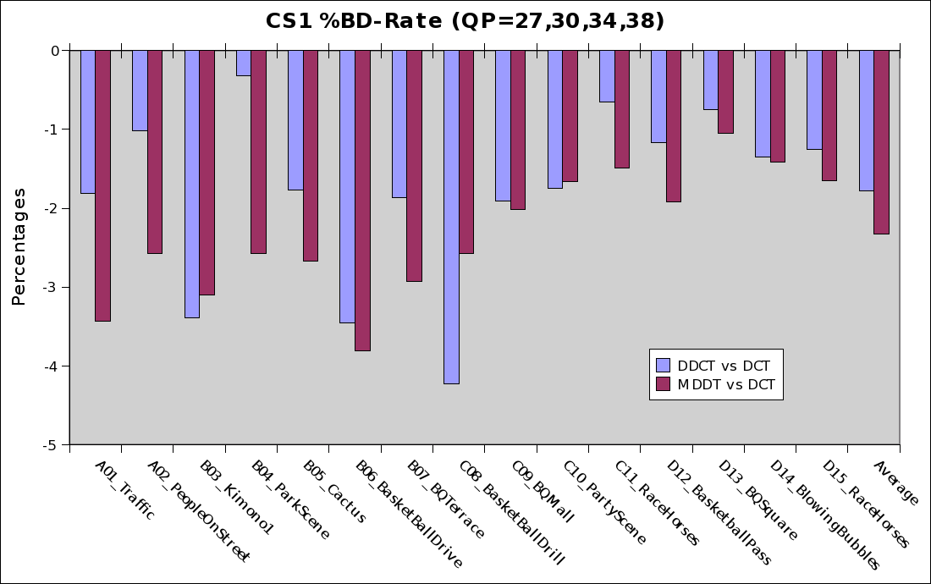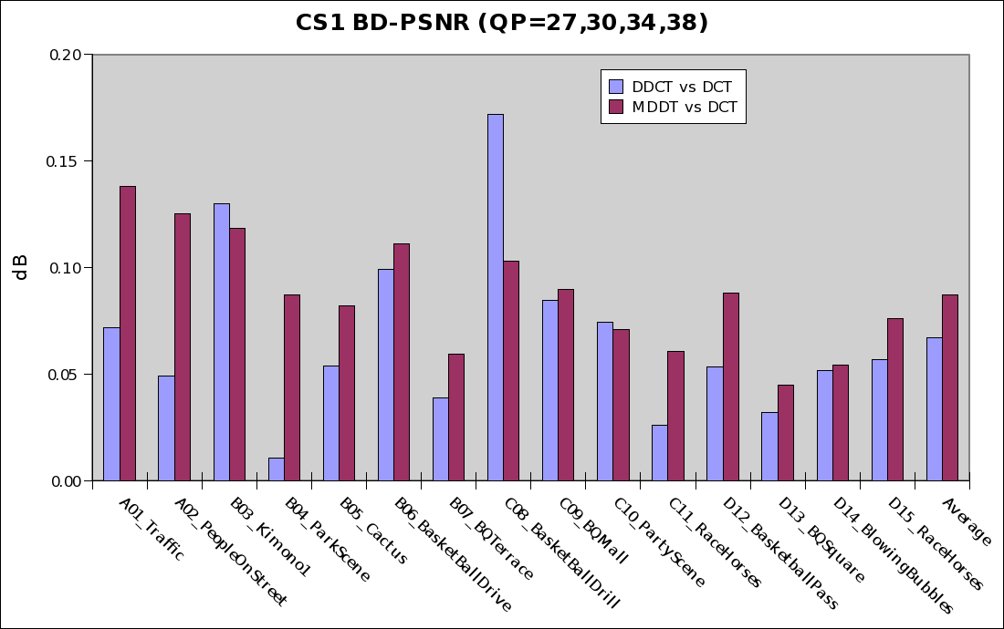
Figure 9: Percentage BD-R and BD-PSNR for CS1 test conditions.
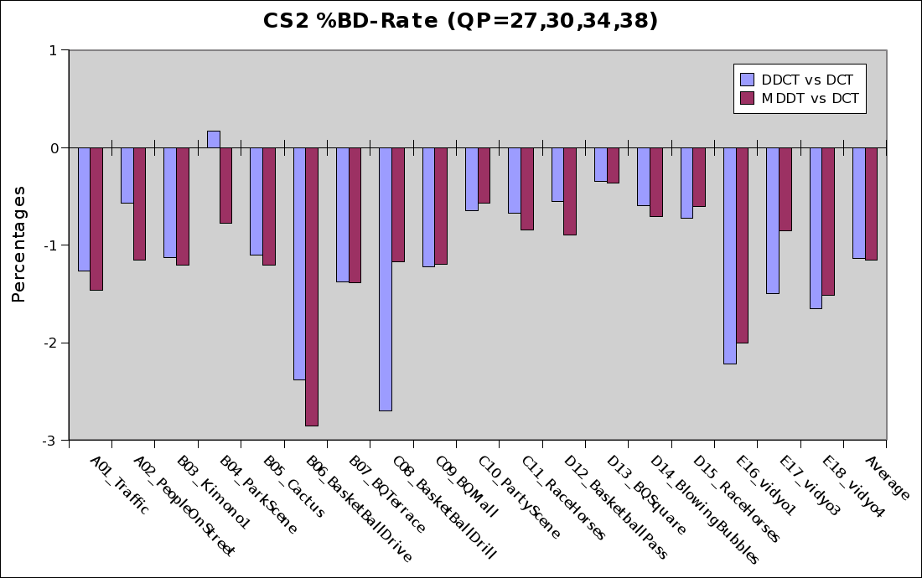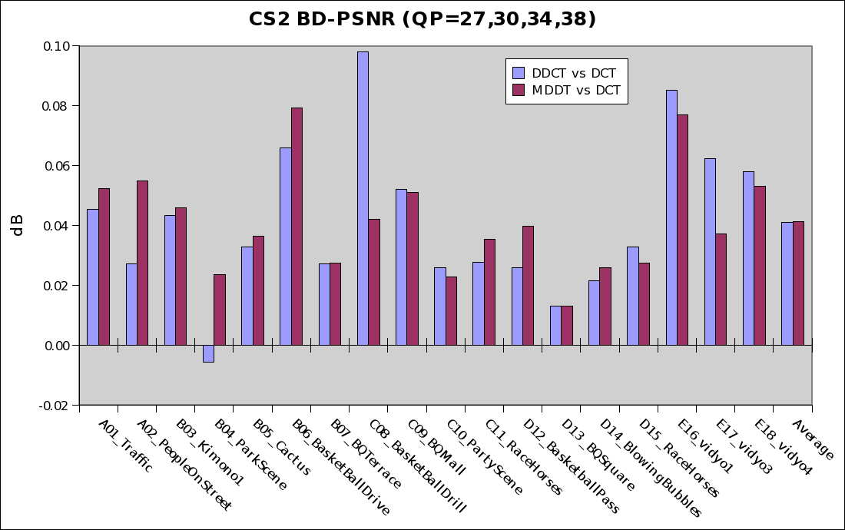
Figure 10: Percentage BD-R and BD-PSNR for CS2 test conditions.
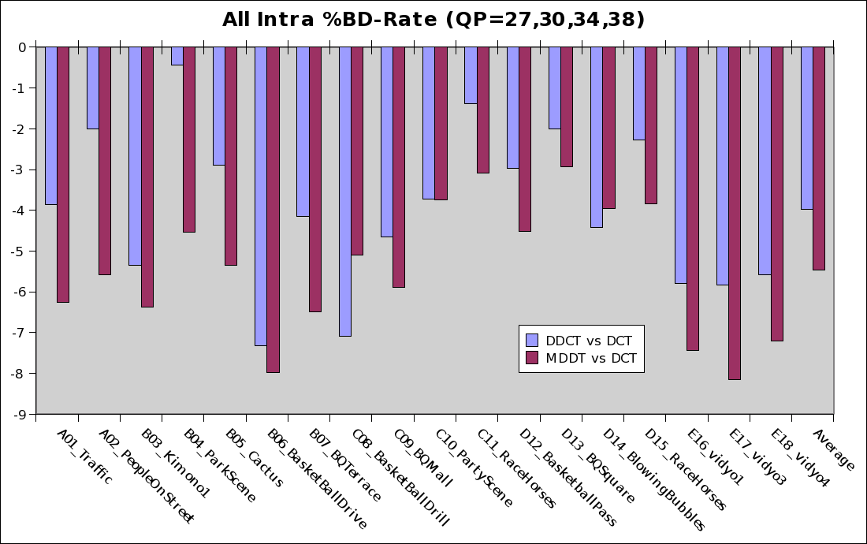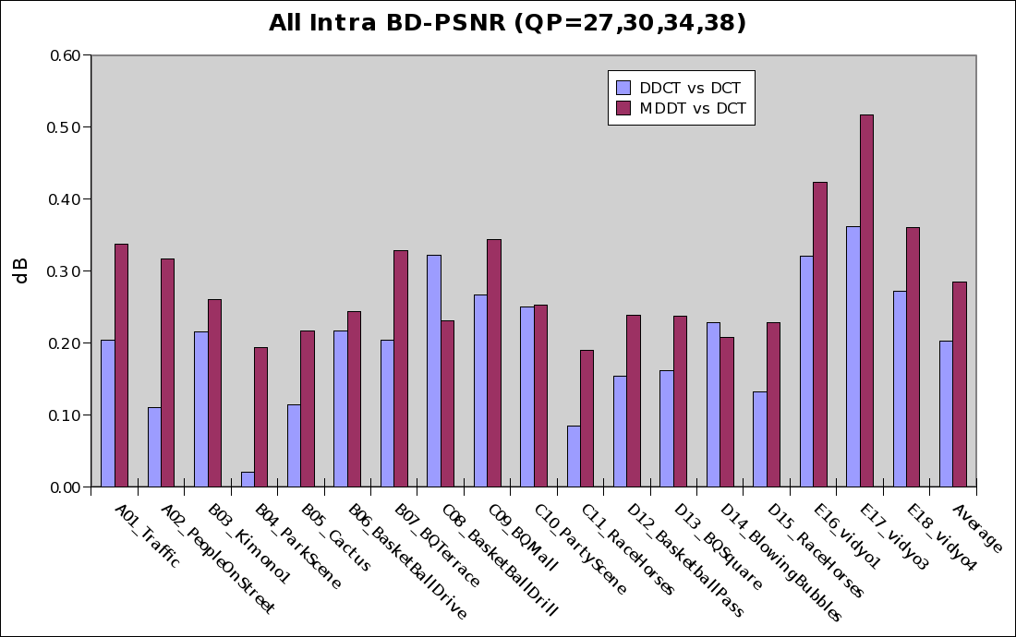
Figure 11: Percentage BD-R and BD-PSNR for all intra test conditions.

Conclusion
The BD-R difference between MDDT and DDCT for CS1 and CS2 test condition is less than 1%. For the All Intra test condition The BD-R difference is less than 1.5%. Since the DDCT can be implemented as fast transform and it does not require collecting scanning statistics in the decoder, computation can be reduced when compared with MDDT.
This document proposes to conduct experiment with DDCT as a part of the Transform Tool Experiment of HEVC.

Reference
- Y.A. Reznik and R.K. Chivukula, “On design of transforms for high-resolution/high performance video coding,” M16438, ISO/IEC JTC1/SC29/WG11, April 2009.
- M.T. Heideman, “Computation of an odd-length DCT from a real-valued DFT of the same length,” IEEE Trans. Signal Proc., vol. 40, no. 1, Jan 1992.
- Yan Ye and Marta Karczewicz, “Improving Intra Coding,” ITU-T Q6/SG16, VCEG-AG11, 20 October, 2007.

Patent rights declaration(s)
Sony Corporation may have IPR relating to the technology described in this contribution and, conditioned on reciprocity, is prepared to grant licenses under reasonable and non-discriminatory terms as necessary for implementation of the resulting ITU-T Recommendation | ISO/IEC International Standard (per box 2 of the ITU-T/ITU-R/ISO/IEC patent statement and licensing declaration form).

