    Joint Collaborative Team on Video Coding (JCT-VC)  of ITU-T SG16 WP3 and ISO/IEC JTC1/SC29/WG11  2nd Meeting: Geneva, CH, 21-27 July, 2010 | Document: JCTVC-B103

Title: | Reference Frame Compression Using Image Coder
Status: | Input Document to JCT-VC
Purpose: | Proposal
Author(s) or  Contact(s): | ChongSoon Lim  HaiWei Sun  Viktor Wahadaniah
Author(s) or  Contact(s): | Blk 1022 Tai Seng Avenue #06-3530 Singapore 534415 | Tel:  Email: | ChongSoon.Lim@sg.panasonic.com
Source: | Panasonic Corporation
_____________________________

Abstract
This contribution presents a reference frame compression scheme using an image coder. The presented image coder includes a transform, scanning and bitplane coding. Experiments were conducted by running the various software (TMuC revision 25, modified TMuC with 50% reference frame compression, modified TMuC with 33% reference frame compression and JM16.2) using the test set defined in JCTVC-A302 document.
In comparison with the TMuC software without reference frame compression, this document reports a drop of 1.41% in the average coding gain over JM16.2 for CS1 and a drop of 0.25% in the average coding gain over JM16.2 for CS2 using reference frame compression of 50%.
In comparison with the TMuC software without reference frame compression, this document reports a drop of 0.95% in the average coding gain over JM16.2 for CS1 and a drop of 0.14% in the average coding gain over JM16.2 for CS2 using reference frame compression of 67%. It can be noted from the results in both CS1 and CS2 that the largest drop in performance occurs in the smallest resolution images.
This proposal shows that image coder based approach can provide good compression efficiency for reference frame compression especially for the large resolution sequences and recommends JCT-VC to consider standardizing an image coder for reference frame compression.

Introduction
Large memory access bandwidth is a primarily concern for the implementation of a video encoder or a video decoder. For video applications that requires to support large spatial resolution images (example HD and above) or high dynamic range (larger than 8 bits), reducing memory access bandwidth is a key step to reduce implementation cost and power consumption for both video encoder and decoder.
Reference frame compression is a technique used to reduce memory storage size and memory access bandwidth required for video coding and decoding. There are several schemes reported in the literature [2] to [8] to achieve this goal.
Unlike typical image compression schemes, reference frame compression schemes require some specific functionality. The first functionality is random accessibility to each compressed unit of an image. It is also preferred to maintain a fixed data size for each compressed unit. In addition, it is also preferred that complexity for both reference frame compression and decompression schemes are as low as possible and the size of each random accessible compressed memory unit to be as small as possible.

Image Coder Based Reference Frame Compression

Figure 1 Basic Coding Structure Using Reference Frame Compression

In this contribution, a simple image coder based reference frame compression scheme is presented.

Figure 2 Reference Frame Compression Scheme

Figure 3 Reference Frame Decompression Scheme

The compression scheme described in figure 1 is similar to a traditional image coding scheme except that quantization process is purposely omitted. A quantization process in an image compression scheme is used typically to control the compression rate. The reason for omitting the quantization process is because to regulate the final size of the compressed data to the desired data size will require some form of rate control. It is usually difficult to estimate the quantization parameter for the quantization process so that the output size of the entropy coding process is within the targeted size in just one single encoding pass. Therefore to replace the function of the quantization process, bit plane coding is used for entropy coding. Using bit plane coding, the desired compression rate can be easily achieved by fitting the coded bits to the available data storage size in order of significance. The information that is not able to be fitted within the available data storage size is discarded and can be considered as “quantized”.

Transform
The transform used in this proposal is a floating point DCT. The purpose is mainly to demonstrate that potential of using a transform based solution for reference frame compression. A simple integer transform should be used in the final design to reduce implementation complexity.

Scanning
Scanning is required to map 2D block of coefficients to a single array. A set of scanning patterns are designed and selected based on the dimension of the 2D block.

Bit Plane Coding

Figure 4 Order Of Bit Plane Coding

After the scanning process in figure 1, the coefficients are represented by their absolute levels and signed bits. The binary representation of the absolute level values are then bit plane coding starting from the most significant bit planes. Figure 4 shows the order of bit plane coding starting from the most significant bit plane.

Figure 5 Bit Stream Structure Of One Data Block.

Figure 5 shows the coding order of bits to be stored in the data storage. The bits are coded and decoded in the same order. The bits that cannot be stored into the data storage are discarded.
As shown in figure 4, a value representing the number of bit planes is coded in 4 bits. It indicates the minimum number of bit planes required to represent the largest absolute values of the coefficients. Next, each bit plane is coded starting from the bit plane containing the most significant bit of the largest absolute value. The coding of each bit plane is as follows:
Firstly, a flag indicating if it is the end of the bit plane is coded using one bit. This is followed by the coding of run and signed bit pair. For each run and signed bit pair, the run parameter indicates the position of a Most Significant Bit and it is coded using Exp-Golomb code and the signed bit parameter is coded using one bit. The coding of each run and signed bit pair is preceded with coding of an end of plane flag.
When the end of plane flag is coded with the value one, it indicates there is no more Most Significant Bit existing in the bit plane starting from the last coded position. After the coding of end of plane flag with a value of one, the significant bits of other positions, whose most significant bits have previously occurred in higher bit planes, are coded using one bit per significant bit.
Thus the entire entropy coding only uses variable length codes for the run parameter. For the most significant bit plane, the first bit to indicate the end of plane is not required to be coded.

Using figure 3 as an example, a data block of size 40 bits will be as follows:

 | 7th Bit Plane |  |  | 6th Bit Plane
NumOfBitPlanes | Run | Signed Bit | EOP  Bit | EOP  Bit | Run | Signed Bit | EOP  Bit | 1st Pos Bit
0111 | 1 | 1 | 1 | 0 | 1 | 0 | 1 | 1

5th Bit Plane |  |  |  |  |  | 4th Bit Plane
EOP  Bit | Run | Signed Bit | EOP  Bit | 1st Pos.  Bit | 2nd  Pos.  Bit | EOP  Bit | Run | Signed Bit | EOP  Bit | 1st Pos.  Bit | 2nd Pos  Bit | 3rd Pos  Bit
0 | 1 | 0 | 1 | 0 | 0 | 0 | 010 | 0 | 1 | 0 | 1 | 1

3rd Bit Plane
EOP  Bit | Run | Signed Bit | EOP  Bit | Run | Signed Bit | EOP  Bit |  | Run | Signed Bit | EOP  Bit | 1st Pos.  Bit | 2nd Pos.  Bit | 3rd Pos.  Bit | 5th Pos.  Bit
0 | 1 | 1 | 0 | 1 | 1 | 0 | 1 |  | 0 | 1 | 1 | 1 | 0 | X

Table 1 Example of Coded Bits Structure Based On Bit Plane Coding

Bit Plane Decoding
The 40 bits compressed data can be reconstructed to an array of coefficients as shown in figure 5
Figure 6 Decoded Values Of Bit Plane Decoding

Because rounding offset was not performed during bit plane coding, offset values are added after bit plane decoding. This is illustrated in figure 6.

Offset values are added to non decoded bit plane positions to compensate for the rounding errors of quantization.

Combined Bit Plane Coding With U and V Components.
Assuming that the motion vectors of chroma samples can be derived from the motion vectors of luma samples and the interpolation filter tap length used for chroma samples is around half the tap length used for luma samples, a combined bit plane coding for luma and chroma can be utilized to improve coding efficiency of the luma samples. The luma samples and the chroma samples of the same location can be packed together into the same random assessable compressed memory block to improve coding efficiency. Each bit planes of luma and chroma samples are coded sequentially in decreasing order of significance. As the luma plane usually contains more information, more bits of luma samples will be coded in the compressed memory block as a result.

Experiment Details
Experiments were conducted using four settings:
- TMuC revision 25
- TMuC revision 25 + RFC 50% (50% size reduction)
- TMuC revision 25 + RFC 67% (33% size reduction)
- JM 16.2

Test set used is the same as specified in JCTVC-A302.

The setting used for reference frame compression is as follows: The block size is set as 8 by 4 for Y and 4 by 2 for each U and V components. For 50% size reduction, a block of 8 by 4 (4:2:0) image samples are compressed to 24 bytes in total for all 3 components. For 33% size reduction, a block of 8 by 4 (4:2:0) image samples are compressed to 32 bytes in total for all 3 components.

Test set

Class A: Size 2560x1600 (pixel resolution as in original 4Kx2K) 30 fps
Sxx | Name | Duration | QP values for CS1 | QP values for CS2
S01 | Traffic | 0-72 frames | 22, 25, 28, 31, 33 | -
S02 | People on Street | 0-72 frames | 29, 33, 37, 41, 43 | -

Class B1: Size 1920x1080p 24 fps
Sxx | Name | Duration | QP values for CS1 | QP values for CS2
S03 | Kimono | 72-192 frames *  0-120 frames | 21, 24, 27, 30, 34 | 22, 25, 28, 32, 35
S04 | ParkScene | 0-120 frames | 24, 27, 30, 33, 36 | 25, 27, 30, 32, 35

* There is problem to start from 72 frame using TMuC software.

Class B2: Size 1920x1080p 50-60 fps
Sxx | Name | Duration | QP values for CS1 | QP values for CS2
S05 | Cactus | 0-120 frames | 25, 27, 30, 32, 35 | 26, 28, 31, 33, 36
S06 | BasketballDrive | 0-120 frames | 25, 27, 30, 33, 36 | 27, 29, 32, 35, 38
S07 | BQTerrace | 0-120 frames | 26, 28, 30, 31, 34 | 28, 29, 30, 32, 34

Class C: Size 832x480p (WVGA) 30-60 fps
Sxx | Name | Duration | QP values for CS1 | QP values for CS2
S08 | BasketballDrill | 0-120 frames | 27, 30, 34, 37, 39 | 29, 32, 35, 38, 40
S09 | BQMall | 0-120 frames | 27, 31, 34, 37, 39 | 28, 32, 35, 38, 40
S10 | PartyScene | 0-120 frames | 31, 34, 37, 39, 41 | 33, 35, 38, 40, 41
S11 | RaceHorses | 0-120 frames | 28, 31, 34, 37, 39 | 30, 33, 36, 38, 40

Class D: Size 416x240p (WQVGA) 30-60 fps
Sxx | Name | Duration | QP values for CS1 | QP values for CS2
S12 | BasketballPass | 0-120 frames | 23, 27, 31, 33, 36 | 25, 29, 33, 35, 38
S13 | BQSquare | 0-120 frames | 24, 27, 30, 31, 34 | 27, 30, 32, 33, 35
S14 | BlowingBubbles | 0-120 frames | 23, 27, 30, 32, 35 | 26, 29, 32, 33, 35
S15 | RaceHorses | 0-120 frames | 21, 25, 29, 31, 34 | 23, 27, 31, 33, 35

Class E: Size 1280x720p 60 fps
Sxx | Name | Duration | QP values for CS1 | QP values for CS2
S16 | Vidyo1 | 0-120 frames | - | 24, 28, 31, 33, 36
S17 | Vidyo3 | 0-120 frames | - | 26, 29, 32, 34, 37
S18 | Vidyo4 | 0-120 frames | - | 25, 27, 30, 32, 35

Experimental Results

CS1: 5 points BD Rate Compared To JM 16.2

Class | Resolution | Seq. No | Seq. Name | TMuC_R25 | TMuC_R25 + RFC(50%) | TMuC_R25+ RFC(67%)
A | 4K | S01 | Traffic | 33.59% | 32.58% | 33.37%
 |  | S02 | PeopleOnStreet | 26.38% | 26.33% | 26.35%
B | 1080p | S03 | Kimono | 46.33% | 46.31% | 46.34%
 |  | S04 | ParkScene | 33.13% | 32.42% | 32.99%
 |  | S05 | Cactus | 36.22% | 35.35% | 36.04%
 |  | S06 | BasketballDrive | 45.79% | 45.68% | 45.77%
 |  | S07 | BQTerrace | 48.80% | 46.98% | 48.43%
C | WVGA | S08 | BasketballDrill | 37.48% | 36.23% | 37.26%
 |  | S09 | BQMall | 29.53% | 28.84% | 29.49%
 |  | S10 | PartyScene | 34.29% | 33.17% | 34.07%
 |  | S11 | RaceHorses | 29.33% | 28.57% | 29.14%
D | WQVGA | S12 | BasketballPass | 25.88% | 24.13% | 25.51%
 |  | S13 | BQSquare | 45.36% | 40.62% | 44.81%
 |  | S14 | BlowingBubbles | 27.47% | 23.75% | 26.80%
 |  | S15 | RaceHorses | 22.66% | 20.08% | 22.17%
E | 720P | S16 | Vidyo1
 |  | S17 | Vidyo3
 |  | S18 | Vidyo4
All |  |  | Min | 22.66% | 20.08% | 22.17%
 |  |  | Max | 48.80% | 46.98% | 48.43%
 |  |  | Average | 34.82% | 33.40% | 34.57%
 |  |  | Difference |  | -1.41% | -0.25%

CS2: 5 points BD Rate Compared To JM 16.2
Class | Resolution | Seq. No | Seq. Name | TMuC_R25 | TMuC_R25 +RFC(50%) | TMuC_R25 +RFC(67%)
A | 4K | S01 | Traffic
 |  | S02 | PeopleOnStreet
B | 1080p | S03 | Kimono | 27.45% | 27.36% | 27.49%
 |  | S04 | ParkScene | 21.03% | 20.51% | 20.97%
 |  | S05 | Cactus | 20.34% | 19.66% | 20.15%
 |  | S06 | BasketballDrive | 33.97% | 33.89% | 34.03%
 |  | S07 | BQTerrace | 36.68% | 35.43% | 36.44%
C | WVGA | S08 | BasketballDrill | 26.41% | 25.43% | 26.11%
 |  | S09 | BQMall | 16.62% | 16.05% | 16.39%
 |  | S10 | PartyScene | 30.67% | 29.95% | 30.60%
 |  | S11 | RaceHorses | 11.24% | 10.85% | 11.29%
D | WQVGA | S12 | BasketballPass | 10.34% | 9.16% | 10.28%
 |  | S13 | BQSquare | 28.92% | 25.53% | 28.39%
 |  | S14 | BlowingBubbles | 14.31% | 11.67% | 13.90%
 |  | S15 | RaceHorses | 1.31% | -0.93% | 0.78%
E | 720P | S16 | Vidyo1 | 32.77% | 32.55% | 32.87%
 |  | S17 | Vidyo3 | 22.07% | 21.89% | 22.00%
 |  | S18 | Vidyo4 | 27.78% | 27.68% | 27.93%
All |  |  | Min | 1.31% | -0.86% | 0.96%
 |  |  | Max | 36.68% | 35.43% | 36.44%
 |  |  | Average | 22.62% | 21.68% | 22.46%
 |  |  | Difference |  | -0.95% | -0.14%

Conclusion
This contribution shows that image coder based approach can provide good compression efficiency for reference frame compression especially for the large resolution sequences. We believe such an image coder will be useful for next generation video codec implementation targeting applications supporting 4k by 2k resolutions and future mobile applications, and thus we would recommend JCT-VC to consider standardizing an image coder for reference frame compression. We would also recommend JCT-VC to consider the design of the reference image coder together with the design of the interpolation filter so that to achieve the goal of reducing the overall memory access bandwidth for next generation video coding.

Patent rights declaration(s)

(NOTE – Activities in the JCT-VC and contributions to the JCT-VC are subject to the common patent policy for ITU-T/ITU-R/ISO/IEC. A statement of that policy can be found at
http://www.itu.int/ITU-T/dbase/patent/patent-policy.html, with further information available at http://www.itu.int/ITU-T/ipr/index.html and in the ISO/IEC Directives. The form to be used for the formal reporting of patent rights to ITU-T/ITU-R/ISO/IEC can be found at http://www.itu.int/ITU-T/ipr/index.html. Contributions to the JCT-VC proposing normative technical content shall contain a non-binding informal notice of whether the submitter may have patent rights that would be necessary for implementation of the resulting standard. The provided informal notice shall indicate the category of anticipated licensing terms according to the ITU-T/ITU-R/ISO/IEC patent statement and licensing declaration form. This obligation to provide an informal notice is supplemental to, and does not replace, any existing obligations of parties with technology included in a final or draft standard to submit formal IPR declarations to ITU-T/ITU-R/ISO/IEC. An example of an informal IPR notification statement for a contribution is provided below.)

Panasonic Corporation may have IPR relating to the technology described in this contribution and, conditioned on reciprocity, is prepared to grant licenses under reasonable and non-discriminatory terms as necessary for implementation of the resulting ITU-T Recommendation | ISO/IEC International Standard (per box 2 of the ITU-T/ITU-R/ISO/IEC patent statement and licensing declaration form).

References

- Takeshi Chujoh, “Tool Experiment 2 on IBDI and memory compression,” JVTVC-A302.doc, April 2010.
- M. Budagavi and M. Zhou, “Video coding using compressed reference frames”, IEEE International Conference on Acoustics, Speech and Signal Processing 2008, Las Vegas, 31 March 2008 - 4 April 2008.
- Yongseok Jin, Yongje Lee, and Hyuk-Jae Lee, “A New Frame Memory Compression Algorithm with DPCM and VLC in a 4×4 Block”, EURASIP Journal on Advances in Signal Processing Volume 2009, Article ID 629285
- Y.V. Ivanov and D. Moloney, “Reference Frame Compression Using Embedded Reconstruction Patterns for H.264/AVC Decoder”, Third International Conference on Digital Telecommunications 2008, Bucharest, 29 June 2008 - 5 July 2008
- R. P. Kleihorst and R. J. Van Der Vleuten, “DCT-Domain Embedded Memory Compression for Hybrid Video Coders”, Journal of VLSI Signal Processing Systems, Volume 24 , Issue 1, February 2000.
- P.H.N. De With, P.H. Frencken, and M. Schaar-Mitrea, “An MPEG decoder with embedded compression for memory reduction”, IEEE Transactions on Consumer Electronics, August 1998.
- Song Tian and Shimamoto Takashi, “Reference frame data compression method for H.264/AVC”, IEICE Electronics Express 4(3), 121-126, 2007.
- Jaemoon Kim, Jungsoo Kim, and Chong-Min Kyung, “A lossless embedded compression algorithm for high definition video coding”, IEEE International Conference on Multimedia and Expo 2009, New York, 2009.
- G. Bjøntegaard, “Calculation of Average PSNR Differences Between RD-Curves,” ITU-T Q.6/SG16 VCEG, VCEG-M33, April 2001.

Appendix

HB7 Coding Structure RD Graphs

CS1: S01 Traffic_2560x1600_30fps

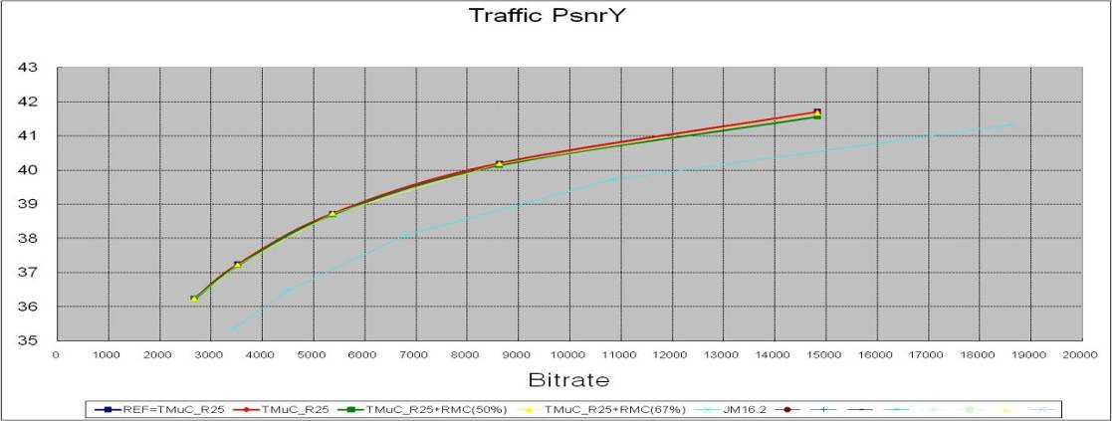

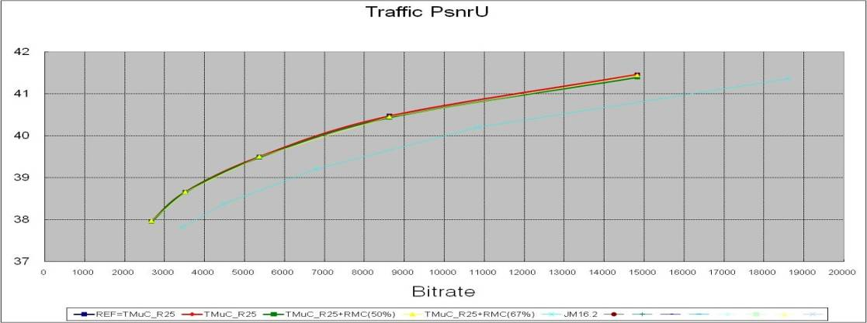

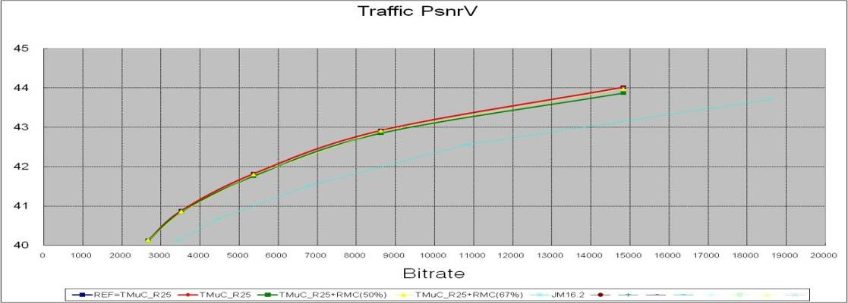

CS1: S02 PeopleOnStreet_2560x1600_30fps

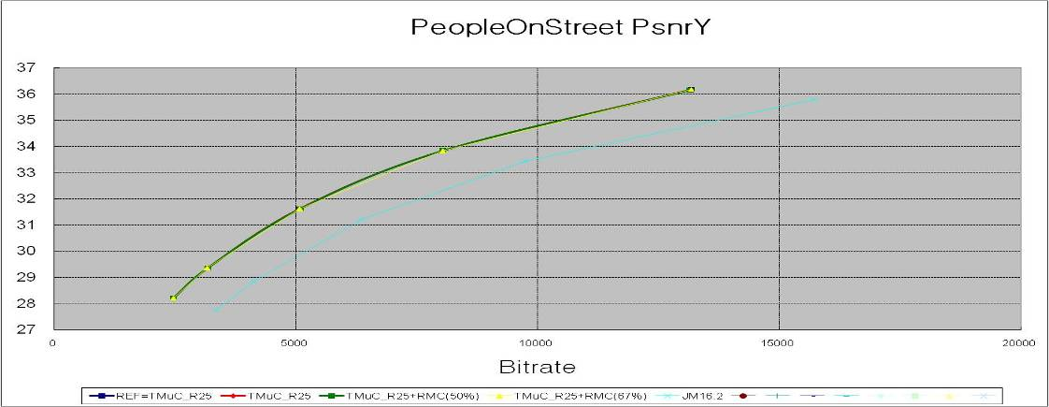

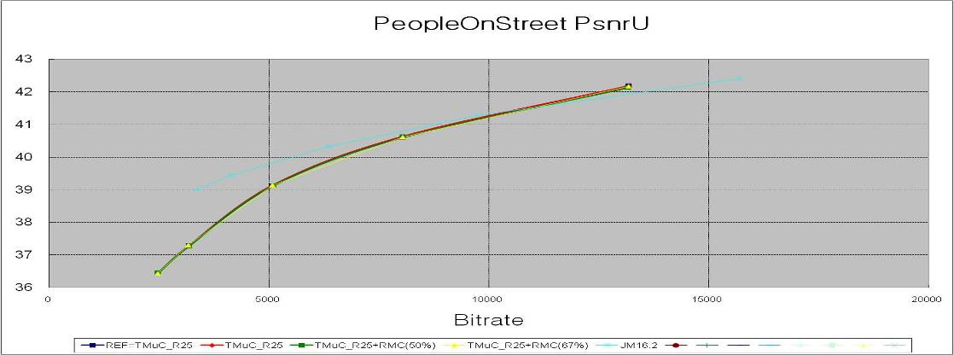

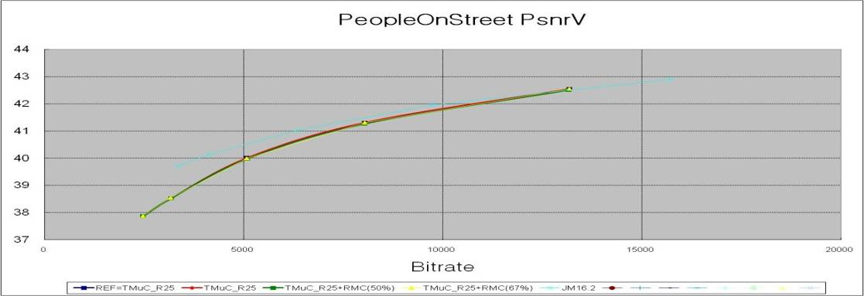

CS1: S03 Kimono_1920x1080_24fps

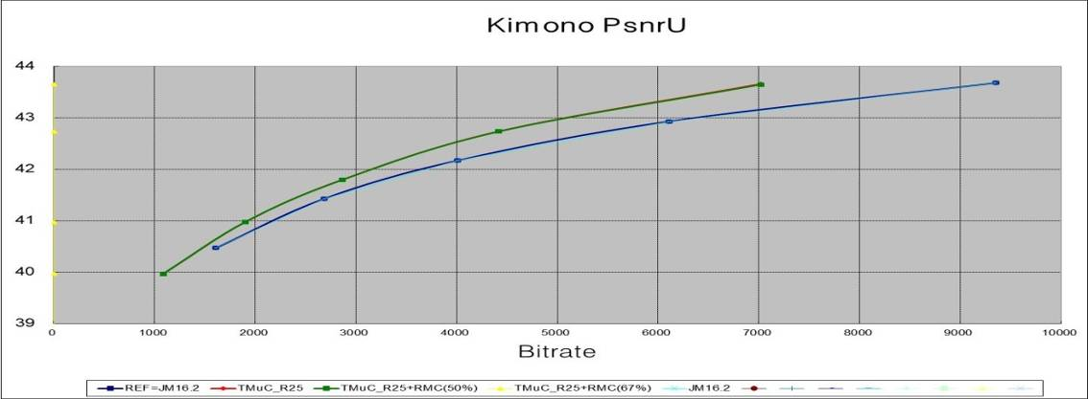

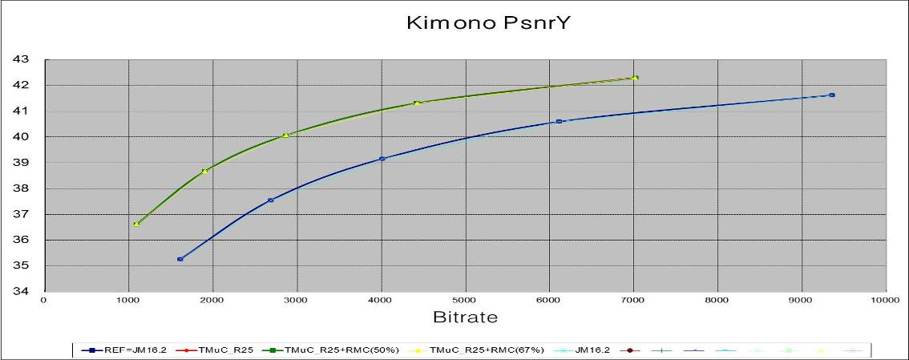

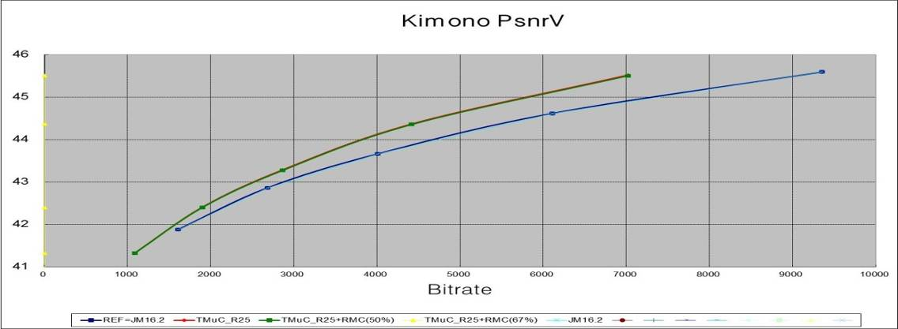

CS1: S04 ParkScene_1920x1080_24fps

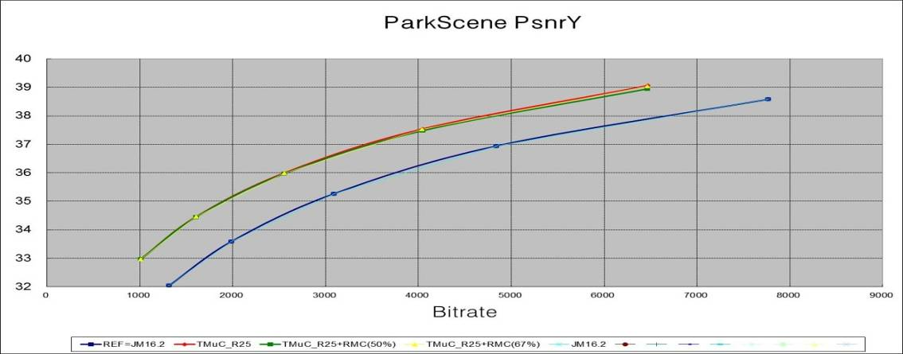

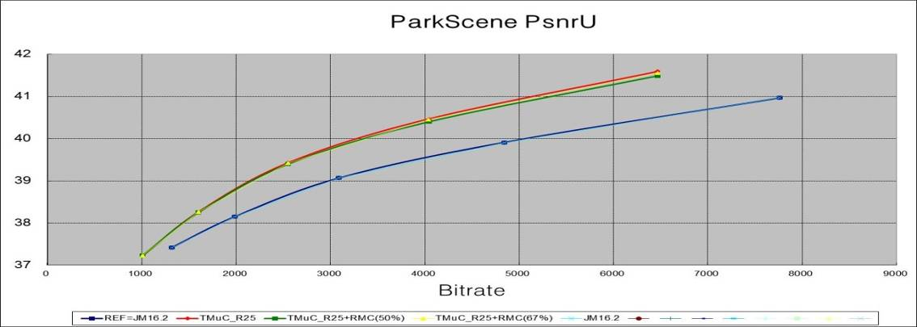

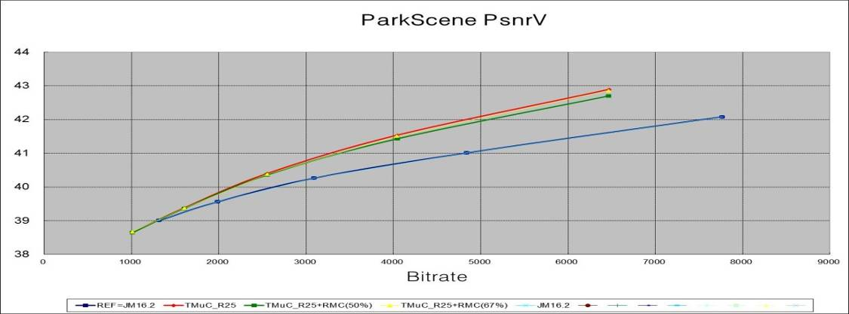

CS1: S05 cactus_1920x1080_50fps

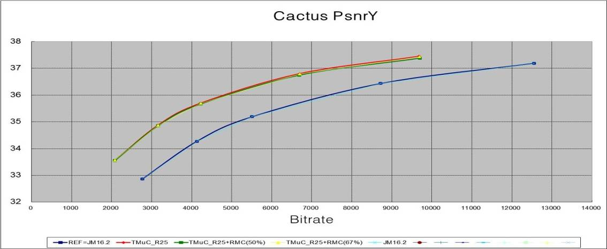

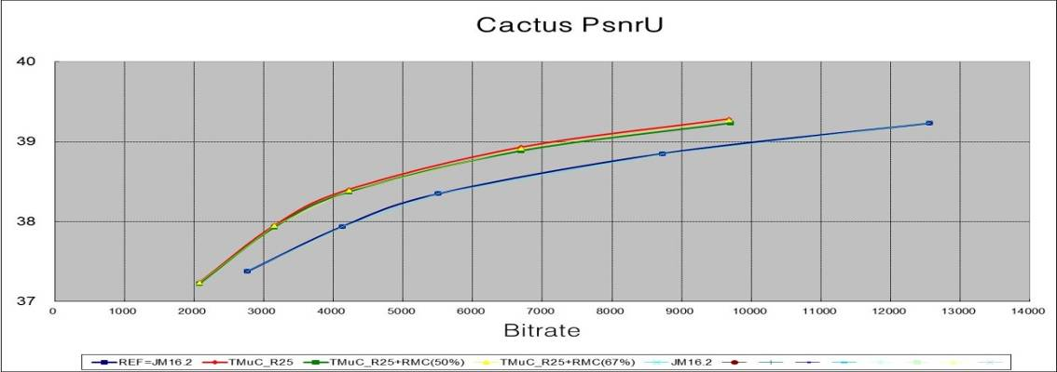

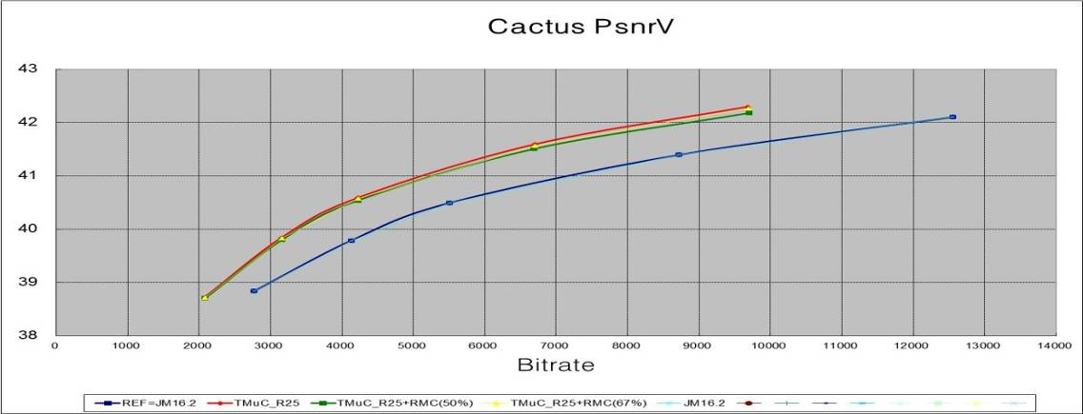

CS1: S06 BasketballDrive_1920x1080_50fps

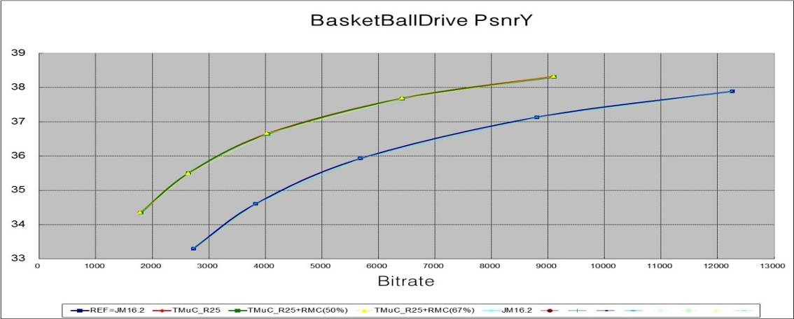

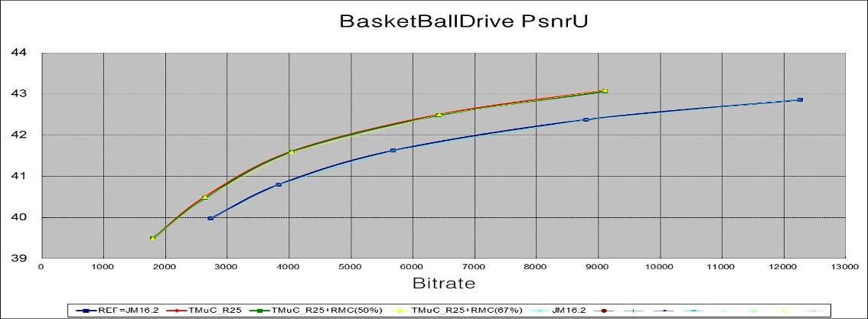

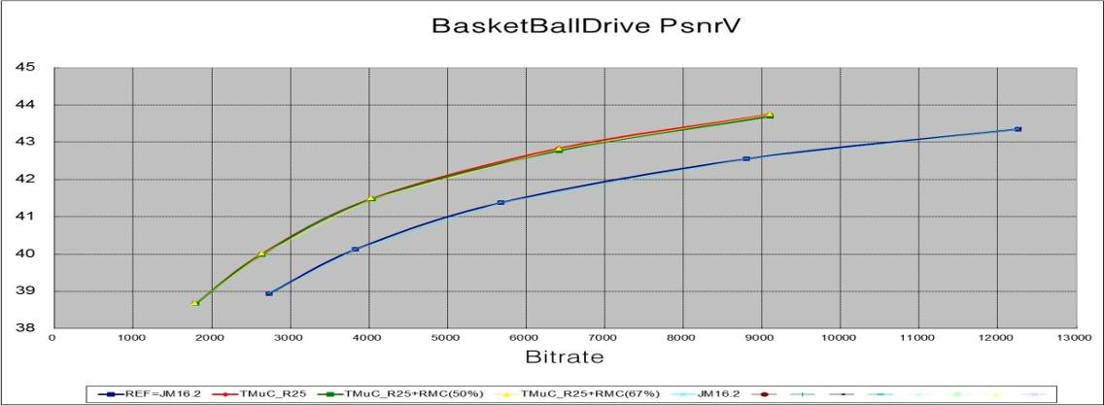

CS1: S07 BQTerrace_1920x1080_60fps

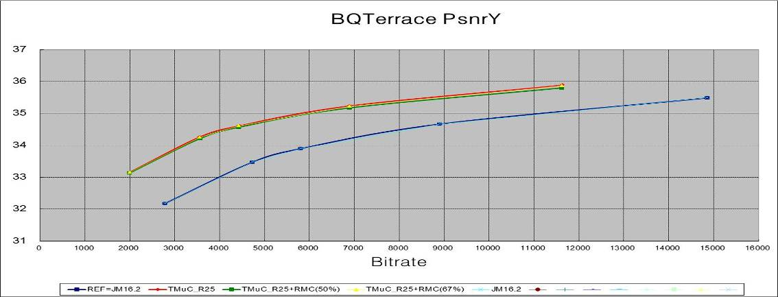

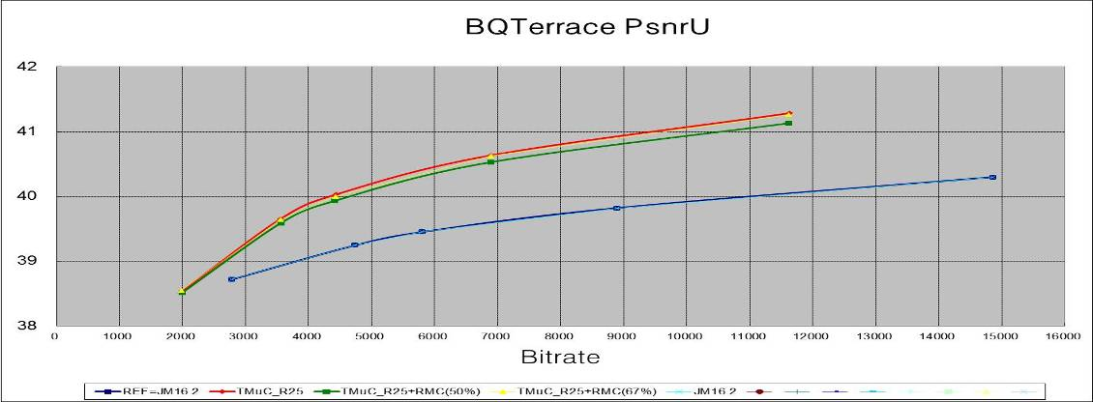

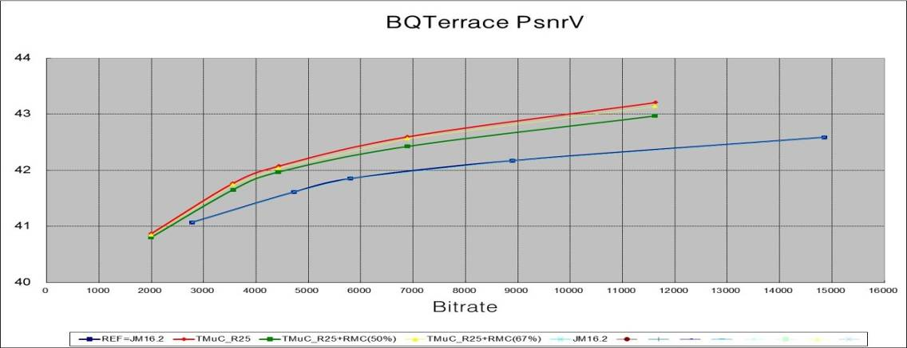

CS1: S08 BasketballDrill_832x480_50fps

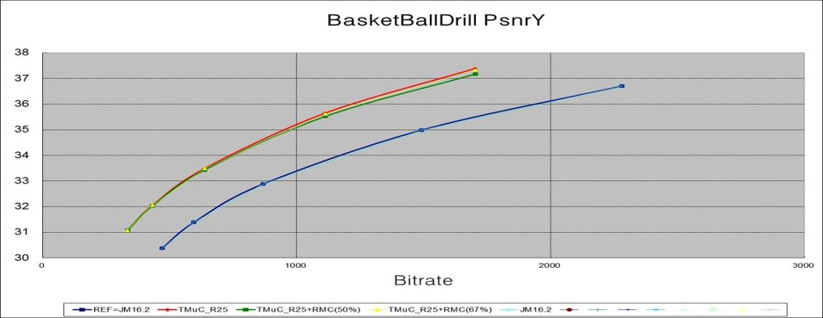

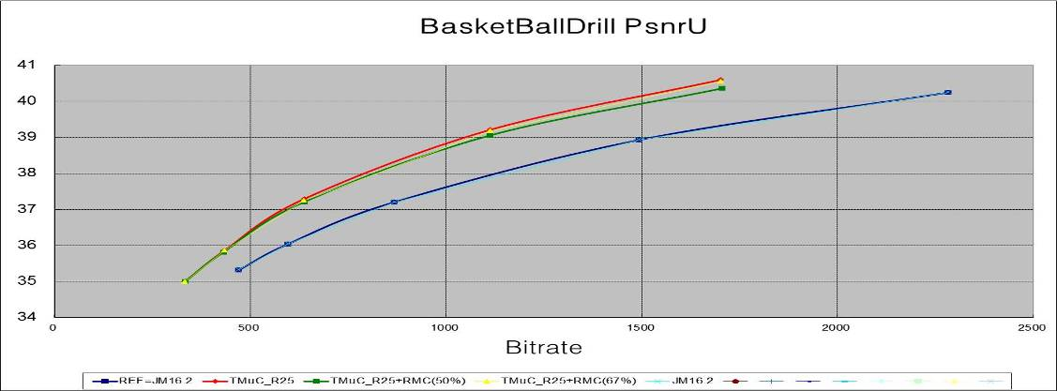

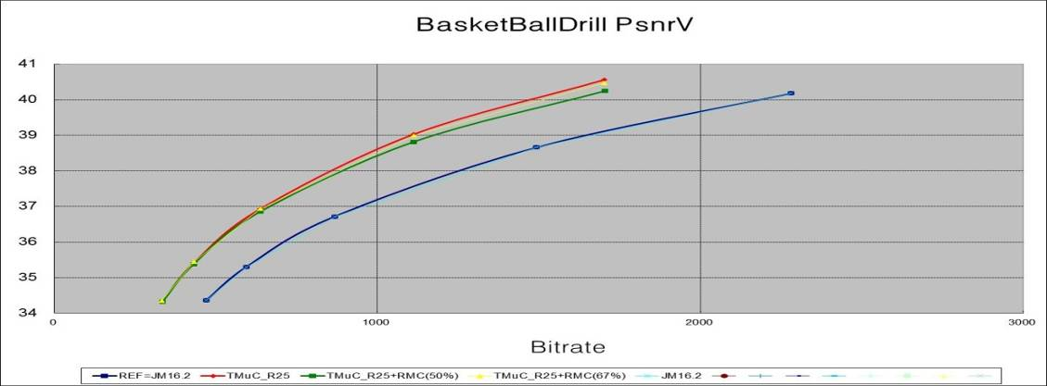

CS1: S09 BQMall_832x480_60fps

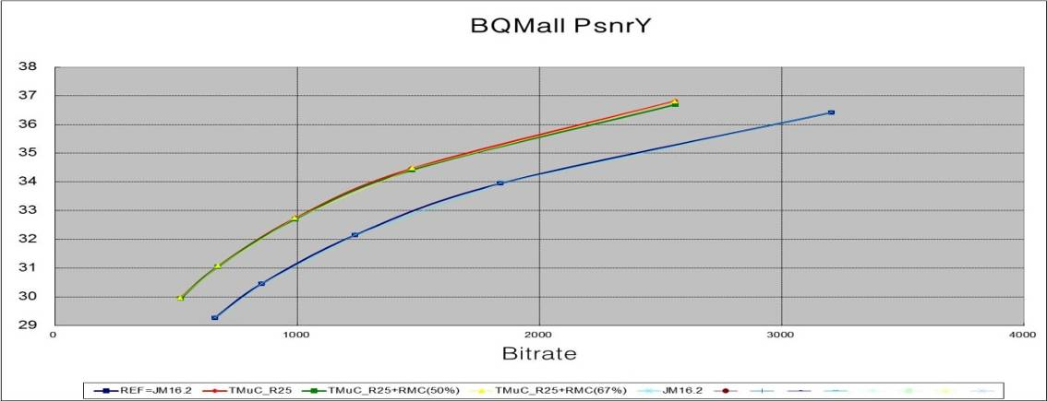

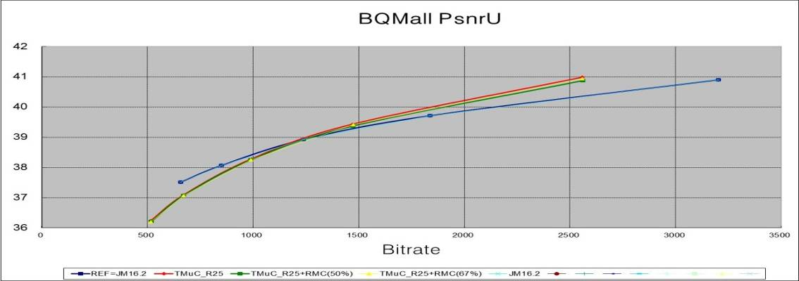

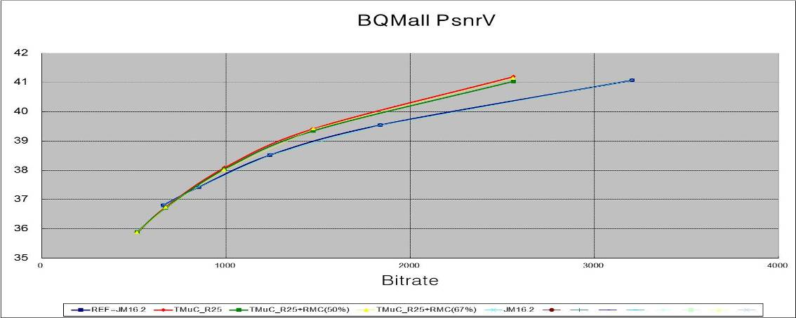

CS1: S10 PartyScene_832x480_50fps

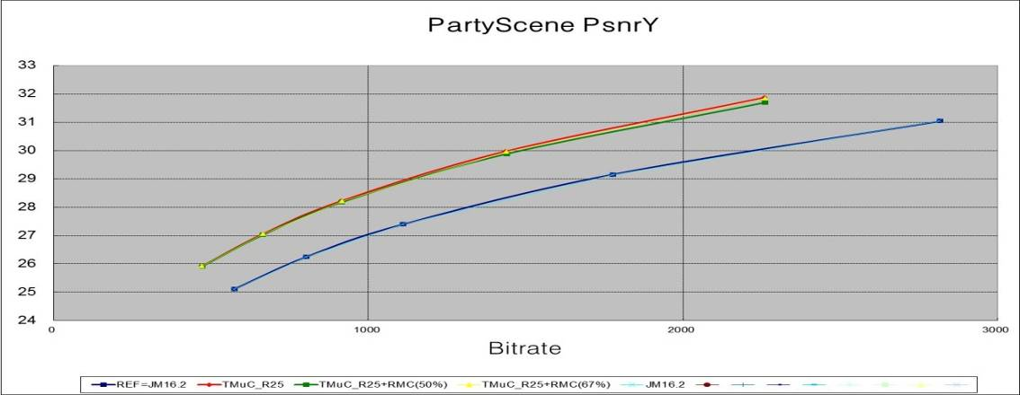

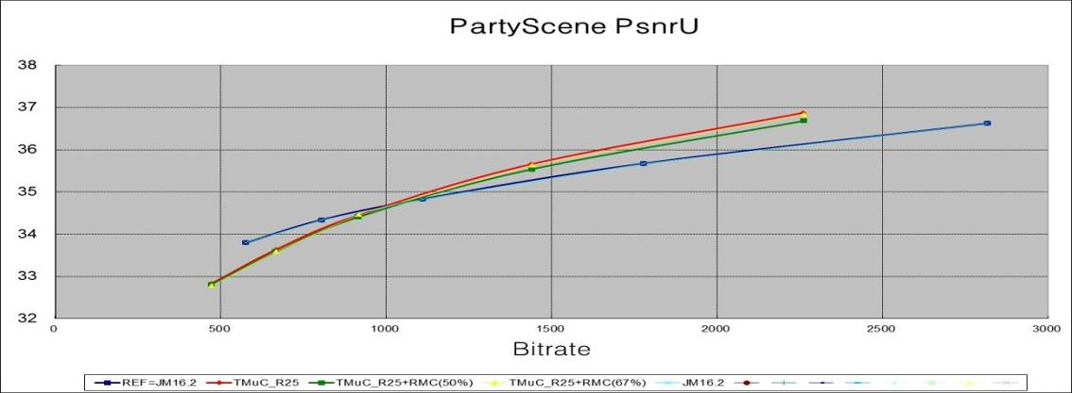

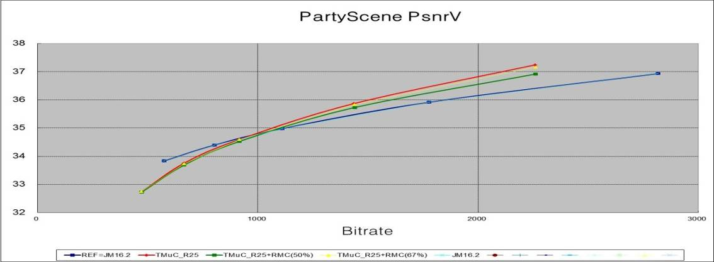

CS1: S11 RaceHorses_832x480_30fps
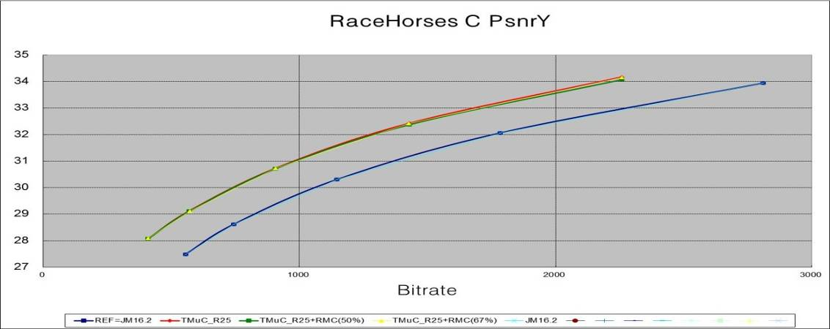

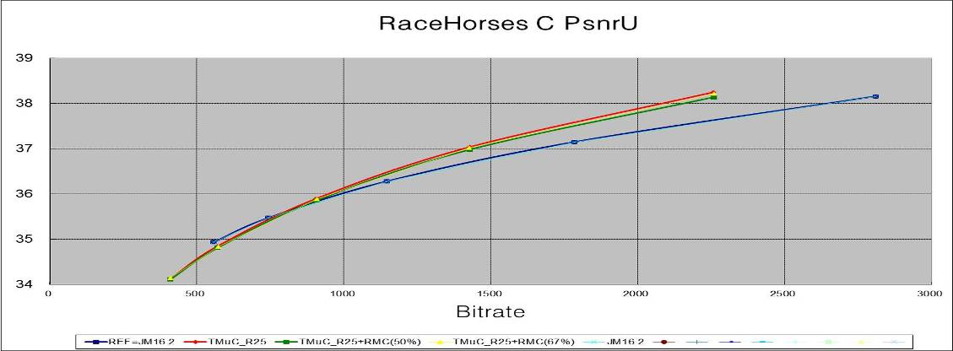

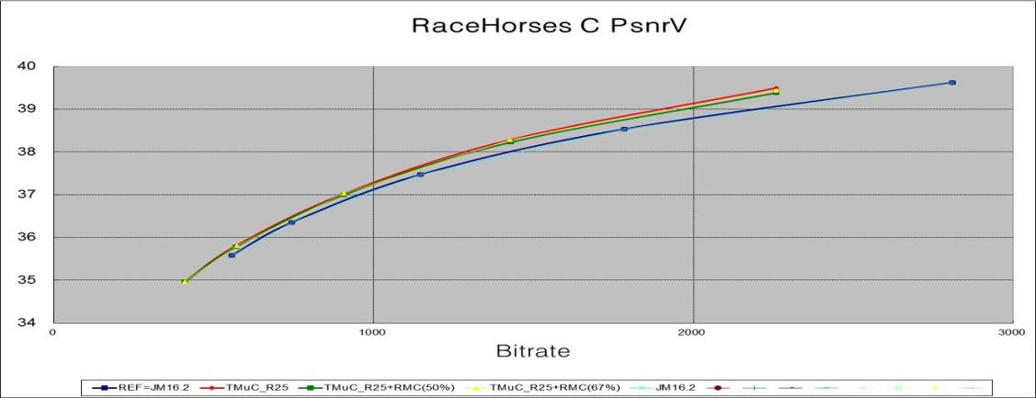

CS1: S12 BasketballPass_416x240_50fps

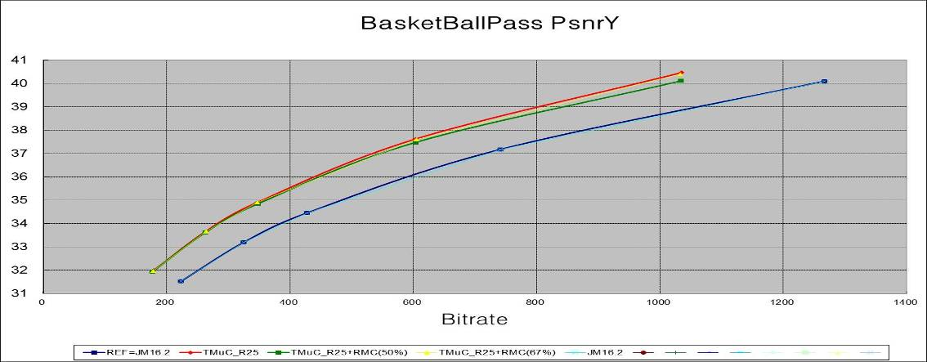

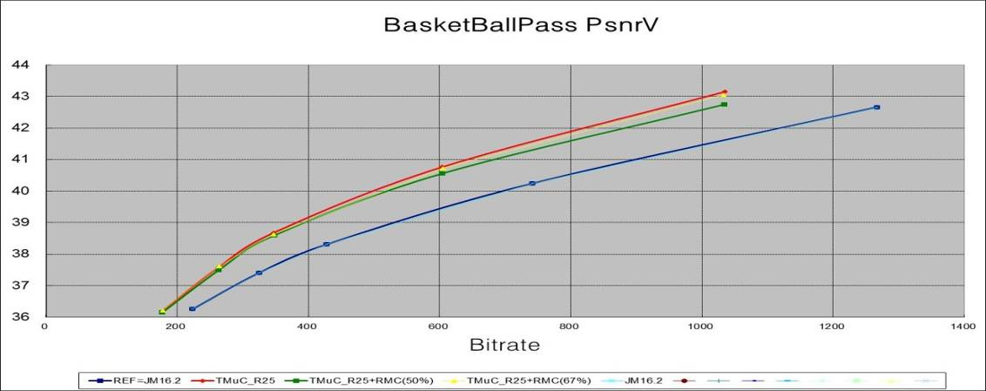

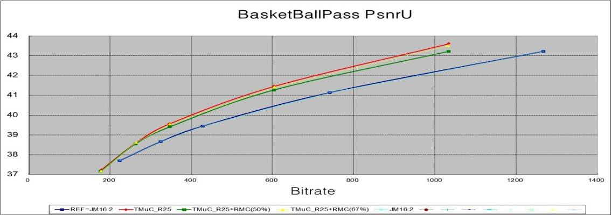

CS1: S13 BQSquare_416x240_60fps

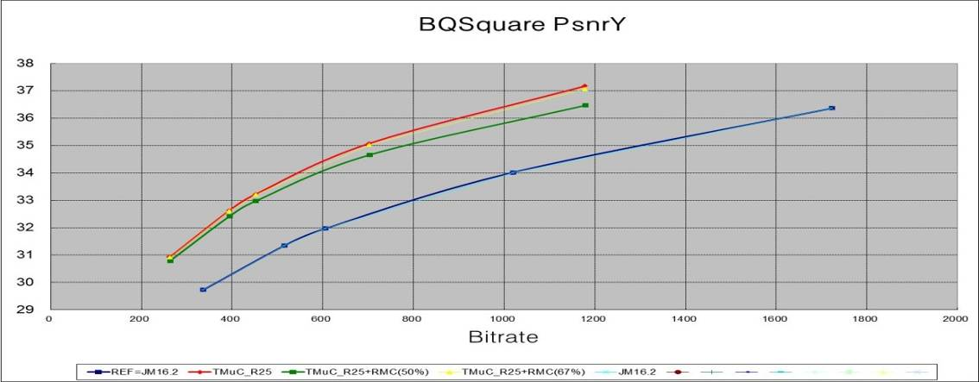

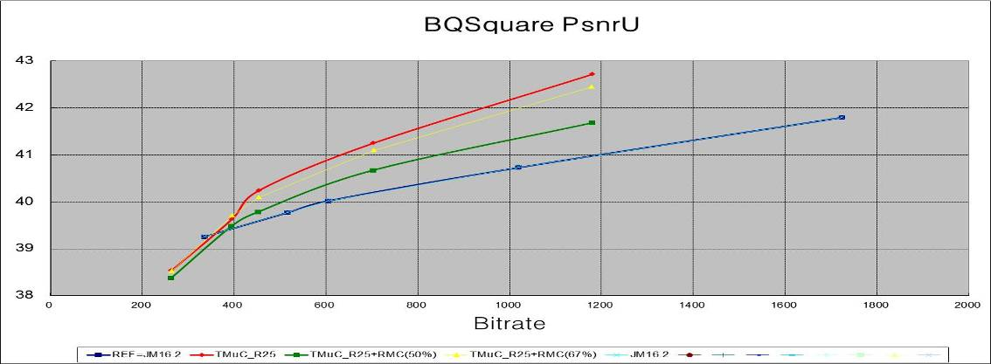

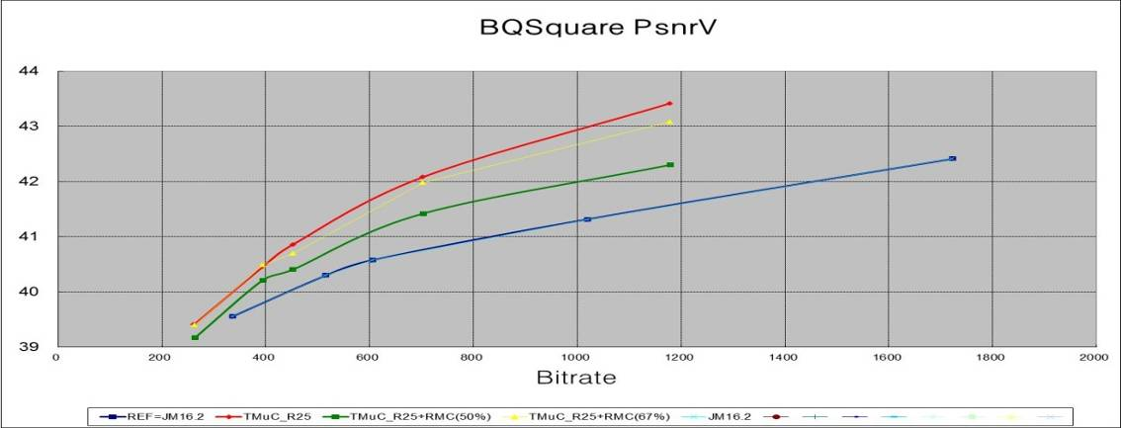

CS1: S14 BlowingBubbles_416x240_50fps

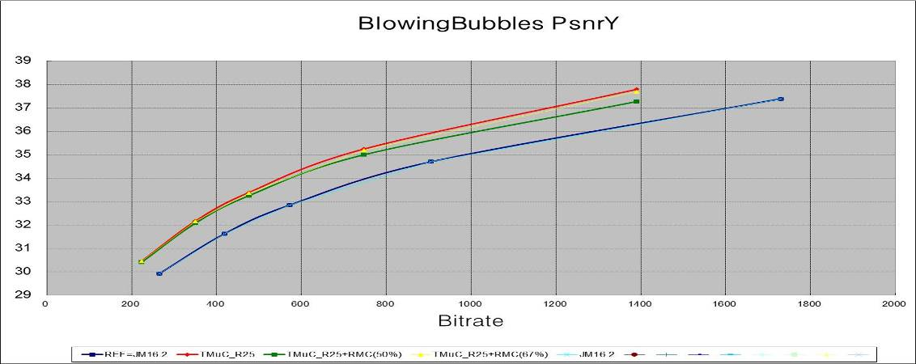

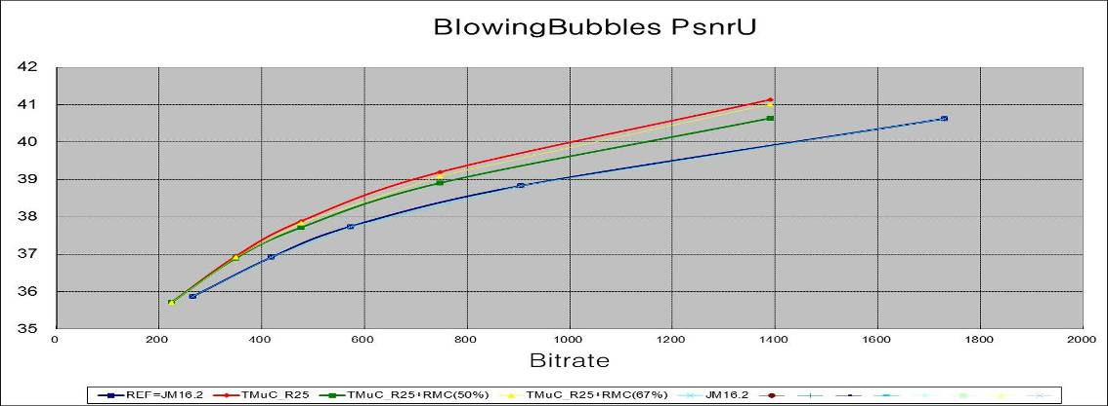

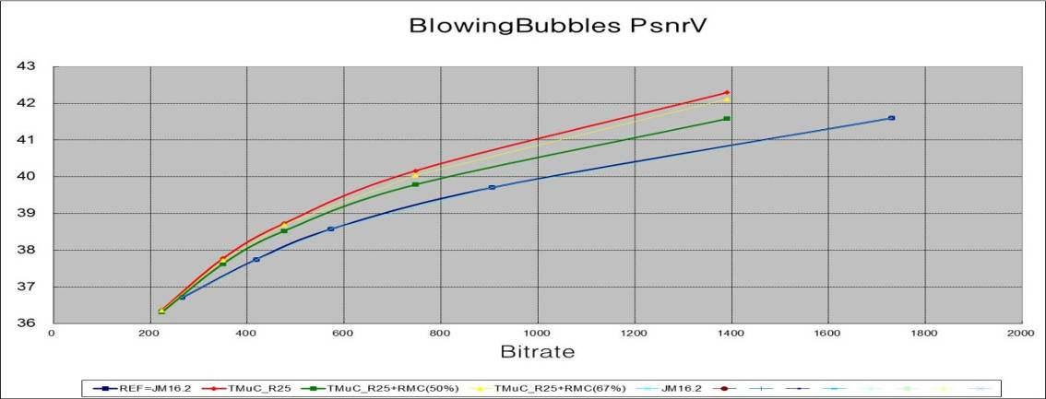

CS1: S15 RaceHorses_416x240_30fps

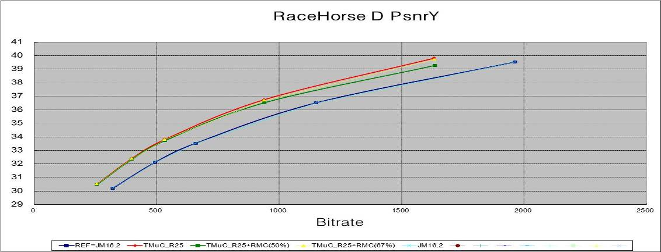

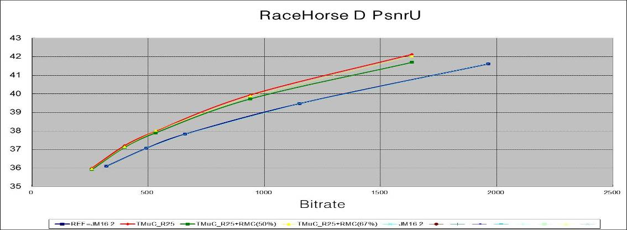

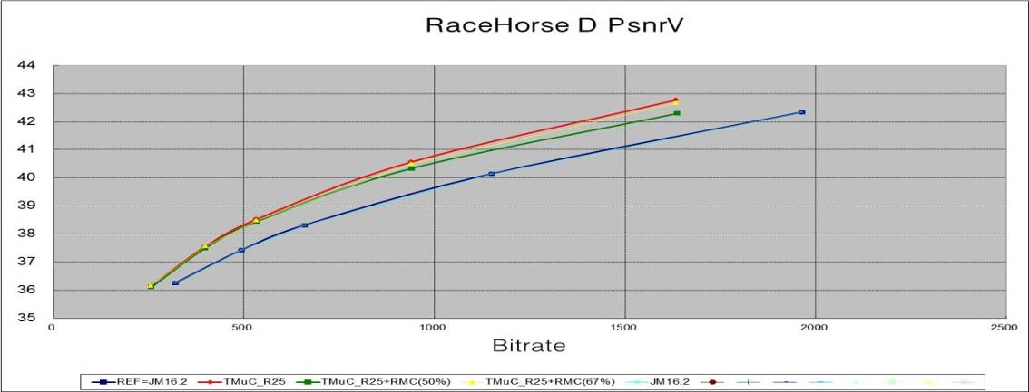

Sample Images For HB7

CS1 BQSquare_416x240_60fps Rate3

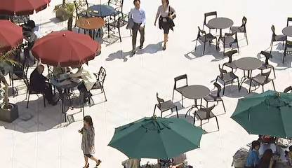
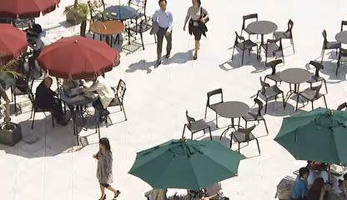
P Frame 72: TmuC R25 QP30 Rate3  32296 bits [Y 34.4388_U 40.4457_ V 41.1686 dB] | P Frame 72 : TmuC R25+ RFC(50%) QP30 Rate3  32264 bits [Y 34.0947_U 39.9686_V 40.6461 dB]

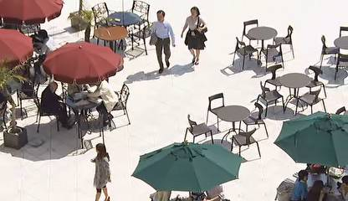
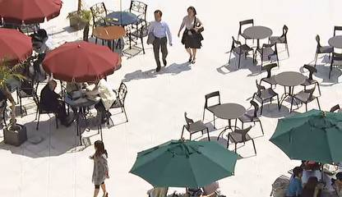
B Frame 92: TmuC R25 QP30 Rate3  5248 bits [Y 33.2141 _U 40.1820 _V 40.9738 dB] | B Frame 92 : TmuC R25+ RFC(50%) QP30 Rate3  5568 bits [Y 32.9543_ U 39.6254 _V 40.5038 dB]

CS2 Coding Structure RD Graphs

CS2: S03 Kimono_1920x1080_24fps

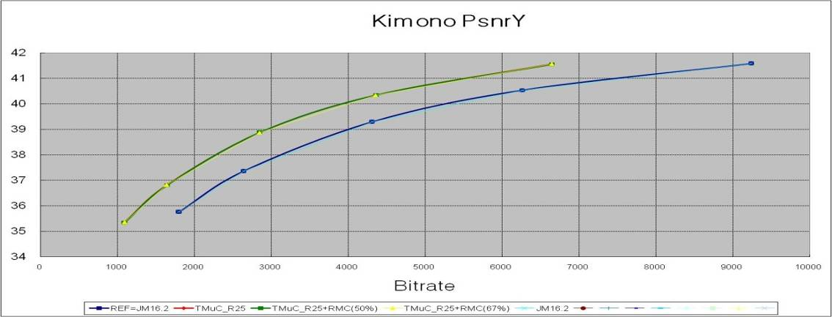

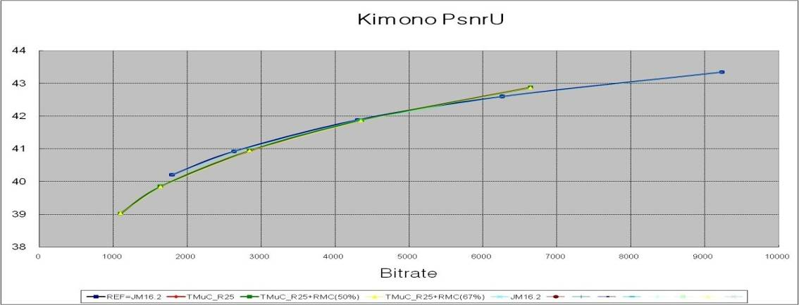

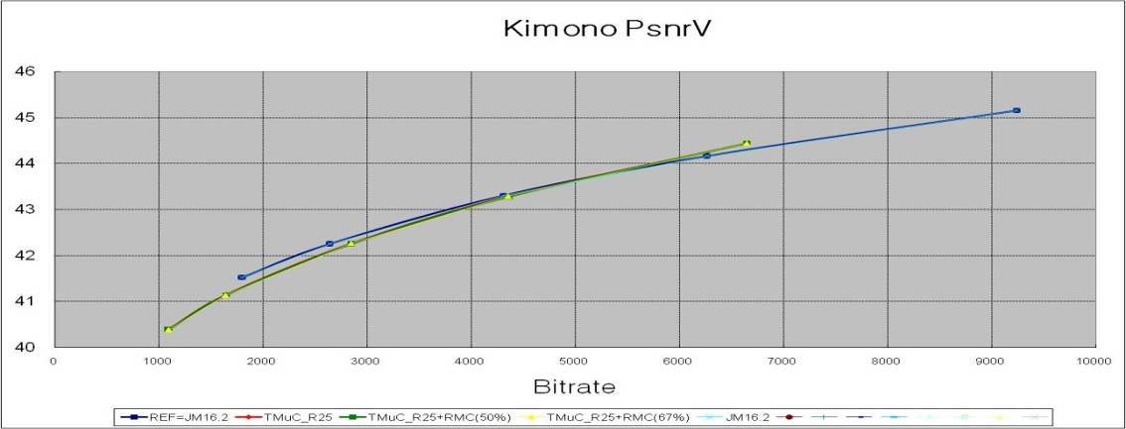

CS2: S04 ParkScene_1920x1080_24fps

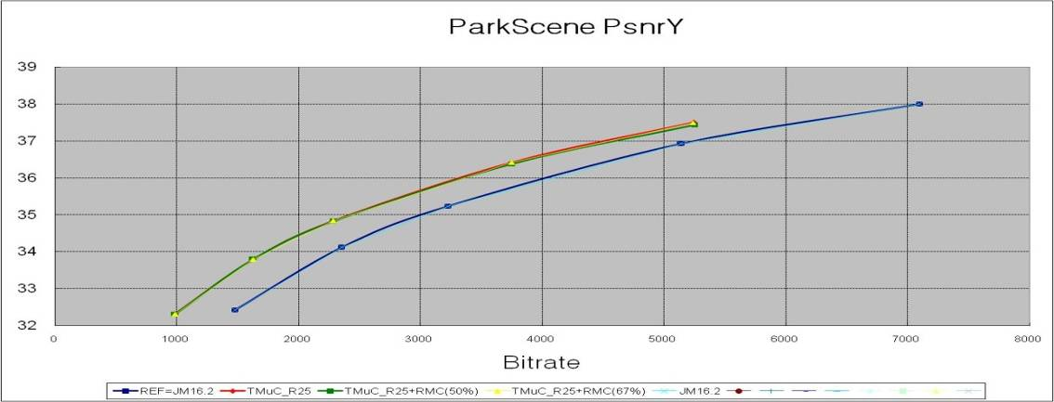

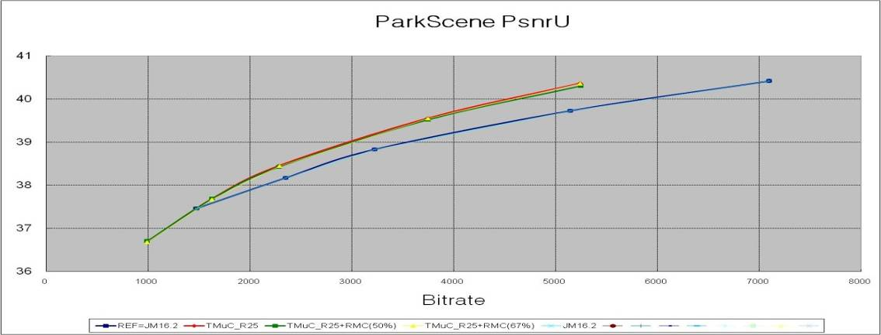

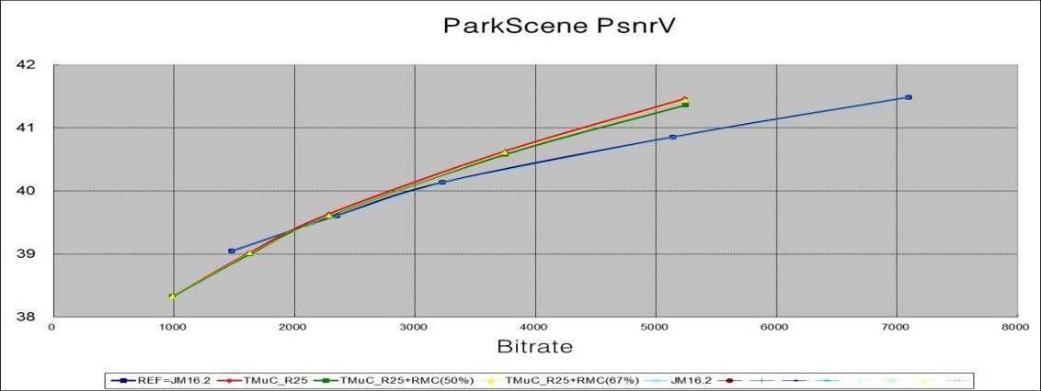

CS2: S05 cactus_1920x1080_50fps

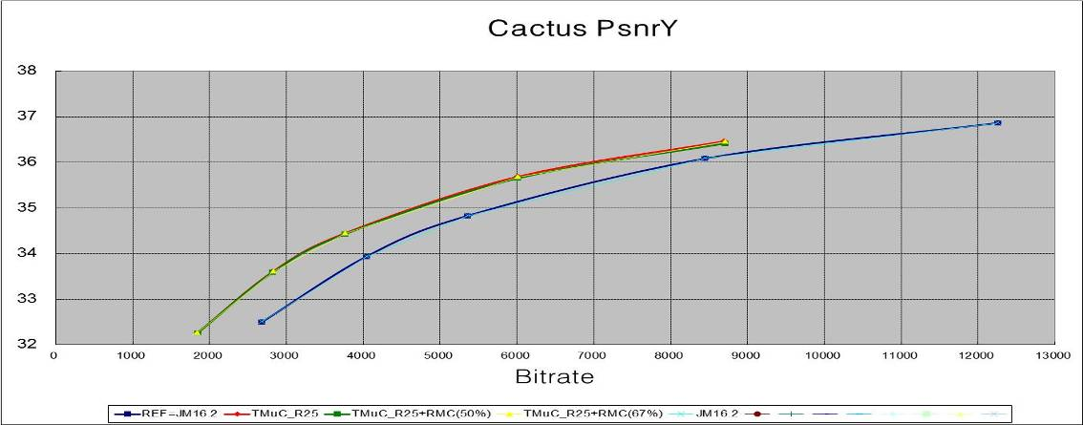

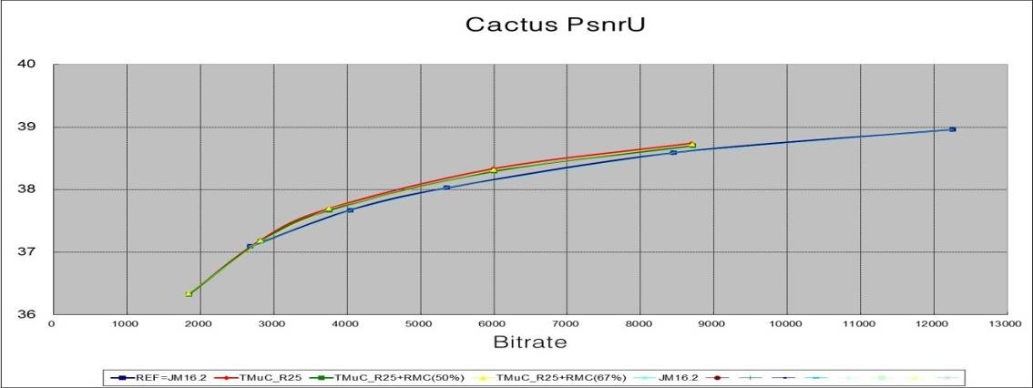

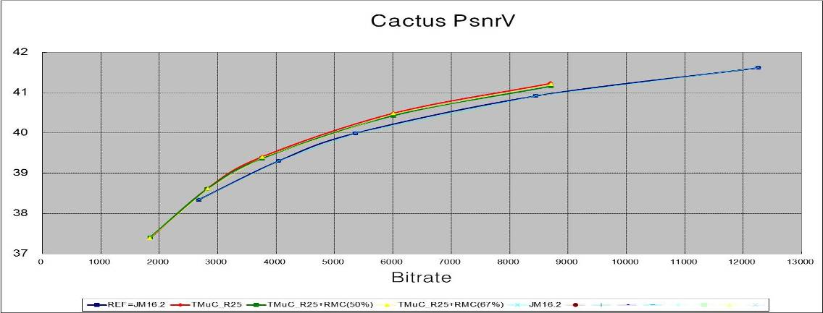

CS2: S06 BasketballDrive_1920x1080_50fps

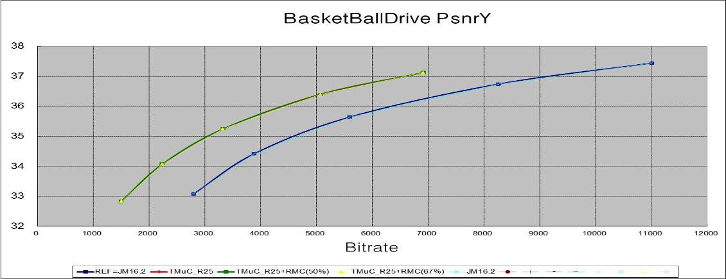

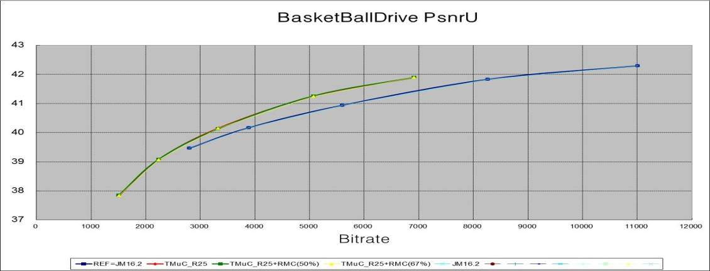

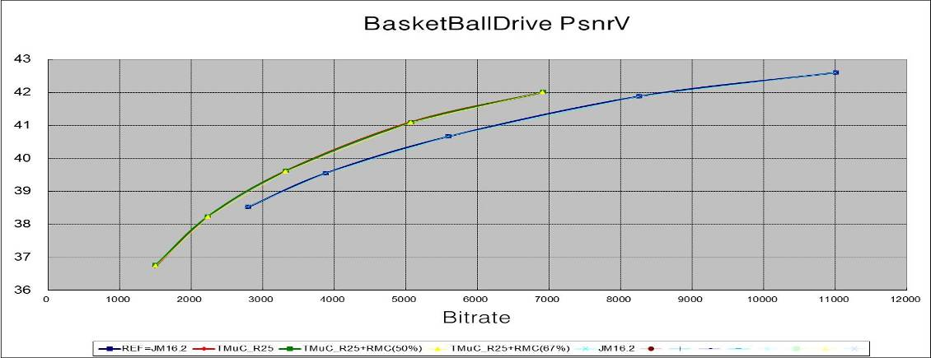

CS2: S07 BQTerrace_1920x1080_60fps

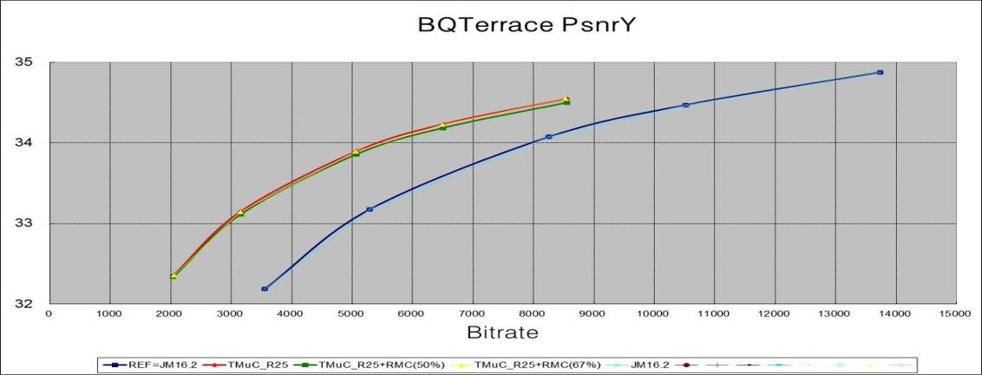

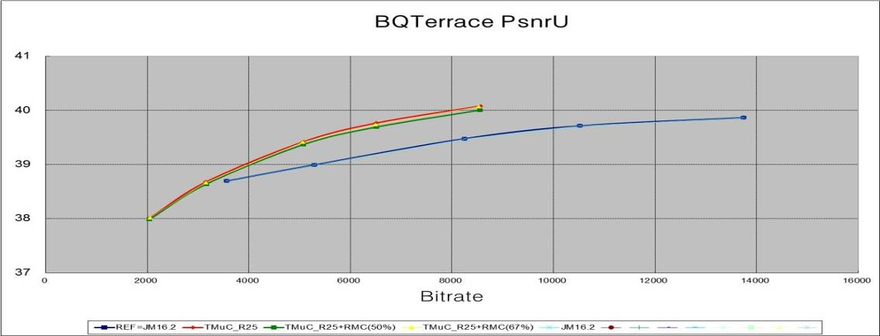

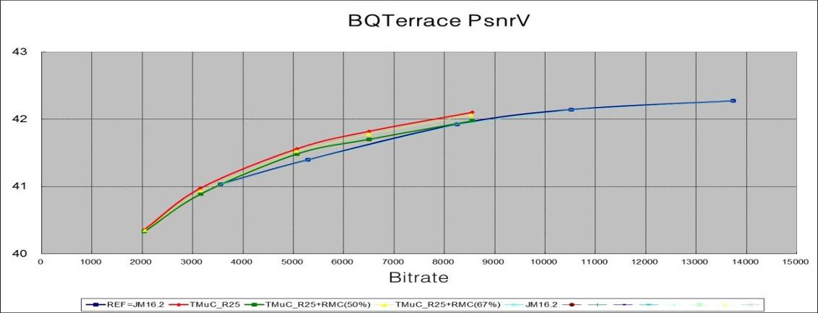

CS2: S08 BasketballDrill_832x480_50fps

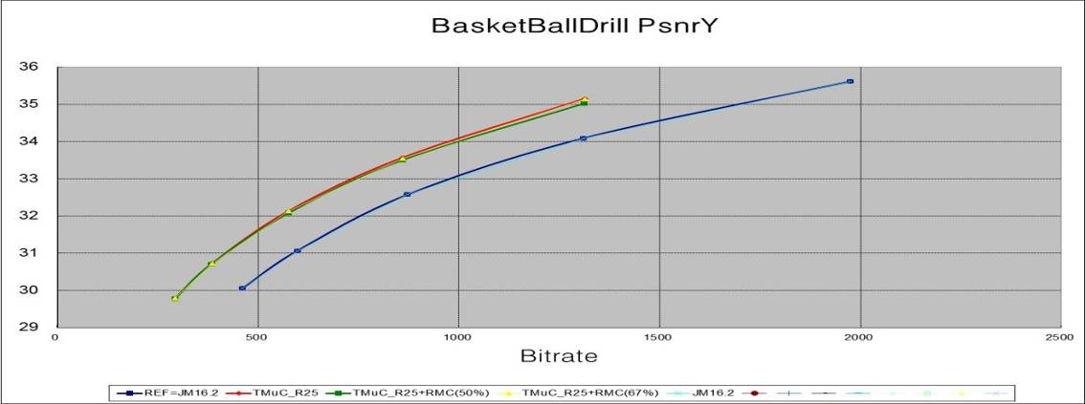

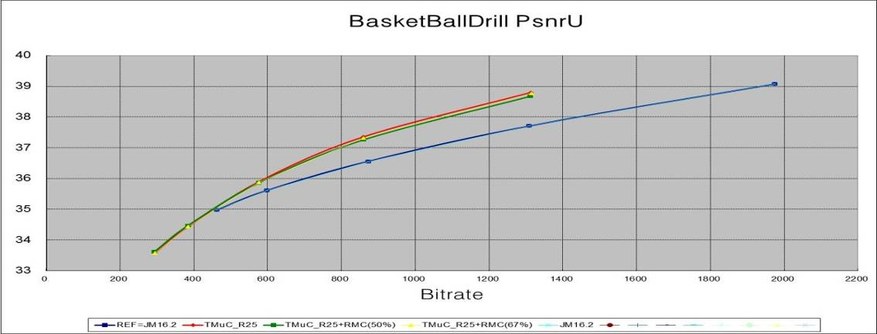

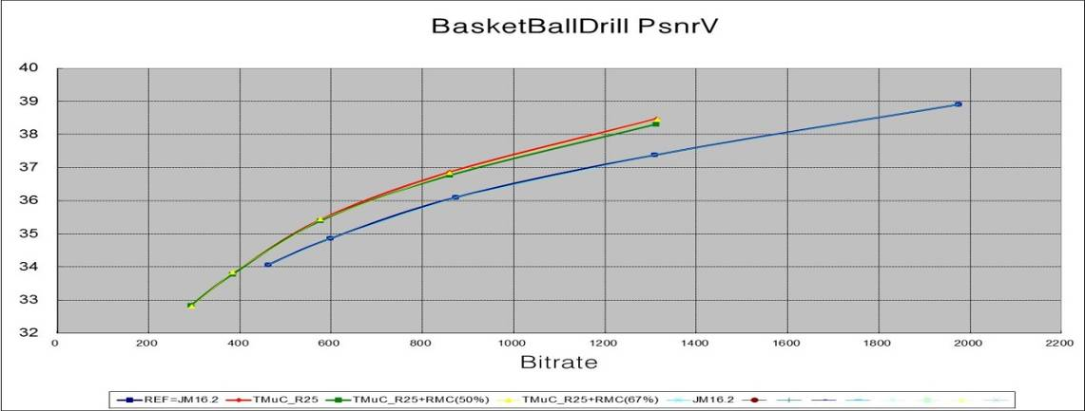

CS2: S09 BQMall_832x480_60fps

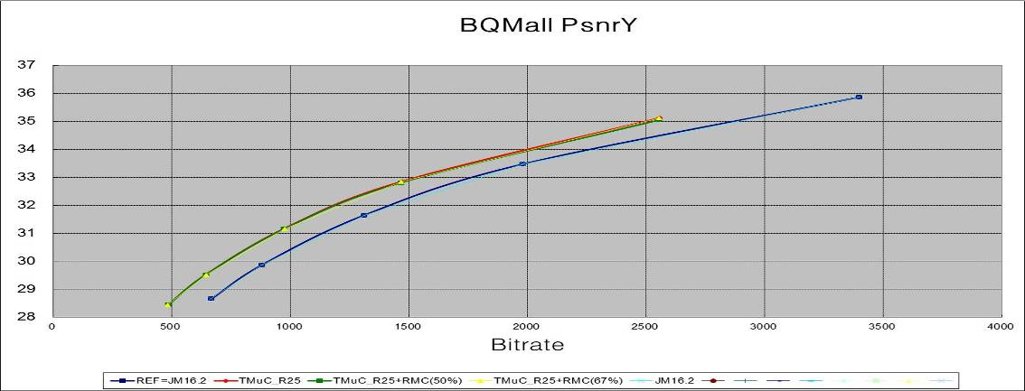

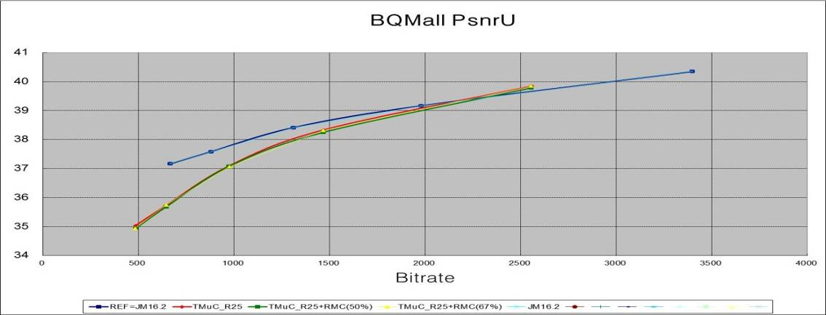

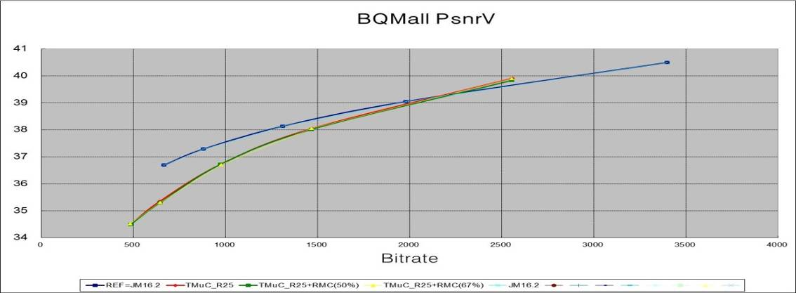

CS2: S10 PartyScene_832x480_50fps

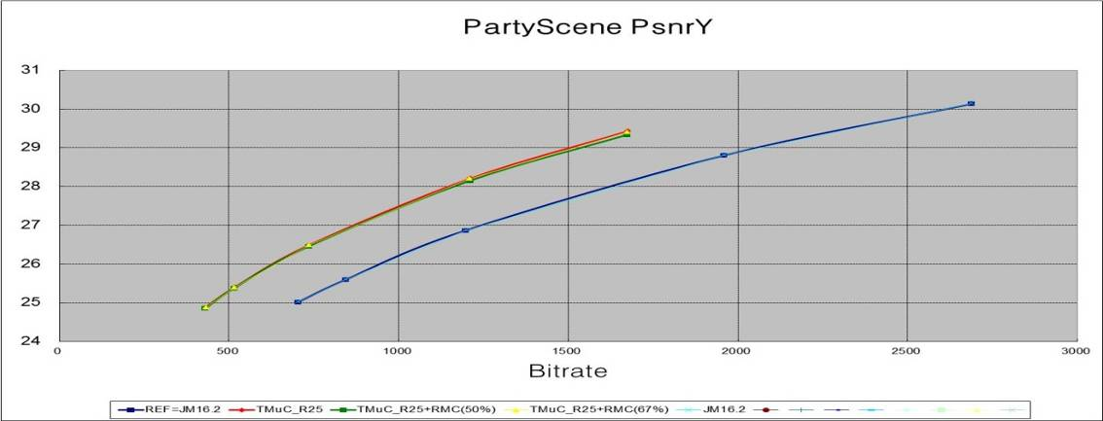

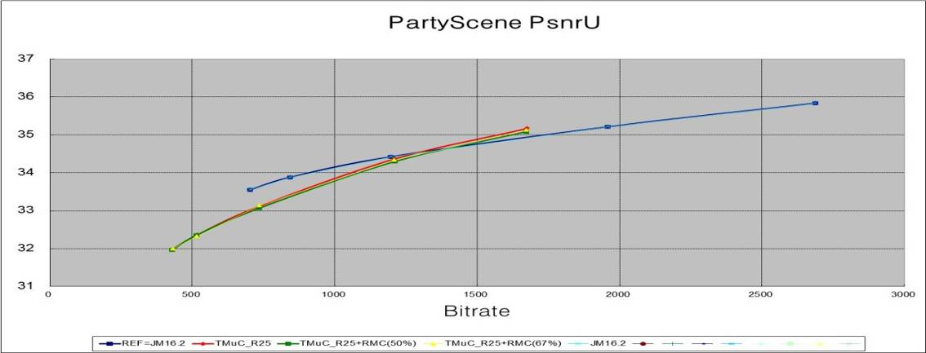

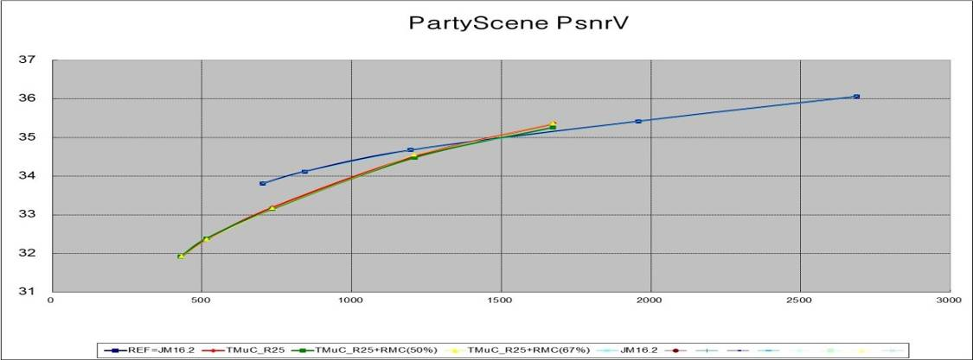

CS2: S11 RaceHorses_832x480_30fps

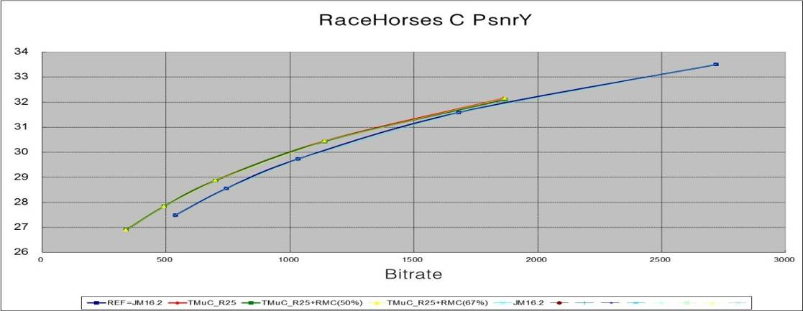

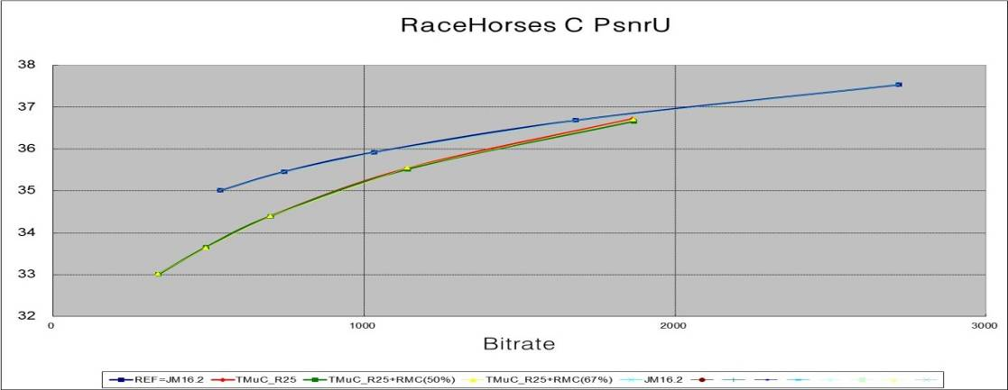

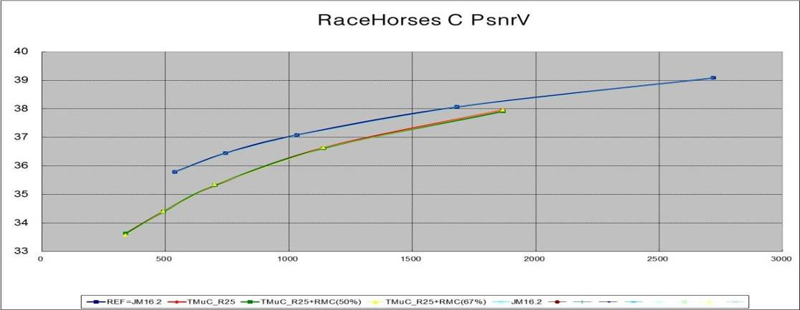

CS2: S12 BasketballPass_416x240_50fps

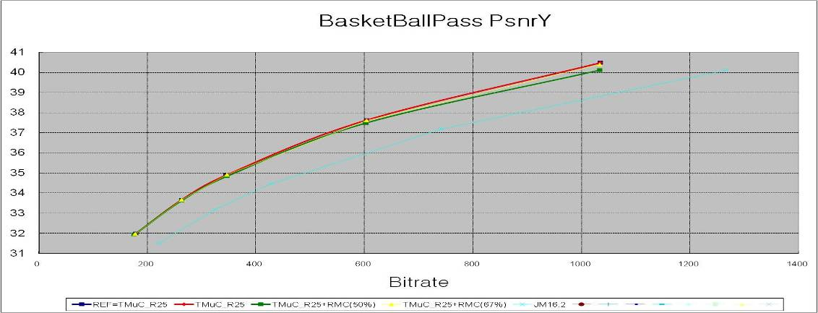

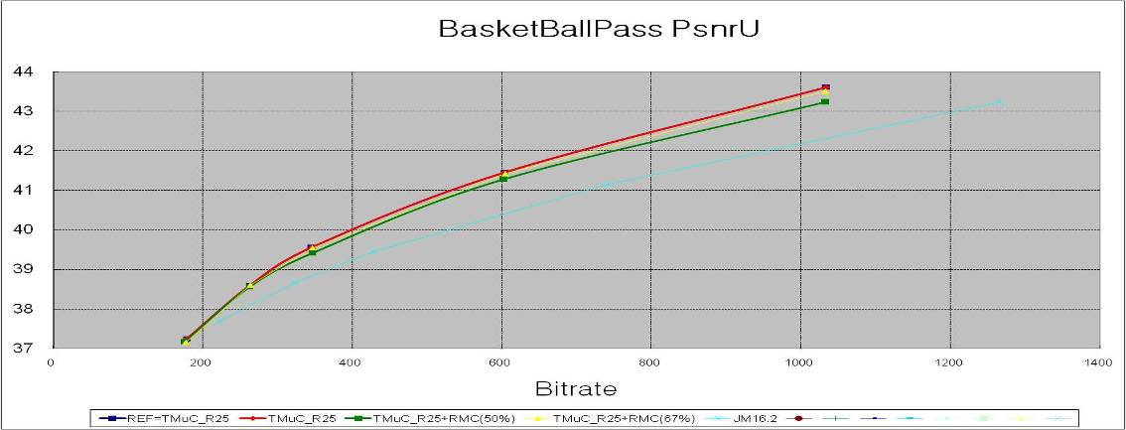

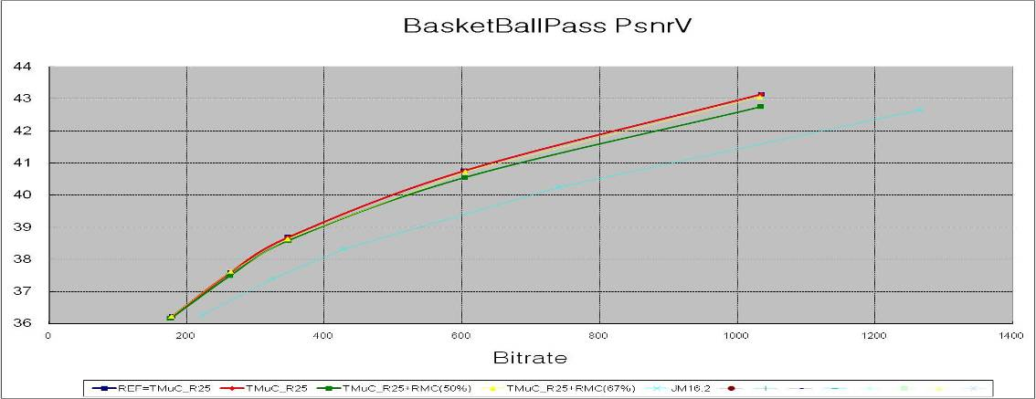

CS2: S13 BQSquare_416x240_60fps

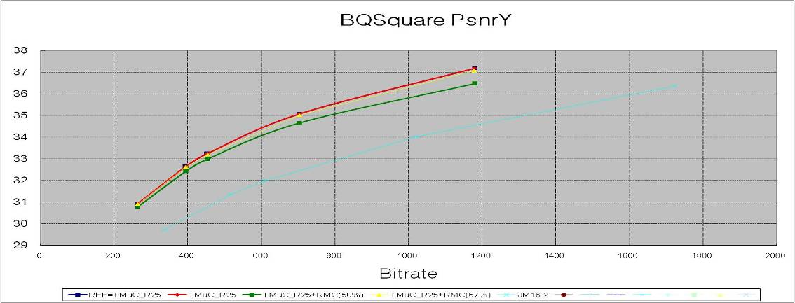

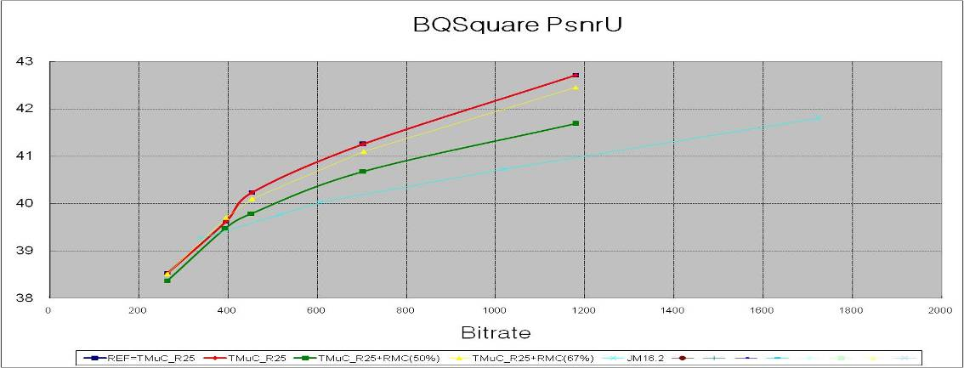

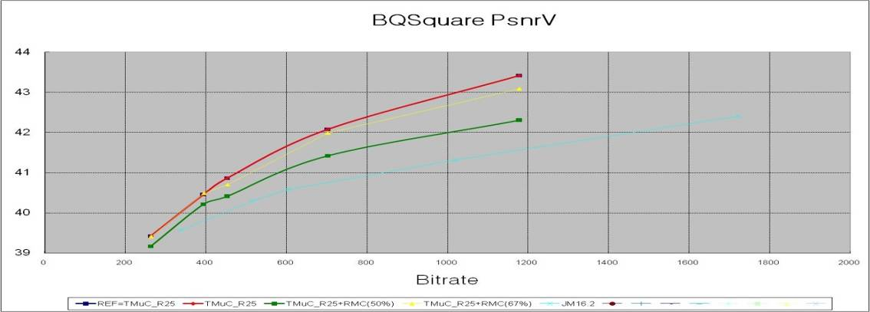

CS2: S14 BlowingBubbles_416x240_50fps

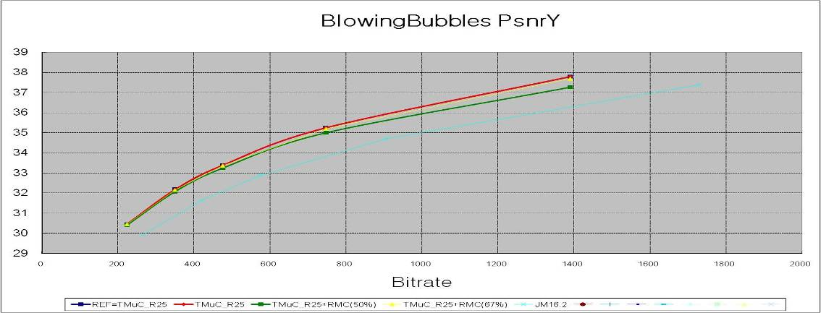

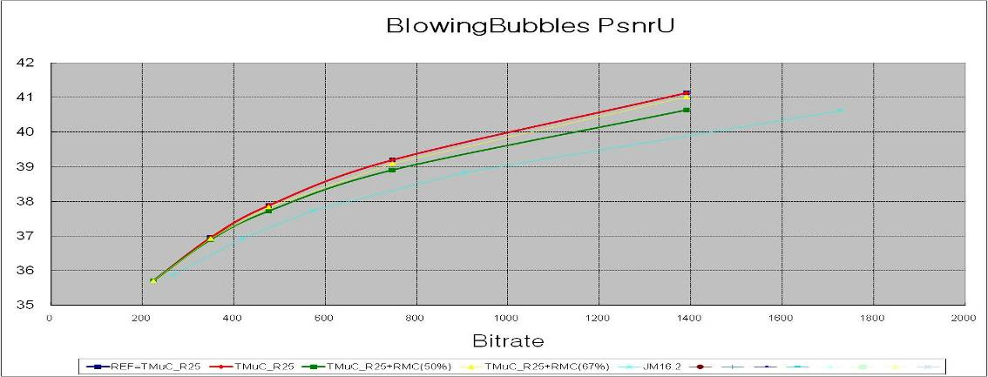

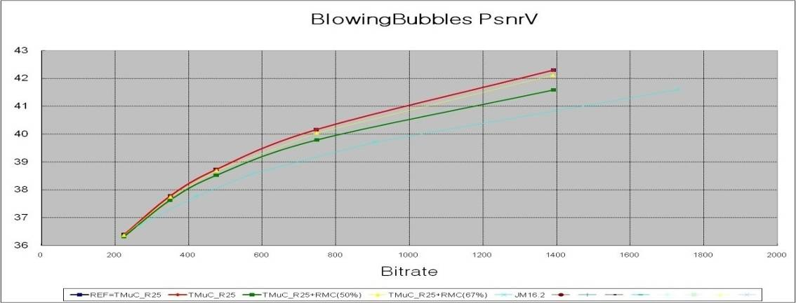

CS2: S15 RaceHorses_416x240_30fps

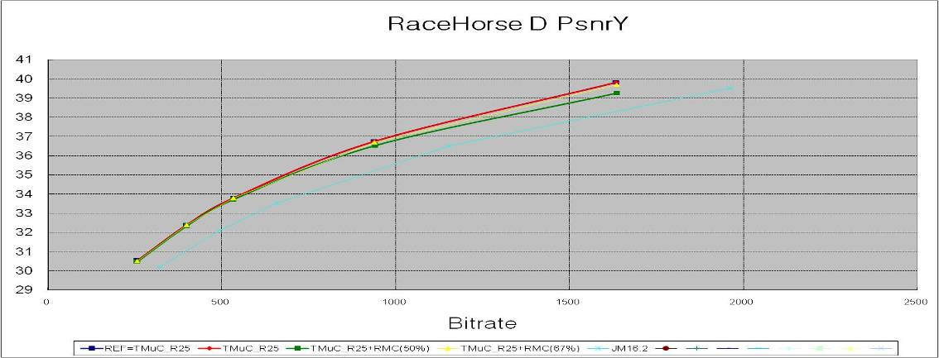

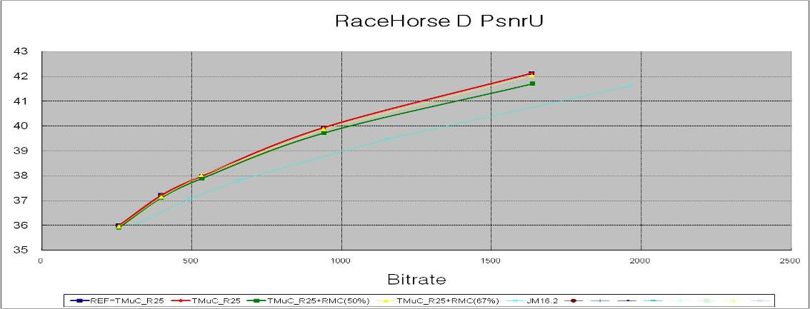

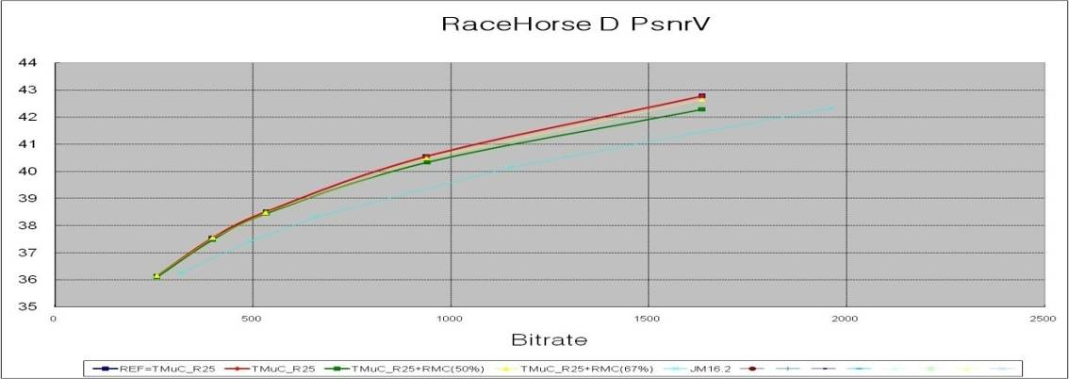

CS2: S16 Vidyo1_1280x720_60fps

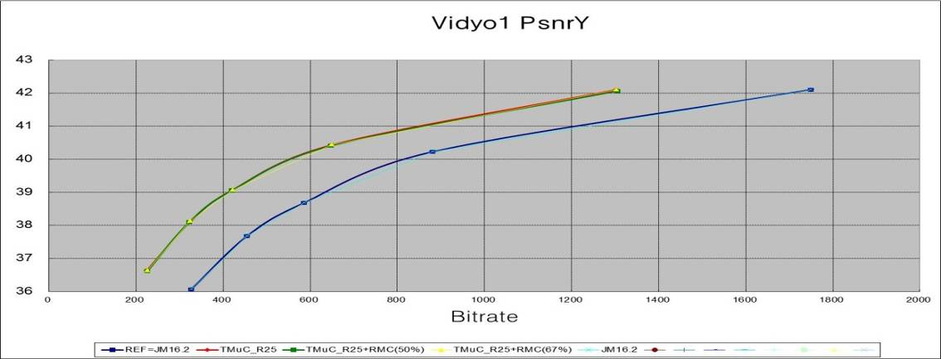

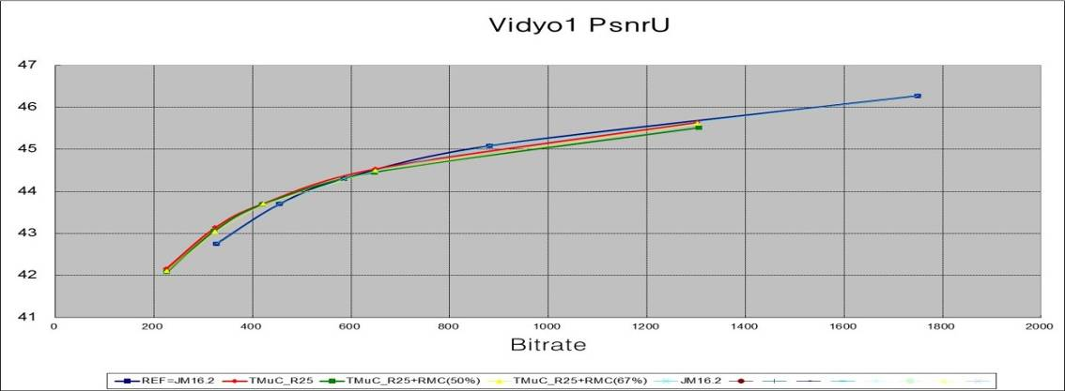

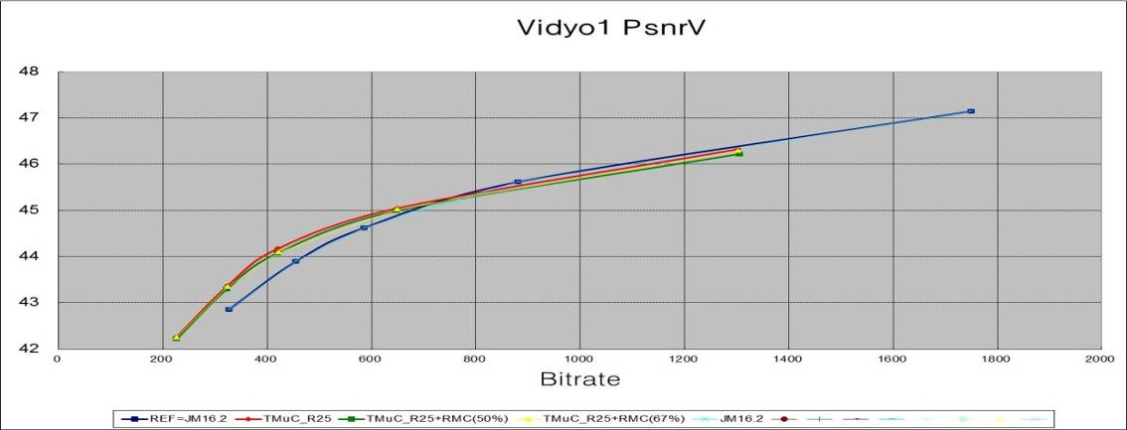

CS2: S17 Vidyo3_1280x720_60fps

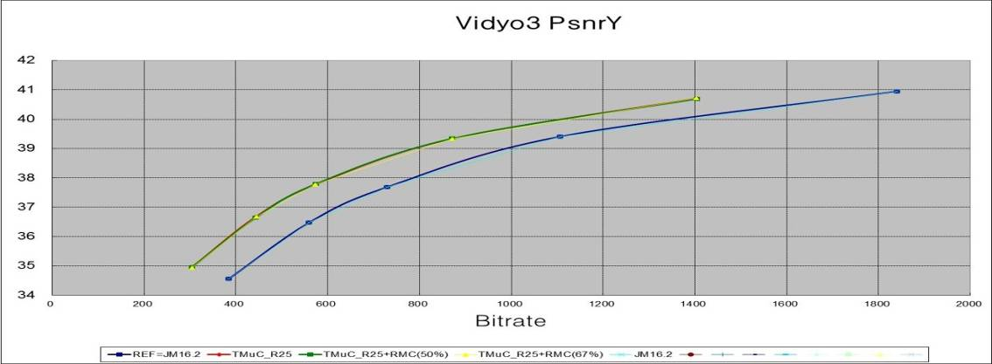

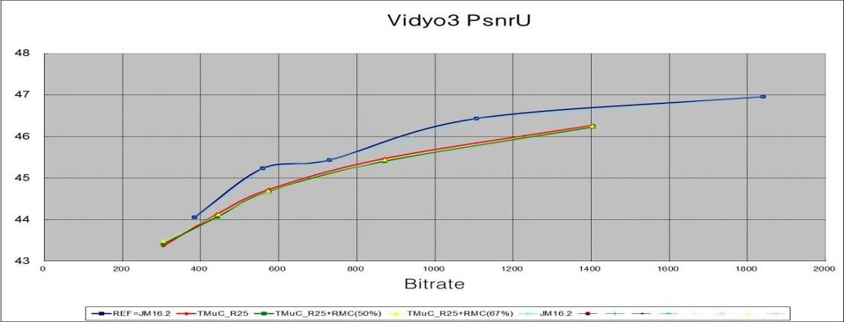

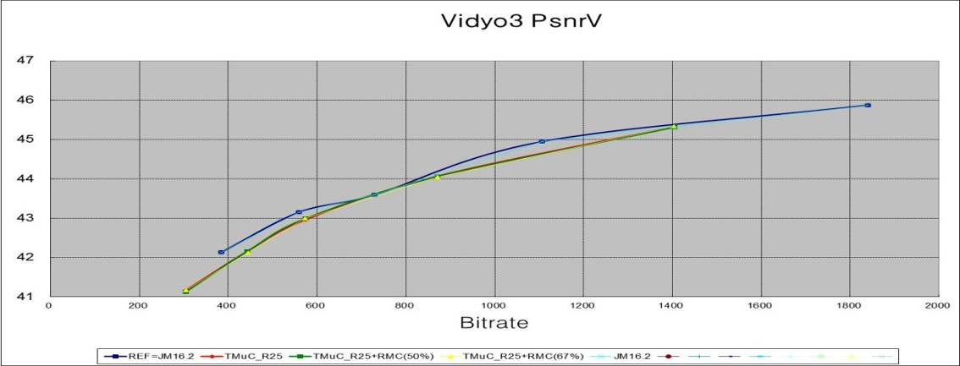

CS2: S18 Vidyo4_1280x720_60fps

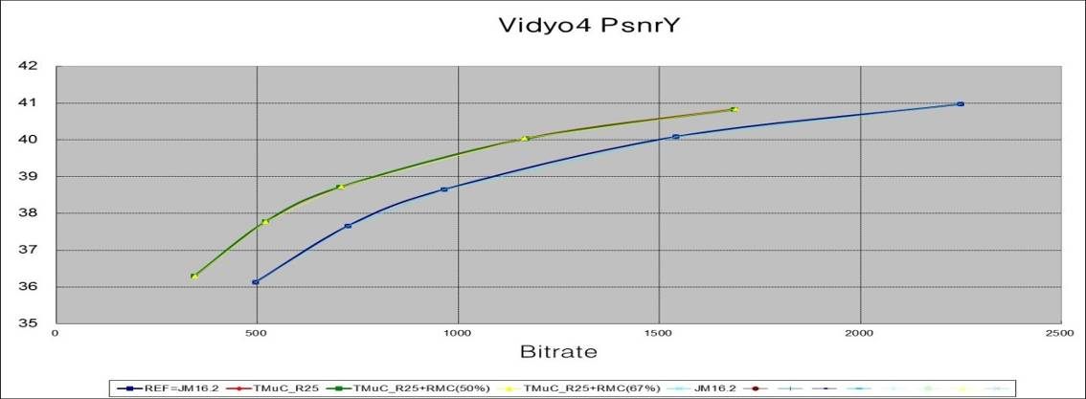

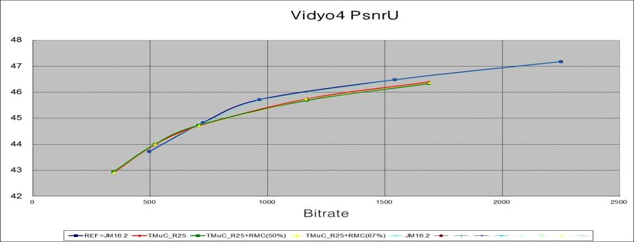

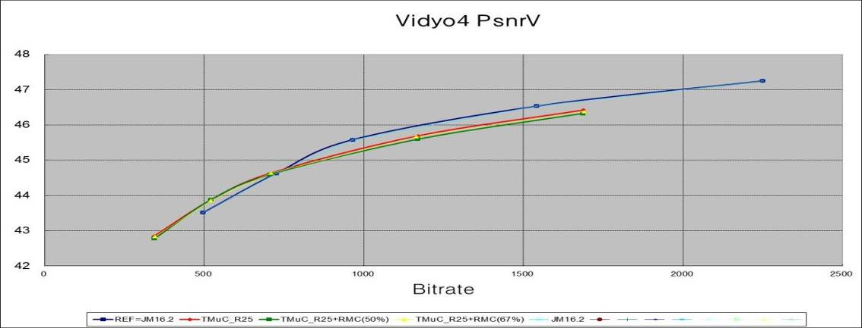

Sample Images For CS2

CS2 BQSquare_416x240_60fps Rate4

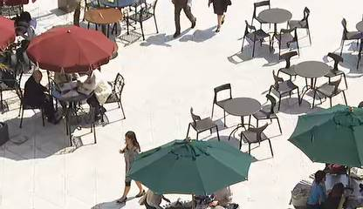
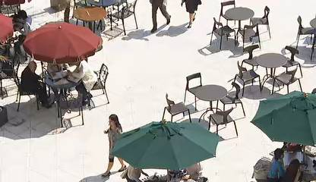
P Frame 10: TmuC R25 QP34 Rate4  2744 bits [Y 31.5879_39.7419_40.6626 dB] | P Frame 10 : TmuC R25+ RFC(50%) QP34 Rate4  2760 bits [Y 31.4143_39.6022_ V 40.3878 dB]

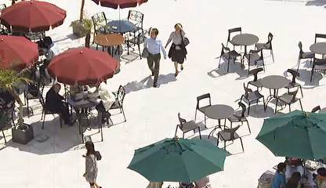
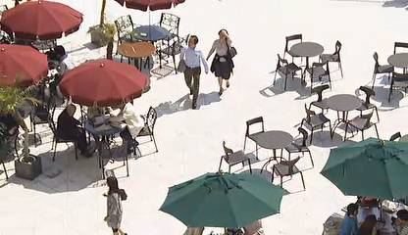
P Frame 120: TmuC R25 QP30 Rate3  5248 bits [Y 33.2141 _U 40.1820 _V 40.9738 dB] | P Frame 120 : TmuC R25+ RFC(50%) QP31 Rate4  28920 bits [Y 33.3487_ U 39.3911_V 39.9009 dB]

