    Joint Collaborative Team on Video Coding (JCT-VC)  of ITU-T SG16 WP3 and ISO/IEC JTC1/SC29/WG11  2nd Meeting: Geneva, CH, 21-28 July, 2010 | Document: JCTVC-B084_r1

Title: | Screen content coding
Status: | Input Document to JCT-VC
Purpose: | Proposal
Author(s) or  Contact(s): | Cuiling Lan  Jizheng Xu  Feng Wu  Gary Sullivan | Email: v-culan@microsoft.com  jzxu@microsoft.com  fengwu@microsoft.com  garysull@microsoft.com
Source: | Microsoft
_____________________________

Abstract
Screen contents are becoming important for various applications, e.g., desktop sharing, video conferencing, remote education. This document presents the new tools to improve the coding performance for screen contents. The improvement indicate that by adding some simple coding tools, the performance of the current video coding scheme can be more suitable for screen contents and thus can expand its role in various new application scenarios.

Introduction
Screen contents refer to images/videos generated/rendered by computers or some other electronic devices, e.g., mobile phone. As these contents are used widely, it becomes important to record, store and transmit them. To handle well these contents can also help many applications and even enable new application scenarios. For example, some application scenarios are listed below.
- Remote desktop
- Desktop sharing
- Video conferencing
- Game video
- Demo recording
- Remote education
- Gaming on demand, e.g., onlive.com
- …
Thus far in the HEVC project, the focus has been on video content that was generated by video cameras, although it is clear that screen content is also an important video source. We would like to point out that that the HEVC requirements [1][2] apply to video coding in general for a wide range of applications – not just video from camera sources. We suggest a greater focus on screen content in the further work on the HEVC project.
Unlike natural images, screen contents may not be very smooth. They usually have totally different statistics. For text or graphics contents, it is much sharper and with high contrast. Because of the high contrast, any little artifact may be perceived by users. Thus, coding for screen contents usually require a very high fidelity of the decoded video.
In this document, two new coding tools are presented to improve the coding performance for screen contents. It will be shown that by simply adding two modes into AVC (ITU-T Rec. H.264 | ISO/IEC 14496-10), the coding performance can be much better than the state-of-the-art image/video coding schemes.

New coding tools for screen image coding
We propose two new coding tools for screen image coding, one is Residual Scalar Quantization (RSQ) and the other is Base Colors and Index Map (BCIM). They are implemented based on the block (or coding unit) structure. Thus, it is easy to integrate the new tools into the current coding scheme by adding two additional intra coding modes. In the following, we will briefly introduce these two modes. More details can be found in [4].

Residual scalar quantization (RSQ)
In the RSQ mode, directional prediction is also used for each block to generate the prediction residue. After the intra prediction, different from the current intra coding modes, no transform is applied on the residue. Instead, the quantization is directly applied on the residual signals, similar to APEC [3] used in KTA inter block coding. We also use the same direction setting when performing intra prediction. But different from the current intra prediction scheme, the residual quantization and sample reconstruction are done pixel by pixel within a block in our scheme. The reconstructed pixel can be used for the prediction of the next pixel along the same direction. The use of intra block reconstructed pixels for prediction is based on the assumption that the shorter the prediction distance is, the stronger the correlation will be. Taking direction 4 in AVC as an example as shown in Fig. 1, the pixel marked by “b” that is to be predicted will use the nearest reconstructed integer pixel “a” for prediction instead of the ﬁltered boundary reconstructed sample “M”.
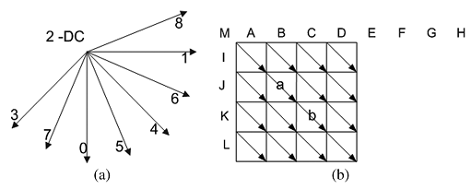
Fig. 1. Intra prediction in RSQ mode. (a) Eight prediction directions with direction 2 (DC mode) as an exception. (b) Example of intraprediction along direction 4.

Base colors and index map (BCIM)
Having limited colors but complicated shapes is another property of the text and graphics parts on screen images. Such text/graphics blocks can be expressed concisely by several base colors together with an index map. It is somewhat like color quantization that is a process of choosing a representative set of colors to approximate all the colors of an image [5]. In the BCIM mode, we ﬁrst get the base colors of a block by using a clustering algorithm. All the base colors constitute a base color table. Then, each sample in the block will be quantized to its nearest base color. The index map indicates which base color is used by each sample. Different from color quantization, each text/graphics block, but not an entire image, has its own base colors and an index map for representation in our scheme. Thus, it is content adaptive for each block. In addition, since the base color number of a block is small, fewer bits are required to represent each mapped index.
In this mode, there are several key problems to solve. First, base colors should be chosen to well represent a block. Second, after base colors are selected, there should be an efficient entropy coding method to code the base colors and index map. If the coding method has been decided and is good enough, the problem is then simpliﬁed as the searching of the best base colors for that block. In this mode, we use dynamic programming to not only achieve the global optimal partition but also avoid intensive computation caused by clustering of multiple times and the iterative updating.
To represent a block, we need to encode the base colors and index map into the bitstream. Instead of using the binarization schemes in AVC, such as Exp-Golomb, the base color number, values and remapped indexes are all simply expressed by their binary format. The context setting for the index map coding is shown in Fig. 2. We take the number of base colors to be 4 as an example. In such a case, there will be 15 basic patterns of the neighboring indexes, as {AAAA, AAAB, AABA, ABAA, BAAA, AABB, ABAB, ABBA, AABC, BAAC, BCAA, ABAC, ABCA, BACA, ABCD}, where A, B, C and D stand for indexes that have been sorted by their occurrences. Thus, there will be 15 contexts for coding the current index. We also remap the current index to 0, 1, 2 or 3 when the current index equals to A, B, C or D before the entropy encoding.
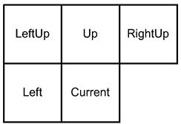
Fig. 2. The neighboring indexes as contexts of the current index.

Experimental results
We have integrated the RSQ and BCIM modes into JM software and use several screen images to test its performance. For comparison, we also use JPEG2000, the original JM software, JCT-A124 software and TMuC0.3 to code the same images.
The images and the coding results are shown in Fig. 3, Fig. 4 and Fig. 5. As we can see, the coding gain can be over 10dB even compared to the state-of-the-art. The improvement is significant.
Visual quality comparisons for those three images are shown in Fig. 6, Fig. 7 and Fig. 8. Parts of those decoded images are shown for better comparisons. It is not difficult to see the difference and the improvement.

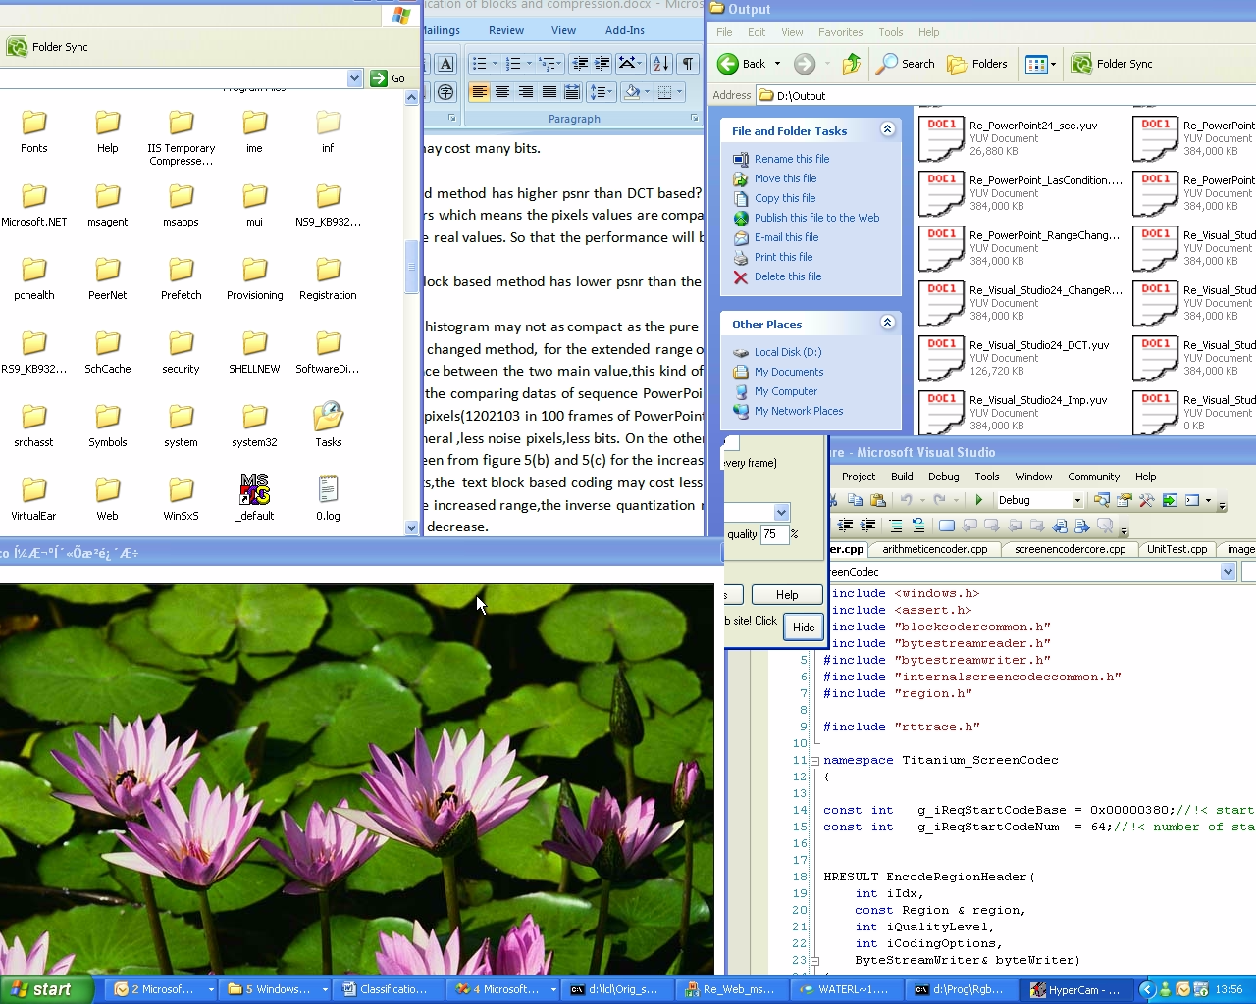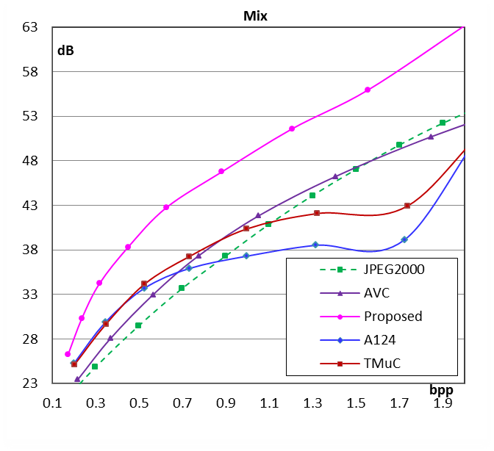
(a ) (b)
Fig. 3. (a) screen image Mix, and (b) coding performance comparison.

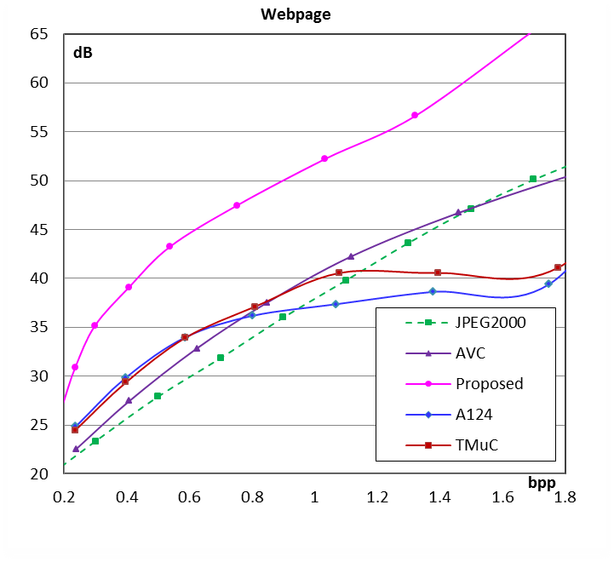
(a) (b)
Fig. 4. (a) screen image Webpage, and (b) coding performance comparison.

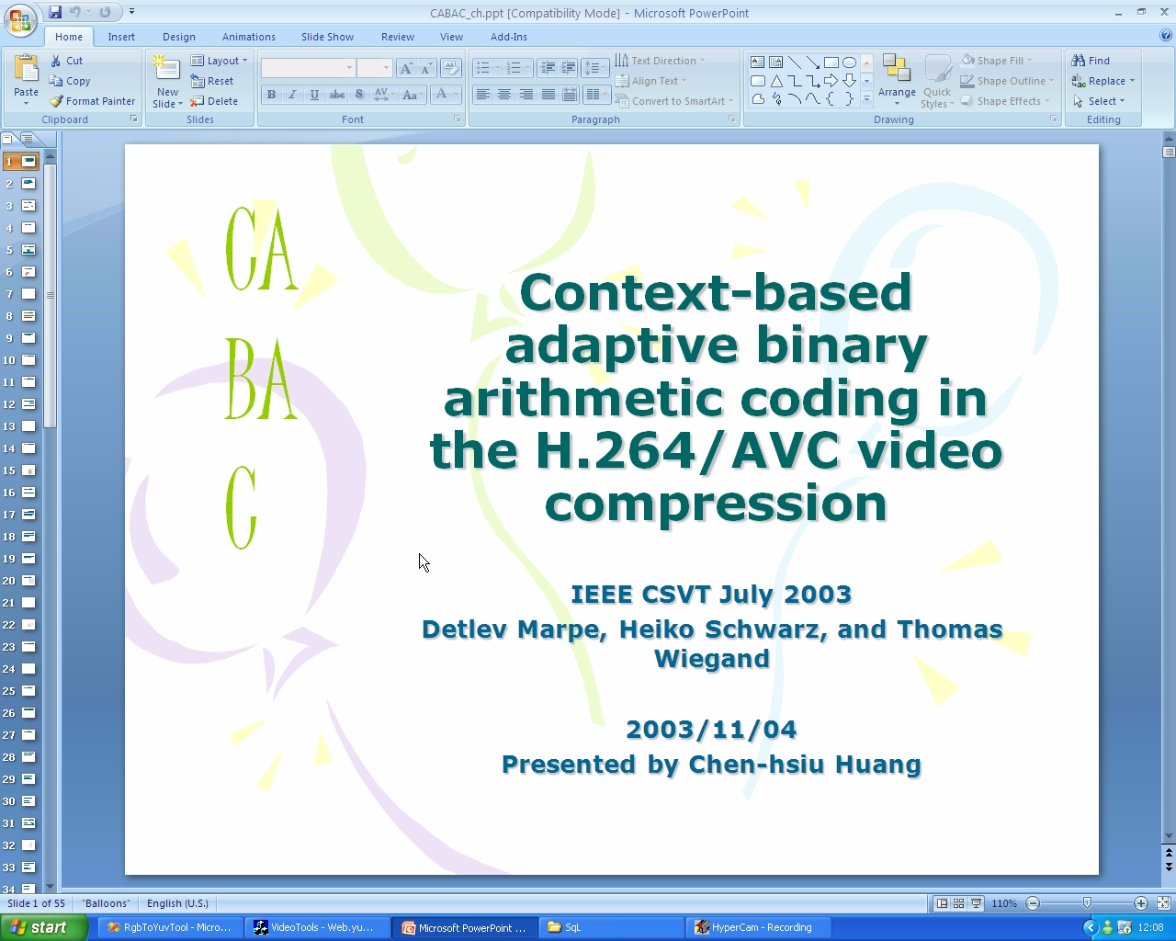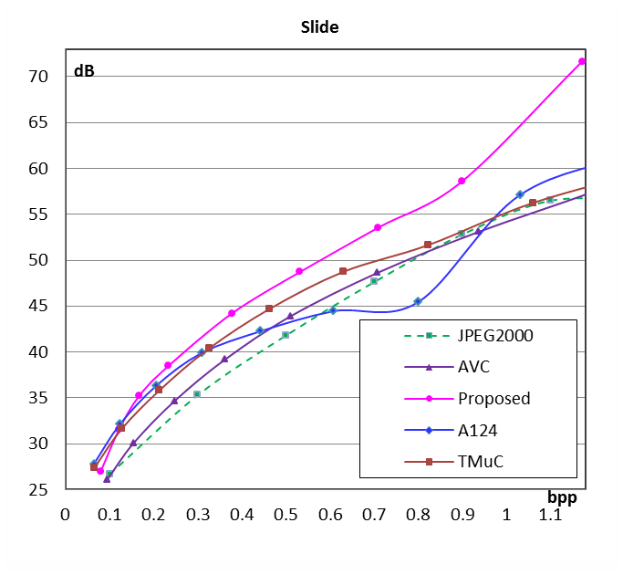
(a) (b)
Fig. 5. (a) screen image Slide, and (b) coding performance comparison.

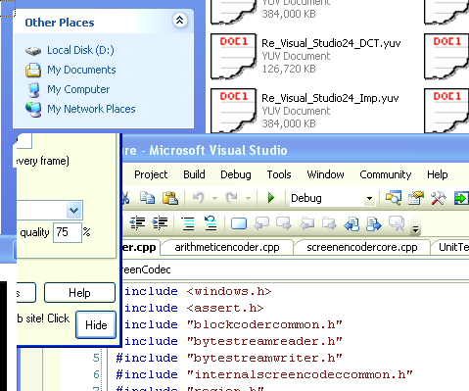
(a) Original
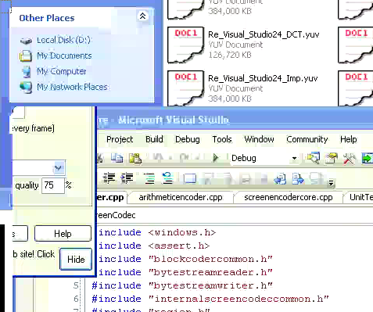
(b) AVC, PSNRY=28.05dB@0.367bpp
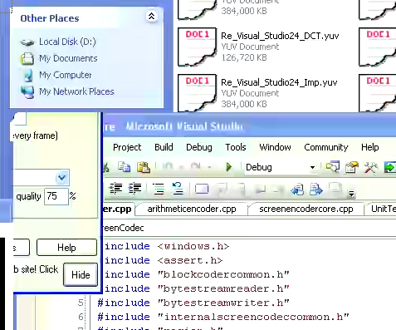
(c) A124, PSNRY=30.70@0.377bpp
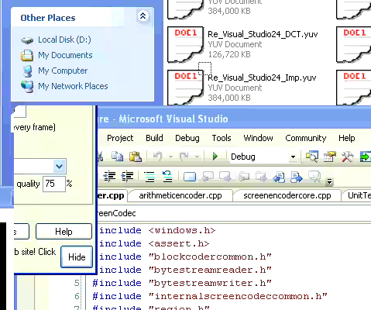
(d) Proposed, PSNRY=35.35dB@0.354bpp
Fig. 6. Visual comparison for image Mix

(a) Original
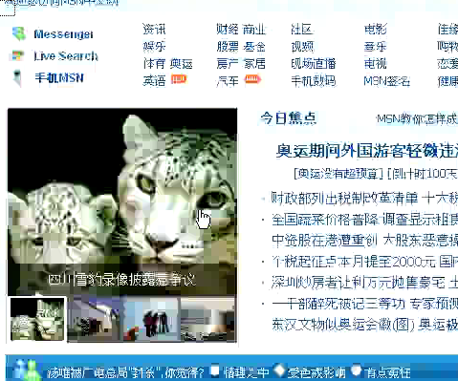
(b) AVC, PSNRY=22.54dB@0.238bpp
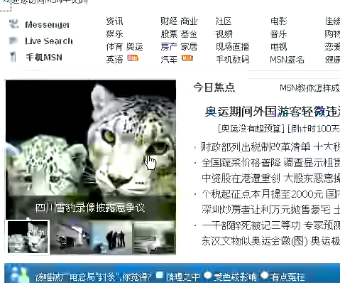
(c) A124, PSNRY=24.85@0.237bpp

(d) Proposed, PSNRY=30.92dB@0.236bpp.
Fig. 7. Visual comparison for image Webpage

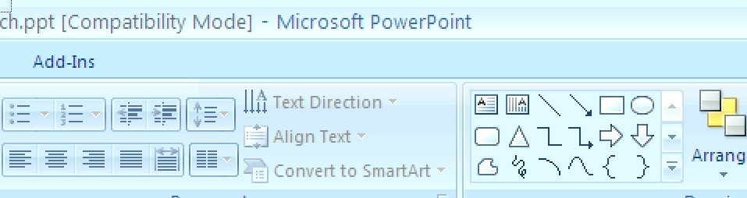
(a) Original
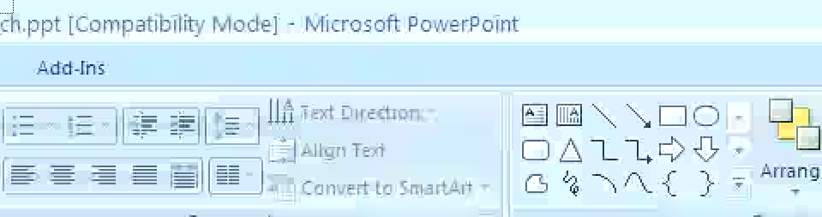
(b) AVC, PSNRY=33.52dB@0.22bpp
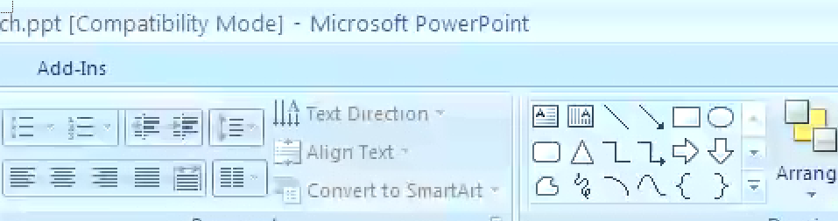
(c) A124, PSNRY=37.11dB@0.225bpp.
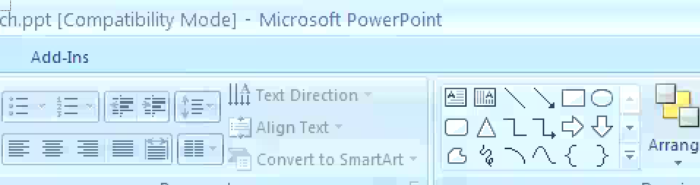
(d) Proposed, PSNRY=37.76dB@0.211bpp
Fig. 8. Visual comparison for image Slide

Conclusions
In this document, we have shown some results that even with JM, with two simple new tools, the coding performance for screen contents can be improved much. Since JCT-A124 software or TMuC software has a much higher performance than JM, we expect more gain can be achieve if the new screen coding tools and various tools in TMuC are used together.
There are still many issues in screen coding to be improved. For example, the motion properties of screen videos are also very different from those of natural videos. Thus, the sooner can JCT-VC consider screen coding and start some efforts, the more likely the new standard can be more mature for the new screen contents and facilitate various new application scenarios.

References
[1] “Draft Requirements for next-generation video coding project,” ITU-T SG16/Q6/VCEG-AL96, London, UK/Geneva, CH, July 2009
[2] “Vision, Applications and Requirements for High-Performance Video Coding (HVC),” ISO/IEC JTC1/SC29/WG11/N11096, Kyoto, JP, Jan. 2010
[3] M. Narroschke, H. G. Musmann, “Adaptive prediction error coding in spatial and frequency domain with a fixed scan in the spatial domain,” ITU-T SG16/Q6/VCEG-AB06, Bangkok, TH, Jan. 2006
[4] C. Lan, G. Shi and F. Wu, “Compress compound images in H.264/MPEG-4 AVC by exploiting spatial correlation,” IEEE Trans. on Image Processing, Apr., 2010.
[5] X. Wu, “Color quantization by dynamic programming and principal analysis,” ACM Trans. Graph., vol. 11, no. 4, pp. 348–372, Oct. 1992.
[6] K. McCann et. al., “Samsung’s Response to the Call for Proposals on Video Compression Technology,” JCT-VC Doc JCT-A124, Dresden, DE, Apr., 2010.

Patent rights declaration(s)
Microsoft Corp. may have IPR relating to the technology described in this contribution and, conditioned on reciprocity, is prepared to grant licenses under reasonable and non-discriminatory terms as necessary for implementation of the resulting ITU-T Recommendation | ISO/IEC International Standard (per box 2 of the ITU-T/ITU-R/ISO/IEC patent statement and licensing declaration form).

