    Joint Collaborative Team on Video Coding (JCT-VC)  of ITU-T SG16 WP3 and ISO/IEC JTC1/SC29/WG11  2nd Meeting: Geneva, CH, 21-28 July, 2010 | Document: JCTVC-B023

Title: | Extended merging scheme using motion-hypothesis inter prediction
Status: | Input Document to JCT-VC
Purpose: | Proposal
Author(s) or  Contact(s): | Jaehyun Lim,
Author(s) or  Contact(s): | Seungwook Park,  Byoengmoon Jeon  Multimedia Lab., LG Electronics Inc.  221, Yangjae-dong, Seocho-gu, Seoul, Korea | Tel:  Email: | jaehyun.lim@lge.com  seungwook.park@lge.com  bm.jeon@lge.com
Source: | LG Electronics
_____________________________

Abstract
This document presents an extended merging process for inter prediction. In the merging process of TMuC, the current motion partition is predicted with one of two neighboring partitions, above and left partitions. In the proposed method, the merging process is combined with motion hypothesis prediction. When enabled, the current partition is predicted with the weighted sum of the two candidate partitions. One additional flag is signaled when condition is satisfied (merge_flag equal to 1, both neighboring partitions are available, and motion parameters of the two candidate partitions are different). The purpose of the proposed method is to enhance the coding efficiency of P picture by extending the current merging process. The simulation result shows that the proposed method achieves 2.94% and 3.30% bit rate reduction under Hier-P and IPPP condition on average for class B, C and D sequences. Moreover, the proposed method introduced negligible complexity increment relative to TMuC with the merging process.

Introduction
At April JCT-VC meeting, the merging scheme was proposed by [1] and adopted into TMuC[2]. The merging process enables to merge neighboring partitions into so-called regions. When a partition is merged with one of its neighboring partitions, the motion parameters do not need to be transmitted but instead the parameters are transmitted only for once for the whole region.
The merging process is signaled by two flags, merge_flag and merge_left_flag. merge_flag specifies whether the motion parameters of the current partition are inferred from the ones of its left and above partitions. merge_left_flag specifies whether the motion parameters of the current partition are inferred from the left or the above neighboring partition. Therefore, when the merging process is enabled, the current partition is motion-compensated by using its above or left partition’s motion parameters.
In this contribution, the merging process is extended by using motion-hypothesis inter prediction. It is known that the accuracy of motion compensated prediction can be increased with multi-hypothesis prediction (motion-compensated prediction using multiple motion parameters) [3]. For better coding efficiency, we applied motion-hypothesis inter prediction to the merging process by using the two motion parameters of the left and the above neighbor.
When the proposed method is enabled, the current partition is motion-compensated using the two motion parameters of the above and the left neighboring partitions and stores motion parameters of the left neighboring partition that will be used to code the following partitions. Otherwise, when the current partition uses the same merging process as TMuC, it is motion-compensated using the motion parameters of only one neighboring partition (the motion parameters of the left or the above partition) and stores the selected motion parameters to be used in the coding process of the following partitions.
By motion-hypothesis of neighboring partitions, the proposed method can significantly increase the coding performance especially in P picture.

Proposed Methods
In the proposed method, motion hypothesis inter prediction can be enabled when the following conditions are satisfied.
- merge_flag equal to 1
- Both above and left neighboring partitions are available and inter-predicted
- The motion parameters of above and left neighboring partitions are different

Figure.1 shows an example of the current partition X and the two neighboring partitions, A and B.
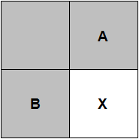
Figure.1 Two neighboring motion partitions used for the merging process

As shown in Figure.2, when the proposed method is enabled, the current partition ‘X’ is predicted from the weighted sum of two partitions which are pointed by the motion parameters (motion vector and reference index) of the two neighboring partitions. In Figure.2, mvA and mvB indicates the motion vectors of the above and left neighboring partitions respectively. X_{pred} indicates the predicted partition which is derived by weighted sum of the two partitions pointed by mvA and mvB.

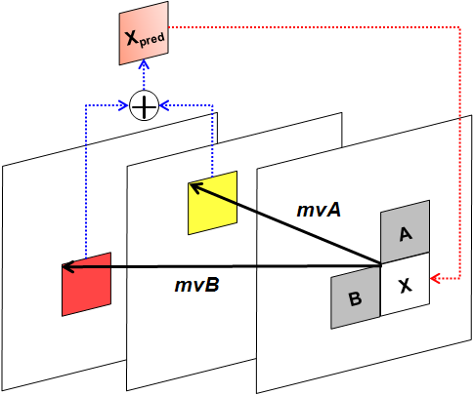
Figure.2 Motion hypothesis prediction

In addition, the current partition needs to have motion parameters because it will be used for prediction of right or below neighbor partition in the future. While, the motion parameters are selected from one of two neighboring partitions in the merging process in TMuC, the motion parameters are copied from the left neighboring partition in the proposed method.
The proposed syntax and semantic changes are like followings

from
prediction_unit( x0, y0, currPredUnitSize ) {
:
else if( PredMode == MODE_INTER ) {
if(entropy_coding_mode_flag)
inter_partitioning_idc | 2 | ue(v) | ae(v)
for( i= 0; i < NumPuParts( inter_partitioning_idc ); i++ ) {
if( NumMergeCandidates > 0 ) {
merge_flag[ i ] | 2 | ue(1) | ae(v)
if( merge_flag[ i ] && NumMergeCandidates > 1 )
merge_left_flag[ i ] | 2 | ue(1) | ae(v)
}
:
}
}
:
}

to
prediction_unit( x0, y0, currPredUnitSize ) {
:
else if( PredMode == MODE_INTER ) {
if(entropy_coding_mode_flag)
inter_partitioning_idc | 2 | ue(v) | ae(v)
for( i= 0; i < NumPuParts( inter_partitioning_idc ); i++ ) {
if( NumMergeCandidates > 0 ) {
merge_flag[ i ] | 2 | ue(1) | ae(v)
if( merge_flag[ i ] && NumMergeCandidates > 1 )
motion_hypothesis_merge_flag[ i ] | 2 | ue(1) | ae(v)
If( motion_hypothesis_merge_flag[i] !=1 )
merge_left_flag[ i ] | 2 | ue(1) | ae(v)
}
:
}
}
:
}

motion_hypothesis_merge_flag[i] specifies whether the motion-hypothesis inter prediction for the current partition with partition index i is applied.

Experimental Results
The proposed method was implemented on the TMuC (Revision 11) software and the performance was measured under both Hier-P and IPPP conditions. The merging scheme in TMuC software was applied in the unit of CU not a motion partition. Therefore, the proposed algorithm was also applied in the unit of CU. Detail test condition for the proposed method is as shown in Table.1.

Table.1 Test condition for the proposed method
software | TMuC software revision 11  (HHI tool integrated version)
test sequences | Class B (100-frame), Class C/D (all-frame)
coding structure | Hierarchical-P and IPPP  (the same as the TMuC software batches)
QP | Higher 4 QPs  (the same QPs in the TMuC software batches)
etc | the same as the HHI released TMuC software configuration

Moreover, when the motion-hypothesis inter prediction is applied, the weight values for neighbor partition A and B are set to 0.5 and 0.5 respectively.
Table.2 shows the experimental results in terms of BD rate reduction [4]. Maximum gain is 22.15% at the BQTerrace sequence (under Hier-P condition) and 9.25% at the BQSquare sequence (under IPPP condition), where the RD curves are shown in Figure.3 and 4. The average gains for Hier-P and IPPP condition are 2.94% and 3.30% respectively.
Table.3 shows the complexity increment of the proposed method compared with TMuC. The average encoder complexity increment under HierP and IPPP conditions are 1.02x and 1.02x respectively. And the average decoder complexity increment under HierP and IPPP conditions are 1.06x and 1.05x respectively.
As the simulation results show, the proposed method is a significantly efficient coding tool in terms of coding efficiency and the overhead complexity of decoder and encoder is negligible.

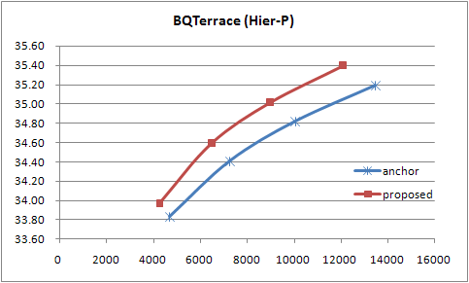
Figure.3 R-D curve of BQTerrace test sequence under Hier-P condition

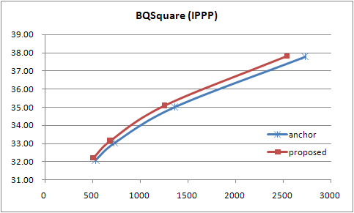
Figure.4 R-D curve of BQSquare test sequence under IPPP condition

Table.2 BD rate (%) reduction of the proposed method under Hier-P and IPPP condition
Class | seq. | BD-rate (%)
Class | seq. | Hier-P | IPPP
B | BasketballDrive | -1.27 | -1.96
B | BQTerrace | -22.15 | -21.99
B | Cactus | -2.16 | -2.13
B | Kimono | -0.41 | -0.33
B | ParkScene | -0.55 | -0.67
Class B Avg. |  | -5.31 | -5.42
C | BasketballDrill | -2.40 | -2.75
C | BQMall | -0.69 | -0.92
C | PartyScene | -1.25 | -1.34
C | RaceHorses | -0.58 | -0.91
Class C Avg. |  | -1.23 | -1.48
D | BasketballPass | -0.08 | -0.12
D | BlowingBubbles | -1.54 | -2.07
D | BQSquare | -7.17 | -9.25
D | RaceHorses | -0.39 | -0.60
Class D Avg. |  | -2.29 | -3.01
Avg. all |  | -2.94 | -3.30

Table.3 Complexity increment of the proposed method compared with TMuC
class | sequence | Hier-P |  | IPPP
class | sequence | encoder | decoder | encoder | decoder
B | BasketballDrive | 1.04 | 1.05 | 1.07 | 1.05
B | BQTerrace | 1.01 | 1.10 | 1.04 | 1.04
B | Cactus | 1.00 | 1.04 | 1.03 | 1.03
B | kimono | 1.01 | 1.03 | 1.03 | 1.03
B | ParkScene | 1.04 | 1.08 | 1.02 | 1.04
Class B Avg. |  | 1.02 | 1.06 | 1.04 | 1.04
C | BasketballDrill | 1.02 | 1.05 | 1.00 | 1.01
C | BQMall | 1.02 | 1.02 | 0.97 | 1.05
C | PartyScene | 1.02 | 1.05 | 1.04 | 1.03
C | RaceHorses | 1.01 | 1.03 | 1.05 | 1.03
Class C Avg. |  | 1.02 | 1.04 | 1.02 | 1.03
D | BasketballPass | 1.01 | 1.01 | 1.03 | 1.08
D | BlowingBubbles | 1.01 | 1.06 | 1.02 | 1.02
D | BQSquare | 1.02 | 1.18 | 1.02 | 1.11
D | RaceHorses | 1.01 | 1.03 | 0.98 | 1.06
Class D Avg. |  | 1.01 | 1.07 | 1.01 | 1.07
Avg. all |  | 1.02 | 1.06 | 1.02 | 1.05

Conclusion
In this document, extended merging scheme using Motion-hypothesis for inter prediction was proposed. The proposed scheme is a useful prediction method because it shows significant bit-rate reduction with one additional flag. Moreover, its complexity is negligible for both encoder and decoder. We recommend enabling this technique in the merging process in the TMuC. Or we recommend JCT-VC to establish a TE or ad-hoc on this, if it is required to be further evaluated on the proposal.

Patent rights declaration(s)
LG Electronics may have IPR relating to the technology described in this contribution and, conditioned on reciprocity, is prepared to grant licenses under reasonable and non-discriminatory terms as necessary for implementation of the resulting ITU-T Recommendation | ISO/IEC International Standard (per box 2 of the ITU-T/ITU-R/ISO/IEC patent statement and licensing declaration form).

References
[1] Fraunhofer HHI, “Description of video coding technology proposal by Fraunhofer HHI”, JCT-VC, 1st Meeting, Dresden, Deutschland, April 2010, Doc. JCTVC-A116.
[2] “Test Model under Consideration”, JCT-VC, 1st Meeting, Dresden, Deutschland, April 2010, Doc. JCTVC-A205.
[3] Bernd Girod, “Efficiency Analysis of Multihypothesis Motion-Compensated Prediction for Video Coding”, IEEE transactions on Image Processing, VOL.9, NO.2, February 2000.
[4] G. Bjontegaard, “Calculation of Average PSNR Differences between RD curves”, ITU-T SC16/Q6, 13th VCEG Meeting, Austin, Texas, USA, April 2001, Doc. VCEG-M33.

