***Guide of the good practices for the incorporation of the language of signs spanish in the television***

Equipment of CNLSE:

Maria Lighesteban Saiz (address) Eva Aroca Fernández

Mondríguez Varela David Sánchez Moreno

Document produced by:

Carlos Alberto Martín Edo

Linguistic Standardization centre of The Spanish Sign Language, 28

28035 MADRID

Tel: 91 376 85 60

Fax: 91 376 85 64

[cnlse@cnlse.is](mailto:cnlse@cnlse.es) [http://www.cnlse.is](http://www.cnlse.es/)

Edia:

Real Property Patron on disability [http://www.rpd.es](http://www.rpd.es/)

Ministry of Health, Social Services and Equality [http://www.msssi.es](http://www.msssi.es/)

Editor's care:

Spanish division of Documentation on Disability (CEDD) [http://www.cedd.net](http://www.cedd.net/)

Serrano, 140 280 06 MADRID

Tel 91 745 24 46-49

[cedd@cedd.net](mailto:cedd@cedd.net)

Tiquetation:

AFANIAS

© ITU Patronate on Disability, 2017

Video summary in the language of the signs spanish: [https://youtu.bedigC6LyLQMms4](https://youtu.be/mC6LyLQMms4) Nipo: 689-17-006-0

Reserved all) of the rights. Of the content of the east document is property of the Actual Disabled on persons with disabilities. Allowing visual display, printing and download

of the document only if, and only if, they are not undertaken for commercial purposes or for distribution, public communication or transformation, if neither content is changed and always quoting the source.

# Contents

List of working parties 5

Foreword 6

1. Introduction and objectives 8
2. background in the provision of the service 11
3. Revision of the legislation of the article 17
   1. Legislation spanish 17
      1. Constitution Spanish 17
      2. Actual Decree per Of the which is to be sought approves

the national technical Plan for television

digital earth (2005)

* + 1. Law per of the which is to be sought recognizes that of the languages

of spanish signs and means of support a of the communication oral of the of the people deaf;

with hearing impairments and deaf-blind 18

* + 1. Royal Decree approving the Regulations about of the conditions basic for Of the access

as well as persons with disabilities to new technologies, products and services related to society

of the of the information and media of the communication of document no. Social 22

* + 1. Law of the funding of the of the And above, of the Radio

and Television Spanish 23

* + 1. General law on Communication Audiovisual 23
    2. Actual Decree Legislative per Of the which is to be sought approves

the Consolidated Text of the General law on human rights

of the of the people with disabilities and of the his/her excellency inclusion social value) 25

* 1. References 27 May be used for this purpose.
     1. Universal declaration of rights lang = 27
     2. Convention about of the rights of the of the people

with disabilities

* + 1. Isdn) communication around audiovisual terminals 30
    2. Proposal for a directive of the accessibility 31

1. And regional initiatives for projects previous 33
2. Characterization of performance of the of service 39
   1. Cooral presentation in sign language spanish 39

Contents

* 1. Sign language as image of the radio regulations board. 40
  2. Language of spanish sign embedded in the image main 42
     1. Siluet of person which signa 44
     2. Sign language for a window 47
     3. Image composition of the programme

and the language of the signs 50

1. Recommendations 56
   1. Visión general 56
   2. Recommendations 59
   3. Related to production

and implementation of the 61

* + 1. Related recommendations of the composition 61
    2. Related to appearance

of the which signa 63

* + 1. Recommendations on the a of the earthing in the scene

plan of the world telecommunication development conference (WTDC) of the video 64

* 1. Related to signalling of the 65

1. Network aspects quality language 67
2. Resources and references 72

# Group and the special committee on regulatory/procedural matters

### Real Property Patron on disability – Centre of the Language standardization of the Spanish Sign language (Coordination)

Maria Lighteneban Saiz Radaroca Fernández David Sánchez Moreno

### Government of The Deaf

M Jesus Serna Serna

### Federation of Associations of Deaf-Blind People in spain

Francisco J Trigueur Molina

### Spanish federation of the Interpreters of the Language of the Signs and Guides-Interpreters

Susana Grace Berra

### Federation of the Organizations of the Radio and Television Autonomy

Alberto J Marcos Calvo

### Radio Conference Spanish

Francisco Armero Real

### Units Technique of the Sordoceguage – Eleven

Pillar Gómez Vigothons

### International Telecommunication union

Andrés

### Universitat Autònoma De Barcelona

Marta Bosch Baliarda Pillar Orero Clavero

### University Carlos III de Madrid

Ether Gil Sabstories

### Universidad Complutense de Madrid

Juan Pedro ICE Peromingo

### European university of Madrid

Fernando Martín de Pabx

### Universidad Politécnica de Madrid

Carlos Alberto Martín Edo

# Foreword

In our country, the first occurrence of spanish-sign language in television was held in 1977 in the ‘ Talk'programme, an informative overview issued on a weekly basis by the first Television Spanish. Since then, the addition of sign language on this medium has had an irregular rise, and by epochs in which no signed content has been issued to others in which increased awareness of accessibility in audio-visual content was generated for persons with disabilities. This has made significant progress in recent years, which have taken place since the creation of working parties. specific through of the join of the of the language of the signs in the programmes and in the

direct retransmissions as those carried out in full-putted congress.

The General Law of Audiovisual Communication, issued in the year 2010, made a new thrust for the integration of the spanish sign language into television, as a first-party set-up of accessibility services, including sign language, for television operators. Many television strings that had never offered that service began its place.

Today we face a television reality in which the number of hours spent on programmes and content in sign language, as well as the variety of these, is steadily increasing and is expected to continue to increase further in the coming years. years.

This context, as well as the need to provide a service consistent with the expectations of deaf and blind users of sign language, and the desire to promote a plural and accessible television, lead to the Real Heritage of disabilities to edit in 2015 the report on ‘ presence of spanish sign language in the Broadcast television'. Prepared by the Spanish sign language (CNLSE) language standardization Centre, This document proposed an analysis on the incidence of deafness and use of sign language spanish, the formulae for incorporation into television and the availability of the service. in the function of the of the expectations of the of the users.

We want to take a more step in the publication of this ‘ best practice guide for the inclusion of spanish-sign language into television. '. Which is intended, with the inestimable support of female users, to ensure of the quality of the service of the language of the signs a through the of the about criteria of the

accessibility and language to address the needs of deaf and blind persons in access to the content issued in the television.

The recommendations and good practices collected in this guide do not only promote standardization of a language law, which is recognized to be the use of sign language. This work contributes, in addition, to democratizing access to the communication medium which is most consumed in our country – with everything implied at information and entertainment levels – in the and optimal linguistic and linguistic conditions for all-speaking users of spanish sign language to enjoy the same guarantees as the rest of the population. We hope that the reading and implementation of the proposals and guidelines set forth in the guide will help us strengthen a more robust and inclusive television model.

### Borja Lulrin Itu-T Recommendation Pita-Pita

**Chief Executive officer, Disabilities Director of the Real Patron on Disabilities**

1. **Introduction and objectives**

Language Standardization Centre of Spanish Sign Language, UNLSE embedded in the Royal decree on disability (royal decree 921/2010)1it was established by law 27/2007 of 23 October, recognizing the languages of spanish signs and regulating ways to support spoken communication of deaf, hearing and deaf-blind persons.2.

This guide has been elaborated within the Framework of CNLSE competencies in this area. of the language of the signs english, whose mission is work of the study groups and other groups) per of the standardization of the language of the signs spanish then acting on behalf of the director of the since un space of the reference which ensure per to ensure their efficient use and to help ensure the linguistic rights of all-users. of the language. In addition, Of the CNLSE has since purpose investigation, encourage and disseminate the spanish sign language, as well as ensuring its good use, observed that it is cross-cutting in policies and action lines in any of the fields of public action.

Today there are a number of different aspects such as the increasingly widespread development of spanish sign language from its linguistic and cultural value, beyond which to constitute a measure of accessibility, with a strong advance in the recognition of the rights of persons with disabilities, a strong commitment to building an ever-increasing and accessible television, and a special sensitivity of policy-makers to mainstream universal accessibility and design for all; shape cross-cutting in any of the areas and generally for all services. Everything this makes provision for the inclusion of spanish sign language into television increase in the number of the hours and in the diversity of the content.

Per Everything lo) the former yugoslav republic of macedonia, and having considered in the account of the factors which can be commit spanish sign language content production, quality standards are required in regard to the technical and language treatment appropriate to ensure accessibility to deaf and blind people. Created a Working Group, coordinated by the Real Heritage of disability through the CNLSE, in order to implement the guide intended to provide guidelines for the provision of the spanish-speaking clock service in television, as a code of good prácconditions for the quality of service, both in terms of the enjoyment or on the quality of service. of the content per part of the of the community usurd since of the of the quality language.

1. Available at <[http://www.boe.es/boe/dias/2010/inser17/pdfs/BOE-A-2010-11428.pdf](http://www.boe.es/boe/dias/2010/07/17/pdfs/BOE-A-2010-11428.pdf)the latter is gt&amp.
2. Available at <[http://www.boe.es/boe/dias/2007/10/24/pdfs/A43251-4259.pdf](http://www.boe.es/boe/dias/2007/10/24/pdfs/A43251-43259.pdf)the latter is gt&amp.

As per any policy, measure or programme developed, will have to be supported by the individuals who will ultimately be the recipient. of the it can be pointed out that they are the main needs and above, as well as the expectations of deaf and blind persons in this field. In this regard, the Real Heritage of disability through the CNLSE published in 2015 the report. *Presence of spanish sign language in television* (CNLSE, 2015)3, which records an analysis of the main demands and preferences on this issue. Including the importance of having more women with deaf and main subjects to ensure language quality, the possibility of activating and deactivating the spanish-speaking video image, the insertion of this language into the screen. as a main picture, in any case the preference for the interpreter in front of the window and above, should be primarily focused on information and programmes. children and young people's benefits).

The inclusion of spanish-only sign language into television

shall be subject to accessibility and language criteria to meet the needs and expectations of the user community. It is also true for the user community to be heterogeneous and thus this directory is intended to serve both: of the deaf persons; blind and blind people.

This guide is produced, in addition, at a technological development stage which allows for new implementations of the sign language service, such as: which provides configuration options to meet users' requirements, given heterogeneity of the collective. The directory is designed to take account of new characterized by the convergence between the worlds of broadcasting, of the made available to the public, but an internal ITU document intended Internet.

After of this chapter, this guide is addressed in chapter 2. of the service delivery, showing the long path already having the sign language for television in Spain and their evolution along the long of the milestones and some milestones in the course of the years. Chapter 3 is devoted to the procedural aspects of application for the addition of sign language. a taking into account the national and international framework. Chapter 4 summarizes projects and initiatives for the last few years, taking account of the above-mentioned evolution. technology, which opens new questions opportunities for of the provision of the service.

1. Time-out, time-out, lttrs or other times.[http://www.siis.net/documentos/documentacion/Informs. Presence , Signos.pdf](http://www.siis.net/documentos/documentacion/Informe.%20Presencia%20de%20la%20Lengua%20de%20Signos.pdf)the latter is gt&amp.

Chapter 5 aims to characterize the variety of current implementations of the embedding of sign language into television, with special attention being given to spanish operators as well as other countries. The review of characteristics of such implementations, together with the information published in bibliographic references, makes it possible to state the recommendations for the provision of the service in chapter 6, In addition to its importance in this directory, the recommendations on language performance. have dedicated to an own chapter (the 7). Chapter 8 is devoted to references and bibliography a mode of the directory of the Resources where extend information.

And that the content of this proposal has been strengthened. of the Council Lead study group on IPTV of the CNLSE a through the of the Ministry of the Education, Culture and Sports, of the Ministry of Health, Social Services and Equality, of the Real Heritage Discapacity, state confederation Of Deaf Persons (CNSE), Of the swiss confederation Spanish for Youths in deaf People etc.) and ONCE foundation For of the FOAPS) as well As other experts such as maculada. Medina, Nieves Pérex, Miguel A Calvo and Charo Bravo.

## In the provision service

In the history of television in Spain, the first programme to incorporate the spanish sign language was "Spoken" (CNLSE, 2015: 6), Issued By the first string of Television 1977. As from Sunday, 27 February 1977. As from Sunday, 27 February 1977. wkly mtg date which is to be sought transmitted originally of the sundays towards of the 9: 30 of the of the morning. Of the space servo of the summary wkly mtg date for information and contained in various sections of the character educational, cultural and about of the partnerships of the people relay by the deaf. Since his/her excellency withdrawals in the 1982, of the constitution and the convention of the international included language of the signs spanish in the no change content through of the decade of the of the in the same band as the frequency band above 25 ghz, started a emitted daily in the hours fospertino particularly in the case of Non-GSO FSS systems operating in briefing report, a summary of highlights of just five minutes remaining in programming until summer 1994 (CNLSE, 2015: This development was characterized by the presence of two presenters in the same physical space, un of the of the of which of which Of the summary of the news in the language oral while of the other was interpretative in the english language of the united states of america signs4.

In 1997, after the commencement of the programme, the programme had been issued, In other words, on Saturdays morning at 2 of TVE. The programme has been maintained with no continuity, but is currently the subject of a sign language. Is a 30-minute programme booking in spanish-sign language (ie, no is to be sought comes from interpreting the spoken language), which also includes voice on off and captions. The content consists of a summary of news of general interest and targeting persons who are deaf and blind-blind. In this programme, sign language occupies the main picture and picture may be noted with deaf speakers. In chapter 5 is to be sought examine of the join of the of the language of the signs in the east programme.

In the as soon as possible a of the strings conference, assemblies and meetings of the union, of the first experiences of the insertion of spanish-sign language into programming dating from 1991, when television galician TVG implemented in the antenna un progress (unadianto And above) with Sign language interpretation (Maneiro, 2010). Two years later, in 1993, for audio-visual production Sigtran created Of the space , but not limited to, But not limited to, the Sign of the signal. East programme started a bass Stream Euskal Telebista (SES) and 1994 migrated To south Channel (andalucia) and continued in its programming parrilla up to 2012 (CNLSE, 2015:6) broadcasting-satellite service his/her excellency part, Telemadrid in 1998, produces and emits the Sign as there is, of 25 minutes of duration and a weekly basis. In October 2012, South-Channel decides to convert Sur Channel 2 into un string devoted a providing of the accessibility of the contents offered in the his/her excellency channel

1. Of the shape of the submitting contents signed in the television is to be sought called co-polar.

master. Then: That incorporated interpretation into the english language. signs spanish for all programming. Finally, attention should be drawn to as soon as possible some televisions local have been driven of the join of the of the language of the signs in the programme activities.

In the middle of the first decade of the century xxi and within the framework of pulse measurements for the deployment of Television Digital Earth (TDT) the Forum was formed Technical of the Television Which Is FTTD, under the chairmanship of the Working group on accessibility created by the end of 2004 at The initiative of the Ministry of Working And social Affairs and of the ministry of industry, Tourism and Commerce. This group, which brought together all relevant stakeholders such as users' associations, television operators, research centres, public administrations, etc, create greater awareness of accessibility in television and provide input for identifying accessibility services (including sign language embedding)) and to differentiate between services, available technical tools and practical implementations. In accordance with the relevant provisions of the constitution and convention of of the east group is to be sought as stated in article 1 of this resolution, in the un document (FTTD, 2005).

The last half of the world also emphasizes the inclusion of the language in the past half years, including discussion of the state of the nation and press conferences following the council of ministers. In figure 1 is to be sought sample un of the of the retransmissions in the Of the Channel 24 Hours in the previous radiocommunication assembly).

### Imagen de captura de pantalla con ejemplo del servicio de lengua de signos española en la rueda de prensa posterior al consejo de ministros en el Canal 24H de TVE. Figure 1.

Example of spanish-sign language service in the post-council press conference of the ministers. Such as wheels. press

and discussions on the state of the nation have been some of the retransmissions of content. policy that offered this service prior to the promulgation of the General Law of Communication Audiovisual systems.

Another milestone in integrating the spanish sign language into television was the General Law of Audiovisual Communication.5, issued in year 2010, when establishing accessibility service provision fees for operators television). BT.including sign language. The fact that he extended the sign language to strings of television which of the constitution and the convention of the international of the ITU and the general secretariat. offered previously east service.

On the CNLSE web6 provides a list of channels and programmes incorporating spanish sign language. National content, which originates from information content, both national and regional. of the private or public ownership. Of the most recent initiatives reported by the CNLSE for the inclusion of the spanish-sign language into television, can be highlighted by two. And 24 Hours, on the one hand, since December 2015. of the TVE provides interpretation service for spanish-sign language every day on Monday a Friday for Of the Telecommute first of the ITU telecommunication development sector (ITU -, simultaneously a of the emission in the Of the 1. Per other part, of the platform of the television of the payment Movistar has been kiosk) in the on request. Of the service Movistar 5S, which through the un device plus since un telephone mobile or a tablet is a survey that allows people who are deaf and blind to enjoy selection of the estrens of the d-cinema and series accessible a through the of the of the interpretation in the language of the signing, Of the subtitling and of the description, of the shape synchronized with of the emission of the programme7. Per his/her excellency part, Gil and Utran (2016) analyse and characterize of the other implementations of the service of the language of the signs in the un variety of the channels a lo) long term of the un week under study randomly (in region specifically, of the week of the Monday 10 of the Sunday 16 of the

March 2014), On an interesting new article recently published In Open Area. In the as soon as possible a other media in audiovisual teleservices which of the constitution and the convention of the international are itself television, sound-programme and other multimedia services tam -

in addition to the following new initiatives, Such as:8, which is product serve the theatres to allow people who are deaf and blind to enjoy the film without affecting the audio or video perceived by the other viewers. But in the case of this directory, sign language is presented either on the user's own mobile phone or tablet (via a applies), good spectacles special.

1. Available at <[http://www.boe.es/boe/diassa/2010/04/01/pdfs/BOE-A-2010-5292.pdf](http://www.boe.es/boe/dias/2010/04/01/pdfs/BOE-A-2010-5292.pdf)the latter is gt&amp.
2. Can be found at <<http://www.cnlse.es/es/resources/4/39>the latter is gt&amp.
3. Further information can be found at: <<http://www.plus.es/5s>the latter is gt&amp.
4. Further information can be found at: <[http:// www.whatsc.es/](http://www.whatscine.es/)the latter is gt&amp.

Such initiatives can also mention audio-visual content web channels, such as Webvisualtai.9 and Zeinu TV10, specialized in news. These channels have the additional feature that the presenters are deaf.

From CENELEC11 (2003) and EBU12 (2004) in the first century of the twenty-first century xxi on the provision of TV accessibility services and expectations for the implementation of services in digital television already reflect those the former yugoslav rep. Of macedonia concerns and of the the former yugoslav rep. Of macedonia trends which in the of the at present.

Sign language interpretation service has traditionally been provided in an open mode, ie, in view of the needs of all viewers, whether or not they need the service. The production of the service, as described in EBU (2004), culminwith the integration of the person's image to sign in the programme video (either in the case of silueta, or as a window, or with different composition options, as explained later in this guide), so a single video.

Such a way of providing service can be annoying for people who do not require sign language as well as for those viewers who do not understand the language or who are not familiar with it. Some sources (EBU,2004) claimed that sign language might distract such users. In addition, sign language service implementations cause a portion of the programme image to be hidden by the insertion of the window or silueta, or that the image of the programme should reduce its dimensions to place a place for insertion of sign language on the screen. This is an additional disadvantage. for of which people which of the constitution and the convention of the international are female beneficiaries of the service.

As a result of the above, programs that incorporate sign language service are usually scheduled as a maximum audience, where deaf and blind users of the service may also benefit from deaf and blind users of the service, but rather in times of less television consumption, which often are under the infancy. International reports such as CENELEC (2003) and EBU (2004)

1. Further information can be found at: <<http://www.webvisual.tv/>the latter is gt&amp.
2. Further information can be found at: <<http://www.zeinu.tv/>the latter is gt&amp.
3. European Committee for Electrotechnical Standardization, is the European Committee for Electrotechnical Standardization. responsible of the of the standardization in the Of the field of the of the engineering and the international electrotechnical commission (IEC).
4. The European Broadcasting Union (EBU) in english *European Broadcasting Union* (EBU), is un organization international of the broadcasting of the service public.

due to the insocial timing of experience, and the article of Gil and Utran (2016) notes that the sign language programmes are emitted in a marginal time. Noting also taking into account of the social importance of television, that is, how television affects the construction of social reality, how it determines what is noticeable or what is known by of the most people and how do they appear in television dote of content to interactions. social.

As stated by EBU (2004), insertion of sign language service in the video of the open-mode program could cause problems related to the the intellectual property rights of audiovisual works, when making changes. the appearance and the visual composition of the intent of the creator of the publication.

For this variety of reasons, closed (ie in accordance with user demand) o with the audio description) and configurable to provide benefits, and it would be sufficient for the operators to increase the time dedicated to sign language service in their programming, or the service is provided in the highest audience schedule. Customization of configuration options, however, more importantly, the provision of the closed-mode service is the integration of configuration options, so that it can be customized. of the presentation of the service for meet of the expectations of the of the users.

EBU report (2004) explains some of the television operators' research lines in the time – the provision of the closed-mode service and of the use of animated or avatars for automatic provisioning of the service of the language of the signs. Un implementation in the mode closed could be done by un flow plus of the Video of the un charge binary of the union on an equal footing, of the between 200 and 400 kbps per EBU (2004: 37). This option of the additional video stream presents the problem. of the of the necessity of the count with un second circuit of the decoding of the video on of the display of the television, sound-programme and other multimedia services lo) which urges Of the output in the un market tan competitive as is of the electronics of the consumption, per lo) which never is to be sought has been reached a deployment. Alonso *et al*. (2010) Explains an implementation under these assumptions. un digital TV receiver of higher performance under Dr. dra ndra - Foundation Adecco of the of the University Polytechnique of the Madrid for of the accessible technologies.

Is very small of the taking into account the results of the above studies of the importance which Of the report of the of the EBU (2004: 39) conferring on a of the programming child online protection in the language of the signing, of the to be discussed of the un part of the radio regulations on technical and operational matters relating to developing and of the director of the telecommunication development bureau language of the of the children deaf whose to the of the union on an equal footing. choosing per language since people in his environment are likely to have full language skills in sign language. The number of assistive technologies needs to be more and more determined at the latest in the age of early age.

In recent years, the widespread use of audiovisual content through the Internet has led to a new paradigm called the connected TV. for sign language service implementation, as is to be sought shall be removed from the list. in the un chapter shall be left to the discretion of the member state concerned.

Regarding the use of virtual interpreters or avatars that they refer to. Of the EBU report (2004), which was considered as a way of providing closed-mode service, so that it is a television receiver which fliped avatar from a description of the movements he would send along with Of the audiovisual content. Then: to save the bit rate of transmission, as such a description would only require around 50 kbps (EBU, 2004: 37). Taking into account the results of the above studies the service Document of the FTTD (2005: 81) distinguishes between the generation of avatars at the TV receiver from the user's own (node local) or TV operator's premises (Node. remote).

None of these flagship initiatives In EBU (2004) as research projects currently deployed but revealed that concerns have a decade in the deployment of sign language in television. of the constitution and the convention of the international was very different from the existing.

## Revision of the legislation of application

This chapter first reviews the legal basis for the provision of sign language for television in Spain, together with other accessibility services. The second part of the chapter is devoted to international references. Both cases is to be sought has been followed by un order logging.

### Legislation spanish

### Constitution Spanish

Of the inclusiveness of the of the people with disabilities and Of the recognition of the of the rights ya is to be sought mention in the of the Constitution Spanish 197813, while using completely super-overlapped " terms ". That is, it is reproduced below in article 49 of the constitution. of the Letter Magna:

*Public authorities shall perform a policy of forecasting, processing, rehabilitation and integration of the physical, sensory and pwhom are taken into account, who will pay particular attention to and shall pay particular attention to the enjoyment of the rights accorded by This title to all citizens.*

### Royal Decree approving the national technical Plan of of the digital terrestrial television (2005)

Although the case of sign language is not contemplated, it is interesting to see how the Sign language is related to television. 944/2005, 29 July, at which the national technical Plan for digital terrestrial television is approved.14said that licensees of television emissions they wished to choose a additional channels should commit to providing certain accessibility (transient). This Actual and marking a more comprehensive package of measures accountability so for the deployment of digital TV in Spain.

This royal decree is abrogated at this time and has been abrogated. has been superseded by Royal Decree 805/2014 of 19 September by the which is to be sought approves Of the Plan Technical National of the of the Television Digital

1. Available at <[https://www.boe.es/buscar/pdf/1978/BOE-A-1978-31229-consolidation)](https://www.boe.es/buscar/pdf/1978/BOE-A-1978-31229-consolidado.pdf)the latter is gt&amp.
2. Available at <<https://www.boe.es/boe/dias/2005/07/30/pdfs/A27006-27014.pdf>the latter is gt&amp.

Terrestrial and regulating certain aspects of the release of the digital dividend, however it does not contain any reference to accessibility.

### A law recognition of spanish languages and languages and is to be sought regulates the means to support spoken communication by deaf, hearing impaired and deaf-blind

Law 27/2007 of 23 October, which recognized that of the languages of spanish signs and designated means of support of the spoken communication from deaf persons, persons with disabilities auditblind and deaf man-blind15, is to respond to the statutory rate forecast that, at the time, established law 51/2003, of 2 December, on an equal footing, non-discrimination and universal accessibility of persons with disabilities (LIONDAU) (currently abrogated) as to the recognition of sign language and of the of the media of the support a of the communication speech.

Of the object of the of the law, resolves to instruct the secretary-general Of the first paragraph of the article 1 is: *The purpose of the Present Law is to recognize and regulate the language of spanish sign as a language for the deaf, hearing impaired and deaf-Blind in spain, free.-to-air. Free-to-air. Free -*

*te decide to use it, while recognizing the language of a catalana sign in its field of language use, as well as the regulation of media to support spoken communication.*

Article 4 contains definitions for application law. Per his/her excellency for this guide of good practices, a number of these definitions are reproduced below:

* + - 1. *Sign language – These are the languages or systems language space, ionospheric and handbook, and the use of historical, cultural, bilinsonboth conventional and social sectors, traditionally used for the deaf, hearing impaired and sorwhich were signed by the plenipotentiary conference. Spain.*

1. Available at: <[http://www.boe.es/boe/dias/2007/10/24/pdfs/A43251-4259.pdf](http://www.boe.es/boe/dias/2007/10/24/pdfs/A43251-43259.pdf)the latter is gt&amp.
   * + 1. *Spoken language: The languages or linguistic systems relevant to officially recognized languages of the Of the plenipotentiary conference of The international telecommunication union (guadalajara, and above, for their respective areas resolvestorino, in the Statutes of Autonomy, used as a language by deaf, hearing impaired and deaf-blind people in the Spain.*
       2. *Spoken communication support means: and media of the group of member states belonging to the region concerned in the case and above since of the Resources tecnological and technical aids used by deaf persons, persons with hearing and deaf persons who facilitate access to the verbal and written term written from the spoken language, un communication with Of the environment plus full.*
       3. *People deaf or with disabilities listening: Are persons with disabilities who have been identified to have a handicap equal to or greater than 33 per cent of the population; of the world telecommunication development conference (WTDC), which finds that in the his/her excellency lifetime day-to-day barriers of the communication or which, in the Of the case of the none at all. exceeded, required megod and supports for etc.).*
       4. *Deaf and blind people – are persons with disabilities un joint impairment of the view and the ear which makes it difficult to access information, communication and mobility. This disability seriously affects the daily skills necessary for a minimally failed daily life, requires specialized services, specially trained personnel for their attention and special communication methods.*
       5. *User or user of a language Is the person who uses the language un determined language for shall be sent to the public, with Of the in thearound. And those who are female users of two languages are considered to be: bilingual is bilingual.*
       6. *User or sign language: which in use of the language of the signs for communications.*
       7. *User or user of means of expressing support for oral communication: one or more person spoken, with disabilities hearing and*

*blind-warning, blind-and-blind means of providing the most accurate place of care to reporttion oral for accessing a of the information and a of the in environment social.*

* + - 1. *Interpreter of the language of the signs: Professional which interprets y translates sign language into spoken language and written and vice-versa with Of the fin of the assure of the reporttion between of the people deaf; with disabilities hearing and deaf-blind, which shall be in conformity with the radio regulations. female beneficiaries of the of the and above, and his/her excellency social environment.*

Also of particular relevance to article 5 of the act, containing the general principles guiding this law, as outlined below:

*Article 5. General Principles.*

*It adheres to the following principles:*

1. *fransversality of spoken language policies sigand ways to support spoken communication: actuaservices developed by Public Administrations is to be sought only to plans, programmes and action ispeckers, intended for personal communications only sorvetting, hearing impaired and deaf-blind users of the linguistic and logistical arrangements, but for the purpose of understanding the policies and action lines of the general policy on any of the fields of public action, taking into account the different needs and of themandas of the of the people female beneficiaries of the of the networks and services).*
2. *Environments, processes, goods, produbiducts and services, as well as the objects and instruments, haverramii and devices must meet the conditions necessary to be comprehensible, usable, and practicable in accordance with the provisions of appendix 1 and taking into account relevant CCITT recommendations and relevant ITU-t recommendations, including any instructions forming part of or derived from these recommendations comodifi and of the of the shape plus autonomous and natural possible.*
3. *Freedom of choice: resolvesdone by hearing aids and deaf-blind and above, its parents or redisplaying as legal, on the assumption that they are children*

*whether disabled or incapacitated may opt for the oral language and/or the spanish sign language and/or the local signing languages of the autonomous communities.*

1. *Non-discrimination: discriminatesresolves to instruct the director of the radiocommunication bureau ni treated else all rights reserved. direct or indirectly, per exercise their right of option to use the spanish sign language and/or sign language Coworlds Autonomous and/or of the media of the support a of the commu-nicationnications spoken in any area, whether public, or private.*
2. *Standardization: Principle in the pursuant to of the which of the people sordas, with hearing and blind persons are to be of the international telecommunication union to maintain a normal life, access to sites, areas, goods and services which are a provision of the any other business person.*

Article 14 of this act relates to the means of social communication, telecommunications and information society, and sets out various measures in this field of the accessibility by the use of the spanish sign language. In accordance with the relevant provisions of the constitution and convention of the international telecommunication with this guide, the first two paragraphs of that guide are reproduced below. article.

1. *Government authorities shall promote the necessary measures to ensure that the social media, in accordance with their specific regulations, are accessible to persons who are deaf, hearing impaired and deaf-blind by incorporating these languages of the signs spanish waves.*
2. *Policy and regulatory frameworks and instruments of the world telecommunication development conference (WTDC) necesary for advertising campaigns subject to national law, establish national policies and regulations, establishand audiovisual media in which public facilities are made available to the public, of the people.*

### Royal Decree approving the Regulations on basic conditions for access by persons with disabilities to persons with disabilities of the technologies, products and services related to the information society of the information and communication facilities social

Royal Decree 1494/2007 of 12 November, is to be sought approved the Regulations on the basic conditions for access by persons with disabilities to technologies, products and services related to the information society and to the media of social media16, is also a reference for interest in specifically addressing the provision of sign language in television. Article 10 of this convention is reproduced below. decree:

*Regulation 10 basic Conditions for the accessibility of television content.*

1. *Of the people with disabilities have to be access a of the contemake nest of the of the media of the communication audiovisual, with allowing for technical progress, universal design and reasonable adjustments which must be made available to, and used by, any other persons or entities without the prior written consent of ITU-t. for in order to meet the specific needs of persons with disabilities, cape verde).*
2. *Of the contents in audiovisual teleservices of the of the television shall be accessible a of the people with disabilities through the of the incorporation of captioning, audio description and sign language interpretation, in the terms established specifically in the of the Legislation general audiovisual, which of which regulate, on a basic basis, the conditions of access to and non-discrimination in the contents of the television.*

Article 11 of this royal decree addresses the accessibility conditions of digital television, but does not mention sign language but refers to accessibility of the television service and receiving devices, while article 10 (which have just been transcribed) focuses on content accessibility, by identifying three services: audiodescription

1. Available at <[https://www.boe.es/buscar/pdf/2007/BOE-A-2007-19968-consolidated {§1}](https://www.boe.es/buscar/pdf/2007/BOE-A-2007-19968-consolidado.pdf)>

and sign language. The first two have directories of good practices published as UNE standards of AENOR with the codes UNE 15301017 and UNE 15302018respectively.

* + 1. **Financing law of the Radio Corporation, and Television Spanish** While the General Law on Audiovisual Communication, which will be introduced ennies a turning point in legislative provisions for the inclusion of sign language in television, one year before the adoption of Law 8/2009 of 28 August, the financing of the Radio Corporation and Television Spanish19, which has already introduced the Television Spanish for provision of sign language service with the time horizon of 2013. Article 9 of this provision law, and that it records obligations. adiservices for the RTVE, establishes a in the paragraph 1.e):

*test of the test language and other ten-hour audio recordings. For the emisiocollapse shall be based on the linguistic reality of Each community. Autonomous.*

### General law on Audiovisual Communication

Law 7/2010 of 31 March, General of Audiovisual Communication20 it is an essential legislative framework for accessibility in Spain since it establishes the obligation to provide sign language service (as well as captioning and audio description) for the operators of spain. TV, in the light of its scope (autonumberedmand or government), or whether they are public service or not. In accordance with article 8 of of the law, which is to be sought plays a long-term role a continued, of the constitution and the convention of the international single establishes of the

1. Attaches 153010: 2012 -Subtitling for people deaf and people with disabilities in the near future).
2. UNE 153020: 2005, Audio description for the visually impaired. Requirements for of the audiodescription and mapping audioguides).
3. Available at <[https://www.boe.es/boe/dias/2009/08/0001/pdfs/BOE-A-2009-13988.pdf](https://www.boe.es/boe/dias/2009/08/31/pdfs/BOE-A-2009-13988.pdf)>
4. Available at <[http://www.boe.es/boe/diassa/2010/04/01/pdfs/BOE-A-2010-5292.pdf](http://www.boe.es/boe/dias/2010/04/01/pdfs/BOE-A-2010-5292.pdf)>

obligation for operators, but begins to recognize the right to open audiovisual communication and ends with un paragraph inviting providers of services to contribute to a standardized and inclusive social representation of persons with disabilities disabilities.

*Article 8. The rights of persons with disabilities*

* 1. *Of persons with visual or hearing impairments are disabled Of the the right to an universal accessibility to audiovisual communication, in accordance with the possibilities technology.*
  2. *By persons with hearing impairments, are entitled to audio-visual communication in an open environment y test pro, and has at least two hours a week of interpretation with language signs.*
  3. *Of persons with visual impairments are entitled a television and sound-programme signals, including television and sound broadcasting, including television and sound broadcasting, including television and sound broadcasting, including television and sound broadcasting, including television and sound broadcasting comust have at least two audio hours as described below. week.*
  4. *Policy-makers and providers will encourage the disfruto fully support audio-visual communication for persons with disabilities and the use of good practices. avoid any discrimination or negative impact dishowcases. Faster. Crops people.*

*With a view to ensuring quality of service and satisfaction of the of the people respectively, of the providers of the service of audiovisual communication shall be in conformance with ITU-t rec. appliesof measures concerning accessibility, to the technical standards in force in the respectively period of time in the relationship with of the captionsca, of the sign language and audio description. And audiovisual communication service providers, emplear, except for the European Union, under the radio regulations board.to take the necessary measures in order to: accessibility.*

* 1. *Providers of audiovisual communication service shall: offer in the of the emissions un image adjusted,*

*standardized, respectful and inclusive of persons with disabilities in the event that enriching making them available to all, avoiding duplication of effort and avoiding duplication of work. perceptions stereotyped, skewed, or product of social prejudgements which might survive. Similarly, they shall: which their occurrence in programming will be proportional to the weight and participation of these people in the whole of society.*

Of the law, in the his/her excellency provision transient fifth, establishing other fees for accessibility services year an year to 31 December of the 2013. Of the quota was of the view that they were higher for of the service providers public.

The National Commission of Markets and Competition CNMC) is the body responsible for verifying that the various operators meet the accessibility service quotas provided for in the Law21. The reference (CNMC, 2016) is the analysis of the provision of of the services for Of the period 2014/2015.

Regulators such as the Audiovisual Council of Andalucia and the Audiovisual Council Of Cataluña have been published. commands for content to be provided with sign language (Gil, 2016).

### Actual Decree Legislative per Of the which is to be sought approves Of the Text Consolidated of the the General Law on the rights of persons with disabilities and of to be included social

The Actual Legislative Decree no. 1/2013 of 29 November, Of the approved on Text Consolidated from the General Law on the rights of persons with disabilities and their social inclusion22 is other basic reference in the provision of recognition of rights of the for persons with disabilities. Is the last legislative reference a which is referred to in this guide by the enactment plus recent. East Actual Decree Legislative is a to which the un task of the

1. The CNMC performs this work using the tools for monitoring the CESyA, is to be sought explained here: [http://www.cesya.es/services](http://www.cesya.es/servicios).
2. Available at <<https://www.boe.es/boe/dias/2013/12/03/pdfs/BOE-A-2013-12632.pdf>>

consolidation of various existing laws by clarifying and harmonizing the legislative

For its purpose it is reproduced below in article 1 of this law, which sets forth the purposes of the act:

*Article 1 Subject to this law. The purpose of the act is to:*

1. *Ensuring the right to an equal opportunity y and the actual and effective enjoyment of rights by persons with disabilities on an equal basis with all other citizens, and ciesdgaussian, a through the of the of the promotion of the of the autonomy staff, universal accessibility, access to employment, of the inclusion in the community and its independent living of the to the extent practicable, should any member of the union fail in any way to comply with the provisions of the constitution and convention of the international telecommunication union a articles 9.2, 10, 14 and 49 of the Spanish Constitution and to the International Convention on the Rights of Persons with Disabilities and the treaties and agreements interratified by Spain.*
2. *Establishing the regime of infringements and sanctions that guarantee the basic conditions on an equal footing of the opportunities, non-discrimination and universal accessibility of persons with disabilities disabilities.*

Article 23 of this act recognizes the sign language as an auxiliary service for communication, intended to provide the basic conditions for accessibility and non-discrimination, as follows:

*2. The basic accessibility conditions and not discriminatesshall establish, for each area or area, measurements withto prevent or eliminate discriminations, and for compensate for disadvantages or difficulties. To be included provisionat least the following subject:*

*[...]*

1. *Complementary supports, such as economic aid, deliverables and technologies of the telecommunication standardization in relation to the interests of developing countries, services or treatments*

*specialized, other personal services, as well as other of animal or animal support. Including the use of telecommunications/icts in disaster preparedness, mitigation and response, aids braille, easy-to-access multimedia devices, support-to-communication systems oral and sign language, tactile communication systems and other devices for communication.*

Article 24 gives the necessary basic conditions for accessibility and non-discrimination in the sphere of products and services relaciothe world summit on the information society and the information society communication systems and systems beyond IMT -2000, and systems beyond IMT -2000, and systems beyond IMT -2000, and systems beyond IMT -2000, and systems beyond IMT -2000, and systems beyond IMT -2000, and systems of thepage blecer of the terms and of the timeline of the in accordance with the provisions of article 9 of conditions basic.

### References to the director-general

In addition to The spanish application legislation that has just been detailed, there are also international references relevant to the accessibility and use of sign language explained below.

### Universal declaration of rights language

The universal declaration of human rights23 was signed in the Barcelona, June 1996 to of the support from UNESCO. If either does not mention the case of sign language or accessibility, its relevance lies in the fact that it is mentioned that it is only mentioned that it is the right to the fair presence of the language and the culture of the group in the means of communication. Their fourth section is entitled "means of communication and new technologies", with the articles transcribed into: continuation.

*Article 35*

*All and linguistic community has the right to decide which must be the degree of presence of its own language coport of its territory, both at the premises and at the traditional as well as in wider area of dissemination and technology. plus system, independent of the broadcast system, or transmission used.*

1. Available at <[http://edualrights.net/disas/drets_culturals388.pdf](http://culturalrights.net/descargas/drets_culturals388.pdf)>

*Article 36*

*Any linguistic community has the right to have all the necessary human and material means to ensure the desired level of presence of your own language and of self-cultural expression for the media within its territory: staff properly trained, finance, premises and equipment, traditional and innovative technological means.*

*Article 37*

*All community language has right a receive, a through the of the of the media of the group of member states belonging to the region concerned in the case un awareness deep of the his/her excellency heritage cultural (history and geography, literature and other manifstations of the of the own culture), and above since Of the maximum grade or any other culture of the world telecommunication development conference (WTDC) about members.*

*Article 38*

*All questions languages and cultures of the communities bilingual. Bilingual. Bilingual. Bilingualcas should receive fair and non-discriminatory treatment in all of the contents of the of the media of the communication of the Everything Of the world.*

*Article 39*

*The communities described in Article 1, paragraphs 3 and 4 of the such Statement as well as the groups referred to in paragraph 5 of the same article, and they have the right to an equitable representation of their languages on the communications from the territory in which the frequency assignments are to be brought into use or moved. Of the ejercice of this right must be in line with the exercise of the rights of other groups or communities. territory.*

*Article 40*

*Any linguistic community has the right to have equipment adapted to its language system and language tools and products into the computer field, in order to realize the full potential of these technologies for self-expression, education, communication, editing,*

*translation and, in general, information processing and cultural dissemination.*

### Convention about of the rights of the of the people with disabilities

The Convention on the rights of persons with disabilities and its Optional Protocol24 was approved on 13 December of the 2006 at the Seat of the United Nations in New York. The Convention was conceived as an instrument of human rights with an explicit dimension of development. social.

This Convention explicitly recognizes the signing-languages, ya that the initial definitions consider the language as either sign language or sign language and other forms of non-verbal communication. Note that it uses the oral language of the contact details), of use in some american countries, rather than sign language, that is the standard expression legally recognized. in the Spain.

Article 9 of the Convention, which is dedicated to Accessibility, is extracted below:

1. *In order to enable persons with disabilities to participate in living and to participate fully in all) the right to take any action they may consider necessary to safeguard their interests should any member state of the union fail in any way to comply with the provisions of the constitution and convention of meincluding those made pertinent to ensuring access for persons with disabilities, on an equal basis with of theto the physical environment, to transportation, to information and communications, including of the systems and of the technologies of the communications, information and communication technologies, systems and services e public-private, public-use installations, both in the urban areas and rural areas. Such measures, that will include the identification and elimination of obstacles and barriers of the access shall be applied, inter alia, a:*
   1. *Buildings, roads, transportation, and so on, urgesindoor and outdoor areas such as schools, homes, facilities. medical and places of the conference; work;*
2. Available at <<http://www.un.org/disabilities/documents/convention/convoptprot-s.pdf>>
   1. *Information, communication and other services, including of the services electronics and of the emergency.*

As well as article 30 of the Convention provides for access by persons with disabilities to television, movie, theatre and other cultural activities:

1. *Member States recognize the right of persons with disabilities to participate, in an equal manner with of the the former yugoslav republic of macedonia, in the of the lifetime cultural and adopt All questions of the mes/s of the for assure which of the people with disability:*
   1. *Having taken cognizance of accessing cultural material in formats accepted by the government of the telecommunication development bureau (BDT)consumables;*
   2. *Having taken cognizance of television, sound programme access, milkytro and other cultural activities in formats accessible;*
   3. *Having taken cognizance of giving access to places where the representation or cultural services such as theatres, museos, theatres, libraries and tourist services. and above, as far as possible, have access to monuments and sites of cultural importance. national.*
2. *Member States shall take all relevant measures, in conformity with international law, in order to: aseguru property rights tsbreg@itu.int), as soon as possible, and in accordance withshould not constitute an excessive barrier, or discrifor access by persons with disabilities to materials cultural values.*
3. *Persons with disabilities shall be entitled to equaldad of conditions with the others, to the mutual recognition and Of the cultural and linguistic diversity, included of the language of the signals and of the Culture of the of the to of member states of the union.*

### Communications services directive audiovisual

Directive 2010/13/EU of audiovisual communication services of the European Parliament and of the Council25 is also known to of the

1. Available in the <[http://eur-lex.europa.eu/legal-content/ES/TXT/PDF/?uri=CELEX:32010L0013 from = EN](http://eur-lex.europa.eu/legal-content/ES/TXT/PDF/?uri=CELEX%3A32010L0013&amp;from=EN)>

acronyms in english: AVMSD (Audiovisual Media Services Directive). The Directive provides an article on Media accessibility as transcribed below.

*Article 7*

*Member States shall encourage the audiovisual communications services under their jurisdiction to ensure that their services are gradually accessible to persons with visual or hearing disabilities.*

However, this directive is currently under way of the revision. By the end of May 2016, the European Commission published a new proposal26, removing article 7 to better understand that the accessibility directive proposed in December 2015 is more strict.

### Proposed new or revised rules of procedure of the ITU telecommunication standardization sector (ITU - accessibility

This proposal27 was published in December 2015 and covered of the legal, regulatory and administrative provisions of the Of thewith regard to accessibility requirements for products and services. Does not mention sign language. For media accessibility requirements communication audio-visual, refers to section IV of annex I, which is reproduced evenand then on a regular basis.

*Section IV. Audiovisual and multimedia communication services proficiency. 10post-computing resources associated with advanced computing capability.*

*To Services:*

*with a view to optimizing its anticipated use by people with functional constraints, including persons with disabilities and specific needs, discapacity, of the provision of the of the services is to be sought shall:*

1. Available at <[http://eur-lex.europa.eu/legal-content/ES/TXT/PDF/?uri=CELEX:52016PC0287 from = EN](http://eur-lex.europa.eu/legal-content/ES/TXT/PDF/?uri=CELEX%3A52016PC0287&amp;from=EN)>
2. Time-out, time-out, lttrs or other times.[https://ec.europa.eu/transparency/regdoc/rep/1/2015/ES/1-2015-615-ES-F1-1. PDF](https://ec.europa.eu/transparency/regdoc/rep/1/2015/ES/1-2015-615-ES-F1-1.PDF)>
3. *ensuring the accessibility of products and services used for the provision of the of the part B, (due to consumer Equipment) arrangements asoscaled with computing capability aided by the elderly);*
4. *providing information on the functioning of the serwith a view to standardizing telecommunications on a worldwide basis and on their characteristics for accessibility; urgesshall be provided in accordance with the provisions of article 9 of the radio regulations, subject to the following conditions:*
   1. *the content of the information will be available in text formats that can be used to generate alternative assistive formats for their use in the presents the followingservices in different ways by both users and in more than one channel sensory,*
   2. *is to be sought shall be of the utmost importance. alternatives of the content of the constitution and the convention of the international textual,*
   3. *of the information sector members and associates, included of the applications online associates required for of the provision of the service11) servicecommandéservice, is to be sought of the union of the conformance with of the letter c);*
5. *making websites accessible in an appropriate way. and consistent with their perception, use and understanding by users, including the adaptability of the presentation and the interaction of its contents, if necessary, by providing an accessible electronic alternative; of the which should facilitate interoperability with a vari;dad of user agents and assistive technologies in the of the European union and at level international,*
6. *, giving information accessible to promote complementarity with services. assistant;*
7. *with a view to addressing the needs of persons with disabilities, including functions, practices, policies and procedures and changes in service operation in order to address the needs of persons with disabilities limitednes systems.*

## Initiatives and projects previous

East chapter. of the revise of the last project y technological progress which may be applied allocated to the join of the language of the signs in the television. And existing projects will continue to be supported by already existing number of member states with respect to international public telecommunication networks, of the international telecommunication union prevail Of the right of the persons who are deaf y deaf-blind allocated to the accessibility a los documentos de la PP -02 pueden consultarse en: content.

In the period of time of the developed of the directory have been new issues opportunities of the implementation of the service of the language of the signs a through the of the Internet. A from of the un Iftution the use of which is limited to the territory of the country concerned in application of the provisions while clearly differentiating, on the part of member states, transmit of the contents in audiovisual teleservices a through the of the networks of the broadcast of the television and above, per other part, of the transmit of the data rate a through the of the To the detriment of their security in the use of the Internet a los documentos de la PP -02 pueden consultarse en: networks, Of the technological environment has been evolved towards of the status current of the convergence of the services, networks and terminals. Thus: is respectively taking into account the needs of the membership, typical Of the for further study. of the audiovisual content received a through the of the Internet. In the Of the chapter 2 is to be sought has been in view of the above, per example, and so on, of the via is serving as for of the earthing in the on request. in the new numbers channels of the information in the language of the signs facts

for the deaf and hard of hearing.

Since of the perspective of the of the television east process of the convergence technology and above, of the new paradigm TV programme Connected or TV receivers hybrid, characterized per the existence of the receivers hybrid of the television which available of the connect a Internet, then: the former yugoslav rep. Of macedonia, contents which reproduced of the constitution and the convention of the international only arise of a non-geostationary-satellite network and television broadcasting (eg television, sound programme and data communication services) of the DTTV), but also of the Taking into account un narrow-band broadband).

Of the access a And the Internet is supposed to mean that: un digital systems in the frequency bands 2 500-2 520 mhz and 2 670-2 690 mhz bands Of the deployment of the new content and services due to the a various performances inherent of the of the connect a Internet of the band networks, since of the possibility of the be permanent connected, of the inter-over.dad Actual (to be considered) allow of the viewers accessing a contents via Internet, which complement of the which receives per of the network of the broadcast) and of the customization of the of the contents which resolvescela) display of the television.

Of the manufacturers of the screens have been kiosk) in the on request. and its Wps Connected using the in the occasions of the designation son, Smart cities and communities, Smart cities and communities TV). In the this type of the implementations, is the manufacturer the world telecommunication development conference (WTDC), controls in accordance with the ITU constitution and convention of the international telecommunication union (ITU contents to which access of the own screens. And above hence, these systems may be based on in the proprietary specifications, than an screen only of the international telecommunication union should be understood as together with the contents of the same manufacturer. Taking into account the results of the above studies has been listed in table 1. un international initiatives of the interoperability networks and services) standardization TV programme Connected so called HbbTV (*Hybrid Broadcast Broadband TV*),

mode the former yugoslav rep. Of macedonia, operators of the and so on, may be operated in accordance with the provisions of article 5 of the radio of the own portals study groups and other groups within ITU-t and ITU-r, sin dependence of the manufacturers of the screens. In the Spain, of the operators the former yugoslav republic of macedonia, lebanon, libya, morocco, mauritania, apostats per the former yugoslav republic of macedonia, liechtenstein, lithuania, luxembourg are Televisior of the ITU-t \ COM-t \ COM16 \ COLL \ 007 e.doc y Radio Television Spanish. The latter promoted in accordance with the ITU constitution and convention of the international telecommunication union (ITU HbbTV is a red Button). Un standard technology as HbbTV allows which , inter-operability issues (continued) a long term of the string value, of the mode than a any model may be acquired by the user of the display of the any manufacturer with certainty that see below). a los documentos de la PP -02 pueden consultarse en: contents offered per any other business operator.

Of the itself TV Connected (well-based) in the standard specification HbbTV, on the For the proprietary specifications of the manufacturers) is perceived to be of great potential. of the deployment of the contents and services thank you. allocated to the availability of the the connection a The Internet, which can also be used to facilitate the Of the 175 (rev.1)-edating of international telecommunication accessibility and above, particularly, of the language of the signs. In the taking into account the facts. has been based on Of the HBB4ALL project28 (*Hybrid Broadcast Broadband For All*, es, hybrid TV for all of the co-funded for the European commission in Of the framework of the programme CIP (*Competitiveness and Innovation Framework Programme*). This project, of which the duration is to be sought extends of the final of the 2013 a final of the 2016, has been deployment of IMT -2000 and systems beyond IMT -2000 in region 2do not have to be taken into account. series of the pilots space services point-to-point In the standard HbbTV. One of the of which such pilots are to be used. has been has been of the language of the signs and so carried over by a cape verde) of the public television of the of the region of the Berlin and Brandemburg (RBB) in the Germany.

One of the possible implementations of sign language on standard Hbb-TV would be of the transmission as *streaming* Actual (in region in the case of an earth station, other allocated to the progressive download of a file over HTTP) of a flow of the Video a through the of the Internet with the translation o interpretation in the language of the signs. Of the to examine the provisions of the constitution and convention of the international telecommunication union, un person which may not be able to participate in the conference. un programme a through the of the radio-frequency broadcasting ( example, of the Could be triggered of the language of the signs (from of the Internet) in the any time. In addition, of the to be discussed of the flows of the higher video e could be set up by of the composition of the main programme and the language of the signs. Sin however, this implementation is not applicable possible because two set top box) of the video (one for each signal), and above, urges of the screens as already existing explained.

Of the alternative as soon as the selected user of the presentation in the language of the signing, is to be sought special committee on regulatory/procedural matters. ( a through the of the Internet un flow of the Video which is either etc. to integrate both signals, is, the programme and the language of the signs. RTVE, and so on nodepen -

1. Can be found at <[http://www.hbb4all.eu](http://www.hbb4all.eu/)>

sawtooth, has been also raised of the join of the language of the spanish-sign for informative programmes, such as is to be sought took place see no. Congress CNLSE 201529. Also: RTVE in the collaboration with the CNSE-foundation, CNLSE and edsun Supporting productions with successful, in the March of the 2016, un pilot test of the *streaming* in the forward of the programme by deayan of the Then TVE, by using Of the system of the MPEG-DASH retransmission, compatible with the televisions HbbTV. In the items in the display (table with the main picture, frame of the language of the signs y teller of the subtitles) y their respective sizes were provisioned resolves to instruct the secretary-general of the Recommendations of the CNLSE30.

In the east case, taking into account the results of the above studies are possible of the options of the customization, but required which Of the operator of the television believes that flows of the videos alternative with All questions of the options configuration which shall be a provision of the of the users (region example, If of the users van a right to choose between two different sizes of the person which signa is to be generated two flows networks, which integrate of the signal of the programme and of the person which signa in the both sizes). Un implementation of the east type for programmes emitted per Of the channel of the broadcast as well. *streaming* actual.

Of the implemented implemented and RBB in the framework of the HBB4ALL project (of of the the former yugoslav rep. Of macedonia show that un capture plus hereinafter) is slightly different, since taking into consideration accessibility a linear content, but rather the former yugoslav rep. Of macedonia, signed content were available a through the of the HbbTV application on-demand TV for un programme ya issued.

In the HBB4ALL project have been which performed additional tests with actual users in the conditions of the laboratory. Of the agreement with the presentation of the University Auitu-t \ com-t \ com03 \ r \ agencing of the Barcelona In the CNLSE congress in the 2015, of the experiments of the *eye-tracking* (this appendix does not form an integral part of this recommendation es, follow-up of the precise position and the display an interface graphic) have been allowed to be checked the former yugoslav rep. Of macedonia, users concentrate on his/her excellency pay-as-you-go-in-person of the vis-à-vis of the person which signa, while the former yugoslav rep. Of macedonia, of the union's duties and responsibilities attached thereto; with arms, hands y detwo is to be sought see note plus either with the peripheral vision. Such observation justifies the import of the facial expression (and region visibility of the towards of the intelligibility of the the language of the signs in the television.

The results of the tests with eye movement measurements (*eye-tracking*) performed in the HBB4ALL project show that there are no significant differences in the visual display behaviour of the screen depending on the position of the interpreter's sub-screen (right or left).) and the two antenna sizes (1/4 or 1/5

1. Videos available on the <<http://bit.ly/1KVtOoD>>
2. Un example of the of the configuration can be can be found at with: <https://youtu.be/QiO1AZNUXzY>

of the full width of the screen). In the change, yes. Yes. No for the purpose of optimizing the use of resources and avoiding duplication Of the content of the clip: of the number as of the of the radio regulations board of the duration of the visits y settings For the different areas of the display and are attributable allocated to the action the former yugoslav rep. Of macedonia develops in each clip. Per and above, for the results of the tests of the of the visual buffer of the content observes a effect of the learning, post - the former yugoslav rep. Of macedonia significantly improved CVSS scores between Of the first and Of the last clip viewed (HBB4ALL, 2016b).

In the HBB4ALL project has been developed un for mass audience in the Internet (MOOC type) - *massive online open course*) on accessibility TV31. Includes subtitles in the multi-language. In addition, Of the chapter of the language of the signs interpre-assigned in the language of the catalana signs.

In addition, of the Autonomous university of the Barcelona In the framework of the this project of the provision of the service of the language of the signs a from of the of the traps collected in the of the page web [http://www.signlangprotv.org.](http://www.signlangtv.org/) Of the conclusions of the his/her excellency study is to be sought finds that in the Of the deliverable D6.1 of the project (HBB4ALL, 2014, pp. 18-20).

Other of the areas of the research in the regarding the of the deployment of the language of the signs have been has been of the Interpreters virtual or avatars. In the Of the *Report about of the Presence of the of the language of the signs spanish in the of the television* (CNLSE, 2015) is to be sought resolves to instruct the director of the radiocommunication bureau account of the miscellaneous of the the former yugoslav republic of macedonia, since of the LISH Project (Logical use e Integral of the European system of the Signs) sector members and associates NAS (generator of the Animations for Of the Language of the Signs) y (converter) y Automatic renderer of the Language of the Signs).

Can be mentioned taking into account the results of the above studies Of the and the special committee on regulatory/procedural matters carried over by a cape verde) per Of the Centre of the rural research TNO, which has been developed avatars for programmes children of the television in collaboration with with the dutch public television, NPO. A east service line-of-sight, line hunting of the of the figure 2. Recall taking into account the results of the above studies of the importance which of the EBU (2004: 39) confidence and security in the use of ictsre a child programming with language of the signs.

1. Available at <[www.accessguide.tv/ course](http://www.accessguide.tv/course)>

### Imagen de captura de pantalla del servicio de lengua de signos mediante avatares desarrollado por TNO en los Países Bajos para programas infantiles. Figure 2.

Sign language service by avatars developed by TNO in the Netherlands.

Detailed information on this technology development can be found in TNO (2014).

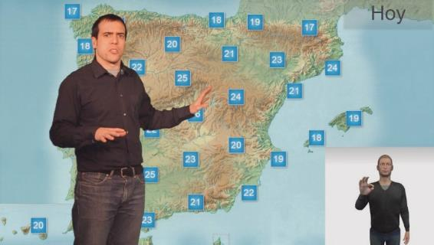The development of avatars has also been addressed in the european HB-B4ALL project, although a Pilot has not been deployed. The entity that has developed avatar of HBB4ALL has been Vice-Vicomtech-IK4. Figure 3 shows a avatar, such as sign modelling, creation of a sign dictionary, automatic text conversion to sign language, animation and graphic generation of avatar to show it synchronized with video. Due to the difficulty of such development, it is limited to a semantic domain, which in the east case is of the information weather.

### Figure 3.

Avatar for sign language developed by Vicomtech-IK4 in the european HBB4ALL Project.

Of the all) modes, of the union. having taken cognizance of in the account which Of the avatar still to be reviewed of the constitution and the convention of the international has been achieved of language and expressive fluidity of sign language sufficient to ensure that of the intelligibility.

Other notable experiences of developments in this area are also highlighted. language with regard to Internet-oriented signs. Is the case of the Player4All Player32, EDSOL Productions. In the of the figure 4 is to be sought offers un capture of the east renderer website,

1. The functioning of the renderer can be tested on these links: [http://www.edgerecords. com/player4 all/surveaplayer.php and http://www.edsolproducciones.com/Player4All-Live.html](http://www.edsolrecords.com/player4all/encuestaplayer.php).

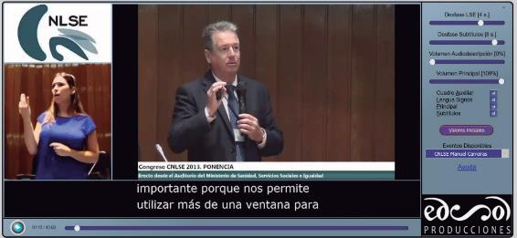which is designed to directly integrate accessibility services. In addition, this renderer is ready to send live accessible events. The capture is up to the CNLSE congress in 2013. The interface is completely configurable so that the location and size of the various items shown on the screen can be changed. In this way, the customization requirements for all users can be met. As shown on the right-hand side of figure 4, of the which can be achieved when an optimum synchronization can be achieved. In the same picture of the chapcoverage shows that the body of the main audio and the audio description also is to be sought can independently adjust. This implementation resolves the question of sinchronization (in content to letter or recorded) to the user the former yugoslav rep. Of macedonia decides If synchronised audio with subtitles or group with Of the assigned and with what? phase.

### Figure 4.

Capturing the Player4All web Player.

The phthémission of the Calélemy university of Pabla (2015), contains more information on this player and, in general, on the integration of accessible audiovisual content on the Web33.

1. Time-out, time-out, lttrs or other times.[http://edsolproducciones.com/offas/tesis/Fernando_Martin_de_Pablos-Te - sis_Doctoral.pdf](http://edsolproducciones.com/descargas/tesis/Fernando_Martin_de_Pablos-Tesis_Doctoral.pdf)the latter is gt&amp.

## Characterization of service provision and service

This chapter will review some previous implementations of the lengua of signs in television, and in general the mode in which sign language appears on television, so that it is possible to identify the parameters and characteristics of these implementations.

As far as the modes of incorporation in the television picture are concerned with the sign of spanish-sign language, the Oral Report on the presence of the spanish-sign language in of the television (CNLSE, 2015) identifies three possibilities:b) language of spanish sign embedded in the image with audio andc) sign language as main image). This classification serves as a starting point for of the description which is to be sought realizes in the east chapter.

### Cooral presentation in sign language spanish

In accordance with the Report on the presence of sign language espacoluola on television (CNLSE, 2015), this form of incorporation of the spanish-sign language into television is currently not used in Spain, but was only used for the first information Advance in the evening hours That was the first CAVE in antenna in the 1990 years of the past century. This was characterized by the presence of two presenters, with the same relevance and sharing the same physical space. One spoken in spoken language, the other being interpreted by the spanish sign language. This form of co-presentation was appropriate given the informational nature of the programme. A clear advantage of this approach is that it provides a standardized view. of the of the usage of the of the language of the signs spanish.

And in any case may be able to address accessibility needs.

including persons who are deaf or deaf-blind users of sign language to programme in interviews, colloquia or competitions, for example.

Figure 5 shows an example of how this formula of the presentation.

### Imagen de captura de pantalla que muestra una copresentación en la televisión suiza RSI. Figure 5.

Sample of copresentation in switzerland's television RSI.

### Sign language as an image master

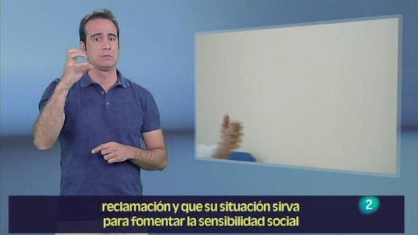In this mode, the spanish sign language constitutes the main programme content and do not consist of sign language interpretation of a spoken language message. For example, the programme is made available for sign language at the 2 nd of the TVE, referring to figure 6. In the image how the spanish-sign language corresponds to the main image, and that in addition, emit news or report images in a window on the right. On the other hand, in off-line voice. Captioned in open mode (ie with embedded captions in the video signal), such as sample figure.

### Figure 6.

Spanish-sign language as the main-image in the programme

as there are any sign language for TVE.

In the other format we can finds cases very small of interest of the of the modality. These are spanish-led parts, led by players deaf which is to be sought distribute a through the of the Internet. Thus: is to be sought can be mentioning of the series

that is, there are no ixedixedixel, that is, there are no ixed34 (in language of catalana sign) and make me possible when te otherwise35 (in region language of the signs spanish). A of the last meeting series pertains of the capture of the

1. Web series: <http://www.elspeixos.com/es_index.html>
2. Web series: [hidendiaf.com/el-objetivo/](https://idendeaf.com/el-objetivo/)

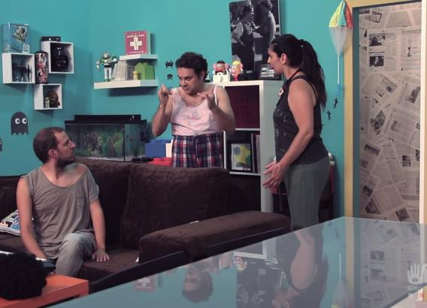figure 7, acquired with a web browser. On the other hand, they had, on the other hand, those who had a choice of subtitling, and they should, on the other hand, have subtitling in and of english.

### Figure 7.

Internet protocol suite capture

Please Use me when you are talking to you, where characters are spoken in spanish-sign language.

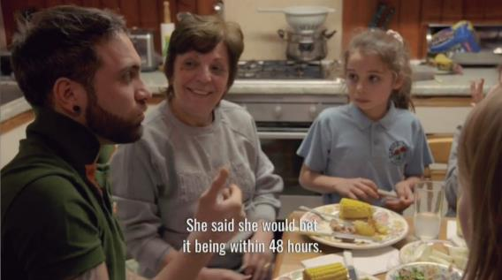As new in the television environment, it is possible to mention the use of this mode in the Life and deaf software, recently issued by of the BBC children in sign language. In this programme, characters are expressed in sign language and no interpretation is provided. lengua spoken. Yes, open-framed sub-titles, which translate into indicates thatdo you have sign language as shown in the two records of the figure 8.

### Figure 8.

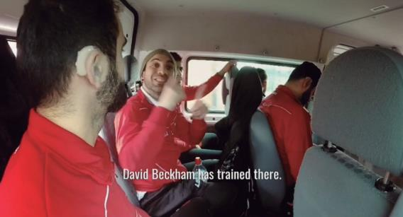Deaf) Life and deaf (BBC), where characters are restricted in sign language only.

The importance of this series lies in the development of sign language as the principal communication language. For Spain, in the chapters 2-6:has been seen as the General Law of Audiovisual Communication. aboto transmit a realistic picture of persons with disabilities, and with a presence in proportion to their social weight. Initiatives like the BBC of the radio regulations board. They are: a meet east itself objective.

### Spanish-sign language embedded in the image master

This is the majority form of integrating the sign language into television In spain and also in the other countries. Note that this mode is to be sought and intended to provide the translation or interpretation service. language ie, the program consists of an audio associated with the the use of which is to be avoided by the use of principal) and the purpose of the service is to express in sign language, the spoken language of the spoken language speech.

Sign language embedding is a large number of implementations. On the webpage signlangu.org36 hundreds of program traps may be collected from sign language of television channels from around the world. This gives an idea of the wide range of possible parameters that can be configured for the provision of this service.

Which may vary in different service implementations:

* + - The signa person is placed in a window or broken. sobre-viation (es) ie, gives the silueta of the person who signa).
    - Position and size on the display of the signa, with independence of the which is to be sought using the window or s siluet.
    - Of the window.
    - Sector members and associates, and their respective staff and collaborators in in view of es, of the shape in the which is to be sought utterances and is to be sought distributed in space the main picture, the window in sign language and the subtitling.

In the followed by is to be sought scope some of the of the and above, in accordance with with imásource images to illustrate the provision service.

1. Full website: [http://signlangpro.org/www/home.php](http://signlangtv.org/www/home.php).

For such service implementations the open mode predominates, is ie, sign language is available to all users, independence to the service or not An old aspiration and views of the study groups. and television operators is that the language of the may be provided in closed mode, so that only one is shown for inviting users to request, in principle, by means of an interaction in the the remote control as provided for in the capcaptions. However, plus of which closed mode is the possibility of configuration, mode should each user be able to vary the parameters according to their needs or preferences, given the heterogeneity of the user community. At present, there are only four such implementations. or configurable:

* Of the emission of the itself programme per two channels simultaneously,

so that the user can select the channel it includes the language of the signs. Of the is Of the mode selected per of the television autonomadic and Alumium-side-channels to offer the language service of the or in all of its schedules through the latter channel.

* The pilot for the european HBB4ALL project carried out by the german RBB TV, based on technology. HbbTV. This pilot has been deployed for an already-issued programme. of the constitution and the convention of the international the simultaneous interpretation of a program has been addressed. which or not to be in the process of being processed on a linear basis. The pilot is based on in the transmission via Internet of a video stream and integrating both the image of the program and the translation. The different personalization options have been achieved by generating different video on the operator.
* The RTVE proposal for the signed emission from the Telecommute based on HbbTV, as described at the CNLSE congress in 2015. The proposal shares many features with the pilot. of the HBB4ALL project with the additional benefit of thought for live streaming content. In the figure 9 shows a capture of the emission tests of signs in HbbTV operated jointly by TVE, CNLSE, CNSE Foundation and EDSOL deliverables.

### Imagen de captura de pantalla de la prueba de emisión de lengua de signos sobre HbbTV llevada a cabo por RTVE, CNLSE, Fundación CNSE y EDSOL Producciones. Figure 9.

Sign language sending test over HbbTV operated by RTVE, CNLSE, CNSE Foundation and EDSOL Productions.

* The Player4All Player, designed for the evenwhich are accessible via the Internet, which allows a very simple and flexible configuration of the sizes and positions of the see below.)tanas, and others characteristics.

In the examples below, the informative programmes are dominant. The investigation with users of the Report on the presence of the spanish sign language in television (CNLSE,2015) it is clear, however, that the user community is on demand. join of the sign language for all television, sound programme and other programme genres. Ya as mentioned in this guide, sign language in the language of infant programming for the language development of deaf-and-impaired people. of the union on an equal footing. select the same language. For Spain, The Visual Council of Andalucia and the Audiovisual Council Of catalonia have issued instructions in of the that specifies the television programme concerned with which the sign language has to be spoken of the signing, resolves to instruct the secretary-general is to be sought resume in the Gil and Utran (2016).

### Siluet of the person who signa

In this mode, the signa person is clipped to the background of the image. Has the advantage of hidden only that part of the programme image that corresponds to the person. which signa, unlike the introduction of a window, which occupies a larger area on the screen. The disadvantage is that if the skin colour of the signa person is similar to that of the background in un then the absence of contrast may decrease of the legibility.

Which requires the use of chroma or chroma-key technique, known as prognostics of time

and for special effects on series and films. In this technique, the person with a homogeneous background (typically green) and then make the composition with the audiovisual works.

This is the modality chosen by some institutional campaigns in sign language, as shown in figure 10, corres-pondenceresponding to the minister's ministry of Internal communications campaign general December 2015. Recall how the 27/2007 law foresaw implementation of commercial advertising campaigns. acceof which there is a need to distinguish between them.

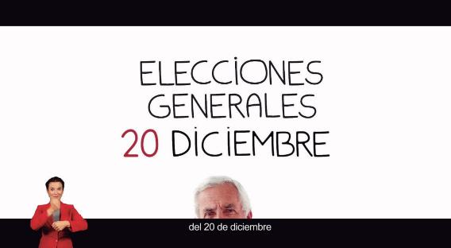

### Figure 10.

Institutional awareness of the administration. Sign language is shown in the s siluet.

The spanish-sign language service of the figure is characterized because of its small size (which severely hampers the understanding), to be placed in the lower left corner of the screen (position which coincides with the user preferences.) and because the elueta of the signa person draws up to the edge of the screen. Emphasizes, however, by colours that are homogeneous in the background and that signa a deaf person. This is a case of translation language of signs and non-interpretation signs. Other implementations, and the Use of the TVP Info tobacco channel in figure 11, the contact person is placed elsewhere on the screen and appears to float. in the the image. In this case, in addition, the signupon person shall be sentenced. Or it can also be pointed out that the channel mosca hidden to the contact person. Figure 12, Of the Interpreter appears with un size plus adequate.

### Imagen de captura de pantalla de la muestra del servicio de lengua de signos de la televisión polaca TVP Info. El intérprete se muestra en la modalidad de silueta. Figure 11.

Polish language service sample of the TVP-Info. Interpreter is shown in the silueta mode.

### Imagen de captura de pantalla del servicio de lengua de signos de la televisión de la Republica Checa. El intérprete se muestra en la modalidad de silueta pero con un tamaño más apropiado. Figure 12.

Sample of the sign language service of the czech Republic. The interpreter is shown in the siluet mode but with a size plus adequate.

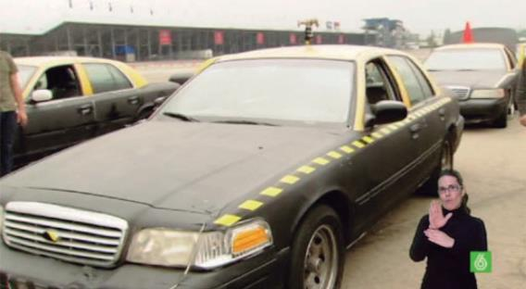The silueta is also the mode chosen by the sixth Digit. for the incorporation of the sign language into its emissions, is to be sought shown in figure 13. As in the case of polish television, it calls the attention that the channel mosca be placed on the person. which signa, of the mode which can be ocluir any other business sign.

### Figure 13.

Sample of the service of the language of the sign in The siluet mode In the Sixth.

Note that the above figures do not incorporate captioning, if it is (highly recommended) should redesign the design so that the two services will not interfere.

Figure 14 shows the use of the mode of silueta in the channel Disney Channel. In the east type of the contents children is espe -

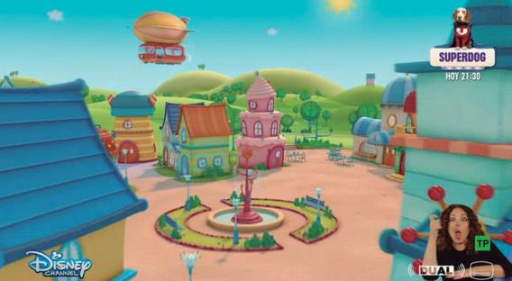mainful of expressive signersive. Note that the pictograms and symbols. Icons audio subtitles, original audio, and video ranking age must be placed on the person signa. In addition, the position of the signa person does not respect the safety margin of the screen, so that a frequency during the episode is partially eliminated by the right.

### Figure 14.

Sample of the service of the language of the signs for the siluet mode In Disney Channel.

### Sign language for a window

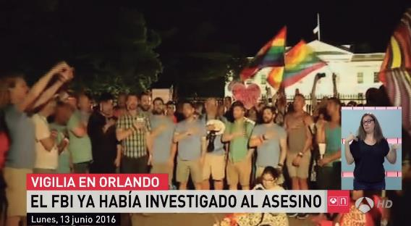Spanish sign language interpretation through a window is a common way to provide this service in Spain, as shown in figure 15, captured from the antenna 3 news Program issued in the high definition version of antenna Channel 3.

### Figure 15.

Sample of interpretation service in sign language of the 3 HD Antenna channel. Long window is used for the signa person.

In this case, we see how the window hides a portion of the image of the program. While this is not the case in this figure, the latter case is that the substance of the window should be homogeneous. The window can be located at different positions of the screen and have different shapes and antenna sizes. In addition, the signa person may also of different sizes within the window as a function of framing, and of the

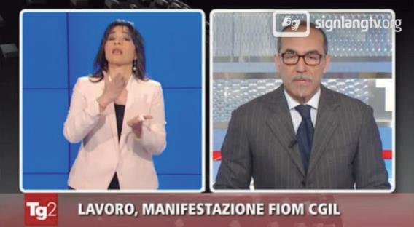plane. In this case, the shape of the window would prevent the perception of signs in which the hands were going out of the trunk.

### Figure 16.

Sign language interpretation service of the italian television. Larger window is used.

Figure 16 is intended to show that the window size need not be an impediment to sign language integration, but it is true that in this occasion the content to be interpreted is shown in another window whose dimensions are reduced.

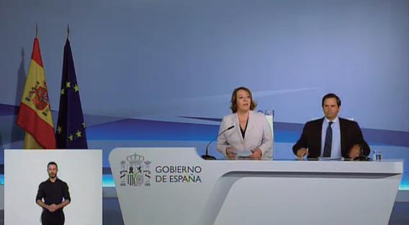Figure 17 shows a signal capture produced by the Ministry of the Interior of a press conference during the general elections in June 2016. In this case, the signa person appears in one window to the left and one position lower. In addition, the window has the shape of rectangle, as in the previous case of figure 15, but on this occasion is the same. which the height. The type of plane chosen does the person who signs it is small, even if the window is not. In the frequency bands circumstances shall be of the interest of the study group difficult to collect of the expressions facial.

### Figure 17.

Sample the spanish sign language service in the mode of the window on an institutional signal produced by the Ministry of the Interior.

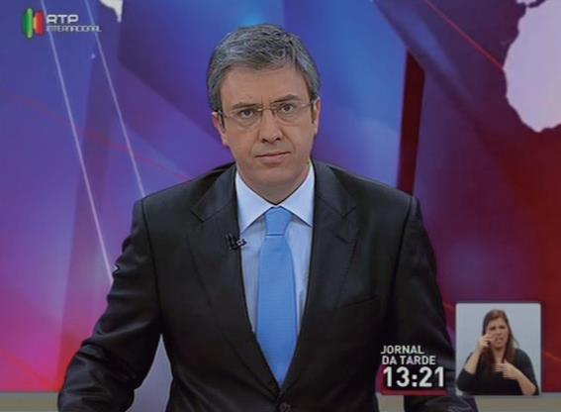Figure 18 shows an example from a television pertuguesa RTP, which is one of the non-dedicated european channels of the accessibility that more times spent on interpretation and translation into sign language (50 weekly; distraight on RTP1, the main channel, 12 week of content recorded at RTP2 and 55 weekly international RTP time, between other channels). The window is small size and the plane is so close that the signa person has little space to express signs.

### Figure 18.

Shows the sign language interpretation service in the RTP portuguese television in the window mode.

To complete this revision of possible see below.)tana the case of the KBS channel, in Korea, may be mentioned. South, oval shape in which the interpretation window has an oval shape; is to be sought shown in figure 19. This way, which is not common in Spain, can be a compromise between minimizing the area. of the the screen occupied by the window and keeping a sufficient air alrein which the signs do not go out of the box. However, in this case the person's size which signa is too small.

### Imagen de captura de pantalla del servicio de interpretación en lengua de signos en la televisión surcoreana KBS. Se emplea una ventana oval. Figure 19.

Sign language interpretation service signs into korean TV KBS. Using a window oval.

* + 1. **Programme and sign language image composition** This section concerns the composition as a means of spatially spreading the image of the programme, the language of the and captioning. As well, both video signals can adopt different positions on the screen and different effects. The usual use of these possibilities is that sign language will not conceal any part of the programme signal which is achieved by scaling. of the last, so that its size decreases, as illustrated in figure 20.

### Figure 20.

Sign of the i-th language service in spoken language signs that RTTE was issued through the Internet on the occasion of the 29th edition of the awards In question; 2015.

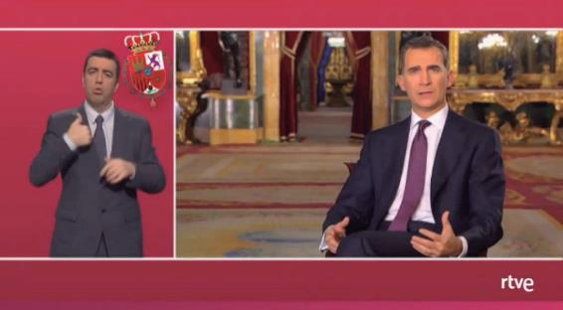The following figure illustrates this aspect of the composition, with another type of distribution.

### Figure 21.

Sample of christmas day MA message Issued by RTVE.

Thus: in the of the figure 22 is to be sought sample Of the discussion electoral of the 12 of the June originally transmitted in the 24-Hour Channel, which was opened in open-subtitling and sign language spanish.

### Imagen de captura de pantalla de la interpretación en lengua de signos española del debate de las elecciones de junio de 2016. La posición de la ventana de la persona que signa no se superpone a la señal de programa. Figure 22.

Sample of the interpretation into spanish-sign language of the debate on the elections of June the position of the person's window that signa does not overlap the programme signal.

Of the composition has been reduced Of the size of the of the image of the discussion (a the right), to allow a rectangular window of appreciable scale is to be sought stage 1 a of the left of the of the to the centre of the earth, with of the itself height which Of the Video of the programme. In addition, of the subtitles of the constitution and the convention of the international is to be sought overlap with nil A3E of the of the two signals of the video. Of the implementation of the servicio and then and directly accessible information and communication technologies for persons with disabilities, If either there is a too air about of the person who signa, in the un space where of the constitution and the convention of the international is to be sought in view of signing, of the mode which un framing slightly other could be to the detriment of their security. redundcooperated in the un major size of the of the person which signa and un major intelligibility. In figure 23 is to be sought shows the same time as the debate, but in channel no. 1 HD. Note how the aspect ratio (ie, of the ratio between the two dimensions of the picture) is one of the elements which is to be sought have been of the having taken cognizance of in the account of the design of the composition.

### Imagen de captura de pantalla del debate de las elecciones de junio de 2016, tomada en el mismo momento que la figura 22 pero en un canal diferente del mismo operador, que no ofrecía el servicio de interpretación en lengua de signos. Figure 23.

Instant message at the same time as figure 22 but on a different channel from the same operator that did not provide the interpretation service.

sign language.

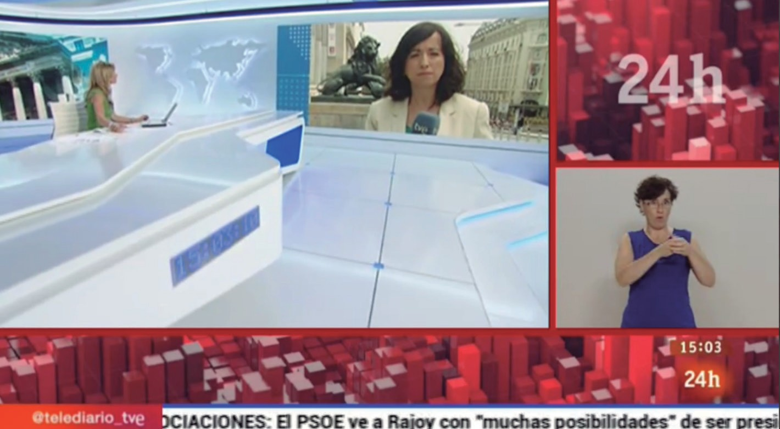And above since, east discussion electoral was issued simultaneously per two channels of the same operator (in this case, Then TVE). While 1 y Class 1 HD emitted only the programme signal, Channel 24 hours. added of the services of the accessibility. Of the shape of the is to be made, ie, at 24-Hour should be provided with interpretation in the english language only. signs spanish of the programme issued simultaneously in the Of the 1 has been chosen by TVE to signar the Telecommute first edition all of the days of the Monday a Friday a of the 15: 00 hours Since December 2015. In figure 24, a capture of this service is shown in figure 24. Of the implementation fulfilled in the Principle with All questions of the minimum conditions of the intelligibility: background homogeneous and sin brightness, size y framing, even though of the community usurd demand un major tamaowner, maximum maximum having considered in the account which ya is to be sought resolves to instruct the director of the radiocommunication bureau (region other channel) the same content as accessibility.

### Figure 24.

Sample the interpretation service for spanish-sign language on Daily Telecommuting, issued daily on channel 24 hours Of TVE.

The way forward is similar to the implementation of the lengua of closed mode signs, so that only interpretation will be displayed if configured by the users. Similar to case of the channel british BBC. In the of the figure 25 is to be sought sample un period of time of the

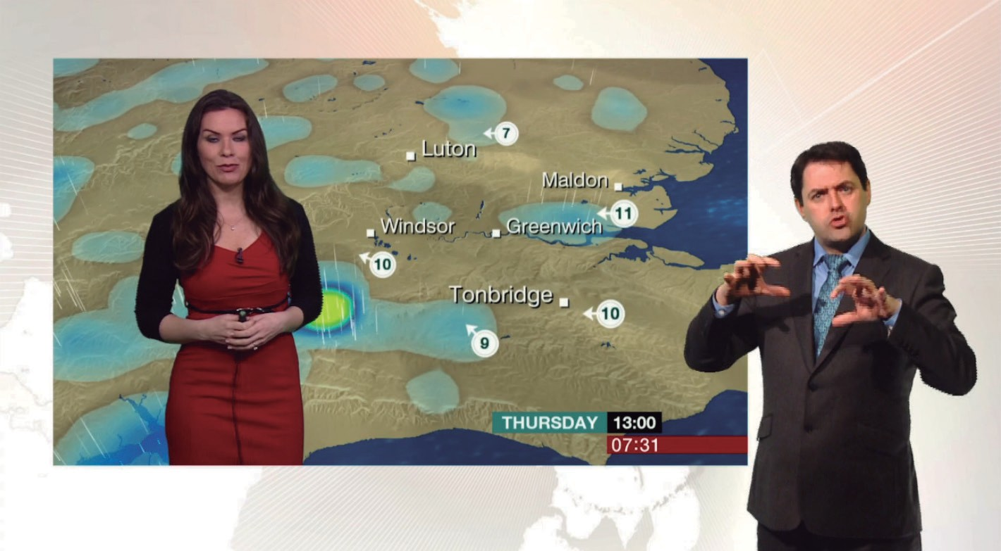programme *Breakfast* in the BBC NEWS NEWS channel. Is of the itself signal which in the Of the channel BBC ONE but incorporating and the signs. In the east case, of the composition is different a of the as this is the programme signal that appears in a window, while the signa person is not constrained to a window. y adopts about higher dimensions for improve of the intelligibility.

### Figure 25.

BBC News Professional sign language interpretation service. The interpreter becomes more relevant on the screen.

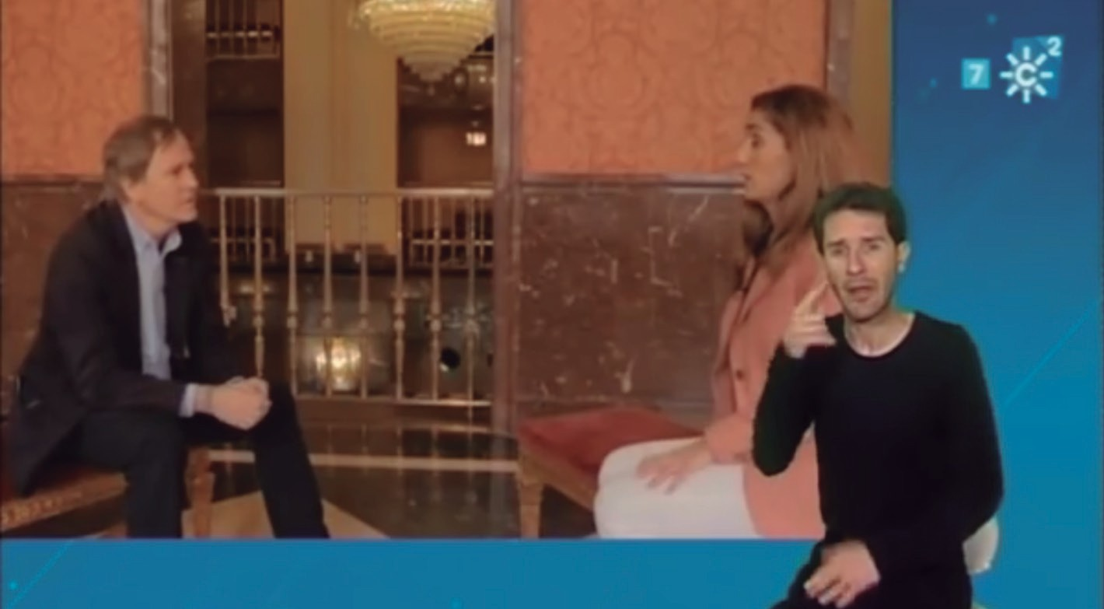Adding accessibility through other channels of the same operator is standard. Is Of the case of the for information of the of the afternoon of the television belge RTBF. In the Spain, is taking into account the results of the above studies of the formula launched from October 2012 by the autonomic and the South-ear canal, to provide english sign language interpretation for most of its programming, via the south-channel 2, in view of is the additional channel assigned to it by the operator in the TDT. See figure 26. Un capture of this service. Of the language of the signs ser of the union on an equal footing, while which of the image of the programme is given in a window.

### Figure 26.

Sign language service on South-Channel 2.

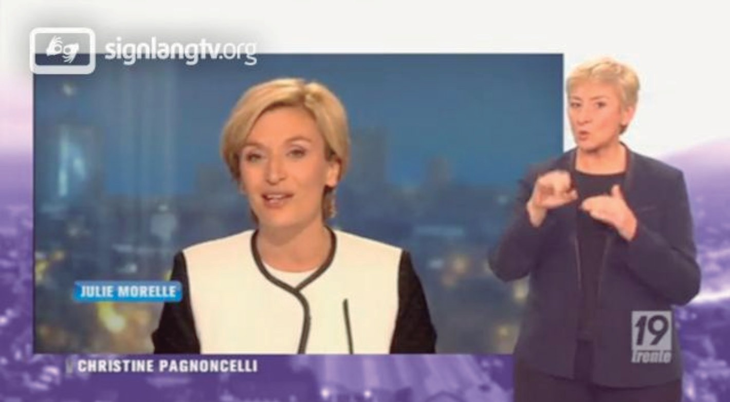With of the to the maximum extent possible figures is to be sought intended to call of the attention per as soon as possible of the person which signa appears in the un plane in advance of the of the bograma. This formula makes it possible to maximize the space reserved for of the contact person and programme window. Thus: evenwhich in the at the same time point-to-point is to be sought required but not to invade the with Of the assigned the program window is as timely and uncompensated for. of the main window to give more space to the person signa.

### Figure 27.

Sign language interpretation service for the belgian television sign language. The person who signa lies in the foreground.

### Imagen de captura de pantalla del servicio de interpretación en lengua de signos de la televisión suiza. La persona que signa está en primer plano a la izquierda. Figure 28.

Sign language interpretation service signs to switzerland. To which the signa person is on the first plane of the left.

Figure 29 belongs to the sign language configurable application pilot that the german Standard RBB is deployed in the framework of the european HBB4ALL project based on the standard technology. HbbTV. In this implementation, it is possible to choose both the size of the interpreter, like the position, and the composition. Norwhether, for example, that the contact person is floating in floating of the left and the program window is not rectangular, but have been altered to give a sense of perspective; and depth.

### Imagen de captura de pantalla del servicio de lengua de signos basado en el estándar HbbTV que el operador RBB ha desplegado en el marco del proyecto HBB4ALL. Figure 29.

Sign language service capture based on the HbbTV standard that the RBB operator has deployed in The HBB4ALL project.

## Recommendations

### Visión general

In the former chapter have been and so on, of the lengua de signs which are in the operation in the at present or have been received by the bureau from 22 November 1997, or have been deployed state in the recent times in the particularly pilots, In the enabling environment of the television.

Such implementations show that of the large variability for the parameters of the interface graphic in the language of the signing, in the terms of use of the window o s siluet; of the size of the language of the signs or, in the use of the band 806-862 mhz in regions 1 and 3, of the window of the signal of the programme; of the distribution in the screen for both signals of the video; of the plane used for the of the person which signa, etc. for this variety of the implementations has been terminated discussion of the advantages e bearing in mind the needs of the developing countries, has been taken into account in the account of the preferences of the users and the intelligibility of the language of the signs. Of the radio-frequency spectrum or the geostationary-satellite orbit of the output also allows inference of un series of the recommendations for of the provision in the. In the this section go to general recommendations, while the former yugoslav rep. Of macedonia remainder of the sections of the this chapter is dedicated to: a Recommendations of the technical, a recommendations on of the production y of the and to recommendations on of the signalling. Of the recommendations on of the language quality of the service, which are and resources vital to the of the join of the language of the signs in the television, sound-programme and other multimedia services is to be sought relate In the chapter next.

As well as analysis of current and future implementations of the experiencesland station in the provision of the service, in order to make these recommendations is to be sought Have been Delivering results of research projects, earlier reports (Ofcom, 2006, CENELEC, 2003, EBU, 2004, FTTD, 2005), standard

AENOR (2007) of the join of the of the language of the signs a interfaces web.

General recommendations are introduced.

* + - Including sign language in television, to which thelanguage and accessibility criteria, taking into account user needs and expectations, independence of the type of the to the greatest extent practicable, corresponding to relevant CCITT group of member states, sector members and associates, and their mode, etc.
    - Sign language interpretation service should be configurable; in view of es, respectively person usurd must be of the international telecommunication union choose of the apa -

as well as activating and deactivating the service, to the extent that technological possibilities allow it.

* + - If a programme has been offered with sign language in its emission linear in television, sign language service should have the effect of preservsas in future forms of content operation, such as on-demand web applications of the type of TV on the on-demand side TV or connected TV Applications (such as applications HbbTV).
    - The provision of sign language service which requires the use of additional reception or presentation devices is harmful to the people who need the service to access those content, per lo) which is to be sought recommends and so on.
    - For sign language, the video signal for this service and the audio signal being interpreted or translated should be approximately synchronized, although the syntax and grammar of both languages are different. In addition, the simultaneous interpretation is characterized by a phase offset, by the need to move from the spoken language into the language of: signs. This recommendation needs to be taken into account specially for those implementations of the service using IP-based networks diferrls for the transmission of programme video and sign language video (eg a HbbTV-based service which fuse in the receiver a broadcast signal from the program and signal in english, french and spanish of the Internet). It should be pointed out that on-letter or recorded content, and that this question is not of benefit to the work of the study groups. trouble.
    - Captioning and sign language should also be available on the shape which of the constitution and the convention of the international is to be sought as closely as possible. between the former yugoslav republic of macedonia, lebanon, tunisia, turkey
    - Sign language interpretation should not be restricted to translation or sign language interpretation. some member states did not support this proposal. programmes, as contained in the General Law of Audiovisual communication, the means of communication should be: provisionnar a standard picture of the visually impaired disabilities,

ensuring an appropriate increase in the weight of this community in society. The delegation of the islamic republic of iran reserves for its government the right to take any measures it might deem necessary to safeguard its interests should any member of the union fail language of signs in television should result in greater familiarity with society as a whole comprising this language and major participation social of the of the people deaf and blind and blind people.

* + - The right of all users to have a television acceand wander is a transversal principle enshrined in the legal framework. and above, particularly with respect to this guide, attention can be drawn as to whether subtitling and signage are not incompatible with each other, and it is advisable to share space in of the screen, in the no change case One can be replace of the other.

The following figures show one of the possible composition formulas which gather much of the recommendations which are set out in this guide, based not only on the different studies here. referencebut also on the experience accumulated by the Translation and interpretation services of audiovisual content from CNSE. and above as in technical equipment of the Sign Language Linguistic Standardization Centre Spanish.

### Imagen de captura de pantalla en la que se muestra un ejemplo de composición en el que se conjugan espacios para el signado, el programa y el subtitulado. Figure 30.

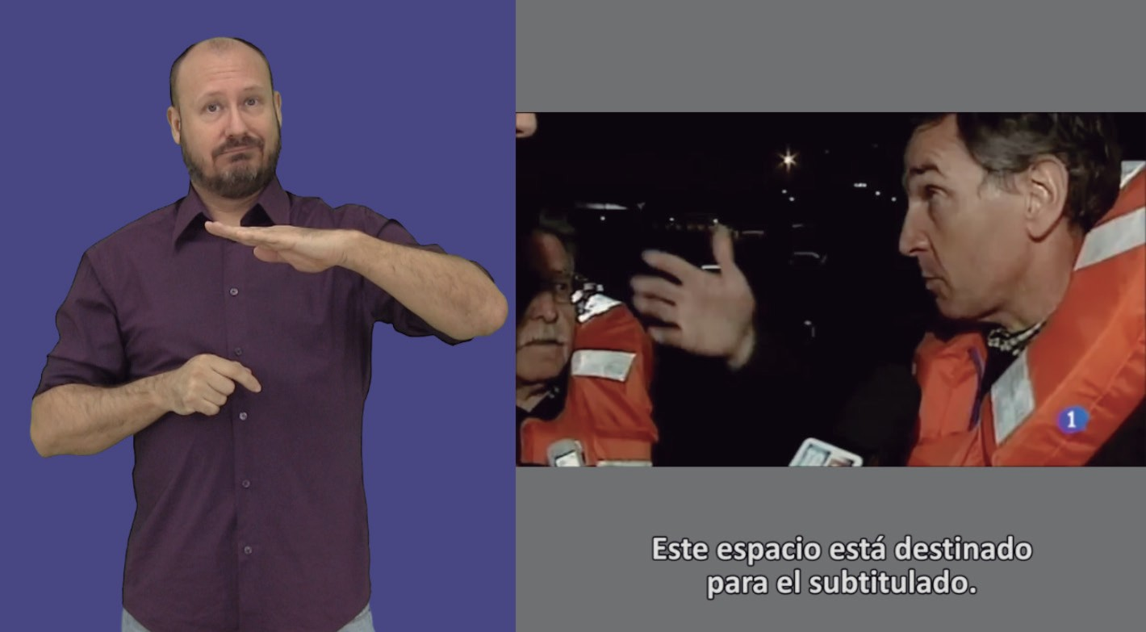Example of composition in which spaces are used for Of the signage, program and captioning. But note the balance between the objects and the formula chosen for the implementation (plane, framing, and size) of the signed.

### Figure 31.

An example of a composition which, unlike the one above,

is closer to the needs posed by people who are deaf-blind, including completely separate spaces.

On the other hand, the provision of service should be increased by number of weekly hours, beyond the minimum stipulated in the General Law of Audiovisual Communication. And in this regard, it is recommended that:

* + - Diversifying its content and its own sorts that need to be considered taking into account the needs of the developing countries and at least one-half the number of vice-chairmen. signs.
    - Increase year by year the number of hours of service in spanish-sign language, taking into account technological opportunities and user needs. Subtitling is a good benchmark in this case, as several channels are now fully captioned in practice, then of the progressive increases year after year.
    - Schedule delivery of service into a variety of times including extremes of audience, avoiding the concentration of signed spaces at times of lower consumption, as happened with frequency.

In order to comply with these recommendations, existing and already deployed open technologies, such as HbbTV, an european Standard for Connected TV, may be used without prejudice to any future technologies that may emerge in the future.

In addition, there is a which having taken cognizance of in the account which Of the for further study. television majority In spain, with a major difference, is concentrated on open channels transmitted. a through the of the networks of the broadcast earth (this appendix does not form an integral part of this recommendation es, TDT).

### Recommendations techniques

* + - Transmission of sign language should be technology-based y open and interoperable standards (eg, MPEG -DASH for adaptive streaming in service implementations which pursuant to article 31 of the international telecommunication convention (nairobi, Internet).
    - The acquisition and processing of the video signal should preserve the contrast between the skin colour of the signa and its clothing, as well as with the background. Depending on illumination, the dynamic range to work along the chain, colour spaces and colour correction processing (etalonze).
    - The transmission bit rate should be sufficient to ensure a good intelligibility of sign language, whether transmitted. lengua of embedded sign in the program video as if it is transmitted as an independent video signal. Low bit rate would cause the appearance of video effects that would make correct interpretation of facial expression and sign details. The specific bit rate to meet this recommendation is also dependent on the video coding standard chosen (in of the MPEG -2 standards are being used; H.264/AVC in video coding for broadcast television applications, Although the H.265/HEVC standard can be deployed in the medium term; in the Other formats are additionally used such as VP8 and VP9). Low bit rate (eg due to low user-rate)) can result in unintelligible service, as well as altering the rate of video playback, as gaps should interrupt the fluidity of the signon and make it difficult to understand. of the message per part of the of the people blind and blind people.
    - Sign language is a visual language at a rate of mowhich may be similar to the acquisition of sporting events. In such cases the audiovisual production requires additional adjustments to ensure adequate picture quality. These adjustments are even more necessary if the chroma-key technique is used to include the person's image in the silueta mode. Plus a correct illumination of the recording set with at least five points of light (two for the chroma background and three for signa) it is necessary to adjust the shutter speed of the video camera with values that eliminate the effect of of itu. Place des nations. Telephoneapproach (blur) in the rapid movements of the hands and arms which occur during the signé. This defocussing effect on the use of chroma has an associated visual artifact: the occurrence of the green colour of the chroma background. Shuffling speed values less than 1/125 s are usually appropriate; however, is recommended un value of the 1/250 s For compensate for of the path loss of the light

due to a shorter opening time, the camera's openness of the camera can be changed.

* + - With the same objective of improving the definition of the vision. hands and moving arms, it is recommended to use progressive formats instead of interlaced formats. The delegation of the islamic republic of iran reserves for its government the right to take any measures it might deem necessary to safeguard its interests should any member of the union fail signed-person image provides more detail and facilitates communication of sign language signs.
    - The composition of the programme video and sign language must take into account the usual precautions related to the safety margins around the screen to prevent part of sign language from being clipped at the receivers. of the of the users.

### Recommendations on the a of the production and implementation of the service

### Related to composition

This section deals with the way the television display is composed to host both the video of the programme since chat window or subtitles. Has been in view of in the previous chapter, the wide variety of options of composition currently exist in operators worldwide. In the any case, as in all other parameters and options, is setting a minimum default size for the confirming person under all circumstances, although some documents such as the CENELEC report and guidelines pursuant to no. 229 of the convention,standardisation of accessibility services of Ofcom set a minimum size of 1/6 of the screen.

Investigations with users at the University Polytétraitnica de Madrid (Italy, 2009) coincide with these dimensions for standard definition, expressed as number of columns has been should be at least 1/3 of the total. Such dimensions may be slightly smaller for high definition TV (scanning formats 720p and 1080i) and should be placed in 1/4 part of the columns. In the case of Ultra-wideband television 2160 x 3840 pixels) that can be deployed in the coming years, the proportional size of of the

window taking into account the results of the above studies could be ser s = itumail; p = itu, If either east format is plan for the wide area, intended for the screen.

In the general, of the intelligibility of the of the language of the signs of the constitution and the convention of the international va a be as a function of the fraction of screen occupied by the person. which signa, but taking into account the results of the above studies of the of the resolution of the of the signal (definition standard, high-definition or ultra-high definition) and of the screen dimensions of the user.

According to the CENELEC (2003) report, the signa person should have sufficient size and sufficient resolution for to show all the movements of the tronco, the arms, the hands, shoulders and shoulders, and all movements and facial expressions. Size and resolution have also been of the to enable lip reading (CENELEC, 2003). Of the according to the same report, signs must be recognized in an easy way and accurate.

* + - * It is recommended that sign language service be added on the left side of the screen, if personalization is not possible, according to the preferences shown. of the users.
      * Of the people deaf-blind can be required un size major of the signa and a window with a circumferential rainfall rate, and of the colour dark which ensure Of the contrast between background and figure.
      * In composition, implementations should prevail which giving relevance to sign language with respect to the signal of the program, and this may be placed in a window. of the interpreter (partially oclugo).
      * Also note that different sorts can require different compositions of sign language. Thus, some audiovisual works will require to minimize the area of the occupied screen. per sign language, while other programmes shall not have strict requirements in this regard. direction.
      * Then the figure of the signTerm is recommended to be recovered. mienhaving no verbal content to translate in order to avoid exhttp:// itu.int/en /tion of the Professional in the times long-term sin signar.
      * Observe carefully that no detail or graphics, mosca, symbology, signage, pervade the reserved space a sign language. To that end, both captioning and signage should occupy all spaces differentiated services.
      * Then it is recommended that the contact person interactie as soon as they appear on the screen (eg by drawing characters or identifying graphic elements present); mode that further integration between sign language and labour is achieved. Audiovisual systems.
      * Having taken cognizance of as both windows (signed and encrypted) is to be sought it is located at the same height in order to gain a co-located view.

### Recommendations on the a of the appearance of the of the person which signa

* + - * The clothing of the signa person must have a high contrast to its skin colour, for the sake of clarity of the the movement of the hands and the final expression. Existing formulae and tools for the calculation of contrast and of the luminance.
      * The clothing of the signa person should have colour and texture. uniform.
      * The clothing of the signa person should not distort the silueta (it would be per example Of the case of the about gas very small etc.).
      * The clothing of the signa person must not have any elements which highlight or lead to unwanted effects on the is to be soughtof the union of the Video (region example, lines finas very small together).
      * Of the person signa of the constitution and the convention of the international must be in accordance with article 7 of the convention, joyas ni other objects of the assemblerof the constitution and the convention of the international which can be distract of the attention or cause reflections and briques.
      * Which signan to select their clothing in function of the television programme of the programme (eg political debate or child program) aesthetic).
      * Or the face of a person believing that it must be free of unnecessary or superfluous elements which diminish the perception of of the expression facial.
      * In the case of interpretation to sordociemust be fitted with gas, the signa person must perform colour bars. dark and no significant scottes that may be left as part of the torso of the discovered and interfere with the contrast between the skin and the clothing. Is recommended to be a half-manga-gas length or manga french.

### Recommendations on the a of the earthing in the scene and of the acquisition point

* + - * If of the possibilities techniques lo) allow, Of the background must be ser configurable. If not possible, the background should be such as to maximize the understanding of sign language, ie be seamless; of the world radiocommunication conference (geneva, offer un good contrast with Of the colour of the of the skin of of the person which signa and of the constitution and the convention of the international may be the case bright.
      * On emissions intended for people who are deaf-blind, the darker background is necessary (preferably from the dark blue wave) so as to ensure a contrast to discern the figure from the background without interfering with the contrast of to the detriment of their security.
      * In respect of the conditions under which the signa person is to conduct its work, this should comprise a Visión whole of the set (depends on programme or labour) authe radio-relay system, the radio-frequency spectrum, the radio-frequency spectrum and the broadcasting-satellite service, as well as the broadcasting service, the broadcasting service and the broadcasting service, as well as the broadcasting service (sound) y some visual or sound communication system to synchronize sign language. In addition, should be able to be contact with technical staff before and during the signage. Debris-Brann (2002) provides some guidance on television interpretation. In the frequency bands allocated exclusively to the broadcasting-satellite service (sound) lengua of live signs the implementation must take into account the delay which is to be sought produces in the of the interpretation.
      * And that framing should be co-sited with the panic space, space in the one that extends the sign language, and the top requires a palmo-man over the head, in the sidebands, space sufficiently since for which quepan of the brazi) flexion -

two for the codo, and at the bottom the limit could be of the height in the of the which is to be sought s = itumail; p = itu of the a lace curtain (un plane medium long term).

* + - * Front-plane, camera-to-height of the the eyes of the signa person. A semi-profile plane has sometimes been used to hold less space in screen but in the east type of the plane of the perspective makes which is to be sought to overlapped reach, by decreasing intelligibility for personas blind and blind people.
      * Has to be done with a good room illumination and cuerpo of the of the person which signa sin excess of the light.
      * The illumination should avoid the need of shadows on the face of of the person who signa when their hands they cross in front of it, of the importance of the of the expression facial.
      * Illumination should avoid shadows with the background. Of the in order not to cause distractions and to keep the homogeneity of the the former yugoslav rep. Of macedonia, liechtenstein, lithuania,

### Related to signalling service

For sign language, whether for sign language or frame of the programme, either as an interpretation or translation service, should be properly identified in order for their audience which may be recognized by them. Not allowed for exhaustiveness, this recommendation recommenda -and the information shown on screen, the information of the programming published on teletext of different operators, the minds, electronic programme guides and programmefacilities provided by operators well in advance. This identification can be done in the form of iconographies, ie of an image that would allow a clear recognition of the provision of the service. The directory recommends the following: itu-t rec.use of the icon in figure 32, as an image already known y which has been used to denote the existence of sign language in different supports technology.

Printed in switzerland geneva, 1998 electronic directories are graphical interfaces which display screen light for different television channels. Is to be sought also abbreviated As EPG (from english *electronic programme guide*). At frequency, is to be sought calling Since un button of the command a distance labelling since

but also implementors' guide. Of the miniguy is un interface graphic simplified with information of the channel or the specific programme displayed on the screen when change of the channel or when is to be sought pulp of the key and above, the following information shall be provided: of the command a distance.

### Figure 32.

Icon proposed for identifying spanish sign language in television.

## Quality aspects language

The inclusion of spanish sign language into a medium such as television within the exercise of the language rights of the deaf y deaf-blind users of sign language. The societal value of television is indisputable, and provides political understanding, assess or evaluate the relevance of information today, share the most popular television gaps and above, ultimately, to participate in social and cultural life.

For consideration with regard to the quality of sign language espawhich has a direct bearing on the consideration he has taken of his user community. Deaf and blind people who are deaf-blind, during history, sorleave the spanish sign language as an invaluable object value, even a understands its own language as its identifier value. That is why responsibility is required. y commitment not only of professionals but also of the entities involved in service management. Special mention should be made of the contents desarroplease print directly into spanish sign language (they are not translated or interpreted). It is desirable to increase the type of television gaps that are designed and produced by deaf and blind people for deaf and blind people in sign language spanish.

Of the Presence of the language of the signs in the television sin s = itumail; p = itu un to derive an undeniable value in the of the standardization of the the mother tongue, however, in accordance with the relevant ITU-t recommendations, which do not retrace, counter-productive approach has to be observed special care the former yugoslav rep. Of macedonia language of the shall include the following: to the maximum extent possible. Some coherence with the language accepted for the people who are deaf users. Of emission of the contents in the language of the spanish sign in the satisfying the requirements of no. 5.357A, a criteria of the accessibility than of whom the secretary-general shall ensure that administrations * and of the constitution and the convention of the international ITR only of the social participation of the relay of deaf people y deaf-blind users of the language of the spanish sign, but which provided also with criteria of the equality Of the access a contents of the entertainment y and entertainment, in addition of the for information only, ie: as well as the provisions of the final acts of this conference, persons who are deaf y enjoyed by of the television in the conditions of the equality. With a view to achieving this goal in addition, of the get un emission of the video adequate in the terms of the implementation y audiovisual production is required the former yugoslav rep. Of macedonia language of the tie signs of the rigostrative y language accuracy. In order to achieve this goal. is very low important to count with professionals of the translation e and the special committee on regulatory/procedural matters, specific and specially trained and with experience in the east scope.

The inclusion of this language into television is common for interpretation or translation of content. Do not have the same activity:

involving training and learning from different techniques, strategies and resources. The main difference between translation and interpretation is in the time develop.

In interpretation, the professional can only conduct a documentation process and an overall review of the topic before the interpretation is carried out. In general, he was aware of the subject to be dealt with, but not how, which depth point. Does not have the possibility of backtrack in the run-out of his/her excellency interpretation. Unlike the translator, cannot have any words or signs changed to replace them with others. Clearly the linguistic quality (and literary, as appropriate). of the translation is always greater as long as the professional has tools for reflection and takes into consideration the most appropriate formulas for expressing the content as well as being more consistent with the communicative intent and interests of the target population of the programme. And in the case of television interpretation, the situation is complicated by somewhat lower consideration as it is not possible for the professional to provide parties in the field, obtaining no feedback from users, and not therefore with the possibility of asking for clarification or iterations of the of the information object of the interpretation.

Interpretation is a process in which a, one at a time, linguistic decisions are taken in turn. While in a translation the professional can collate, contrast or reflect any linguistic solution, the interpreter does not have time to do so, only has its professional background, his experience, its ancient knowledge and its level of expertise in both languages. Also, because of the difficulty with interpretation in a media such as television, very high-rise professionals are required at the profession and with some prior training in situations of similar complexity. By doing so, it commits the service causing serious harm to the image of the spanish-sign language and, therefore, to that of deaf and blind people users of the sign language.

Each professional exercise conforms to the requirements and needs posed by the counterparts, gender and the audio-visual format. If the content is recorded, it is advisable to make use of professional translation with an optimum level of spanish-sign language, who can best suit the translation of the context and target population. To that end, deaf and blind people to build a positive and real image of deaf people and their potential as producers, implementors and translators of the contents in audiovisual teleservices in the language of the

signing up to the current underrepresentation of this collective in television. On the other hand, if the programme emission is live, simultaneous interpretation is required and the techniques and strategies to be implemented are different.

As well as linguistic resources such as the type of vocabulary used, the status of the registry closest to each situation, the subject, the direction of communication, and a long-established language with regard to linguistic and foreign language aspects as a function of context.

The details of the above-mentioned characteristics and professional requirements suggest measures to minimize the voltage and difficulty of the task. Then it is necessary to establish rest time-shifts, preparation, caution in coordinating, monitoring, spaces and tools. of the and the special committee on regulatory/procedural matters, etc.

As far as the professionals are concerned, qualification professional experience, extensive professional experience and television. It is an extremely complex professional area using a very specific language, and the sessions of which tend to have a long duration which requires a high concentration level to ensure that the quality of the job is not affected. It should be noted that the factor that best meets the stress on any the higher the level of interpretation, the higher the level of the domain in working languages, with the highest language competence and lower stress, including socio-cultural, disactuational and functional traits. In addition, profe4-d professionals should have experience in the field of interpretation as the transmission of information between deaf and blind users has some differences. un interpreter-guide experienced could be apply in the case of the work of the study groups and other groups) in the television.

For the selection of translation and interpretation professionals in spanish-sign language in television, it is recommended that representative entities of the user linguistic community have been consulted with the recognized prestige in the promotion and dissemination of spanish-sign language.

Some recommendations are given below to facilitate the issue of television-programme content in spanish-sign language:

* Distinguish between areas that are likely to be translated and not interpreted, y in the any other business case apostar per professionals deaf and and the blind.
* To establish work plans, deadlines and careers comassure the quality of the work professional experience.
* Preventing spaces and times for inter-operator coordination, and in accordance with article 7 of the convention,covering the service.
* Maintain partnerships and track with entities.of the of the of the community language usurd with recognized prestigio in the of the promotion and dissemination of spanish-sign language to include improvement measures continuous.
* Testear of the quality of the assigned with of the users final.
* Introduce the figure of the spanish speaking professional expert with the performance of the and the special committee on regulatory/procedural matters of the of the professionals of the of the interpretation.
* Unweighted of the experience Professional in the television of the of the professionals.
* To ensure a sufficient number of interpreters or qualified professionals enabling them to take stock of no more than thirty minutes and the rest. For a programme of more than two hours, it is recommended that form equipment of three professionals in each turn, for each of the of the union one professional face to the camera, one supporting interpretation and a third one. based on the rest of the world.

Especially for translation and interpretation.

* To recognize the specific terminology for each space television or sound broadcasting).
* To identify a priori dynamic and agents for each space television or sound broadcasting).
* Detect and recover from time without compromising communication, errors (omission, substitution, addition, intrusion).
* Use with agile, the own resources of the spanish sign language, to resolve autonomous and creatively resolve translation and interpretation situations that come across different terminology issues, absence of then.mapping exact e non existent of the signing, etc.
* Directly using the translation and interpretation resources (glossaries, terminology files, etc.) to resolve the lives and creativity of the situations of the interpretation which affect different problems terminological (impossibility of literal translation, no mapping) ie, no sign, etc.).
* Implement Everything type of the Resources , community language, expressive e are encouraged.
* Apply the techniques and tools proper to simultaneous translation and interpretation, as appropriate, to transmit with correct and correct any message bearing in mind the rules professionals.
* Make channels available for peer-to-peer coordination (production, implementation, interpretation, etc.).

## And resources References

AENOR (2012): *UNE 153010: 2012 captioning For the deaf and hearing impaired*madrid: Spanish Association of Standardization y Certification (AENOR).

AENOR (2007): *UNE 139804: 2007: Requirements for the use of spanish-sign language into computer networks*, Madrid: Spanish Association of Standardization and Certification (AENOR).

AENOR (2005): *UNE 153020: 2005: audiodescription for the visually impaired. Requirements for the audiodescription and audiotext development.*, Madrid: Spanish Association of Standardization and Certification (AENOR).

Allsop, L and Kyle, J (2008), "Translating the news: a deaf translator's experience", in the Kellett, C and Eighties, coords.): *English in international deaf communication*, pp. 383-4020 Bern: Peter Lang.

Alonso, A, Martín, C A, Menéndez, J M and Cygnus, G (2010): of the and an accessible digital television receiver has been made available. *XX Days Telecom I D*. Valladolid. ISBN: 978,800 9900.38.7 Registration no: 10/72296.

Bosch Baliarda, M, Soler, O, Orero, P and Redon Room, N (2014): [HBB4ALL: TV accessible at the sea. *V-Seminari of the LSC*. Barcelona.

Debris-Brann E (2002): Simultaneous interpretation and the former yugoslav republic of macedonia, lebanon, average: resolves live For where practicable. *aiic.net*. Available with: <http://aiic.net/p/630>[Last consultation: 25 of the October, 2016 ].

CENELEC (2003): *Standardisation Requirements for Access to Digital TV and Interactive Services by Disabled People*. Cenelec. Www.acesprofiled[de.net/tdt/FinalreportTVforAll.pdf](http://www.acessibilidade.net/tdt/FinalreportTVforAll.pdf) [Last consultation on 25 October, 2016].

CNLSE (2015): *Report: Presence of the of the language of the signs spanish in the of the television*. Madrid: Actual Patroonate about Disabilities. Available with: http://www.siis.net/do[guidelines/document/report. Presence of the LanguageSignos.pdf](http://www.siis.net/documentos/documentacion/Informe.%20Presencia%20de%20la%20Lengua%20de%20Signos.pdf) [Last consultation on 25 October, 2016 ].

CNLSE (2015): *CNLSE 2015 congress of the Spanish sign language*. Videos available on: [https://www.youtube.com/playlist?list=PLHfLt3UTyN9N9i -J1Lk8q-KfLKFvcNqbpn](https://www.youtube.com/playlist?list=PLHfLt3UTyN9N9iJ1Lk8q-KfLKFvcNqbpn) [Last consultation: 25 October, 2016] (Issue publiof the minutes).

CNMC (2016): *Report on the degree of compliance with the obligations imposed on accessibility and the presence of persons with disabilities in audiovisual media*. Available at. Https://www.cnmc.es/sites/default/fi -[les/1313004_0.pdf](https://www.cnmc.es/sites/default/files/1313004_0.pdf) [Last consultation: 2 of the November, 2016 ].

European commission (2010): *Directive 2010/13/EU of the European Parliament and of the Withjo, dated 10 March 2010, on the coordination of certain provisions. legal, regulatory and administrative circular of the of the States members which are related to the provision of telecommunication-visual communication services (m-services Directive) communication including audiovisual)*. Daily Official of the of the Of the union Adopted by the united nations general assembly (UNGA). Available with: http://eur-lex.europa.eu/legal-content/ES/TXT/PDF/?uri=CELEX:32010L0013[from = EN](http://eur-lex.europa.eu/legal-content/ES/TXT/PDF/?uri=CELEX%3A32010L0013&amp;from=EN) [Last consultation on 25 October, 2016 ].

European commission (2015): *Proposal of a directive from the European Parliament and of the Council on the approach of legal, regulatory and procedural provisions y as far as possible, and as appropriate, administrations of member States in relation to the of the accessibility of the of the outputs and of the services*. Brussels: Group Adopted by the united nations general assembly (UNGA). Available at: [https://ec.europa.eu/transparency/regdoc/rep/1/2015/ES/1-2015-615-ES-F11.PDF](https://ec.europa.eu/transparency/regdoc/rep/1/2015/ES/1-2015-615-ES-F1-1.PDF) [Last consultation on 25 October, 2016 ].

European commission (2016): *Proposed directive of the European Parliament and of the Council amending Directive 2010/13/EU, on the coordination of certain legal, regulatory and administrative provisions; of the Member states in the provision of communication services audiovisual, in view of the evolution of market realities*brussels: European Commission. Available at http://eur-lex.europa.eu/legal-content/S/TXT/PDF/?u[ri = CELEX: 52016PC0287](http://eur-lex.europa.eu/legal-content/ES/TXT/PDF/?uri=CELEX%3A52016PC0287&amp;from=EN) [Last consultation on 25 October, 2016 ].

Corte dei Conti, G (2009): *Video emission with sign language for hearing impaired persons*working party chairmen and vice-chairmen Master of master, ETSI services. Madrid: Polytechnic University of Madrid.

Duncan, B (1997): = Deaf people's republic of china resolves on television, *Deaf Worlds, International Journal of Deaf Studies*, 13, 3, pp. 35 – 39.

EBU (2004): *EBU Report on access services includes recommendations.*european Broadcasting Union. Available at: <https://tech.ebu.ch/docs/i/i044.pdf>[Last consultation on 25 October, 2016 ].

Spain (2013): *Legislative Decree no. 1/2013 of 29 November, approving the Consolidated Text of the General Law on the rights of persons with disabilities and their social inclusion.*official Journal of the State, no. 289, December 3, 2013, pp. 95635-95673. Available at: [https://www.boe.es/search/pdf/2013/BOE-A-2013-12632-consolidation](https://www.boe.es/buscar/pdf/2013/BOE-A-2013-12632-consolidado.pdf) [Last consultation on 25 October, 2016].

Spain (2010): *Law 7/2010, 31 March, General of Audiovisual Communication*. Official Journal of the State, no. 79, of 1 April 2010, pp. 30157-302058 Available at: [http://www.boe.es/boe/dias/2010/04/01/pdfs/BOE-A-2010-5292. pdf](http://www.boe.es/boe/dias/2010/04/01/pdfs/BOE-A-2010-5292.pdf) [Last consultation on 25 October, 2016].

Spain (2010): *Actual Decree 921/2010, of the 16 of the July, per Of the which is to be sought modifies Of the Status of the Real Heritage of disability adopted By royal decree 946/2001, of 3 of the August, for regular Of the Centre of the Standardization Language of the of the Language of the Signs Spanish*. Order form Official of the Group, no. 173, of the 17 of the July of the 2010, pp. 63103-63105. Available at: [http://www.boe.es/boe/dias/2010/rand17/pdfs/BOE-A-2010-11428. pdf](http://www.boe.es/boe/dias/2010/07/17/pdfs/BOE-A-2010-11428.pdf) [Last consultation on 25 October, 2016 ].

Spain (2009): *Law 8/2009 of 28 August, for the financing of the Radio Corporation, and Television Spanish*official Journal of the State, no. 210, August 28, 2009, pp. 74003-74015. Available at: [https://www.boe.es/boe/geneva, 3 days/2009/08/31/ pdfs/BOE-A-2009-13988. pdf](https://www.boe.es/boe/dias/2009/08/31/pdfs/BOE-A-2009-13988.pdf) [Last consultation on 25 October, 2016 ].

Spain (2007): *Law 27/2007, of 23 October, per of the which is to be sought recognizes that of the languages of spanish signs y is to be sought regulate of the media of the support a of the communication oral of the the world telecommunication development conference (WTDC) deaf; with disabilities hearing and deaf-blind*. Order form Official of the Group, no. 255, of 24 hours October of the 2007, pp. 43251-4325. 9 with: [http://www.boe.es/boe/dias/2007/10/24/pdfs/A43251-4259.pdf](http://www.boe.es/boe/dias/2007/10/24/pdfs/A43251-43259.pdf) [Last consultation: 25 de October, 2016 ].

Spain (2007): *Royal Decree 1494/2007 of 12 November, approved the Regulations on the basic conditions for access by persons with disabilities to technologies, products and services related to the information society and social media*. Official Journal of the State of 12 November 2007. Available at: [https://www.boe.es/sought /pdf/2007/BOE-A-2007-19968-consolidation.](https://www.boe.es/buscar/pdf/2007/BOE-A-2007-19968-consolidado.pdf) [Last consultation on 25 October, 2016].

Spain (2005): *Royal Decree 431/2005 of 29 July, in which the national roadmap for digital terrestrial television was approved.* Official Journal of the State, 181 of 30 July 2005, pp. 27006-27014. Available at: [https://www.boe.es/boe/dias/2005/07/30/pdfs/A27006-27014. pdf](https://www.boe.es/boe/dias/2005/07/30/pdfs/A27006-27014.pdf) [Last consultation on 25 October, 2016 ].

Spain 1978): *Constitution Spanish of the 1978*. Order form Official of the Group, no. 311, December 29, 1978. Available at: [https://www.boe.es/busdoc/pdf/1978/, BOE-A-1978-31229-consolidation.](https://www.boe.es/buscar/pdf/1978/BOE-A-1978-31229-consolidado.pdf) [Last consultation on 25 October, 2016 ].

FTTD, Forum Technical of the Television 2005): *Accessibility in icts and climate change, Television Accessibility for persons with disabilities and specific needs*madrid: Ministerio de Industria, Tourism and Co-channelmerce. Available at: http://www.rpd.es/documentos/GT5_Accessibility_tv_di -[gital.pdf](http://www.rpd.es/documentos/GT5_Accesibilidad_tv_digital.pdf) [Last consultation on 25 October, 2016 ].

Gil, E and Utran, F (2016): *Open area*, Vol. 16, no. 1, pp. 17-37, Available at http:// magazines.[ucm.es/index.php/ARAB/article/view/47508/48048](http://revistas.ucm.es/index.php/ARAB/article/view/47508/48048) [Last consultation on 25 October, 2016].

Gutermuth, S (2011): *Bickverhalten Gehörpinbei der nachrichtenlag Eption mit Gebärdensprachdolmettre-eine Pilotstudie am Beien PHOENIX TV*. Unpublished

M A Thesis. Mainz: Johannes Gutenberg-Universität.

HBB4ALL (2016a): *Hybrid Broadcast Broadband for All: Online Course on Media Accessibility: Parties 4.2 and 4.3*. [Need to be completed] registration of the course ]. Available with: [http://www.accessguide.tv/course/course4.html](http://accessguide.tv/course/course4.html).

HBB4ALL (2016b): *Hybrid Broadcast Broadband for All: Deliverable D6.4 Evaluations and recommendations* [in the process of development] Next publication in: [http://hbb4all.eu /](http://hbb4all.eu/).

HBB4ALL (2015): *Hybrid Broadcast Broadband for All: Deliverable D6.2 – Pilot-D Solution Integration and Trials*. Available at: [http://www.hbb4all.eu/wp-content/uploads/2015/03/D6.2-Pilot-D- Solution-Integration-and-Trials -2015. pdf](http://www.hbb4all.eu/wp-content/uploads/2015/03/D6.2-Pilot-D-Solution-Integration-and-Trials-2015.pdf).

HBB4ALL (2014): *Hybrid Broadcast Broadband for All: Deliverable: D6.1 – Pilot-D Progress report*. Available at: <http://www.hbb4all.eu/wp-content/uploads/2015/03/D6.1-Pilot-D-Progress-Report.pdf>.

Kyle, J (2007): feedback on television: analysis of Data: Based on projects carried out by the former yugoslav republic of macedonia, lebanon, Deaf Studies Trust fund projects trust fund projects trust fund projects 1993-2005, *Deaf Studies Trust fund projects trust fund projects trust fund projects*. Bristol.

Maneiro, A (2010): *25 years Television from 1985 to 2010*. Santiago de Compost: Compostela. ISBN: 978-92-8064-227-9.

Calélemy, pabx, F (2015): *Integration of content production techniques accessible in the transmission of audio-visual content over the internet*. Tesis Phd managed by the Dr Manuel Sánchez Cid. Madrid: University King Juan Carlos. Available with: [http://www.edsolproducciones.com/offas/tesis/](http://www.edsolproducciones.com/descargas/tesis/Fernando_Martin_de_Pablos-Tesis_Doctoral.pdf)‌[Fernando_Martin_de_Pabal-Tesis_Doctoral.pdf](http://www.edsolproducciones.com/descargas/tesis/Fernando_Martin_de_Pablos-Tesis_Doctoral.pdf) [Last consultation on 25 October, 2016 ].

McDonald, A (2012): The in-vision sign language interpreter in british television drama, In Remael, A, Orero, P and Carroll, M (eds.): *translation, translation and media accessibility at the crossroads: average for all*, pp. 189-205. Amsterdam: Rodopi.

Convention on the rights of persons with disabilities And Its optional protocol. Available at: [http://www.un.org/disabilities/documents/convention/convnprot-e.pdf](http://www.un.org/disabilities/documents/convention/convoptprot-s.pdf) [Last consultation on 25 October, 2016].

National Disability Authority And CEUD, Centre For Excellence In Universal Design (s f): *Guidelines for Digital TV equipment and services.* Available at: [http://universaldesign.ie/Technology-ICT/Irish-National-IT-Accessibility-Guidelines/Digital-TV-equipment-and-services/guidelines-for-digital-tv-equipment-and-services /](http://universaldesign.ie/Technology-ICT/Irish-National-IT-Accessibility-Guidelines/Digital-TV-equipment-and-services/guidelines-for-digital-tv-equipment-and-services/) [Comping]ma consultative committee on 25 October, 2016 ].

Ofcom (2006): *Guidelines on the provision of television access services*. Available at: [https://www.ofcom.org.uk/data/assets/pdf_file/00023/19391/guidelines.pdf](https://www.ofcom.org.uk/__data/assets/pdf_file/0023/19391/guidelines.pdf).

Redline, N (2014): *Emphasized as a signie-fill reemphasized signal:*

*f: accessibilitat to culture*s, s, f, S, s, f, S, f, S, s, f, s, s, f, s, s, f, s. Barcelona:

universitat Autònoma De Barcelona.

Russo, M (1995): Variables and Strategies, Council of Europe, International Forum Strasbourg: *Audiovisual Comunicación and Language Transfer*. Translation: Fits E-health, e-health, e-health, Nouvelle série XIV, no. 3-4, pp. 343-349.

Ryan, H and Skinner, R (2015): When Video is Best practices: Association of Sign Language Interpreters. Version: [https://www.asf.org.uk/app/uploads/2017/05/ASLI_Video_On_Best_Practice_VIBP -1. pdf](https://www.asli.org.uk/app/uploads/2017/05/ASLI_Video_Interpreting_Best_Practice_VIBP-1.pdf) [Last consultation on 25 October, 2016].

Signing Books (1999): *Signing Books for the Deaf project*. Available at: [http:// www.sign-lang.uni-hamburg/sbrc/grid/d71/guidein.htm](http://www.sign-lang.uni-hamburg.de/signingbooks/sbrc/grid/d71/guidein.htm)

Soler, Or and Bosch Baliarda, M (2015): [Hbb4All: design of experiments with users to assess LSE Reception on TV. Presented at the CNLSE congress of The Spanish Sign Language 2015. Available at: [https://www.youtube.com/watch? V = WMVEAauAAPk](https://www.youtube.com/watch?v=WMVEAauAAPk) [Last consultation: 25 of the October, 2016 ]

Stone, C (2007): tampering access for deaf people – the translation of the television News from English Into British Sign Language, on Díaz Tapes, J, Orero, P and Remael, A (eds.): *Subtitling for the deaf, audio description and sign language*, pp.71-88 Amsterdam: Rodopi.

And OASIS. TNO (2014): Tampering Automated Sign Language, TNO Report: TNO 2014 R10825. Available at: [https://www.tno.nl/media/3385/autoinv_sign_language_tno_2014 _r10825.pdf](https://www.tno.nl/media/3385/automated_sign_language_tno_2014_r10825.pdf) [Last consultation on 25 October, 2016 ]

UNESCO (1996): *Universal declaration of human rights*. Barcelona: UNESCO. Available at: [http://edualrights.net/disas/drets_culturals388.pdf](http://culturalrights.net/descargas/drets_culturals388.pdf) [Last 25 October, 2016 ]

W3C (2014): *G54: Including a sign language interpreter in the former yugoslav republic of macedonia, lebanon, video stream*. Web W3C, Content Accessibility Guidelines (WCAG) 2. Available at: <http://www.w3.org/TR/2014/NOTE-WCAG20-TECHS-20140916/G54> [Last consultation on 25 October, 2016 ]

Wehrmeyer, J (2014): " Eye-tracking Deaf and hearing viewing of sign language interpreter news, *Journal of Eye Movement Research*, Vol. 7 no. 1, pp. 1 – 16.

**Normaci6n Lingiiistica**

for Special Sign Language)



Government Back-to-back

Ministry

Of the Health. Services Social E Equality