 | INTERNATIONAL TELECOMMUNICATION UNION  TELECOMMUNICATION  STANDARDIZATION SECTOR  STUDY PERIOD 2025-2028 |  |  | SG21 VCEG-BZ06-v1
 |  |  |  | Question 6, Study Group 21
 |  |  |  | English only
Question(s): |  | Q6/21 | E-meeting 13-23 January 2026
CONTRIBUTION
Source: |  | Interdigital
Title: |  | Proposed updates to technical report on Multimedia authentication
Contact: |  | Sylvain Lelievre  InterDigital Canada Ltee | Tel: +332 56 85 63 02  E-mail: sylvain.lelievre@interdigital.com
Contact: |  | Gaëlle Martin-Cocher | Tel:  Email: Gaelle.Martin-Cocher@InterDigital.com
Contact: |  |  | Tel:  E-mail:

Abstract: | This contribution proposes updates to the draft Technical Report “Multimedia authentication framework, workflows and procedures”. This is based on the contribution SG21-512 at the Q6/21 meeting (Geneva, 6 October– 17 October 2025).

Discussion
At the ITU-T SG21 meeting in October 2025, the contribution 512 proposed an initial text for a technical paper on “Multimedia authentication framework, workflows and procedures”.
This contribution proposes updates to this technical paper, highlighting the need of cross-authentication in a file-based delivery workflow. To ensure consistency of media across platform, media cross-authentication is particularly critical and the combination of multiple synchronized elements, media types (e.g., video, audio, subtitles, immersive components) must be authenticated.

Proposal
This contribution proposes updates to the draft Technical Report “Multimedia authentication framework, workflows and procedures”, with a new 5.4 clause on cross-authentication.
_______________________

Media authentication end-to-end workflows
…

5.4 Cross-authentication workflow

The following figure, based on the above file-based workflow, highlights where cross-authentication (X-auth) mechanisms may be applied.

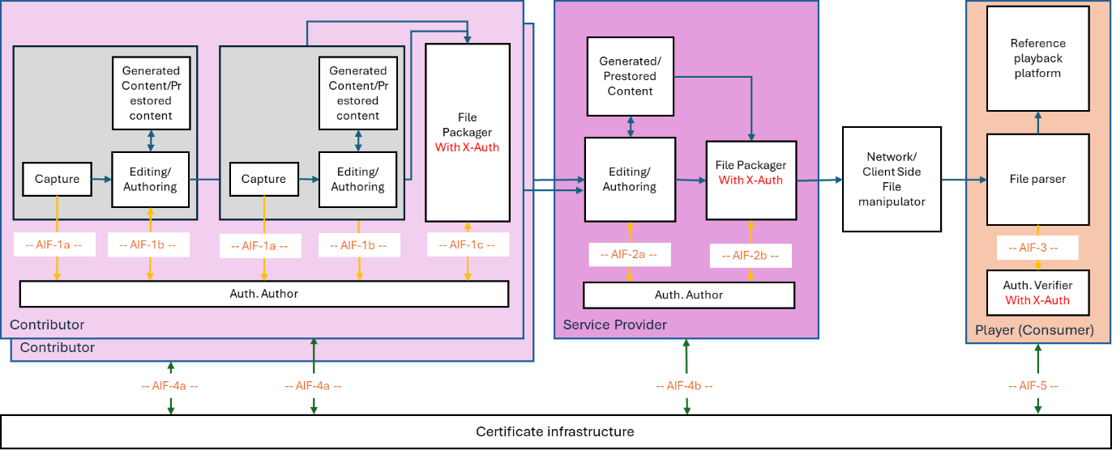
Figure 1: File-based workflow with cross authentication (X-Auth) of different Media types

On the contributor side, media components possibly with different media types (e.g. video, audio tracks, subtitles, etc.) of a media asset are captured (original content), retrieved or generated. Each component is authenticated individually through the AIF-1a and AIF1b interfaces. Once authenticated, all media components with different media types building the media asset are packaged with cross-authentication performed through the AIF-1c interface. The resulting packaged file is then made available to the service provider. There can multiple contributors providing media components with different variants or different media types to the Service provider e.g. different audio tracks, etc.
On the service provider side, the packaged file can be edited by modifying existing media types, reusing prestored content or incorporating new ones (possibly from multiple contributors). Similar to contributors, the service provider must ensure cross-authentication of the new packaged file, handled through the AIF-2a and AIF-2b interfaces.

