ITU – Telecommunications Standardization Sector  STUDY GROUP 21 Question 6  Video Coding Experts Group (VCEG)  78th Meeting: 13–23 January 2026, by teleconference | Document VCEG-BZ05-v1

Question: | 6/21 (VCEG)
Source: | Iraj Sodagar (Dolby Labratories) | Email: | irajs@live.com
Title: | [HSTP-MMAuth] Update to the technical paper draft (C512)
Purpose: | Proposal
_____________________________

Abstract
This contribution provides an update to the HSTP-MMAuth technical paper draft.

Introduction
The attached document provides an update to the HSTP-MMAuth technical paper draft (C512) that was reviewed at the last Q6 meeting.
The updates include:
- Rephrasing the “shall” statements
- Updating the broadcast workflow
- A new clause of media authentication entities and their functionalities.

Proposal
We suggest updating the draft with the above changes and additions.

 |  | International Telecommunication Union
 |  | ITU-T | Technical Paper
 |  | TELECOMMUNICATION  STANDARDIZATION SECTOR  OF ITU |  | dd MMM YYYY
xSTP-ACRONYM
Multimedia authentication framework, workflows and procedures

Summary
This technical paper ... (complete).

Keywords
[Mandatory]

Change Log
This document contains Version X of the ITU-T Technical Paper xSTP-ACRONYM on "Title" approved at the ITU-T Study Group xx meeting held in Geneva, dd-dd MMMM YYYY.
[If there are earlier versions: This version supersedes Version VV, which was approved at the ITU-T Study Group xx meeting held in Geneva, d MMMM YYYY]

Editor: | Iraj Sodagar  Dolby Laboratories  USA | Tel:  E-mail: irajs@live.com

CONTENTS
Page
1 Scope 1
2 References 1
3 Terms and definitions 1
3.1 Terms defined elsewhere 1
3.2 Terms defined here 1
4 Abbreviations 1
5 Media authentication end-to-end workflows 2
5.1 Streaming Workflow 2
5.2 File based workflow 3
5.3 Broadcast workflow 5
5.4 General considerations 5
5.5 Content properties 6
5.6 Authentication properties 6
Annex A Example of annex 7
Appendix I Example of appendix 7

List of Tables
Page
Table 1: Example of a table 2

List of Figures
Page
Figure 1: Example of a figure 2

Technical Paper ITU-T xSTP-ACRONYM
ITU-T Technical Paper
Multimedia authentication framework, workflows and procedures

Summary
[ADD TEXT].

Scope
[ADD TEXT].

References
- Add references here.

Terms and definitions

Terms defined elsewhere
This Technical Paper uses the following terms defined elsewhere:
3.1.1 term [reference]: definition
3.1.2 term [reference]: definition

Terms defined here
This Technical Paper defines the following terms:
3.1.1 term [reference]: definition
3.1.2 term [reference]: definition

Abbreviations
ABC | spell it out

Media authentication end-to-end workflows

Streaming Workflow
Figure 1 describes the general end to end workflow of media authentication for media streaming applications.
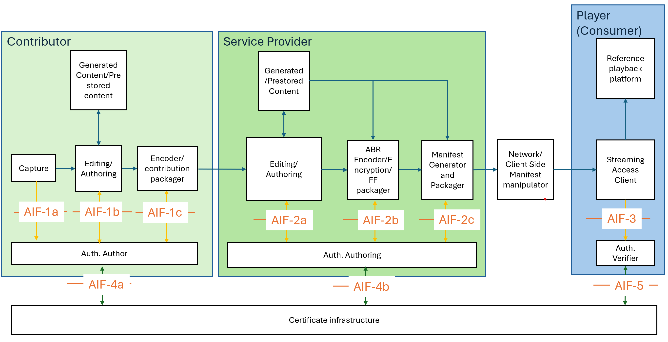
Figure 1: The media authentication workflow for streaming
In this figure, the workflow consists of:
- Media is captured by the device. Raw authentication information is provided to authentication creator (AIF-1a).
- The content is edited, manipulated and mixed with prestored and/or generated content. The provenance information is updated (AIF-1b)
- Media is encoded and packaged. The authentication creator runs algorithms on the data (AIF-1c), interacts with the certificate infrastructure if needed (AIF-4a) and includes the authentication metadata in encoded and packaged data (AIF-1c). Optionally it may include some data in cloud (AIF-4a).
- Media is provided to the content /service provider.
  - The content received may be verified by the content/service provider (AIF-2a).
  - The authentication metadata may be removed/redacted by the content/service provider.
- The content is edited and revised. It may be manipulated, enhanced or revised and/or combined with other prestored or generated content. The provenance information are provided to auth manipulation/authoring module along with the provenance information provided at the contribution (AIF-2a). The new parts of the content may have its own provenance information.
- Additional authentication metadata is included during the media packaging and manifest generation (AIF-2b/2c).
- The media presentation may be repackaged at the network or client side or transmitted by a transmitter. Such operations maintain the authentication metadata for the part of media originated from the service provider.
  - The inserted content (such as inserted ad) should not impact the authentication metadata nor verification of the main content.
  - Each inserted content may add its own authentication information.
  - If the inserted content causes failure in the verification of the main content, it should either
    - Remove signaling that the manifest to avoid confusing the player, or
    - Add the new authentication metadata for the combined content.
- The player/receiver uses the verification module (AIF-3) for media verification through AIF-5.
  - The player may use the manifest to select the media that can be verified.
  - The verification may occur during the playback of media.
The following authentication interfaces are defined:
- AIF-1a: Capture provenance data
- AIF-1b: Authentication data created during editing
- AIF-1c: Authentication data embedding in encoding/packaging
- AIF-2a: Provenance data update during authoring
- AIF-2b: Authentication data embedding in the media content
- AIF-2c: Authentication data embedding in manifest/packaging
- AIF-3: Extraction of authentication data for verification
- AIF-4a/4b: Auth. author cloud interface
- AIF-5: Auth. Verifier cloud interface

File based workflow
Figure 2 describes the workflow for file-based transfer applications.
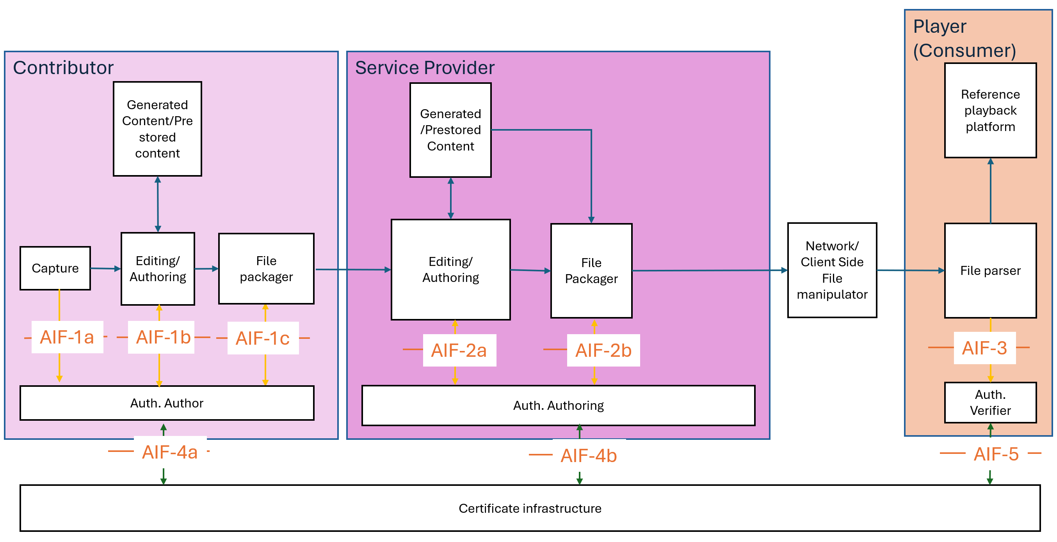
Figure 2: The media authentication workflow for file-based transfer
In this figure, the workflow consists of:
- Media is captured by the device. Raw authentication information is provided to authentication creator (AIF-1a).
- The content is edited, manipulated and mixed with prestored and/or generated content. The provenance information is updated (AIF-1b)
- Media is encoded and packaged into one or multiple files. The authentication creator runs algorithms on the data (AIF-1c), interacts with the certificate infrastructure if needed (AIF-4a) and includes the authentication metadata in encoded and packaged data (AIF-1c). Optionally it may include some data in cloud (AIF-4a).
- Media is provided to the content /service provider.
  - The content received may be verified by the content/service provider (AIF-2a).
  - The authentication metadata may be removed/redacted by the content/service provider.
- The content is edited and revised. It may be manipulated, enhanced or revised and/or combined with other prestored or generated content. The provenance information are provided to auth manipulation/authoring module along with the provenance information provided at the contribution (AIF-2a). The new parts of the content may have its own provenance information.
- The media presentation may be repackaged at the network or client side or transmitted by a transmitter. Such operations maintain the authentication metadata for the part of media originated from the service provider.
  - The inserted content (such as inserted ad) should not impact on the authentication metadata nor verification of the main content.
  - Each inserted content may add its own authentication information.
  - If the inserted content causes failure in the verification of the main content, it should either
    - Remove signaling that the manifest to avoid confusing the player, or
    - Add the new authentication metadata for the combined content.
- The player uses the verification module (AIF-3) for media verification through AIF-5.
  - The verification may occur during the playback of media.
The media authentication interfaces are a subset of the ones identified for the streaming workflow. All interfaces are the same except AIF-2c that does not exist in this case.

Broadcast workflow
Figure 3 describes the workflow for broadcast applications.
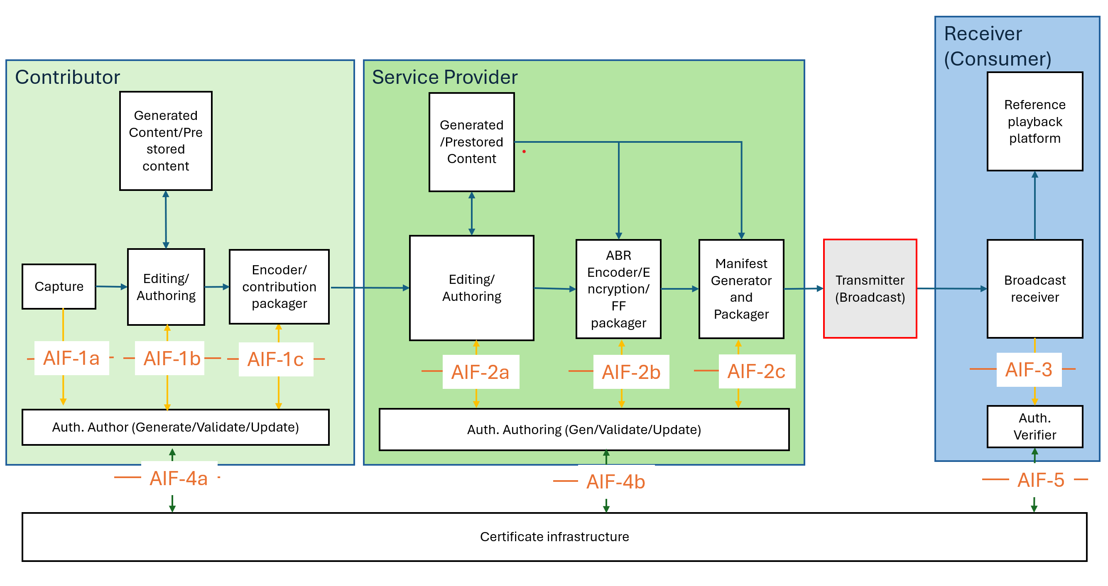

Figure 3: The media authentication workflow for broadcast
As shown in Figure 3, the broadcast media authentication workflow is very similar to the streaming. The major change is the distribution that is achieved through broadcast compared to the network distribution. Note that we assume a local broadcaster be part of the service provider functionality and therefore in the case of broadcast, the content is not manipulated during the distribution. We also assume that the receiver is a connected device, i.e. it can connect to the certificate infrastructure to retrieve keys and signatures.
The authentication interfaces in this workflow are similar to the streaming case.

General considerations
The following are considered for the streaming workflow:
- The content is produced by contributor and/or service provider.
- The receiver is the main consumer that validates the authenticity of the content.
- The service provider may also be a consumer when receiving the contribution, i.e. wants to validate the received content before editing/repurposing/publishing.
- The certificate infrastructures include the signature store, the certificate authority and other possible functionalities (such as watermarking validation).
- The workflow covers on-demand, time-shift, live and low latency content.

Content properties
The following content properties are considered:
- The content may be produced for on-demand, live or low latency live consumption.
- The content may be produced as single or multi-period content by the contributor and further be spliced to multi-period content by the provider.
- Timed based events may be added by the contributor or service provider to the content.
- The content may be manipulated by the provider or at the client to be spliced with other contents (such as ads). Use cases such as DASH MPD insert event, with dynamic ad duration and early termination are considered.

Authentication properties
The following authentication properties are considered:
- The authentication metadata provides information to verify the content for specific verification periods, i.e. each time interval of the content has authentication metadata.
  - Since the content may be produced on-demand, live or in low latency case, the media verification periods are defined to enable each use case accordingly.
  - If authentication verification requires insertion of period transition (i.e. changing the period structure), the resulting content needs to conform to the streaming standards such as ISO/IEC 23009-1, including not losing the ad insertion opportunities.
  - Adding ad insertion opportunities needs still allow verification of the content for each verification period intended by the service provider.
  - A pass-through verifiable content is only possible, if the content is contained in one or more periods, marked as “unchangeable”.
  - Cross media authentication, i.e. authentication between different tracks or representation of media components, need to be addressed.
- The manifest and its updates may provide:
  - High level information about the existence of authentication metadata and their format, and possible playback constraints.
  - The cross-media authentication information, i.e. which tracks are expected to be authenticated together.

Authentication Functions
This clause provides a functional description of the authentication related entities utilized in the workflows defined in Clause 5.

Authentication Author (Generate/Validate/Update)
This entity validates, creates, and updates the provenance and media authentication metadata for the media presentation. Its responsibilities include:

- Validating the authenticity of the content if existing metadata is present.

- Parsing and updating provenance information.

- Calculating new hashes and generating new digital signatures.

- Formatting and embedding media authentication information into a format suitable for integration with the media content.

The Authentication Author interfaces with the media delivery modules via interfaces AIF-1 and AIF-2, and with the certificate infrastructure via interface AIF-4.

Authentication Verifier
This entity is responsible for verifying the authenticity of received media content. It receives the relevant media data along with the associated metadata to perform verification. Because multimedia content is typically time-based, verification is performed continuously at various intervals. The frequency and boundaries of these verification periods (i.e., the specific segments of content being verified) are defined by the media authentication metadata carried within the content.
This entity interfaces with the media access function via interface AIF-3 and with the certificate infrastructure via AIF-5.

Certificate Infrastructure
This entity represents the network or cloud-based functionality that enables the following functions:
- For Authoring (AIF-4):
  - Registration with a Certificate Authority (CA).
  - Provisioning of certificates and public/private key pairs.
  - Provisioning of signed timestamps.
  - Cloud storage for provenance information.
- For Verification (AIF-5):
  - Retrieval of provenance information stored in the cloud.
  - Verification of the Certificate Authority's validity.
  - Verification of the certificate validity and the intermediate trust chain.
  - Provisioning of certificate status and timestamp validation.
Table 1: Example of a table
Number | Observation
1 | Sample table
2 | Table header (1st row) uses style Table_head
3 | Other table rows use style Table_text
4 | Heading with table number uses style "Table_No & title"

A | à | B
Captions for figures use WinWord style "Figure_No & title"
Figure 1: Example of a figure
Annex A
Example of annex
[ADD TEXT].

Appendix I
Example of appendix
[ADD TEXT, IF ANY].

___________________

