ITU – Telecommunications Standardization Sector  STUDY GROUP 21 Question 6  Video Coding Experts Group (VCEG)  76th Meeting: 27 March – 4 April 2025, by teleconference | Document VCEG-BX08-v1

Question: | 6/21 (VCEG)
Source: | Jonatan Samuelsson-Allendes, Sachin Deshpande, Tomohiro Ikai (Sharp) | Email: | samuelssonj@sharplabs.com
Title: | Gap analysis and suggested updates to next-generation video coding requirements draft
Purpose: | Proposal
_____________________________

Abstract
This contribution presents a summary of a gap analysis carried out with respect to existing MPEG/VCEG video coding standards. The contribution also provides suggestions for updates of “Preliminary draft of use cases and requirements for potential next-generation video coding standard beyond VVC capability” based on the gap analysis. This contribution is an update of the previous contribution JVET-AK0338.

Introduction
For a mature technology area such as video compression, we believe that the motivation for starting a new standardization effort should be based on analysis around existing standards. In particular, we believe it is valuable to identify gaps between existing standards and expectations by the market. Such expectations may be based on new technical demands, demonstration of new technological developments or competing approaches presented by external organizations.

Additionally, we would like to make the remark that we think it is important to be prepared to challenge conventions and traditions when developing standards serving an ever-progressing media industry. Just because something has “always been done this way” does not mean it always has to be done that way. On the contrary, a standardization process aimed at serving future market needs, should try to challenge existing conventions and practices in order to reach beyond the capabilities of existing standards. We believe an open mindset should be applied throughout the development process not only when it comes to technology but also to other areas such as ways of working and scope of the project.

Gap analysis
Three areas have been identified as particularly important to consider in the design of the next-generation video coding standard:
- Film grain and digital noise
- Mobile video content uploading
- Packet loss resilience

Each of these areas are presented in its own subsection below and in section 3 there are suggested updates to the requirements document corresponding to each of the three areas.

Film grain and digital noise
By far the most important aspect of our gap analysis is the part about film grain and digital noise. We prefer to include the term digital noise in order to highlight that this aspect is not constrained only to content captured with analogue film cameras or to one specific content type. In this context, digital noise relates to randomness captured by a camera sensor. Broader terms such as video noise or image noise could also be used.

It is well known that existing video coding standards such as HEVC and VVC tend to suppress or completely remove video noise, in particular at lower bitrates. Reports in JVET, such as JVET-AJ0374 [1] have indicated that there may be a significant benefit in visual quality when Film Grain Synthesis is applied to decoded VVC video based on the Film Grain Characteristics (FGC) Supplemental Enhancement Information (SEI) message. An example can be seen in Figure 1 (borrowed from JVET-AJ0374) where the MOS scores indicate that the same visual quality can be achieved at around 60% lower bitrate when Film Grain Synthesis is applied for the TearsOfSteel-044-final sequence.
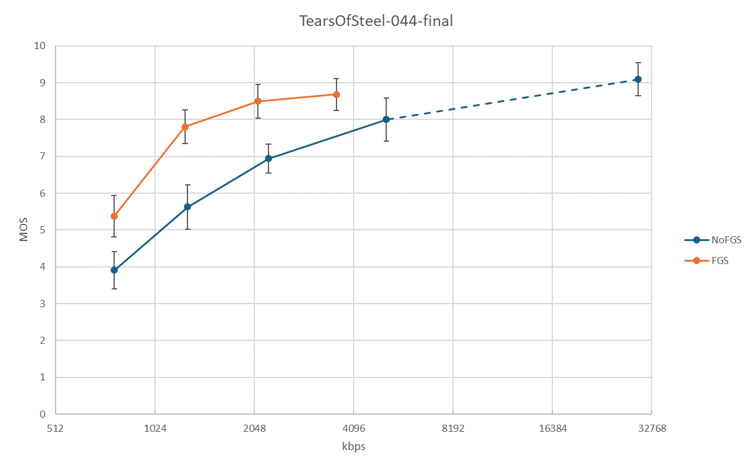
Figure 1. Example result for Film Grain Synthesis from JVET-AJ0374.

However, SEI messages are by design constructed to enable optional enhancement of decoded video and do generally not allow content providers and service providers to prescribe if, how, and to what extent, the data contained in the SEI message is used by decoders. A design that relies on voluntary implementation by decoders is bound to end up in a classical chicken-and-egg situation where service providers don’t include the SEI message since receivers may produce different results based on if they implement support for it or not. Receivers on the other hand do not implement support for the SEI message since service providers do not use it.

The suggestion to include film grain synthesis as a mandatory processing step has been brought up in JVET at multiple occasions, such as JVET-Q0424 [2] and JVET-Z0132 [3], but our understanding is that not enough focus was put on the subject in the past and that discussions started at a too late stage of the development of VVC. We would advocate for timely and thorough consideration of the topic when starting the work on a next-generation video coding standard.

Mobile video content uploading
The uploading of user-generated videos from smartphones presents a significant opportunity for social networking services (SNS) application and entertainment. However, the limitation in uplink speed for wireless communication poses significant challenges. Furthermore, cloud storage has become an essential tool for individuals to preserve their digital media such as images and videos, but uploading large files to cloud services remains a time-consuming process due to restricted uplink speeds. For instance, uploading a 1 GB file on a 10 Mbps uplink takes approximately 13 minutes, compared to approximately 1½ minutes on a 100 Mbps uplink.

Connection | Downlink | Uplink
5G | 340 Mbps | 81 Mbps
4G | 20-50 Mbps | 10-15 Mbps
Home broadband | 100 Mbps | 10–20 Mbps
Table 1. Example downlink and uplink speeds

To meet the demands of mobile uploading, cloud storage, and video capturing for social networking services (SNS), it is important to target bit-rate reductions for real-time encoding operation with as low power consumption as possible. Based on projections for advancements in chip design and based on analysis of implementations of existing video coding standards, we believe an operating point of around 2.5x the encoding complexity of VVC will be a sweet spot for the mobile video content uploading use case. We believe that improving compression efficiency at this operating point will be crucial for the next generation video coding standard.

We encourage consideration of mobile video content uploading for cloud storage and social networking services (SNS) applications as use cases for a next generation video coding standard.

Packet loss resilience
Video coding standards have generally been designed bearing in mind that compressed bitstreams may include errors, such as loss of data.

When data corresponding to one or more complete pictures have been lost, there are methods in place in HEVC and VVC for addressing this, such as usage of long-term reference pictures and decoder refresh operations (e.g. using Intra Random Access Point pictures). Our understanding is that modern systems and protocols used for delivering compressed videos are not subject to bit-errors or to undetected loss of data.

However, the one area where we see a potential gap in existing video coding standards is where a part of a compressed picture is lost. In some cases, the lost part corresponds to a spatial area precisely known by the decoder (such as the loss of a NAL-unit containing one out of multiple slices) but it is also possible that the lost data does not correspond to a spatial area known by the decoder (such as when an RTP fragmentation unit is lost).

In-picture error concealment of partially lost compressed pictures is particularly important in applications with very strict latency requirements, where other methods such as picture freeze and retransmission are not feasible.

We note that VVC does not include the same level of tools for in-picture error concealment as previous standards (for example constrained intra).

We encourage consideration of packet loss resilience for the above-mentioned scenario in the design of the next-generation video coding standard.

Suggested updates
With respect to our gap analysis, we suggest the following updates to the “Preliminary draft of use cases and requirements for potential next-generation video coding standard beyond VVC capability”. The suggested updates are relative to the text produced in the joint session of VCEG and MPEG at the meeting in Geneva, January 2025, available in m71662 [4]:

Film grain and digital noise
We suggest adding the following, marked in red, in section 1:
- Specific content types to be addressed
  - User-generated content.
  - High-dynamic range and extended colour gamut content.
  - High frame-rate and sports content.
  - Content with film grain and content with digital noise.
  - …

Mobile video content uploading
We suggest adding the following, marked in red, in section 1:
- Anticipated use cases include:
- Mobile communication and entertainment.
- On-demand streaming, download-and-play, and storage-media-based applications.
- Live streaming.
- Mobile video content uploading for cloud storage and social networking services (SNS) applications.
- …

Packet loss resilience
We propose to add the following, marked in red, in section 9:

9 Packet loss resilience
- The video layer and its interfaces to the network layer shall be designed in a way such that relevant data loss resilience measures can effectively and flexibly be applied for networks needing loss recovery, e.g. networks subject to burst errors. Proper balance of increase in complexity, loss in coding efficiency and benefits achieved by loss resilience measures at the coding layer should be achieved.
- Frame-level loss resilience should be applicable for interactive/low-delay networks, including channels with up to 20% packet loss.
- The loss resilience should be effective in ultra-low delay applications.
- The standard should provision for error concealment techniques to handle loss of data corresponding to parts of a coded picture.

References
- JVET-AJ0374 Results of expert viewing for FGC subjective test category 1, M. Wien (RWTH), P. de Lagrange (InterDigital), A. Wieckowski (Fraunhofer HHI), 2024-11-07
- JVET-Q0424 Mandatory film grain, R. Sjöberg, D. Saffar, M. Pettersson, M. Damghanian (Ericsson), 2019-12-31
- JVET-Z0132 AHG13: On film grain synthesis, Y. He, M. Coban, M. Karczewicz (Qualcomm), P. de Lagrange, E. François (InterDigital), M. Radosavljević (Xiaomi), S. McCarthy, W. Husak (Dolby),
2022-04-14
- m71662, Update on Preliminary draft of use cases and requirements for potential next-generation video coding standard beyond VVC capability, Igor D.D. Curcio (WG2 Convenor), 2025-01-24

________________________

