ITU – Telecommunications Standardization Sector  STUDY GROUP 21 Question C/16 (ex-Q6/16)  Video Coding Experts Group (VCEG)  75th Meeting: 2-8 November 2024, Kemer, TR | Document VCEG-BW02-v1

Question: | C/16 SG21 (VCEG)
Source: | Jonathan Pfaff, Heiner Kirchhoffer, Christian Helmrich, Sophie Pientka, Christian Rudat, Heiko Schwarz, Detlev Marpe, Thomas Wiegand (Fraunhofer HHI) | Email: | jonathan.pfaff@hhi.fraunhofer.de, heiko.schwarz@hhi.fraunhofer.de
Title: | Description of Fraunhofer HHI’s response to the Call for Proposals on the compression of biomedical waveform data
Purpose: | Proposal
_____________________________

Introduction
This document describes Fraunhofer HHI’s response to the Call for Proposals on the coding of biomedical waveform data issued by VCEG. The proposed codec follows the concept of a block-based hybrid architecture. Thus, the samples are partitioned into blocks of variable size. For each block, a prediction signal is computed out of already reconstructed sample values which either belong to the same channel or to a different channel. The prediction residual is transformed, where the transform is either the identity or a trigonometric transform. A sample-wise prediction on the prediction residual is additionally supported. Finally, the resulting transform coefficients are quantized and the quantization indices and the prediction mode information are entropy coded. To enable random access as well as separate encoding and decoding of distinct groups of channels, a specific packet format using dedicated network abstraction layer units is additionally proposed. Experimental results are presented as averaged results at the end of this document, where per sequence results can be found in the attached files.

A Proposed Draft Specification Text is attached to this document in order to present detailed descriptions for the proposed technologies from a decoding point of view.

Description of the proposed packet format
It is proposed to use Network Abstraction Layer Units (NAL units) as packets in a coded bit stream. It is anticipated that in a possible self-contained byte stream format, each such NAL unit would be preceded by a dedicated start code. Therefore, a removal of start code emulation prevention bytes is proposed for the decoding of each NAL unit, using the same mechanism as, for example, H.264, H.265 or H.266.

The following types of NAL units are proposed and described below:
- Waveform parameter set NAL units
- Independent frame NAL units
- Dependent frame NAL units
- Annotation channel NAL units
- Auxilliary metadata NAL units

Waveform parameter set NAL units
The proposed waveform parameter set NAL units describe the partitioning of a biomedical waveform signal into groups of channels, called channel groups. Here, a channel group can consist of any possible subset of the set of input channels in any possible order. In the proposed codec, each channel group can be coded independently from each other channel group. The envisioned application of a partitioning of a signal into multiple channel groups is that biomedical or general waveform signals might consist of a large number of channels. It is asserted that in such a case, parallel encoding and decoding as well as independent accessing of groups of channels might be needed to limit the maximum delay and memory complexity. Moreover, it is claimed that for such a purpose, the proposed reordering functionality by which channels which are likely to be jointly accessed at a receiver can be grouped together might be additionally feasible.

The proposed waveform parameter set syntax and semantics are described in clause 7.3.2.1 and clause 7.4.3.1 of the attached Proposed Draft Specification Text. Their proposed functionality in the channel reordering for output purposes is described in clause 8.1.2 of the attached Proposed Draft Specification Text.

Independent frame NAL units
The proposed independent frame NAL units consist of a waveform parameter set identifier, a channel group identifier, a coding tool parameter set and actual coded sample value data. The coding tool parameter set specifies parameters like, for example, a quantization step size, an input bit depth or a supported maximum and minimum block size as well as the applicability of specific proposed coding tools like, for example, block-matching prediction, cross channel prediction or signal-adaptive prediction filtering as well as the specific configuration of such tools like, for example, the support of multi-hypothesis prediction for cross channel or block-matching prediction. For an independent frame, the decoded sample values can be generated independently of any other NAL unit. However, to obtain the output channel indices of its decoded channels, the syntax elements of the last previously decoded waveform parameter set in bit stream order which has the same waveform parameter set identifier as the independent frame need to be invoked together with the channel group identifier of the independent frame.

The proposed syntax and semantics for the proposed high level functionality of independent frame NAL units are described in clause 7.3.2.2 and clause 7.4.3.2 of the attached Proposed Draft Specification Text. The proposed high level functionality in the decoding process is described in clause 8.1.3 of the attached Proposed Draft Specification Text.

Dependent frame NAL units
The proposed dependent frame NAL units consist of a waveform parameter set identifier, a channel group identifier and actual coded sample value data. The coding tool parameter set for a dependent frame is proposed to be inferred from the last previously coded independent frame in bit stream order which has the same waveform parameter set identifier and the same channel group identifier as the dependent frame. To decode the syntax elements of a dependent frame, the latter tool parameter set is needed. To generate the decoded sample values of a dependent frame, the decoded sample values of the last previously coded independent frame in bit stream order which has the same waveform parameter set identifier and the same channel group identifier as the dependent frame and the decoded sample values of all previously decoded dependent frames in bit stream order which succeed the latter independent frame and which have the same waveform parameter set identifier and the same channel group identifier as the dependent frame might be needed. As for independent frames, to obtain the output channel indices of the decoded channels of a dependent frame, the syntax elements of the last previously decoded waveform parameter set in bit stream order which has the same waveform parameter set identifier as the dependent frame need to be invoked together with the channel group identifier of the dependent frame.

The proposed syntax and semantics for the proposed high level functionality of dependent frame NAL units are described in clause 7.3.2.3 and clause 7.4.3.3 of the attached Proposed Draft Specification Text. The proposed high level functionality in the decoding process is described in clause 8.1.4 of the attached Proposed Draft Specification Text.

Annotation channel NAL units and Auxiliary metadata NAL units
Annotation channel NAL units are proposed to contain the information of annotation channels which might accompany biomedical waveform signals. Similarly, the proposed Auxiliary metadata NAL units are intended to carry additional information associated to the waveform data such as a sampling rate. Moreover, it is anticipated that metadata associated to the waveform signal in a specific format like EDF might be coded inside an auxiliary metadata NAL unit.

Example for the proposed packet format
In this section, the proposed channel grouping, channel reordering and frame concepts are illustrated for a signal consisting of 8 channels.

- An encoder wants to encode a biomedical signal consisting of eight channels Channel _ 0, …, Channel _VII:
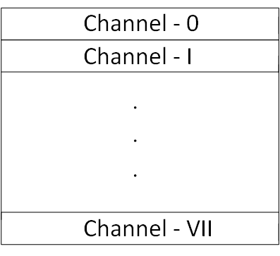

- The encoder groups these channels into three channel groups CG_0, CG_1 and CG_2 with a dedicated ordering as follows:

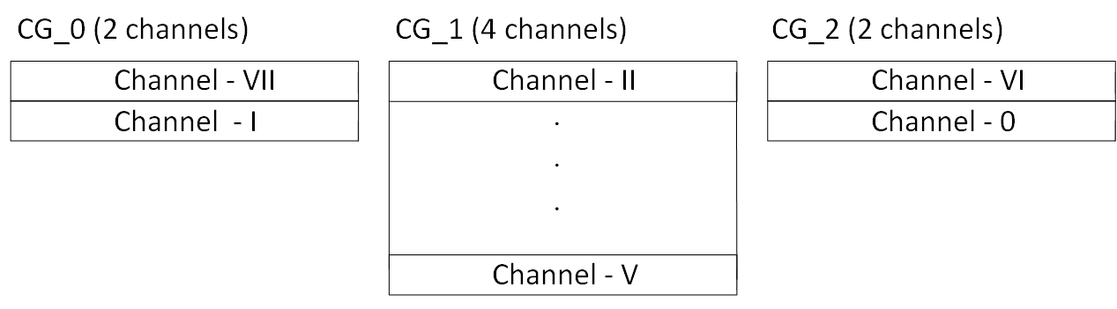

- The encoder generates a waveform parameter set WPS specifiying the following data:
  - The presence of a list of three channel groups CG_0, CG_1 and CG_2 having two, four and two channels respectively.
  - The permutation (0, 1, 2, 3, 4, 5, 6, 7 ) $↦$ (7, 1, 2, 3, 4, 5, 6, 0), which is represented by specifying the presence of a single swap between index 0 and index 7
- The encoder generates a bitstream that begins with the waveform parameter set WPS and is succeeded by the sample value data corresponding to three channel groups CG_0, CG_1 and CG_2.
In the figure below, the sample value data from each channel group CG_0, CG_1 and CG_2 are coded as single independent frames IF_0, IF_1 and IF_2. Each such independent frame contains a reference to the waveform parameter set WPS and its channel group identifier:
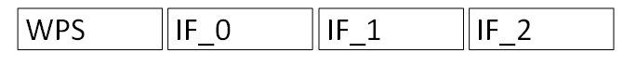
The three independent frames IF_0, IF_1 and IF_2 can be decoded independent of each other.

- The proposed packet format also supports that the sample value data of a channel group are split into multiple independent and dependent frames as long as for each dependent frame with given channel group and waveform parameter set identifiers an independent frame with the same identifiers is already present in the bitstream.
For example, the data of each channel group CG_0, CG_1 and CG_2 may be split into independent frames $\tilde{IF}$_0, $\tilde{IF}$_1 and $\tilde{IF}$_2 and dependent frames DF_0, DF_1 and DF_2 where all frames reference WPS and contain their respective channel group identifier. An example of a corresponding bit stream might be

The three independent frames $\tilde{IF}$_0, $\tilde{IF}$_1 and $\tilde{IF}$_2 can be decoded independent of each other. On the other hand, besides the respective tool parameter sets, the dependent frame DF_0 may need the reconstructed sample values of $\tilde{IF}$_0, the dependent frame DF_1 may need the reconstructed sample values of $\tilde{IF}$_1 and the dependent frame DF_2 may need the reconstructed sample values of $\tilde{IF}$_2 to generate the respective reconstructed sample values.

Description of the proposed codec
The present section describes the proposed codec for the coding of a single channel group with M channels and N samples per channel. The corresponding sample values shall be denoted by x[i][j], where $0≤i<M$ and $0≤j<N.$ For notational simplicity, it is assumed that the channel group is coded as an independent frame. For a dependent frame, the proposed architecture is the same but reference samples of previously coded frames in bitstream order might as well be invoked in the prediction process as described above.

The proposed syntax and semantics for the sample data decoding process of frames are described in clause 7.3.3 and 7.4.4 of the attached Proposed Draft Specification Text.

Block partitioning and sample processing order
It is proposed to partition the sample values into a sequence of blocks denoted as $b_{k}$. Each $b_{k}$ is described by the position of its first sample, denoted by $s_{k}$, and by its length in sample direction, denoted by $l_{k}$. The length $l_{k}$ is always an integral power of two. The block $b_{k}$ is defined as

$$b_{k}=\{x[i][j], 0≤i<M, s_{k}≤j<s_{k}+l_{k}\}.$$

Furthermore, adjacent blocks $b_{k}$ and $b_{k+1}$ contain adjacent samples. More precisely, one has

$s_{k+1}=s_{k}+l_{k} .$ (1)

The blocks $b_{k}$ are sequentially coded. Thus, one starts with coding $b_{0}$ and then codes the block $b_{k+1}$ after having coded the block $b_{k}$ until one has reached the final position in the channel group.
For coding a block $b_{k}$, one partitions it into its channel-wise sub-blocks $b_{k,m}$ with $0≤m<M$. The block $b_{k,m}$ is defined as

$$b_{k,m}=\{x[m][j], s_{k}≤j<s_{k}+l_{k}\}.$$

The block $b_{k}$ is coded by sequentially coding the blocks $b_{k,m}$. This means that for the coding of $b_{k}$, one starts with coding $b_{k,0}$ and, until $m=M-1$, codes the block $b_{k,m+1}$after having coded the block $b_{k,m}$.

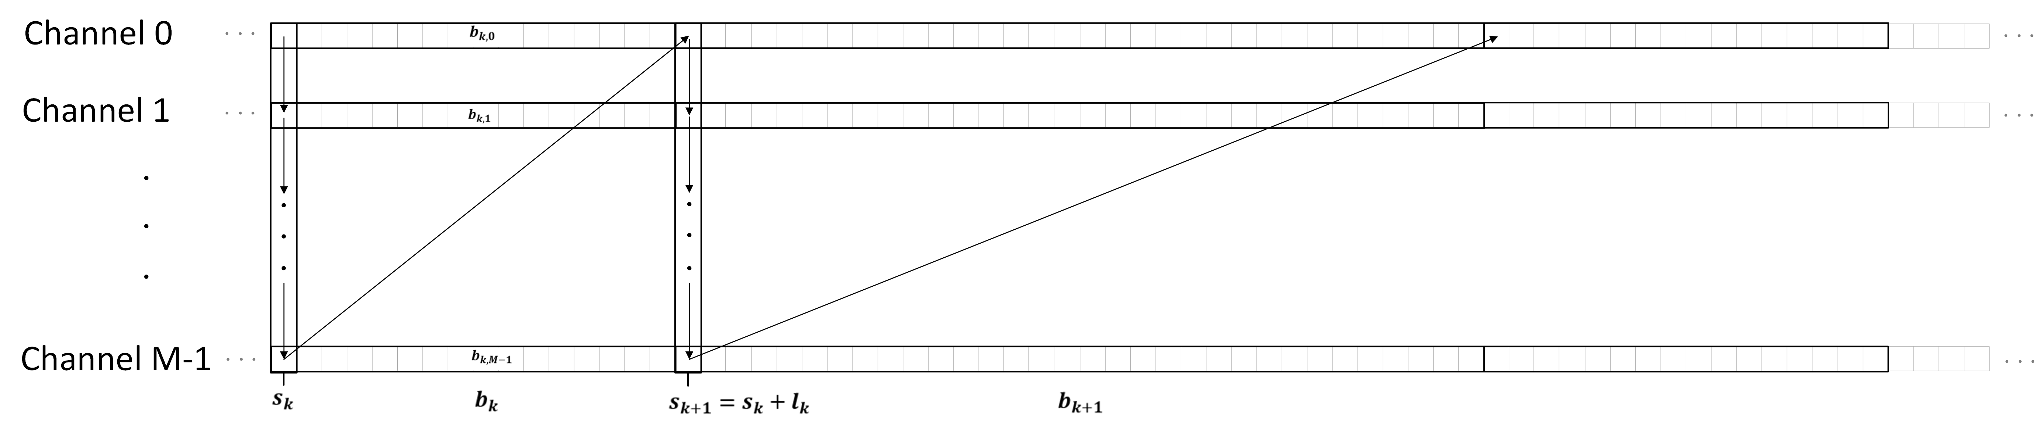
Figure 1: Illustration of the block partitioning and sample processing order
The value of a given block length $l_{k}$ is derived from the syntax element block_split_log2 and the variable Log2MaxBlockSize from the independent frame coding tool parameter set according to

$l_{k} = (1<<(Log2MaxBlockSize – block_split_log2)$).

Prediction
The prediction signal sample values

$$pred\left[j\right], 0≤j<l_{k}$$

are generated on each block $b_{k,m}$out of already reconstructed sample values

$$\{rec\left[m\right]\left[p\right], 0≤p<s_{k}\}$$

that belong to the same channel or out of already reconstructed sample values

$$\{rec\left[r\right]\left[p\right], 0≤p<s_{k}+l_{k}, 0≤r<m\}$$

that belong to a previously coded channel in channel order.

Four prediction modes are supported and described below: The DC Prediction mode, the Line fitting prediction mode, the Cross-Channel Prediction mode and the Block-Matching Prediction mode. It is also supported to completely bypass the prediction. The prediction mode is selected per block $b_{k,m}$ and is signaled in the bit stream.

DC Prediction
For the proposed DC prediction mode, the predictions signal is defined as the mean value of the four preceding already reconstructed sample value. Thus, one puts
$$dcVal=(\sum_{p=0}^{3}{rec[m]\left[s_{k}-4+p]+2\right)≫2}$$

and sets

$$pred\left[j\right]=dcVal, 0≤j<l_{k}.$$

The proposed DC prediction mode is used if the value of the syntax element block_matching_or_cross_channel_pred_flag is equal to zero and if the value of the syntax element block_pred_mode is equal to 0.

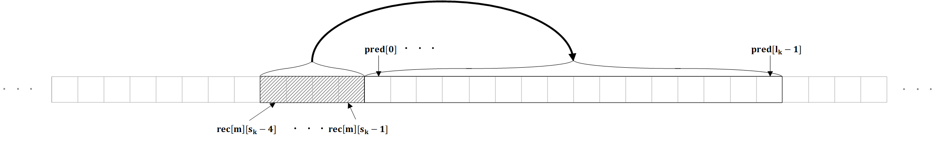
Figure 2: Illustration of the setup for the DC- and the Line-Fitting Prediction modes
The syntax and the decoding process related to the proposed DC prediction mode can be found in clause in clause 7.3.3.1 and clause 8.3.4 of the attached Proposed Draft Specification Text.

Line-Fitting Prediction
In the proposed line fitting prediction, the prediction signal is defined by a line with a damped slope where the slope is determined by the four reconstructed sample values preceding the current block. Thus, with

$$μ_{lf}=15*(rec\left[m\right][s_{k}-1]-rec[m][s_{k}-4])+5*(rec\left[m\right][s_{k}-2]-rec[m][s_{k}-3])$$

$$offset=(rec\left[m\right][s_{k}-4]+rec[m][s_{k}-3]+rec\left[m\right][s_{k}-2]+rec[m][s_{k}-1]+2)≪7$$

it is proposed to set
$$pred\left[j\right]=\left(\left(offset≪3\right)+μ_{lf}*\left(8-j\right)*\left(25+10*j\right)\right)≫12, 0≤j<l_{k}.$$

The proposed line fitting prediction mode is used if the value of the syntax element block_matching_or_cross_channel_pred_flag is equal to zero and if the value of the syntax element block_pred_mode is equal to 1.

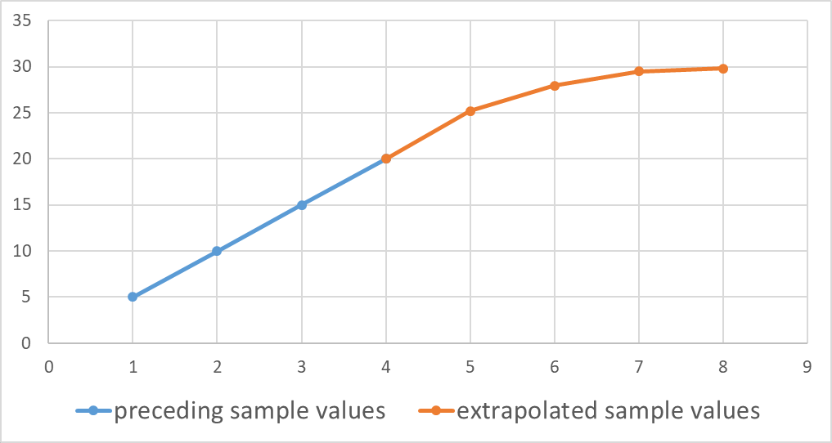
Figure 3: Illustration of the proposed extrapolation method for the line fitting prediction.
The syntax and the decoding process related to the proposed line fitting prediction mode can be found in clause 7.3.3.1 and clause 8.3.5 of the attached Proposed Draft Specification Text.

Cross-Channel Prediction
In the proposed cross channel prediction process, the prediction signal is generated by a linear model using collocated reconstructed sample values from different channels. The parameters of the linear model are derived from already reconstructed samples on a left adjacent template of size tSize = 16.

The cross channel prediction mode is invoked if the syntax elements block_matching_of_cross_channel_pred_flag and cross_channel_pred_flag are equal to 1. Cross channel prediction with a single hypothesis (cc_pred_mult_hyp_flag equal to zero) and cross channel prediction with two hypothesis (cc_pred_mult_hyp_flag equal to one) are supported.

For the cross channel mode, which is only applicable if $m>0$, a reference channel index $m_{ref}^{0}$ with $0≤m_{ref}^{0}<m$ is transmitted. In the case of multi-hypothesis cross channel prediction, also a second reference channel index $m_{ref}^{1}$ with $0≤m_{ref}^{1}<m$ is transmitted.

If cc_pred_mult_hyp_flag is equal to zero and $m=1$, $m_{ref}^{0}$ is not signaled and inferred to be 0. Similarly, if cc_pred_mult_hyp_flag is not equal to zero and $m=2$, $m_{ref}^{0}$ and $m_{ref}^{1}$ are not signaled and are inferred to be 0 and 1, respectively.

The values of $m_{ref}^{j}$ are coded predictively by invoking the corresponding values from previous blocks as a prediction. The difference to this prediction is determined by the syntax elements cc_pred_abs_chd_greater0_flag[ j ], cc_pred_abs_chd_minus1[j] and cc_pred_chd_sign_flag[j].
More details regarding the proposed cross channel prediction can be found in clause 7.3.3.1, clause 7.3.3.2, clause 7.4.4.2 and clause 8.3.6 of the attached Proposed Draft Specification Text.

Cross channel prediction with a single prediction hypothesis
For the cross channel prediction with a single hypothesis, integral values $α$ and $β$ are derived from the preceding already reconstructed sample values

$$\{rec[m_{ref}^{0}][s_{k}-tSize+q], 0≤q<tSize\}$$

in the reference channel and from the preceding already reconstructed sample values

$$\{rec\left[m\right][s_{k}-tSize+q], 0≤q<tSize\}$$

in the current channel by solving a $2×2$ linear equation that is motivated by the minimization of the quadratic prediction error

$$\min_{γ,δ}{\sum_{q=0}^{tSize-1}{( γ⋅rec[m_{ref }^{0}][s_{k}-tSize+q]+δ-rec[m][s_{k}-tSize+q] )^{2}.}}$$

If cc_pred_offset_only_flag is equal to one, $γ$ is set to 1 which results in the simplified equation

$$\min_{δ}{\sum_{q=0}^{tSize-1}{( rec[m_{ref }^{0}][s_{k}-tSize+q]+δ-rec[m][s_{k}-tSize+q] )^{2},}}$$

whose integral solution is proposed to be given as

$$β=\left(\sum_{q=0}^{tSize-1}{(rec[m][s_{k}-tSize+q]- rec[m_{ref}^{0}][s_{k}-tSize+q])}+ 8\right)≫4.$$

In this case, an intermediate prediction is computed as

$$pred_{imd}\left[j\right]=rec\left[m_{ref}^{0}\right]\left[s_{k}+j\right]+β, 0≤j<l_{k}.$$

Otherwise, if cc_pred_offset_only_flag is not equal to one, the parameters of the aforementioned linear equation

$$A\left({α \atop β}\right)=b$$

are proposed to be determined as follows:

$$A_{00}=\sum_{q=0}^{tSize-1}{ \left(rec[m_{ref }^{0}][s_{k}-tSize+q]⋅ rec[m_{ref }^{0}][s_{k}-tSize+q]\right)} \\ A_{01}=\sum_{q=0}^{tSize-1}{ rec[m_{ref }^{0}][s_{k}-tSize+q]} \\ A_{10}={ A}_{01} \\ A_{11}= 16 \\ b_{0}= \sum_{q=0}^{tSize-1}{ \left(rec[m][s_{k}-tSize+q]⋅ rec[m_{ref }^{0}][s_{k}-tSize+q]\right)} \\ b_{1}=\sum_{q=0}^{tSize-1}{ rec[m][s_{k}-tSize+q]} .$$

It is proposed to solve the linear equation at the decoder by invoking a specified process for the solution of linear equations in fixed point arithmetic which is described in Section 5.10.4.5 of the attached Proposed Draft Specification Text. Here, the precision shift is set as ccShift = 16.

After the determination of $α$ and$β,$an intermediate prediction signal is computed as

$$pred_{imd}\left[j\right]=\left(α⋅rec\left[m_{ref}^{0}\right]\left[s_{k}+j\right]+β+(1≪(ccShift-1))\right)≫ccShift, 0≤j<l_{k}.$$

If cc_pred_filter_flag is equal to zero, the final prediction signal is proposed to be

$$pred\left[j\right]= pred_{imd}\left[j\right] , with 0≤j<l_{k}.$$

Otherwise (cc_pred_filter_flag is equal to one) the intermediate prediction is extended to the left by

$$pred_{imd}\left[-fPdL+j\right]=\left(α⋅rec\left[m_{ref}^{0}\right]\left[s_{k}-fPdL+j\right]+β+\left(1≪\left(ccShift-1\right)\right)\right)≫ccShift, 0≤j<fPdL,$$

where fPdL equals 3. The intermediate prediction is extrapolated to the right by setting fPdR=4 and invoking the extrapolation process from section 8.3.1 of the attached Proposed Draft Specification Text, which results in the sample values $pred_{imd}\left[l_{k}+j\right] with 0≤j<fPdR.$ Then, the final prediction signal is proposed to be

$$pred\left[j\right]= \left(\left(\sum_{k=0}^{fPdL+fPdR}{pred_{imd}\left[-fPdL+j+k\right]}·CCFiltCoeffs\left[k\right]\right)+32\right)≫6,$$

with $0≤j<l_{k}$. Here, depending on the value of the syntax element cc_pred_filter_idx, the filter coefficients CCFiltCoeffs[ k ] either represent a fixed smoothing filter or a fixed half-pel interpolation filter as described in the following table:

cc_pred_filter_idx | CCFiltCoeffs
0 | {-3, 0, 19, 32, 19, 0, -3, 0}
1 | {-1, -4, 8, 29, 29, 8, -4, -1}

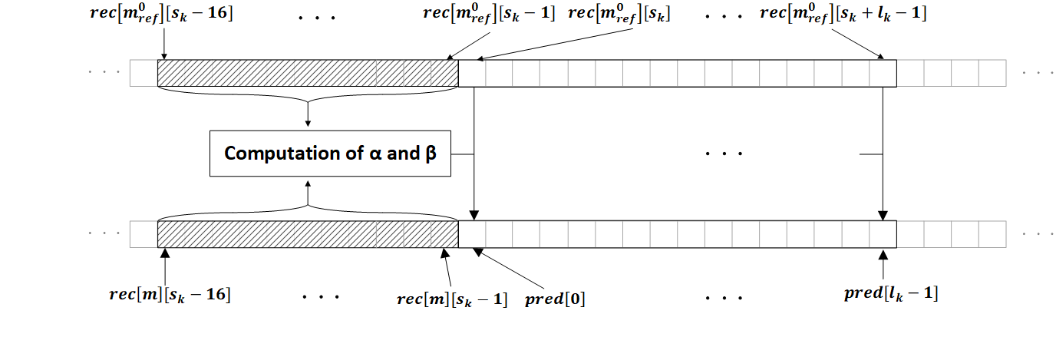
Figure 4: Ilustration of the Inter-Channel Prediction with one reference channel

Cross channel prediction with two prediction hypotheses
For the proposed cross channel prediction with two hypotheses, integral values $α_{1},α_{2}$ and $β$ are derived from the preceding already reconstructed sample values

$$\{rec[m_{ref}^{j}][s_{k}-tSize+q], 0≤q<tSize, 0≤j≤1\}$$

in the reference channels $m_{ref}^{0}$ and $m_{ref}^{1}$ and from the preceding already reconstructed sample values

$$\{rec\left[m\right][s_{k}-tSize+q], 0≤q<tSize\}$$

in the current channel by solving a $3×3$ linear equation that is motivated by the minimization of the quadratic prediction error

$$\min_{γ_{1}. γ_{2},δ}{\sum_{q=0}^{tSize-1}{( γ_{1}⋅rec[m_{ref }^{0}][s_{k}-tSize+q]+γ_{2}⋅rec[m_{ref }^{1}][s_{k}-tSize+q]+δ-rec[m][s_{k}-tSize+q] )^{2}.}}$$

If cc_pred_offset_only_flag is equal to one, $γ_{1}$and $γ_{2}$ are set to 0.5. This results in the simplified equation

$$\min_{δ}{\sum_{q=0}^{tSize-1}{( \left(\left(rec[m_{ref }^{0}][s_{k}-tSize+q]+rec[m_{ref }^{1}][s_{k}-tSize+q]+1\right)≫1\right)+δ-rec[m][s_{k}-tSize+q] )^{2},}}$$

which is proposed to be solved by

$$β=\left(\sum_{q=0}^{tSize-1}{\left(rec[m][s_{k}-tSize+q]-\left(\left(rec[m_{ref}^{0}][s_{k}-tSize+q]+rec[m_{ref}^{1}][s_{k}-tSize+q]+1\right)≫1\right)\right)}+ 8\right)≫4.$$

In this case, an intermediate prediction is proposed to be computed as

$$pred_{imd}\left[j\right]=\left(\left(rec[m_{ref}^{0}][s_{k}+j]+rec[m_{ref}^{1}][s_{k}+j]+1\right)≫1\right)+β, 0≤j<l_{k}.$$

Otherwise, if cc_pred_offset_only_flag is not equal to one, the parameters of the aforementioned linear equation

$$A\left({\begin{aligned}α_{1} \\ α_{2}\end{aligned} \atop β}\right)=b$$

are proposed to be determined as follows:

$$A_{00}=\sum_{q=0}^{tSize-1}{ \left(rec[m_{ref }^{0}][s_{k}-tSize+q]⋅ rec[m_{ref }^{0}][s_{k}-tSize+q]\right)} \\ A_{01}= \sum_{q=0}^{tSize-1}{ \left(rec[m_{ref }^{0}][s_{k}-tSize+q]⋅ rec[m_{ref }^{1}][s_{k}-tSize+q]\right)} \\ A_{02}=\sum_{q=0}^{tSize-1}{ rec[m_{ref }^{0}][s_{k}-tSize+q]} \\ A_{10}={ A}_{01} \\ A_{11}= \sum_{q=0}^{tSize-1}{ \left(rec[m_{ref }^{1}][s_{k}-tSize+q]⋅ rec[m_{ref }^{1}][s_{k}-tSize+q]\right)} \\ A_{12}=\sum_{q=0}^{tSize-1}{rec[m_{ref }^{1}][s_{k}-tSize+q]} \\ A_{20}={ A}_{02} \\ A_{21}={ A}_{12} \\ A_{22}= 16 \\ b_{0}= \sum_{q=0}^{tSize-1}{ \left(rec[m][s_{k}-tSize+q]⋅ rec[m_{ref }^{0}][s_{k}-tSize+q]\right)} \\ b_{1}= \sum_{q=0}^{tSize-1}{ \left(rec[m][s_{k}-tSize+q]⋅ rec[m_{ref }^{1}][s_{k}-tSize+q]\right)} \\ b_{2}=\sum_{q=0}^{tSize-1}{ rec[m][s_{k}-tSize+q]}.$$

As for the case of a single hypothesis, it is proposed that the latter 3x3linear equation is solved at the decoder by invoking the process of Section 5.10.4.5 of the attached Proposed Draft Specification Text with precision ccShift=16.
After the determination of $α_{1}$, $α_{2}$ and$β,$the intermediate prediction signal is proposed to be computed as

$$pred_{imd}\left[j\right]=\left(α_{1}⋅rec\left[m_{ref}^{0}\right]\left[s_{k}+j\right]+α_{2}⋅rec\left[m_{ref}^{1}\right]\left[s_{k}+j\right]+β+(1≪(ccShift-1))\right)≫ccShift, 0≤j<l_{k}.$$

If cc_pred_filter_flag equal to zero, the final prediction signal pred is proposed to be equal to $pred_{imd}\left[j\right]$.
Otherwise, the same filtering process as for the case of cross channel prediction with a single hypothesis is proposed for the intermediate prediction signal to obtain the final prediction signal $pred$.

Block-Matching Prediction
In the proposed block matching prediction mode, the prediction signal is generated by copying the sample values of already reconstructed reference blocks of the same channel. The locations of these blocks are transmitted. Block matching prediction with a single hypothesis and block matching prediction with two hypotheses are proposed.

Additionally, it is proposed that an offset can be derived at the decoder from adjacent already reconstructed sample values on a template of size tSize=16. A half-pel accurate representation of the location of the reference block and a smoothing prediction filter are also proposed.

The proposed block matching prediction mode is invoked if the value of the syntax element block_matching_or_cross_channel_pred_flag is equal 1 and if the value of the syntax element cross_channel_pred_flag is not equal to one. If bm_pred_mult_hyp_flag is equal to 0, block matching prediction with a single hypothesis is used. If bm_pred_mult_hyp_flag is equal to 1, block matching prediction with two hypothesis is used.

The values of the block matching offsets are coded predictively by invoking the corresponding values from previous blocks as a prediction. Here, the values of the current channel are invoked for prediction if the value of the syntax element bm_pred_off_pred_prev_ch_flag is equal to 0 and the values of the preceding channel are invoked if the value of the syntax element bm_pred_off_pred_prev_ch_flag is equal to 1.

More details regarding the proposed block matching prediction can be found in clause 7.3.3.1, clause 7.3.3.3, clause 7.4.4.3 and clause 8.3.7 of the attached Proposed Draft Specification Text.

Block-Matching Prediction with a single hypothesis
For block matching prediction with a single hypothesis and offset value $t_{r}$, the unfiltered prediction signal is proposed to be

$$pred_{uf}[j]=rec[m][s_{k}-l_{k}-t_{r}+j], 0≤j<l_{k}.$$

If the value of the syntax element bm_pred_filter_flag is equal to zero, the prediction signal before offset addition is proposed to be

$$pred_{bo}\left[j\right]= pred_{uf}\left[j\right] , with 0≤j<l_{k}.$$

Otherwise, if bm_pred_filter_flag is equal to 1, the intermediate prediction is extended to the left by fPdL=3 samples and it is extended to the right by fPdR=4 samples according to

$$pred_{uf}[-fPdL+j]=rec[m][s_{k}-l_{k}-fPdL-t_{r}+j], 0≤j<fPdL+l_{k}+fPdR.$$

and the filtered prediction signal before offset calculation is proposed to be computed as

$$pred_{bo}\left[j\right]= \left(\left(\sum_{k=0}^{fPdL+fPdR}{pred_{uf}\left[-fPdL+j+k\right]}·BMFiltCoeffs\left[k\right]\right)+32\right)≫6,$$

with $0≤j<l_{k}$ . Here, depending on the value of the syntax element bm_pred_filter_idx, the filter coefficients BMFiltCoeffs[ k ] either represent a fixed smoothing filter or a fixed half-pel interpolation filter as described in the following table:

bm_pred_filter_idx | BMFilterCoeffs
0 | {-3, 0, 19, 32, 19, 0, -3, 0}
1 | {-1, -4, 8, 29, 29, 8, -4, -1}

If bm_pred_add_offset_flag is equal to zero, the final prediction sample values are proposed to be

$$pred\left[j\right]= pred_{bo}\left[j\right] , with 0≤j<l_{k}.$$

Otherwise, if bm_pred_add_offset_flag is equal to one, it is proposed that an offset value is calculated on the tSize = 16 left adjacent already reconstruct boundary samples as

$$offset_{val}= \left(\left(\sum_{j=0}^{tSize-1}{(rec[m][s_{k}-tSize+j]- rec[m][s_{k}-l_{k}-t_{r}-tSize+j])}\right)+8\right)≫4.$$

Then, the final prediction sample values are proposed to be

$$pred\left[j\right]= pred_{bo}\left[j\right]+offset_{val} , with 0≤j<l_{k}.$$

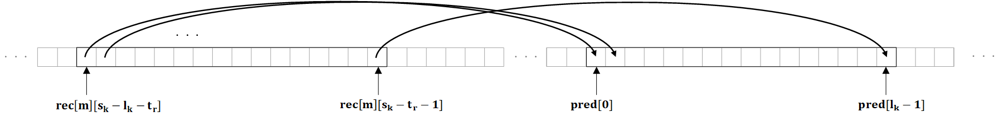
Figure 5: Illustration of the single hypothesis Block-Matching Prediction (without filtering)

Block-Matching Prediction with two hypotheses
For the block matching prediction with two hypotheses and offset values $t_{r}^{0}, t_{r}^{1}$, two intermediate prediction signals before offset value addition, $pred_{bo}^{0}$ and $pred_{bo}^{1}$, are computed in the same way as in the case of block matching prediction with a single hypothesis. Each prediction hypothesis can individually be filtered as in the case of a single prediction hypothesis, where the applicability of a filtering depends on the value of the syntax elements bm_pred_filter_flag[ 0 ], bm_pred_filter_flag[ 1 ] and where the selection of the filter depends on the syntax elements bm_pred_filter_idx[ 0 ] and bm_pred_filter_idx[ 1 ].

If the value of the syntax element bm_pred_add_offset_flag is equal to zero, the final prediction signal sample values are proposed to be

$$pred\left[j\right]=(\left(pred_{bo}^{0}\left[j\right]+pred_{bo}^{1}[j]+1\right)≫1) , with 0≤j<l_{k}.$$

Otherwise ( bm_pred_add_offset_flag is equal to one), it is proposed that an offset value is calculated on the tSize = 16 left adjacent boundary values according to

$$offset_{val}=(\sum_{j=0}^{tSize-1}{rec\left[m\right]\left[s_{k}-tSize+j\right]-\left(\left(pred_{bo}^{0}\left[j\right]+ pred_{bo}^{1}\left[j\right]+1\right)≫1\right)+8)≫4}$$

and the final prediction signal sample values are proposed to be

$$pred\left[j\right]=(\left(pred_{bo}^{0}\left[j\right]+pred_{bo}^{1}[j]+1\right)≫1)+offset_{val} , with 0≤j<l_{k}.$$

Extension of prediction signals the left adjacent samples
In order to obtain an extension of the prediction residual to the left, which is invoked in the sample wise prediction of reconstructed residuals described in Section 3.3.7 below, for each prediction signal, an extension

$$pred\left[-tSize+j\right], 0≤j<tSize$$

to tSize=16 many left adjacent prediction values is proposed. Here, to determine the extended prediction, essentially the same process that was used in the respective prediction generation on the given block is invoked. Further details can be found in clause 8.3 of the attached Proposed Draft Specification Text. Given the extended prediction signal, an extended residual signal is defined as

$$resExt\left[j\right]=rec\left[m\right]\left[s_{k}-tSize+j\right]- pred\left[-tSize+j\right], 0≤j<tSize .$$

Here, a specified padding process for sample values at unavailable sample locations is invoked.

Transform coding of prediction residuals and sample wise residual prediction

Overview
The following transform coding scheme is proposed. A blockwise transform is applied to the original prediction residual sample values

$$resOrig\left[j\right]= x\left[m\right]\left[s_{k}+j\right]-pred\left[j\right], 0≤j<l_{k}.$$

at the encoder. The resulting transform coefficients are quantized to obtain the transform coefficient levels c[ j ]. The levels c[ j ] are entropy coded using the syntax proposed below. At the decoder, the levels c[ j ] are multiplied with an appropriate quantization step size to obtain the intermediate reconstructed residual sample values

$$resImd\left[j\right], 0≤j<l_{k}.$$

A sample wise prediction process can be applied to the intermediate reconstructed residual sample values resImd[ j ], where also the extended left residual sample values resExt[ j ] from the previous section are needed as an input. This yields the final reconstructed residual sample values

$$res\left[j\right], 0≤j<l_{k}.$$

and the final reconstructed sample values

$$rec\left[ j \right]=pred\left[ j \right]+ res\left[ j \right], 0≤j<l_{k}.$$

Block wise transforms
It is proposed to support the identity transform, the Discrete Sine Transform DST-II and the Discrete Cosine Transform DCT-II as block wise transforms. The DST-II is only supported if the blocksize $l_{k}$ satisfies $l_{k}≤ 256$ and the DCT-II is only supported if the blocksize $l_{k}$ satisfies $l_{k}≤ 1024$. The block wise transform is determined by the syntax elements transform_skip_flag and the syntax element transform_dst_flag as follows. If transform_skip_flag is equal to 1, the identity transform is used. If transform_skip_flag is equal to 0 and transform_dst_flag is equal to 1, the DST-VII transform is used. If transform_skip_flag is equal to 0 and transform_dst_flag is equal to 0, the DCT-II transform is used. The proposed forward and inverse transforms are implemented in fixed point arithmetic with 32 bit precision.

At the encoder, the transform coefficients are quantized and the resulting quantization indices

$$c\left[ j \right], 0≤j<l_{k} ,$$

also referred to as transform coefficient levels, are entropy coded. Two separate paths of level coding are proposed depending on whether a trigonometric transform or whether the identity transform is used for the current block.

The relevant syntax and semantics for the proposed transform coefficient level coding can be found in clause 7.3.3.6 of the attached Proposed Draft Specification Text. More details regarding the proposed binarization and context modelling can be found in clause 9.3.2. and clause 9.3.3 of the attached Proposed Draft Specification Text.

Level coding for the identity transform
First, in the special case that the identity transform is used and that no block-based prediction and that no sample wise prediction are used, it is proposed that the levels c[ j] of the identity transform are coded in a fixed length representation depending on the bit-depth, starting from j=0 until ${j=l}_{k}-1$, where all bins are bypass coded.

Otherwise, it is proposed that for the identity transform, the coefficient levels are always sequentially coded in decreasing order starting from ${j=l}_{k}-1$ by the following procedure.

For a coefficient level c[ j ], the syntax element abs_tskip_coeff_gt0_flag[ k ] indicates whether c[ j ] is zero or not. If $c[ j ]≠0$, the absolute value $\left|c[j]\right|$ is transmitted as follows. First, the syntax elements abs_tskip_coeff_offset[ j ] is coded, with

0<= abs_tskip_coeff_offset[ j ] < 5.

If abs_tskip_coeff_offset[ j ]<4, one sets

$$\left|c[j]\right|=1+abs_tskip_coeff_offset[ j ].$$

Otherwise, a truncated Rice whose prefix is specified by the syntax element abs_tskip_coeff_rem_pref[ j ] is invoked, where

0<= abs_tskip_coeff_rem_pref[ j ] < 32.

The Rice parameter R of this Rice code is determined from the sum

$$\sum_{p=j+1}^{l_{k}-1}{|c[p]|}$$

of absolute values of all previously coded coefficient levels of the same block. If abs_tskip_coeff_rem_prefix[ j ] < 32, the suffix abs_tskip_coeff_rem_fl_suffix[ j ] is coded with R bits and one sets

$$\left|c[j]\right|=1+abs_tskip_coeff_offset\left[ j \right] + (abs_tskip_coeff_rem_prefix[ j ]≪R )+ abs_tskip_coeff_rem_fl_suffix\left[ j \right].$$

Otherwise, the suffix abs_tskip_coeff_rem_eg0_suffix[ j ] is coded using an Exponential-Golomb code of order zero and one sets

$$\left|c[j]\right|=1+abs_tskip_coeff_offset\left[ j \right] + (abs_tskip_coeff_rem_prefix[ j ]≪R )+ abs_tskip_coeff_rem_eg0_suffix[ j ].$$

Finally, the sign of c[ j ] is coded using the syntax element tskip_coeff_sign_flag[ j ],

The syntax element abs_tskip_coeff_gt0_flag[ k ] is context coded using a single context model per channel.

The bins of the truncated unary binarization of abs_tskip_coeff_offset[ j ] are context coded, where a dedicated context model per channel is used for each bin position. For each channel, 5 context models are supported for the coding of these bins.

In the same way, the bins of the truncated unary binarization of abs_tskip_coeff_rem_prefix[ j ] are context coded, where a dedicated context model per channel is used for each bin position. For each channel, 33 context models are supported for the coding of these bins.

The bins that belong to the prefix in the Exponential-Golomb binarization of abs_tskip_coeff_rem_eg0_suffix[ j ] are context coded where the context model selection depends on the position of a bin. For each channel, 32 context models are supported for the coding of these bins.

All other bins that occur in the proposed coding scheme for the identity transform are coded in bypass mode.

State machine for level coding and coefficient reconstruction process
It is proposed that the level coding and the coefficient reconstruction process for transform coefficient levels of a trigonometric transform invoke a specified state machine which can have 1 state, 4 states or 8 states.
As further described in Section 3.3.6 below, the state machine determines the switching between two scalar quantizers $Q_{0}$ and $Q_{1}$: For a given quantization step size $Δ$, the reconstruction levels of $Q_{0}$ are the even integral multiples of $Δ$ while the reconstruction levels of $Q_{1}$ are the odd multiples of $Δ$ and the value 0.
The state transition from a state $S_{m}$ to a next state $S_{n}$ given a value q is determined by the respective state transition table invoking the state $S_{m}$ and the parity of q. The number of states and the invoked state-transition table are determined by the syntax element if_residual_quant_mode as follows.
If if_residual_quant_mode is equal to 0, a single state is used. This case corresponds to scalar quantization with uniform reconstruction quantizer $Q_{0}$.

It if_residual_quant_mode is equal to 1, the following state transition table is used:

 | Next state
Current state | even parity | odd parity
$$S_{0}$$ | 0 | 1
$$S_{1}$$ | 2 | 3
$$S_{2}$$ | 1 | 0
$$S_{3}$$ | 3 | 2

If if_residual_quant_mode is equal to 2, the following state transition table is used:

 | Next state
Current state | even parity | odd parity
$$S_{0}$$ | 0 | 2
$$S_{1}$$ | 5 | 7
$$S_{2}$$ | 1 | 3
$$S_{3}$$ | 6 | 4
$$S_{4}$$ | 2 | 0
$$S_{5}$$ | 4 | 6
$$S_{6}$$ | 3 | 1
$$S_{7}$$ | 7 | 5

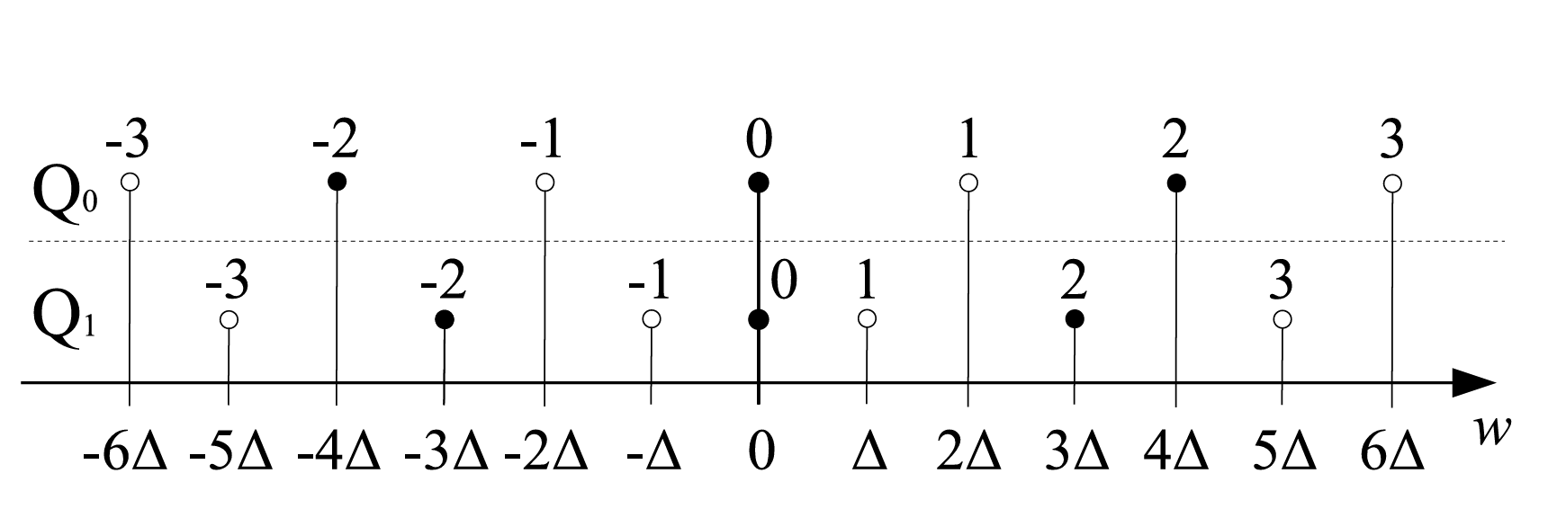
Figure 6: Illustration of the reconstruction points of the quantizers $Q_{0}$ and $Q_{1}$

Level coding for trigonometric transforms
If a trigonometric transform is used, a value last_scan_pos with $0≤last_scan_pos<l_{k}$ is transmitted first. Here, for all $j$ with $last_scan_pos<j<l_{k}$ one has

$$c[j]=0$$

and, if $last_scan_pos≠0$, one always has

$c[last_scan_pos]≠0.$ (2)

Then, starting with last_scan_pos, the coefficients $c[j]$ are sequentially coded in a backwards scan and in a single pass. Thus, one first codes $c[last_scan_pos]$ and then, until $j=0$, codes $c[j]$ after having coded $c[j+1]$.

The state Qstate[ j ] of the used state machine S that holds for the coefficient level c[ j ] is determined as follows. For j=last_scan pos, one initializes Qstate[ j ] = 0 and then, after the reconstruction of c[ j ], one updates Qstate[ j-1 ] according to the parity c[ j ]&1 of c[ j ] by invoking the respective state-transition table from the previous section.

The value of last_scan_pos is derived from the syntax elements last_sbb_index_gt0_flag, last_sbb_index_rem and last_index_offset, where

0 <= last_sbb_index_rem < ($l_{k}$>>1) – 1 and 0 <= last_index_offset < 2

as follows: If last_sbb_index_gt0_flag is equal to zero, one sets last_scan_pos = last_index_offset. Otherwise, one sets

last_scan_pos = ((last_sbb_index_rem+1)<<1) + last_index_offset.

The value of last_sbb_index_rem is binarized using a limited Exponential-Golomb code.

For the coding of a coefficient $c[j]$, its significance flag $abs_trafo_coeff_gt0_flag[j]$, defined as

$$abs_trafo_coeff_gt0_flag[j]=\left\{\begin{aligned}0, &c[j]=0 \\ 1, &c[j]≠0\end{aligned}\right.$$

is transmitted first except for the case that j = last_scan_pos and last_scan_pos>0 , where the value of abs_trafo_coeff_gt0_flag[j] is inferred to be $1$ in accordance to (2).
Next, if $abs_trafo_coeff_gt0_flag[j]≠0$, the absolute value $|c[j]|$ and the sign of $c[j]$ are transmitted. The absolute value is determined by the two syntax elements abs_trafo_coeff_offset[ j ] and abs_trafo_coeff_remainder[ j ], where

0 <= abs_trafo_coeff_offset[ j ] < 20 and 0 <= abs_trafo_coeff_remainder[ j ],

by using the relation

$\left|c[j]\right|=1+ abs_trafo_coeff_offset[ j ]+abs_trafo_coeff_remainder[ j ].$ (5)

The value abs_trafo_coeff_offset[ j ] is transmitted first using truncated unary coding. Then, if abs_trafo_coeff_offset[ j ] = 19, the value abs_trafo_coeff_remainder[ j ] is transmitted using Exponential Golomb coding. Finally, the sign is transmitted by the syntax element trafo_coeff_sign_flag[ j ].

The bins that belong to the prefix in the Exponential-Golomb binarization of last_sbb_index_rem are context coded where the context model selection depends on the position of a bin. For each channel, 15 context models are supported for the coding of these bins.

The flag $abs_trafo_coeff_gt0_flag[j]$ is context coded. The selection of the context model depends on the position j within the block, the template sum

$$\sum_{p=0}^{\min\left(2,l_{k}-j-2\right)}{|c[j+1+p]|}$$

of absolute values of up to three neighboring previously coded transform coefficient levels, and the parity of the state Qstate[ j ]. The reason for the latter dependency is that, from an encoder point of view, the reconstruction interval around zero is larger if Qstate[ j ] is even than it is if Qstate[ j ] is odd. For each channel, 54 context models for $abs_trafo_coeff_gt0_flag[j]$ are supported.

The bins of the truncated unary binarization of abs_trafo_coeff_offset[j] are context coded. The same context model is used for all bins. However, this context model is selected out of a set of 9 context models per channel, where the selection depends on the position j.

The bins that belong to the prefix in the Exponential-Golomb binarization of abs_trafo_coeff_remainder[ j ] are context coded where the context model selection depends on the position of a bin. For each channel, 31 context models are supported for the coding of these bins.

All other bins that occur in the proposed coding scheme for the trigonometric transforms are coded in bypass mode.

Reconstruction process for transform coefficients
Each transform coefficient level value c[ j ] is reconstructed by invoking a quantization stepsize $Δ$ that is transmitted in the bit stream. For the trigonometric transforms, this reconstruction process involves the state Qstate[ j ] at the current position j with respect to the specified state machine S which is determined as in the previous section. To ease notation, if the identity transform is used, it is assumed that Qstate[ j ] is equal to 0. Then, putting

$$σ\left(0\right)=0 and σ(c[j])=\left\{\begin{aligned}-1, &c[j]<0 \\ 1, &c[j]>0\end{aligned},\right.$$

the reconstruction of the intermediate residual coefficients can always be realized as

$$resImd\left[ j \right]=\left(2·c\left[ j \right]-σ\left(c\left[j\right]\right)⋅\left(Qstate\left[ j \right]\&1\right)\right)⋅Δ .$$

More details related to the proposed reconstruction process for transform coefficients can be found in clause 8.4 of the attached Proposed Draft Specification Text.

Sample wise prediction of reconstructed residual sample values
If the identity transform is used on the current block $b_{k,m}$, it is proposed to support a sample wise prediction for the residual samples $res\left[j\right]$ for the case that the prediction mode is, the Inter-Channel Prediction, the Block-Matching Prediction or the Zero Prediction mode.

More details related to the proposed sample wise prediction of residuals can be found in clause 7.3.3.4, clause 7.3.3.5, clause 7.4.4.4, clause 7.4.4.5 and clause 8.5 of the attached Proposed Draft Specification Text.

General form of sample wise prediction
The general proposed sample wise prediction works as follows.
Input are
- The reconstructed sample values
$$rec\left[ c \right]\left[ j \right], 0<= c≤\min\left(2, m-1\right)=C_{max} and 0<=j < l_{k},$$of the adjacent blocks $b_{k-1-c,m}$ from up to three previously coded channels
- The reconstructed residual sample values
$$resExt\left[j\right], 0<=j < tSize=16$$on the left adjacent template of size tSize which are obtained as in Section 3.2.5.
- The intermediate reconstructed residual sample values
$$resImd\left[j\right], 0<=j <l_{k}$$which are obtained as in Section 3.3.6.
- Two set of filter coefficients
$$F=\{α_{0},…, α_{tSize-1}\}, G=\{β_{0},…, β_{4}\},$$together with a filter precision pRF and the corresponding rounding offset offRnd = (1<<pRF).

The array of sample values u[ j ] with $–tSize< j < l_{k}$ is initialized for negative values of j according to

$$u\left[j\right]=resExt\left[tSize+ j\right], -tSize≤j<0.$$

The values u[ j ] are sequentially computed starting with j=0 and proceeding until $j=l_{k}-1$ by setting for each j:

$$u\left[j\right]=((\sum_{p=0}^{tSize-1}{α_{p}⋅u[}j-1-p]+ \sum_{c=0}^{C_{max}}{β_{c}⋅rec\left[c\right]\left[j\right]}+β_{4}+ ofRnd)≫pRF)+resImd[j].$$

Here the sum invoking the sample values of the previous channels is understood to be zero in the case that $C_{max}<0$.
The final reconstructed residual sample res[ j ] are set as

$$res\left[ j \right]= u\left[ j+tSize \right], 0≤ j<l_{k}.$$

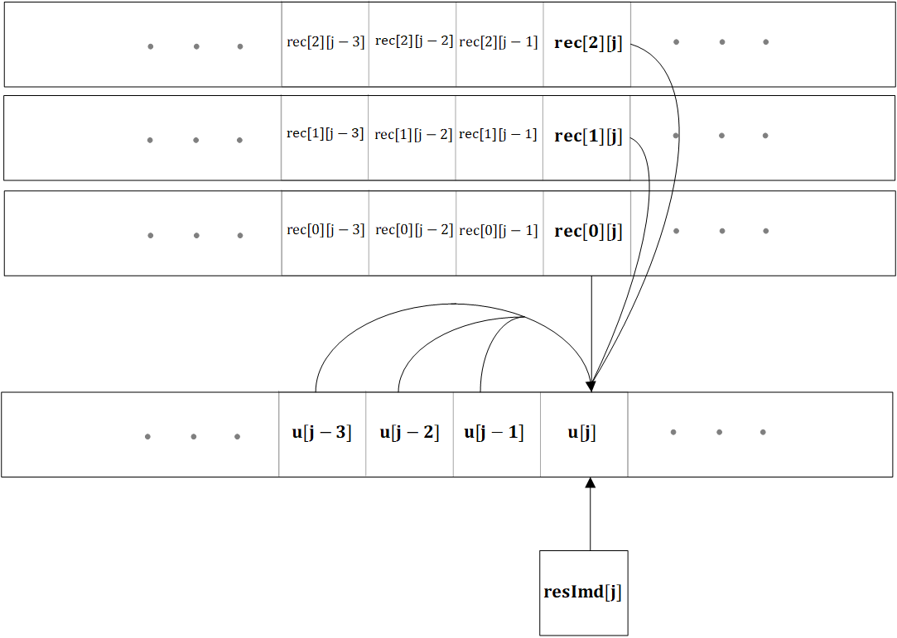
Figure 7: Illustration of the proposed sample wise prediction

Sample wise prediction with fixed weights
Three sample wise prediction modes with fixed weights are proposed. All three proposed modes do not invoke the samples from previous channels, which means that the weights $β_{c}$ are always zero for these modes.
First, the difference sample wise prediction mode, with

$$α_{0}=1, α_{p}=0 if p>0 and pRF=0.$$

is proposed.
Second, the slope sample wise prediction mode, with

$$α_{0}=3, α_{1}=-1, α_{p}=0 if p>1 and pRF=1.$$

is proposed.
Third, the half slope sample wise prediction mode with

$$α_{0}=5, α_{1}=-1, α_{p}=0 if p>1 and pRF=2.$$
is proposed.

The selection of the sample wise prediction mode with fixed weights is determined by the syntax elements spred_lpf_or_diff_flag, spred_lpf_flag and spred_rem_mode_idx as follows. If spred_lpf_or_diff_flag is equal to 1 and spred_lpf_flag is equal to 0, the difference sample wise prediction mode is used. If spred_lpf_or_diff_flag is equal to 0 and spred_rem_mode_idx is equal to 0, the slope sample wise prediction mode is used. If spred_lpf_or_diff_flag is equal to 0 and spred_rem_mode_idx is equal to 1, the half slope sample wise prediction mode is used

It is also proposed to support a complete bypassing of the sample wise prediction process, in which case the final residual sample values res[ j ] are proposed to be set to the intermediate residual values resImd[ j ]. This is invoked if spred_lpf_or_diff_flag is equal to 0 and spred_rem_mode_idx is equal to 2.

Sample wise prediction with adaptive weights
The proposed sample wise prediction with adaptive weights is used if the syntax elements spred_lpf_or_diff_flag and spred_lpf_flag are equal to one. If the sample wise prediction with adaptive weights is used, the values of the coefficients $α_{p}$and $β_{c}$ are coded in the bitstream.

The maximal number of non-zero coefficients $α_{p}$ is determined by the syntax element lpf_num_weights_idx with 0 < = lpf_num_weights_idx < 8 by setting

$$fltrSz= ((lpf_num_weight_idx+1) >>1 )$$

and inferring

$$α_{p}=0, if p≥fltrSz.$$
The filter precision $prF$ is set to 14 for the case of sample wise prediction with adaptive weights.

Transmission of filter coefficients for prediction from the current channel only
If the syntax element lpf_prev_ch_flag is equal to zero, it is proposed that no sample values from previous channels and no adaptive offset value are used for the sample wise prediction and thus it is proposed that $β_{c}$ is set to 0 for all c. In this case, for transmission and predictive coding, the values of the coefficients $α_{p}$ with 0 <= p < fltrSz are represented by the corresponding reflection-coefficients (sometimes also referred to as partial correlation or PARCOR coefficients) $μ_{p}$. The coefficients $α_{p}$ are derived from the coefficients $μ_{p}$ by invoking the following algorithm:

Set p = 0
do
$α_{p}=μ_{p}$
set q = 0
do
$γ_{q}= {α_{q}- μ}_{p}⋅α_{p-q-1}$
while( q < p)
set q = 0
do
$α_{q}=γ_{q}$
while ( q < p )
while( p < fltrSz )

For transmission, it is proposed that the values $μ_{p}$ are represented as a quadratic polynomial in a value $θ_{p}$. To determine the value $θ_{p}$, it is proposed that a value $δ_{p}$ is transmitted in the bitstream as follows. If abs_lpf_weight_greater0_flag[ p ] is equal to zero, one sets $δ_{p}=0.$ Otherwise, the absolute value ${|δ}_{p}|$ is inferred from the value of the syntax element abs_lpf_weight_minus1[ p ] by setting

$${|δ}_{p}|=abs_lpf_weights_minus1\left[ p \right]+1,$$

while the sign of $δ_{p}$ is inferred from the syntax element lpf_weight_sign_flag[ p ].

If the value of the syntax element lpf_prev_ch_flag is equal to 0, it is proposed to set $θ_{p}=δ_{p}$.

If the value of the syntax lpf_prev_ch_flag is equal to 1, it is proposed to set

$θ_{p} =δ_{p}+ θ_{p}^{prev}$,

where $θ_{p}^{prev}$ is a corresponding value of $θ_{p}$ from a previous block of the same channel.
After the reconstruction of the $θ_{p}$, it is proposed to update:

$$θ_{p}^{prev}=\left\{\begin{aligned}θ_{p}, &if p<fltrSz \\ 0, &else.\end{aligned}\right.$$

Transmission of filter coefficients for prediction invoking a previous channel
If the syntax element lpf_prev_ch_flag is equal to 1, it is inferred that samples from previous channels are to be invoked for the adaptive predictive filtering process. In this case, fltrSz many coefficients $α_{p}$ as well as $C_{max}+1$ many filter coefficients $β_{c}$ are coded. All coefficients are coded directly invoking the syntax elements abs_lpf_weight_greater0_flag[ ], $abs_lpf_weights_minus1\left[ \right]$ and lpf_weight_sign_flag[ ], which means that the reflection-coefficient representation as well as the predictive transmission of filter coefficients is disabled for this case. The reflection representation of filter coefficients is not used since, from an encoder point of view, the correlation matrix which is typically invoked to determine the filter coefficients by solving a system of linear equations is generally a Toeplitz matrix only if no sample values from previous channels are employed. On the other hand, the reflection coefficient representation can only be meaningfully derived for the solution of a linear equation $Ax = b$ when A is a Toeplitz matrix.

Proposed arithmetic coding engine
For entropy coding, the state-based probability estimator and arithmetic coding engine of the Neural Network Coding Standard (NNC, ISO/IEC 15938-17) with a few minor modifications are proposed. First, the two state variables per context model are represented with 10 and 13 bit, respectively, and the adaptation rates are set to 2 and 5, respectively. Next, the first 63 bins of each context model are encoded with an adaptation rate of 1 in order to allow a fast initial adaptation to the received bin sequence. The proposed coding of syntax elements of a channel employs separate context models per channel, as indicated for example in Section 3.3.3 and Section 3.3.5. However, for initialization, the channel dependency is neglected and the same initialization probability is used for a context model across all channels. Here, the initialization probability depends on the quantization parameter of the sequence, which is represented by the syntax element if_indep_init_block_qp. Initialization values have been trained on a set of bitstreams of all sequences of all three datasets and all working points. Further details about the proposed arithmetic coding engine can be found in clause 9.3. of the attached Proposed Draft Specification Text.

Encoder Algorithm
For the generation of the bitstreams, an encoding algorithm that is based on the minimization of Lagrangian costs D + $λ⋅R$ was used. In the case that the targeted error metric was the PRD, the error measure D was set to be the sum of squared errors. In the case that the targeted error metric was the CPRD, for each channel, the error measure D was set to be the sum of squared errors scaled with the inverse of the channel variance in accordance to the definition of the CPRD.

For the determination of the coding tools used per block, an encoder pre-search was invoked which determines a list of block based prediction candidates based on the sum of absolute transformed differences and the rate needed to transmit the prediction parameters. For all prediction candidates of the latter list, the Lagrangian costs of several combinations of these prediction modes with either a trigonometric transform or with the identity transform and sample wise residual prediction modes were computed. Here, for trigonometric transforms, the transform coefficient levels were determined by invoking trellis coded quantization. The coding mode for a given block was set to be the mode which minimized the Lagrangian cost among all tested modes. The block partitioning was determined at the encoder by a split-merge algorithm with a fixed maximal and minimal block size. In this algorithm, besides testing the partitioning of a block into smaller blocks, it is also tested to merge the left-most block of such a partitioning with the right-most subblock of a neighboring previously partitioned block in the case that both blocks have the same size strictly smaller than the maximum block size.

Experimental Results
In this section, average experimental results are presented for the three categories (ECG, EMG, EEG) of the Call for Proposals. For each of the three categories, three figures are displayed which have the rate on the horizontal axis and either the PRD, the CPRD or the PSNR on the vertical axis. Here, the PRD, the CPRD and the PSNR are computed as defined in the Call for Proposals.

For each working point of the Call for Proposals, the PRD, CPRD and PSNR values were averaged across all sequences of a category to obtain the corresponding average value at the given working point for the respective category.

For the PSNR of a given sequence at a given working point, the average of channel PSNRs was only computed over those channels for which the sum of squared errors was not equal to zero.

Each figure shows two curves corresponding to the two specific settings of the distortion function D for the encoder control which are described in the previous Section 4: The green curves display results that were generated with an encoder for which D is set to the sum of squared errors without a separate scaling per channel, thus targeting the PRD as an error metric. The blue curves display results that were generated with an encoder for which D is set to the sum of squared errors, scaled per channel as described in the previous Section 4, thus targeting the CPRD as an error metric. Except this difference in the scaling of the distortion function, the same encoder algorithm was applied for the generation of the blue and the green curves. The vertical grid lines in the curves correspond to the working points of the Call for Proposals.

Results for the ECG category

Figure 8: PRD values over bits per sample averaged per working point for the ECG dataset.

Figure 9: CPRD values over bits per sample averaged per working point for the ECG dataset.

Figure 10: PSNR values over bits per sample averaged per working point for the ECG dataset.

Results for the EMG category

Figure 11: PRD values over bits per sample averaged per working point for the EMG dataset.

Figure 12: CPRD values over bits per sample averaged per working point for the EMG dataset.

Figure 13: PSNR values over bits per sample averaged per working point for the EMG dataset.

Results for the EEG category
Figure 14: PRD values over bits per sample averaged per working point for the EEG dataset.

Figure 15: CPRD values over bits per sample averaged per working point for the EEG dataset.

Figure 16: PSNR values over bits per sample averaged per working point for the EEG dataset.

Patent rights declarations(s)
Fraunhofer HHI may have current or pending patent rights relating to the technology described in this contribution and, conditioned on reciprocity, is prepared to grant licenses under reasonable and non-discriminatory terms as necessary for implementation of the resulting ITU-T Recommendation (per box 2 of the ITU-T/ITU-R/ISO/IEC patent statement and licensing declaration form).

________________________

