ITU – Telecommunications Standardization Sector  STUDY GROUP 16 Question 6  Video Coding Experts Group (VCEG)  72nd Meeting: 16–20 October 2023, Hannover | Document: VCEG-BT04

Question: | Q.6/SG16 (VCEG)
Source: | Yan Ye (Alibaba)  Sean McCarthy (Dolby)  Han Boon Teo (Panasonic)  Zhuoyi Lv (vivo)  Shiqi Wang (CityU)  Kai Zhang (Bytedance)  Marta Karczewicz (Qualcomm)  Iole Moccagatta (Intel) | Email: | yan.ye@alibaba-inc.com  Sean.McCarthy@dolby.com  hanboon.teo@sg.panasonic.com  zhuoyi.lv@vivo.com  shiqwang@cityu.edu.hk  martak@qti.qualcomm.com  iole.moccagatta@intel.com
Title: | On VVC-assisted ultra-low rate generative face video coding
Purpose: | Proposal
_____________________________

Abstract
This contribution provides a brief overview of generative face video coding algorithms and shows that they can achieve significantly better reconstruction quality than the state-of-the-art VVC standard at ultra-low bitrate ranges. JVET has been studying these algorithms since the beginning of this year. Given JVET’s successful track record of developing 2D video coding standards, the proponents of this contribution suggest that JVET continue to be tasked with the exploration and potential standardization of ultra-low bitrate 2D generative face video coding methods.
- Background
Recently, deep generative models, especially generative adversarial network (GAN) [1], have shown great potentials in compression of talking-head video (referred to as face video in this contribution). In [2]-[9], various authors proposed video coding systems that rely on generative models to reconstruct moving pictures. Similar to model-based coding [10]-[12] studied in the 1990’s, a generative model-based encoder uses the analysis model to extract compact information about the face, which can economically represent the input face video with a small number of transmitted parameters (e.g., facial semantics, facial landmarks, temporal motion features, etc.). At the decoder, a deep generative model can use the decoded parameters and a key picture to reconstruct high quality face images. Compared to the early work on model-based video coding, which had to rely on much simpler synthesis methods, nowadays deep generative networks provide significantly higher capability to infer and synthesize the reconstructed video based on the compact parameters, resulting in much better reconstruction quality.
Figure 1 illustrates the system block diagram of a generative face video codec. The system consists of two parts. The first part is coding of the key picture, which is used to provide essential texture information about the face. The key pictures are coded using a traditional video codec such as VVC. The second part of the system uses analysis model to extract and convey motion information economically, and uses synthesis model to reconstruct the face pictures based on the texture information and the motion information thus conveyed. All of the prior work in this area [2]-[9] share this system diagram, and the main difference between them is the specific choice of parameters that the analysis model extracts and transmits. The types of parameters used in [2]-[9] include 2D landmarks, 2D keypoints, region matrix, 3D keypoints, compact motion features and facial semantics. Though different systems result in different trade-offs of bitrate versus reconstruction quality, they have all demonstrated the ability to achieve much higher reconstruction quality of the face images compared to VVC at ultra-low rates, as will be shown in Section 2.
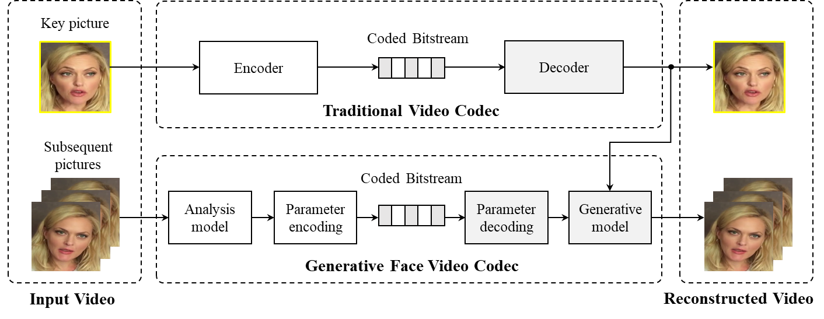
Figure 1 - General system diagram of a generative face video codec

Coding performance with generative face video codecs
A set of 50 face video sequences, cropped from the open source VoxCeleb2 dataset (https://www.robots.ox.ac.uk/~vgg/data/voxceleb/vox2.html) were used to showcase the coding efficiency of the generative face video coding methods in comparison with VVC, especially at ultra-low rates. A snapshot of the video set is shown in Figure 2. Figure 3 shows the rate distortion performance of different generative methods compared to that of VVC. Traditional metrics such as PSNR do not have a strong correlation with subjective quality, and are especially unsuitable for generative coding methods which do not optimize for sample-level fidelity. For this reason, in Figure 3, two well-known perceptual metrics, Deep Image Structure and Texture Similarity (DISTS) [15] and Learned Perceptual Image Patch Similarity (LPIPS) [16], are used to measure distortion. Note that smaller DISTS and LPIPS values indicate better perceptual quality. It is clear that the generative methods not only have far better rate distortion performance compared to VVC, they also operate at ultra-low bitrate ranges that are currently not reachable by VVC.

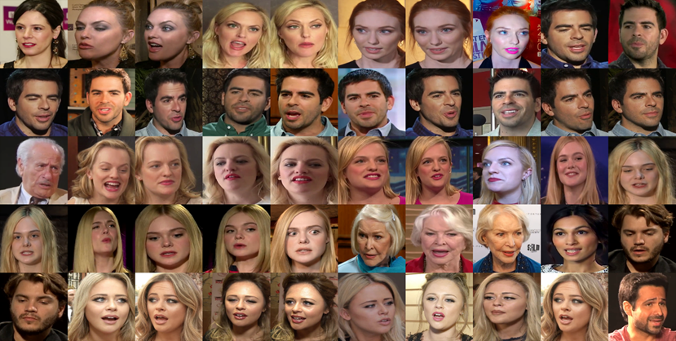
Figure 2 – Test set of 50 face video sequences

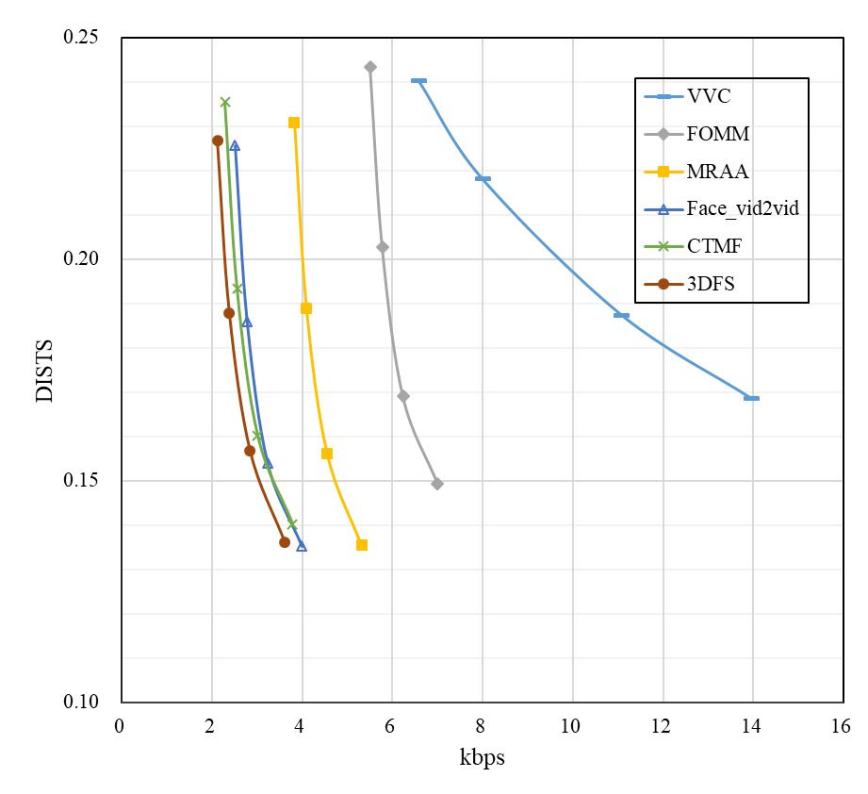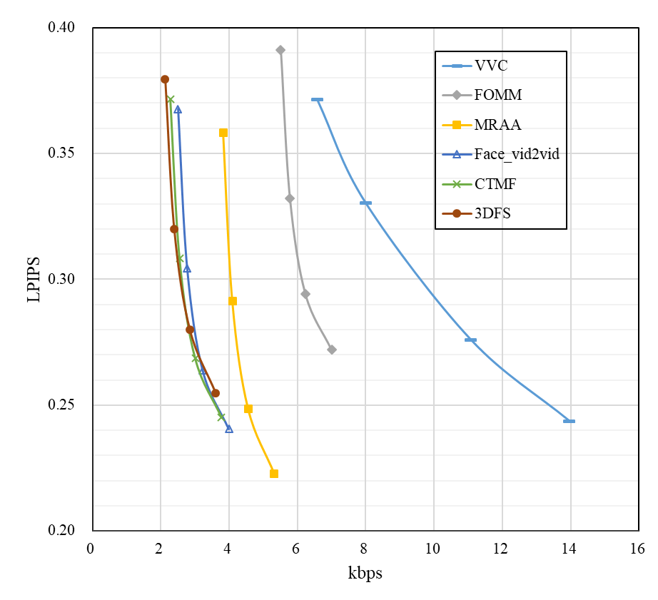
Figure 3 – Rate distortion performance of a generative face video codec measured by two perceptual quality metrics: DISTS (left) and LPIPS (right)
Reconstructed face images are shown in Figure 4 to provide comparison of reconstruction quality using VVC and a few generative coding schemes at similar bitrates. It can be seen that at ultra-low bitrates, VVC reconstructed face images are unrecognizable, whereas generative coding methods can still reconstruct vivid faces. Figure 5 compares coded bitrates of different coding schemes when reconstructed quality is approximately the same. It can be seen that VVC needs almost 3 times the bitrate as the generative methods in order to deliver similar quality. Video demos using more test sequences will be shown during presentation at the meeting, and will emphasize very similar observations.

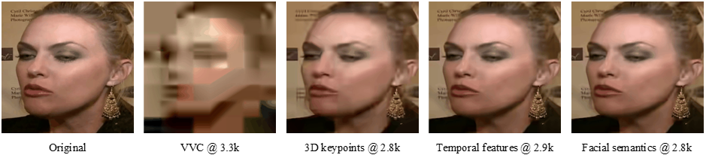
Figure 4 – Comparison of reconstruction quality using VVC vs. generative face video coding methods at similar coded bitrates

Figure 5 – Comparison of coded bitrates using VVC vs. generative face video coding methods at similar reconstruction quality
- Proposal
Results above have demonstrated the power of a deep generative network to enable the following use cases, which are currently unavailable in the VVC standard:
- Ultra-low rate communication: the key pictures can be sent with large time gap in between, and in between two key pictures, only a few facial parameters per time instance need to be sent, significantly reducing the coded bit rate compared to coding all pictures using VVC;
- User-specified animation/filtering: face animation and face filters have become very popular in many mobile apps. These apps can alter or manipulate face video captured using the camera on the phone. As the encoder has the uncoded face images, it can extract more precise facial landmarks and/or keypoints, facilitating higher quality facial animation at the decoder side.
In terms of device readiness, the work in [2] provides evidence that current-generation mobile devices already have the capability to run a generative face video compression codec in real time.
A number of contributions have been made to the JVET group to advocate for adding syntax to VVC-coded bitstream to support generative face video coding:
- Jan 2023 meeting: JVET-AC0088
- April 2023 meeting: JVET-AD0051
- July 2023 meeting: JVET-AE0080, JVET-AE0083, JVET-AE0088, JVET-AE0280
These contributions proposed to carry various face parameters such as landmarks, keypoints, transformation matrices, temporal motion feature matrices, facial semantics, etc., in a new SEI message. However, during the discussion at JVET, it has been suggested to study other ways of standardizing a generative face video coding system, e.g., as a separate profile of VVC, which would solve the problem of interoperability that carrying these parameters in an SEI message would create. At this meeting, contribution JVET-AF0048 shares some recent work that aimed at addressing the interoperability issue.
It is proposed that JVET be tasked with the exploration and potential standardization effort with focus on ultra-low rate 2D face video coding. JVET is familiar with this topic as technical discussions have been ongoing since January 2023. Undoubtedly JVET has the expertise to develop efficient 2D video coding standards. Further, as shown in Figure 1, all the generative face video coding systems rely on a traditional codec to code the key pictures (which provide essential texture information to the generative models), the work on generative face video coding can also be considered an extension to VVC, which JVET developed.

References
- Goodfellow I, Pouget-Abadie J, Mirza M, et al. “Generative adversarial nets,” Advances in neural information processing systems, vol. 27, 2014.
- Oquab M, Stock P, Haziza D, et al. Low bandwidth video-chat compression using deep generative models[C]//Proceedings of the IEEE/CVF Conference on Computer Vision and Pattern Recognition. 2021: 2388-2397.
- Konuko G, Valenzise G, Lathuilière S. Ultra-low bitrate video conferencing using deep image animation[C]//ICASSP 2021-2021 IEEE International Conference on Acoustics, Speech and Signal Processing (ICASSP). IEEE, 2021: 4210-4214.
- Feng D, Huang Y, Zhang Y, et al. A generative compression framework for low bandwidth video conference[C]//2021 IEEE International Conference on Multimedia & Expo Workshops (ICMEW). IEEE, 2021: 1-6.
- Siarohin A, Lathuilière S, Tulyakov S, et al. First order motion model for image animation[J]. Advances in Neural Information Processing Systems, 2019, 32.
- Siarohin A, Woodford O J, Ren J, et al. Motion representations for articulated animation[C]//Proceedings of the IEEE/CVF Conference on Computer Vision and Pattern Recognition. 2021: 13653-13662.
- Wang T C, Mallya A, Liu M Y. One-shot free-view neural talking-head synthesis for video conferencing[C]//Proceedings of the IEEE/CVF conference on computer vision and pattern recognition. 2021: 10039-10049.
- Chen B, Wang Z, Li B, et al. Beyond keypoint coding: Temporal evolution inference with compact feature representation for talking face video compression[C]//2022 Data Compression Conference (DCC). IEEE, 2022: 13-22.
- Chen B, Wang Z, Li B, et al. Interactive Face Video Coding: A Generative Compression Framework[J]. arXiv preprint arXiv:2302.09919, 2023.
- Pearson D E, Robinson J A. Visual communication at very low data rates[J]. Proceedings of the IEEE, 1985, 73(4): 795-812.
- Musmann H G, Hötter M, Ostermann J. Object-oriented analysis-synthesis coding of moving images[J]. Signal processing: Image communication, 1989, 1(2): 117-138.
- Nakaya Y, Chuah Y C, Harashima H. Model-based/waveform hybrid coding for videotelephone images[C]//Acoustics, Speech, and Signal Processing, IEEE International Conference on. IEEE Computer Society, 1991: 2741, 2742, 2743, 2744-2741, 2742, 2743, 2744.
- Chen B, Chen J, et al. “AHG9: Generative Face Video SEI Message,” The Joint Video Experts Team of ITU-T SG 16 WP 3 and ISO/IEC JTC 1/SC 29, doc. no. JVET-AC0088, January 2023.
- Chen B, Chen J, et al. “AHG9: Common SEI Message for Generative Face Video,” The Joint Video Experts Team of ITU-T SG 16 WP 3 and ISO/IEC JTC 1/SC 29, doc. no. JVET-AD0051, April 2023.
- Ding K, Ma K, Wang S, et al. Image quality assessment: Unifying structure and texture similarity[J]. IEEE transactions on pattern analysis and machine intelligence, 2020, 44(5): 2567-2581.
- Zhang R, Isola P, Efros A A, et al. The unreasonable effectiveness of deep features as a perceptual metric[C]//Proceedings of the IEEE conference on computer vision and pattern recognition. 2018: 586-595.

________________________

The two contribution documents of the April 2023 meeting were erroneously also marked as “BT”. This is a document of the meeting held in Hannover, Germany, in October 2023.

