Rapporteur Meeting of Questions 1, 2, 3, 5 and 21/16
TELECOMMUNICATION  STANDARDIZATION SECTOR  STUDY PERIOD 2013-2016 |  |  | STUDY GROUP 16
 |  |  | Original: English
Question(s): | 1, 2, 3, 5, 21 | Oslo, 17 - 21 June 2013
RAPPORTEUR MEETING DOCUMENT
Source: | Meeting host
Title: | Additional information about meeting location and transportation
Purpose: | Information

Summary
This document provides some additional information about the Cisco meeting location in Lysaker. It also describes some of the transportation options available to attendees.
Cisco Systems Norway, Lysaker – main building:
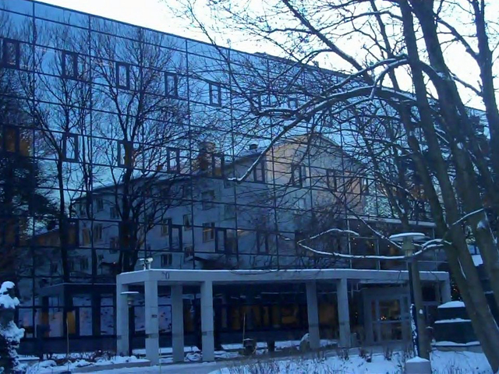

Reception opening hours
Monday to Thursday 08:00 – 17:00
Friday 08:00-16:00

How to find us
Cisco systems Norway
Philip Pedersens vei 20
1366 Lysaker
+47 67 125 125
e-mail: reception_lysaker@cisco.com

By Car
From Oslo: Take the E18 towards “Drammen”, and take the exit at “Lysaker”. Go left on the first roundabout, and right on the next roundabout. Follow “Gamle Drammensvei” and continue onto “Professor Kohts vei” for about 400 meters until you see two black buildings to your left. Take a left on Philip Pedersens vei.
From Drammen: Take the E18 towards “Oslo” and take the exit at “Strand/Stabekk”.
Turn right at the roundabout, then go straight. Follow “Markalléen” and continue onto
“Professor Kohts vei” for about 500 metres until you see two black buildings to your right. Take a right on Philip Pedersens vei.
The main building and reception is located in the larger of the two buildings.

Arriving by Air
The closest airport is Oslo airport Gardemoen (OSL).
The Oslo Airport Express Train (Flytoget) leaves from inside the Oslo Airport terminal building 70 meters to the right after leaving the custom area in the arrival hall. Your train ticket must be bought before boarding the train. There is a ticket office and vending machines in the arrival area before accessing the train. This service is the fastest and most frequent way of travelling between the Airport and the city. This is also one of the fastest going airport trains in the world running at a speed of 210 km/h.
The train takes you downtown to Oslo Central Station (Oslo S) in 19 minutes and leaves every 10 minutes. Every second train also stops at Lillestrøm, Oslo Central Station, Nationaltheatret, Skøyen, Lysaker, Sandvika and Asker.
From the central station, if you are not familiar with the area, the easiest is to simply take a taxi to your hotel. If you are more adventurous, most hotels being located close to the Royal Palace and Karl Johans gate, you could get off at the National Theatre train station (Nationaltheatret) and walk 10 or 15 minutes to your hotel.
If you wish to travel directly to Cisco, you need to get off at Lysaker Station and take a taxi from there. Travel time from the airport to Lysaker is about 40 minutes and the Cisco office is 5 minutes from the train station by car. There is a taxi stand right outside of the station. You can also take the bus to the Cisco Office, bus 151 or 252 to "Oksenøyveien", this is the next bus stop after Lysaker station and it stops right outside the main building. The entrance to the office is located on the opposite side of the building.

From Oslo to Lysaker
Most hotels are located in Oslo. The lists of hotels provided in the meeting notice are conveniently located close to the Royal Palace and Karl Johans gate, in a central part of Oslo, about 15-20 minutes (by taxi or bus) from the Cisco office in Lysaker.
Again, the easy, but more expensive way, is to take a taxi to the Cisco office. The hotel will arrange a taxi for you and, if you share it with other attendees, it should be reasonable. Taxis are expensive. Taxi companies have a starting fee (0-160 NOK) and a fee per kilometer that varies from 14-30 NOK.
You can also take the bus to the Cisco Office, bus 151 or 252 to "Oksenøyveien", this is the next bus stop after Lysaker station and it stops right outside the main building. The entrance to the office is located on the opposite side of the building. One conveniently located bus stop, close to the hotels, is at the corner of Karl Johans gate and Fredriks gate. The bus routes usually start at the Oslo bus terminal (Bussterminal).

Cisco Lysaker campus
At the Lysaker site, Cisco has three buildings: Lysaker 01, Lysaker 02 and Lysaker 03. See picture below for location. The ITU-T Rapporteur meeting will take place in Lysaker 02.
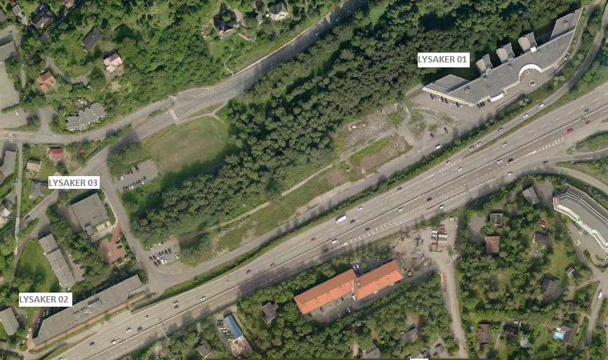

Taxis service
The preferred Taxi Service company in Lysaker is Asker & Bærum taxi – 06710/81533815
Payment methods are cash or credit card.

Parking
Parking is free outside all buildings during daytime, after7 pm you need a valid parking ID. To avoid a parking ticket 700 NOK, please pick up a Cisco/Q-park parking ID from the reception.

Bus and train
Bus 151 or 252 from Oksenøyveien to Lysaker train station (connects to airport express train) and to the center of Oslo.
Train to Gardermoen airport departs from Lysaker train station every 20 minutes. First departure is 04:27 and the last is at 23:47.
Bus stop Oksenøyveien to travel to Lysaker station or Oslo is located on the other side of E18 motorway. The figure below shows how to walk to the bus stop using the pedestrian underpass. When arriving from Oslo or Lysaker station, the bus stop is located right next to the Lysaker 02 building.
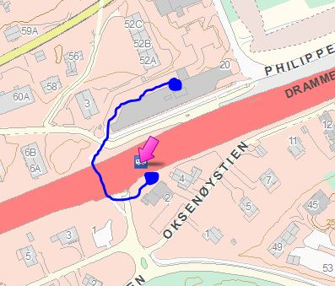

Lunch
They are two cafeterias (canteen) on the campus. A small one in the building where the meeting will take place and a larger one, with more food options, in building 01, a 5 minute walk.

Smoking policy
There is no smoking on site, except in designated smoking areas (front of the building). All cigarettes must be fully extinguished and placed in the appropriate ash cans.

__________________

