 | INTERNATIONAL TELECOMMUNICATION UNION  TELECOMMUNICATION  STANDARDIZATION SECTOR  STUDY PERIOD 2025-2028 |  | VCEG-CA03-v1
 |  |  | STUDY GROUP 21 QUSESTION 6
 |  |  | Original: English
Question(s): |  | Q6/21 |  | q
CONTRIBUTION
Source: |  | Huawei Technologies Co., Ltd,
Title: |  | On ultra-low latency and packet loss resilience functionality
Contact: |  | Sergey Ikonin  Xiang Ma  Elena Alshina |  |  | sergey.ikonin@huawei.com  maxiang6@huawei.com  elena.alshina@huawei.com

Abstract
In order to insure the ultra-low latency and packet loss resilience requirement will be satisfied, this contribution suggests to address this functionality during collaborative phase of next generation video coding standard, and use the test conditions designed by JVET-AhG18 and approved by JVET as document JVET-AN2039, for assessment the technologies and finding proper balance of loss in coding efficiency and benefits achieved by error resilience at the coding layer.

Introduction
The AhG18, established by JVET in January 2025, designed test conditions [1] exercising behavior and reconstruction quality in respect to different latency restrictions in the range of 16 to 50ms. During the discussions this latency range was assessed as appropriate estimation corresponding to desired end-to-end latency in interactive video applications such as cloud gaming, cloud desktop, screen casting etc. impacting the user experience.
The abovementioned video applications use network connection, typically wireless one such as Wi-Fi or 5G between sending (encoder) and receiving (decoder) side. Under latency restriction the delivery all the information required for decoding can not be guarantied. Some packets can be lost and delayed on the way and be not available in time, affecting decoding and reconstruction performance. Jitter buffer or retransmission can not solve the problem because of the latency constraint. In order to study the performance and latency restriction impact AhG18 designed test conditions , corresponding software and evaluation framework.

Clarifications of ultra-low latency and packet loss resilience
During the discussion of last meeting, several experts expressed questions about the meaning and requirement of ultra-low latency and packet loss resilience. This proposal includes the clarifications of those questions.

The meaning of ultra-low latency
The real-time applications scenarios need consistent ultra-low latency (ultra-low latency and smoothness), to keep a high-quality user experience, especially for applications with user interaction. Based on the analysis of the end-to-end pipeline [2], the latency of capture, encoding, decoding and display is stable since they are conducted on hardware. The latency from hardware encoder and decoder is typically very small (e.g., 5-7 ms per frame), and cannot exceed frame-to-frame distance at most to guarantee real-time performance. Among the modules in the pipeline, transmission is the module with most unstable processing time, because it highly depends on the transmission condition, which may vary quickly and significantly, and cannot be adapted quickly by the transmission system due to the latency constrain. When a packet loss happens in the transmission process, the decoder cannot start decoding a frame even if all other packets of the frame have been received successfully. Retransmission of the lost packet may take place one or multiple times, which will increase the delay significantly. Larger jitter buffer can improve the smoothness of decoding process, however it will also increase the end-to-end latency breaking the requirement and affecting user experience.
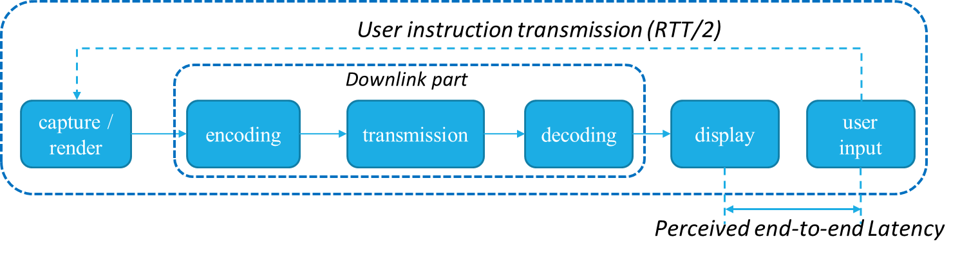
Figure 1 Interactive video application pipeline
Ultra-low latency does not necessarily demand a new 'fast codec' – modern hardware encoders and decoders are already sufficiently fast. For example, the main desktop/server hardware (like Nvidia) could archive 2160P @200+fps in encoder [3], and 1080P@800-1800fps in decoder with different GPU architectures [4], and the main mobile hardware (like Qualcomm) could archive 4K@120fps in encoder [5], and 8K@60fps in decoder [5]. Further decreasing the processing time of encoder and decoder will not provide much help to the end-to-end latency reduction at the application level. The key challenges rather lie in packet loss resilience and transmission reliability under real-world network conditions

The requirement of ultra-low latency and packet loss resilience
During the requirements collection phase for the next generation video coding standard, several companies submitted proposals emphasizing ultra-low latency and packet loss resilience, driven by their business needs [6-12].
Furthermore, in the successful joint workshop between ITU and ISO/IEC on the next-generation video coding standard [13], multiple companies highlighted the importance of low latency and/or robustness against packet loss [14].
As a result, the ultra-low latency and packet loss resilience have been formally included in the official use cases and requirements document for the next-generation video coding standard [15].
With the error resilience functionality in the codec, the wireless communication channel can provide “more efficient transmission schemes tailored to service needs, avoiding unnecessary redundant transmission protection mechanisms” [16], and then increase the throughput and user capacity up to 18-33% [17]. Even the wireless standard evolves, the inherent logic will not be changed. Besides the discussion in wireless standard group, the AI Codec with loss resilient was also studied in WebRTC platform [18], the P98 frame delay could be reduced by 2x-5x, and non-rendered frames could be reduced by up to 95%.

Test conditions for ultra-low latency and packet loss resilience
The common test conditions for ultra-low latency and packet loss resilience functionality designed by AhG18 and approved by JVET as document JVET-AN2039 evaluates the reconstruction quality under different latency restrictions in the range of 16 to 50ms. The several quality metrics such as freeze ratio, average and worst case PSNR obtained at four different QPs (from 22 to 37) are collected to reporting excel template. To evaluate BD-Rate impact of error resilient technologies the reconstruction quality on the channel without packet loss and latency restrictions is also collected, which corresponds to regular compression efficiency test normally conducted in JVET. Therefore, the testing procedure and reporting template allows to estimate the balance of BD-rate and complexity impact, and benefits achieved by loss resilience.
The simulation software for conducting the test described above is available as part on AhG18 repository [19], and includes emulation of transmission network based on pre-recorded packet trace files for Wi-Fi and 5G connections, jitter buffer, and latency model. The test environment allows to exercise and evaluate error resilience aspects of different compression technologies under same network transmission problems causing burst packet loss at the level of 20% and above. To avoid test overfitting on specific network pattern a random initialisation of starting point in network pattern is assumed. Three different randomized starting points are defined and the performance is evaluated by statistical averaging across these starting points and different connection types.
Figure 2 ULL evaluation framework
The network model includes capabilities to evaluate performance on communication channel with transmission priorities, which can be supported by modern existing and emerging protocols such as QUIC and L2 protocols of Wi-Fi and 5/6G, allowing to evaluate the benefits of coding and transmission layers collaboration.

Response to Joint Call for Evidence in ultra-low latency and packet loss resilience functionality category
The subset of test conditions described above has been used by contribution JVET-AN0080 “AHG18: CfE response in additional functionality on ultra-low latency and packet loss resilience” [20] in response to joint Call for Evidence [21]. The response was evaluated by formal expert viewing during October JVET meeting in Geneva. The evaluation results reported in JVET-AN2029 [22] confirmed the evidence of substantial improvement over error-resilient version of VTM. Couple of examples of MOS plots are provided below. The complete set can be found in the report JVET-AN2029 [22]
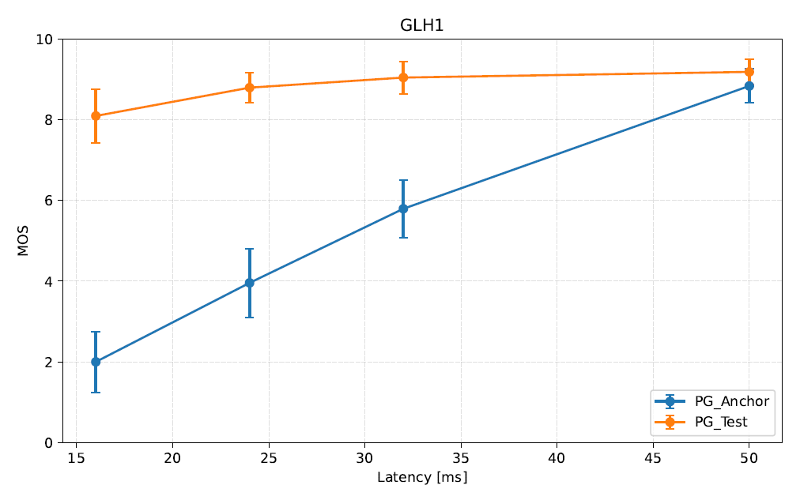
Figure 3 MOS plot of CfE response JVET-AN0080 (Test) vs. VTM (Anchor), Unicast scenario,
DOTA2s360 sequence, JVET-AN2029
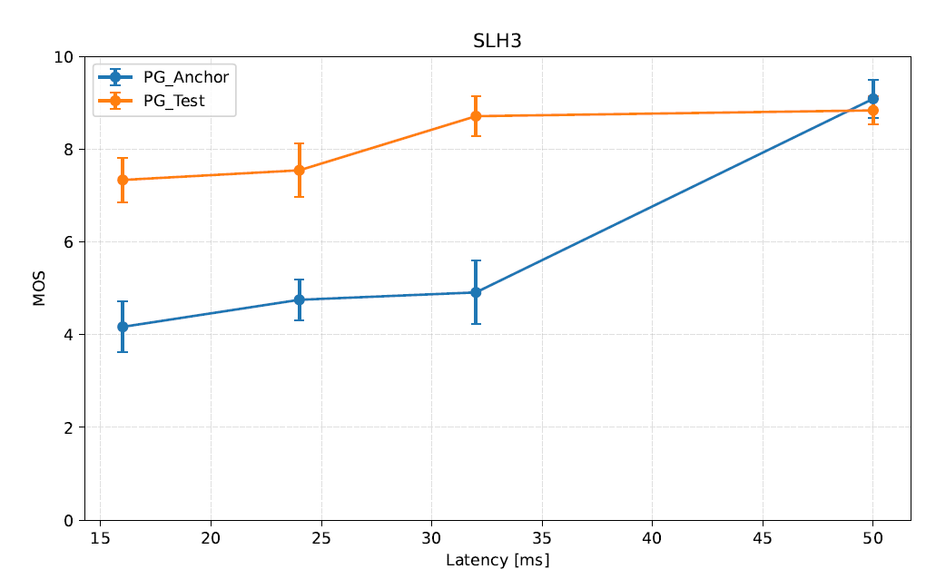
Figure 4 MOS plot of CfE response JVET-AN0080 (Test) vs. VTM (Anchor), Broadcast scenario,
GregoryScart2 sequence, JVET-AN2029

Conclusion
Considering industry requirements, as well as progress in test condition design and technical research within JVET, it is suggested that ultra-low latency and packet loss resilience functionality be addressed during the collaborative phase of next-generation standard development. Given the rapidly growing popularity of interactive low-latency applications in recent years—far beyond what was seen decades ago—the video coding standard must proactively tackle transmission-related challenges posed by real-time, time-sensitive video applications. Drawing on the collective expertise and collaboration of standardization experts, ultra-low latency and packet loss resilience functionality will become one of the most distinctive and strategically important features of the next-generation standard. This will distinguish it from both previous generations and competing standards developed by other organizations, and stimulating wider adoption by the industry.

References
- Common test conditions for technology targeting ultra low latency and packet loss resilience, S. Ikonin, S. Deshpande, V. Zakharchenko, JVET-AN2039, October 2025.
- Low latency Wi-Fi transmission simulation and suggestions on codec requirements, S. Ikonin, X. Ma, I. Gribushin, M. Sychev, V. Khamidullin, R. Shabaev, E. Alshina, JVET-AK0193, January 2025.
- https://developer.nvidia.com/blog/improving-video-quality-and-performance-with-av1-and-nvidia-ada-lovelace-architecture/?f_link_type=f_linkinlinenote&flow_extra=eyJpbmxpbmVfZGlzcGxheV9wb3NpdGlvbiI6MCwiZG9jX3Bvc2l0aW9uIjowLCJkb2NfaWQiOiJjYWZiNGRiY2VkYjYxYmI1LTA0MzNmMThmMWJkODRiOWQifQ%3D%3D
- https://docs.nvidia.com/video-technologies/video-codec-sdk/13.0/nvdec-application-note/
- https://www.qualcomm.com/smartphones/products/8-series/snapdragon-8-elite-gen-5
- Comments on the requirements for the next generation video coding standard, Jingxin Li (CESI), Yin Zhao (Huawei), Yuan Zhang (China Telecom), Siwei Ma (Peking University), Hui Yuan (Shandong University), Qian Zhang (BOE), m69713, Kemer, November 2024.
- Proposed additional requirements for the next generation video coding standard, S. Wenger (Tencent), m69793, Kemer, November 2024.
- Requirements for future video coding, Justin Ridge, Jill Boyce, Miska Hannuksela, Jani Lainema, Ville-Veikko Mattila, Sebastian Schwarz (Nokia), m70192, Kemer, November 2024
- Market Needs: Orange response to the market needs questionnaire on NextGenVideoCodec, Julien Lemotheux (Orange), m70762, Geneva, January 2025.
- Gap analysis and suggested updates to next-generation video coding requirements draft, Jonatan Samuelsson-Allendes, Sachin Deshpande, Tomohiro Ikai (Sharp), m71221, Geneva, January 2025.
- On requirements for next generation video coding standard, Lukasz Litwic, Anders Furuskär (Ericsson), m73483 , Daejon, June 2025.
- Implementation of error resilient transmission system for scalable services, S. Iwamura, S. Nemoto, Y. Kondo, A. Ichigaya (NHK), JVET-AM0235, Daejon, June 2025
- ITU and ISO/IEC JTC 1 SC 29 Joint ​ Workshop on “Future video coding – advanced signal processing, AI and standards”, https://www.itu.int/en/ITU-T/Workshops-and- Seminars/2025/0117/Pages/default.aspx
- https://www.itu.int/en/ITU-T/Workshops-and-Seminars/2025/0117/Pages/programme.aspx
- Draft of use cases and requirements for potential next-generation video coding standard beyond VVC capability, ISO/IEC SC 29/WG 2 document N 448 and ITU-T Q6/21 document VCEG-BX25, April 2025.
- AI/ML use cases for 6GR air interface, 3GPP TSG RAN WG1 #123, R1-2508732, Dallas, USA, November, 2025.
- Views on AI/ML in 6GR air interface , 3GPP TSG-RAN WG1 #122, R1-2507064 , Prague, Czech Republic, October, 2025.
- GRACE: Loss-Resilient Real-Time video through neural codecs, Cheng Y, Zhang Z, Li H, et al. 21st USENIX Symposium on Networked Systems Design and Implementation (NSDI 24), Santa Clara, April 2024.
- AhG18 simulation software, https://vcgit.hhi.fraunhofer.de/jvet-ahg-ull/VVCSoftware_VTM/
- AHG18: CfE response in additional functionality on ultra-low latency and packet loss resilience, S. Ikonin, V. Khamidullin, I. Gribushin, M. Sychev, K. Malyshev, A. Dzugaev, A. Bovsha, X. Ma, E. Alshina, JVET-AN0080, October 2025.
- Joint Call for Evidence on video compression with capability beyond VVC, J-R. Ohm, M. Wien, F. Bossen, JVET-AM2026 / SC 29 / WG 5 N 367, July 2025.
- Results of the Joint Call for Evidence on video compression with capability beyond VVC, F. Bossen, J.-R. Ohm, M. Wien, JVET-AN2029, October 2025.

_______________________

