ITU – Telecommunications Standardization Sector  STUDY GROUP 21 Question 6  Video Coding Experts Group (VCEG)  79th Meeting: 25 April – 1 May 2026, Santa Eulària, Spain | Document VCEG-CA02-v1

Question: | 6/21 (VCEG)
Source: | Iraj Sodagar (Dolby Laboratories) | Email: | irajs@live.com
Title: | [HSTP-MMAuth] Proposed update to the HSTP-MMAuth draft technical paper
Purpose: | Proposal
_____________________________

Abstract
This contribution provides an update to the HSTP-MMAuth technical paper draft.

Introduction
The attached document provides an update to the HSTP-MMAuth technical paper draft (that was reviewed at the last Q6 meeting.
The updates include:
- Adding references, terms, and definitions
- Adding summary, scope, keywords
- Editing the text for consistency of terms and adding references.

Proposal
We suggest updating the draft with these changes and additions.

 |  | International Telecommunication Union
 |  | ITU-T | Technical Paper
 |  | TELECOMMUNICATION  STANDARDIZATION SECTOR  OF ITU |  | dd MMM YYYY
HSTP-MMAuth
Multimedia authentication framework, workflows and procedures

Summary
This technical paper provides an overview of media authentication for end-to-end media streaming, file transfer and broadcast workflows. It includes the functional description of various entities, the workflow procedures and the definition of interfaces.

Keywords
authentication, media authentication, media delivery, provenance, verification, streaming, file transfer, broadcast, certificate, certificate authority, X.509

Change Log
This document contains Version 1 of the ITU-T Technical Paper HSTP-MMAuth on "Multimedia authentication framework, workflows and procedures" approved at the ITU-T Study Group 21 meeting held in Geneva, dd-dd MMMM YYYY.

Editor: | Iraj Sodagar  Dolby Laboratories  USA | Tel:  E-mail: irajs@live.com

CONTENTS
Page
3 Scope 1
4 References 1
5 Terms and definitions 1
5.1 Terms defined elsewhere 1
5.2 Terms defined here 2
6 Abbreviations 2
7 Media authentication end-to-end workflows 2
7.1 Streaming Workflow 2
7.2 File-based workflow 4
7.3 Cross-authentication workflow 5
7.4 Broadcast workflow 6
7.5 General considerations 7
7.6 Content properties 7
7.7 Authentication properties 7
8 Authentication Functions 8
8.1 Authentication author (generate/validate/update) 8
8.2 Authentication Verifier 8
8.3 Certificate Infrastructure 8

List of Figures
Page
Figure 1: The media authentication workflow for streaming 3
Figure 2: The media authentication workflow for file-based transfer 4
Figure 3: File-based workflow with cross authentication (x-auth) of different Media types 6
Figure 4: The media authentication workflow for broadcast 6

Technical Paper ITU-T HSTP-MMAUTH
ITU-T Technical Paper
Multimedia authentication framework, workflows and procedures

Summary

This Technical paper provides a general framework for media authentication in streaming, file based and broadcast workflows. The end-to-end workflows cover capture and ingest, delivery and distributions, and playback of the content. The functions and interfaces needed for media authentication and verification are introduced in these workflows, along with the interaction between different entities.

Scope
This report only covers media authentication procedures that authentication is achieved by attaching metadata to the content and the verification is performed using these metadata and through interaction with a certification infrastructure. In such process, the metadata contains information about the provenance information including ownership, and optionally revisions and edits as well as the capture/creation location and time, and other information such as the origin and original copies of the assets used to create the media content. The information also includes authentication signature(s) as well as owner certificate(s). The information may be added during the capture and editing at the source and/or changed or augmented during production and distribution. The consumer of the content may use the metadata to verify that the content has not been altered and the owner certificate, and therefore verify the content is authentication according to its owner.

References
- ITU_T Recommendation X.509
- ISO/IEC CD 26080-1 Authenticity for Media
- Content Credentials: C2PA Technical Specification
- ISO/IEC 23009-1 Information technology — Dynamic adaptive streaming over HTTP (DASH)
- id3.org ID3 tag
- ANSI/SCTE 214 MPEG DASH for IP-Based Cable Services Terms and definitions

Terms and definitions

Terms defined elsewhere
This Technical Paper uses the following terms defined elsewhere:
5.1.1 certificate Authority [1]: a trusted party that authenticates the digital identities of entities.
5.1.2 media authentication [2]: process or action of proving or showing a media asset to be true, genuine, or valid according to its producer.
5.1.3 media authenticity [2]: trustworthiness and reliability of media content, ensuring that it accurately represents the claimed information or events
5.1.4

provenance [3]: the history of an asset and its interaction with entities and other assets, as represented by the provenance data
5.1.5 Watermarking [1]: process that imperceptibly inserts data representing some information into multimedia

Terms defined here
5.2.1 authentication author: the entity responsible for creating, editing, updating the authentication metadata

5.2.2 authentication metadata: the metadata that carries metadata necessary for authentication of the content optionally including provenance information
5.2.3 authentication verifier: the entity responsible for verifying the authenticity of content
5.2.4 certificate infrastructure: a comprehensive network that creates, manages, stores, and distributes the digital certificates and public-private key pairs
5.2.5 cross-authentication: authentication of various content components to be consumed together
5.2.6 streaming manifest: document providing information about streaming media content, its format, components, network/internet location and various attributes
5.2.7 file-based: content that is stored in a file
5.2.8
verification: process of verifying the authenticity of media content using the provided authentication metadata.

Abbreviations
AIF | Authentication Interface
CA | Certificate Authority
x-auth | cross authentication

Media authentication end-to-end workflows

Streaming Workflow
Figure 1 describes the general end-to-end workflow of media authentication for media streaming applications.
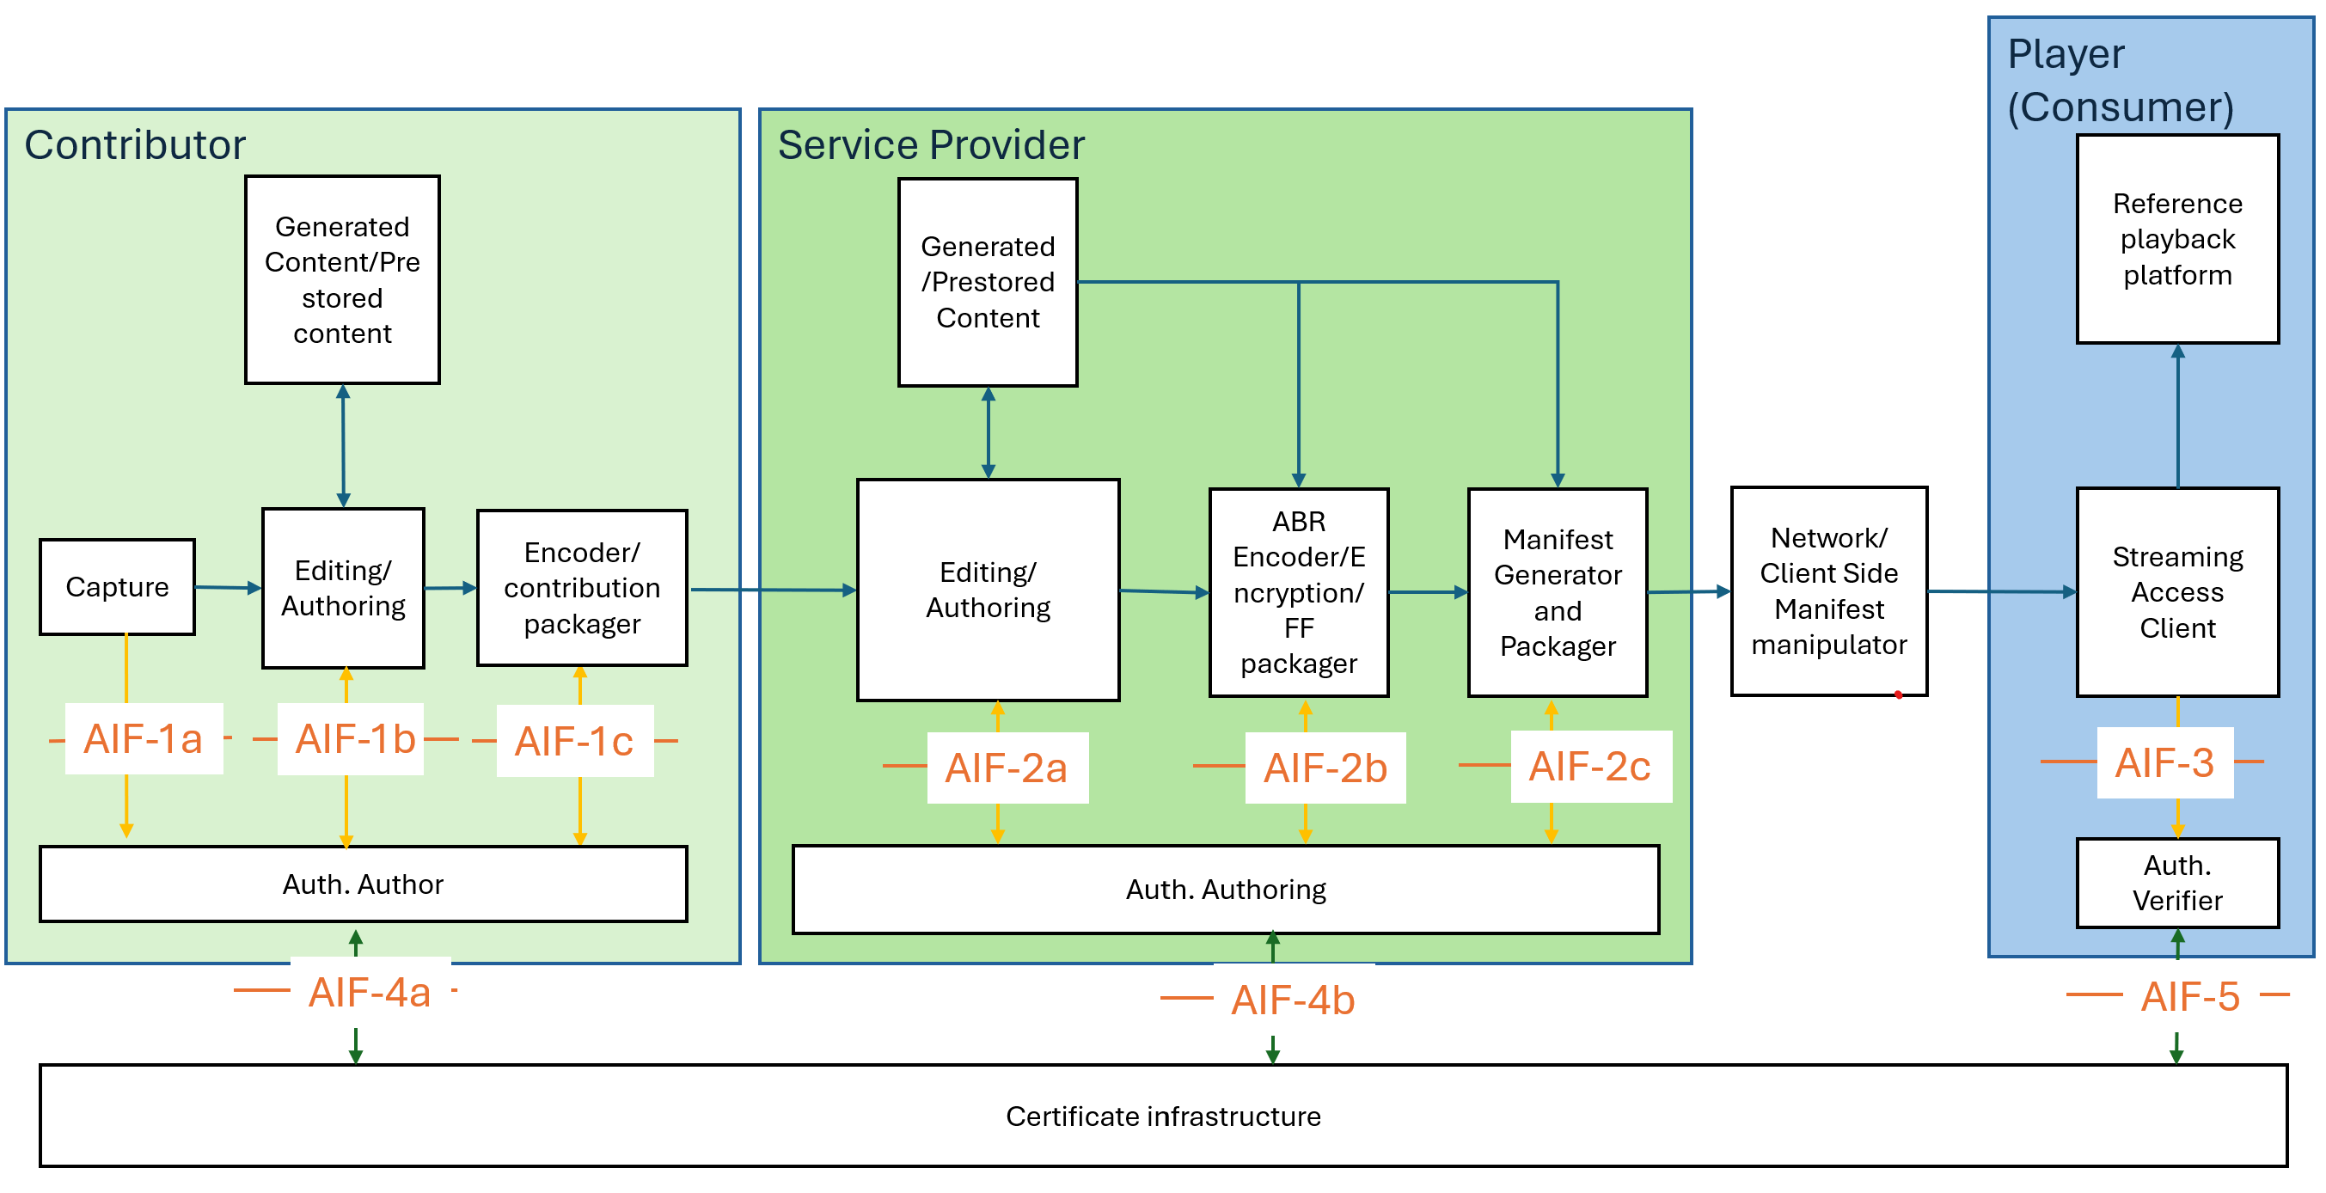
Figure 1: The media authentication workflow for streaming
In this figure, the workflow consists of:
- Media is captured by the device. Preliminary provenance information is provided to authentication author function (AIF-1a).
- The content is edited, manipulated and mixed with prestored and/or generated content. The provenance information is updated, and other authentication metadata is added. (AIF-1b)
- Media is encoded and packaged. The authentication authoring function runs algorithms on the data (AIF-1c), interacts with the certificate infrastructure if needed (AIF-4a) and includes the authentication metadata in encoded and packaged data (AIF-1c). Optionally it uploads some authentication-related data in cloud (AIF-4a).
- Media is provided to the content /service provider.
  - The content received may be verified by the content/service provider (AIF-2a).
  - The authentication metadata may be removed/redacted by the content/service provider.
- The content is edited and revised. It may be manipulated, enhanced or revised and/or combined with other prestored or generated content. The provenance information is provided to authentication authoring function along with the provenance information provided at the contribution (AIF-2a). The new parts of the content may have its own provenance information.
- Additional authentication metadata is included during the media packaging and streaming manifest generation (AIF-2b/2c).
- The media presentation may be repackaged at the network or client side. Such operations maintain the authentication metadata for the part of media originated from the service provider.
  - The inserted content (such as inserted ad) does not impact on the authentication metadata nor verification of the main content.
  - Each inserted content can include its own authentication metadata.
  - If the inserted content causes failure in the verification of the main content, it either
    - removes signaling that the manifest to avoid confusing the player, or
    - adds the new authentication metadata for the combined content.
- The player/receiver uses the authentication verifier function (AIF-3) for media verification through AIF-5.
  - The player can use the manifest to select the media that can be verified.
  - The verification can occur during the playback of media.
The following authentication interfaces are defined:
- AIF-1a: Capture provenance data
- AIF-1b: Authentication data created during editing
- AIF-1c: Authentication data embedding in encoding/packaging
- AIF-2a: Provenance data update during authoring
- AIF-2b: Authentication data embedding in the media content
- AIF-2c: Authentication data embedding in manifest/packaging
- AIF-3: Extraction of authentication data for verification
- AIF-4a/4b: Authentication author cloud interface
- AIF-5: Authentication verifier cloud interface

File-based workflow
Figure 2 describes the workflow for file-based transfer applications.
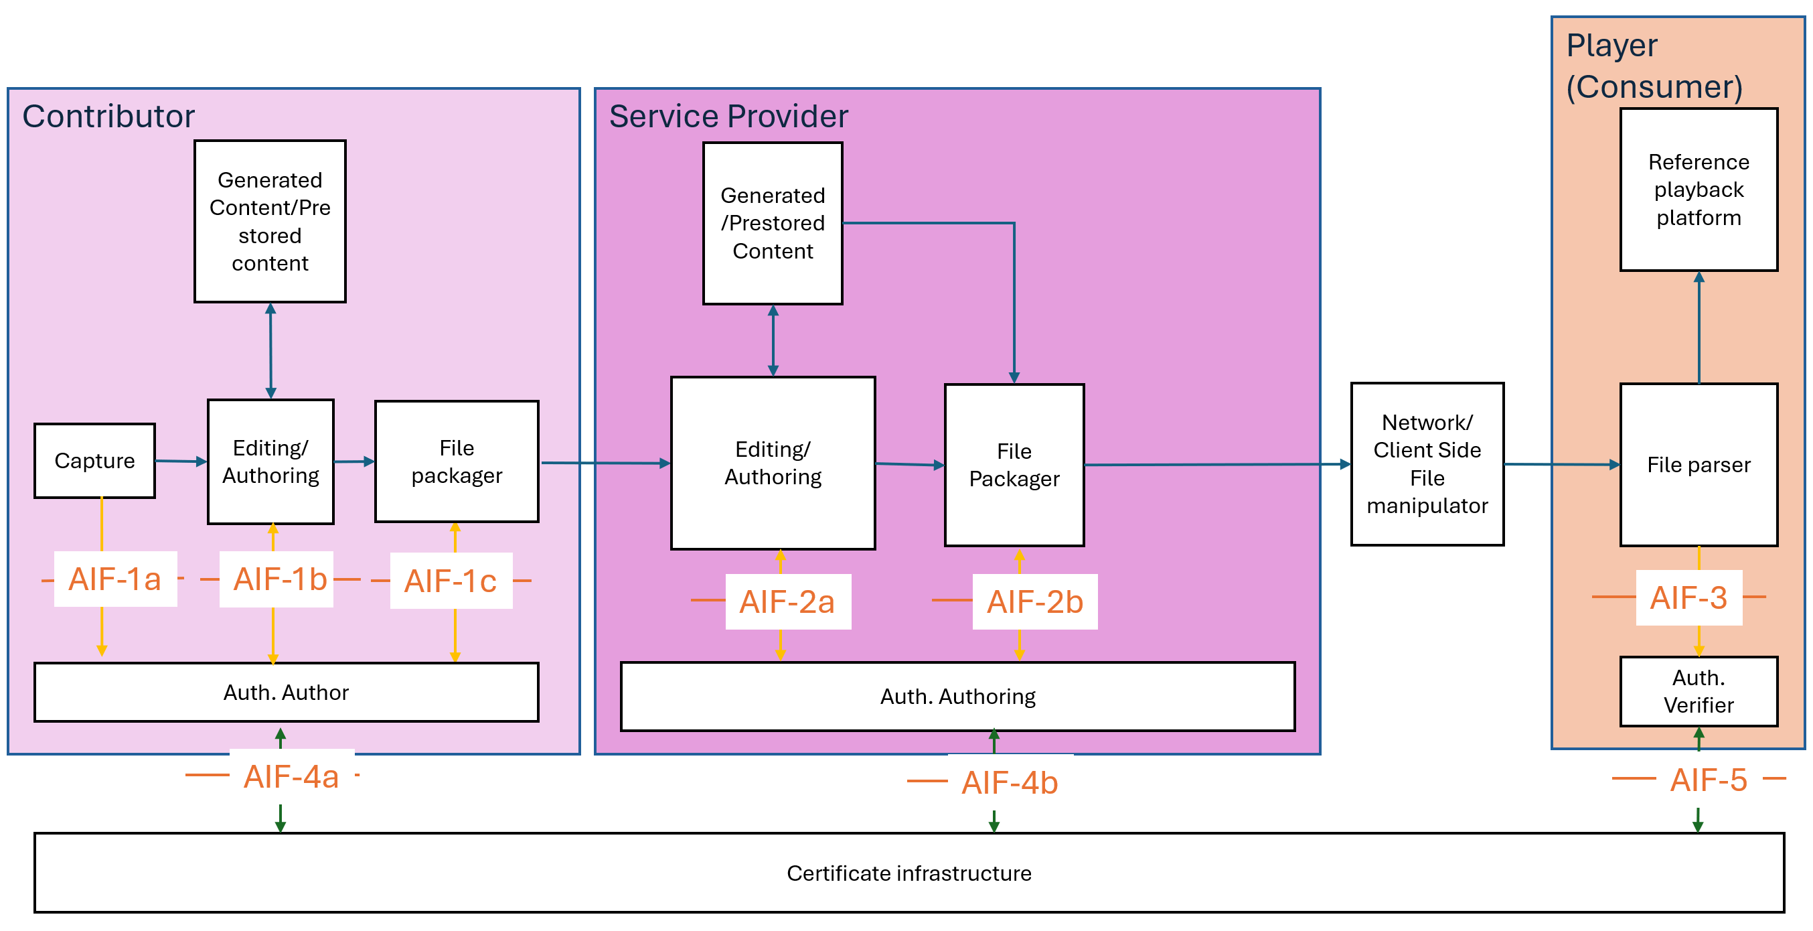
Figure 2: The media authentication workflow for file-based transfer
In this figure, the workflow consists of:
- Media is captured by the device. Preliminary provenance information is provided to authentication creator function (AIF-1a).
- The content is edited, manipulated and mixed with prestored and/or generated content. The provenance information is updated (AIF-1b).
- Media is encoded and packaged into one or multiple files. The authentication creator runs algorithms on the data (AIF-1c), interacts with the certificate infrastructure if needed (AIF-4a) and includes the authentication metadata in encoded and packaged data (AIF-1c). Optionally it uploads some related authentication data in cloud (AIF-4a).
- Media is provided to the content /service provider.
  - The content received may be verified by the content/service provider (AIF-2a).
  - The authentication metadata may be removed/redacted by the content/service provider.
- The content is edited and revised. It may be manipulated, enhanced or revised and/or combined with other prestored or generated content. The provenance information is provided to auth authoring function along with the provenance information provided at the contribution (AIF-2a). The new parts of the content may have its own provenance information.
- The media presentation may be repackaged at the network or client side. Such operations maintain the authentication metadata for the part of media originated from the service provider.
  - The inserted content (such as inserted ad) does not impact on the authentication metadata nor verification of the main content.
  - Each inserted content can include its own authentication information.
  - If the inserted content causes failure in the verification of the main content, it either
    - removes signaling that the manifest to avoid confusing the player, or
    - adds the new authentication metadata for the combined content.
- The player uses the authentication verifier function (AIF-3) for media verification through AIF-5.
  - The verification may occur during the playback of media.
The media authentication interfaces are a subset of the ones identified for the streaming workflow. All interfaces are the same except AIF-2c which does not exist in the file-based workflow.

Cross-authentication workflow
Figure 3, based on the above file-based workflow, highlights where cross-authentication (x-auth) mechanisms may be applied.

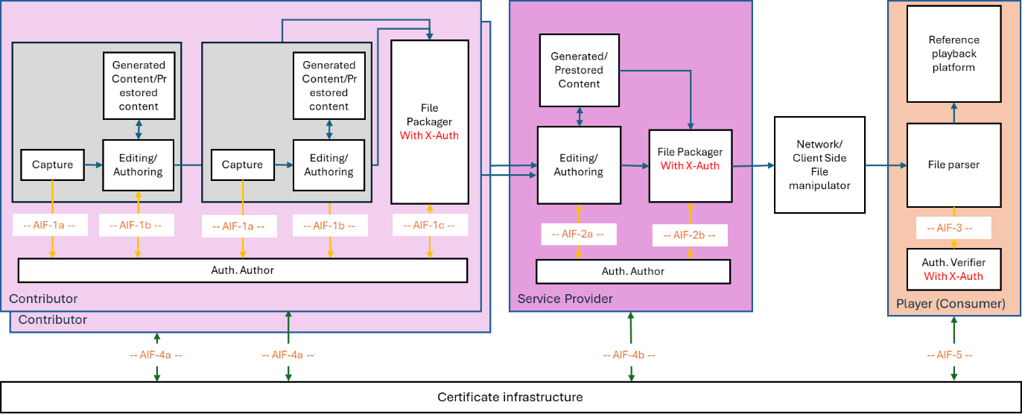
Figure 3: File-based workflow with cross authentication (x-auth) of different Media types

On the contributor side, media components possibly with different media types (e.g. video, audio tracks, subtitles, etc.) of a media asset are captured (original content), retrieved or generated. Each component is authenticated individually through the AIF-1a and AIF1b interfaces. Once authenticated, all media components with different media types building the media asset are packaged with cross-authentication performed through the AIF-1c interface. The resulting packaged file is then made available to the service provider. There can multiple contributors providing media components with different variants or different media types to the Service provider e.g. different audio tracks, etc.
On the service provider side, the packaged file can be edited by modifying existing media types, reusing prestored content or incorporating new ones (possibly from multiple contributors). Similar to contributors, the service provider ensures cross-authentication of the new packaged file, handled through the AIF-2a and AIF-2b interfaces.

Broadcast workflow
Figure 4 describes the workflow for broadcast applications.
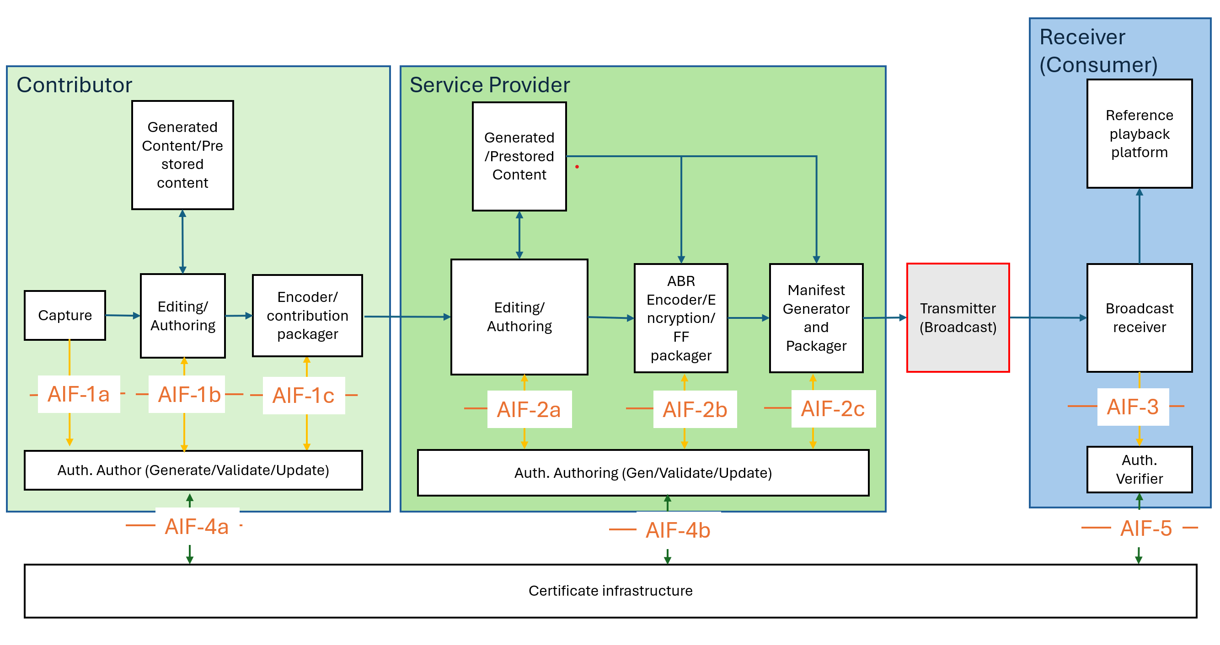
Figure 4: The media authentication workflow for broadcast
As shown in Figure 4, the broadcast media authentication workflow is very similar to the streaming. The major change is the distribution that is achieved through broadcast compared to the network distribution. Note that it is assumed that a local broadcaster is a part of the service provider functionality and therefore in the case of broadcast, the content is not manipulated during the distribution. It is also assumed that the receiver is a connected device, i.e. it can connect to the certificate infrastructure to retrieve certification data such as required keys and signatures.
The authentication interfaces in this workflow are identical to the interface in the streaming workflow.

General considerations
The following are considered for the streaming workflow:
- The content is produced by contributor and/or service provider.
- The receiver is the main consumer that validates the authenticity of the content.
- The service provider may also be a consumer when receiving the contribution, i.e. wants to validate the received content before editing/repurposing/publishing.
- The certificate infrastructures include the signature store, the certificate authority and other possible functionalities (such as watermarking validation).
- The workflow covers on-demand, time-shift, live and low latency content.

Content properties
The following content properties are considered:
- The content may be produced for on-demand, live or low latency live consumption.
- The content may be produced as single or multi-period [4] content by the contributor and further be spliced to multi-period content by the provider.
- Timed based events such as ID3 tags [5], SCTE 214 [6], and DASH events [5] can be added by the contributor or service provider to the content.
- The content may be manipulated by the provider or at the client to be spliced with other contents (such as ads) including dynamic content insertion and early termination.

Authentication properties
The following authentication properties are considered:
- The authentication metadata provides information to verify the content for specific verification periods, i.e. each time interval of the content has authentication metadata.
  - Since the content may be produced on-demand, live or in low latency case, the media verification periods are defined to enable each case accordingly.
  - If authentication verification requires insertion of period transition (i.e., changing the period structure) [4], the resulting content needs to remain conforming to the original content format, including not losing the ad insertion opportunities.
  - Adding ad insertion opportunities need maintaining the verification of the content for each verification period intended by the service provider.
  - A pass-through verifiable content is only possible, if the content is contained in one or more time interval, marked as “unchangeable”.
  - Cross media authentication, i.e. authentication between different tracks or representations of media components, need.
- The streaming manifest and its updates may provide:
  - High level information about the existence of authentication metadata and their format, and possible playback constraints.
  - The cross-media authentication information, i.e. which tracks are expected to be authenticated together.

Authentication Functions
This clause provides a functional description of the authentication related entities utilized in the workflows defined in Clause 5.

Authentication author (generate/validate/update)
This entity validates, creates, and updates the provenance and media authentication metadata for the media presentation. Its responsibilities include:

- Validating the authenticity of the content if existing metadata is present.

- Parsing and updating provenance information.

- Calculating new hashes and generating new digital signatures.

- Formatting and embedding media authentication information into a format suitable for integration with the media content.

The Authentication author interfaces with the media delivery modules via interfaces AIF-1 and AIF-2, and with the certificate infrastructure via interface AIF-4.

Authentication Verifier
This entity is responsible for verifying the authenticity of received media content. It receives the relevant media data along with the associated metadata to perform verification. Because multimedia content is typically time-based, verification is performed continuously at various intervals. The frequency and boundaries of these verification periods (i.e., the specific segments of content being verified) are defined by the media authentication metadata carried within the content.

This entity interfaces with the media access function via interface AIF-3 and with the certificate infrastructure via AIF-5.

Certificate Infrastructure
This entity represents the network or cloud-based functionality that enables the following functions:

- For Authoring (AIF-4):
  - Registration with a Certificate Authority (CA).
  - Provisioning of certificates and public/private key pairs.
  - Provisioning of signed timestamps.
  - Cloud storage for provenance information.

- For Verification (AIF-5):
  - Retrieval of provenance information stored in the cloud.
  - Verification of the Certificate Authority's validity.
  - Verification of the certificate validity and the intermediate trust chain.
  - Provisioning of certificate status and timestamp validation.

