ITU – Telecommunications Standardization Sector  STUDY GROUP 21 Question 6/21  Video Coding Experts Group (VCEG)  78th Meeting: 13–23 January 2026, by teleconference | Document VCEG-BZ22-v2

Question: | 6/21 (VCEG)
Source: | Sooyoung Park, Byeongho Jo,  Jongmo Sung (ETRI) | Email: | {sooyoung, bhjo, jmseong}@etri.re.kr
Title: | CE proposal on montage-based graph coding for redundant channels
Purpose: | Proposal
_____________________________

Abstract
This contribution proposes Montage-based Graph Coding (MGC), a lightweight tool designed to enhance the H.BWC standard. Unlike sample-domain analysis, MGC identifies redundant relation between channels strictly through header parsing of channel labels, constructing a deterministic electrode graph to detect redundant channels. This metadata-driven graph construction approach significantly improves both coding efficiency and processing speed for datasets having redundant channels (e.g., CHB-MIT). For datasets without redundant channels, it maintains baseline performance with negligible signalling overhead.

Introduction
Biomedical signal compression, particularly within the framework of Recommendation H.BWC, requires efficient representation of multi-channel data. A key element in these recordings is the Montage—the specific pairing of electrodes used to derive bipolar potential differences.
Crucially, as defined in the EDF/EDF+ specification [2], the channel label is not merely a name but a strict semantic definition of the signal: a label like "Fpz-Cz" explicitly dictates that the stored value is the potential at the first node minus the potential at the second. This standardized labeling convention is universally adopted in clinical practice, meaning the physical relationship between channels is fully transparent and deterministic based on the header alone.
This convention allows a montage to be modeled as a graph, where electrodes are nodes and channels are edges. In practice, montages often contain structural redundancy where a channel can be perfectly reconstructed from a linear combination of others.
For example, a channel (Fp1-O1) is redundant if it can be derived from six other channels in the montage:
(Fp1-O1) = (Fp1-F7) + (F7-T3) + (T3-T5) - (C3-T5) - (P3-C3) - (O1-P3)
Storing such dependent channels leads to inefficient bit allocation and forces users to manually curate non-redundant sets. To resolve this, we propose Montage-based Graph Coding (MGC).
MGC eliminates the need for heavy cross-correlation analysis between signal samples by identifying sophisticated relationships with near-zero computational overhead using only header information. By automating the detection of redundant channels at the metadata level, MGC significantly improves coding efficiency without any sample-domain processing. This approach not only optimizes compression performance but also removes the manual burden on users to identify or exclude redundant data, providing a seamless and highly efficient coding solution.

Proposed Method: Montage-based Graph Coding

Graph Construction and MGC Logic
At the header parsing stage, MGC decomposes each bipolar channel label into its constituent electrode nodes. These nodes form the vertices of an electrode graph, while the bipolar derivations are mapped as directed edges.
During graph construction, if a new channel creates a path that already exists between two nodes, the system identifies a redundant channel. To maintain causal dependency for the encoder, the latest appearing channel in the montage is designated as the redundant channel. This redundant edge is then expressed as an Oracle Combination—a deterministic signed sum of the preceding reference channels.

Coding Modes and RDO Integration
MGC adaptively selects a coding mode based on the precision of the oracle prediction. In practice, while many bipolar relationships are mathematically exact, some datasets may contain slight numerical discrepancies or noise.
Direct Reconstruction: This mode is selected when the Mean Absolute Error (MAE) is zero between the original signal and the oracle combination. Since the reconstruction is perfect, the encoder entirely skips the residual coding for this channel, maximizing compression gains.
Predictive Coding with RDO: In cases where the MAE is non-zero due to noise or precision loss, the oracle combination is utilized as a high-precision predictor. This operates as a block prediction mode within the encoder's Rate-Distortion Optimization (RDO) loop. The encoder evaluates whether coding the residual of the MGC prediction is more bit-efficient than standard coding modes, ensuring optimal rate-distortion performance.

Signalling and Bitstream Integration
The signalling for MGC is divided into two parts: static structural information in the header and dynamic mode selection in the block-level bitstream.

Static Configuration in WPS
To define the oracle combinations without redundant signal analysis, the following metadata is transmitted once in the Waveform Parameter Set (WPS).
Redundancy Flags: A 1-bit flag per channel indicating whether it is a redundant channel.
Combination Information: For each redundant channel, two sets of bitmasks are signaled:
- Reference Mask: An N-bit mask (N = total number of channels) identifying which channels serve as references.
- Sign Mask: A bitmask indicating the sign (positive or negative) for each identified reference channel.

Dynamic Mode Signalling
For channels flagged as redundant in the WPS, the encoder signals the specific coding mode at the block level. The syntax flow is as follows:

// For each block in the redundant channel (defined in WPS)
if (is_redundant[ch]) {
direct_recon_flag; // 1-bit, do direct reconstruction
if (!direct_recon_flag) {
predictive_coding_flag; // 1-bit, do montage block prediction
if (!predictive_coding_flag)
prediction_trafo_data[ch];
}
} else
prediction_trafo_data[ch];

Experimental Results of MGC
Table 3-1. Experiment evaluation result compared to TM 4.0 with CTC (joint coding for lossy) [3]
Dataset | BD rate #1 (%) | BD rate #2 (%) | EncT (%) | DecT (%)
CHBMIT_EEG | -2.054 | -2.054 | 89.7 | 89.8
Table 3-2. Experiment evaluation result compared to TM 4.0 with CTC (joint coding for lossless) [3]
Dataset | BR-R (%) | EncT (%) | DecT (%)
CHBMIT_EEG | -3.185 | 98.1 | 91.5
As shown in Table 3-1 (Lossy) and Table 3-2 (Lossless), the proposed MGC significantly improves both coding efficiency and processing speed for the CHB-MIT dataset. This is achieved by utilizing Direct Reconstruction for redundant channels, which eliminates unnecessary residual coding and reduces computational load.
For other datasets without redundant montages, MGC performs identically to the TM (Test Model) [1]. The only overhead is a 1-bit redundancy flag per channel in the WPS, which results in negligible bit increase and zero impact on execution time. These results prove that MGC provides substantial gains in the presence of structural redundancy while maintaining baseline performance in all other cases. The corresponding BD-rate curves are presented in Figure 3-1 and 3-2.
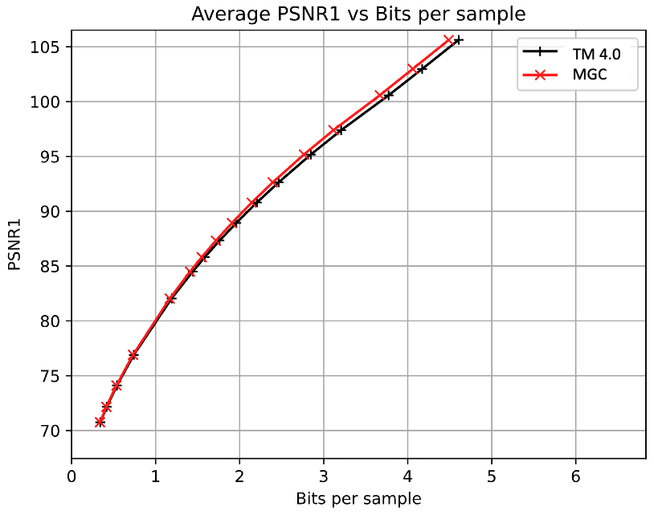
Figure 3-1. BD-rate#1 curve compared to TM 4.0 with CTC (joint coding for lossy)
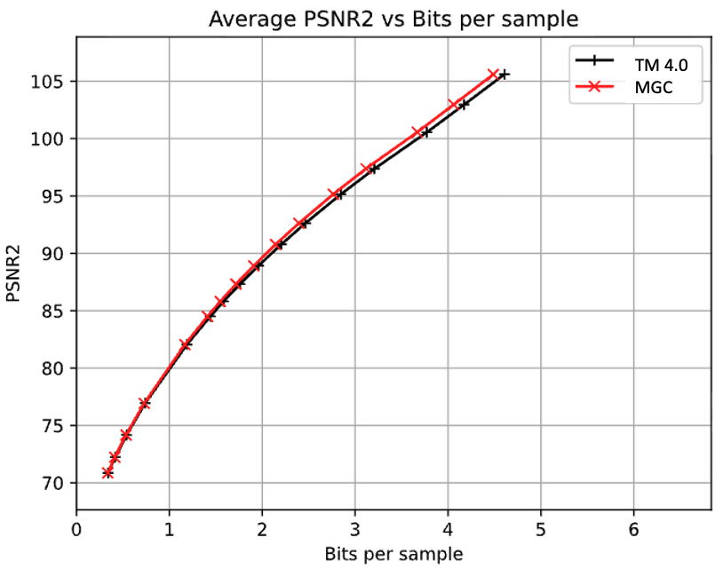
Figure 3-2. BD-rate#2 curve compared to TM 4.0 with CTC (joint coding for lossy)

Conclusion
MGC is a powerful and low-complexity tool that identifies channel redundancy using header information, imposing near-zero computational overhead to construct montage graph. The proposed method can deliver significant compression gains for redundant montages while incurring no penalties for common datasets.
Under the current H.BWC framework, minimal WPS signalling is used. However, if the decoder can access metadata in future versions, MGC can operate as a "zero-bit overhead, always-on" feature. Based on its efficiency and seamless integration, we propose the adoption of MGC into the next version of H.BWC to optimize multi-channel signal coding.

Patent rights declaration(s)
ETRI may have current or pending patent rights relating to the technology described in this contribution and, conditioned on reciprocity, is prepared to grant licenses under reasonable and non-discriminatory terms as necessary for implementation of the resulting ITU-T Recommendation | ISO/IEC International Standard (per box 2 of the ITU-T/ITU-R/ISO/IEC patent statement and licensing declaration form).

References
- VCEG, “Reference software for biomedical waveform data compression,” tag BWC-4.0, Nov. 2025. https://www.vcgit.hhi.fraunhofer.de/vceg-sw/bwc/-/tags/
- B. Kemp et al., “Standard texts and polarity rules”, September 2003. https://www.edfplus.info/specs/edftexts.html
- J. Pfaff et al., “Common test conditions and evaluation procedures for H.BWC technical experiments,”, Teleconference, Jan. 2026. https://www.itu.int/wftp3/av-arch/video-site/2601_Tel/VCEG-BZ03-Post-Geneva_CTC-v1.docx

