ITU – Telecommunications Standardization Sector  STUDY GROUP 21 Question 6  Video Coding Experts Group (VCEG)  76th Meeting: 27 March – 4 April 2025, by teleconference | Document VCEG-BX02-v1

Question: | 6/21 (VCEG)
Source: | Byeongho Jo, Sooyoung Park, Jongmo Sung, Seungkwon Beack (ETRI) | Email: | {bhjo, sooyoung, jmseong, skbeack}@etri.re.kr
Title: | Core Experiment on Selective Shaping for H.BWC
Purpose: | Proposal
_____________________________

Abstract
This document presents ETRI’s Core Experiment on the selective shaping of coding biomedical waveforms.

- Introduction
In the last Q6/21 meeting, specific features for H.BWC were discussed for testing in Core Experiments (CEs) as described in [1]. This document describes the CE on selective shaping, which was initially proposed in our Call for Proposal (CfP) response [2]. Based on the selective shaping in the CfP response, we developed a more sophisticated tool that manipulates the temporal and spectral dynamics of the biomedical signals.
Predictive coding is a fundamental processing in data compression that reduces redundancy by using previously reconstructed data to predict new samples. In block-wise predictive transform coding of a waveform, a residual signal obtained through block prediction is subjected to transforms followed by quantization and entropy coding. The prediction residual signal may retain certain inherent characteristics of the original signal such as temporal and spectral dynamics that limit the effectiveness of subsequent compression. These retained characteristics can prevent full exploitation of the potential of the redundancy reduction, ultimately imposing a bottleneck on the achievable coding efficiency.
To address this issue, we propose selective shaping, which is the subject of this CE. The idea is to apply an additional modification to the prediction residual signal prior to the transform. By selectively shaping the residual signal, its dynamics can be controlled more effectively in a rate distortion (RD) sense, thus reducing the overall entropy and enabling more efficient coding. This approach is particularly beneficial for signals with non-stationary properties, such as biomedical signals (ECG, EMG, and EEG).
This additional shaping step inserted in the bitstream after the block absolute delta QP element allows the encoder to evaluate the RD performance of each mode and select the optimal one on a block-by-block basis. Although this selective shaping process introduces additional computational load on the encoder and the decoder, experimental results demonstrate a BD-rate improvement without imposing a notable computational overhead on the decoder.
By dynamically controlling the residual’s dynamic range, the proposed method improves the efficiency of subsequent transform (discrete cosine transform; DCT and discrete sine transform; DST), quantization, and entropy coding stages, thus achieving a more favorable overall RD trade-off. This contribution details the underlying principles, implementation details, and syntax modifications required to integrate selective shaping into the H.BWC Test Model, paving the way for its potential inclusion in future ITU-T recommendations.

- Technical description
Predictive coding of one-dimensional waveform data typically involves block‐based prediction, followed by a transform, quantization, and entropy coding of the residual signal. However, the prediction residual often retains significant temporal and spectral dynamics that limit the effectiveness of subsequent compression stages. To overcome this bottleneck, the proposed selective shaping adds an additional processing stage to further decorrelate and manipulate the residual signal. In this CE, we apply the selective shaping to the residual before quantization, thereby controlling its time and frequency domain dynamics and overall entropy. Figure 1 illustrates the overall process of selective shaping applied in both the encoder (left) and decoder (right). In the encoder, the residual signal obtained from block prediction is selectively shaped, followed by transformation, quantization, and entropy coding. On the decoder side, the received bitstream undergoes entropy decoding and inverse transformation, followed by selective inverse shaping to reconstruct the final signal. The objective of selective shaping is effectively exploiting the statistical properties of the prediction residual signal, thereby improving coding efficiency.
The proposed selective shaping introduces four distinct modes that are applied on a per-block basis:
- No shaping (Mode 0): The residual is left unaltered, which is useful when the prediction error is already compact.
- Selective sub-band spectral shaping (Mode 1): A constant scaling is applied to the specific spectral sub-band (i.e., lower band).
- Selective temporal shaping (Mode 2, 3): A shaping using a left- or right-attenuated window is applied to the predetermined temporal sub-block.
- Selective sub-block spectral shaping (Mode 4): A shaping using a window linearly attenuated to the left is applied to the spectrum of the predetermined temporal sub-block.
Our approach is to allow the encoder to choose one of four selective shaping modes on a per-block basis. In our implementation, the selected mode is signaled via a syntax element, selectiveShapingFlag, which is inserted into the transform unit header immediately after the block_abs_delta_qp field.
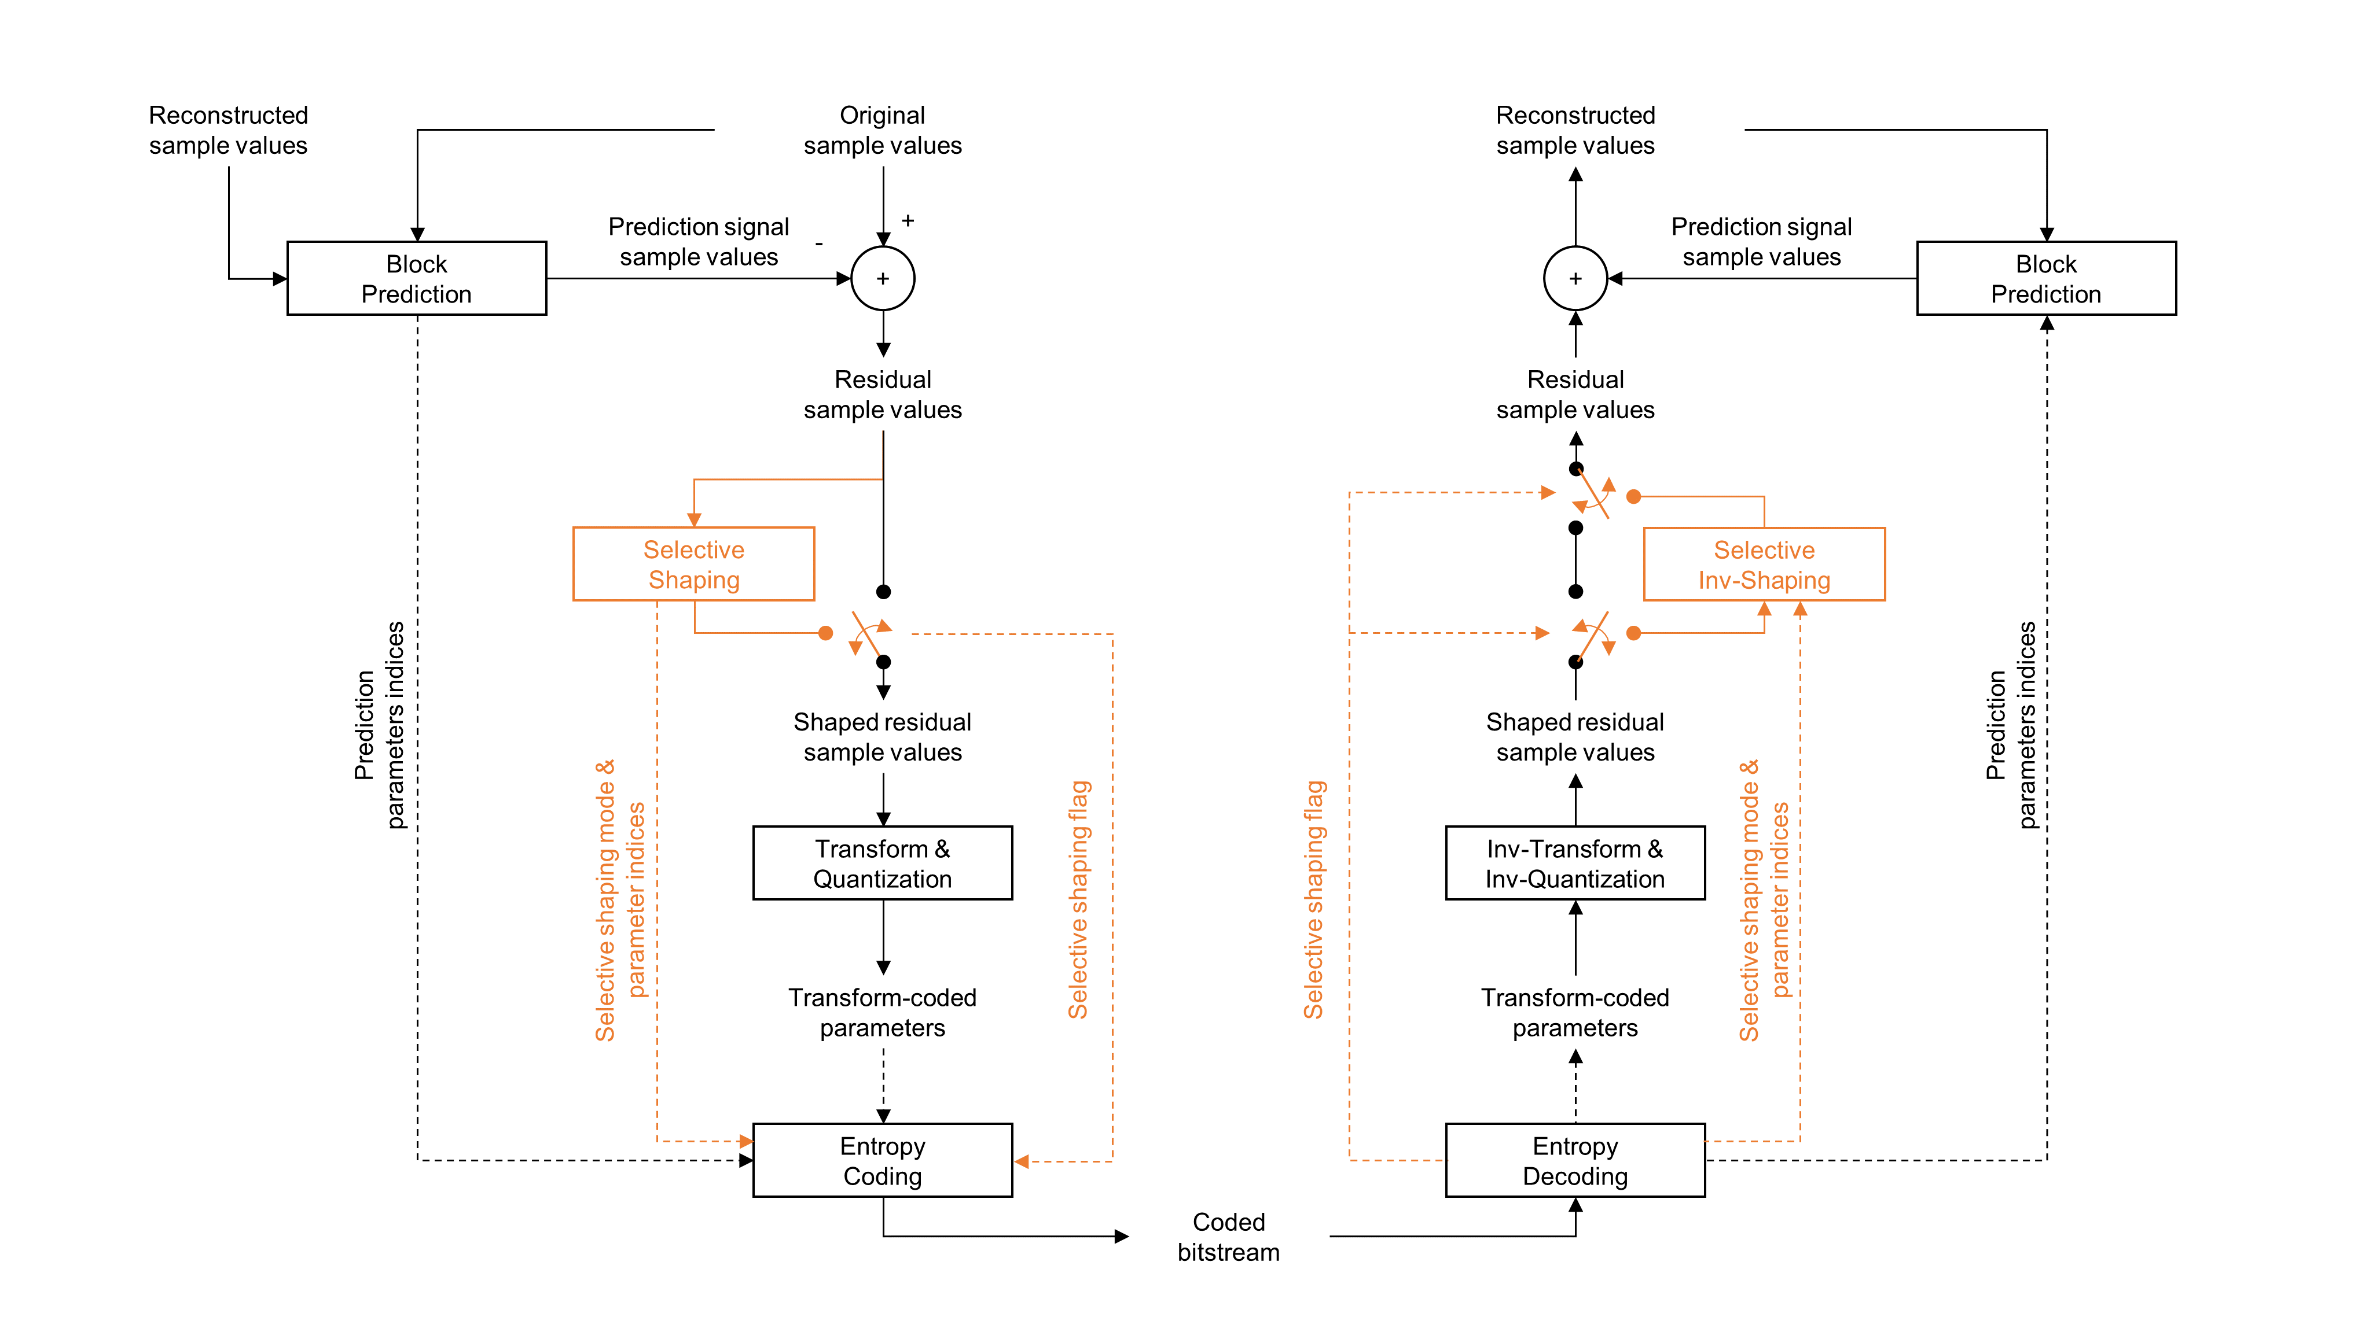Figure 1: Overview of the CE system
The selectiveShapingFlag is derived through context-adaptive binary arithmetic coding (CABAC) using a set of five context models, which are determined by the previous SS flag value (prevSSFlag). This history-based context adaptation ensures that the probability model reflects local inter-channel correlations in shaping mode decisions, thereby improving coding efficiency.
In mode 1 (selectiveShapingFlag = 1), the encoder applies a fixed spectral shaping to the specific spectral sub-band. The conceptual diagram of mode 1 is shown in Figure 2. The prediction residual signal is transformed using a DCT, and the DCT coefficients are equally partitioned into fixed-size (SUB_BLOCK_SIZE_SEL_SHAPING) sub-bands. The DCT coefficients in the lowest sub-band are then scaled by a predefined shaping factor (ssFactor) to compress the energy distribution. An inverse DCT is performed to reconstruct a shaped residual in the time domain. At the decoder, the decoded residual signal is manipulated similarly. The only difference is that the DCT coefficients in the lowest sub-band are inversely scaled by the predefined shaping factor (ssFactor).
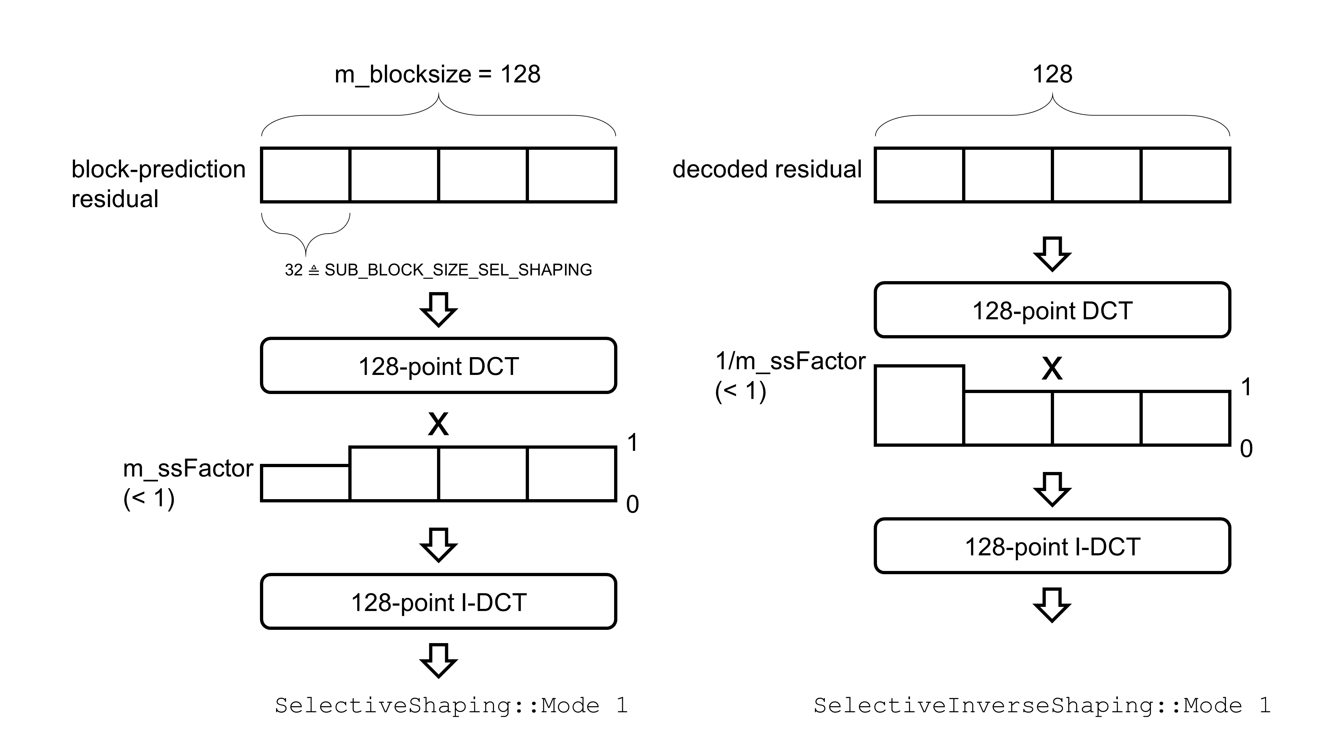
Figure 2: A block diagram of the selective sub-band spectral shaping (mode 1)
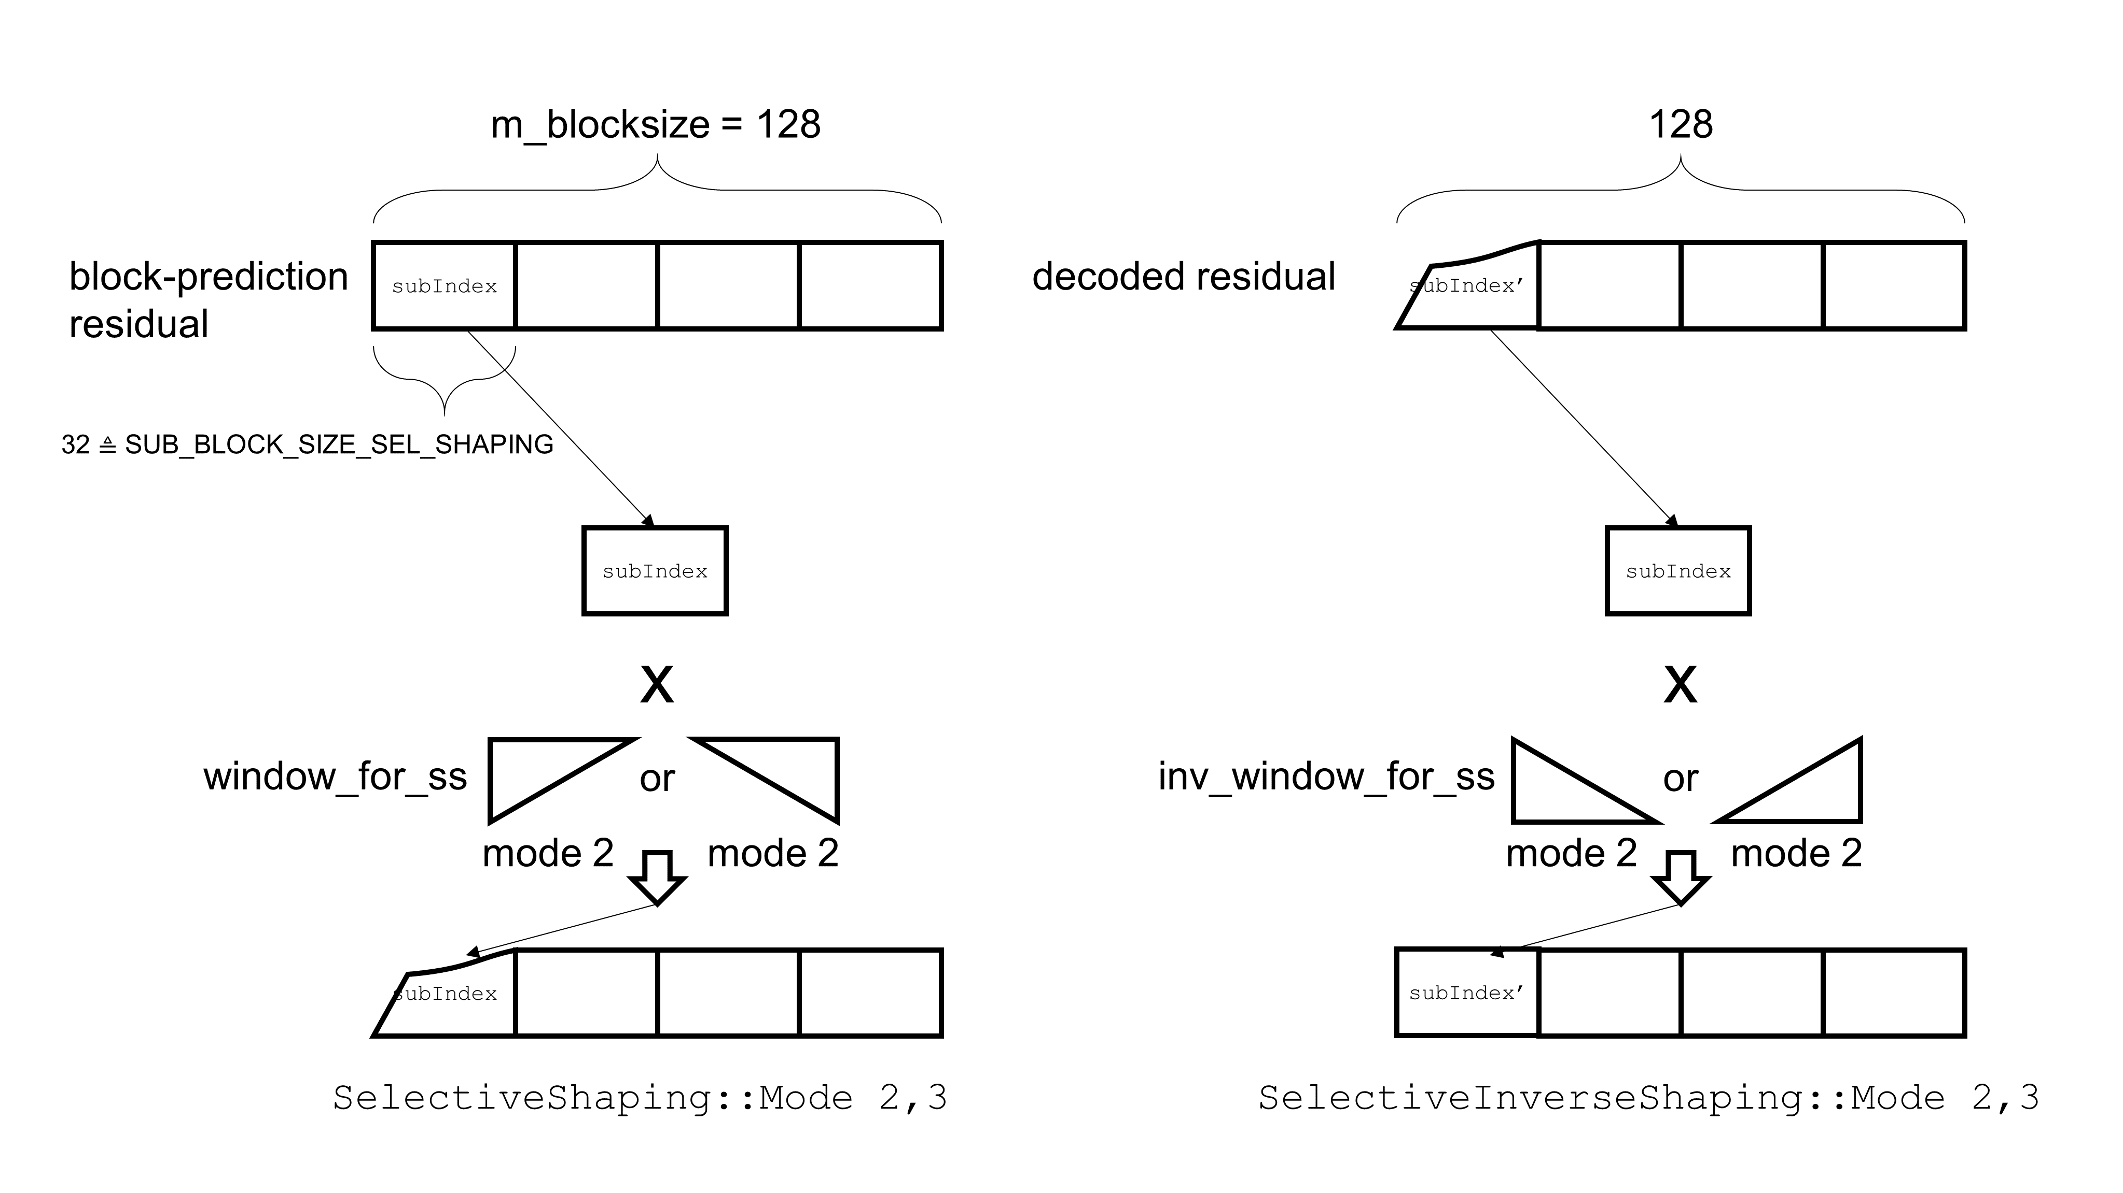
Figure 3: A block diagram of the selective temporal shaping (modes 2 and 3)

In modes 2 and 3 (selectiveShapingFlag = 2, 3), the selective shaping operates in the time domain on a specific sub-block of the residual. The block is partitioned into fixed-size sub-blocks, and the encoder selects a target sub-block via an additional parameter called subBlockIndex. The target sub-block is selected as a sub-block with the largest energy. In mode 2, as shown in Figure 3, a left-attenuated window is applied to the selected sub-block. In mode 3, a right-attenuated window is applied. Figure 4 plots the example window shapes with an attenuation factor of 1.5 in fixed-point arithmetic.
Mode 4 extends the shaping to operate on the spectrum of a specific sub-block. Figure 5 shows a conceptual diagram of selective shaping in mode 4. In this mode, the selected sub-block is first transformed using DCT. Then, its DCT coefficients are multiplied by a linear left-attenuated window, and an inverse DCT is applied to produce the shaped residual for the selected sub-block.
The encoding of the selective shaping parameters is handled by the function encodeSelectiveShapingParams(). Initially, encodeSSFlag() is invoked to signal the SS flag. The flag is generated by first encoding a binary decision (flag0) which is set to 1 when shaping is enabled, followed by two additional binary symbols (flag1 and flag2) that determine the specific mode according to: value = flag0 + 2 × flag1 + flag2 yielding a value from 1 to 4. Importantly, the context for these binary symbols is derived from a previous SS flag value (prevSSFlag), with five distinct contexts (0–4) defined to capture the interchannel correlation of mode usage. If the SS flag is greater than 1, the encoder further signals a subBlockIndex using encodeSubBlockIndexForSS(). The context for this sub-block index is computed from the number of sub-blocks and the previous sub-block index (prevSubBlock) via the function CalculateSubBlockClass(), which reduces the index to one of four possible context classes. The index is then binarized using a fixed number of bits (equal to the ceiling of log₂(numBins)) with context-adaptive models provided by get_SubBlockForSSCtx(). The decoder mirrors this process using decodeSSFlag() and decodeSubBlockIndexForSS(), ensuring that the selective shaping parameters remain synchronized between the encoder and decoder.
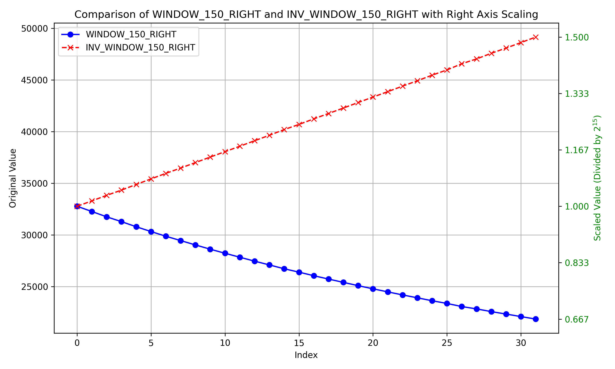
Figure 4: Right-attenuated window and its inverse window with an attenuating value of 1.5
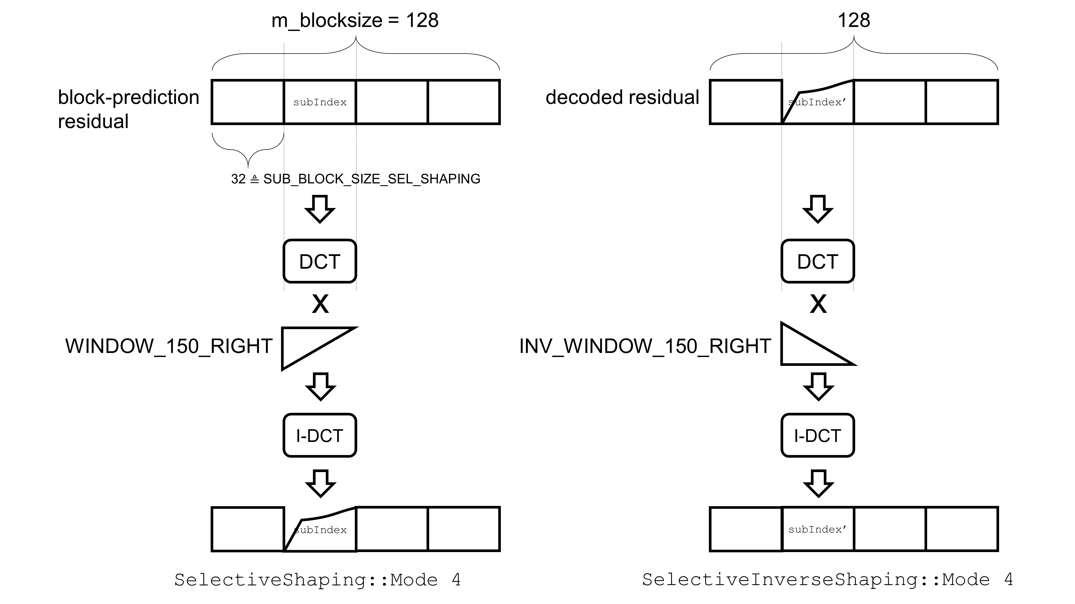
Figure 5: A block diagram of the selective sub-block spectral shaping (mode 4)
The proposed selective shaping dynamically adjusts its windowing parameters and scaling factors based on the type of biomedical signal (ECG, EMG, or EEG) to accommodate their distinct temporal and spectral characteristics. In the implementation, the function setWindowDepthForSS() examines the quantization step size (StepSizeForQP) and, based on predefined threshold values for each signal type, selects an appropriate window array and its inverse window array (e.g., {INV_}WINDOW_120_RIGHT, {INV_}WINDOW_150_RIGHT, etc.) and a corresponding shaping factor (ssFactor). For example, for ECG signals, a lower step size (below the first threshold) leads to the use of INV_WINDOW_120_RIGHT with a shaping factor of 1.1, whereas higher step sizes trigger the selection of INV_WINDOW_150_RIGHT or INV_WINDOW_180_RIGHT with progressively larger factors (1.2 and 1.4, respectively). Similar conditional logic is applied to EMG and EEG signals, with EEG utilizing an additional threshold level to finely adjust the shaping process.
The adaptive selective scaling factor is critical for optimizing the residual energy compaction in the transform domain. By tailoring the attenuating value and scaling factor to the inherent signal dynamics, the algorithm achieves a more effective RD performance for each signal type. The selectiveShaping() and selectiveInverseShaping() functions then apply these parameters in different selective shaping modes. Specifically, mode 1 performs spectral scaling using ssFactor, modes 2 and 3 apply temporal scaling with direct and mirrored windows respectively, and mode 4 utilizes a sub-block spectral shaping approach. Table 1 summarizes the threshold values and the corresponding window and scaling factor selections depending on signal types (ECG, EMG, and EEG) and StepSizeForQP parameters.

- Syntax modifications
In our contribution, we propose a modification of the bitstream syntax to signal the selective shaping (SS) parameters. SS parameters are inserted into the frame_data. In particular, the syntax element for selective shaping is placed immediately after the block_abs_delta_qp syntax element. This placement ensures that the SS parameters are signaled after the quantization parameter adjustment, thus allowing the selective shaping tool to operate on the residual before entropy coding.
Table 1: Adaptive Parameter Settings for Biomedical Signals
Dataset | Condition | ssFactor | Attenuating value
ECG | StepSizeForQP < 5 | 1.1 | 1.2
ECG | StepSizeForQP < 9 | 1.2 | 1.5
ECG | StepSizeForQP >= 9 | 1.4 | 1.8
EMG | StepSizeForQP < 5.5 | 1.1 | 1.1
EMG | StepSizeForQP < 25.5 | 1.2 | 1.4
EMG | StepSizeForQP >= 25.5 | 1.4 | 1.6
EEG | StepSizeForQP < 4 | 1.2 | 1.1
EEG | StepSizeForQP < 11 | 1.3 | 1.3
EEG | StepSizeForQP < 33 | 1.4 | 1.5
EEG | StepSizeForQP >= 33 | 1.5 | 1.7

The proposed syntax modification (in the General frame data syntax) is defined as follows:
frame_data(numChannels) { | Descriptor
...
block_abs_delta_qp | ae(v)
selectiveShapingFlag // New syntax for selective shaping | ae(v)
// A 3-bit field indicating the selective shaping mode:
// 0: No selective shaping is applied.
// 1: Mode 1, 2: Mode 2, 3: Mode 3, 4: Mode 4
if (selectiveShapingFlag > 1) {
subBlockIndex | ae(v)
}
}
In our implementation, the function encodeSelectiveShapingParams() encapsulates the encoding of the selective shaping (SS) parameters. First, the encoder calls encodeSSFlag() to signal the SS flag. This flag is derived as follows:
- If no selective shaping is applied, the flag is set to 0.
- Otherwise, if selective shaping is enabled, a first binary decision (flag0) is set to 1. Two additional binary symbols (flag1 and flag2) are then coded to indicate one of four possible SS modes (i.e., values 1–4). The final value of the SS flag is computed as: value = flag0 + 2 * flag1 + flag2 resulting in a value of 1, 2, 3, or 4.
A key feature of our implementation is the use of context-adaptive binary arithmetic coding (CABAC) to efficiently code these binary symbols. For the SS flag, five context models (corresponding to context indices 0 through 4) are defined based on the previous SS flag value (prevSSFlag). The encoder stores the selective shaping mode from the previous block and uses this value to select the appropriate context for encoding the current flag. This context adaptation leverages the temporal correlation in SS mode decisions, leading to more efficient coding.
If the resulting selectiveShapingFlag is greater than 1 (i.e., when one of the shaping modes requiring spatial parameterization is applied), the encoder further signals the sub-block index using the function encodeSubBlockIndexForSS(). In this case, the block (of size blockSize) is divided into fixed-size sub-blocks (with size defined by the constant SUB_BLOCK_SIZE_SEL_SHAPING), and the sub-block index corresponding to the region that will be shaped is determined. For efficient CABAC coding of this index, its context is derived from two factors:
- The number of sub-blocks in the block.
- The previous sub-block index (prevSubBlock), is simplified via the function CalculateSubBlockClass() into one of four possible context classes.
The sub-block index is then binarized using a fixed number of bits (equal to the ceiling of log₂(numBins)) with context-adaptive probability models provided by get_SubBlockForSSCtx(subBlockClass). On the decoder side, the corresponding functions decodeSSFlag() and decodeSubBlockIndexForSS() mirror this process: the decoder first reads the SS flag using the context derived from prevSSFlag, and if the flag is nonzero, it decodes the sub-block index using the same context derivation. This ensures that both encoder and decoder remain synchronized in their selective shaping parameters.
In the proposed syntax modifications, the prevSubBlock context is updated in an exponential averaged sense to enhance context adaptation efficiency when selective shaping is applied. Specifically, if the selectiveShapingFlag is greater than 1, the prevSubBlock is updated according to a weighted average scheme. When the current channel is 0, prevSubBlock is directly set to the current sub-block index as signaled by getSubBlockIndex(). However, for other channels, prevSubBlock is computed using an exponential averaging mechanism where the new sub-block index is weighted by a factor of PREV_SUB_MUL_FACTOR while the previous index is weighted by the difference between PREV_SUB_DIV_FACTOR and PREV_SUB_MUL_FACTOR. The final value of prevSubBlock is then normalized by dividing by PREV_SUB_DIV_FACTOR. The proposed updating mechanism applies a weighted average between the previous sub-block index and the current index, providing a smoother context transition. This approach enhances the prediction accuracy of the CABAC model and consequently improves overall coding efficiency.
In summary, the proposed syntax changes allow the encoder to signal:
- A 3-bit selectiveShapingFlag (with possible values [0,1,2,3,4]) indicates whether selective shaping is disabled (0) or which of the four SS modes is applied [1,2,3,4].
- When the flag is greater than 1, an additional subBlockIndex is transmitted, which provides finer control over the sub-block on which the shaping operation is applied.
These modifications are designed to be minimally invasive while providing the necessary flexibility for the encoder to choose among multiple selective shaping modes based on rate distortion (RD) optimization. The use of context-adaptive models for both the SS flag and the sub-block index (with five contexts for the flag based on prevSSFlag and four contexts for the sub-block index derived from the simplified sub-block class) ensures efficient CABAC coding, making the additional syntax overhead marginal compared to the substantial BD-rate improvements achieved across various biomedical signal datasets. This proposal, integrated into the transform unit syntax immediately after the block_abs_delta_qp element, ensures that the selective shaping parameters are parsed in the proper order and that the residual is processed with the correct shaping transform before quantization and entropy coding.

- Experimental evaluation
The proposed selective shaping was evaluated under two main configurations “Joint” and “Independent” across a diverse set of biomedical datasets (ECG, EMG, and EEG). Table 2 presents the results in terms of BD rate (BD-rate1, BD-rate2) based on the PSNR1 and PSNR2, respectively, as well as the relative changes in the encoder (EncT) and decoder (DecT) runtimes. The BD rate measures are reported against the anchor, following the common test conditions, while the percentage changes in runtime are computed as ratios relative to the anchor [3]. The calculation of PSNR and BD rate values was conducted using target StepSizeForQP values defined in the CTC document, except those corresponding to lossless conditions. Specifically, StepSizeForQP values of 1 for ECG, 1 and 1.125 for EEG, and 1 for EMG were excluded from the evaluation. All other StepSizeForQP values defined in the CTC document were utilized to generate the reported PSNR and BD rate results.
Table 2: Validation results
Config | Dataset | BD-rate #1 (%) | BD-rate #2 (%) | $Δ$ EncT (%) | $Δ$ DecT (%)
Joint | MIT_ECG | -0.379 | -0.380 | 37.55 | 9.72
Joint | Ozdemir_EMG | -0.241 | -0.241 | 98.18 | 8.59
Joint | CHBMIT_EEG | -0.172 | -0.167 | 90.31 | 0.51
Joint | NMR55_EEG | -0.266 | -0.311 | 88.27 | 4.11
Joint | NMR57_EEG | -0.175 | -0.172 | 56.65 | -3.78
Independent | MIT_ECG | -0.348 | -0.350 | 40.44 | 9.42
Independent | Ozdemir_EMG | -0.168 | -0.171 | 60.89 | 8.69
Independent | CHBMIT_EEG | -0.189 | -0.193 | 61.50 | 11.98
Independent | NMR55_EEG | -0.152 | -0.164 | 55.25 | 6.00
Independent | NMR57_EEG | -0.205 | -0.200 | 51.09 | 13.61

Table 2 shows the averaged metrics per sequence. The experimental results demonstrate modest improvements in coding efficiency with the proposed selective shaping across both configurations. Under the Joint configuration, BD-rate reductions range from -0.379% to -0.172%, while the Independent configuration yields reductions from -0.348% to -0.152%. The Joint configuration tends to achieve slightly greater BD-rate gains on certain datasets, such as MIT_ECG and NMR55_EEG, although the overall performance trends remain consistent between the two approaches.
In terms of computational complexity, the encoder runtime increases are more pronounced under the Joint configuration, with values between 37.55% and 98.18%, compared to a narrower range of 40.44% to 61.50% under the Independent configuration. The decoder runtime modifications are generally modest for both configurations, with most values within a 10% range and an observed reduction of -3.78% for NMR57_EEG under the Joint configuration. These findings indicate a trade-off between achieving higher coding gains and incurring increased encoder complexity, while the Independent configuration offers a more balanced runtime profile with slightly reduced BD-rate improvements.
Overall, the “Joint” configuration appears to yield consistently better rate distortion for the MIT_ECG dataset, while the “Independent” configuration offers more flexible shaping decisions but sometimes incurs higher encoding runtime overhead. The difference in runtime overhead between the two configurations reflects how shaping parameters are signaled and shared across channels. Additional raw data and detailed performance curves (including objective waveform fidelity) are provided as supplementary zip files.

- Conclusion
In conclusion, the proposed selective shaping was demonstrated to enhance RD performance for coding biomedical waveforms. By introducing an adaptive modification to the prediction residual signal, the proposed method effectively controls the dynamic range of the prediction residual prior to the transform, thereby enabling more efficient entropy coding. The experimental results under both Joint and Independent configurations across ECG, EMG, and EEG datasets, consistently show negative BD-rate values. While the approach incurs a moderate encoder runtime overhead, the decoder complexity remains minimally affected.
Furthermore, the integration of context-adaptive binary arithmetic coding (CABAC) with exponential averaging for sub-block context updates provides a smooth transition of contextual parameters, further enhancing prediction accuracy. The syntax modifications introduced in this CE, including the signaling of the selectiveShapingFlag and sub-block index, are marginally invasive and offer flexibility for optimal mode selection on a block-by-block basis.
Future investigations may focus on optimizing the shaping parameters and extending the evaluation to additional signal types and test conditions. We sincerely request that the proposed technology be adopted in the next H.BWC Test Model.

- Patent rights declaration(s)
ETRI may have current or pending patent rights relating to the technology described in this contribution and, conditioned on reciprocity, is prepared to grant licenses under reasonable and non-discriminatory terms as necessary for implementation of the resulting ITU-T Recommendation ISO/IEC International Standard (per box 2 of the ITU-T/ITU-R/ISO/IEC patent statement and licensing declaration form).

- References
- J. Pfaff and C. Fersch, “Core experiments for H.BWC,” Q.6/SG21, SG21-TD71R1/WP3, Geneva, Jan. 2025.
- J. Sung et al., “ETRI response to Call for Proposals for Recommendation H.BWC on the coding of biomedical waveform data,” VCEG-BW05, Nov. 2024. https://www.itu.int/wftp3/av-arch/video-site/2411_Kem/
- J. Pfaff and C. Fersch, “Common test conditions and evaluation procedures for H.BWC technical experiments,” Q.6/SG21, SG21-TD68/WP3, Geneva, Jan. 2025

