ITU – Telecommunications Standardization Sector  STUDY GROUP 21 Question 6  Video Coding Experts Group (VCEG)  79th Meeting: 25 April – 1 May, Santa Eulària, Spain | Document: VCEG-CA04 (v1)

Question: | 6/21 (VCEG)
Source: | Sam Jelfs, Tsvetomira Tsoneva, Werner Oomen | Email: | sam.jelfs@philips.com, tsvetomira.tsoneva@philips.com, werner.oomen@philips.com
Title: | Report on investigations into 60601 / 80601 standards compliance for H.BWC
Purpose: | Information
_____________________________

Abstract
The ISO/IEC 60601 and 80601 series of standards define the basic safety and general performance requirements for medical electrical devices, and conformance with these standards is normally required for regulatory approval of devices by the FDA. Where possible, the proposed H.BWC test model has been evaluated against the relevant test conditions defined in these standards.

Introduction
Biomedical waveform compression is intended to reduce storage and transmission cost while preserving the diagnostic and clinical value of the recorded signal. This means that compression performance cannot be assessed only in terms of coding efficiency. In addition to bitrate reduction and reconstruction quality, it is necessary to verify that the reconstructed waveform preserves the signal characteristics required for medical interpretation, monitoring, and downstream processing.
Medical device and health informatics standards play a central role in this context. They are used to ensure that physiological measurements are safe, clinically trustworthy, and interoperable across devices and systems. In practice, such standards define what level of performance is acceptable, how that performance should be verified, and how medical data should be represented and exchanged. For waveform data, this is particularly important because a compressed biosignal is not only a technical data stream: it may be used for diagnosis, patient monitoring, alarms, reporting, storage, retrospective review, or automated analysis. A compression method therefore has to preserve the signal fidelity, meaning that clinically relevant waveform characteristics remain unchanged.
Across biosignal modalities, several families of standards are especially important. The IEC 60601 family is central for medical electrical equipment because it defines requirements for basic safety and essential performance, with particular standards for a range of device types and signal modalities. These include, for example, standards for electrocardiographs, electroencephalographs, pulse oximeters and photoplethysmographic measurements, as well as other physiological monitoring equipment.
More broadly, the importance of compliance does not depend on the specific biosignal modality. Clinical systems do not judge a signal only by compression ratio or by mathematical reconstruction error. They rely on standards to ensure that the signal remains safe to use, clinically meaningful, and interoperable with the surrounding ecosystem. A technically efficient codec that changes waveform behavior in a way that could affect diagnosis, monitoring, or downstream interpretation would not be acceptable in practice. For this reason, evaluation against relevant standards is needed not only to demonstrate technical quality, but also to build confidence that the compression method can be used in realistic clinical and regulatory settings.

Medical standards and IEC CD-2 80601-2-86 in particular
The 60601 series consists of a general standard, about 10 collateral standards, and about 80 particular standards. For this study the relevant standards are:
- IEC 60601-2-25 - “Particular requirements for the basic safety and essential performance of electrocardiographs”,
- IEC 60601-2-27 - “Particular requirements for the basic safety and essential performance of electrocardiographic monitoring equipment”,
- IEC 60601-2-47 - “Particular requirements for the basic safety and essential performance of ambulatory electrocardiographic systems”.
These are currently in the process of being combined and replaced by IEC 80601-2-86 – “Particular requirements for the basic safety and essential performance of electrocardiographs, including diagnostic equipment, monitoring equipment, ambulatory equipment, electrodes, cables and leadwires”, which is at Committee Draft stage in ISO/TC 121/SC 3.
While still not completed, the tests as defined in 80601-2-86 have been applied here, with relevant sections of the CD text included for reference. They are broadly the same as how they are defined in the individual 60601 standards, just unified into a single specification.
Software configuration
The compression system evaluated in this work is based on the BWC reference software, version 5.0, using the implementation available in the shared development repository. The experiments were carried out with the latest available BWC-5.0 software version at the time of evaluation, using the ECG configuration files provided with that software baseline.
For the experiments reported here, the encoder was operated with:
- v5.0/cfg/combinedPresetECG.cfg for all lossy operating points with QP > 1
- v5.0/cfg/combinedPresetECG_lossless.cfg for the lossless operating point with QP = 1
The condition under evaluation uses the same overall encoder and decoder framework as the current BWC test model, while varying the operating point through the selected QP values. This allows direct comparison of coding efficiency, reconstruction fidelity, and runtime behaviour across lossy and lossless settings using a common software baseline.
Test approach
The evaluation treats the codec as part of the digital waveform chain and assesses not only coding efficiency, but also whether the decoded waveform remains consistent with selected medically relevant standard requirements.
To do this, we use synthetic test signals with known amplitudes, frequencies, and durations chosen to match the behaviour required by specific standard clauses. These signals provide a controlled and reproducible way to probe the codec response under well-defined input conditions. After encoding and decoding, the reconstructed output is compared against the corresponding reference waveform, and the required measurements are extracted for each clause.
The evaluation complements conventional rate-distortion metrics, such as bitrate and PSNR, with clause-based pass/fail tests. This is important because generic compression metrics alone do not show whether the waveform remains within the limits expected for medical use.
The current workflow is as follows:

Figure 1: Processing pipeline
The present work evaluates the compression stage through synthetic inputs and decoded waveform analysis, and should therefore be regarded as a digital-output pre-compliance assessment rather than full device compliance testing, which may additionally require analog test setups, device-specific hardware conditions, and reporting behaviour. Its purpose is to provide a targeted and reproducible check of whether the compression process preserves the waveform characteristics required by the selected standard clauses.

IEC 80601-2-86 Standard
IEC 80601-2-86 standard covers the basic safety and essential performance of electrocardiographic equipment, including diagnostic, monitoring, and ambulatory ECG equipment, as well as electrodes, cables, and lead wires.
It should be noted that the standard assumes a complete device under test, that is an analogue front end, signal amplifiers, and A/D and D/A conversion, etc. Due to this many of the tests are defined by specifying a signal with a certain voltage range or offset, as well as its shape, and the tests are again based on voltage measurements. To enable testing of only the compression algorithm without having the complete device, synthetic signals have been generated which best mimic what would be expected when received from the A-D converters of a complete system.
Table 201.101 from the standard (Table 1 of this document) identifies these as the essential performance requirements for ECG equipment, focused on accuracy of signal reproduction and frequency response. For waveform fidelity, the key essential-performance clauses are 201.12.4.101 and 201.12.4.102.

Table 1. ESSENTIAL PERFORMANCE requirements of IEC 80601-2-86 standard, table 201.101
Type of ecg me equipment | essential performance | Subclause
All ecg me equipment | Accuracy of signal reproduction and frequency response | 201.12.4.101, 201.12.4.102
diagnostic ecg me equipment | Accuracy of signal reproduction and frequency response | 201.12.4.101, 201.12.4.102
monitoring ecg me equipment | Accuracy of signal reproduction and frequency response  Defibrillation protection  Protection against depletion of battery  Heart rate range, accuracy, and QRS detection range  Time to alarm for heart rate (Cardiac standstill or arrest) alarm conditions | 201.12.4.101, 201.12.4.102  201.8.5.5.1  201.11.8.101  201.12.4.116  208.6.6.2.103
ambulatory ecg me equipment | Accuracy of signal reproduction and frequency response | 201.12.4.101, 201.12.4.102

201.12.4.101 — Accuracy of signal reproduction
This clause requires input signals in the range of ±5 mV to be reproduced with an error no greater than ±20% of the nominal output or ±100 µV, whichever is greater. It is aimed at verifying amplitude fidelity of the ECG signal.
The standard defines two tests:
First, a 2 Hz triangular-wave test is applied at several amplitudes: ±5.0 mV, ±2.5 mV, ±1.0 mV, and ±0.5 mV peak-to-peak. The output is measured and checked for linearity and amplitude accuracy. The test passes if each measured output stays within the allowed tolerance of ±20% or ±100 µV of the injected input. It fails if any tested amplitude lies outside that tolerance.
Second, a 20 Hz sinusoidal test is applied at 2 mV peak-to-peak. The output must remain fully visible, and its measured amplitude must lie between 1.6 mV and 2.4 mV peak-to-peak. The test passes if the output is within that interval and fails otherwise.
201.12.4.102 — Frequency response requirements
This clause defines the ECG frequency-response requirements according to intended use. The standard states that compliance may be checked using permanent display output, non-permanent display output, or digital data output.
201.12.4.102.1 — General frequency response
All ECG equipment must have an amplitude response from 0.67 Hz to 40 Hz that stays between 70% and 110% of the response at 5 Hz. The test is performed by injecting a 2 mV peak-to-peak sinusoid at 0.67, 1, 2, 5, 10, 20, and 40 Hz. The amplitudes at all required frequencies are normalized to the 5 Hz response. The test passes if each ratio is between 0.70 and 1.10. It fails if any required frequency falls outside that band.
201.12.4.102.2 — ST measurement frequency response
This applies to diagnostic ECG equipment and any equipment whose intended use includes measurement or clinical interpretation of the ST segment. A single triangular pulse of 4 mV amplitude and 150 ms duration is applied after a zero baseline. Two conditions are checked afterward.
The first is baseline displacement: after the pulse, the baseline must not shift by more than 0.1 mV relative to the isoelectric baseline before the pulse.
The second is post-pulse distortion: within the observation period after the pulse, the largest amplitude change inside any 200 ms window must not exceed 0.060 mV.
The test passes only if both conditions are met. It fails if either the baseline displacement exceeds 0.1 mV or the maximum 200 ms variation exceeds 0.060 mV.

Synthetic signal generation
To evaluate the waveform-preservation behaviour of the codec in a controlled and reproducible way, synthetic reference signals were generated for each selected clause. The signal shapes, amplitudes, frequencies, and durations were chosen to match the corresponding clause definitions as closely as possible within the current digital evaluation framework. Each generated signal was then encoded and decoded, and the reconstructed output was compared against the original synthetic reference.
A key advantage of this approach is that the input conditions are exactly known. This makes it possible to isolate the effect of compression on specific waveform properties, such as amplitude accuracy, frequency response, baseline displacement, and short-window signal variation, without the ambiguity that can arise when using only real clinical recordings.
Signal scaling and digital representation
The synthetic signals were first defined in physical units and then mapped to digital sample values for encoder input generation. In the present workflow, this mapping follows the ADC gain convention specified in the INCART dataset (250 to 1100 ADC units per mV). This provides a realistic and transparent connection between physical waveform amplitude and the digital representation used by the codec.
For a gain $G$expressed in counts per millivolt, the conversion is:
$$x_{counts}=x_{mV}⋅G$$This scaling is used consistently when writing the synthetic encoder input and when converting the decoded waveform back to physical units for evaluation. The use of an INCART-style gain does not change the clause limits themselves; it only defines how the physical waveform is represented digitally during the experiment. Three different gains were tested: 250, 500 and 1000 units per mV. All synthetic test signals were generated at a sampling rate of 360 Hz.
Clause 201.12.4.101 — Accuracy of signal reproduction
For this clause, two types of synthetic test signals are generated, as illustrated in Figure 2.
For the first test, a 2 Hz triangular waveform is generated at four amplitude levels corresponding to the clause conditions: ±5, ±2.5, ±1 and ±0.5 mV. These signals are used to assess amplitude reproduction and linearity across the specified range.
For the second test, a 20 Hz sinusoidal waveform with 2.0 mV peak-to-peak amplitude is generated. This signal is used to verify that the reconstructed amplitude remains within the allowed range defined by the clause.
The purpose of these signals is to probe the codec with simple, well-defined waveforms whose expected amplitude behaviour is known exactly. This makes them suitable for checking whether the codec alters signal magnitude beyond the permitted tolerance.

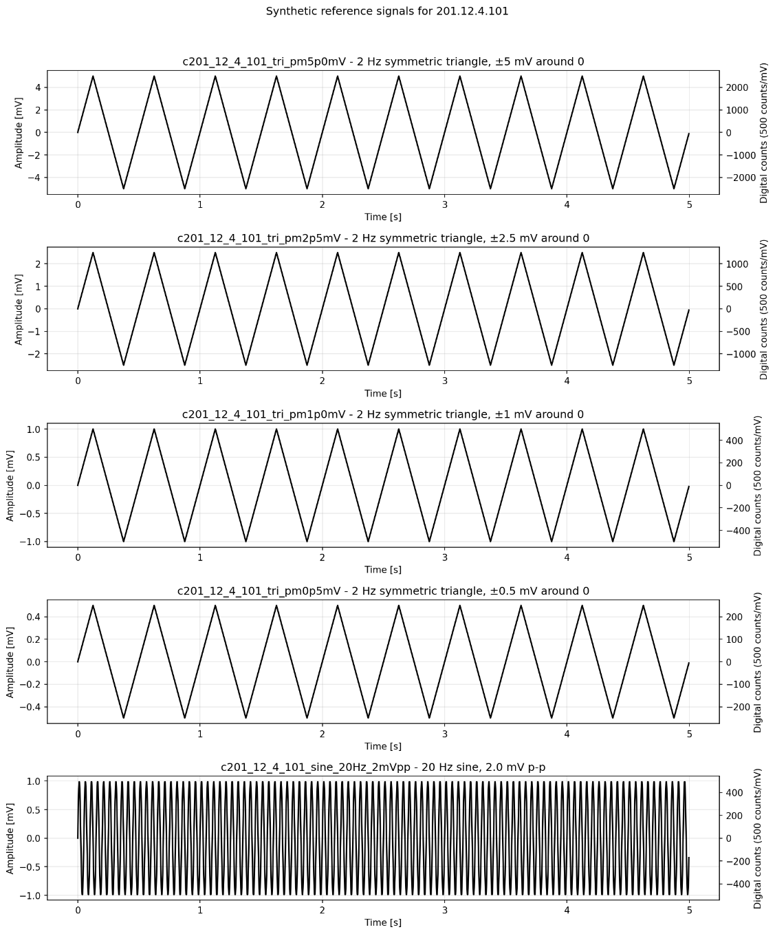

±5 mV

±2.5 mV

± 1mV

± 0.5 mV

20 Hz sine

Figure 2: Synthetic signals for Clause 201.12.4.101

Clause 201.12.4.102.1 — General frequency response
For this clause, a set of sinusoidal signals is generated, each with 2.0 mV peak-to-peak amplitude and a duration of at least 5 s, at the following frequencies: 0.67, 1, 2, 5, 10, 20, 40 Hz. The resulting waveforms are shown in Figure 3.
These signals are used to measure the decoded amplitude response across the general ECG passband and to normalize the result to the decoded 5 Hz reference response.
This signal set is intended to reveal any amplitude attenuation or amplification introduced by the codec across the low- and mid-frequency ECG band. Because the inputs are pure sinusoids, the resulting measurements are straightforward to interpret and compare to the clause limits.

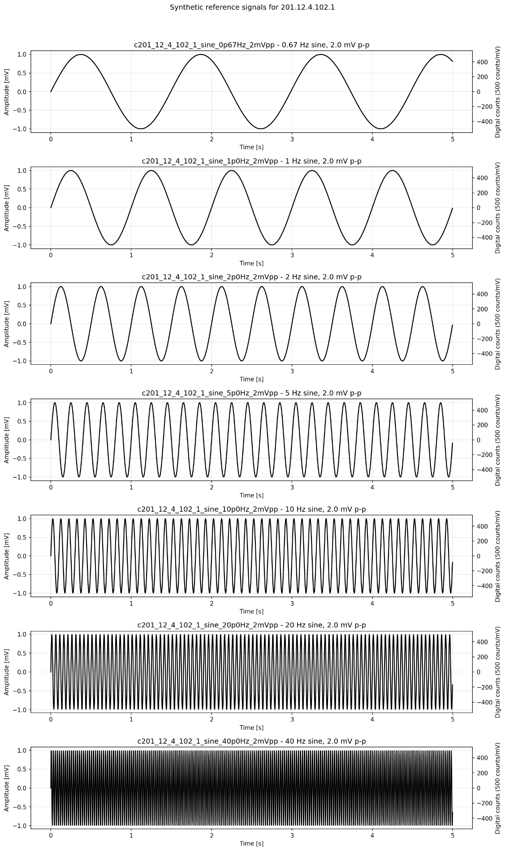

0.67 Hz sine
1 Hz sine
2 Hz sine
5 Hz sine
10 Hz sine
20 Hz sine
40 Hz sine
Figure 3: Synthetic signals for Clause 201.12.4.102.1.
Clause 201.12.4.102.2 — ST measurement frequency response
For this clause, we generate a waveform consisting of a 5 second long zero baseline segment before a single triangular pulse of 4 mV amplitude and 150 ms duration, followed by a 5 sec long zero baseline segment. The baseline intervals are chosen to provide sufficient pre-pulse and post-pulse observation time for the required measurements. The resulting waveform is visualized in Figure 4.
This waveform is specifically designed to test baseline stability and post-pulse distortion. In the current implementation, the pre-pulse baseline is used to define the reference level, and the post-pulse segment is analyzed for both maximum baseline displacement and the largest variation within any 200 ms window.

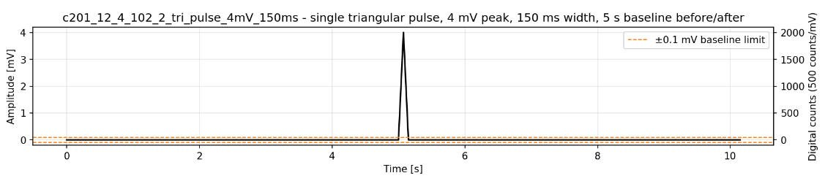
Figure 4: Synthetic signal for Clause 201.12.4.102.2

Experimental results
Codec-level performance
Before presenting the clause-based waveform-fidelity results, it is useful to first summarize the general compression behaviour of the codec using conventional rate-distortion measures. In this section, codec performance is summarized using PSNR as a function of QP and the corresponding rate-distortion curve. These plots provide the standard view of how reconstruction quality changes with operating point and coding rate and serve as a baseline for interpreting the compliance-oriented results presented later. The codec-level performance results for all tested clauses are presented in Figures 5 and 6. Note the very low bit-rates in figure 6 due to the purely periodic nature of the signals.
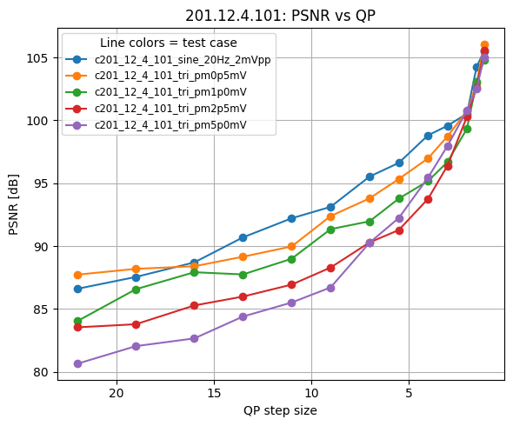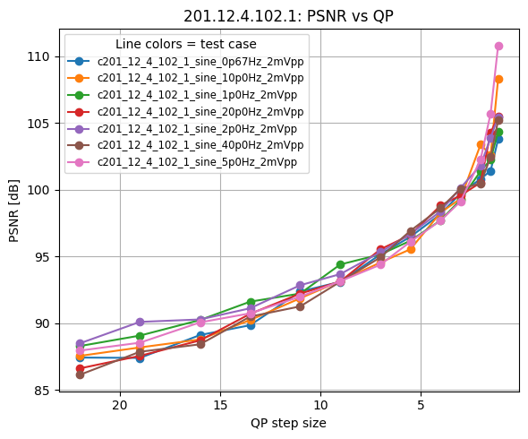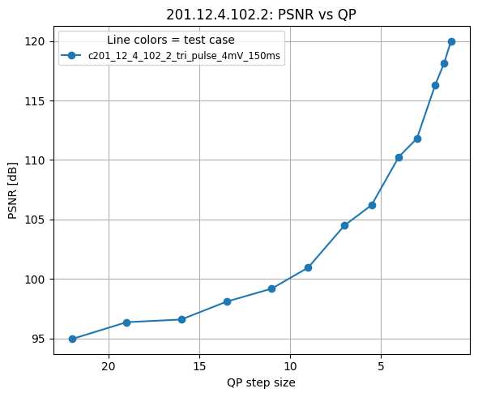
Figure 5: PSNR as a function of QP for gain of 500 units/mV
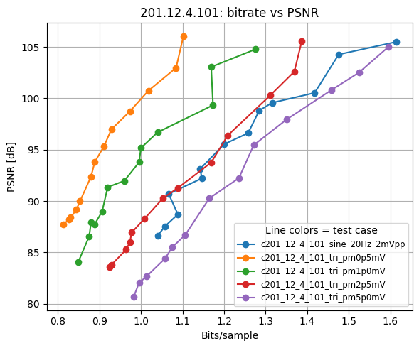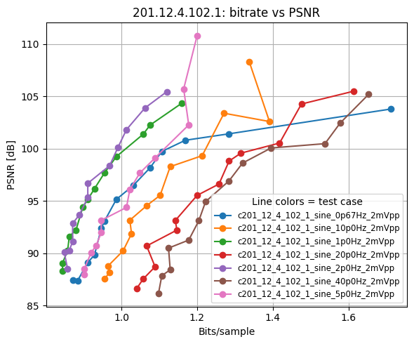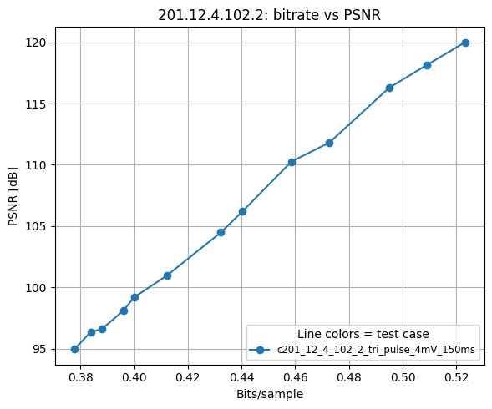
Figure 6: Rate distortion curve for gain of 500 units/mV

Clause-level compliance evaluation
In addition to the codec-level performance measures, the reconstructed waveform was evaluated against selected clause-based requirements derived from IEC 80601-2-86 document. For each clause, synthetic reference signals were generated according to the required waveform characteristics as described above, then encoded and decoded by the codec under test, and finally analyzed using the decoded output. The resulting measurements were compared against the corresponding clause limits to determine whether the reconstructed waveform remained within the required tolerance.
The results are presented for all QP step levels defined for ECG, and for the three evaluated gain settings.

201.12.4.101 — Accuracy of signal reproduction
This clause evaluates whether the decoded waveform preserves signal amplitude accurately.
For the triangular-wave part of the test, the peak-to-peak amplitude of the waveform is measured as:
$$A_{pp}=max⁡(x)-min⁡(x)$$where $x$is the waveform expressed in millivolts. The measured amplitude of the decoded waveform is compared against the reference amplitude, and the allowed tolerance is defined as:
$$T=max⁡(0.20∙A_{pp,ref},0.10mV)$$
The test passes if:
$$∣A_{pp,meas}-A_{pp,ref}∣≤T \\ For the$$sinusoidal part of the test, the decoded waveform is fitted with a sinusoidal model at 20 Hz,
$$x(t)≈c_{0}+c_{1}sin⁡(2πft)+c_{2}cos⁡(2πft),f=20$$and the fitted peak-to-peak amplitude is estimated as:
$$A_{pp,meas}=2\sqrt{c_{1}^{2}+c_{2}^{2}}$$For a reference input amplitude of 2mV peak-to-peak, the test passes if:
$$1.6mV<A_{pp,meas}≤2.4mV$$Figure 7 shows the results for the 2 Hz triangular-wave test at amplitude levels of ±5.0 mV, ±2.5 mV, ±1.0 mV, and ±0.5mV and Figure 8 shows the results for the 20 Hz sinusoidal test at an input amplitude of 2.0 mV peak-to-peak. For this clause, no failures were observed. All measured values remained within the corresponding tolerance limits for the full range of tested QP steps and gain settings.

201.12.4.102.1 — General frequency response
This clause evaluates whether the decoded waveform preserves the relative amplitude response across the general ECG frequency band. The response is measured at 0.67, 1, 2, 5, 10, 20, and 40 Hz, and normalized to the decoded 5 Hz reference response. The peak-to-peak amplitude $A_{pp}(f)$is estimated in the same way as in the previous clause, using a sinusoidal fit to the decoded waveform.
$$R\left(f\right)=\frac{A_{pp}(f)}{A_{pp}(5Hz)}$$
The test passes if, for each required frequency, the normalized response remains within the allowed band:
$$0.70≤R\left(f\right)≤1.10$$
Figure 9 shows the results for the corresponding sinusoidal inputs at 2.0 mV peak-to-peak for the frequencies 0.67, 1, 2, 5, 10, 20, and 40 Hz. For this clause, the measured values remained within the specified tolerance limits across all evaluated QP steps and gain settings, and the test was passed in all cases.
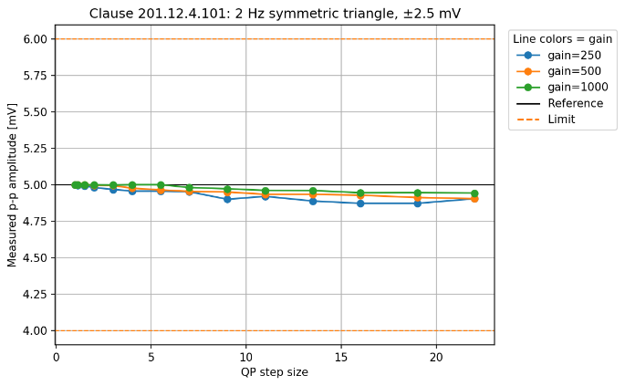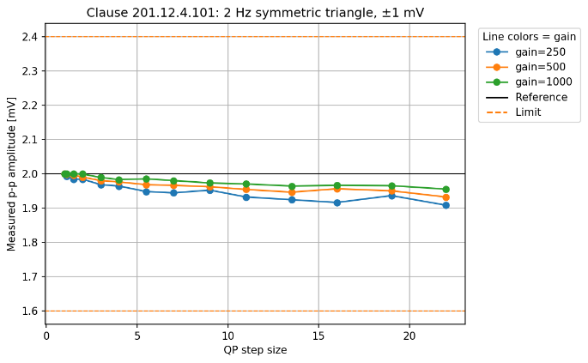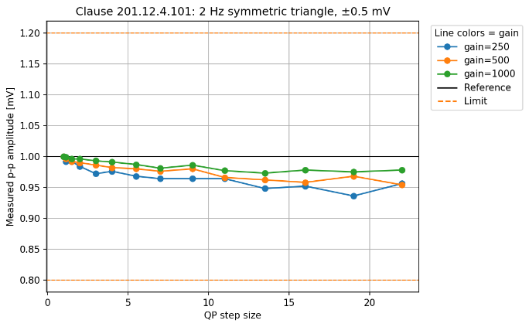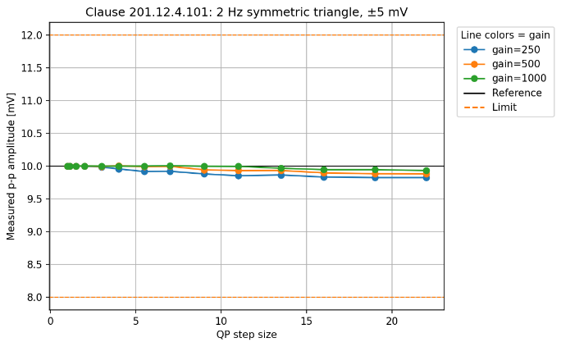Figure 7: Clause 201.12.4.101 results for the 2 Hz triangular-wave test at the three gain settings.

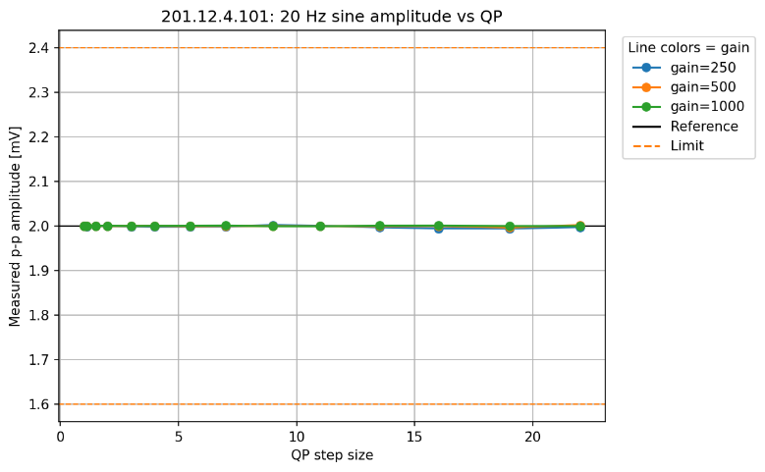
Figure 8: Clause 201.12.4.101 results for the 20 Hz sinusoidal test at the three gain settings.

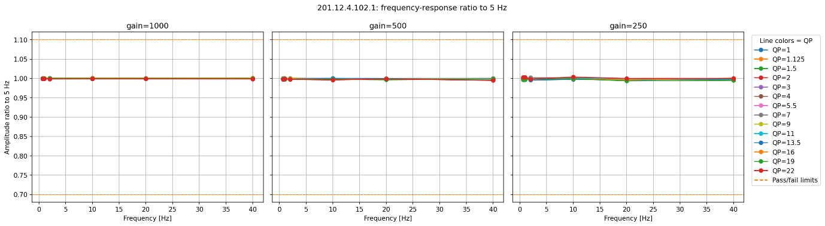
Figure 9: Clause 201.12.4.102.1 results for the three gain settings

201.12.4.102.2 — ST measurement frequency response
This clause evaluates the effect of the codec on post-pulse baseline stability and short-window signal variation.
The baseline reference is defined as the mean value of the decoded waveform in the 50 ms interval immediately before the triangular pulse:
$$B_{ref}=mean(x(t)\text{ in the 50 ms before pulse start})$$
The first measured quantity is the maximum post-pulse baseline displacement relative to this reference:
$$Δ_{base}=\underset{t∈\text{post-pulse}}{max⁡}∣x(t)-B_{ref}∣$$
The second measured quantity is the largest peak-to-peak variation within any 200 ms window in the post-pulse region:
$$Δ_{200\text{ms}}=\underset{\text{all 200 ms windows}}{max⁡}\left(max⁡(x(t)-B_{ref})-min⁡(x(t)-B_{ref})\right)$$
The test passes only if both conditions are satisfied:
$$∆_{base}≤0.10mV \\ ∆_{200ms}≤0.060mV$$
This clause is relevant for assessing whether the codec introduces post-pulse distortion, ringing, or baseline drift that could affect ST-related waveform interpretation.
Figure 10 shows the results for the ST-related pulse test using a single triangular pulse of 4 mV amplitude and 150 ms duration.
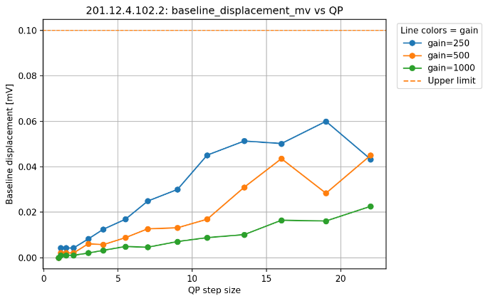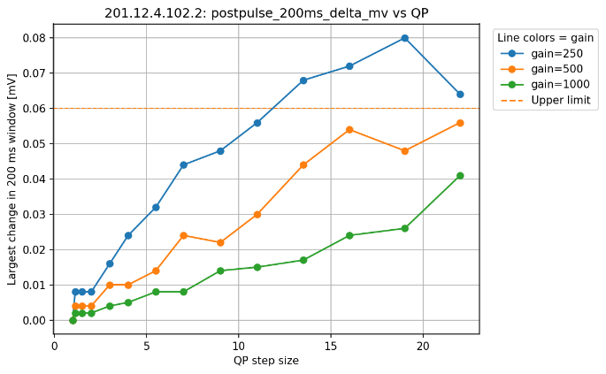
Figure 10: Clause 201.12.4.102.2 results for the three gain settings
For this clause, failure occurs only at the four highest tested QP steps, corresponding to strongest compression. In all cases, the failing measure is the 200 ms post-pulse variation, whereas the baseline displacement remains within tolerance. This suggests that stronger compression mainly introduces short-term post-pulse distortion or residual oscillatory artifacts, rather than a larger overall baseline shift.
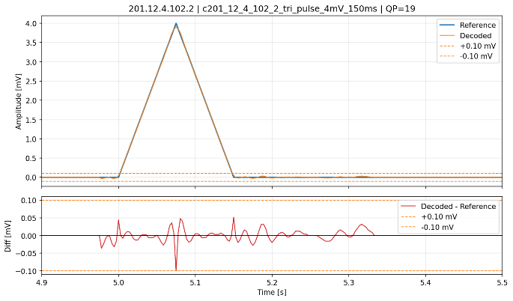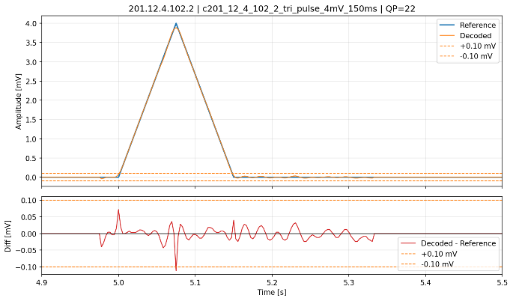
Figure 11: Clause 201.12.4.102.2 difference between decoded and reference waveform for gain 250 at QP 19/22

Observations and Summary
The results presented show that for the tests that target the frequency response of the system the H.BWC codec does not introduce any meaningful degradation, at least in the common ECG frequency range. At high compression ratios the codec does introduce some temporal artifacts that would mean that it is not suitable for compressing ECG signals for these specific operating points of the codec.
These observations come with the caveat that the tests are designed for a full system-integration level test, and that when applying to just the codec it is difficult to ensure that the input digital signals truly match what would be received in a device with an analogue front end and A-D converters.
The tests should be replicated for the other modalities (EEG, EMG, etc.) that are covered in different specifications in the 60601 series.
________________________

Appendix

Figure A.1: PSNR as a function of QP for gain of 250 units/mV
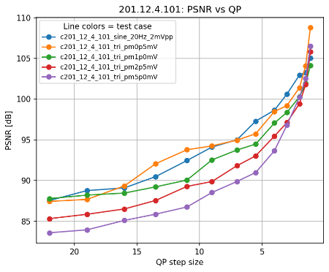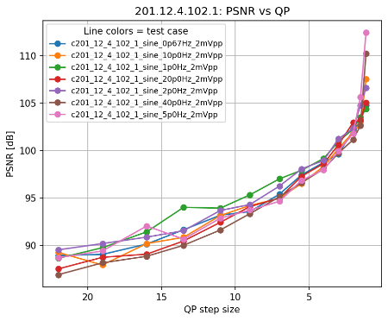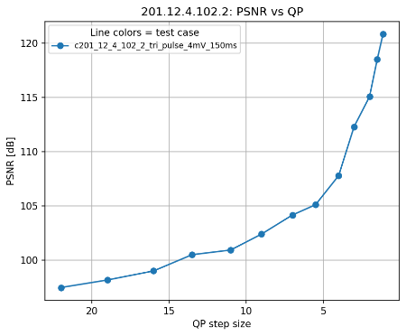
Figure A.2: Rate distortion curve for gain of 250 units/mV
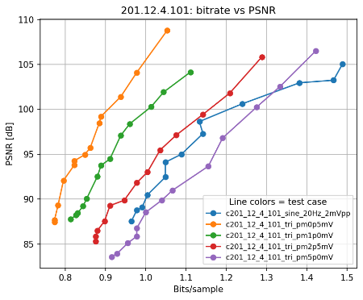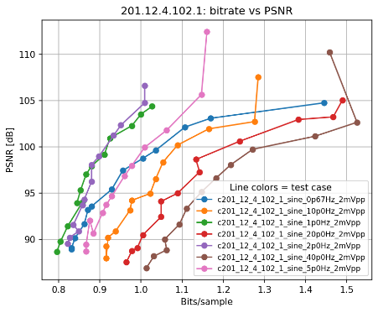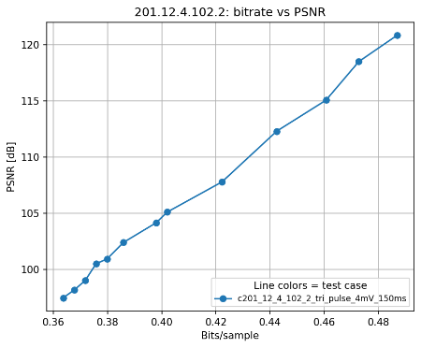
Figure A.3: PSNR as a function of QP for gain of 1000 units/mV
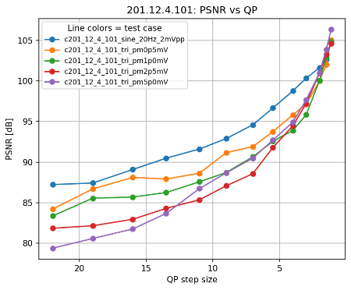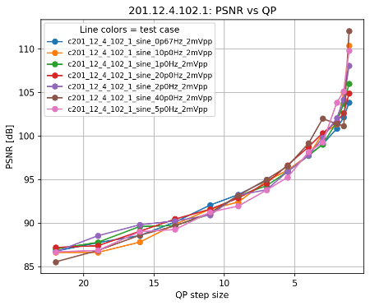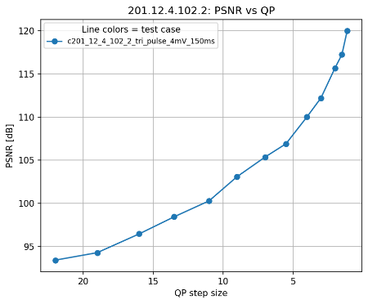
Figure A.4: Rate distortion curve for gain of 1000 units/mV
