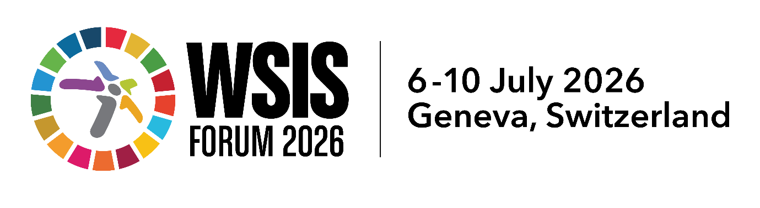

Inclusion Without Safety Is Not Empowerment: Automation Is Scaling Harm Faster Than We Can Respond
Organizer organisation(s): Away from Keyboard Inc.,
Women 4 STEM, Soroptimist International, National Council of Women Victoria, Australian Gender Equality Council
Date and time: Friday 10 July 2026, 09:00–09:45 (UTC+02:00), Palexpo, Room L

Key Issues Discussed
- The gap between expanding technological access and ensuring safety, and how that gap disproportionately shifts risk onto women, girls, and marginalised communities.
- The shift required in how digital inclusion is measured, from optimising for engagement and efficiency to optimising for safety and wellbeing.
- The 'automation multiplier': how engagement-driven design, algorithmic learning, and accelerated scale interact to amplify existing inequality faster than human oversight can respond.
- Seven recurring patterns of automated harm, spanning content-level harms (escalating content, digital overload) through to institutional-level harms (automated denial of care, automated coercive control, cultural and linguistic exclusion).
- The Vulnerability Stacking framework: why overlapping vulnerabilities, gender, disability, isolation, language, compound multiplicatively rather than additively, and what that means for risk assessment design.
- The Compounding-Risk Screen: a nine-question structural tool across three phases, design and data architecture, systemic human impact, and meaningful governance, for assessing systems before they are built, deployed, or scaled.
- [Concerns from participants about the escalation of harm, expressions of gratitude regarding the thorough explanation of risks and the sense of urgency]

Key Outcomes of the Session
- Reinforced that safe participation is a precondition for sustainable development, not a later add-on, directly linking WSIS Action Lines C5 and C10 to SDGs 5, 10, and 16.
- Introduced the Compounding-Risk Screen and Vulnerability Stacking framework to the WSIS audience as practical, structural tools rather than abstract principles.
- Announced free availability of governance tools, including the Alt-TAB pre-deployment AI ethics assessment tool, at alttab.afk.org.au.

Main Implementation Activities & Corresponding WSIS Action Lines
- C5, Building confidence and security in the use of ICTs: embedding the Compounding-Risk Screen into pre-deployment assessment practice for AI systems affecting vulnerable users.
- C7, E-government / e-health: applying fairness and inclusion questions to automated decision-making in welfare, disability, and health-adjacent systems.
- C9, Media: addressing algorithmic amplification of harmful narratives through accountability in content distribution systems.
- C10, Ethical dimensions of the information society: formalising the Vulnerability Stacking framework as a mechanism for recognising compounding risk in ethical assessment.
- C11, International and regional cooperation: sharing the governance screen as a free, openly available tool to support cross-jurisdictional consistency in AI safety practice.
- [Add: discussion by Away from Keyboard Inc. and Soroptimist International having opportunity to raise awareness through our platform of the Action Lines and the Key Indicators.

Key Recommendations and Forward-Looking Actions
- Encourage system designers and policymakers to adopt multiplicative, not additive, risk models when assessing how automated systems affect individuals with overlapping vulnerabilities.
- Integrate structural risk screens, such as the Compounding-Risk Screen, into standard practice before systems are built, deployed, or scaled, rather than relying on post-deployment remediation.
- Strengthen the WSIS Action Line C10 mandate by embedding accountability requirements at the point where harm is foreseeable, not only where it is administratively convenient.
- Sustain cross-sectoral collaboration between civil society, technical, and policy communities so that safety and inclusion remain linked priorities rather than sequential ones.

