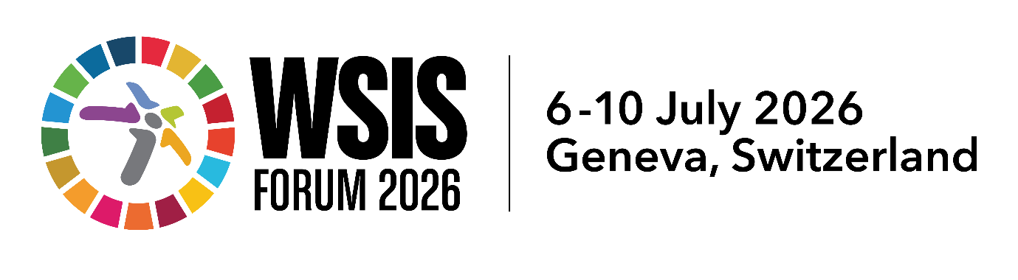

Session Outcome Document
Accessible digital educational environments: transferring research knowledge
Xarxa AccessCat, Universitat Autònoma de Barcelona (Spain)
6 July 2026, 10 AM (CEST)
https://www.itu.int/net4/wsis/forum/2026/Agenda/Session/155

Key issues discussed
- Accessibility as a core pillar, not an add-on: Shift from viewing accessibility as an afterthought or a compliance measure to a fundamental element of high-quality, equitable education.
- Complex digital learning communication spaces: The challenges and opportunities of modern educational settings transformed by migration, internationalization, multilingualism, and digital learning.
- Audio description for inclusion and minoritized languages: Utilizing audio description (AD) beyond traditional accessibility services—specifically as a pedagogical tool for active language learning and promoting minoritized languages.
- Eliminating cognitive and format barriers: Designing learning materials that focus on structural formatting and presentation to remove unnecessary barriers, allowing diverse learners to focus on learning objectives rather than format struggles.
- Multimodal and autonomous sign language resources: Enhancing inclusive classrooms and student autonomy through digital, multimodal self-learning environments for Catalan Sign Language (LSC).
- Research knowledge transfer to society: Transforming academic research into practical, innovative, and accessible digital tools to address systemic exclusion in the digital society.

Key outcomes of the session

Key insights and findings
- Accessibility inherently benefits the entire educational community, not just specific target demographics, by creating cleaner, more flexible, and multi-channel paths to information.
- Simplification should move beyond adapting the level of text difficulty to re-evaluating layout, presentation, and delivery mediums.

Announcements, launches, or new initiatives presented during the session
- Presentation of the AccessCat Network ecosystem (accesscat.net), showcasing Catalonia's centralized framework for driving knowledge transfer in communication and digital accessibility.
- Showcasing of multimodal online resources and self-learning platforms developed by member research groups (such as the LSC Lab tools; NeurekaLab, a spin-off by the Digital Care group, or the digital and media accessibility related project outputs by TransMedia Catalonia).

Agreements, collaborations, or commitments made
- Shared commitment by the network's specialized researchers to continue bridging the gap between scientific innovation and educational institutions to foster social justice.

Key recommendations and forward-looking actions
- Embed accessible, universal design early: Urge educational developers and tech creators to systematically integrate universal design principles into digital content creation pipelines from inception, aligning with WSIS implementation goals for inclusive education.
- Cocreate with end users to ensure usability and impact: Actively involve end users, especially local organisations, in the design, development, and testing phases of digital educational tools. This ensures that technologies are genuinely co-created, ground-tested, and tailored to the lived experiences and specific needs of the communities they serve.
- Promote multimodal and linguistic diversity: Leverage access services (e.g., Audio Description, Sign Language tools) to protect local or minoritized languages, ensuring digital acceleration does not trigger further cultural or linguistic exclusion by 2035.
- Strengthen knowledge transfer ecosystems: Establish institutional frameworks modelled on networks like AccessCat to foster direct, fluid collaboration between academic accessibility researchers, policymakers, and classroom educators.

