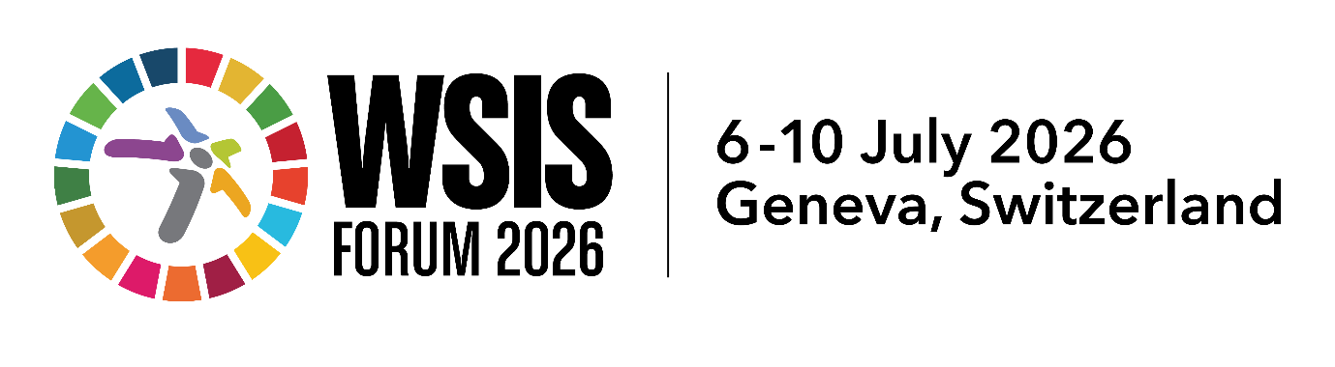

Session 347 Outcome Document

(2 pages max)
Session 347: Digital Inclusion in an Unequal World
ICT4D Collective

16.00-16.45 Monday 6 July 2026

[https://www.itu.int/net4/wsis/forum/2026/Agenda/Session/347]

Key Issues discussed: (5–8 bullet points summarizing the main discussion points)
This session built on the outcomes of our session (306) at WSIS 2025 on "Digital Tech and the Most Marginalised: what still needs to be done", and provides an overview and examples from the new book "Digital Inclusion in an Unequal World: An Emancipatory Manifesto" which was partly derived from discussions in that session. The speakers included Benita Rowe, Prof G. ‘Hari’ Harindranath, Yuliya Morenets (online) and Prof Tim Unwin.

The session was highly interactive, and addressed the following broad issues:
- Why there is so much reinvention of the wheel in the field of digital tech for developent;
- Why the poorest and most marginalised have insufficiently benefitted from the use of digital tech in development
- How it is possible for individuals, governments, the private sector and civil society to make a positive difference to the lives of the most marginalised through gteh use of digital tech
Key Outcomes of the session (concise billet points capturing the concrete results of the session)
- Five main reasons were offered to help us all understand why the poorest are insufficiently benefitting frm the use of digital tech:
  - A global focus that is more on economic growth than on equity
  - The capture of the UN digityal agenda by the private sector
  - A focus on “me” rather than “we”
  - The innovation fetish
  - Digital enslavement
- The session also served as a launch platform for Tim Unwin’s latest book Digital Inclusion in an Unequal World: An Empancipatory Manifesto (Routledge, 2026; https://ict4d.or.uk.diuw)
- The session concluded with advocacy for a responsibilities-based approach to the use of digital tech in “development” to balance the existing human rights agenda, that would emphasise the responsibilities of individuals (both personally and professionally) alongside governments, UN agencies, the private sector and civil society.
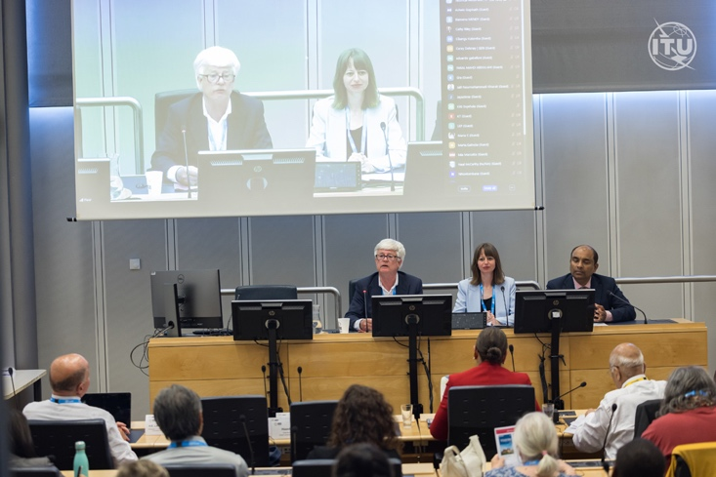
Session 347, Credit ITU Photographer
Key Recommendations and Forward-Looking Actions
Looking forward, we need to shift the balance of the seesaw “from” the emphasis in the left sack in the image below “towards” those on the right sack if “we” are seriously committed to using digital tech in the interests of the poor and marginalised.
