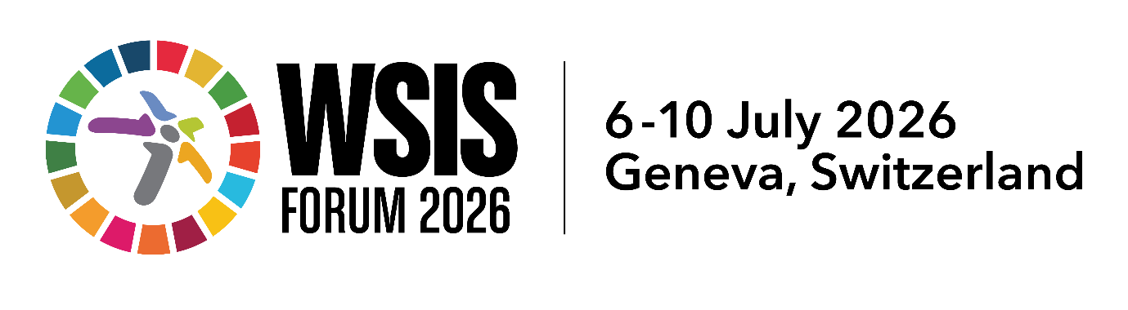

Session Outcome Document
(2 pages max)
[Bridging the Intelligence Divide: AI Capacity Building and Knowledge Sharing for the Global South]
[CAST UN Consultative Committee on Information Technology (CCIT)]
[7 July 2026, 09:00–09:45 (UTC+02:00)]
[https://www.itu.int/net4/wsis/forum/2026/Agenda/Session/183]

Key Issues discussed: (5–8 bullet points summarizing the main discussion points)
- The intelligence divide between the Global North and Global South is widening, with Africa facing the most severe challenges: less than 7% of Africa’s measurable Sustainable Development Goals are on track to be achieved by 2030. Africa’s independent AI development suffers from two major drawbacks: a severe shortage of local data centers and homegrown AI and engineering professionals, alongside heavy reliance on foreign providers for data storage and core technologies.

- Six interrelated core obstacles restrict Africa’s independent AI development: humanistic values and governance systems, critical mineral supply chains, investment capital, data sovereignty, green energy supply, and inclusive political governance. These six factors are interdependent and equally indispensable.

- Equitable international AI cooperation faces multiple barriers, including cross-cultural cognitive gaps, incompatible cross-border communication tools, one-size-fits-all overseas training programs ill-suited to local demands, and the underutilization of Africa’s indigenous talent pool.

- China offers a differentiated approach to bridging the intelligence divide: instead of waiting for full infrastructure deployment before talent cultivation, it promotes lightweight open-source AI tools and tiered customized local training models, distinct from the standardized export model adopted by Western countries. China stands as a key partner supporting Africa’s AI capacity building, yet its cooperation needs improvements in cross-cultural exchange and inclusive communication mechanisms.
Key Outcomes of the session (concise billet points capturing the concrete results of the session)
- AI capacity building must not focus solely on technical training; it must simultaneously address six supporting dimensions: labor rights, data sovereignty, green energy, local industrialization of critical minerals, governance systems, and cross-cultural collaboration.
- Africa’s youth represent a vast, untapped talent pool for AI development, yet local talents cannot fully realize their potential due to poor infrastructure and insufficient domestic investment.
- Talent cultivation can be carried out in parallel without waiting for the full completion of infrastructure. Low-cost cloud services, multilingual open-source AI models and basic hardware can be leveraged to boost local workforce capabilities concurrently.
- Language barriers hinder participation from the Global South in AI development, as mainstream AI translation tools lack support for indigenous African languages.
- All participants reached a consensus that global AI governance negotiations must include representatives from communities and data workers in the Global South, and guarantee formal representation for data labeling labor unions.
Key Recommendations and Forward-Looking Actions (2–5 bullet points outlining practical and actionable recommendations to support WSIS implementation towards 2035)
- Establish unified and fair global regulatory standards for the AI data ecosystem: enshrine the fundamental ownership of community data and formulate reciprocal benefit mechanisms for data sharing.
- Build indigenous foundational AI infrastructure for Africa: jointly develop local data centers powered by green energy (solar and hydropower); advance local deep processing and industrialization of critical minerals.
- Improve inclusive international AI cooperation mechanisms for the WSIS 2035 agenda: Mandate cross-cultural exchange modules and multilingual AI translation tools covering indigenous African languages in all North-South technology cooperation projects. Require open-source communities to adopt globally accessible communication tools to facilitate participation from stakeholders across the Global South.

