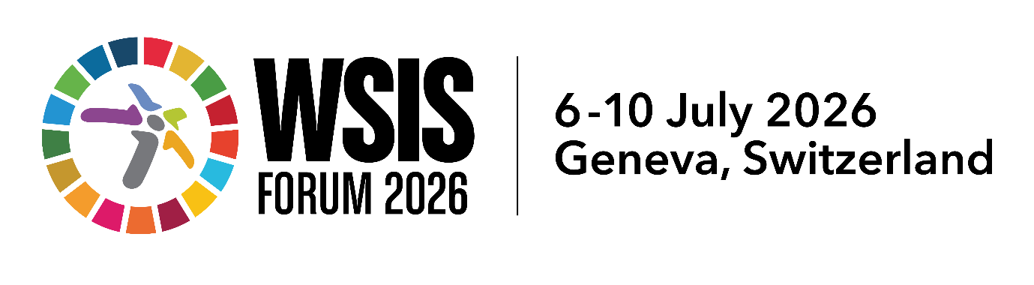

Session 425 Outcome Document
(2 pages max)

Title: From Dialogue to Practice: NRI-Driven Multistakeholder Labs for WSIS Implementation
Organization: Concettina Cassa (AGID), Anriette Esterhuysen (APC), Valeria Betancourt (Secretariat of the LACIGF), in collaboration with the IGF Secretariat (Anja Gengo).
Date &Time: 9 July 2026, 17.00- 17.45
Session page link: https://www.itu.int/net4/wsis/forum/2026/Agenda/Session/425

Key Issues discussed:
- NRI contributions to WSIS implementation.
- Bridging local and global digital governance.
- NRI Labs as multistakeholder knowledge-sharing spaces.
- Knowledge aggregation and peer learning across NRIs.
- Feeding in NRI outcomes to the WSIS Forum.
- Operationalizing paragraphs 100 and 102 of UN General Assembly Resolution 80/173 through practical multistakeholder mechanisms.

Key Outcomes of the session

Overall Outcome
Participants recognised that National and Regional IGF Initiatives generate a rich diversity of knowledge, experiences and good practices through their local multistakeholder processes. This diversity reflects different regional priorities, governance models and implementation contexts, representing one of the greatest strengths of the IGF ecosystem rather than a challenge.
Across all discussion groups, participants agreed that the key objective is to establish practical mechanisms capable of capturing, connecting, aggregating and transmitting this distributed knowledge to support the implementation of the WSIS outcomes and the Global Digital Compact.
The NRI Labs concept was broadly recognised as a promising, voluntary and community-driven approach to foster continuous peer learning while strengthening the contribution of local multistakeholder processes to global digital governance.

- Outcomes from Group 1 – Connecting Local Experiences
  - Participants highlighted the importance of establishing a predictable annual contribution cycle linking NRIs with the global IGF and the WSIS Forum.
  - Several participants suggested launching the planning process well in advance—ideally around one year before each IGF cycle—to allow interested NRIs to voluntarily identify the WSIS Action Lines and Global Digital Compact commitments most relevant to their local priorities.
  - This would provide sufficient time to organise multistakeholder discussions, engage local stakeholders, document implementation experiences and prepare meaningful contributions throughout the year.
  - Participants stressed that the objective should not be to require all NRIs to work on the same issues, but rather to allow each initiative to contribute where it can add the greatest value, while progressively building a shared body of implementation knowledge across the global NRI community.
- Outcomes from Group 2 – Designing NRI Labs
  - Participants discussed possible operational models for NRI Labs and suggested drawing inspiration from open collaborative community platforms, such as the RIPE NCC model.
  - NRI Labs could provide an open space where participants voluntarily share project ideas, implementation experiences, methodologies and practical resources.
  - The discussion highlighted the importance of organising contributions through a common tagging system to facilitate thematic searches, peer learning and collaboration among NRIs working on similar issues.
- Outcomes from Group 3 – From IGF to WSIS Forum
  - Participants discussed how knowledge generated through NRI Labs could better inform the WSIS Forum and other global digital governance processes.
  - The discussion highlighted the need to strengthen the visibility and participation of the IGF ecosystem in broader international processes, including initiatives such as the Global AI Dialogue and AI for Good and other UN digital cooperation processes..
  - Participants also emphasised the importance of strengthening cooperation between NRIs and existing IGF intersessional work, creating stronger connections across the different components of the IGF ecosystem.
  - Participants considered NRI Labs a practical mechanism for improving the flow of knowledge from local multistakeholder discussions into global implementation processes, consistent with paragraphs 100 and 102 of UN General Assembly Resolution 80/173.
Key Recommendations and Forward-Looking Actions
Continue developing the NRI Labs concept as a voluntary, community-driven mechanism to capture, connect, aggregate and disseminate implementation knowledge emerging from National and Regional IGF Initiatives.
Establish an annual planning cycle beginning sufficiently in advance of each IGF process, enabling interested NRIs to voluntarily identify priority WSIS Action Lines and Global Digital Compact commitments and organise corresponding multistakeholder activities throughout the year.
Preserve the diversity of National and Regional IGF Initiatives while creating a common framework that facilitates collaboration, peer learning and knowledge exchange across the global NRI network.
Develop collaborative digital tools, common tagging methodologies and lightweight knowledge-management practices to improve the discoverability, aggregation and reuse of implementation experiences.
Strengthen cooperation between NRI Labs, existing IGF intersessional activities, the global IGF programme and the WSIS Forum, ensuring that knowledge generated through local multistakeholder processes contributes more effectively to global implementation efforts.
Continue the community-driven discussion involving NRIs, the IGF Secretariat and interested stakeholders to refine the operational model and explore possible pilot activities for future IGF cycles.
Participants agreed that the long-term value of NRI Labs lies in transforming the knowledge generated through more than 180 National and Regional IGF Initiatives into a shared global learning ecosystem capable of continuously supporting WSIS implementation, strengthening multistakeholder cooperation and informing future digital governance processes.

