**Biography**

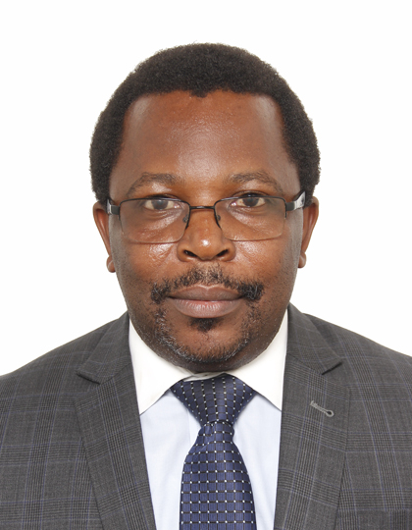

Dr. Emmanuel C. MANASSEH has more than 17 years of experience in the telecommunications sector. He is a skilled public policy professional with the proven ability to conduct evidence-based policy analysis and provide advice on a range of government priorities, from the design of domestic co-management models to international telecommunications policy.

Dr. Manasseh is now working as the ITU Regional Director, Regional Office for Africa. Prior to this, he was a Lecturer at Nelson Mandela African Institute of Science and Technology (NM-AIST) Arusha, from June 2023 to January 2024. He joined Tanzania Communications Regulatory Authority (TCRA) in October 2014. From June 2019 to June 2023, he was working as a Director, Industry Affairs at TCRA. Prior to joining TCRA, he was a Lecturer at Nelson Mandela African Institute of Science and Technology (NM-AIST) Arusha, Tanzania, from May 2014. From April 2013 to March 2014, he was an Assistant Professor at Hiroshima University in the Department of System Cybernetics. Dr. Manasseh began his career at Celtel Tanzania Limited (Now Airtel Tanzania), as a Telecommunications Engineer, working on Operation & Maintenance of all 2G/3G Base Station Subsystem (BSS) from 2005 to 2007.

Dr. Manasseh holds different leadership roles, including Chairman of the Board of Trustees, Tanzania Education and Research Network (TERNET); Board Member of Maendeleo Bank PLC; and was an Alternate Councillor for the United Republic of Tanzania in the International Telecommunications union (ITU). He was also a Vice Chair of ITU -T Study Group 20, Internet of Things and Smart Sustainable Cities.

He is also a member of professional institutes and bodies including, Engineers Registration Board of Tanzania (ERB); Senior member of the Institute for Electrical and Electronics Engineers (IEEE); Institution of Engineering and Technology (IET) UK.

Dr. Manasseh holds Doctor of Engineering (Dr. Eng.) from the department of System Cybernetics, Hiroshima University, Japan in 2013; Masters of Engineer- ing (M.Eng.) from Hiroshima University, Japan in 2010; and BSc. degree in Telecommunications Engineering from the University of Dar Es Salaam, Tanzania in 2005.