

DIGITAL ECONOMY DEVELOPMENT
IN CHINA
(2020)

China Academy of Information and Communications Technology (CAICT)
July 2020
Copyright Statement

The copyright of this report is owned by China Academy of Information and Communications Technology and is protected by law. Any reprint, excerpt or use of the text or ideas in this report by other means shall be marked "Source: China Academy of Information and Communications Technology". Anyone who violates the above statement will be held accountable.
Preface
Mankind is now drawn into an information revolution, following the agricultural and industrial revolutions in history. A new wave of revolution in technology and industries has swept the globe. This can find full expression in accelerated data-to-value transition, integrated digital technology and substantial economy, and fully-enabled digital application in industries, leading to all-round reforms in new models and emerging commercial activities as well as significant enhancement of modernized national governance.
According to the Report (2020), digital economy refers to an emerging economic form, taking digitalized knowledge and information as the essential productive factors, digital technology as the core drive and modern information network as the key carrier, promotes accelerated restructuring of economic growth and governance models by continuously improving digital, networking and intelligent capabilities through the extensive integration of digital technology and substantial economy.
Continuous expansion of digital economy with greater contribution to GDP. The year 2019 saw the added value of digital economy in China hitting RMB 35.8 trillion, accounting for 36.2% of GDP, up by 1.4 percentage points on a year-on-year basis. Calculated in comparable terms, the nominal growth rate of digital economy in China climbed by 15.6% in 2019, around 7.85 percentage points higher than that of GDP in the same period. This is more telling that digital economy plays a role in the national economy.
Steady growth of digital industrialization. In 2019, digital industry secured a steady growth with more solid foundation and continuously improved internal structure. In terms of scale, 2019 witnessed the added value of digital industrialization reaching RMB 7.1 trillion, increased by 11.1% on a year-on-year basis. As for structure, the industrial structure kept softening, with modest increments in software industry and the Internet-based industries.
Advancing industry digitalization. The transformation of industry digitalization has evolved from single application to continuous coordination, while industry digitalization has pivoted on data integration and platform empowerment. The year 2019 saw the added value of industry digitalization in China touching around RMB 28.8 trillion, making up 29.0% of GDP. In addition, the penetration rates of digital economy in the service, industry and agriculture sectors notched up 37.8%, 19.5% and 8.2% respectively. The fast-developing industry digitalization has become a vital support that sustains the national economy.
Improved digital governance capability. On the one hand, building a digital government will be a transformation of its governance from inefficient to efficient, from passive to active, from extensive to precise, and from procedural feedback to quick and flexible response. In recent years, China's public service supply capacity from the central to local governments has been significantly improved. On the other hand, China's new smart cities have entered a new stage of development that is people-oriented, result-oriented, coordinated and intensive, and collaborative and innovative. The focus of development has gradually shifted from overall planning and comprehensive construction to creation of a high-quality environment and design of a long-term sustainable development mechanism.
Accelerating data valuelization development. Data has become a key factor of production in the development of digital economy. From the angle of industry, China has already formed a relatively complete data supply chain, shaping a data industry system in various links such as data acquisition, data annotations, time-series database management, data storage, business intelligence processing, data mining and analysis, data security, and data exchange, and constantly improving data management and data application capabilities.
The China Academy of Information and Communications Technology has published the digital economy development report for six consecutive years, and its measurement method has been included in the G20 (Argentina) Tookit for Measuring the Digital Economy. The measuring results have been widely cited. In 2019, based on previous studies, the Report reflected the development process of digital economy from "two orientations" (digital industrialization and industry digitization) to "three orientations" (digital industrialization, industry digitization and digital governance). In 2020, the Report extends the "three orientations" (digital industrialization, industry digitalization and digital governance) to the "four orientations " (digital industrialization, industry digitalization and digital governance, data valuelization development). The Report has combed out the data valuelization development and digital economy policy system, hoping that the results can provide reference for all sectors of the society.
Of course, there are still many shortcomings in the Report, and we welcome the criticism and correction from all sectors of the society.

Contents
I. The Digital Economy Has Entered a New Stage of Coordinated Development of “Four Orientations” 1
(I) Framework of “four orientations” for digital economy 1
(II) Connotation of “four orientations” for digital economy 3
II. The Overall Development of the Digital Economy Has Hit a New High 4
(I) The scale of digital economy hit a new record high 4
(II) Digital economy continues to grow at a high rate 6
(III) Significant progress has been made in the contribution of digital economy 7
(IV) The structure of digital economy continues to be optimized and upgraded 8
(V) Prosperous regional development of digital economy 8
III. Digital Economy Witnesses Various Highlights in Development of all Fields 10
(I) Steady development of digital industrialization 11
(II) Deepening industry digitization 15
(III) Improving the capacity of digital governance 22
(IV) Accelerating advancement of data valuelization development 25
IV. Digital Economy Policy Layout and Promotion Suggestions 29
(I) Development strategies of digital economy in major countries 29
(II) Development strategies and planning of China’s digital economy 30
(III) Regional development strategies of China’s digital economy 31
(IV) Key directions of promoting digital economy development 33
Annex: Accounting Framework of Digital Economy 34

Contents of Figures

Fig. 1 Data Becoming a Key Factor of Production in Digital Economy 3
Fig. 2 Framework of “Four Orientations” in Digital Economy 3
Fig. 3 Scale and Proportion of China's Digital Economy Value Added 5
Fig. 6 Growth of China’s Digital Economy and GDP Growth 7
Fig. 7 Contribution of China’s Digital Economy to Economic Growth 8
Fig. 8 Internal Structure of China's Digital Economy 8
Fig. 9 Scale, Proportion and Growth Rate of Digital Economy Value Added in Some Provinces and Cities in China in 2019... 9
Fig. 10 Added Value of Digital Industrialization in Some Provinces and Cities and Proportion in GDP in 2019............................ 10
Fig. 11 Added Value of Industry Digitization in Some Provinces and Cities and Proportion in GDP in 2019............................. 10
Fig. 13 Internal Structure of Digital Industrialization in China 11
Fig. 14 Scale and Growth of Telecom Revenue in China 12
Fig. 15 Value Added of Electronic Information Manufacturing Industry and Monthly Growth of Delivered Value of Export since December 2018 13
Fig. 16 Growth of Software Business during 2012-2019 14
Fig. 17 Growth of Revenue in Internet Business during 2013-2019 15
Fig. 18 Development of Industry Digitization in China 15
Fig. 19 Development of Digital Economy of Three Industries in China 16
Fig. 20 View of Technology System in Data Industry 29
Attached Fig. 1 Measuring Framework of Digital Economy 35

Contents of Table
Table 1 Existing Data Exchange Platforms in China 27

I. The Digital Economy Has Entered a New Stage of Coordinated Development of “Four Orientations”
Mankind is now drawn into an information revolution, following the agricultural and industrial revolutions in history. The agricultural revolution enhanced human survival ability, the industrial revolution expanded human physical strength, and the information revolution enhanced human brain power, bringing about another qualitative leap in productivity and production relations. A new wave of revolution in technology and industries has swept the globe. This can find full expression in accelerated data-to-value transition, integrated digital technology and substantial economy, and fully-enabled digital application in industries, leading to all-round reforms in new models and emerging commercial activities as well as significant enhancement of modernized national governance. Human history has entered the era of digital economy.
We believe that digital economy takes digital knowledge and information as the key factor of production. With digital technology as the core driving force and modern information network as an important carrier, we will continue to improve the digital, networked and intelligent level of economic society through in-depth integration of digital technology and the real economy, and accelerate the reconstruction of a new economic form of economic development and governance.

(I) Framework of “four orientations” for digital economy
The framework of "two orientations", "three orientations" and "four orientations" in digital economy. In the China’s Digital Economy Development Report(2017), combining with the characteristics of digital economy development, we put forward the framework of “two orientations” in digital economy from the point of view of productivity, namely digital industrialization and industry digitization, and thought that digital economy had transcended the category of information and communication industry department, and should fully realize that digital technology, as a general purpose technology, had been widely used in all sectors of the economy and the society to promote economic growth and increase total factor productivity and open up new space for economic growth. In the China’s Digital Economy Development Report (2019), we noticed that organizational and social form of significant had changed, and then proposed the framework of “three orientations” in digital economy framework from the perspective of productivity and production relations, namely digital industrialization, industry digitization and digital governance, and thought that the vigorous development of the digital economy not only promoted the transformation of economic development quality, efficiency and power, but also brought about profound changes in governance models of the government, organizations and enterprises, reflecting the dialectical unity of productivity and production relations. At present, as the digitalization, networking and intelligent development characterized by data driving are further advanced, and digitized knowledge and information, as key production factors, play a more prominent role in promoting the development of productivity and the transformation of production relations, and the economic society has witnessed a comprehensive and systematic transformation from production factors to productivity and then to production relations. To this end, we further revise the digital economy into the framework of "four orientations", and believe that:
It is the core of the development of digital economy to reshape productivity through digital industrialization and industrial digitization. Productive forces are the ability of human beings to create wealth and the internal driving force for economic and social development. Digital industrialization and industry digitalization are developing vigorously, accelerating the reshaping of human economic production and living patterns. Digital industrialization represents the development direction and latest achievements of the new generation of information technology. With the innovation and breakthrough of technology, new theories, new hardware, new software and new algorithms emerge one after another, and the new digital industrial system defined by software definition and driven by data is taking shape at an accelerating pace. The digitization of industries has brought about profound changes in the real economy. The Internet, big data, artificial intelligence and other new-generation information technologies are widely and deeply integrated with the real economy. The popularization of open innovation system has accelerated the arrival of new intelligent production methods. The new ecosystem of platformized industry is rising rapidly, and new technologies, industries, models and forms of business are emerging. Industrial transformation, economic development and social progress have embraced new drivers of growth.
Digital governance leads to profound changes in relations of production and guarantees the development of the digital economy. Relations of production are social relations formed by people in the process of material production. Digital economy promotes the innovative development of data, intelligent equipment, and digital workers, accelerates the integration of digital technology with traditional industries, advances the governance system to a higher level, and speeds up the modernization of supporting national governance system and governance capacity. On the subject of governance, the construction of a collaborative governance system featuring departmental coordination and social participation has been accelerated, and digital governance is continuously improving the modernization level of national governance system and governance capacity. In terms of governance methods, digital economy promotes governance from fuzzy governance based on "personal judgment" and " empiricism" to "meticulous and accurate" and "data-driven" digital governance. In terms of governance means, the application of cloud computing, big data and other technologies in governance can enhance situational awareness, scientific decision-making and risk prevention capabilities. In terms of service content, digital technology and traditional public services are developing in multiple fields, industries and regions, accelerating the process of equalizing public services.
It is the foundation of digital economy development to reconstruct production factor system through data valuelization development. Factors of production are the resources needed for economic and social production and management. In agricultural economy, technology (represented by agricultural technology), labor force and land constituted the combination of production factors. In the industrial economy, technology (represented by industrial technology), capital, labor force and land constituted the combination of production factors. In the digital economy, technology (represented by digital technology), data, capital, labor force and land constitute the combination of production factors. Data is not the only factor of production, but as a new and key factor of production in the digital economy, it runs through the whole process of the development of the digital economy, combines and iterates with other factors of production continuously, accelerates the cross fusion, and leads to the breakthrough of production factors in multiple fields, multi-dimensional, systematic and revolutionary groups. On the one hand, the value of the data elements will promote the technology, capital, labor force, land and other traditional factors of production to undergo profound transformation and optimization reorganization, giving the digital economy a strong driving force for development. The combination of data elements and traditional factors of production created a "new technology" like artificial intelligence, "new capital" like financial technology, “new labor” like intelligent robots, “new land” like digital twin, and “new idea” like Blockchain. The new combination of factors of production and new forms of production will continuously release the amplifying, superimposing and multiplying effects for the development of digital economy. On the other hand, the value of data directly drives the transformation and upgrading of traditional industries to digitalization, networking and intelligence. The extensive and deep integration of data elements with traditional industries highlights the multiplier effect and shows great value and potential for economic development. Data drives the service industry to explore customer segmentation, risk prevention and control, and credit evaluation by using data elements, promotes the industry to accelerate the realization of intelligent production with intelligent perception and accurate control, and promotes the transformation of agriculture to data-driven intelligent production mode.

(1) Data becomes a key factor of production;
(2) A new technological and economic paradigm ("digital technology-economic paradigm") is taking shape.
Agricultural economy | Industrial economy | Digital economy
Y=F1（A1,L,T） | Y=F2（A2,K,L,T） | Y=F3（A3,D,K,L,T）
Y: Economic value-added F: Production function (including organizational form, government governance, etc.)
A: Technology advancement L: Labor T: Land D: Data element
Source: CAICT
Fig. 1 Data Becoming a Key Factor of Production in Digital Economy
“Framework of Four Orientations” in Digital Economy
Production factor | Productivity | Production relations
Data valuelization development | Digital industrialization | Digital governance
   | Collection and gathering
   | Right determination and pricing
   | Trading market
   | Security and protection
   | Basic telecommunications |  | Electronic information manufacturing
   | Software and services |  | Internet
   | Multi-subject participation
   | Combination of technology and management
   | Digital public services
Technology, capital  labor, land… | Industry digitization  Digital marginal contribution of digital technology    Agriculture  Industry  Service  Industrial marginal contribution of digital technology  Agricultural marginal contribution of digital technology
Source: CAICT
Fig. 2 Framework of “Four Orientations” in Digital Economy
The development of digital economy is the dialectical unity of productivity and production relations. Developing digital economy and constructing the collaborative development ecology of "four orientations" based on data valuelization development, and having digital industrialization and industry digitization as the core, and digital governance as the guarantee, are not only important theoretical propositions, but also important practical subjects, with distinctive features of the times and internal logic of dialectical unity. The four are closely linked, complementary, mutually promoting and influencing each other. In essence, they are the relations between the productivity and the relations of production and between the economic foundation and the superstructure. It is the essential requirement to promote the development of digital economy through dealing with the relationship between the four. At present, the operation characteristics of the large-scale release of digital technology dividend and the major strategic transformation of the concept of economic development in the new era have formed a historical convergence. It is of great significance at the right time to develop the digital economy, build new advantages in its development, and promote changes in its quality, efficiency and driving force.

(II) Connotation of “four orientations” for digital economy
First, digital industrialization. Digital industrialization, namely information and communication industry, is the leading industry of digital economy development, providing technology, products, services and solutions for the development of digital economy. It includes electronic information manufacturing industry, telecommunications industry, software and information technology service industry, Internet industry and so on. Digital industrialization includes but is not limited to 5G, integrated circuits, software, artificial intelligence, big data, cloud computing, blockchain and other technologies, products and services.
Second, industry digitization. Industry digitization is the main front for the development of digital economy, which provides a broad space for the development of digital economy. Industry digitization refers to the production quantity and efficiency improvement brought by the application of digital technology in traditional industries, and the new output constitutes an important part of digital economy. The digital economy is not the economy of figures, but an integrated economy, the foothold of real economy, with high-quality development as the overall requirement. Industry digitalization includes but is not limited to industrial Internet, integration of industrialization and modernization, intelligent manufacturing, Internet of vehicles, platform economy and other integrated new industries, new models and new forms of business.
Third, digital governance. Digital governance is the guarantee for the rapid and healthy development of digital economy innovation. It is an important part of the modernization of national governance system and governance capacity, and a new government governance model that uses digital technology to establish and improve the system of administrative management, innovate the way of service supervision and realize a more optimized system of administrative decision-making, administrative execution, administrative organization and administrative supervision. Digital governance includes the innovation of governance model, the use of digital technology to improve the governance system, and the enhancement of comprehensive governance capacity. It includes but is not limited to multi-level governance featuring multi-subject participation, technology and management integration featuring "digital technology + governance", and digital public services.
Fourth, digital value development. Value-oriented data is the key factor of production in the development of digital economy. Accelerating the process of value-oriented data is the essential requirement of developing digital economy. President Xi Jinping has repeatedly stressed the need to "build a digital economy with data as the key element". The Fourth Plenary Session of the 19th CPC Central Committee made it clear for the first time that data could be distributed as a production factor according to their contributions. On April 9, 2020, the CPC Central Committee and the State Council issued the Opinions on Building a More Perfect System and Mechanism for Market-based Allocation of Factors, which clearly stated that it was necessary to "accelerate the cultivation of data factor market". Data can be stored and reused. It is characterized by explosive growth and massive aggregation, and is a basic strategic resource for the digital, networked and intelligent development of the real economy. Data valuelization development includes but is not limited to data collection, data standards, data right determination, data annotation, data pricing, data exchange, data flow, and data protection.

II. The Overall Development of the Digital Economy Has Hit a New High
In 2019, against the backdrop of a complex and grim international economic environment and arduous domestic development tasks, China's digital economy maintained rapid growth, made steady progress in various fields, and made new strides in high-quality development of the digital economy.

(I) The scale of digital economy hit a new record high
The scale of China's digital economy continues to expand and reach a new level. In recent years, the digital economy has become one of the core growth poles in the national economy. The scale of digital economy value added in China expanded from RMB 2.6 trillion in 2005 to RMB 35.8 trillion in 2019. The proportion of digital economy in GDP increased year by year and its position in national economy was further highlighted. From 2005 to 2019, the share of digital economy in China's GDP rose from 14.2% to 36.2%, and the proportion in 2019 increased by 1.4% on a year-on-year basis.

Total scale of digital economy  (Criterion of value added, RMB ,000,000,000, current price) | Proportion of digital economy in GDP
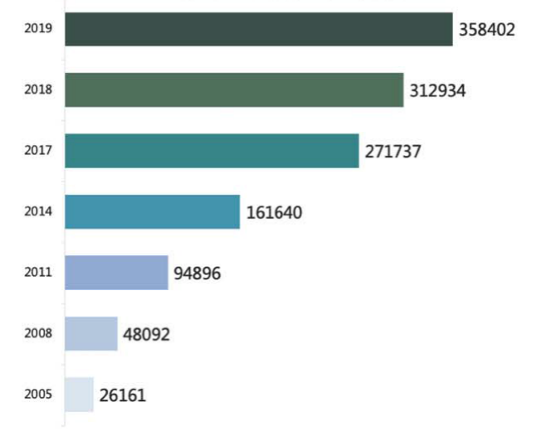 | 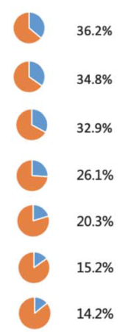
Source: CAICT
Fig. 3 Scale and Proportion of China's Digital Economy Value Added
Column 1: Digital trade drives the transformation and development of global economic and trade relations
Digital trade is an important part of digital economy and the most important embodiment of the internationalization of digital economy. The salient feature of digital trade is the digitization of trade mode and trade object. The digitization of trade mode refers to the integration and penetration of information and communication technology and various links of traditional trade, which improves trade efficiency and reduces trade cost. The digitalization of trade objects is the product and service trade in the form of index data and data, which greatly expands the depth and breadth of the existing service trade.
From the perspective of trade in goods, digital trade is mainly reflected in the change in the way of trade, which promotes the vigorous development of cross-border e-commerce. According to data from relevant institutions, the global B2C market of cross-border e-commerce reached USD 675 billion in 2018, with an average growth rate of about 30% in recent years, far surpassing the traditional trade in goods. From the perspective of e-commerce transaction subjects, the transaction volume between enterprises (B2B) accounts for the vast majority, while the transaction volume between enterprises and consumers (B2C) is relatively limited. From the perspective of national development of e-commerce, developed countries have a good development environment for cross-border e-commerce, but developing countries have huge potential.
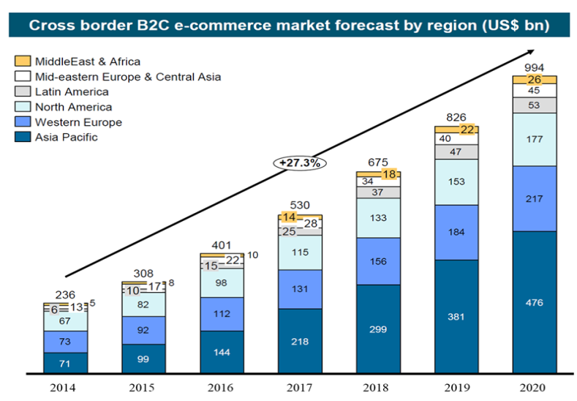
Source: AliResearch, USD 1 billion
Fig. 4 Market of Global B2C Cross-border E-commerce during 2016-2020
From the perspective of service trade, digital trade is mainly reflected in the digitalization of trade objects and the rapid growth of data and products and services in digital form. According to the data from UNCTAD, from 2008 to 2018, the global export volume of digital services increased from USD 1837.99 billion to USD 2931.40 billion, with an average annual growth rate of 5.8%. From the perspective of service composition, the top 3 types of digital trade in service in 2018 were engineering R&D, insurance and finance, and intellectual property. From the perspective of nationality structure, developed countries had more influence in digital services trade than trade in goods, and developing countries faced new development challenges.
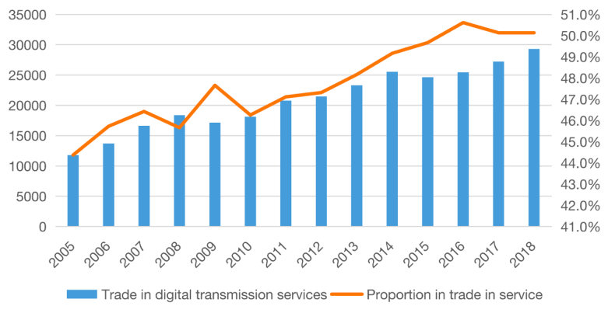
Source: UNCTAD
Fig. 5 Scale and Proportion of Trade in Digital Service

(II) Digital economy continues to grow at a high rate
Digital economy continues to grow at a high speed and has become a key tool for China to cope with the downward economic pressure. On a comparable basis, the nominal growth of China's digital economy in 2019 was 15.6%, about 7.85% higher than that of GDP in the same period, 6.8% higher than that of the primary industry, 9.79% higher than that of the secondary industry, and 6.54% higher than that of the tertiary industry. From the perspective of history, compared with 2005, the scale of digital economy in China has increased by 12.7 times and the compound annual growth rate was as high as 20.6%, while GDP in the same period has only increased by 4.3 times and the compound annual growth rate was 12.6%. The primary industry, secondary industry and tertiary industry grew by 2.2, 3.4 and 5.9 times respectively, and the annual compound growth rate was 8.7%, 11.1% and 14.8% respectively. Digital economy has become the key driver for the sustained and steady growth of national economy.
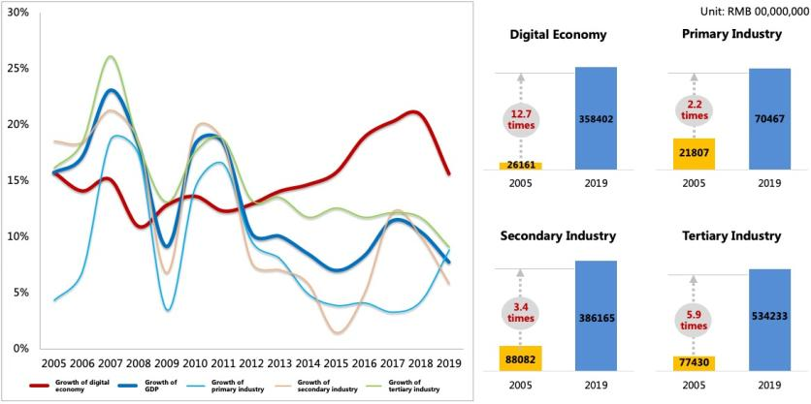
Source: CAICT
Fig. 6 Growth of China’s Digital Economy and GDP Growth

(III) Significant progress has been made in the contribution of digital economy
Digital economy in China has more prominent position in national economy. The contribution of digital economy to GDP growth continues to increase. In the six years from 2014 to 2019, the contribution rate of digital economy to GDP growth in China remained above 50%. In 2019, digital economy contributed 67.7% of China's economic growth, becoming a core driver for China's economic growth. At the same time, the contribution of digital economy to economic growth was significantly higher than that of three industries. In 2019, the contribution of the three industries to GDP growth was 3.8%, 36.8% and 59.4%, respectively, lower than that of the digital economy.
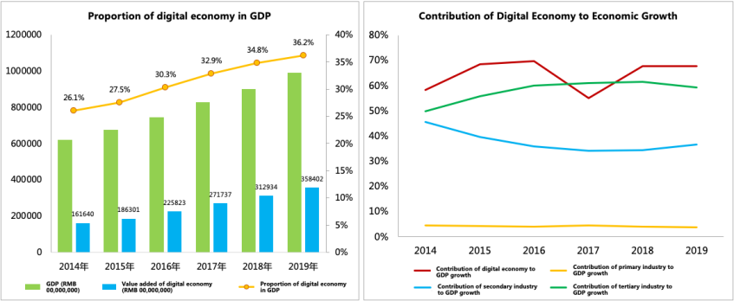
Source: CAICT and National Bureau of Statistics
Fig. 7 Contribution of China’s Digital Economy to Economic Growth

(IV) The structure of digital economy continues to be optimized and upgraded
The position of industrial digitization as the main engine of digital economy has been further consolidated. From the perspective of the internal structure of digital economy, it is an inevitable trend for the development of digital economy that the proportion of digital industrialization decreases year by year and the proportion of industrial digitization increases year by year. In 2019, China's digital industrialization has made further progress towards high-quality development, and the industry strength continued to be enhanced. The value added of digital industrialization reached RMB 7.1 trillion, with a nominal year-on-year growth of 11.1%, and its proportion in the digital economy dropped from 50.9% in 2005 to 19.8% in 2019. In 2019, industry digitization was explored in a deeper and broader field. The value added of digital industrialization reached RMB 28.8 trillion, with a nominal year-on-year growth of 16.8%. The share of digital economy in digital economy increased from 49.1% in 2005 to 80.2% in 2019. Industrial digitization has been deepened, adding momentum to the development of digital economy.
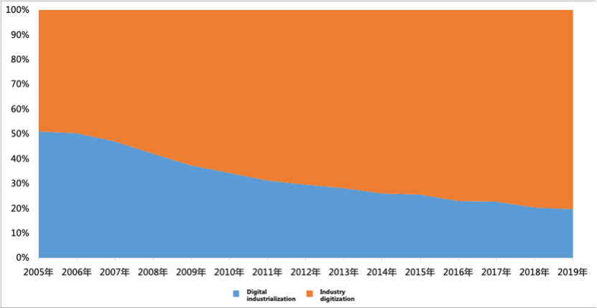
Source: CAICT
Fig. 8 Internal Structure of China's Digital Economy

(V) Prosperous regional development of digital economy
There is a strong positive correlation between the digital economy and the development level of national economy in various regions. In 2019, the development level of digital economy in all regions basically continued the development trend of previous years, and the provinces with a higher level of economic development also enjoyed a higher level of digital economy. In terms of total amount, the provinces and cities with the added value of digital economy more than RMB 1 trillion included Guangdong, Jiangsu, Zhejiang, Shanghai, Beijing, Fujian, Hubei, Sichuan, Henan, Hebei, Anhui, and Hunan in 2019, and the provinces with the added value of digital economy more than RMB 500 billion included Liaoning, Chongqing, Jiangxi, Shaanxi and Guangxi. In terms of proportion, the digital economy in Beijing and Shanghai occupied a dominant position in the regional economy, with the proportion of digital economy GDP exceeding 50%; in Guangdong, Zhejiang, Jiangsu and Fujian, the proportion of digital economy in GDP also exceeded 40%; in Chongqing, Hubei, Liaoning, Hebei, Guangxi and Sichuan, the proportion of digital economy in GDP exceeded 30%. In terms of growth rate, Guizhou and Fujian were still leading the country in digital economy growth, with growth rate exceeding 20% in 2019; Chongqing, Zhejiang, and Hebei grew by more than 15%; most of the rest provinces and cities grew at 10%-15%.

The size of the circle represents the scale of digital economy value added (Unit: RMB 00,000,000)
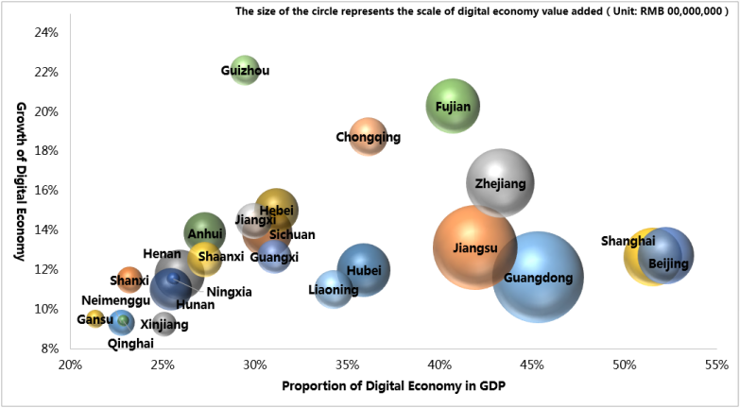
Source: CAICT
Fig. 9 Scale, Proportion and Growth Rate of Digital Economy Value Added in Some Provinces and Cities in China in 2019
The development of digital industrialization is closely related to regional industrial structure. From the perspective of total amount, Guangdong and Jiangsu, which have strong information industries, continued to lead the development of digital industrialization in China, with the added value of digital industrialization exceeding RMB 1.5 trillion in 2019; the added value of digital industrialization in Beijing, Zhejiang, Shanghai, Sichuan, Fujian, Hubei, Henan, Chongqing, Anhui and Shaanxi all exceeded RMB 100 billion. In terms of the proportion in GDP, information industry, as one of the leading industries that promote local economic development and have strong innovation ability, accounted for more than 15% in the regional economy of Guangdong, Jiangsu and Beijing, while the proportion of other provinces and cities was relatively low, especially the central and western provinces and cities, which accounted for less than 5%.
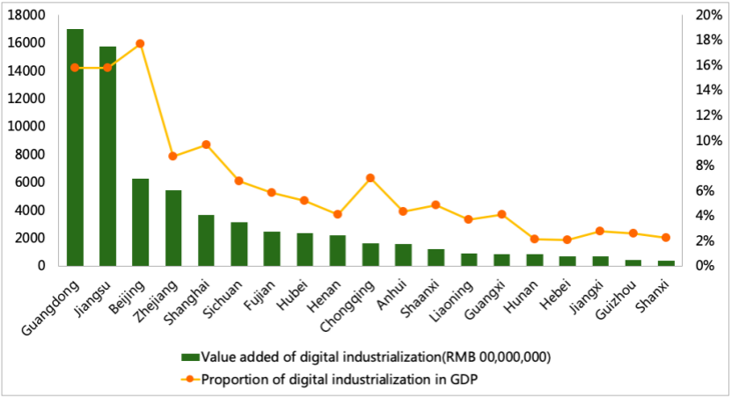
Source: CAICT
Fig. 10 Added Value of Digital Industrialization in Some Provinces and Cities and Proportion in GDP in 2019
Industry digitization in regions is the main engine driving the development of digital economy. In 2019, the proportion of industry digitization in the digital economy in all provinces and cities exceeded 60%. In western provinces and cities such as Xinjiang, Qinghai and Inner Mongolia, the proportion of industrial digitization was even close to 95%, and industrial digitization has become a key support for the regional digital economy. In terms of total amount, the value added of industry digitization in Guangdong, Jiangsu and Zhejiang has all exceeded RMB 2 trillion; Shanghai, Beijing, Fujian, Hubei, Sichuan, Henan, and Hebei also saw their added value of industry digitization exceed RMB 1 trillion. In terms of the proportion in GDP, the proportion of industrial digitization in Shanghai was the highest, exceeding 40%; in Fujian, Zhejiang, Beijing, Hubei, and Liaoning, the proportion of industry digitalization in GDP accounted for more than 30%.

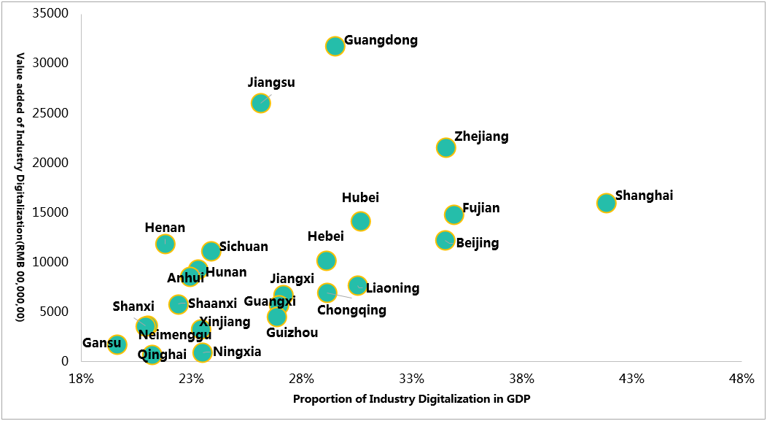
Source: CAICT
Fig. 11 Added Value of Industry Digitization in Some Provinces and Cities and Proportion in GDP in 2019

III. Digital Economy Witnesses Various Highlights in Development of all Fields

(I) Steady development of digital industrialization
1. Steady development of digital industrialization
In 2019, the digital industry consolidated its foundation and continued to optimize its internal structure. In terms of scale, the added value of digital industrialization reached RMB 7.1 trillion in 2019, accounting for 7.2% of GDP and 11.1% of year-on-year growth. From the perspective of structure, the digital industrial structure continued to be softened, and the share of software industry and Internet industry continued to be improved slightly, with an increase of 2.15% and 0.79% over last year respectively. The proportion of telecom and electronic information manufacturing fell slightly.
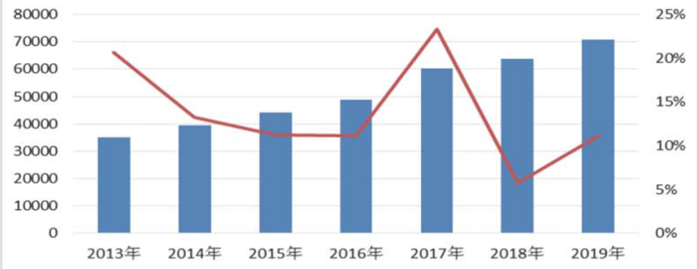
2019
2018
2017
2016
2015
2014
2013
Added value of digital industry (RMB 00,000,000) | Growth of digital industry
Source: CAICT and National Bureau of Statistics
Fig. 12 Value Added and Growth of Digital Industrialization in China in 2013-2019
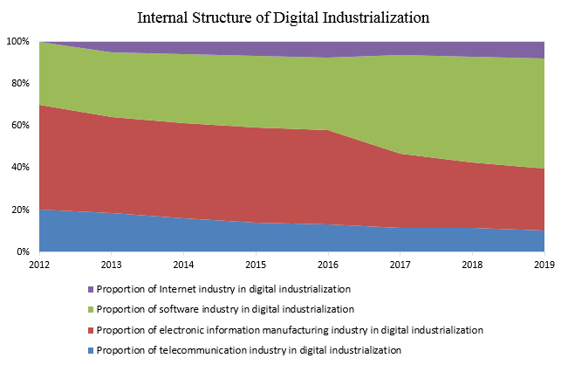
Source: CAICT and National Bureau of Statistics
Fig. 13 Internal Structure of Digital Industrialization in China
2. Steady development of various industries in digital industrialization
The basic supporting role of the telecommunications industry has been continuously enhanced. In 2019, China's communications industry has fully implemented the decisions and plans of the CPC Central Committee and the State Council, adhered to new development concepts, actively implemented the strategy of building a nature with Internet Power, ensured orderly progress of 5G construction, continuously improved the capacity of new information infrastructure, and strongly supported the digital transformation of society. In 2019, telecom revenue stabilized and recovered, and total telecom business grew rapidly. According to a preliminary calculation, China's telecom business revenue totaled RMB 1.31 trillion in 2019, up 0.8% over the previous year. The implementation of the "Double G and double-speed increase" has been accelerated, and the speed of the network has been effectively speeded up, with the fixed broadband entering the gigabit era. The total number of 4G users reached 1.28 billion, with a net increase of 117 million, accounting for 80.1% of the total number of mobile phone users.
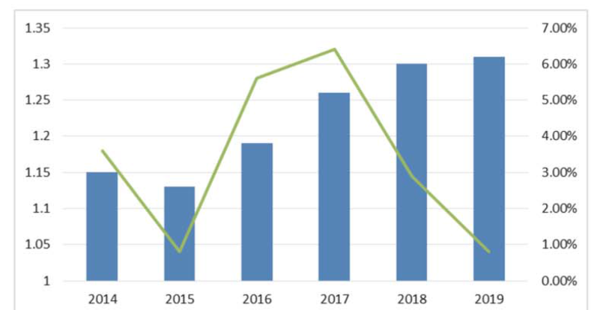
Scale of telecom business revenue (RMB trillion) | Growth of telecom revenue
Source: Ministry of Industry and Information Technology
Fig. 14 Scale and Growth of Telecom Revenue in China
The electronic information industry is in a periodic trough. The year 2019 is a period for the upgrading of mobile communication systems. Investment in communication infrastructure and sales of mobile terminals are shrinking. Moreover, the components industry, such as integrated circuits, is in a trough of periodic fluctuations. The global economic and trade environment is facing unstable factors. In general, in 2019, the added value of the electronic information manufacturing industry above designated size increased by 9.3% on a year-on-year basis, 3.8% lower than that of the previous year. In 2019, the value of export delivery increased by 1.7%, 8.1% lower than that of the previous year. By subdivided sector, the revenue of communications equipment manufacturing grew by 4.9%, electronic components and special-purpose electronic materials manufacturing 1%, electronic components manufacturing 8.3%, and computer manufacturing 4.4% on a year-on-year basis.

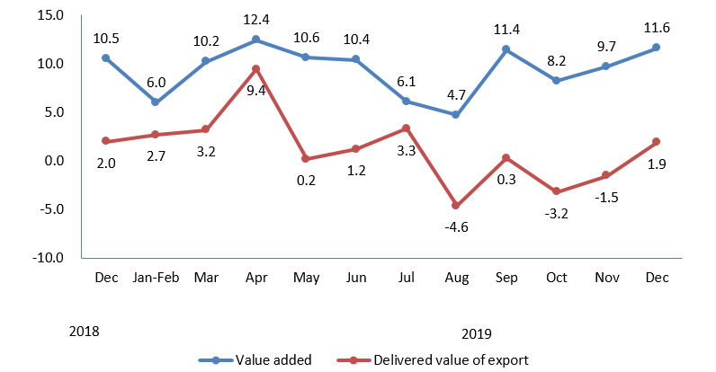
Source: Ministry of Industry and Information Technology
Fig. 15 Value Added of Electronic Information Manufacturing Industry and Monthly Growth of Delivered Value of Export since December 2018
The software and information technology services sector grew steadily and rapidly. In 2019, China's software and information technology service industry presented a steady development trend, with rapid growth in revenue and profits and steady increase in the number of employees. Information technology services accelerate the cloud-based development, with obvious trend of service-oriented and platform-oriented software application. In general, the software business revenue maintained rapid growth. In 2019, there were more than 40,000 enterprises above the designated size in the software and information technology service industry in China, with a total software business revenue of RMB 7.2 trillion, an increase of 15.4% on a year-on-year basis. From the perspective of subdivided sector, software revenue grew rapidly. In 2019, revenue from software products reached RMB 2 trillion, up 12.5% on a year-on-year basis. Among them, the revenue of industrial software products reached RMB 172 billion, up 14.6%, playing an important role in supporting the independent and controllable development of the industrial sector. The cloud-based development of information technology services was accelerated, with revenue reaching RMB 4.3 trillion, up 18.4% on a year-on-year basis. Among them, the technical service revenue of e-commerce platform was RMB 790.5 billion, up 28.1% on a year-on-year basis. Revenue from cloud services and big data services totaled RMB 346 billion, up 17.6% on a year-on-year basis. Revenue from embedded system software grew steadily. In 2019, the revenue of embedded system software reached RMB 782 billion, up 7.8% on a year-on-year basis. Embedded system software has become a key driving technology for digital transformation of products and equipment and intelligent value-added in various fields.
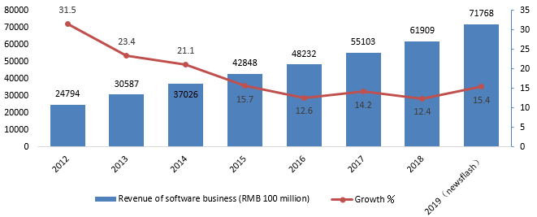
Source: Ministry of Industry and Information Technology
Fig. 16 Growth of Software Business during 2012-2019
Innovation in the Internet and related service industries was vigorous. With the help of artificial intelligence, cloud computing, big data such as information technology and capital strength, and under the support of state policies, in 2019, China's Internet and related service industries have maintained a steady and rapid growth, with rapid growth in business revenue and profits, rapid increase in research and development investment, continuous innovation and expansion of business models, and a growing role in supporting the development of the digital economy. In general, China's Internet business revenue maintained a relatively high growth rate. In 2019, China's Internet and related service enterprises (hereinafter referred to as Internet enterprises) above the designated size completed the business revenue of RMB 1206.1 billion, a year-on-year increase of 21.4% on a comparable basis. From the perspective of subdivided field, the overall revenue of information services was growing rapidly, and the growth rate of audio and video services remained in the lead. In 2019, the revenue of Internet companies' online music and video services, online games, news and information services, and online reading services reached RMB 787.9 billion, up 22.7% on a year-on-year basis. Revenue from Internet platform services grew rapidly, and the scale of life services and online sales services continued to expand. In 2019, Internet platform service enterprises, mainly providing production service platforms, life service platforms, scientific and technological innovation platforms and public service platforms, achieved business revenue of RMB 319.3 billion, up 24.9% on a year-on-year basis. Revenue from Internet data services has maintained rapid growth. In 2019, with the acceleration of the application of new technologies such as 5G, cloud computing, big data and artificial intelligence, the construction of new infrastructure entered a period of rapid growth, driving Internet data services (including data center business and cloud computing business, etc.), achieving revenue of RMB 11.62 billion, up 25.6% on a year-on-year basis.
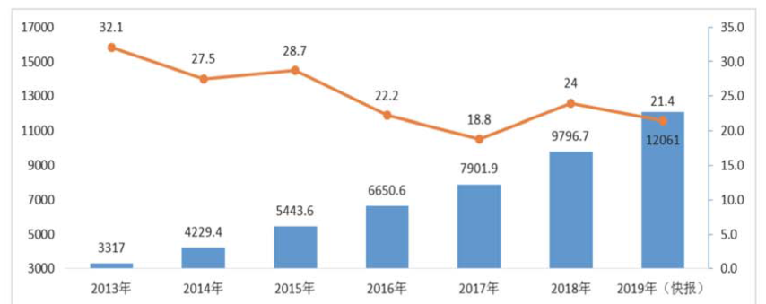
2018
2017
2016
2015
2014
2013
2019
(newsflash)
Revenue of Internet business (RMB 00,000,000) | Growth ％
Source: Ministry of Industry and Information Technology
Fig. 17 Growth of Revenue in Internet Business during 2013-2019

(II) Deepening industry digitization
The transformation of industry digitization is evolving from a single-point application to a continuous collaboration. The traditional industry is transforming and upgrading in an all-round, multi-angle and full-chain way by using digital technology. Data integration and platform empowerment are the keys to promote the digital development of the industry. In 2019, the scale of value added in China's industry digitization was about RMB 28.8 trillion. From 2005 to 2019, its compound annual growth rate was as high as 24.9%, significantly higher than the GDP growth rate in the same period, and its share of GDP increased from 7% in 2005 to 29.0% in 2019. Industry digitalization has accelerated its growth and become an important supporting force for national economic development.
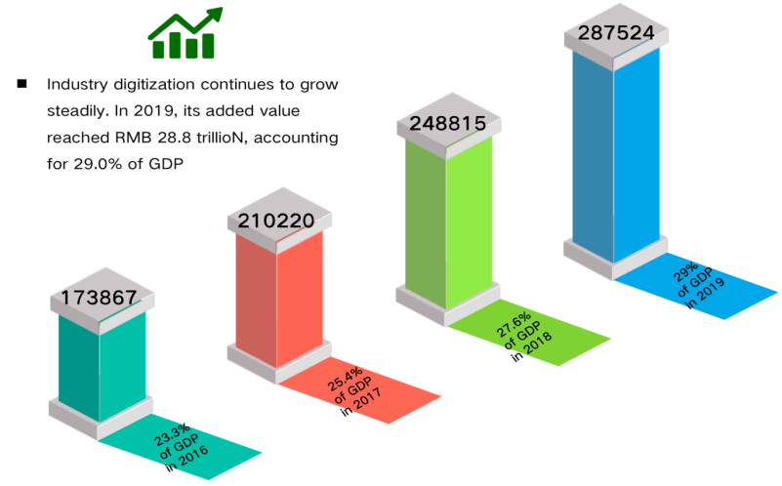
Source: CAICT
Fig. 18 Development of Industry Digitization in China
The digital economy of the three industries still features unbalanced development. The development of digital economy in all sectors continued to be characterized by the superiority of tertiary industry over secondary industry and secondary industry over primary industry. The service sector has been the fastest-growing field of industry digitization. In 2019, the added value of digital economy in service sector took up 37.8% of the added value of the industry, up 1.9% on a year-on-year basis and significantly higher than the average level of the whole industry. The digital transformation of industry was accelerating. In 2019, the added value of industrial digital economy accounted for 19.5% of the added value of the industry, up 1.2% on a year-on-year basis, and the growth rate was approaching that of the service sector. Due to the natural nature of industry production, the demand for digital transformation in agriculture was relatively weak. In 2019, the added value of agricultural digital economy accounted for 8.2% of the added value of the industry, up 0.9% on a year-on-year basis, but still significantly lower than the average level of the industry, showing great potential for digital development.
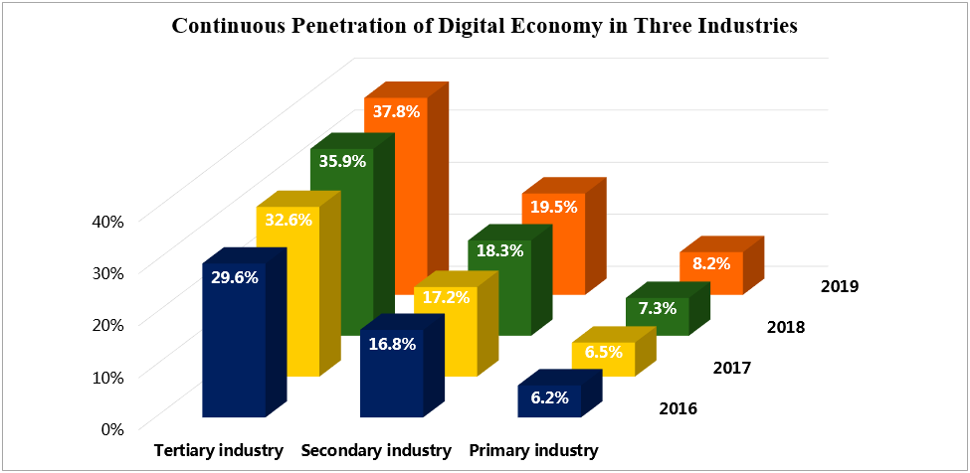
Source: CAICT
Fig. 19 Development of Digital Economy of Three Industries in China
1. The rapid rise of solution suppliers of digital transformation
The increasing demand for digital transformation in all walks of life has given birth to the emerging industry sectors that are specialized in providing corresponding hardware and software products and various services for the digital transformation and upgrading of all walks of life. Solution suppliers of digital transformation emerge at the right moment.
In the face of huge and personalized market demand, various enterprises have been exploring to be the solution provider of digital transformation. Combined with their own advantages, they have extended their business transformation to the field of providing digital solutions to create a new enterprise digital business. First, many leading enterprises in traditional industries, while actively promoting their own digital transformation, rely on their profound industrial development accumulation and transformation technical experience to export solutions to other enterprises with digital transformation needs. The “Rootcloud” platform of Rootcloud under SANY, for example, integrates profound industrial genes and emerging Internet technologies. Through the digital transformation of equipment, it helps enterprises enjoy the industrial Internet at a low threshold, and has served large advanced manufacturing enterprises and small- and medium-sized industrial enterprises with weak information level, so as to meet the demand of China's manufacturing industry. Second, relying on their own Internet technology, huge user market and other advantages, powerful Internet companies have been expanding into the B-end market and providing digital solutions to various enterprises, cities and communities. For example, Internet companies such as BATJ have accelerated their business layout and penetrated into traditional fields such as manufacturing, agriculture and finance. Brands such as Taogongchang, Ant Financial Services and JD Digits have been rapidly developed. Third, hardware and software enterprises in the traditional IT field combine their own advantages to enter the digital transformation solution market. For example, H3C, as digital solutions leader, is committed to becoming the most reliable partner for customers' business innovation and digital transformation. It has comprehensive digital infrastructure capabilities of computing, storage, network and security, and provides one-stop digital solutions including cloud computing, big data, intelligent connection, information security, new security, Internet of Things, edge computing, artificial intelligence and 5G.
At present, digital transformation solutions have been explored in various fields. In terms of intelligent manufacturing, through the seamless integration of digital factory simulation, ERP, MES and intelligent logistics, the assembly line makeup of highly flexible production and discrete manufacturing is realized, which helps manufacturing enterprises to accelerate the integration of industry and digital technology, improve manufacturing quality and production efficiency, and realize intelligent manufacturing and industrial upgrading. In smart transportation, cloud computing, big data, the Internet of Things, network security and other technologies will be comprehensively applied to meet the real needs of the development of traditional transportation industries such as highways, railways, civil aviation, subways and ports, and help the upgrading and transformation of digital construction. In terms of industrial chain collaboration, blockchain, Internet of Things, big data, cloud computing and other technologies are used to build a collaborative service platform for the industrial chain of bulk commodities, providing online warehousing, secure delivery, bulk trading, supply chain finance and other comprehensive services for large upstream and downstream enterprises. In terms of smart storage, digital technologies such as electronic fence, smart forklift, smart tray and RFID are applied to daily warehouse management, and a supervision system for bulk storage is established to provide security control and accurate inquiry of bulk goods.
Column 2: The driving effect of industrial Internet convergence appears initially
The industrial Internet is a new economic ecology, key infrastructure and new application mode deeply integrated with the new generation of information technology and industrial economy.
In the core industry of industrial Internet, industrial digital equipment can realize digital perception, analysis, reasoning, decision-making and control capability by loading additional functions such as digital communication, digital control and intelligent analysis equipment, modules or devices on traditional industrial equipment. Industrial interconnection automation provides products and solutions with digital sensing, control, and execution capabilities for industrial control, industrial sensors, and edge computing gateways. The industrial Internet network constructs the network infrastructure of the comprehensive interconnection between people, machines and materials in the industrial environment. The industrial Internet security industry ensures the healthy and orderly development of the industrial Internet by means of monitoring and early warning, emergency response, detection and evaluation, and attack and defense testing. The industrial Internet platform is geared to the needs of the manufacturing industry in terms of digitalization, networking and intelligentization, and builds a service system based on mass data collection, aggregation and analysis. Industrial software in industry or industrial scenario provides research and development design, production management, operation and management and other kinds of software, and accelerate the cloud and lightweight change of software.
In terms of the integration of industrial Internet, its application scope has been extended from manufacturing industry to construction, energy, transportation, medical treatment, smart city and other fields, and has been expanding to other related fields of first, second and third industries. In the construction industry, enterprises make use of the industrial Internet to deploy collaborative design management and construction collaborative management integrating reality and reality, so as to greatly improve design efficiency, construction quality, safety production level and control level of cost and schedule. In the field of transportation, industrial Internet cannot only realize automatic driving through intelligent identification, intelligent decision-making and intelligent execution, but also realize intelligent traffic control through real-time analysis, optimization, traceability and deployment.
It is estimated that the economic added value of China's industrial Internet industry has reached RMB 2.13 trillion in 2019, up 47.3% on a year-on-year basis. Among them, the core industry of industrial Internet was RMB 536.1 billion and the economic impact driven by the integration of industrial Internet reached RMB 1.6 trillion, indicating that the industrial Internet is playing an increasingly important role in promoting economic development.
2. Important progress has been made in integrated development
China's digital economy continues to grow at a high speed. After the evolution and upgrading of digital industrialization and its comprehensive integration with the service industry, China is entering a new stage of continuous expansion, deepening and optimization of integration with the real economy.
The digital economy in the service sector is leading the way. In particular, digital services such as e-commerce and sharing economy are developing rapidly, making a huge contribution to the growth of the digital economy. In 2019, China's online retail sales of physical goods reached RMB 8.5 trillion, an increase of 19.5% over the previous year, accounting for 20.7% of total retail sales of consumer goods, 2.3% higher than that in the previous year. In 2019, mobile payment business grew rapidly, with 101.431 billion deals of transactions, totaling RMB 347.11 trillion, up 67.57% and 25.13% year-on-year respectively.
Column 3: Platform economy converges the development potential of supply and demand
Platform economy is a modern platform economy based on the convergence and integration of multiple types of market players and resources and the organization of new models and formats around digital platforms. Since the 1990s, the rise of digital platforms based on the Internet has accelerated. 20 years ago, there were no platform companies among the world's top 10 most valuable companies. A decade ago, there was only Microsoft. In 2019, there were 7 platform companies such as Apple, Google and Microsoft whose market value exceeded that of established multinational companies such as Mobil and Johnson & Johnson. The platform economy has unleashed new vitality and accelerated its shift from the periphery to the center of the economic stage.
At the end of the 1990s, China gathered the three advantages of Internet users, the market and the after effects to start the platform economy. First, its international influence has grown steadily. From the perspective of development scale, a number of online platform enterprises such as Alibaba, Baidu, Tencent, Didi and so on have grown rapidly, and Alibaba and Tencent have also occupied two seats of the world's top 10 by market value. From the perspective of innovation mode, China's platform economy has transformed from imitation and catch-up to innovation and leading. In the early stage, it basically started by imitating the United States. For example, Netease, Sina and other portal websites imitated Yahoo, and Baidu imitated Google. However, in recent years, local innovation has been driven by market applications, and products have been innovated through short video and mobile live broadcast, so as to create a better panoramic experience for users. For example, TikTok, the overseas version of Douyin, has set off a global short video craze, covering 150 countries and regions and supporting 75 languages. In February 2020, TikTok ranked second in the global App revenue list. Second, the industry penetration boundary unceasingly expands. China's platform economy is constantly bringing out new forms of business. The single mode dominated by Internet application extends and penetrates into e-commerce, network medical treatment, online travel, online education and other fields. On the one hand, the traditional lifestyle of modern urban residents is being gradually changed by the digital lifestyle relying on the platform. Residents use Taobao, WeChat, Didi and other platforms to assist shopping, social networking and travel. On the other hand, rural residents rely on e-commerce platforms and public welfare platforms to export quality products and services to increase income and lift themselves out of poverty. By April 22, the "Rainbow" public welfare platform of targeted poverty alleviation built by China Pacific Insurance had been launched with 309 agricultural and sideline products in 23 provinces in China. Through purchasing and donating, employees have collected a total amount of over RMB 26.93 million and distributed it to 24,700 registered poverty-stricken households. Third, profound changes have been promoted in production. The platform economy has been deeply integrated with the national economy, which is exerting a profound influence on the whole process, industrial chain and life cycle of China's production and manufacturing. It has become a key support to promote China's industry to reduce cost and increase efficiency, and move towards the middle and high end. Industrial Internet platform links diversified external resources to help enterprises solve the pain points such as fragmentation of procurement, weak research and development ability, and serious product homogeneity, so as to improve production and operation efficiency. During the outbreak of NCP, COSMOPlat used its ecological supply chain to provide enterprises with efficient and accurate matching of equipment and raw materials for the production of protective clothing, masks and other materials. It provided enterprises with whole-process solutions such as production line planning and process technology manufacturing, and designed 10 scenario solutions including intelligent management, online training and online office to ensure the resumption of work and production.
Manufacturing industry has become the main battleground in the digital economy. The basic digital capability of manufacturing enterprises has been steadily improved. The rate of equipment digitization and network connection continues to improve. In 2018, the networking rate of production equipment, the numerical control rate of key processes and the network connection rate of digital equipment for industrial enterprises above designated size reached 45.9%, 48.7% and 39.4%, respectively. The penetration rate of industrial software continues to rise, and enterprises in key industries speed up the application of industrial software such as computer-aided design (CAD), manufacturing execution system (MES) and Product Lifecycle Management system (PLM). In 2018, the penetration rate of digital R&D and design tools for industrial enterprises reached 68.7%, providing support for further promoting the digital transformation of the manufacturing industry. New models and forms of business in the manufacturing industry are developing vigorously. The integration of new-generation information technology and manufacturing industry is accelerating, bringing about new technologies, new products, new models and new forms of business. According to statistics, in 2018, 33.7%, 24.7%, and 7.6% of Chinese enterprises engaged in networked collaborative manufacturing, service-oriented manufacturing, and customized manufacturing, becoming a new driver for the transformation of the development model of the manufacturing industry. Leading manufacturers are actively using 5G construction to upgrade their internal networks, which have covered several key areas such as aircraft, automobiles, electronics, machinery, rail transit and chemical industry. 5G+ industrial Internet, in particular, integrates new technologies such as cloud computing, edge computing, big data, artificial intelligence, AR/NR, and extends from peripheral production links such as monitoring, security and logistics to internal production links such as simulation, control, and quality inspection. This will effectively shift the manufacturing industry from single-point and partial application of information technology to comprehensive digitalization, networking and intelligence.
3. Model innovation has become an important engine for manufacturing transformation
With the application and penetration of the new generation of information technology in the whole process of manufacturing, the whole industrial chain and the whole life cycle of products, a large number of new products and new enterprises have emerged, and production, organization and business model have been innovated comprehensively, which has become a new driver for the development of “mass entrepreneurship and innovation” in the manufacturing industry. A new pattern of development, in which large enterprises stand firm and small enterprises are ubiquitous, has taken shape. First, the transformation of production mode has been accelerated. With the help of cross-field, collaborative and networked innovation platforms, enterprises such as CASICloud, CSIC and Wanxiang Group have more convenient access to and use of external innovation resources, effectively improving their R&D, design, production, manufacturing and management services. Second, the transformation of organizational management mode is accelerated. Through the innovation of organizational structure and management mechanism, Haier, Royalstar, Huawei and other enterprises speed up the transformation to a flat, platform-based innovative organization, which has greatly released the innovation vitality within the enterprise. Third, business models are changing at a faster pace. "Mass entrepreneurship and innovation" has brought about changes in the operating models of enterprises in traditional industries such as clothing, home furnishing and home appliances. The new mode of "platform + maker + user", which is oriented by consumer demand and involves multiple parties, has promoted the construction of a new ecosystem of mass entrepreneurship and innovation in the manufacturing industry that combines online and offline activities, innovation and entrepreneurship, resource pooling and capacity opening.
Column 4: Information and communication technology innovation drives the rise of the contactless economy
Information and communication technologies are deeply integrated with traditional industries, the contactless economy is developing rapidly, and new models and forms of business are making innovations in production, service and governance.
Contactless production promotes the transformation and upgrading of the real economy. With the development of industrial Internet, 5G and artificial intelligence, China's industrial sector has accelerated the digital transformation, and the development of contact-free production mode in manufacturing, operation, maintenance and management has initial effects. In terms of manufacturing, industrial Internet and industrial robots are applied in the production and manufacturing process of enterprises to help enterprises improve labor productivity, as well as quality and efficiency. For example, the 24-hour "lamp-free plant" established by CHINA BAOWU STEEL GROUP increased labor efficiency by 30% and production capacity by 20%, reduced costs by 10%, and maintained stable operation during the epidemic. In terms of operation and maintenance, the monitoring platform connects key production equipment and business systems of key enterprises more widely, and its functions such as monitoring and early warning, emergency response and information sharing are constantly improved. For example, Huawei RMS remote operation and maintenance service provides active management, service monitoring, remote fault handling and asset report management of enterprise operation and maintenance, offering 7X24 real-time network management and active operation and maintenance. In terms of management, telecommuting, online recruitment, teleconference and other contactless office management modes have become the choice of more and more enterprises. More than 400 million users in China used telecommuting Apps during the work resumption after the Spring Festival holiday in 2020.
Contactless service opens up new space of service economy. In recent years, China's contactless service model has emerged in many life service industries such as catering and retail. In the process of service consumption and performance, the supplier provides non-face-to-face service to the demanders with the support of digital technology. In terms of retail, social e-commerce, smart retail and other modes have been innovated and developed, the distribution chain has been optimized and upgraded, physical stores have been shifting towards e-commerce, and contactless meeting the immediate needs of users has become the future trend. From January to February in 2020, the online retail sales of physical goods in China grew by 3.0% on a year-on-year against the trend, accounting for 21.5% of the total retail sales of consumer goods. In terms of online education, the integration of online educational resources is accelerated, visual educational tools are gradually enriched, and educational services are developing towards individuation, refinement and stratification. Since the beginning of the new semester, the number of online education users has increased by 22% compared with last year and the hours of use has increased by 30%. In terms of telemedicine, 5G-based telemedicine provides services such as remote consultation and image cloud, avoiding medical resource congestion and difficulty in getting medical services in remote areas. In 2020, the scale of China's Internet medical industry will break through RMB 94 billion, and the industry will embrace a high-speed growth period of standardized development in the future.
Contactless governance creates new values for social governance. The contact-free governance model optimizes the working process of government affairs, solves the problems of difficulty, slowness and complexity in getting things done by enterprises and the public, and realizes "more data exchanges", and changes from assisting enterprises and the public "less going-out" to "no going-out" for working process of government affairs. In terms of enterprise services, "cloud investment attraction", "cloud approval" and "cloud contract" simplify the business process, and connect the business customer connection and implement the projects without meeting or hand shaking. For example, there were 480 signed projects of "cloud investment promotion" in Liaoning Province, with the amount of agreement reaching RMB 441 billion. In terms of people benefit services, the window for handling business has been further reduced, and the government affairs APPs have been continuously optimized. With big data, face recognition and other technologies, the identity authentication can be done and it is available for the shift from the application processing to automatic processing. In terms of judicial administration, contactless trial can be realized based on remote video and VR technology, and "cloud court", "cloud execution" and "cloud mediation" can help the parties concerned resolve disputes "without leaving home".
Under the guidance of the national strategy, China's digital transformation has been steadily promoted and has achieved remarkable results. In terms of the transformation process, in 2018, China's industrial Internet witnessed fast development, and the gap between China's industrial digital transformation level and that of developed countries had been narrowing. In 2018, the penetration rate of China's industry digitalization was 18.3%, narrowing the gap by 5% over 5 years from the country with the highest proportion. From the perspective of transformation level, in the industrial field, more than 50% of enterprises have passed the initial stage of single point application, 22.5% have entered the deepening stage of comprehensive integration, and 5% have entered the advanced stage of innovation and breakthrough. From the perspective of transformation path, manufacturing enterprises actively made use of the Internet, big data, artificial intelligence and other new-generation information and communication technologies. Starting from solving practical problems of enterprises, they transform from internal transformation to external coordination, from single point application to global optimization, and continue to promote digitalization and service-oriented upgrading of enterprises.
4. Huge potential of demand for micro, small and medium enterprises in transformation
Micro, small and medium enterprises are the main components of the market economy and the main carriers of entrepreneurship and employment. The digital transformation of them is the key to release the economic potential. However, compared with large enterprises, micro, small and medium enterprises lag behind in terms of talents, capital, technology and management. In the context of the wave of digitization sweeping the world, it has been the core question for the micro, small and medium enterprises to figure out how to establish a foothold in the digital era, and how to use digital technology to innovate production modes, management concepts and promote sustainable development. In particular, in the current COVID-19 epidemic, micro, small and medium enterprises are particularly sensitive to the changes in the external environment brought by the epidemic and face the pressure of life and death.
Having a general view of the course of the digital transformation of micro, small and medium enterprises, eight ministries and commissions, including the National Development and Reform Commission, issued the Notice on Issuing Opinions on Strengthening Services to Promote the Informatization of Small and Medium Enterprises (SMEs) in 2008, forming the idea of technology transformation for SMEs, that is, driving their investment with public services and social services. In 2020, the National Development and Reform Commission and the Office of the Central Cyberspace Affairs Commission issued the Implementation Plan on Promoting the Action of ‘Adopting Cloud, Data and Intelligent Technology’ to Foster New Economic Development, which formed the idea of factor transformation for SMEs. The government and the platform provided universal data capital investment to replace the self-investment of SMEs. The common point of the two policies is that the government and the platform should bear the fixed asset input, so that the burden of micro, small and medium enterprises can be reduced with marginal input to facilitate their digital transformation.
It is proposed in the action of "Adopting Cloud, Data and Intelligent Technology" to deepen the digital transformation services, accelerate the enterprise to adopt "Cloud, Data and Intelligent Technology ". In particular, it is necessary to promote the digital transformation of micro, small and medium enterprises, cultivate key industry application scenarios, and create "Internet +" upgrade version. This action of "Adopting Cloud, Data and Intelligent Technology" is to help micro, small and medium enterprises to solve the digital economy transformation difficulties, to solve the problems of "being unable to transform", "being forbidden to transform", and "being afraid to transform". To solve the problem of " being unable to transform ", we will establish a connection mechanism between platform enterprises and micro, small and medium enterprises, guide them to raise demands, encourage platform enterprises to develop more transformation products, services and tools, and form market initiative of digital transformation. To solve the "being forbidden to transform", we will provide inclusive services, explore "cloud-based borrowing", offer low-interest or subsidized loans, and encourage exploration return tax cuts and measures to reduce the cost of enterprise transformation. In principle, pilot platforms, service agencies and demonstration projects supported by national policies should be provided with reduced free services for at least one year for micro, small and medium enterprises. To solve the problem of "being afraid to transform", we will build "virtual industrial park" and "virtual industrial cluster" that cross the physical boundary, so as to fully explore the synergy and amplification benefits between enterprises.

(III) Improving the capacity of digital governance
The development of big data-based decision support and comprehensive governance capacity has made remarkable progress, and an orderly, inclusive and prudent environment for the development of the digital economy that encourages innovation and co-governance is taking shape at a faster pace. First, the governance rules are gradually improved. In recent years, the legislative level of digital economy has been significantly improved. A series of national laws, including the Cybersecurity Law, Law against Unfair Competition, and E-commerce Law, have been introduced and revised, providing a legal basis for digital governance. From the perspective of departmental rules, the rules centering on the protection of personal information, the standardization of market order, the integration of business regulation, information content governance and other aspects have been constantly improved. For example, the Regulations on Protection of Children's Personal Information on the Internet, which was officially released this year, set specific principles for the protection of children's personal information on the Internet, filling the legal gap in the protection of children's personal information in the Internet era. The second is the further optimization of governance means. We should make full use of the Internet, big data and cloud computing, artificial intelligence, blockchain, and other modern information technology; strengthen the construction and use of technology platforms; conduct in-depth mining and analysis based on massive data; and gradually realize online footprints, risk early warning, scientific analysis and implementation and disposal of network subjects, so as to make government decisions more scientific, social governance more accurate and public services more efficient through digital means. The third is the accelerating innovation in governance means. At present, the integration of modern information technology and various fields of economy and society is further deepened, cross-border integration has become the norm, and various kinds of integrated business forms emerge one after another. Various regulatory authorities have been exploring and improving communication and coordination mechanisms. In particular, they have clarified their responsibilities for digital economy integration businesses such as online car-hailing, e-commerce and Internet finance, and enhanced the effectiveness of collaborative governance through cross-department joint meetings and joint punishment for dishonesty.
1. Digital government
Building a digital government is a response to government change in the digital economy era, and it will transform government governance from inefficient to efficient, passive to active, extensive to precise, and programmed feedback to fast and flexible response. In recent years, China has accelerated the construction of digital government from the central to local levels, and the government's public service supply capacity has been significantly improved.
First, the steady improvement of government data collection and sharing supports more scientific decision-making. Data is a basic strategic resource, and its in-depth mining and application will provide a more accurate direction for economic and social governance. At present, the connotation and function of the urban big data platform derived from the government sharing and exchange platform are greatly expanded and enhanced. On the one hand, the data resources of the urban big data platform are more diversified and rich, gradually expanding from the government information resources to the operational perception data, Internet data, enterprise data, etc., so as to realize the leapfrog from the closed and self-used government information resources to the urban big data jointly built and shared by multiple parties. On the other hand, the capacity of urban big data platform is also greatly enhanced, comprehensively improving the capabilities of multi-source heterogeneous data collection, processing, development, analysis, presentation and governance, and realizing the transformation of urban data from sharing and exchange, and open development to the governance of the full life cycle of urban big data.
Second, smart government services are transformed from "usable" to " user-friendly" to build a more efficient public service system. With the advancement of "Internet + government service", online handling of government services is becoming more convenient, accelerating the transformation from "one number, one window, one network" to "one network, one door, one time". Advanced modes such as "one going-out at most ", "no going-out", "non-face-to-face approval" and "approval and handling in a second" have been explored and popularized nationwide. Online inquiry and online handling of public services have been basically achieved nationwide. Some regions have adopted intelligent means such as big data and government service robots to promote standardization of government data, networking of services and automation of handling, and continue to explore new ways for innovative digital government to benefit the people and enterprises.
Third, the means and modes of government governance are becoming more digital, networked and intelligent, and a new mode of co-governance is being built. With the deepening of the reform of "delegation, regulation and service", "Internet + supervision" has gradually become an effective means to strengthen and innovate ongoing and post supervision. Local governments have made full use of big data and other technologies, combined with the construction of smart city social credit system, strengthened tracking and early warning of market risks, and explored remote supervision, mobile supervision, early warning and prevention in industry and commerce, quality supervision, food and drug supervision and other fields, so as to provide strong support for improving the efficiency of smart city market supervision services and creating a healthy and orderly consumption and business environment. For example, relying on the enterprise credit information network, Beijing has listed 200,000 enterprises in the list of abnormal operations, conducted effective research and judgment on market supervision risks by using big data technology, and had inter-departmental credit joint punishment on dishonest enterprises, so as to effectively improve the efficiency of market supervision. The people's court of Jianggan District, Hangzhou City, Zhejiang Province, put an order of reward on WeChat Moment, exposed the refusal of more than 100 people subject to execution for dishonesty, and guided the insiders of relevant property clues to make paid reports.
Column 5: Full display of digital governance in fighting the epidemic
The COVID-19 outbreak is a major test of national governance systems and capacities. Epidemic prevention and control are not only a major challenge to governance, but also an important opportunity to optimize the governance system and enhance governance capacity.
First, we have made steady progress in precise epidemic control and resumption of work and production. In terms of epidemic prevention and control, National Health Commission of the People’s Republic of China shared diagnosis of suspected personnel information; the Ministry of Transport is responsible for finding information about companions; and the Ministry of Industry and Information Technology locates the track of companions based on mobile phone signaling data, gives timely feedback to government departments and individuals, and quickly locks dangerous people based on multi-source data fusion and sharing and takes quarantine measures to effectively prevent the spread of the epidemic. In terms of the resumption of work and production, the telecom big data is used to realize the self-certification of employees' travel; the power big data is used to monitor the power resumption index of enterprises; the health big data is used to form the personal "health code"; the data-driven decision-making is adopted; and the policy of enterprise resumption of work and production is issued in a classified and orderly way, depending on the place and time.
The second is to facilitate the rapid deployment and transportation of materials and remote supervision. The national key medical supplies support and dispatch platform of the Ministry of Industry and Information Technology for epidemic prevention and control, combined with the warehousing and outbound records of materials, tracked the location of emergency supplies in real-time and remotely, understood the types and quantities of materials, compared with the needs of various regions, arranged emergency supplies in an orderly manner, and improved the poor management and unbalanced distribution of materials. Relying on the industrial Internet platform, basic telecom enterprises provide "material supply and demand matching" service to facilitate a more accurate and efficient connection between medical material demand departments and suppliers; and also offer networked and intelligent remote control of equipment through "remote equipment control" service, so as to ensure accurate allocation of construction and production.
Third, the implementation of special periods of supervision and enforcement discipline. Digital technology and its application play an indispensable role in the implementation of the main responsibility, supervisor responsibility, and regulatory responsibility for epidemic prevention and control. For example, the General Office of the State Council, through the “Internet + supervision” platform of the State Council, solicited clues from the public on issues such as inadequate implementation of local and departmental responsibilities in the epidemic prevention and control work, as well as suggestions for improvement, and gave full play to the supervision role of the general public.
The fourth is to ensure the orderly supply of public services. To fight against the epidemic, local governments have developed an APP platform where citizens can voluntarily declare and provide clues to the epidemic as well as conduct consultations and consultations on the epidemic. Major Internet platforms have set up epidemic columns, providing real-time epidemic information, refuting rumors, patients seeking help, online free medical treatment and other functions. Many hospitals have launched online fever clinics, 5G+ remote consultation and other functions.
2. Smart city
The new smart city is the core carrier of building digital China and smart society. China's new smart cities have entered a new stage of development that is people-oriented, result-oriented, coordinated and intensive, and collaborative innovation. The focus of the development of new smart cities has gradually shifted from overall planning and overall construction to creating a high-quality environment and designing long-term sustainable development mechanisms, and comprehensively innovating mechanisms such as organization management, construction and operation, and interactive participation.
First, smart facilities lay the foundation for development. Smart infrastructure is a strategic facility integrating perception, transmission, storage, computing and processing. It is also a "new infrastructure" to support urban economic and social development and a cornerstone for the construction of a new smart city. With the decrease of the marginal benefit and demographic dividend of the traditional "railway, highway and other infrastructure", the smart facilities supporting the intelligent upgrading of industry and society will become the future growth point.
Second, intelligent center leads data service. Strengthening the integration and unified empowerment of key common capabilities is an inevitable choice to eliminate data islands and support the linkage of upper business lines. The common capacity unit of the smart city business layer gradually sinks, and the supporting platform layer (data sharing and exchange platform, space-time information platform, etc.) gradually expands, which aggregates into the urban big data platform, urban information model platform, common technology enabling and application supporting platform, forming a powerful data resource hub and capacity enabling center, and becoming the intelligent operation center connecting the smart infrastructure downward and driving the industrial application upward.
Third, super Apps empower city life. Construction of new smart city has entered a new stage where service is the core and the effectiveness is the criterion. The accessible service for the people and enterprises has become the focus of the development of a new smart city in recent years; super Apps grow to become an important channel of service delivery; the smart government services are comprehensively popularized and deepened; new technology enables convenient life services; and various enterprises are actively involved in providing urban integration services.
Fourth, smart production contributes to the development of the digital economy. Digital economy has become an important part of the construction of new smart cities. Through the development of digital economy, cities forms superposition spillover effect, which better supports the transformation of urban innovation and accelerates the evolution of the modern urban economic system and production mode to be more networked, digital and intelligent. All regions promote regional digital economy deployment according to local conditions, vigorously advance digital transformation of local industries, attach importance to digital economy monitoring and evaluation, and strive to seize the commanding heights of the new round of digital economy competition and enhance urban competitiveness.

(IV) Accelerating advancement of data valuelization development
The improvement of the attributes of data production factors is related to the long-term power of economic growth and the future of China's development. As a key factor of production, value-oriented data reflects that with the acceleration of digital transformation, the multiplier effect of data on improving production efficiency has become prominent, making it a new factor of production with the characteristics of the times.
From the perspective of industry, China has formed a relatively complete supply chain of data elements, and has constructed a data industry system in various links such as data acquisition, data labeling, timing database management, data storage, business intelligence processing, data mining and analysis, data security, and data exchange. Data management and data application capabilities continue to be improved. However, there are still many gaps in data elements such as data right determination, data pricing, data transaction and other aspects of marketization, and circulation mechanism design, and the lag in data right determination, pricing, trading and other links has become the key bottleneck restricting the development process of data element value.
1. Data valuelization will be promoted in three stages: resourcization, assetization and capital
The stage data valuelization development has been opened. Massive data collection and processing, right determination and transaction, and explicit value will be advanced along the three stages of data resourcization, asset and capital. In terms of data resourcization, with the significant reduction of data collection, storage and processing costs and the significant improvement of computing capacity, digitalization and data orientation are changing the economic and social production mode of human beings, and the digital economy, with value data as the key production factor, is injecting new momentum into global economic development.
With the rapid development and popularization of the new generation of information technology, global data is produced at a "blowout" speed, which provides a foundation for the application of data valuelization. According to the Data Age 2025 released by IDC, the annual global data generation will grow from 33ZB (1ZB=10 trillion gigabytes) in 2018 to 175ZB, which equals 491 EB (lEB=1.1529e+18 bytes) every day. According to IDC, there will be 44ZB in the global data sector in 2020, and 19,000 ZB in 2035. In terms of data assetization, data ownership is the premise and the biggest difficulty. The property right is the basic condition of any asset transaction, but it is difficult to define the property right of data elements. Participants who master data content, data collection, data analysis and other aspects are not the same. In the process of data factor production, consumers, platforms and countries are associated at the same time, and the ownership boundary is often difficult to be determined. Data pricing is the key, and the key to trading. Data pricing makes assets transferable. In the current data factor market, there is little transparency and serious information asymmetry between buyers and sellers, which leads to the misleading of all parties involved in the transaction, resulting in "bad money driving out good money" and finally the formation of the "Market for Lemons". At present, some researches have explored data pricing. Moody and Walsh (1999) proposed to evaluate information assets as tangible assets, believing that the value of information is determined by the cost of collecting information, the cost of managing information and the quality of information. From the perspective of data asset management, Pitney Bowes and John Gallaugher (2009) studied the management of data assets through the data flow process. Long Staff and Schwartz (2001) put forward LSM method by using B-S option pricing theory to solve the issue of option pricing with price dependence on historical data. Data markets are the means and the most effective way of allocating factors. On May 22, the government work report called for promoting market-oriented allocation reform of factors, cultivating technology and data markets, and activating the potential of various factors. The term "nurturing the data market", which first appeared in the government work report, will also become the only way for data assetization in the future. In terms of data capitalization, on the one hand, there will be a lot of innovations in the way of data capitalization. For example, capital contribution and data elements may be securitized. Capital contribution refers to converting the data value and use value into shares or proportion of capital contribution, so as to make it into capital, which can be used to increase the unit's own capital or for outbound investment and realize its value; and also includes rewarding or distributing a portion of the shares or proportion of the capital contribution to the inventor or creator of the intellectual property and its principal implementors. Data factor securitization includes converting job data into earnings and the portion of cash that is awarded to inventors, designers and their main implementers as shares or investment proportion and enjoying the earnings. On the other hand, "data participating in distribution as a factor" not only conforms to the general trend of the development of digital economy, but also has great practical significance. Data participation and distribution can mobilize the enthusiasm of all subjects, so as to enhance the country's innovation-driven capacity; data participation in distribution is conducive to the development of new forms of business, creating more jobs and expanding the size of the middle-income group.
2. The exploration of data ownership has been accelerated to effectively stimulate the data transaction circulation
Data element circulation is the circulation process of index data and currency, and clear property right is the basis of effective data element circulation. Under the premise that the data is legal and there is no property right dispute, the data provider sells the data through the trading platform and other platforms, and the two parties complete the data transaction after matching the demand.
Clear data ownership is the basis of the data transaction flow process. At present, China's data rights are mainly determined by big data exchanges (platforms), industry institutions, data service providers, large Internet enterprises, etc. The first is represented by big data exchanges, such as Global Big Data Exchange, Yangtze River Big Data Exchange and Donghu Big Data Exchange Platform. This kind of subject is established under the guidance of the government, and its right determination is endorsed by the government to a certain extent, with certain authority. The second is represented by industry organizations, such as those in the fields of transportation, retail and finance. For example, the "Traffic Big Data Exchange Platform" jointly established by Shenzhen Institute of Beidou Applied Technology of Research Institute of Shenzhen Institute of Advanced Technology Chinese Academy of Sciences and VisionChina Connected provides registration and right determination of traffic big data exchanged on the platform. The third is represented by data service providers, such as Datatang, Lovedata, and MeritData. Such subjects collect, mine, produce and sell big data in an integrated operation, with strong profitability. The fourth is represented by the trading platform established by large Internet companies, which aims to serve the development strategy of large Internet companies. For example, JD Wanxiang Data Service Mall established by JD.com can provide right determination service for customer exchange data on JD Cloud platform and mainly provide support for operation of JD Cloud platform.
Different subjects have different degrees of exploration for data confirmation. On April 24, 2016, Global Big Data Exchange launched the big data registration, right determination and settlement service. In September 2016, Global Big Data Exchange issued the Interim Management Measures for Data Rights Determination, which determined data sovereignty and further deepened the cashability of data. On December 6, 2017, Zhejiang Big Data Trading Center officially released a new version of the big data confirmation platform at the 4th World Internet Conference. In cooperation with Xihu Electronics, the platform will be used as the data technology support for the intelligent cloud ecological community of the new generation of Internet of Things. On December 8, 2017, General Secretary Xi Jinping pointed out at the collective learning session of the Political Bureau of the Central Committee of the CPC that "it is necessary to formulate relevant systems for the confirmation, opening, circulation and transaction of data resources and improve the system for the protection of data property rights". On September 29, 2019, the people's data assets service platform, China's first data right determination service platform, was officially opened for operation approved by the Ministry of Industry and Information Technology. The platform will determine and register rights through cloud platform acceptance, manual audit and blockchain technology to ensure the standardization of data flow.
3. Data pricing rules are still in their infancy
Data prices are often an important factor in the success or failure of data exchange. Many factors are affecting the data price, including data type, data depth, data integrity, real-time data and other factors, and the data price mechanism of different varieties is different. At present, trusted third-party pricing is generally adopted by big data exchange platforms at home and abroad. In cases where the data owner is unable to price the data accurately, a trusted third party may be entrusted for data exchange. For example, big data exchange platforms such as Shanghai Data Exchange Center and Global Big Data Exchange can price data according to their own data quality evaluation indexes including data volume, data integrity, data time span and data scarcity. With the third-party pricing method, the price of each dataset is calculated based on the data attributes and the amount of data in the dataset.
Taking the pricing system of Global Big Data Exchange in China as an example, the real-time price of the data is mainly determined by the sample size of the data and the value of the data index item of a single sample, and then the price is automatically determined through the exchange system, with the price floating in real time. The final price of data exchange is determined by the seller and the exchange. Due to different data sources, data exchange can design an automatic pricing formula for each data variety, and data buyers can query the real-time price of each type of data through the exchange system. According to the ways of transaction, the transaction price includes three forms: the first is the automatic transaction price. When the agreed price of the data buyer is equal to or higher than the listed price of the seller, the transaction will be automatically matched according to the data platform, and the transaction price is the agreed price of the buyer. The second is the price the seller chooses to close the deal. For a deal that cannot be automatically closed, the seller may choose which can be accepted and close with it, and the transaction price should be agreed price of the buyer. The third is the price of the data split transaction. Because the data buyer does not necessarily need all the data samples, the system will set the principle of splitting the data, the system will automatically quote, and then automatically match the successful deal.
4. The data factor market has not been widely established
Data transaction connects both ends of data source and data application. On the basis of collecting and processing the original data, the data is transmitted to the demanders who need data analysis so as to realize the flow and value-added of data. In the Program of Action on Promoting Development of Big Data in 2015, the State Council clearly proposed to "guide and cultivate the big data exchange market", taking the lead in pointing out the macro development direction of data exchange. In the Development Plan of Big Data Industry 2016-2020, the Ministry of Industry and Information Technology further clarified the development goal, construction path and safeguard measures of big data exchange. The State Council proposed the idea of "unimpeded two-way flow mechanism of government and enterprise data" in Guiding Opinions on Promoting the Healthy Development of Platform Economy in 2019, and "accelerated cultivation of data element market" in Opinions on Constructing a More Complete System of Factor-based Market Allocation in 2020. The awareness and emphasis of China on data circulation and exchange and market cultivation have been constantly enhanced.
Although China has not yet formed a data element market, there are some data exchange platforms, which can be roughly divided into two categories: one is a data exchange platform dominated by data production or data service enterprises and dominated by business functions; the other one is the data exchange platform that the local government unites other main body to invest and brought together by a third party.
Table 1 Existing Data Exchange Platforms in China
S/N | Name
1 | Global Big Data Exchange
2 | Shanghai Data Exchange Corp.
3 | Xixian New District Big Data Exchange
4 | Wuhan Donghu Big Data Exchange Center
5 | Jiangsu Big Data Exchange
6 | Yangtze River Big Data Exchange Center
7 | Zhejiang Big Data Exchange Center
8 | Harbin Data Exchange Center
9 | Central China BigData Exchange
10 | Qiantang Big Data Exchange Center
11 | Beijing Big Data Transaction Service Platform
12 | Zhongguancun Shuhai Big Data Exchange Platform
13 | Zhongyuan Big Data Exchagne
14 | Chongqing Big Data Exchange Market
Source: CAICT
Meanwhile, China's data exchange system and standards are constantly improving, providing an institutional guarantee for the development of data exchange. In 2016, the Standing Committee of the 12th Guizhou Provincial People's Congress adopted the Regulations on Promoting the Development and Application of Big Data in Guizhou Province to preliminarily standardize data transactions. In addition, the Regulations of Guiyang on the Management of Data Exchange Service Institutions will be issued soon, and the Regulations of Guiyang on the Management of Data Resources will also be formulated in 2020. Other standards are being drafted. For example, State Administration for Market Regulation and the Standardization Administration published three national standards of big data exchange of Information Technology – Data Transaction Service Platform – Transaction Data Description, Information technology—Data Transaction Service Platform—General Functional Requirements and Information Security Technology – Security Requirements for Data Exchange Service, on January 1, 2019, and March 1, 2020, respectively.
At present, although different regions have explored data right determination, pricing and transaction to varying degrees, it is difficult to determine data right, market pricing, and market transaction due to the intangible, reproducible and shareable characteristics of data, and the existing system is relatively fragmented and cannot meet the requirements of data circulation. Data ownership analysis and pricing transaction have become the fundamental theoretical issues that need to be solved urgently in data element circulation and become the key to the development, circulation and utilization of data elements.
Column 6: The data annotations industry is booming
Data annotations refer to the process of marking out the differences, similarities or categories of data and providing training and learning materials for machines through tagging, marking, coloring and highlighting. For example, in the application of artificial intelligence technology, the image data of human face is divided into different areas of "eyebrows", "nose" and "eyes". The machine can recognize and learn the object by marking some features of the object through the data.
With the continuous development of digital technology and the increasing demand for standardized data from all walks of life, a new industry -- "data annotations" has emerged. At present, although the industry has huge demand and low entrance threshold, Internet companies are focusing more on algorithms, software, computing power and other fields, instead of paying enough attention to data annotations data annotations. The industry has huge demand and low entrance threshold. In the whole market, there are thousands of enterprises and workshops in various sizes, which still cannot meet the needs of the industry. The low entrance threshold and large demand for employees have led to a large number of rural and town employment. Therefore, enterprises of data annotations are called the "digital Foxconn" of the new era.
Data annotations have the characteristics of relatively low employment threshold, flexible employment forms, high fairness of income distribution and obvious effect of employment creation. Data annotations are a new technology requirement and new business form emerging in the development of in-depth learning. The posts of data annotations have no substitution effect on original employment, but only bring new employment opportunities. Currently, they mainly focus on areas with low labor costs, such as Shanxi, Henan, Hebei and Inner Mongolia, etc. There are a number of data annotations villages, such as Jiaxian County, Pingdingshan City in Henan and Dongtuanbao Village in Hebei Province. Data annotations have the characteristics of multi-level and classification. The posts of annotators with different demands can effectively solve the employment problems of the "four groups" in China: college graduates, surplus workers, rural surplus labor force, army man transferred to civilian work and other special groups.
Data annotations promote the rapid development of digital economy, and the industrial potential continues to be unleashed. At present, the data that can be modeled and quantified only accounts for a very small part of the real world. The annotated data in the whole society is small, and more than 46% of the data annotation orders cannot be satisfied, so the market is in short supply for a long time. The existing data annotation business mainly focuses on computer vision, natural language understanding, security, autonomous driving and other fields. In the future, new demand will continue to emerge as the digital economy empowers more vertical sectors.
From the perspective of industrial development trend, data annotations are expected to become a new engine to leverage industrial scale development. China's big data-related industry is expected to reach RMB 1 trillion by 2020. The scale of China's ai-related industries is expected to exceed RMB 10 trillion by 2030, which contains a huge demand for data annotations. It is estimated that by 2025, the scale of China's core industry of data annotations will reach RMB 50 billion, driving the scale of related industries to reach RMB 180 billion.

Source: CAICT
Fig. 20 View of Technology System in Data Industry

IV. Digital Economy Policy Layout and Promotion Suggestions
In recent years, the international economic situation has become complex, with weakening global economic recovery, and the world economy is at a stage of shifting momentum. Countries all over the world are attaching increasing importance to the digital economy and accelerating their strategic deployment of the digital economy.

(I) Development strategies of digital economy in major countries
There are five common trends in digital economy policies of different countries: first, innovation-driven development has become a priority in the development of the digital economy; second, new types of infrastructure support the economic and social development of all countries; third, deepening the integrated application of digital economy has become the strategic focus; fourth, the countries are actively addressing the issue of adjusting and improving governance in the digital economy; fifth, the countries are improving national digital skills and seizing the opportunities of digital talents.
Most developed countries recognized the importance of the digital economy early, and the strategic layout of the development of the digital economy started early. The United States is the first country in the world to develop a digital economy and launched the "information superhighway" strategy in the 1990s. It regards the development of the digital economy as the key to prosperity and competitiveness, and promotes the development of the digital economy from big data, artificial intelligence, intelligent manufacturing and other fields. Adhering to the principle of win-win cooperation, the EU has made great efforts to break down digital market barriers among member states, promote the establishment of a digital single market, attach importance to data protection and open sharing, actively build a unified digital market within the EU, and promote the development and governance of artificial intelligence. The UK is the first country to launch a digital economy policy. The Digital Britain, released in 2009, is the first time that digitization took the form of a national top-level design. Subsequently, it constantly upgraded the digital economy strategy, vigorously promoted the innovative development of the digital economy, built a strong digital country, enhanced the ability of network security and governance, committed to achieving new breakthroughs in network governance, adhered to the concept of "digital government as a platform" to promote the digital transformation of the government and improve the efficiency of government digital services.
Germany actively implements the "Industry 4.0", constantly upgrades the high-tech innovation strategy, promotes the digital transformation of SMEs, and enhances the competitiveness of the digital economy. As early as 2001, the Japanese government put forward the e-Japan Strategy, followed by u-Japan, I-Japan, ICT Growth Strategy and Intelligent Japan ICT Strategy, etc., so that the development of digital economy in various stages of informatization, networking and intelligent orientation have rules to follow. Since 2013, it has been committed to building a "super-intelligent society".
In contrast, developing countries have lagged behind in the layout of digital economy, and most of them have just started to make relevant strategies in recent years. The “Digital India” initiative launched in 2015 mainly included three aspects: universal broadband access, the establishment of national data centers and the promotion of e-government. In 2016, Brazil promulgated the National Science and Technology Innovation Strategy (2016-2019), which clearly listed the digital economy and the digital society as one of the 11 areas of national priority development. In 2017, the Russian Federation has included digital economy in the Catalogue of Major Strategic Development Directions of the Russian Federation for 2018-2025, compiled and completed the Digital Economy Plan of the Russian Federation, and entered into the implementation phase in 2018 to improve the efficiency of all links of production and operation with the help of digital economy. Despite the late start of digital economy in developing countries, they have actively carried out digital economy planning, created a relaxed environment for the development of digital economy, seized the new opportunities of digital economy development, and made great efforts to achieve parallel development with developed countries.

(II) Development strategies and planning of China’s digital economy
Since the 18th National Congress of the Communist Party of China (CPC), the Chinese government has attached great importance to the development of digital economy and gradually promoted digital economy as a national strategy. On the whole, China's digital economy development strategic planning has gone through the rapid development and iterative evolution of information and communication technology to the in-depth integrated development of economic and social fields. The Circular of the State Council on Printing and Distributing the Strategy and Implementation Plan of "Broadband China" issued in 2013 proposed for the first time to take broadband network as a national strategic public infrastructure and make comprehensive deployment from top-level design, core technology research and development, information security and other aspects. The Opinions of the State Council on Promoting Information Consumption and Expanding Domestic Demand, which was promulgated in the same year, supported the development of new products, services and forms of business in the information field from the following aspects: enhancing the supply capacity of information products, fostering the demand for information consumption, elevating the informatization level of public services, and strengthening the construction of information consumption environment. The Guidance of the State Council on Actively Promoting the "Internet +" Action issued in 2015 promoted the in-depth integration of Internet innovation achievements with economic and social sectors in 11 fields, including entrepreneurship and innovation, collaborative manufacturing, and modern agriculture, so as to enhance innovation and productivity in the real economy. With the penetration of digital economy from tertiary to secondary to primary industries, the State Council further issued a series of related policies in the manufacturing sector. The Guidance of the State Council on Deepening the Integrated Development of Manufacturing and the Internet issued in 2016 promoted the comprehensive integration of manufacturing and Internet enterprises in terms of development philosophy, industrial system, production model and business model, gave full play to the advantages of the Internet in gathering and optimizing various factors of resources, and speeded up the transformation of new growth drivers and production systems. The Outline of Digital Rural Development Strategy issued in 2019 set the development of rural digital economy as a key task, speed up the construction of rural information infrastructure, promote the integration of online and offline modern agriculture, further explore the huge potential of informatization in rural revitalization, and promote the comprehensive upgrading of agriculture, rural progress and rural development.
At present, the development strategy of digital economy focuses on cultivating new forms of economic and social development with data as the key element. In December 2017, the Political Bureau of the CPC Central Committee held its second collective learning on the implementation of the national big data strategy, and General Secretary Xi Jinping pointed out that the digital economy should be built with data as the key element. In terms of government and platform data, Notice issued by the National Development and Reform Commission, the Office of the Central Cyberspace Affairs Commission, and the Ministry of Industry and Information Technology on the Issue of “Guiding Opinions on Promoting the Development of Sharing Economy” and Guiding Opinions of the General Office of the State Council on Promoting the Standard and Healthy Development of Platform Economy called for strengthening the efforts of government departments to promote the opening of data on the platform. In terms of industrial data, Guiding Opinions of the State Council on Deepening "Internet + Advanced Manufacturing" and Developing Industrial Internet and the Notice of the General Office of the Ministry of Industry and Information Technology on Promoting the Development of Industrial Internet proposed to strengthen the resource gathering capacity of industrial Internet platform and effectively integrate product design, production process, equipment operation, operation management and other data resources. In terms of data factor market, the Opinions of the CPC Central Committee and the State Council on Building a More Perfect System and Mechanism of Market-based Allocation of Factors were issued in 2020, which took data as a new production factor for the first time and proposed to promote the open sharing of government data, enhance the value of social data resources, strengthen the integration and security protection of data resources.

(III) Regional development strategies of China’s digital economy
Under the guidance of national policies, local governments at all levels have taken the development of digital economy as an important measure to promote high-quality economic development. Guangdong Province vigorously develops the digital economy driven by the digital transformation of the tertiary industry. It is one of the earliest provinces in China to deploy digital economy policies. As early as May 2003, the People's Government of Guangdong Province issued the Administrative Measures for the Qualification Recognition and Annual Examination of E-commerce certification Bodies (Interim) for the first time, aiming to promote the development of e-commerce, strengthen the standardized management of e-commerce certification bodies, and ensure the security, reliability and authority of digital certificates. Since then, during 2012-2016, it has issued a lot of industry digitization policies to promote transformation and upgrading of the tertiary industry, such as, Opinions of the General Office of the People's Government of Guangdong Province on Accelerating the Development of E-commerce, Implementation Opinions of the General Office of the People's Government of Guangdong Province on Promoting the Healthy and Rapid Development of Cross-border E-commerce, and Implementation Plans on Vigorously Developing E-commerce and Accelerating the Cultivation of New Economic Power. Since 2018, the digital economy policy of Guangdong Province has focused more on the top-level design and digital governance of the digital economy, with policies and regulations such as the Digital Economy Development Plan of Guangdong Province (2018-2025).
The strategic planning of digital economy in Jiangsu Province is characterized by the transformation from the field of e-commerce to the field of manufacturing. Opinions on Accelerating the Development of E-commerce issued by the General Office of the Government of Jiangsu Province in July 2014 is aimed at enhancing the contribution of e-commerce to the economic growth of Jiangsu Province and forming a group of e-commerce platforms and leading enterprises with high popularity and influence in China. After that, the Opinions on Supporting Rural E-commerce Entrepreneurship and Employment were issued to promote rural e-commerce. Since 2016, its policy focus had gradually shifted to areas such as "Internet Plus" and intelligent manufacturing. In 2016, it issued the Big Data Development Action Plan of Jiangsu Province, the Opinions on In-depth Implementation of the Action Plan of "Internet + Circulation" and other policies to put forward requirements for the development of digital economy from the perspective of digital industrialization. In 2017, it began to pay attention to the digital transformation and upgrading of the secondary industry, and issued the Development Plan of 13th Five-Year Plan for Intelligent Manufacturing of Jiangsu Province and the Three-year Action Plan for Intelligent Manufacturing Demonstration Plant Construction of Jiangsu Province (2018-2020).
Shandong Province attaches great importance to the establishment of a digital economy policy system and explores the use of new generation of information technology to drive the conversion of old and new growth drivers and drive high-quality economic development. In May 2003, it issued Opinions of the General Office of the People's Government of Shandong Province on Further Accelerating the Development of E-commerce, pointing out that under the new situation of fighting against SARS in China and in the whole province, it is the effective ways to reduce the influence of SARS on people flow, logistics and information flow, and promote business negotiation and product sales by vigorously promoting e-commerce, and actively carrying out online transactions and network marketing. Since then, in the field of e-commerce, it has issued the Action Plan of Shandong Province Cross-border E-commerce Development, and the Opinions of the Shandong Provincial Government on Accelerating the Development of E-commerce. In 2017-2018, its digital economy policy began to incline to the digital transformation of primary and secondary industries, with the issuance of Development Plan of Shandong Intelligent Manufacturing (2017-2022), Development Plan of Shandong Agriculture "New Six Industries", and Shandong People's Government General Office's Opinions on Accelerating the Development of Smart Agriculture in the Province. In 2019, it began to pay attention to top-level design and digital governance of the digital economy, and issued the Development Plan of Digital Shandong (2018-2022), Work Plan of Shandong Province New Smart City Pilot Demonstration Construction and Implementation Plan of Shandong Province Digital Government Construction (2019-2022).
Zhejiang province takes the "No. 1 project" of digital economy as the traction to construct the relatively complete digital economy policy system. As early as 2003, Zhejiang Provincial Government issued the Outline of Digital Zhejiang Construction Plan (2003-2007), aiming at comprehensively promoting the construction of national economy and social informatization of the province, realizing informatization driving industrialization, and organically combining the process of informatization, industrialization, urbanization, marketization and internationalization. Then, the digital economy policy of Zhejiang Province is closely centered on the digitization of the industry, with special emphasis on the digitization transformation of the tertiary industry. Policies such as Several Opinions of the People's Government of Zhejiang Province on Further Accelerating the Development of E-commerce, Implementation Opinions of Zhejiang Province on the Construction of E-commerce Service System, and Implementation Plan of Zhejiang Province on Cross-border E-commerce have been successively issued. In 2017, it began to focus on the digital transformation of the secondary industry, with the release of the Made in China 2025 – Zhejiang Action Plan and the Action Plan of Zhejiang Intelligent Manufacturing (2018-2020). In December 2017, the provincial Party Committee's economic work conference proposed to take digital economy as the " No. 1 Project". In 2018, it issued the Construction Plan of National Digital Economy Demonstration Province of Zhejiang Province and the Five-Year Action Plan for Digital Economy in Zhejiang Province to support the development of the national digital economy demonstration province.
Jiangxi Province continuously strengthens the development of the top-level design of digital economy. In 2017, it was one of the first provinces in China to issue the Opinions on Accelerating the Development of New Economy and Fostering New Drivers of Growth, taking the smart economy and sharing economy as the two main directions for fostering new drivers of growth. In 2019, the provincial Party Committee, the provincial government issued the Opinions on the implementation of the digital economy development strategy in Jiangxi Province, and at the same time, introduced the national “03 special” pilot demonstration, Internet of Things in Jiangxi, virtual reality, 5G, Industrial Internet and other plans or action plans. It has also issued supporting policy documents for 5G, VR industrial innovation and talent team building, and financial support for the development of mobile Internet of Things, forming a "1+N" policy system. In April 2020, a three-year action plan for the development of digital economy in Jiangxi was issued, and digital economy was put forward as the "No. 1 project" to accelerate the cultivation of new driving forces in Jiangxi. Its overall positioning is "four areas, one center and one highland", namely, the national mobile demonstration area of Internet of Things, the national industry digital transformation pilot area, the national digital terminal manufacturing cluster area, the national demonstration area of digital governance application, the world-class virtual reality (VR) center, and the national new highland of digital economy development.

(IV) Key directions of promoting digital economy development
The current and future period is a major period of strategic opportunities for the development of the global digital economy. We should follow the guidance of Xi Jinping Thought on Socialism with Chinese Characteristics for a New Era, adhere to the new development philosophy, the requirements for high-quality development, and the supply-side structural reform as the main task, and closely focus on building a modern economic system, and on building a strong manufacturing and cyber country, and accelerate the development of the digital economy.
First, accelerate the value orientation of data element. Promote full life cycle value management such as data collection, annotation, storage, transmission, management and application, break down data barriers between different subjects, and integrate multi-source data such as sensing, control, management and operation. Build data collection and sharing mechanism for different subjects, promote the implementation of data annotation and management application in different fields. Build national data acquisition and annotation platform and data resource platform to fuse and store heterogeneous data from multiple sources. Establish data quality management mechanism, formulate standardized data quality assessment supervision, response accountability and process improvement plan, actively apply advanced quality management tools, and form a closed loop of data quality management. Accelerate the improvement of the market system for the digital economy, promote the formation of a market for data elements, study and formulate rules for data circulation and trading, guide the development of a market for data elements trading, conduct data exchanges in accordance with the law, and support enterprises of all types of ownership in participating in the development of a platform for data elements trading. Promote the comprehensive and in-depth application of data elements, deepen the data-driven application of the whole process, improve the supply and consumption of industry, service industry and agriculture based on data analysis, and comprehensively apply the whole process of production management in different industries. Organize the development of data standards and promote the connection and matching of various standards.
Second, promote digital transformation of the real economy. Strengthen digital transformation of enterprises, guide enterprises in the real economy to speed up the digital upgrading of production equipment, deepen the digital application of manufacturing, operation and management, market services and other links, and accelerate the integration and sharing of business data. Accelerate the digital upgrading of the industry, formulate a digital transformation roadmap for key industries such as steel, petrochemical, machinery and electronic information, and form a batch of replicable digital transformation system solutions for the industry. Build regional manufacturing digital clusters, speed up the digital transformation of manufacturing cluster infrastructure in key regions, and promote the co-construction and sharing of new types of infrastructure such as smart logistics networks and energy management and control systems. Fourth, cultivate a new mode of data-driven new formats; guide enterprises relying on Internet platform through consumption and industrial production, supply and manufacturing, the data flow between the products and services, and business flow; speed up the innovation online together and sharing resources; foster personalized customization, on-demand manufacturing, industrial chain of collaborative manufacture new patterns, such as economic development platform, shared economic and financial new formats such as industrial chain.
Third, focus on improving the basic capabilities of our industries. Make breakthroughs in core and key technologies, strengthen basic research, enhance original innovation capability, and strive to be at the forefront of theories, occupy the commanding heights of innovation, and gain new industrial advantages. Continue to apply traction and systematic advances, accelerate breakthroughs in core and key technologies in the information sector, and improve the supply capacity and engineering capabilities of digital technologies. Strengthen the weak links in our industrial infrastructure, focus on key areas such as integrated circuits, basic software, and major equipment, and accelerate efforts to strengthen the weak links in the industrial chain, such as basic components, key basic materials, advanced basic processes, and industrial technological bases. Modernize the industrial chain, support upstream and downstream enterprises in enhancing product coordination and technical cooperation, and make the industrial chain more resilient. Promote the development of clusters of advanced manufacturing industries and support the development of generic technology platforms and public service platforms. Prevent and mitigate industrial relocation, retain key links in the industrial chain and core enterprises, and promote orderly and gradient transfer of production capacity in coastal areas to the central and western regions and the northeast regions of China.
Fourth, strengthen our ability to govern the digital economy. Establish and improve laws and regulations. Improve laws and regulations such as data open sharing, data exchange, intellectual property rights protection, privacy protection, and security protection; revise relevant administrative rules and regulations; and make better use of industrial conventions and other effective supplements to the legal and regulatory system. Strengthen policy and standard guidance, continue to improve strategic measures for the development of the digital economy, strengthen coordination and coordination among policies, and work to form a long-term mechanism to support development. Promote the establishment of a system of integrated standards, and accelerate the formulation and dissemination of common digital standards and standards for key technologies. Improve the theories, methods and means of statistics in the digital economy. Use modern information technologies to improve governance efficiency; strengthen the application of modern information technologies such as big data, artificial intelligence and blockchain in governance; enhance situational awareness, scientific decision-making and risk prevention capabilities, reduce governance costs and improve governance efficiency. Strengthen security and risk prevention, comprehensively improve the security capabilities of key information infrastructure, network data, and personal information, enhance security protection capabilities in integrated areas, and actively respond to new types of network security risks.
Fifth, deepen opening-up and cooperation in the digital economy. Strengthen policy coordination among countries in the field of digital economy, promote pilot and demonstration cooperation in technology, standards, industrial parks and personnel training, and support a number of demonstrative, leading and landmark international cooperation projects. Participate in the global digital economy innovation cooperation in an in-depth way, strengthen the connection with the multilateral mechanism of the United Nations, the G20 and BRIC, as well as forums; enhance the alliance with the relevant international organizations, industry and scientific research institution of strategic cooperation, the promotion of digital economy related technologies, products, standards, service, rules, and consensus; and deepen the mutual benefits and win-win. Create a fair, equitable, innovative, inclusive and non-discriminatory market environment, fully implement the management system of pre-establishment national treatment plus a negative list, and enable companies from all countries to participate in China's innovative development of the digital economy on an equal footing and share development opportunities.

Annex: Accounting Framework of Digital Economy
I. Accounting methods
According to the definition, digital economy includes data valuelization development, digital industrialization, industry digitalization and digital governance. In view of the availability of data and the limitations of accounting methods, the accounting of the scale of digital economy value added only includes the two parts: digital industrialization and industry digitalization.
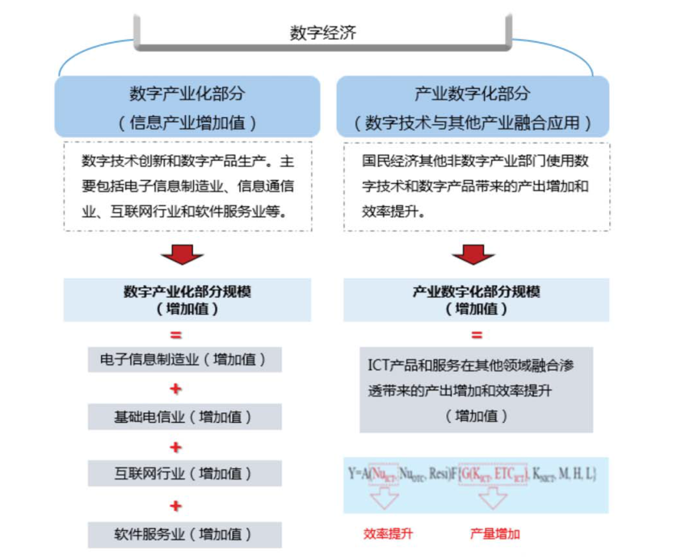
Output increase
Efficiency improvement
The added value and efficiency improvement of output due to the integration and penetration of ICT products and services in other sectors (added value)
Scale of industry digitization (added value)
The added value and efficiency improvement of output due to the use of digital technologies and digital products in other non-digital sectors of the national economy.
Industry digitization (integration of digital technology with other industries)
Software services (added value)
Internet industry (added value)
Basic telecommunications (added value)
Electronic information manufacturing (added value)
Scale of digital industrialization (added value)
Digital technology innovation and digital product production. It mainly includes electronic information manufacturing industry, information communication industry, Internet industry and software service industry.
Digital industrialization (added value of information industry)
Digital economy
Source: CAICT
Attached Fig. 1 Measuring Framework of Digital Economy
The specific accounting methods of the two parts are as follows.
1. Measuring method of digital industrialization
Digital industrialization is the information and communication industry, mainly including electronic information equipment manufacturing, sales and leasing of electronic information equipment, electronic information transmission services, computer services and software industry, and other information related services, as well as emerging industries brought about by the extensive integration and penetration of digital technology, such as cloud computing, Internet of Things, big data, Internet finance, etc. The added value of digital industrialization is totaled according to the added values of all sectors in the national economic statistics system
2. Accounting method of industry digitization
Digital technology has all the characteristics of general purpose technology (GPT). Extensive integration and penetration of traditional industries are of great significance to increase output and improve production efficiency of traditional industries. The calculation idea of digital economy in traditional industries is to strip out the contribution of digital technology in the output of different traditional industries and sum this part of each traditional industry to get the total amount of digital economy in traditional industries.
(1) Introduction to the measuring method of the scale of industry digitization
For the digital economy in traditional industries, we use the growth accounting account framework (KLEMS). We divided the entire national economy into 139 industries and calculated ICT capital stock, non-ICT capital stock, labor and intermediate inputs for each province. The total output of each industry can be used to define the final and intermediate demand. GDP is the sum of the final demand of all industries. The core of our interpretation of the model lies in two parts: the growth accounting account model and the measurement of industry-specific ICT capital stock.
(2) Account model of growth accounting
First, we define technological progress as Hicks Neutral. Province i used different types of factors of production in t period. These factors of production include ICT capital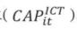, non-ICT capital, labor (LABit) and intermediate products (MIDit). Hicks Neutral technological progress is expressed by (HBit). After summation of various types of production factors, the production function of a single input index can be obtained, denoted as:
Where, is the total output of province i in t period. For the feasibility of empirical calculation, the above production function is converted into the following transcendental logarithmic production function: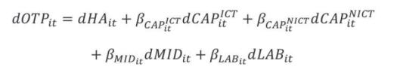
Where, represents the growth rate; βx represents the contribution share of different factors of production in total output, , and has the following relationship: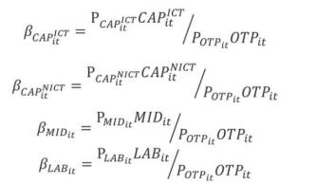
Where, p stands for price. P_{OTPit} is the price that a manufacturer produces (equal to the factory price minus the tax on the product; and respectively represent the lease prices of ICT capital and non-ICT capital; P_{MIDit} and P_{LABit} respectively represent the price and unit labor remuneration of intermediate input products. According to the product allocation competition theorem, the sum of returns of all factors of production is equal to the total output:
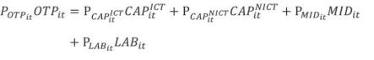
In a perfectly competitive market, the elasticity of output of each factor is equal to its share of income in total output. In the case of constant returns to scale, the sum of income elasticity of various production factors is exactly 1.
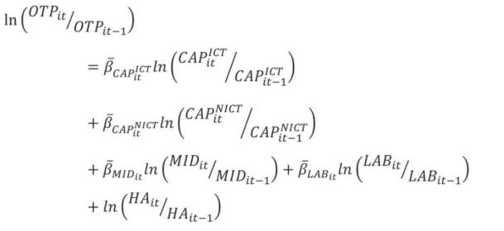
(3) Measuring of ICT capital stock
On the basis of the "perpetual inventory method", the time-efficiency model is considered, that is, the production capacity of capital input is lost with time, and the relative production efficiency attenuation is different from the loss of market value. Under these conditions, the productive capital stock can be measured.
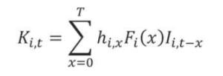
According to the research of Schreyer (2004) on IT capital input, in which, is a hyperbolic time-efficiency function, reflecting the change of relative productivity of ICT capital, and is a normal distribution probability distribution function, reflecting the withdrawal status of ICT capital from service.
h_{i} =(T-x)/(T-βx)
Where, T is the maximum service life of the invested capital; X is the service life of the capital; and the value of β is stipulated as 0.8.
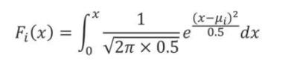
Where, μ is the expected service life of capital goods, the maximum of which is specified as 1.5 times the expected service life, and the variance of the distribution is 0.25. Where, i represents various types of investment, which in this study are computer hardware, software and communication equipment respectively. As for the ICT capital stock in the base year, the following formula is used for estimation: 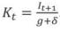. Where, Kt is the capital stock in the initial year; It+1 is the investment in subsequent years; g is the average growth rate of investment in the observation period; and σ is the depreciation rate.
(4) Measuring steps of industry digitization
First, define ICT investment. In order to ensure the international comparability of the measuring, and to consider the actual situation in China, this paper has excluded items such as "household audiovisual equipment manufacturing", "electronic component manufacturing" and "electronic component manufacturing", and determined the statistical scope of ICT investment as:
Schedule 1 Statistical Framework of China's ICT Investment
Classification | Computer | Communication equiment | Software
Item | Electronic computer manufacturing | Radar and related equipment manufacturing | Public software service
 | Computer network equipment manufacturing | Communication transmission equipment manufacturing | Other software service
 | Peripheral equipment manufacturing of electronic computer | Communication switching equipment manufacturing
 |  | Communication terminal equipment manufacturing
 |  | Mobile communication and terminal equipment manufacturing
 |  | Other communication equipment manufacturing
 |  | Radio and television program production and transmission equipment manufacturing
 |  | Radio and television receiving equipment and device manufacturing
Source: CAICT
Second, calculation method to determine ICT investment. In selecting the calculation method of investment, we adopted the method proposed by Akihiko Shinozaki (1996, 1998, 2003). The idea is to take the total fixed asset in the year of the input-output table as the benchmark data and combine the ICT output domestic demand data to calculate the annual average growth rate of domestic demand and investment in the intervening years respectively, subtract the two to obtain the conversion coefficient, and add the annual growth rate of domestic demand to obtain the growth rate of investment, and then calculate the investment data between years on this basis. The specific formula is as follows:
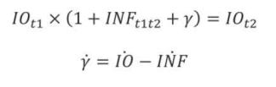
Where, the benchmark data value of the input-output table in the beginning year of IOt1; IOt2 is the benchmark data value of the input-output table in the ending year; INF_{t1t2} represents the rate of increase in domestic demand from the beginning to the end of the year (domestic demand = output value - exports + imports); is the average annual growth rate of the actual investment data in the input-output table between years; is the average annual growth rate of real domestic demand data between years; and represents the connection factor of annual rate conversion. Here, ICT investment growth rate = domestic demand growth rate + connection factor of annual rate conversion (Y).
Third, determine the service life and depreciation rate of hardware, software and communication equipment. We still use the American 0.3119 with a service life of 4 years; the median service life of communication equipment is 7.5 years, with the depreciation rate of 0.2644. Since there is no official data on software depreciation rate, and considering the universality of the global market, we chose the depreciation rate of 0.315 with a service life of 5 years.
Fourth, calculate the price index of ICT investment in China. The benchmark country is usually the United States.
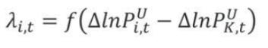
Where, is the predicted value sequence of the variation difference between ICT capital input and non-ICT capital input in the United States; represents the change difference of the price index of non-ICT fixed investment in the United States; and represents the change in the ICT price index in the United States.
Exponential smoothing regression is performed on the price difference to obtain , which is then put into the following equation to estimate the ICT price index in China.

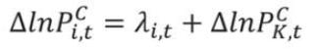
We use this method to estimate the ICT price index in China, all data being constant prices in 2000.
Fifth, calculate the actual ICT investment and measure the total ICT capital stock and regional capital stock in China, that is, the scale of industry digitization. The network infrastructure, hardware and software, emerging industries and the digital economy in traditional industries are summed up to obtain the overall scale of China's digital economy.
II. Processing of missing data
There are some missing data in the process of digital economic accounting, and the processing method of missing data is shown as follows:
1. Mixed dynamic factor algorithm
We regard the data without statistical monitoring as the missing sequence and the existing data as the constraint condition. Taking the missing of data A as an example, A^{Q}_{t} is set as observable data and A^{M}_{t} as missing data sequence, with the following constraints:

V_{t} is set as a vector composed of M observable data, V^{Q}_{t} a vector composed of n observable data, and V^{M}_{t} a vector composed of non-observable monthly data corresponding to V^{Q}_{t}, then a mixed dynamic factor model with missing values based on different frequencies can be constructed:
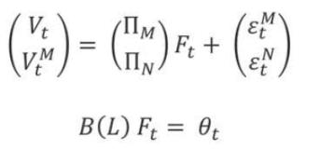
Where, F_{t} is the common factor of c ×1 dimension, which represents the synergetic change information,  and 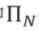 the m× c dimension and n × c load coefficient matrix respectively, 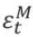and represent the random disturbance term, and B(L) the c × c dimension coefficient matrix composed of p-order hysteresis operator. Assume that , .
Since V^{M} is a non-observable data series, and the model cannot directly estimate the parameters, replace the observable data series V^{Q}_{t} with the non-observable data series. See the following equation in V^{M}_{t}:
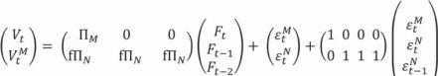
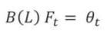
The model composed of the above two equations is a mixed approximate dynamic factor model. Assuming that Ft follows the Markov transformation autoregression process, the maximum likelihood method is used to estimate the corresponding missing values.
2. Grey prediction method
There is a data sequence on the plane, roughly distributed on a line. Let the regression line be: Y = + to minimize the sum of the distances from all points to the line (least squares), even if the square-error and 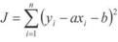 are minimized. J is a function of two variables with respect to a and b.
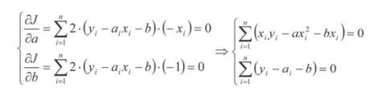
Then the requisite for making J minimum is:
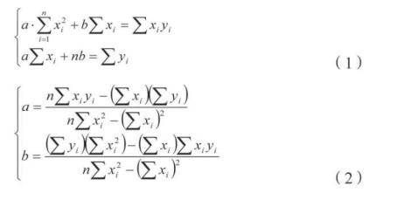
So that's the calculation of least squares. Essentially, the above algorithm uses actual observed data ^{x}_{i} and ^{y}_{i} to represent a and b, so that the square-error and j is minimized, that is, that is, a and b can be worked out from the form of the approximate equation.
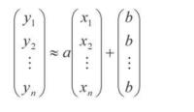
Write the above equation as a matrix equation.
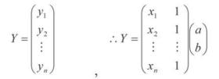
Make
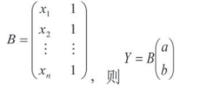
Make
We can have the following equation after multiplying BT at the left
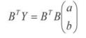
We note that BTB is a second-order square, and its determinant is not zero, so its inverse (BTB)-1 exists. Therefore, we can have the following after multiplying the above equation by (BTB)-1
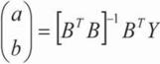
(3)
The results obtained by the least squares method (1) and (2) are exactly the same. The two algorithms are unified as follows:
Results obtained by least squares:
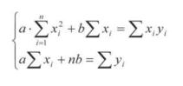
The equation set can be rewritten as:
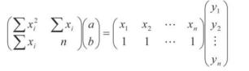
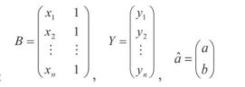
Make:
Change (3) into:
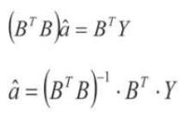
In the future, as long as the data column 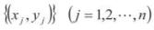 is roughly straight line, there will be an approximate expression
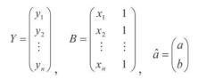
When make:
Then 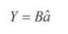
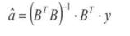
The above equation is the result of least squares, that is, the regression line y=ax+ b is less = like +6 regression coefficient a and b.
Accuracy test: posterior difference test is used in this report.
The posterior difference test is a common basic test method based on probability statistics. Based on the prediction error of ε and according to the size of , the probability of occurrence of the point with small prediction error and the size of the index related to the variance of prediction error are investigated. Level i prediction error is defined as 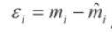. Where is the i^{th} observed data, and is the level i predicted value.
The posterior difference test is based on the following data:
(1) The mean value of the observed data and the mean deviation ^{S}₁ (standard deviation)
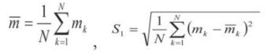
Where, N is the number of observed data.
(2) The mean deviation ^{S}₁ of prediction error ^ S1 (standard deviation)
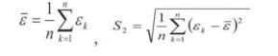
Where, n is the number of predicted data, generally n< N.
(3) Posterior difference ratio C and small error frequency P are defined as:
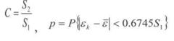
For the prediction of good extrapolation, the ratio C has to be small. Because a small C indicates that ^{S}₂ is small and ^{S}₁ is large, that is, the dispersion of prediction error is small; while a large swing amplitude of observed data means that the regularity of the original data is poor, while the regularity of the predicted data is good. Therefore, a good prediction requires that ^{S}₂ be as small as possible when ^{S}₁ is large. As a prediction indicator, the smaller C is, the better. Generally, we require C<0.35, with the maximum of C≤0.65.
Another indicator of the prediction of good extrapolation is: "small error frequency P is large". Small error refers to the deviation is large. This is a relative deviation. Generally, small error frequency P≥0.95 should not be less than 0.75, as shown below:

Predicated accuracy level | P | C
Good | >0.95 | <0.35
Pass | >0.8 | <0.5
Barely qualified | >0.7 | <0.65
Fail | <0.7 | >0.65
III. Data of source
1. Basic data, including input-output table, industry output (or income), price index, population data, employment data, economic value added of provinces and cities, and industrial value added, all come from the database of National Bureau of Statistics, statistical departments of provinces and cities, and relevant ministries and commissions.
2. Measured data, including the latest input-output tables of the state and provinces, are adjusted according to the J-RAS technology published by the National Bureau of Statistics. If there is any change in the intermediate input data, the latest adjusted data of the state or provinces and cities shall prevail.
3. The comprehensive price index should be aggregated by the weight of added value.
4. Limited by the availability of data, the proportion of ICT input in each province and industry in the report refers to the intermediate input data.
5. The criterion for judging abnormal data is that the provincial or industrial index value is more than 10 times higher than the national average, or the annual growth rate/deceleration is more than 100%. Abnormal judgment is made based on the comprehensive data related to each province or industry development.
6. The adjustment of abnormal value includes data on paper, printing, cultural and educational sports goods of Guangdong Province, data on general equipment and special equipment of Guangdong Province, data on other manufacturing industries of Guangdong Province, data on transportation, warehousing and postal services of Guangdong Province, data on leasing and business services of Guangdong Province, data on Shanghai metal products, data on other manufacturing industries of Shanghai, data on power and heat production and supply of Shanghai, data on resident service repair and other services of Shanghai, data on Beijing resident service repair and other service, data on petroleum and natural gas exploitation products of Chongqing, data on non-metallic and other mineral extraction products of Chongqing, data on scientific research and technical services of Chongqing, data on leasing and business services of Sichuan Province, data on scientific research and technical services of Sichuan Province, data on water resources, environment and public facilities management of Sichuan Province, data on education of Sichuan Province, data on health and social work of Fujian Province, data on water production and supply data of Shanxi Province, financial data of Shanxi Province, data on leasing and business services of Shanxi Province, data on scientific research and technical services of Shanxi Province, data on culture, sports and entertainment of Shanxi Province, data on public administration social security and social organization of Shanxi Province, data on general equipment of Jiangxi Province, special equipment data of Jiangxi Province, data on other manufactured products of Jiangxi Province, waste products data of Jiangxi Province, data on water production and supply of Jiangxi Province, data on transportation, warehousing and postal of Shaanxi Province, financial data of Shaanxi Province, data on transportation equipment of Zhejiang Province, data on communication equipment, computer and other electronic equipment of Zhejiang Province, data on instrument and meter of Zhejiang Province, construction data of Zhejiang Province, wholesale and retail data of Zhejiang Province, transportation, warehousing and postal data of Zhejiang Province, data on information transmission software and information service of Zhejiang Province, financial data of Zhejiang Province, data on scientific research and service of Zhejiang Province, data on water resources environment and public facilities management of Zhejiang Province, data on health and social work of Zhejiang Province, data on information transmission software and information service of Guangxi Province, financial data of Guangxi Province, data on other manufactured products of Guangxi Province, data on machinery and equipment repair services of metal products of Guangxi Province, data on commercial leasing of Shaanxi Province, data on transportation equipment of Hunan Province, financial data of Hunan Province, data on instruments and meters of Liaoning Province, data on transportation equipment of Liaoning Province, data on communications equipment, computer and other electronic equipment of Liaoning Province, instrumentation data of Liaoning Province, construction data of Liaoning Province, wholesale and retail data of Liaoning Province, transportation warehousing and postal data of Liaoning Province, data on information transmission software and information service of Liaoning Province, financial data of Liaoning Province, scientific research and service data of Liaoning Province, data on water environment and public facility management of Liaoning Province, and business leasing data of Qinghai Province.
7. If the year is not mentioned in the report, it refers to 2019.

China Academy of Information and Communications Technology (CAICT)  Address: No. 52, North Huayuan Road, Haidian District, Beijing,  Postal code: 100191  Phone No.: 010-62302667  Fax: 010-62304980  Website: http://www.caict.ac.cn/english/ | 

Due to issues such as data availability and data continuity, the report excludes Shandong, Tianjin, Hainan, Heilongjiang, Jilin, Yunnan, Xizang, Hong Kong, Macao and Taiwan.
Source: Ministry of Industry and Information Technology
It refers to the software and information technology service enterprises whose main business annual revenue is more than RMB 5 million.
It refers to enterprises whose main business annual revenue in Internet and related service is more than RMB 5 million last year.
Excluding information and communication services, software and information technology services.
Excluding electronic information manufacturing.
The Ministry of Industry and Information Technology, Development Plan of Big Data Industry (2016-2020)
The State Council, A New Generation of AI Development Plan
Calculated based on expert interviews, enterprise surveys and model, and predicted by CAICT

