Older persons and new technologies: a smart mix
- A session at WSIS Forum 2019, Geneva
Monday, April 8 2019, from 4:30pm to 6:15pm, Room M
This event is organized by ITU, CSEND and AARP.
Demographic shifts mean that many countries around the world have aging populations and that there is growing demand for newer technologies that better meet the needs of older persons. Among other things, information and communication technologies (ICT) have extraordinary potential to help with the response to the demands of this demographic shift, including meeting the challenges of a shrinking workforce and improving healthcare and caregiving for older persons. Importantly, older persons are also tech entrepreneurs, investors in tech, tech employees and consumers of ICTs. Game-changing new technologies such as artificial intelligence, big data, drones and robotics are already being harnessed by and for older persons to create opportunities and improve older persons’ well-being. Accessible ICTs, assistive devices and smart living environments also allow older persons to maintain their independence and autonomy longer, while enhancing their dignity and safety. These technologies can also increase the capacity of human care givers, who can focus on activities that need quality human interaction.

At the same time, there are also key challenges that need to be addressed, including accessibility of these technologies and digital skills for older persons. They are generally less connected than younger persons and there are stereotypes to be overcome about older persons’ interest and capacity for digital skills and tech entrepreneurship. There are also instances of exploitation of older people as consumers online. It is important that these technologies are developed and introduced with respect for older persons’ rights, including their autonomy, dignity and privacy, and with their participation.

This event will explore how older persons are using ICTs to ensure positive change for themselves and others, manage age-related challenges, and overcome risks, barriers and stereotypes. It will include speakers from a variety of stakeholder groups.

Programme

- Introduction by Master of Ceremonies
Mr. Raymond Saner, Co-founder, Centre for Socio-Eco-Nomic Development (CSEND)

- Introductory remarks and moderation of panel by Moderator
Ms. Roxana Widmer-Iliescu, Senior Programme Officer, Digital Inclusion, ITU

Panellists

- Dr. J. Alison Bryant, Senior Vice President, AARP Research, AARP

- Dr. Bénédicte Défontaines, Neurologist, Director of Réseau Alois, Head of French Institute for Dementia

- Mr. Alfonso Di Ianni, retired top manager at Oracle; Head of LongLifeJoy for Seniors

- Mr. Cyrus Mechkat and Mr. Bill Boulding, architects, Designers of Environments for Older People

Q & A

Speaker bios

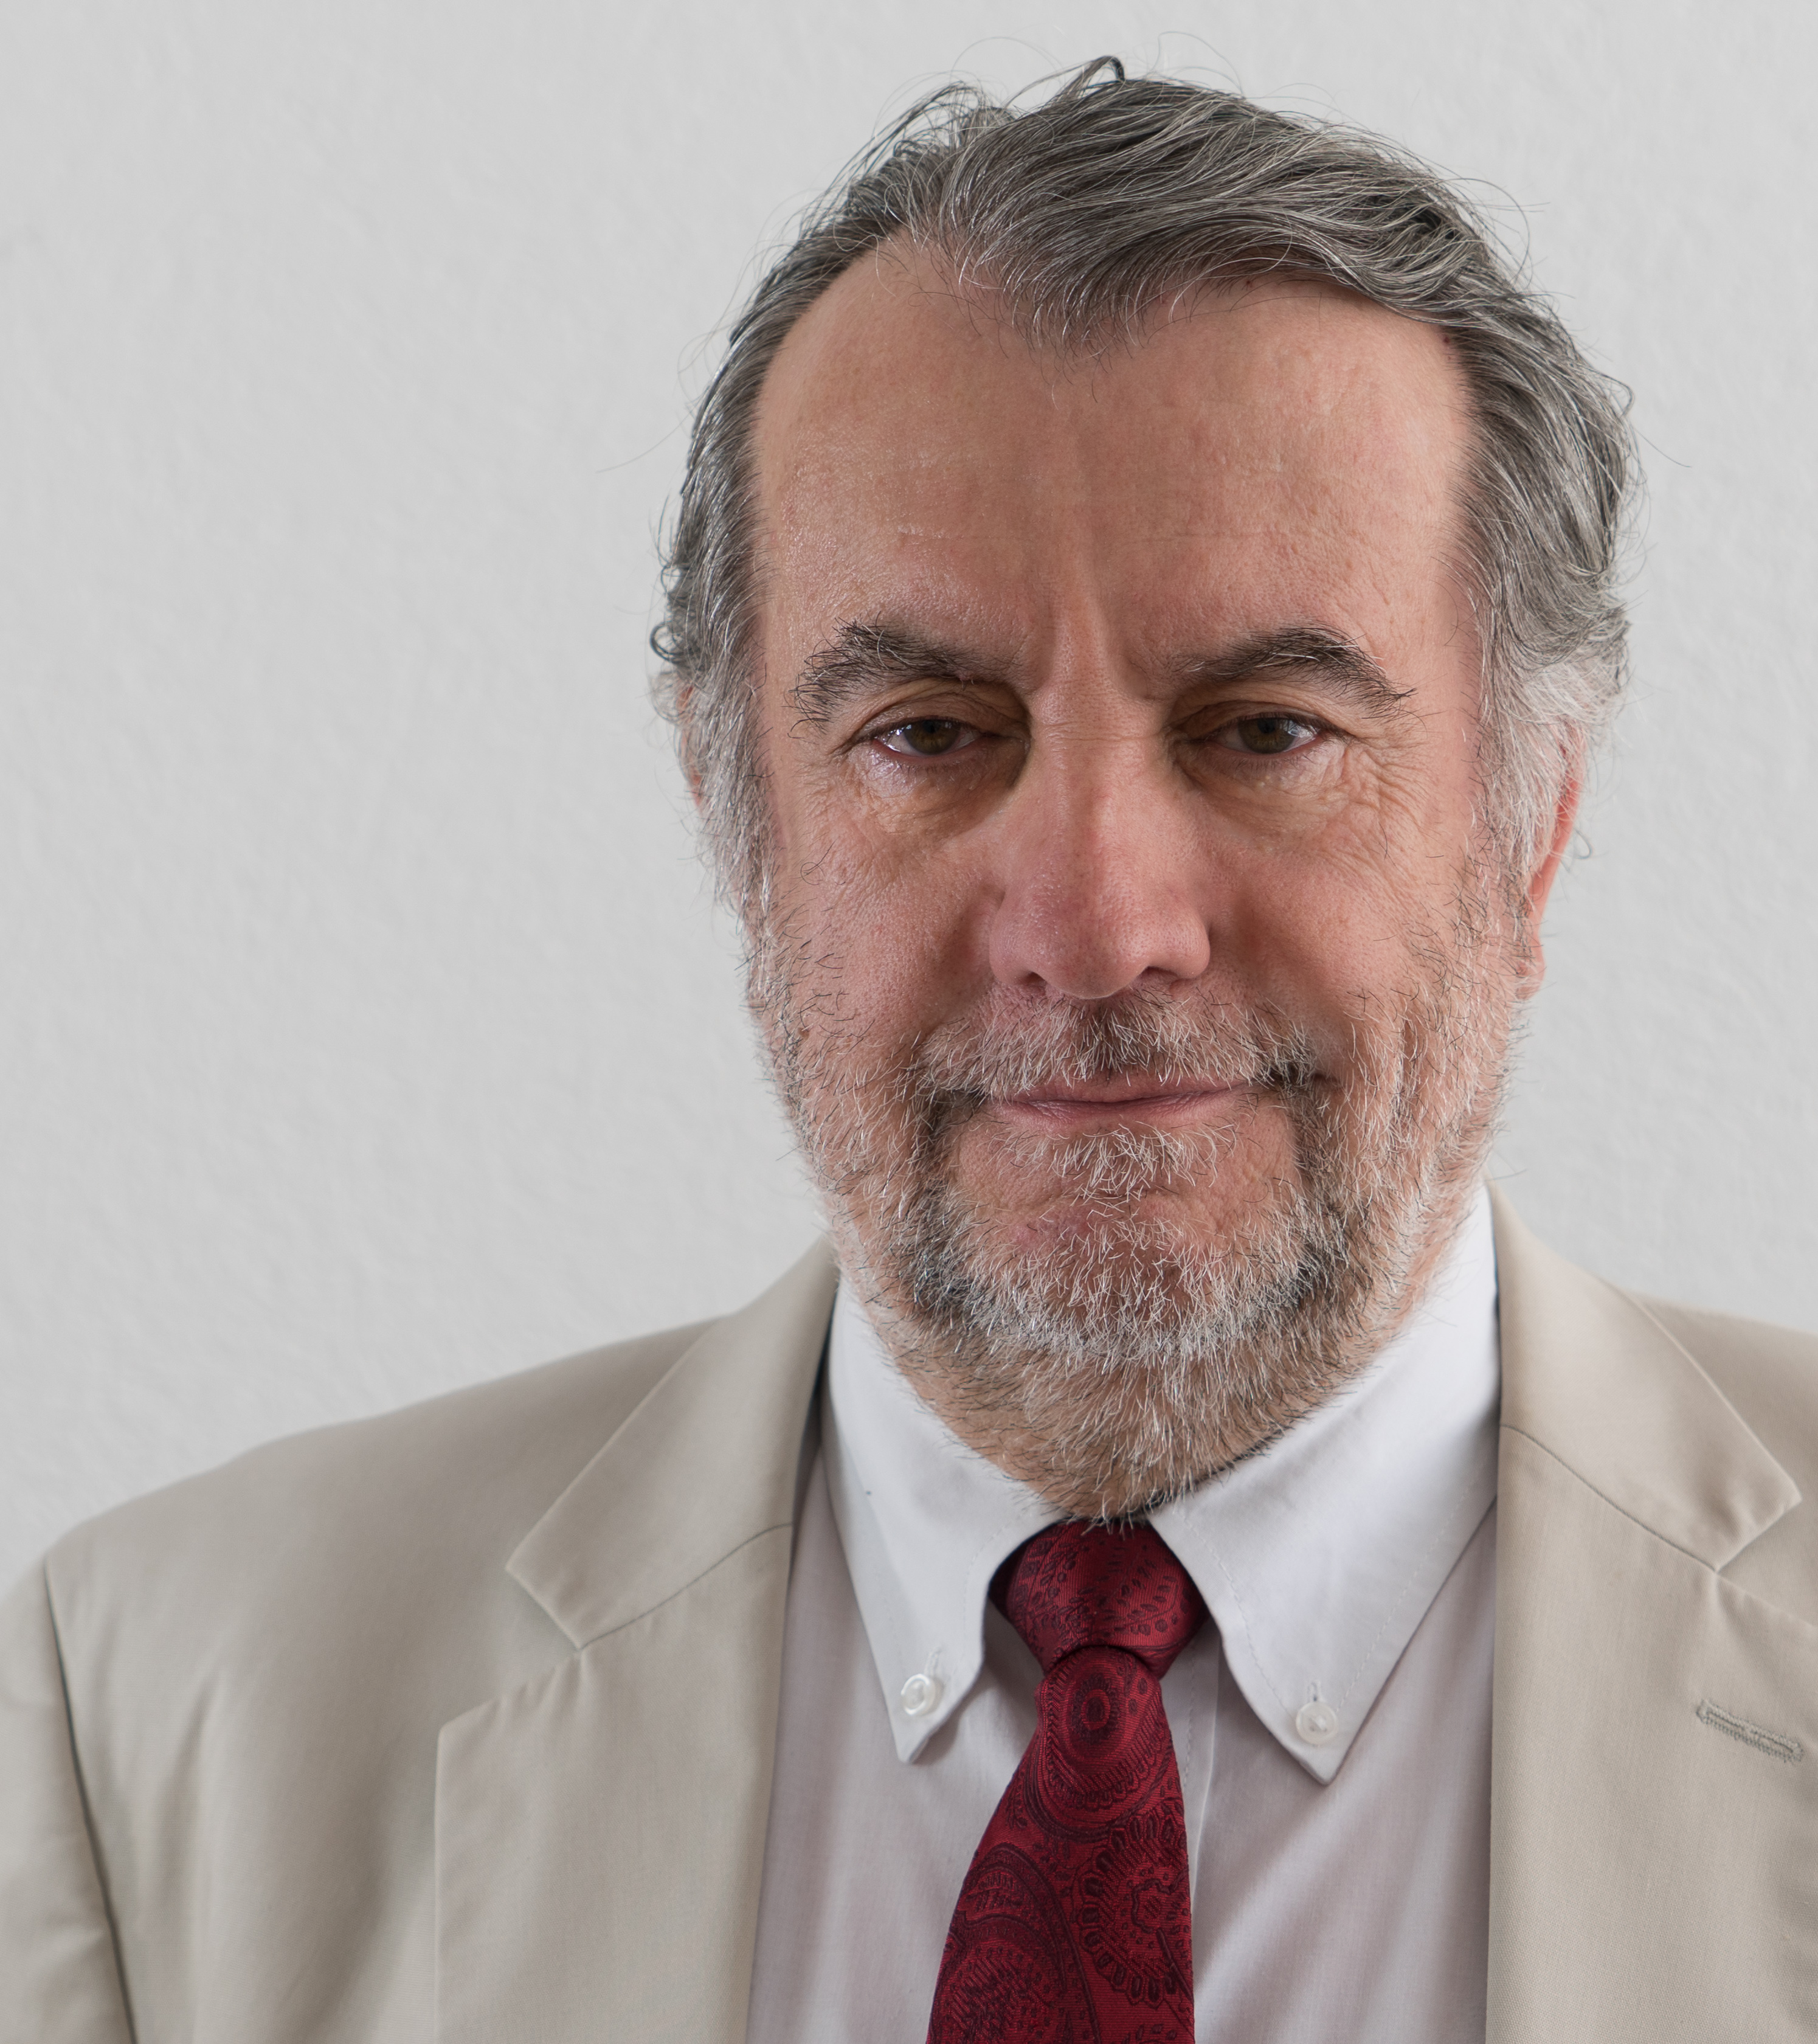 | Mr. Raymond Saner is Titular professor at Basle University (Economics Department), teaches at Sciences Po, Paris and has been a reviewer of research projects and partner of research consortia for the Swiss National Science Foundation and the International Institute of Administrative Sciences, Brussels.  Raymond Saner is co-founder of CSEND, a Geneva based NGRDO (non-governmental research and development organization, 1993-present), and expert working for international organizations such as WTO, the WB, UNDP (United Nations Development Programme), EBRD (European Bank for Reconstruction and Development), ILO, UNICEF, BIS, government agencies from Switzerland, Sweden, Germany, Spain, China, Brazil, the Netherlands and the EU Commission (DG Trade).  Mr. Saner’s engagement on issues of ageing include:  - Member of the NGO Committee on Ageing, Geneva, 2014 to date.  - Member of the Geneva Global Health Hub (H2G2), an accredited NGO by the World Health Organisation (WHO), 2018 – to date.  - Swiss representatives to the Technical Committee 314 on Ageing Society of the International Organisation of Standardisation (ISO TC 314)  - Participant to the annual meetings of the Open Ended Working Group on Aging (OEWGA-UNDESA) and the Working Group on Ageing (WGA) of UNECE (2016-to date)
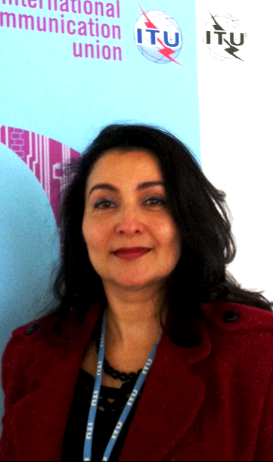 | Ms. Roxana Widmer-Iliescu is the Senior Programme Officer, Digital Inclusion for the International Telecommunication Union (ITU). Mr. Widmer has been working at the ITU Development Sector (ITU-D) since 1998. As Senior Programme Officer in charge of Digital Inclusion, she promotes the empowerment through ICTs of persons with specific needs – including Indigenous peoples, women and girls, youth, persons with disabilities (PwD) and older persons. To achieve this, Ms. Widmer leads and coordinates the development of activities that enable these groups to further their social and economic development through access to and use and knowledge of ICTs.  As ITU-D Focal Point in ICT accessibility, she also advises ITU Members on designing policies and executing strategies to ensure that ICT products and services are accessible for all people without discrimination of gender, location, abilities or financial means. To support digital inclusion global implementation, she directed the development of several ITU-D key resources, including: the “Web Accessibility Programme ”Internet for @ll”, the on-line trainings “ICT accessibility: the key to inclusive communication”, video-tutorials on the development and remediation of accessible digital content. These are concrete tools that can be used by all stakeholders to ensure that everyone including PwD can use affordable and accessible ICTs, so they can access education, job opportunities and thus leverage their social and economic development and be part of the digital society. The ultimate goal of Ms. Widmer’s work is to contribute to building inclusive digital societies globally.
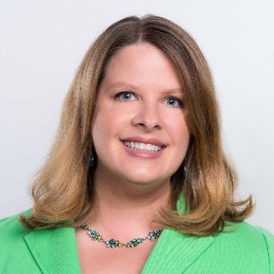 | Dr. Alison Bryant leads the Research Center for AARP, integrating insights and ideas that help the organization, consumers, and external stakeholders understand, engage with, and innovate for the 50+ consumer and their families. She is a renowned expert on the impact of media, technology, and play on consumers.  Prior to AARP, Dr. Bryant was the founder and co-CEO of PlayScience, a research and design firm that led innovation around branding, content creation and development for major global companies. Under her leadership, PlayScience partnered with dozens of marquee family brands, including Sesame Workshop, Disney, Girl Scouts, and many others. Dr. Bryant was also Senior Director of Digital Research & Strategy for the Nickelodeon/MTV Networks Kids & Family Group.  Before joining Nickelodeon, she was an assistant professor of communication at Indiana University. Dr. Bryant has three edited books -The Children’s Television Community, Television and the American Family (2nd Ed), and Service-Learning in the University Classroom – and over 30 research articles and chapters. She earned her Ph.D. from the Annenberg School of Communication at the University of Southern California.
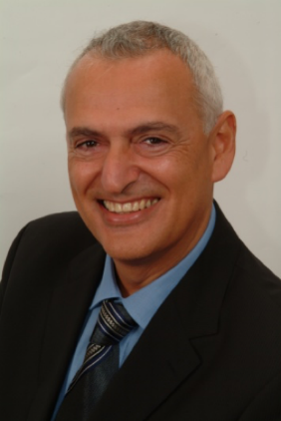 | Mr. Alfonso Di Ianni, is a senior in search of a solution to his own journey to find joyful activities in this part of a (long) life, where technology can change everything. Alfonso has over 40 years of High Tech experience in executive roles in the Silicon Valley IT industry. He has managed major IT transformations in Government and Private sector companies around the world. He is based in Switzerland, near Geneva, and considers himself part of a new breed of ‘senior illuminist’ entrepreneurs and investors to bring technology to enhance and integrate with the local life of his fellow senior citizens.  For the last two years, he has worked exclusively on the Long Life Joy project. Its aim is to facilitate the search and adoption of joyful activities for healthy and willing seniors (over 55 years) through the use of a Digital place, local and open. He has spent considerable amount of time to understand the impact of Technology on senior people, from the usability issues, to the integration between digital and real life worlds, to the relevance of technology solutions to the everyday life of senior people. His focus is on how to change Social Media from a digital daily destination (which it is for younger people) to a window to a more meaningful daily physical life. He has held a number of workshops and meetings on the social aspects of Technology with leading ageing-focused research centres in Europe.  Alfonso Di Ianni was a Senior Vice President of the Eastern Central Europe, Middle East, and Africa (ECEMEA) regions for Oracle till 2016. In this role, Mr. Di Ianni provided overall leadership for Oracle's operations, growth, and profitability in 86 countries, comprising some of the most dynamic economic regions in the world. Previously, Mr. Di Ianni held several other positions within Oracle including global leadership of Oracle Field Marketing and Alliances and Channels. Mr. Di Ianni joined Oracle in March 1997 from Digital Equipment, where he held various European management roles in consulting and product development. Mr. Di Ianni holds a Master's degree in electronic engineering from the Turin Polytechnic University (Italy) and a Master's degree in business administration from Bocconi University (Italy). He is a long-term member of IEEE and ACM
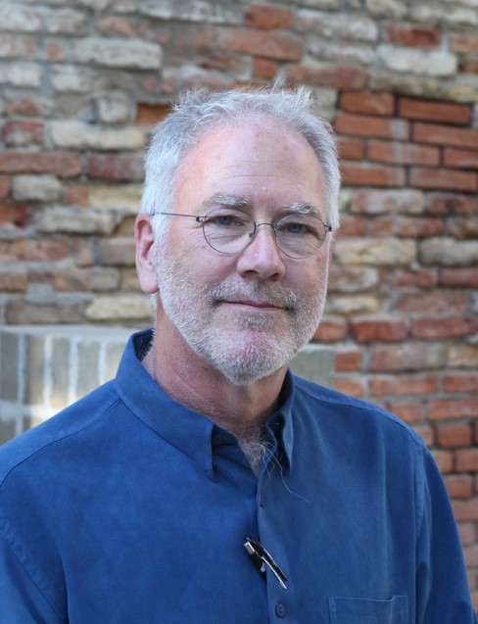  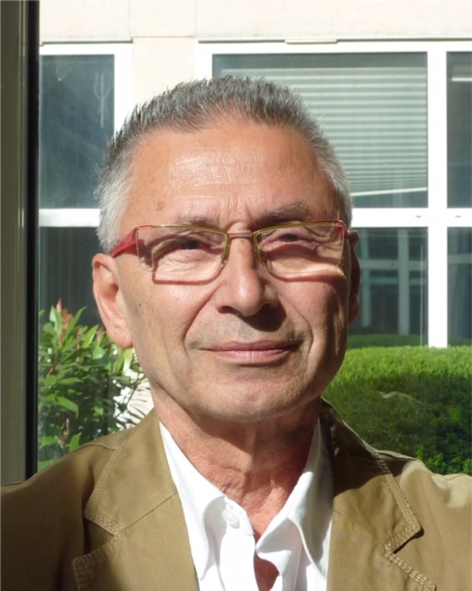 | Mr. Bill Bouldin and Mr. Cyrus Mechkat  Bill Bouldin and Cyrus Mechkat began their work together on the built environment over twenty-five years ago. Their architectural firm specializes particularly in creating spaces for fragile populations, whether the fragility is due to age, poverty, infirmity, natural or man-made disasters. Both architects have taught at the University of Geneva and have carried out extensive studies on the interactions of housing and health, whether on the scale of the neighbourhood, of health and medical institutions, or on the scale of individual and collective dwellings. They are interested in how communications and information technologies can help elderly people maintain their independence longer and more securely, how these technologies can compensate for failing capacities due to ageing, and how these same technological interventions can offer added value to every segment of the population.
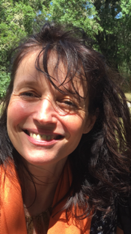 | Dr. Bénédicte Défontaines is a Neurologist and Founder and Chairwoma of the Réseau Mémoire Alois. She has Doctorate in Medicine, Post-graduate diplomas in Bio-chemistry Post-graduate diploma in Neurology, and an Advanced Studies Degree in Neurosciences. After working as an intern and assistant to the head of a medical department in a hospital, she specialized in the diagnosis and care of patients with cognitive problems.  As a full-time hospital practitioner, she participated in the first memory consultations in hospitals from 1994, first in the neurology ward at la Salpêtrière hospital (Paris 13), then at St Joseph’s Hospital (Paris 14). In 2004, she started offering memory consultations outside the hospital walls: the réseau mémoire Aloïs – Aloïs’ memory network and at her private medical offices both in Paris and at Hôpital de Moze in St-Agrève (in Ardèche Nord).  She has been an Ashoka Fellow since 2013. She is also a published author on memory and dementia, a frequent presenter at conferences, and has won awards (Gold medal as a medical intern and URML prize).

