[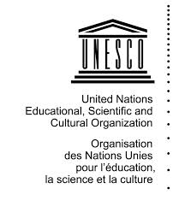](http://www.google.fr/imgres?imgurl=http://www.123savoie.com/pic/41/40276_t6.jpg&imgrefurl=http://www.123savoie.com/photo-40276-logo-unesco.html&h=850&w=739&tbnid=GS6jhECZweM60M:&tbnh=120&tbnw=104&zoom=1&usg=__R0m4gnKslQAeQpOLHdD5Dc2bQWg%3D&docid=b7uT5vWH5OPsOM&sa=X&ei=bsUdU6vhMM_e7AbOxYHgDw&sqi=2&ved=0CEQQ9QEwBw)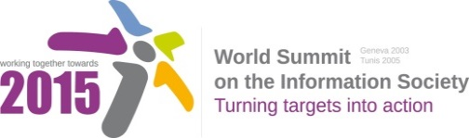

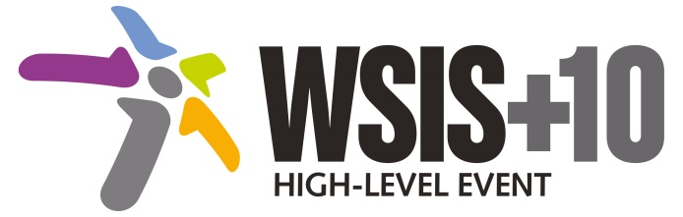

**Document Number: WSIS+10/4/17**

**Note: This Executive Summary captures the main achievements, challenges and recommendations of the Action Line during the 10-year period of WSIS Implementation; this has been submitted by the Action Line Facilitator in response to the request by the participants of the Third WSIS+10 MPP meeting. The complete report on the 10-Year Implementation of the Action line was submitted to the Third WSIS+10 MPP meeting held on 17-18 February 2014 and is available at the following url:**

[**www.itu.int/wsis/review/reports/#actionline**](http://www.itu.int/wsis/review/reports/#actionline)

**10-Year WSIS Action Line Facilitator's Reports on the Implementation of WSIS Outcomes**

**WSIS Action Line –** **C8: Cultural diversity and identity, linguistic diversity and local content**

**Lead Facilitator: UNESCO**

**Executive Summary**

1. **Achievements of the Action Line**

Cultural diversity and multilingualism on the Internet play a central role in fostering pluralistic, equitable, open and inclusive Knowledge Societies. One of the important emerging trends since the since the 1998 Stockholm Conference on cultural policies and the World Summit on the Information Society in 2005 and 2003, is the progressive worldwide affirmation of the strategic link between culture and development, both transformed by the evolving uses of technologies. Important policy documents[1] have underscored the weight of culture for sustainable development in recent years, and this vision has been translated as partners and UNESCO promoted multilingualism online, particularly through the internationalization of domain names (in partnership with ICANN) and support for local content; promoted the inclusion of disadvantaged and minority communities, and indigenous peoples, in the benefits of the Information Society through government strategies and specific projects; supported the development of community media which give opportunities to marginalized communities to participate in public debate and maintain their cultural identities; provided opportunities to disseminate information online about world cultural heritage; and addressed challenges concerning the preservation of digital heritage.

The worldwide spread and affirmation of the culture and development vision, including distinct references to the importance of information technology-enabled sectors, was also presented in the 2013 special edition of the Creative Economy Report (co-published by UNESCO and UNDP). It highlights that the expansion of information and communications technologies (ICT) is providing a much needed boost to the development of the creative economy, which is also a basic condition for the implementation of strategies in favour of cultural and linguistic diversity at global level.

More recently, the Action Line has also focused attention on the needs and interests of indigenous peoples. These are often marginalized by geographical, social and linguistic constraints. Agencies participating in the Action Line have emphasized the importance of consultation and of ensuring balance between the need to promote access and economic opportunity and the need to protect cultural values and identity. The Action Line meeting in 2011 focused on promoting indigenous education and intergenerational transmission of indigenous knowledge.

UNESCO has also worked to promote the development of local content through this Action Line, in partnership with the Internet Society and the Organisation for Economic Cooperation and Development. Their joint report on *The Relationship between Local Content, Internet Development and Access Prices* was one of the 2012 Action Line achievements.

1. **Challenges**

This Action Line brings together both broad general themes, which affect all societies, and the specific needs of particular, often marginalised, communities. The impact of rapidly changing technologies and markets on cultural diversity is, and will continue to be, complex. On the one hand, new technologies enable greater communication and knowledge sharing in developing countries, not least for marginalised communities, offering new ways to them of maintaining cultural traditions while benefiting from innovations in other societies. On the other hand, there is a risk that traditional cultures and languages will be overwhelmed by the global cultures and languages which predominate online.

1. **Way Forward**

By fully implementing normative tools and policies based on a culture-led vision of sustainable development, the international community aims in the framework of the C8 Action Line at building inclusive Knowledge Societies, which reflects and supports the current linguistically diversity; where development takes into account local contexts, builds on the knowledge generated by all communities, promotes innovation and creativity, and allows all human beings to practice their own culture and enjoy that of others free from fear; where artists, cultural professionals and practitioners are empowered to create, produce, disseminate and enjoy a broad range of cultural goods, services and activities; and where traditions or living expressions inherited from our ancestors are safeguarded for future generations.

UNESCO and other stakeholders in this Action Line must continue to respond to these complex challenges by fostering access, including multilingual content and capabilities, for all cultures and language groups, and by reinforcing the standards and other mechanisms (such as multilingualism) which are required for genuine universality to be achieved. More disaggregated data sets are desirable in order to improve understanding of the impact of ICTs and the Internet on marginalised communities, and facilitate this approach.

UNESCO will continue to promote cultural and linguistic diversity, and to support development which takes local contexts into account, building on the knowledge generated by all communities while promoting innovation and creativity. It will focus attention on indigenous peoples within its work on cultural and linguistic diversity, placing their own knowledge and experience at the heart of initiatives to address their needs, concerns and opportunities, and will also pay attention to the needs of ethnic minorities, migrant and diaspora communities. UNESCO will support efforts to ensure the survival and continued relevance of tangible and intangible heritage, as well as helping to empower artists, cultural practitioners and the wider public to create, produce, disseminate and enjoy a wide range of cultural goods, services and activities.

For the post-2015 development agenda process, culture is increasingly recognized by Member States as a powerful driver and an enabler for sustainable development. The link between cultural heritage, cultural and creative industries, of sustainable, cultural tourism, cultural infrastructure and poverty alleviation has been established, but also non-monetized cultural benefits, such as social inclusiveness, resilience, creativity are increasingly linked to innovative uses of technologies, as shown in post-2015 think pieces and debates.

1. Including: the UN General Assembly Resolutions 65/1 (“Keeping the Promise: United to Achieve the Millennium Development Goals”, 2010), 65/166 (2010) and 66/208 (2011) and 68/223 (2013) on “Culture and Development”, the outcome document of the UN Conference on Sustainable Development, "The Future We Want" (Rio de Janeiro, June 2012) and the final declaration of the Hangzhou International Congress (May 2013).