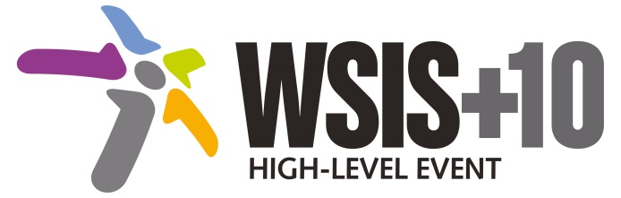[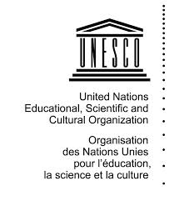](http://www.google.fr/imgres?imgurl=http://www.123savoie.com/pic/41/40276_t6.jpg&imgrefurl=http://www.123savoie.com/photo-40276-logo-unesco.html&h=850&w=739&tbnid=GS6jhECZweM60M:&tbnh=120&tbnw=104&zoom=1&usg=__R0m4gnKslQAeQpOLHdD5Dc2bQWg%3D&docid=b7uT5vWH5OPsOM&sa=X&ei=bsUdU6vhMM_e7AbOxYHgDw&sqi=2&ved=0CEQQ9QEwBw)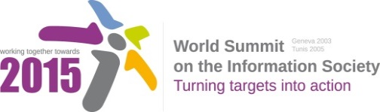

**Document Number: WSIS+10/4/16**

**Note: This Executive Summary captures the main achievements, challenges and recommendations of the Action Line during the 10-year period of WSIS Implementation; this has been submitted by the Action Line Facilitator in response to the request by the participants of the Third WSIS+10 MPP meeting. The complete report on the 10-Year Implementation of the Action line was submitted to the Third WSIS+10 MPP meeting held on 17-18 February 2014 and is available at the following url:**

[**www.itu.int/wsis/review/reports/#actionline**](http://www.itu.int/wsis/review/reports/#actionline)

**10-Year WSIS Action Line Facilitator's Reports on the Implementation of WSIS Outcomes**

**WSIS Action Line –** **C7: E-science**

**Lead Facilitator: UNESCO**

**Executive Summary**

1. **Introduction**

Perceptions, practices and instruments of e-science reflect the changing nature of the relationship between science-policy and society. UNESCO’s efforts in e-science encourage a mutually beneficial interface between science-society and policy to achieve sustainable development. The organization’s activities in this action line are focused on the role of knowledge including traditional and indigenous knowledge in shaping Technology and Innovation particularly, Information Communication and technology (ICTs) and vice versa. It also recognizes and incorporates the increasing role of ICTs in the entire scientific process. The organization continues to identify emerging trends and best practices in e-science such as the increasing use of mobile technologies in Citizen Science and highlight the practical ways in which e-science platforms improve the interface between science society and policy.

1. **Achievements of the Action Line**

Improving access to scientific knowledge, the science policy process and information-sharing has been major achievements of this action line. The Global Observatory of Science, Technology and Innovation (STI) Policy Instruments programme (GO→SPIN) is one example. GO→SPIN consists of a cluster of databases equipped with graphic and analytical tools which has the potential to be the first global observatory on STI policies that can provide end-users with structural information on STI national systems, descriptions of STI national priorities and goals, STI legal framework texts, a complete inventory with a full description of STI operational policy instruments, international cooperation strategies, long-term temporal series of indicators on STI, innovation surveys, as well as data on gender equality, economic, energy, environmental, governance and social issues. GO→SPIN has been devised for knowledge brokers, planners, managers and administrators of science and technology in governments, parliaments, universities, research institutions, production enterprises concerned with innovation, international organizations working for development, and researchers and specialists whose work and interest involve STI policies. The first volume in UNESCO’s new online series of GO→SPIN Country Profiles in Science, Technology and Innovation Policy was launched on 14 November 2013 at UNESCO headquarters. It is dedicated to the research and innovation landscape of Botswana.

1. **Challenges**

E-science related activities continue to be incorporated in the ongoing activities of the organization, however, the major challenge remains establishing and sustaining standalone activities to support and highlight emerging trends such as the increasingly high level of innovation particularly, in developing country to use web-based and mobile technology to improve scientific activity and provide improved services in areas such as health, agriculture, and education.

1. **Ways forward**

UNESCO wishes to advance existing efforts and new ones which started as a part of the WSIS +10 Review frameworks relating to Citizen Science and the establishment of the e-science platform to strengthen the interface between science, policy and society. These activities will aim to;

1. Improve access to Scientific assessments on climate change, biodiversity and ecosystem services and agriculture by creating a web-based platform (with complementary mobile applications) based on a multidisciplinary knowledge system that critically reviews and synthesize new knowledge in as a real time as possible
2. Use e-science to promote data and knowledge exchange, provide relevant and timely information for citizens, scientists and policy-makers that will improve decision making, science, policy and society relations and standards of living, particularly for marginalized communities
3. Strengthen policy and programme activities in Citizen Science by encouraging the use of the internet and mobile technologies to facilitate greater participation of civil society in the entire scientific process.
4. Facilitate more public and private partnerships to promote e-science in the post 2015 development agenda.