[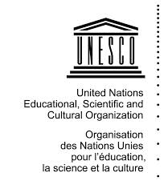](http://www.google.fr/imgres?imgurl=http://www.123savoie.com/pic/41/40276_t6.jpg&imgrefurl=http://www.123savoie.com/photo-40276-logo-unesco.html&h=850&w=739&tbnid=GS6jhECZweM60M:&tbnh=120&tbnw=104&zoom=1&usg=__R0m4gnKslQAeQpOLHdD5Dc2bQWg%3D&docid=b7uT5vWH5OPsOM&sa=X&ei=bsUdU6vhMM_e7AbOxYHgDw&sqi=2&ved=0CEQQ9QEwBw)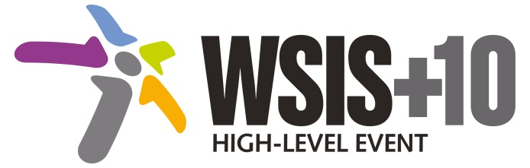

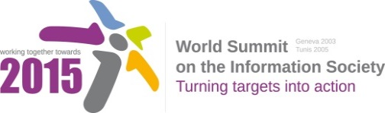

**Document Number: WSIS+10/4/19**

**Note: This Executive Summary captures the main achievements, challenges and recommendations of the Action Line during the 10-year period of WSIS Implementation; this has been submitted by the Action Line Facilitator in response to the request by the participants of the Third WSIS+10 MPP meeting. The complete report on the 10-Year Implementation of the Action line was submitted to the Third WSIS+10 MPP meeting held on 17-18 February 2014 and is available at the following url:**

[**www.itu.int/wsis/review/reports/#actionline**](http://www.itu.int/wsis/review/reports/#actionline)

**10-Year WSIS Action Line Facilitator's Reports on the Implementation of WSIS Outcomes**

**WSIS Action Line –** **C10: Ethical dimensions of the Information Society**

**Lead Facilitator: UNESCO**

**Executive Summary**

1. **Achievements of the Action Line**

*This Executive Summary provides a succinct overview of the achievements and emerging challenges in the areas studied by the Action Line and points to approaches that could be adopted to enhance its work in the Post WSIS+10 period.*

**The C10 Action Line reflect optimism for the prospects and opportunities provided by** ICTs present for advancing human well-being but tempered with the concern that ICTs may also bring harm. The Action Line has been contributing to the reflection and debate on the ethical, legal and societal aspects of the ever-evolving Information and Knowledge Societies, on the basis of ethical principles that derive from the Universal Declaration of Human Rights.

In its role as Coordinator of this Action Line, UNESCO has organized regional Info-Ethics conferences which have brought together a broad range of stakeholders and perspectives. These fora have helped to promote the sharing of global experiences and served to shape the thinking and practice of public, private sector and civil society actors. Several pioneering research studies have also been undertaken to better understand the impact and implications of the use and application of technologies on individuals and society. Various initiatives aimed at support the capacity building of stakeholders, particularly policy-makers and youth have been launched. This research effort continues to inform the ongoing discussion amongst Member States and other stakeholder of possible voluntary codes that could serve to guide on-line conduct.

Since 2005 the emergence of new services and applications has seen the Internet move from a source of information to a platform for communication. Innovative ‘Web 2.0’ services such as social networks, have led to enormous growth in user-generated content, facilitated freedom of expression and association and broadened participation in public policy debates. These changes are widely believed to have contributed to political transformations in several countries.

ICTs and the Internet have also made it much more difficult for individuals and organizations to protect their privacy. Everything that people do online leaves a trail of information much more extensive than in their offline lives. Recent revelations concerning government surveillance of online activity have heightened debate about privacy, data protection, the detection of crime and national security.

Technological developments, such as big data analysis and the Internet of Things are also raising discussions and ethical concerns around how the adoption and experience of such technologies may alter human interactions and the societal fabric.

The ethical challenges of the Information Society will continue to grow and become more complex as ICTs continue to become more pervasive and have increased impact on human society. Technological innovation will present people with opportunities to do things which were previously inconceivable. In addition, we will continue to see the evolution of concepts such as security and privacy..

Increased confluence between the issues covered under this Action Line and those of Action Lines in particular C3 (access to information and knowledge), C5 (confidence and security in the use of ICTs) and C9 (media) can be expected. This should in turn serve to stimulate greater interdisciplinary between Action Lines and more holistic approaches to addressing these complex, far-reaching issues. The blurring of boundaries between issues, the emergence of new opportunities as well as threats to rights, points to the need for greater public discourse around these challenges. UNESCO will contribute to provide space for exploring and debating these changes, as well as conducting and disseminating research that serves to provide all stakeholders with greater insights into their implications.