******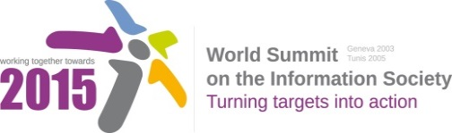**



**Document Number: WSIS+10/4/97**

**Submission by: ESCWA, International organization**

**Please note that this is a submission for the Fourth Physical meeting of the WSIS +10 MPP to be held on 14-17 April 2014.**

С8. Cultural Diversity and identity, linguistic diversity and local content

**(Doc#:** [**V2/C/ALC8**](http://www.itu.int/wsis/review/inc/docs/phase3/1-R/V2-C-ALC8.docx)**)**

* *Vision:* We suggest the includes of the “phrase under-represented languages and” before “language minorities”, as follows:
  + ...It is a world where marginalized groups, including indigenous peoples, and those coming from migrations, diasporas and from under-represented languages and language minorities, enjoy increase recognition...
* *Pillar a (iv)*: Suggest the inclusion of “digital content”, as follows
  + Encourage implementation of national and regional digital content and programmes launched...
* *Pillar a(vi)* Suggest the inclusion of digital, as follows
  + Promote infrastructure to facilitate development of local digital content, given the relationship between...
* *Suggested Pillar*
  + We suggest the inclusion of a new pillar on capacity building for digital content creation, as follows:
    - Encourage the creation of special curricula, programmes, post-graduate courses, as well as the establishment of training centres for the development of digital content.