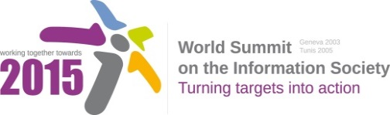

**Document Number: WSIS+10/4/8**

**Submission by: Association for Proper Internet Governance, Civil Society**

**Please note that this is a submission for the Fourth Physical meeting of the WSIS +10 MPP to be held on 14-17 April 2014.**

**Corrections to the published outcome documents of the second the WSIS+10 Open Consultation meeting   
Association for Proper Internet Governance**9 January 2014

At the 16-18 December 2013 Open Consultation Meeting, a proposal was made to add, in square brackets, a new item 2(l) to Action Line C5 of the Vision (document V2-C-ALC5) and that proposal was displayed on the screen. The published document does not correctly reflect the proposal. Paragraph item 2(l) of V2-C-ALC5 should read:

2(l) [Recognize the need for **international agreement to cooperate on security matters** and to avoid unilateral assertions of national laws and to avoid extra-territorial actions. In this context, states shall individually and collectively endeavour to ensure the security and robustness of international telecommunication networks in a manner that respects and upholds their human rights obligations, and they should consider best practices regarding human rights, in particular those put forward by civil society organizations.]