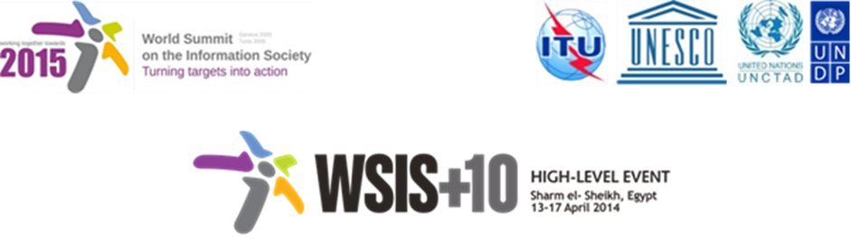
Document Number : WSIS+10/3/97
Submission by: Internet Society, Civil Society
Please note that this is a submission for the Third Physical meeting of the WSIS +10 MPP to be held on the 17th and 18th of February.

Internet Society comments on the proposals of the 1st drafts of the Outcome Documents as well as results of the first reading of Documents of the second MPP physical meeting

The Internet Society has provided detailed comments on most WSIS+10 Outcome Documents currently discussed within the Open Consultation Process (in text using track changes). These edited documents have been forwarded to the Secretariat at wsis-info@itu.int and are also available here:
https://isoc.box.com/s/3u35lxq2mdr33qzy1lay

We invite the ITU Secretariat and the MPP Chair to consider them as input to the next Preparatory Meeting in Geneva (17-18 February 2014).

In addition, the Internet Society would like to associate itself to the numerous delegates, from all stakeholder groups, who expressed concerns regarding the process and modalities of negotiations of the Outcome Documents. We would also like to formulate a few recommendations in this regard.

Process and modalities of negotiations of the Outcome Documents

The Internet Society is concerned that the current negotiation process for the WSIS+10 Review Outcome Documents has not produced sufficient progress towards a successful outcome for the WSIS+10 High Level Event. The lengthy documents currently under discussion are cumbersome and full of duplications and overlap. It is difficult to envision these documents as a basis for an international consensus.

While we appreciate the open and inclusive process so far in producing the draft texts under consideration, we believe that there is a need fore more editorial work to facilitate the discussions at the physical meetings, especially given time constraints of the process.

Our review of several Outcome Documents has shown a high number of redundancies and duplications of issues, within and between documents.

For instance, we notice a heavy duplication between the Preamble (A) and the Priority Areas (B) of the WSIS+10 Vision for WSIS beyond 2015. We would encourage the Chair and Secretariat to consider keeping and merging the substance into one single document, possibly the Priority Areas (B). The Preamble should be very short and high-level.

We would therefore urge the MPP Chair and ITU Secretariat to make concrete proposals at the February session on ways to move forward within the allocated time for the review. We suggest an editing process to follow the completion of the first round of reviews leading to 1st drafts of the Outcome Documents. While the essence of issues submitted by WSIS stakeholders should not be excluded, there is ample margin to condense similar inputs.

Different modalities could be explored to undertake this process. The Computer & Communications Industry Association (CCIA) and other stakeholders have made specific suggestions to improve the process. Multistakeholder collaboration could be explored such as a “Committee of the Whole”, which is a fairly standard procedure in international negotiations. Such a Committee would build on the model used by UNESCO to develop the 2013 WSIS+10 outcome document. An open-ended multistakeholder drafting group, focusing on a short High-Level statement, should be able to provide the expected outcome documents. The Internet Society experienced the efficiency of the UNESCO process and felt that it led to an excellent outcome.

The objective of the MPP should be to provide a set of short and concise documents, build around multistakeholder input, in order to seek agreement and consensus at the WSIS+10 High Level Event.

Finally, we would like to question to value of having detailed targets in the Vision documents. The Outcome Documents should provide general guidance on possible ways forward beyond 2015, and not to agree on specific numbers and figures. We would therefore suggest leaving targets aside from the current review exercise.

The Internet Society strongly supports the organization of the WSIS+10 High Level Event in 2014 as planned, and therefore we look forward for proposals at the February session on how to make progress on those issues.

http://www.unesco.org/new/fileadmin/MULTIMEDIA/HQ/CI/CI/pdf/wsis/WSIS_10_Event/wsis10_final_statement_en.pdf

