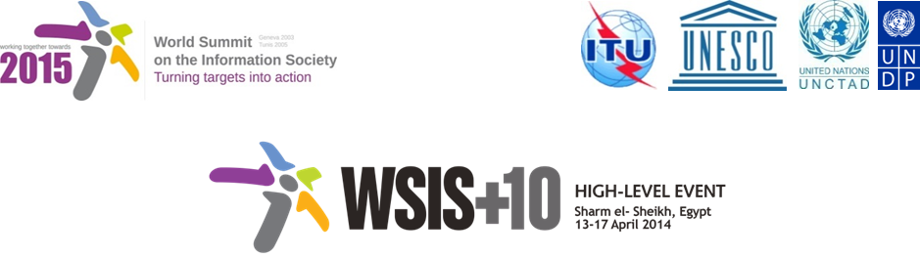

Document Number : WSIS+10/3/93
Submission by: Center of Technology and Society, Civil Society
Please note that this is a submission for the Third Physical meeting of the WSIS +10 MPP to be held on the 17th and 18th of February.

Draft WSIS+10 Vision for WSIS Beyond 2015

C6. Enabling environment

1. Vision
In order to leverage the transformational power of ICTs and broadband in particular to maximize the social, economic and environmental benefits of the digital ecosystem Information Society, governments need to create a trustworthy, transparent and non-discriminatory policy, legal and regulatory environment. Such an environment enables innovation, investment and growth while providing regulatory certainty and flexibility .to expand
To overcome the current challenges in a highly dynamic and rapidly changing digital economy, governments need to develop a multi-pronged approach and urgently take action to accomplish the pillars below.
2. Pillars
- Design and enforce open, effective and forward looking policy, legal and regulatory frameworks based on inclusive and wide-ranging public consultation with all stakeholders.

- Reexamine and redefine such frameworks mentioned in para a above regimes to promote digital inclusion ensuring that all communities as well as targeted population groups such as youth, women, persons with disabilities and indigenous peoples can access and use ICTs for their social and economic empowerment.

- Adopt a holistic approach to governing the ICT sector and move towards cross-sector regulation in view of fueling synergies among government agencies, private sector and the society as a whole.

- Enact a consistent and overarching ICT and/or broadband policy to foster broadband development across all sectorsthat and drives digital inclusion, and implements and monitors related activities, .

- Ensure effective and fair competition level-playing field, promote transparency and create a regulatory framework that nurtures innovation while stimulating investment, including foreign direct investment, for the roll-out of broadband infrastructure (including broadband) and the development and take up of e-applications and services.

- Enact a consistent and overarching ICT and/or broadband policy to foster broadband development across all sectors and drive digital inclusion of all.

Recognizing the economic potential of ICTs for Small and Medium-Sized Enterprises (SMEs), contribute to increasing their competitiveness by streamlining administrative procedures, facilitating their access to capital, reducing the cost of doing business and enhancing their capacity to participate in ICT-related projects.

- Encourage Promote the development and adoption of appropriate national, regional and international standards that are required to foster interoperability and to facilitate the flow of information and services across borders and address the concerns of various ICT providers and users.

- Raise awareness of the benefits and risks of technological progress for the market and consumers and consider regulatory measures to address issues such as personal and data protection, consumer rights, and protection of minors and vulnerable segments of the society, and collaborate at the regional and international levels.

- Eadopt and nforce legal frameworks for ensuring confidence and security in the development and the use of ICT, particularly in regard of the right to privacy.

3. Targets
- [Target 1: Empower governments to mitigate the challenges of the Information Society. By 2020, all countries should empower the government agency(ies) in charge of ICT regulation to adopt and effectively enforce relevant regulations.
- Target 2: Make broadband policy universal. By 2020, all countries should have a national broadband plan or strategy or include broadband in their Universal Access/Service Definitions.
- Target 3: Boost the competitiveness of broadband markets. By 2020, all countries should have effective competition in the main broadband market segments (mobile, DSL, cable modem, fixed wireless, leased lines, Internet services, international gateways and Voice over IP (VoIP).)

