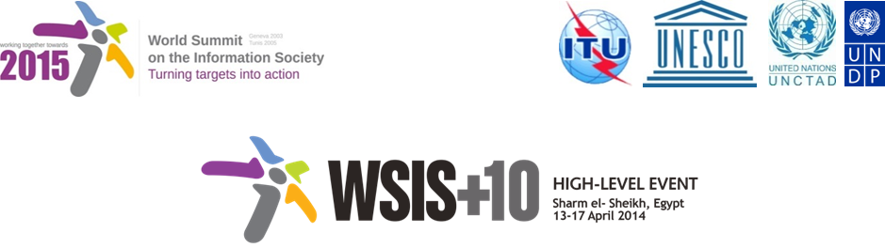

Document Number : WSIS+10/3/91
Submission by: Center of Technology and Society, Civil Society
Please note that this is a submission for the Third Physical meeting of the WSIS +10 MPP to be held on the 17th and 18th of February.

Draft WSIS+10 Vision for WSIS Beyond 2015

С2. Information and communication infrastructure

1. Vision

Infrastructure is the cornerstone and the most important aspect in achieving goals such as digital inclusion, enabling universal, sustainable, ubiquitous and affordable access to ICTs by all, taking into account relevant experiences from developing countries and countries with economies in transition. Provide sustainable connectivity and access to rural, remote and marginalized areas at national and regional levels, Broadband connection based on converged services and enhanced radio frequency spectrum and orbit management supported by efficient backbone, new technologies, innovative policies, national broadband plans based on reliable data, and international standardization are the keys for such achievement.

2. Pillars
- To enhance the coverage, quality, and affordability of Broadband telecommunication networks, infrastructure development utilizing converged services, enhanced frequency spectrum management, and both wired and wireless fixed and mobile technologies are essential.

- Develop a well-planned, well-maintained, robust, economic, and efficient Broadband infrastructure to ensure the delivery of high quality services including, Internet and access to affordable information and technologies for citizens. High quality services should be considered upon an standard of minimum speed, stability, same bandwidth for uploads and downloads, respect of net neutrality, reliable customer support services.

- Increase research and development, and deployment of new technologies, to provide reliable and affordable information and communication infrastructure.

- Utilize policy and financing mechanisms such as Universal Service Funds and/or Public Private Partnership, to connect and cover rural and remote areas with affordable Broadband information and communication Broadband telecommunication infrastructure.

- To attract private investment, competition policies, financing, and new business models need to be studied and deployed.

- Policies, technologies, and actions, such as connecting public facilities and encouraging the usage of multi-/sign- language, need to be considered to ensure minorities, disadvantaged, aged, and persons with impairments are connected to Broadband telecommunication networks, bearing in mind that market solutions may not always result in the rollout of sufficient infrastructure.

- Planning and actions based on proper and reliable data related to information and communication infrastructure are essential, keeing in mind the protection of privacy of consumers an.d their personal data.

- To develop affordable equipment, access to telecommunicatiks and ICequipment, developed in conformity with international standards and seeking interoperability and services by economy of scale, development,tiona.
[Affordable should be understood in relation to the user’s disposable income.] Access should be understood as affordable access, meaning that the price of access should be aligned with a user's disposable income.

i) Emergency telecommunication services should be secured.

j) [Identify the main difficulties that the digital economy poses for the application of existing international tax rules and develop detailed options to address these difficulties.]

k)

3. Targets

[Access to Broadband telecommunication networks, and the gaps

- By 2020, XX % of households should have Internet access (World, developing countries)

- By 2020, Internet user penetration should reach YY% (World, developing countries)]

