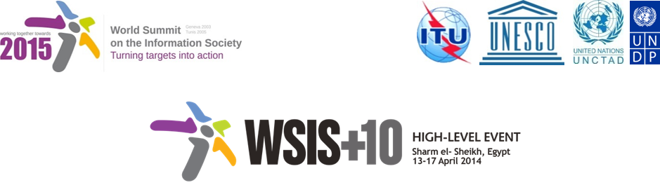

Document Number : WSIS+10/3/90
Submission by: Center of Technology and Society, Civil Society
Please note that this is a submission for the Third Physical meeting of the WSIS +10 MPP to be held on the 17th and 18th of February.

Draft WSIS+10 Vision for WSIS Beyond 2015

С3. Access to information and knowledge

Regarding to the Document V1/C/ALC3, the approach toward “Access to information and knowledge” is not comprehensive and merely deals with the right of having access and not the right of controlling the access, meaning that ICT users should be able to merely receive the information they are willing to. In other words, the right to have access to information and knowledge encompasses the right of being protected against unwanted information (advertisements, malwares, spam etc.). Consequently, the both aspects of the So-rights have to be notified.

1. Vision
For the post-2015 era, we envision inclusive Knowledge Societies to facilitate access to information and knowledge all the world's people, where there is an increased and informed participation of all groups, where there is an increased and informed participation of all groups, including those the aged and coming from previously marginalized groups and regions in addition toandand persons with impairmentsdisabilities, with a significant portion of knowledge flows and innovations that advance human rights and the attainment of development goals. Facilitated access should be considered access that is unfettered by technological restraints, and respectful of users’ privacy and other human rights.
2. Pillars
- Government-led open data, open science, open access, open educational resources, FOSS, and other open solution strategies and resources promoted in all countries and languages.
- Project support for expanding and enhancing access to information in the public domain
- or alternative: Strong policy, programme and project support for expanding and enhancing public access to information, including through incentives for the adoption of open licensing models.
- .Enhance international solidarity to promote exchange of experiences and research within and across nations and regions in the context of information and knowledge societies.
- Youth-focused and pro-poor iinitiatives focused on youth, elderly and the poor that emphasize the role of information-based development oriented entrepreneurial activities.
- Media and Information literacy emphasized as a core element of all formal, non-formal and life-long learning initiatives.
- Information literacy emphasized as a core element of all formal, non-formal and life-long learning initiatives to promote healthy ageing and foster independent living solutions for the aged and the impaired.

- National efforts undertaken to promote access to development content – accessibility standards, accessible and inclusive ICTs, multilingual/culturally diverse content and tools.
- Strong commitment to creating, developing and supporting sustainable multi-purpose community public access points providing affordable or free-of-charge access for all citizens to ICTs, as well as improved infrastructure, with universal coverage, under fair and equitable terms.
- The preservation user rightsprotection of privacy, freedom of expression, and other human rights , that are fundamental for the existence of an ecosystem that is enabling of unfettered access to information and knowledge., such as privacy, freedom of expression, and other human rights.
- Continue the ongoing multi-stakeholder consultative and participatory processes for creating a post-2015 strategy, linking the Action Line C3 Access to Information to the post-2015 development agenda.
- Support of Open Government initiatives

3. Targets
- All Governments to undertake necessary ing efforts to support expansion of public domain, accessibility of public information services and products through the use of FOSS, open data and open solutions.
- The development of policies that promote and remove legal barriers to an unrestricted access to public domain;
- The development of policies that facilitate digitization of libraries and collections, in order to promote preservation and broadened access.
- The creation of an open educational resources policy and the incentive of an open access mandate;
- The promotion of the production of FOSS and fostering its adoption by public administration.
- The promotion of open standards for increased interoperability, innovation and ease of access.
- The implementation of Open Government initiatives;

- Indicator (a-f)r: Relevant national policies implemented.

- Enhancing levels of Media and Information Literacy levels, and mass media and communications enhanced amongst school age population.
- Indicator: % of schools with teachers trained to offer a MIL curriculum.
- Indicator: Relevant lifelong educational and learning programmes and initiatives developed.

- Development and integration of accessible and inclusive ICTs including for persons with disabilities.
- Indicator: Relevant national ICT teacher training programmes developed.
- Indicator: Relevant ICT training / tertiary education programmes included elements of accessible and inclusive ICT design

