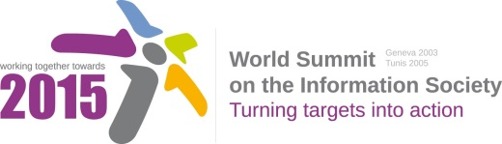

Document Number : WSIS+10/3/65
Submission by: Canada, Government
Please note that this is a submission for the Third Physical meeting of the WSIS +10 MPP to be held on the 17th and 18th of February.

Document Number: V1.1/C/ALC7/E- Government

Note: This document consolidates the comments received by WSIS Stakeholders from the 9th October to 17th November. All the detailed submissions are available at:
http://www.itu.int/wsis/review/mpp/pages/consolidated-texts.html

This serves as an input to the 2nd Physical meeting and could be considered as the proposal for the 1st draft to be considered by the meeting.
This document has been developed keeping in mind the Principles.
Please note that the Geneva Declaration and the Geneva Plan of Action still remain valid until further decisions by the General Assembly.

Draft WSIS+10 Vision for WSIS Beyond 2015

С7. ICT Applications: E-Government

1. Vision
The advancement of e-government should be carried out with a view to transform governments to be more efficient, effective, transparent, accountable, open, and citizen centric. We should collectively strive to promote e-government for more effective public service without undermining privacy and security to support sustainable development. We encourage co-production of e-government services, transfer of knowledge and sharing of best practices to promote innovation and effective development.

2. Pillars
- Encourage integrated e-government services through whole-of-government approach to support the three pillars of sustainable development
- Promote inclusive e-government through e-participation and increase availability of government data for reuse in order to promote participation in public policy-decision-making, responsiveness, transparency and accountability
- Promote people-centered delivery of e-services and bridge the digital divide
- Address privacy and security issues through concerted efforts
- Promote capacity building and knowledge sharing for effective utilization of resources
- Utilize existing infrastructure (e.g. community access points including kiosks, community centers, libraries, and post offices) and use of intermediaries to ensure that e-government services reach all end users.
- Improve government service through open and transformational ways and provide multi-channel service delivery particularly through mobile devices

