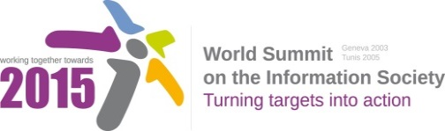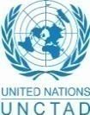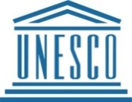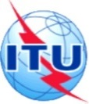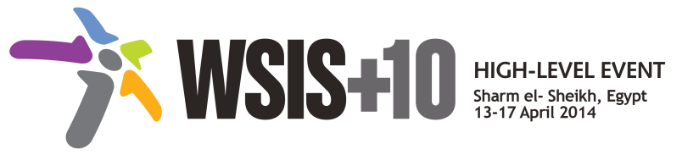

**Document Number : WSIS+10/3/12**

**Submission by: GDCO Sudan, Civil Society**

***Please note that this is a submission for the Third Physical meeting of the WSIS +10 MPP to be held on the 17th and 18th of February.***

Draft WSIS+10 Vision for WSIS Beyond 2015

[Telecentre](http://www.telecentre.org/)  is a public place where people can access computers, Internet, and other digital technologies that enable them to gather information to develop skill to facilitate their lives. There are four types of Telecentres 1- Standard Telecentre which deals with Training, capacity building and skill development 2- Knowledge Telecentre and this where GDCO share knowledge, experience and best practices with other Telecentre practioners and transfer it to Gedaref Sudan e-g. e-Agriculture, e-learning and e-government and e-health. 3- Investment Telecentres are applications of the knowledge Telecentres for more sustainability e.g. agro-mobile, telemedicine for more Telecentre sustainability without changing the objectives 4- Portable Telecentre is the future of Telecentre it is multi-services Telecentre which combine the above three types. Globally there are 87531 Individual Telecentres in 52 countries with 73 Telecentre Networks in 6 Regional Networks.

1. In GDCO there are big challenges faced the implementation of Action Lines including:-
2. ICT is not part of the culture and not a priority
3. Poverty and financial support
4. High running cost
5. High cost of e-infrastructure and low speed internet
6. Limited number of student in out of school classroom because all children go in the morning to bring the water from far distance and then they go with their animals looking for grazing area and in the evening they help their families in milking them
7. Limited number in al-amal deaf school because it is very difficult for the teacher to teach more than 10 deaf in the classroom
8. Most of the Telecentres depend on donation and grants.
9. Reluctance to change and automation 4 senior staff
10. Limited access to energy sources and power supply
11. a big digital gap (divide) everywhere in rural area
12. There are many areas should have priorities because they have being ignored or not included in Geneva WSIS action lines
13. Empowering, people with disability and human rights through ICT for equal access because more than 16% of the world population are living with disability, in addition they had been ignored by Geneva WSIS action lines and this is why they had special session the 68th session of the  General Assembly of the United Nations on 23rd September 2013.
14. Promoting [Women digital literacy campaign](http://women.telecentre.org/) Telecentre [Women Digital Literacy](http://community.telecentre.org/photo/albums/gdco-telecentres-for-gender-equality) Campaign is a global initiative of  TCF & ITU to empower disadvantaged, marginalized and underserved women through ICT for better lives. Partners trained 914.368 women by December 2013**.** GDCO participated in the foundation of [the first IT women network in Arab States](http://community.telecentre.org/photo/albums/gdco-participated-in-ict4-women-conference)
15. Cloud computing
16. Drying resources of illiteracy because there are 57 million illiterate people according to the UNESCO report in July 2013 where more than 50% are in Africa and 14% in in the Arab State and this is not including 28.5 million due to war and disaster.
17. Telecentres as tools for community development through ICT
18. Blogging, promoting and writing for WSIS
19. Areas need more concentration
20. Fighting against poverty
21. Increase mobile penetration in rural area with Affordable wide broadband accessibility
22. Promote eHealth and telemedicine
23. Integration of ICTs e-services
24. Promotion of online crop market