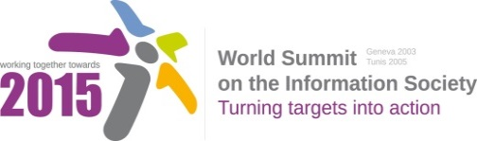
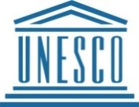

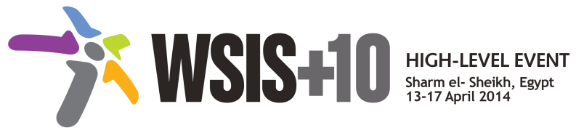

Document Number : WSIS+10/3/103
Submission by: UN Women, International Organization/Sweden, Government/ Access, Civil Society and Internet Democracy Project, Civil Society
Please note that this is a submission for the Third Physical meeting of the WSIS +10 MPP to be held on the 17th and 18th of February.

13. To fully integrate gender equality perspectives in WSIS related strategies and facilitate their implementation, so as to advance women's innovative and meaningful use of ICTs for their empowerment, development and employment, including employment in digitally-based industries such as the creative and cultural industries. This requires a continual improvement in women's technology access, skills and awareness, as well as greatly improved representation of women among producers and decision-makers in the ICT sector.

