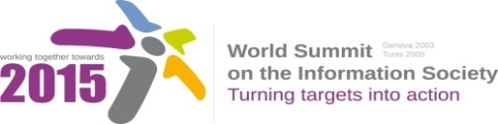
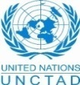
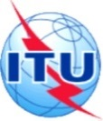
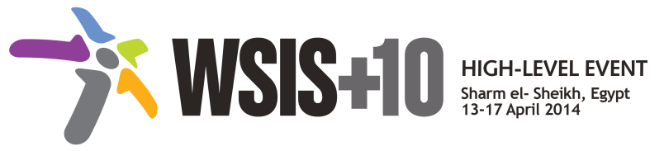
Document Number: V1/C/ALC7/E-Learning/8
Submission by Russian Federation, Government

Draft WSIS+10 Vision Beyond 2015

C7. ICT Applications: E-Learning

1. Vision
For the post-2015 era, we envision inclusive Knowledge Societies, in which e-learning will truly transform formal and non-formal education for all (EFA), will facilitate lifelong learning and global access to information and knowledge, it will help provide media, information literacy (21st century) and work skills and will offer a medium for expression and communication, allowing also to meet specific needs of all learners and to improve the effectiveness of administrative and planning tasks in education systems.
2. Pillars
- Develop enabling policies for ICTs in Education.
- Support the construction of new multiple literacies for the 21st Century for teachers and learners.
- Harness emerging technological innovations for teaching and learning, including open modalities and strategies (i.e. Open Educational Resources - OERs, Free and Open Software - FOSS, Massive Online Open Courses- MOOCS).
- Support the creation of relevant content in local languages, curriculum integration and assessment.
- Mobilize public and private funding to ensure that learners can benefit from ICTs and participate fully in Knowledge Societies.

3. Targets
- Every person can access and use ICTs for learning.
- Indicator: Percentage of population enabled to use ICTs for learning.

- Global monitoring of development for e-Education services and quality assessment for e-Learning.]
- Indicator: Global monitoring system of development for e-Education services.
- Indicator: Number of relevant structures covered by the monitoring.
- Indicator: Quality assessment system for e-Learning.

