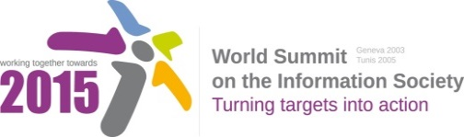
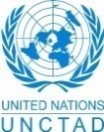
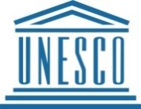
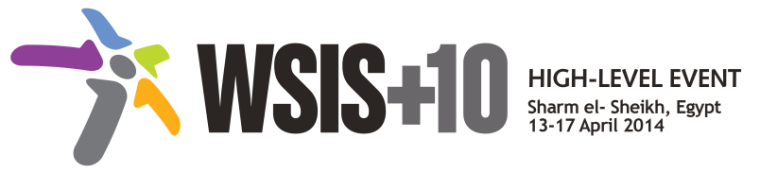
Document Number: V1/C/ALC7/E-Learning
Note: This Consolidated Text has been prepared by the UN Action Line focal points for review by WSIS Stakeholders. WSIS Stakeholders are invited to review this document, using track changes, and submit the document to wsis-info@itu.int by 17 November 2013 (non-extendable). The consolidated texts aim at building a vision upon the existing framework of Action Lines, identifying emerging trends, challenges and priorities for the new decade, without making the existing framework of Action Lines obsolete. The Geneva Declaration and the Geneva Plan of Action still remain valid until further decisions by the General Assembly.

Draft WSIS+10 Vision for WSIS Beyond 2015

C7. ICT Applications: E-Learning

1. Vision
For the post-2015 era, we envision inclusive Knowledge Societies, in which e-learning will truly transform formal and non-formal education for all (EFA), will facilitate lifelong learning and global access to information and knowledge, it will help provide media, information literacy (21st century) and work skills and will offer a medium for expression and communication, allowing also to meet specific needs of all learners and to improve the effectiveness of administrative and planning tasks in education systems.
2. Pillars
- Develop enabling policies for ICTs in Education.
- Support the construction of new multiple literacies for the 21st Century for teachers and learners.
- Harness emerging technological innovations for teaching and learning, including open modalities and strategies (i.e. Open Educational Resources - OERs, Free and Open Software - FOSS, Massive Online Open Courses- MOOCS).
- Support the creation of relevant content in local languages, curriculum integration and assessment.
- Mobilize public and private funding to ensure that learners can benefit from ICTs and participate fully in Knowledge Societies.

3. Targets
- Every person can access and use ICTs for learning.
- Indicator: Percentage of population enabled to use ICTs for learning.

Annex: Zero Draft Stakeholder Contributions
- Support the construction of new multiple literacies for the 21st Century, including digital, media and information literacies.
- Harness emerging technological innovations such as open modalities and strategies for using ICT for education (Open Educational Resources - OERs, Free and Open Software - FOSS, Massive Online Open Courses- MOOCS) to ensure recognized learning opportunities to ease participation in Knowledge Societies.
- Mobilize public funding to ensure that learners have access to ICT to participate fully in Knowledge Societies.
- Develop enabling policies for mobile learning including support for making affordable devices, content and connectivity more widely available and ensuring the professional development to teachers on the use of mobile technologies to support teaching and learning in mixed, face-to-face and/or distance modes.
- Promote the effective policies to support e-learning for all, ensuring the inclusion of marginalized groups and empowerment of women.
- Support the creation of relevant content in local languages.
- Train teachers in online e-learning platforms so they can profit from existing programs or they can create their own learning content and program, with a preference on open licenses (as OER).

- What are areas that have not been adequately captured by the framework of the existing 11 WSIS Action Lines and would need to be addressed beyond 2015? Please specify the Action Line you are providing an input for.
  - Investing and deploying ICT to support open strategies for education (OER, Open Access to scientific data, Free and Open Source Software, new online strategies for distance education (including MOOCs)
  - Development of an ecosystem for the safe use of mobile technologies for education, including teaching digital citizenship and responsible use.
  - Leveraging mobile technologies for greater reach and inclusiveness
  - Greater support to programs and systems aimed at marginalized and diasadvantaged groups.

