 |  | 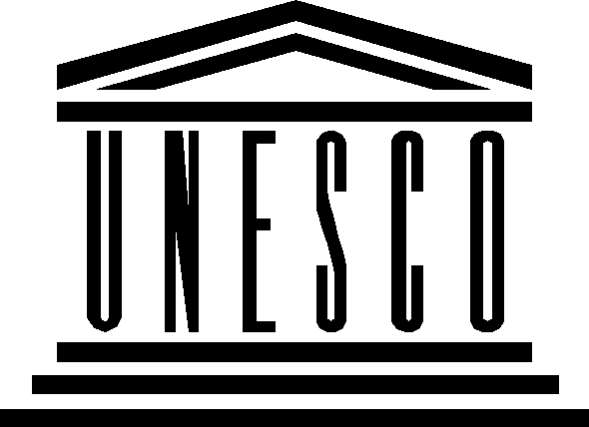 |  | 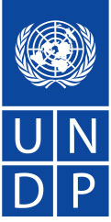
THIRD CONSULTATION MEETING OF WSIS ACTION LINE FACILITATORS
23 May 2008

FINAL REPORT

1. Welcoming remarks

The meeting was jointly chaired by Mr. Houlin Zhao, ITU Deputy Secretary-General, Mrs. Miriam Nisbet, Director, Information Society Division, UNESCO and Mrs. Radhika Lal, from UNDP. Mr. Zhao explained that the meeting had the following objectives:
- To exchange information among Facilitators and other stakeholders on the Action Line (AL) Facilitation.
- To improve the reporting modalities.
- To identify ways to improve the Action Line Facilitation process.

2. Approval of the Agenda

The draft agenda (ALFM/2008/1) was adopted as drafted. However, some discussions were held earlier in order to allow Mrs. Lal to catch her flight.

3. Report from WSIS Action Line Facilitators on activities and results since May 2007

Mr. Zhao invited all Action Line Facilitators to report on progress since 2007.

Mrs. Radhika Lal presented UNDP position as regard the WSIS process. She mentioned that UNDP’s new strategic plan focuses on regional and national coordination rather than global coordination. In that respect she informed that ITU agreed to take over the facilitation of Action Line C6. She also proposed that Action Line C4 be mainstreamed amongst the other Action Lines. This idea was supported by Susan Teltscher from UNCTAD. Mrs. Esterhuysen from APC proposed holding one day event on capacity building including on reporting from the different Action Lines.

Mrs. Nisbet (UNESCO) reported on activities undertaken under Action Lines C3, C7, C8, C9 and C10. She indicated that UNESCO tried to hold meetings as participatory as possible. UNESCO also sought to focus on key emerging issues such as low cost educational devices and diversity of software models.

Mrs. Masiello (FAO) reported on the C7 (e-agriculture) Action Line meeting. She mentioned that a virtual forum will be set up to discuss the themes raised during the meeting. This forum will complement the existing platform of discussion already created to facilitate the work under the Action Line. She underlined that the platform gathers around 4000 people.

Mrs. Nair-Bedouelle (UNESCO) reported on Action Line C7 (e-science). She stated that the meeting has been more successful than previous ones. During the meeting a special attention was given to “open access” as a means to access information for scientists in developing countries. Discussions included the roles of the funding bodies as well as governments and the evaluation procedures based on publications in high impact journals whose costs certainly disadvantage scientists from the developing countries. Participants also requested that the roles of facilitators be more clearly spelled out.

Gherardo Casini (UNDESA) reported on Action Lines C1, C7 (e-government) and C11. He mentioned that the meeting was an opportunity for the sub-groups identified two years ago (ICT for sustainable development and peace; national ICT strategies, e-governance and parliaments, e-participation; partnerships) to exchange information and experiences.

Mrs. Barayre (UNCTAD) reported on Action Line C7 (e-business) meeting organized jointly with ITC, ILO and UPU. The meeting addressed the issue of the contribution of electronic commerce to development and discussed successful e-commerce policies and strategies that facilitate the access of developing country SMEs to world markets, focusing on the harmonization of legal frameworks.

Mr. Behdad (ITU) reported on the outcomes of the C2 Action Line facilitation meeting. He stressed that the meeting was successful in bringing new people. One of the innovative features of the meeting was the organization of an “Ambassador Round Table” followed by a dynamic discussion with stakeholders.

Mrs. Sunberg (ITU) reported on the outcomes of the C6 Action Line facilitation meeting as ITU took over the lead facilitator’s role on this Action Line. She mentioned that the meeting allowed great interactions between all stakeholders. Participants recognized the importance of harmonization of legal and institutional environment both at the national and international level. The second part of the meeting focused on infrastructure sharing at the national and at the international levels, drawing major outcomes of the last ITU Global Symposium for Regulators, held in March 2008 in Thailand.

Mr. Levin (ITU) reported on the outcomes of Action Line C7 (e-environment) meeting. ITU took the main role in organizing this meeting. New emerging issues were discussed such as climate change and the role of ICTs. The meeting was an opportunity for stakeholders to present their initiatives. The web site will be improved to include a list of projects and information about best practices. UNEP confirmed that they should take the main facilitator role in the future.

Mr. Rivera Giraldo (ITU) informed participants about the Action Line C5 meeting. He mentioned that the first day consisted of multi-stakeholders panels composed of World renowned Cybersecurity experts. The panels were followed by open and dynamic discussions with participants. The second day was dedicated to stakeholders’ presentations on key initiatives.

In general, it was noted that Action Line facilitators should collect information from all stakeholders and not report only on their own activities.

Reports on Action Line Meetings were followed by some intervention from the floor.

Mrs. Pluchon, from ITU Secretariat presented data on the participation during the 2008 cluster of WSIS-related meetings. As of 22 May 1182 participants were announced. 490 received a badge (409 at ITU and 87 at UNOG). Amongst the 403 people who received a badge at ITU, 118 came from governments; 95 from he UN or Specialized Agencies; 56 from the private sector, 81 from NGOs and 27 from other entities (University, research institute). 26 people also registered for the HLEG meeting.

4. Report on WSIS stocktaking exercise

Mr. Ponder informed briefly participants about the publication of the new report on the WSIS Stocktaking 2008.

5. Ways to improve reporting on Action Line facilitation

This item was not discussed in detail, due to lack of time.

6. Way to strengthen the Action Line Facilitation process

The general discussion highlighted an overall consensus to improve the Action Line Facilitation process. There was a general agreement on the following proposals:

- The Cluster of WSIS-related events would be concentrated in one week with a few plenary sessions at the beginning and at the end of the week as well as parallel sessions in between. The naming of the Cluster of WSIS-related events could be changed to be more appealing and to clearly express the objectives of the meetings. Proposed names included “WSIS Implementation conference” (proposal from UNCTAD) or “the information Society forum” (proposal from ENSTA).
- The Cluster of WSIS-related events could concentrate on a number of themes and not necessarily on Action Lines.
- The cluster of WSIS-related meetings could be organized at global level as well as at regional level, with greater involvement of the UN Regional Commission as recommended by the ‘Tunis Agenda for the Information Society’ (art 101).
- Each Action Line is encouraged to set up a steering Committee. A global steering committee including the different constituencies could also be established.
- An open web platform on reporting should be set up.

The following decisions have been reached:

- The next cluster of WSIS-related meeting will be held in May 2009 in Geneva.
- An open consultation meeting will be held to organize the 2009 events.
- All WSIS stakeholders will be invited to the open consultation meeting
- ITU, UNESCO and UNDP will coordinate the preparation of the open consultation meeting.
- The participants of this meeting are invited to join the preparatory process

7. Future actions and next meeting

A report of the meeting will be made available on the WSIS web site and will be open for comments. The report will also be conveyed to the next UNGIS meeting.

