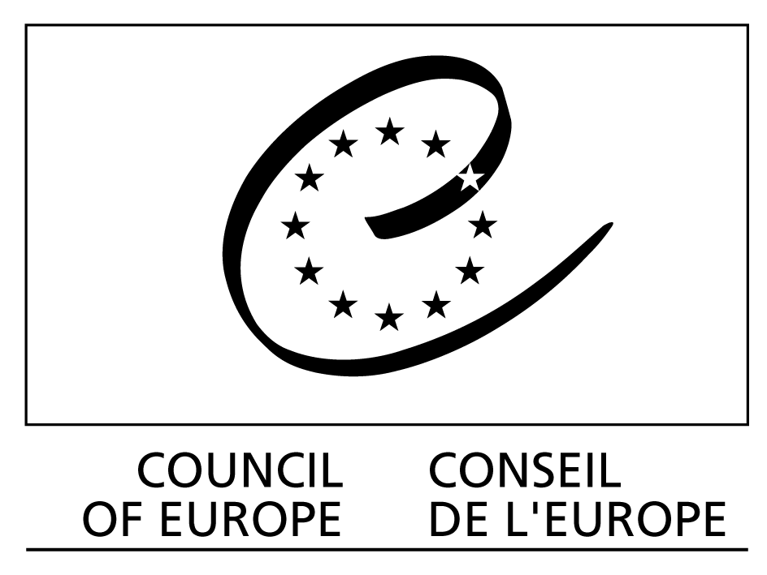

Roundtable

THE INTERNET AND PUBLIC SERVICE :
DO THEY GO TOGETHER?

24 May 2007, 13:30 – 14:50

Room K1/K2,
International Telecommunication Union, Montbrillant building,
2, rue Varembe, Geneva

Agenda

13:30 Opening by the Council of Europe: Lee Hibbard, Media and Information Society Division.

13:35 Karol Jakubowicz: ""The Internet as a public service for the citizen: what role for the state?".

13:50 Roundtable discussion, moderated by Mr Christian S. Nissen.

14:10 Christian S. Nissen: “Public Service Broadcasters in the new online territory: from swords of conflict to ploughshares of co-operation.

14:25 Roundtable discussion, moderated by Mr. Karol Jakubowicz.

14:45 Concluding comments and remarks.

14:50 Close.

Council of Europe and the public service value of the Internet

Everyone should be entitled to expect the delivery of a minimum level of Internet services (for example effective and affordable access, a suitable environment for businesses to operate, etc.) irrespective of both the architecture of the World Wide Web (infrastructure, accessibility, interconnectivity) and the arrangements concerning its construction and development, with regard to the rules or principles that apply – or ought to apply – to the Internet’s use (such as freedom of speech and of association, right to private life and correspondence, consumer protection, security, crime-prevention).

The effective delivery of Internet services of public value requires offering access in a range of appropriate languages (that is, including non-ASCII characters) and with suitable tools for all types of user (for example technical means or assistance allowing persons with disabilities full and effective access to such services).

There are a number of services which are already, or will be, provided directly by states through the Internet with respect to, for example, initiatives concerning e-government, education and culture, as well as the use of the Internet to facilitate participation in public matters and democratic processes (e-democracy), the Internet as a means of eliminating inequalities (for example distance work for persons with disabilities), etc. Such initiatives are increasingly important as they aim to improve access to information by all, and enhance the opportunities for all, including people with disabilities, to participate in education and in political, cultural and social life. Participation and access to information are essential elements of democracy and citizenship, and it is a permanent duty of the state to facilitate them.
To ensure the delivery of public services by delegation, the state should facilitate and lead a multi-stakeholder framework within which the private sector can operate and, where necessary, should adopt measures to fill gaps left by private operators.

Council of Europe and public service media

In the context of digitisation, media convergence and emergence of the new communication means, the Council of Europe is concerned with the need to safeguard the fundamental objectives of the public interest in the information society, including freedom of expression and access to information, media pluralism, cultural diversity, and the protection of minors and human dignity. The Organisation is convinced that the public service remit should continue to be relevant in the information society and that it can be discharged by public service organisations via diverse platforms and an offer of various services, resulting in the emergence of public service media.

This is why, in its Recommendation Rec(2007)3 on the remit of public service media in the information society (adopted on 31 January 2007), the Committee of Ministers of the Council of Europe encourages its 47 member states to guarantee the fundamental role of the public service media in the new digital environment, setting a clear remit for public service media, and enabling them to use new technical means to better fulfil this remit and adapt to rapid changes in the current media and technological landscape, and to changes in the viewing and listening patterns and expectations of the audience.

Public service media should be able to make full use of their potential and especially to promote broader democratic, social and cultural participation, ensuring that universal access to their programmes and services is offered to all individuals and social groups, including minority and disadvantaged groups, through a range of technological means. For this purpose, member states should ensure that the specific legal, technical, financial and organisational conditions required to fulfil the public service remit continue to apply in, and are adapted to, the new digital environment.
***
Mr Christian S. Nissen began his career as associate professor in international politics, University of Copenhagen and has worked in different management positions in the Danish public administration and institutions (the Ministry of Environment, the Ministry of Finance, The National Museum of History and the National University Hospital). In the period 1994 – 2004 he was Director General of the Danish Broadcasting Corporation (DR) and chairman of the EBU, Digital Strategy Group. Since 2004 he has been independent advisor and lecturer in media and management and is adjunct professor at the Copenhagen Business School. Author/editor of articles and books on international politics, public administration and media. Web: www.christiannissen.com.
Mr Karol Jakubowicz, Ph.D., was until recently Director, Strategy and Analysis Department, the National Broadcasting Council of Poland, the broadcasting regulatory authority, and Chairman of the Steering Committee on the Media and New Communication Services at the Council of Europe. He has worked as a journalist and executive in the Polish press, radio and television for many years. He has been Vice-President, Television, Polish Radio and Television; Chairman, Supervisory Board, Polish Television and Head of Strategic Planning and Development at Polish Television. He has been active in the Council of Europe, in part as former Chairman of the Committee of Experts on Media Concentrations and Pluralism, Chairman of the Standing Committee on Transfrontier Television. He was involved in developing the 2005 Declaration of the Council of Europe on human rights and the rule of law in the Information Society.
He has been involved in policy-making and regulation in the field of broadcasting in Poland and internationally, in part through his contribution to writing Poland’s Broadcasting Act of 1992, and its subsequent revisions, and to the revision of the European Convention on Transfrontier Television in 1998, as Poland’s representative to the Contact Committee, created on the basis of the “Television Without Frontiers” Directive, and as an expert participating in two focus groups, dealing with selected aspects of the revision of the ““Television Without Frontiers” Directive. As a Council of Europe, UNESCO, European Union and OSCE expert, he has taken part in many missions to advise on the development of broadcasting legislation in a number of countries and has written analyses of drafts or existing broadcasting laws in many countries.

http://www.coe.int/t/e/human_rights/media/Links/Events/1IGFAthens2006Homepage_en.asp#TopOfPage.
The Council of Europe has always paid a particular attention to the public service broadcasting and established a number of principles and standards in the field. Relevant in this connection are for example, Recommendations No. R (96) 10 on the guarantee of the independence of public service broadcasting, Rec(2003)9 on measures to promote the democratic and social contribution of digital broadcasting, or its Resolution No. 1 on the future of public service broadcasting adopted at the 4th European Ministerial Conference on Mass Media Policy (Prague, December 1994), as well as its Declaration on the guarantee of the independence of public service broadcasting in the member states (September 2006).
http://www.coe.int/t/e/human_rights/media/1_Intergovernmental_Co-operation/MC-S-PSB/2hinf(2006)003_en.pdf

