 |  | 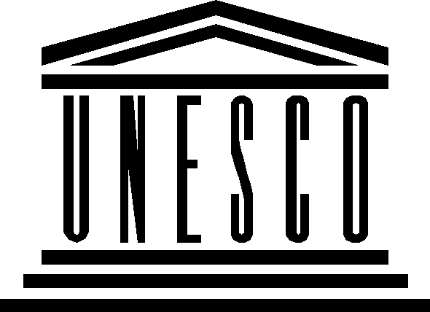 | 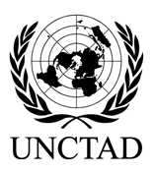 | 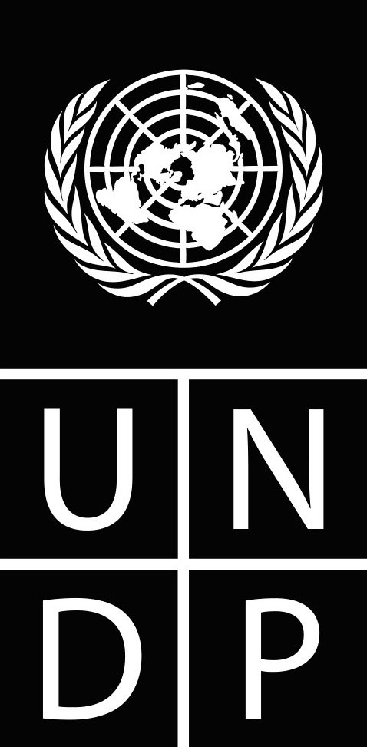
OPEN CONSULTATIONS: WSIS FORUM 2010

Expression of interest

Overview of Submitted Contributions

The purpose of this document is to provide a brief overview of contributions submitted. Please note that this document is a compilation of extracts from the contributions, and serves as a document that provides only a quick overview for your convenience and is not an exhaustive list.

No | Geographic Location | Entity | Topic
1 | Togo | CS | Increasing women’s access to ICTs in developing countries  Making IT Education and Training Available to Girls and Women
2 | Senegal | CS | ICTs and Human Rights
3 | Burundi | CS | Access to information and knowledge – libraries, archives and information centres
4 | Syria | GOV | ICTs and Disability
5 | Kenya | GOV | - Early childhood publishing in 3rd world  - Digital Libraries and villages  - Poverty Reduction and Gender Equity
6 | Gabon | GOV | Gestion de l\'information administrative, le Web 2.0 et les bibliothèques, la lecture publique en milieu rural et scolaire
7 | Paris | CS | Open Access to Scientific Information.
8 | Tunisia | CS | Space application for the building of information society in Africa.
9 | Nigeria | CS | - La problématique du développement des infrastructures à haut débit: cas de l\'Afrique Centrale  - la gouvernance de l\'Internet pour l\'accélération, la compétition et l\'innovation en Afrique
10 | Nigeria | GOV | - Women in ICT  - Effective implementation of ICT policies in developing countries.  - Convergence between traditional and new ICTs in Africa.
11 | Nigeria | BUS | E Security
12 | Switzerland | BUS | Security, Investment and Development if Information Technologies and Innovation in Communication Systems for Africa.
13 | Canada | IO | Translation of Publications
14 | Burundi | CS | - Impact de l\'information dans la réduction des conséquences aux effets des changements climatques;  - Les chagements climatiques et la malnutrtion avec corrélation l\'accès des populations rurales à l\'information
15 | Argentina | CS | Public Policies for Information Society
16 | Tunisia | GOV | Archives
17 | Benin | CS | - Use of ICTs to access basic services.  - e governance  - ICT in Education  - Low power advantage to develop ICTs
18 | UAE | IO | - Information Literacy 2.0: Empowering Literacies in 21st Century  - Social Networking; Sustainable online Community Development
19 | Bangladesh | CS | - ICT and Climate Change  - Community Radio/ media for climate change  - 3ICTfor the disables, print disabled.
20 | Gabon | CS | - Media for Rural Development  - Information
21 | Cameroon | CS | L\'entreprenariat féminin ET TIC
22 | Uganda | GOV | - Content dissemination through Community Radio  - Media solution to information gap – media needs to be strengthened.
23 | Nigeria | CS | - Enhancing IT infrastructure in Africa  - ICTs for youth and rural people
24 | France | CS | la cooperation decentralisee bilan perspective insertion des personnes handicapees par les tic centre de tele-travail reseau solidaire handicap et ntic
25 | Bangui | CS | The New ICTs: a source of peace and sustainable development.
26 | Madagascar | BUS | Information Access
27 | Pakistan | GOV | Rural Development Communication
28 | Ethiopia | GOV | How have ICTs played a crucial role
29 | USA | CS | Reliable up to date data and analysis on use of media- ICTs and personal communication.
30 | Peru | GOV | - PreservaciÃ³n del agua dulce fuente de la vida cÃ³smica.  - InversiÃ³n en el fortalecimiento de capacidades de los recursos humanos de las empresas prestadoras de servicios de agua potable y saneamiento saneamiento bÃ¡sico(EPS.)  - GestiÃ³n por competencias laborales de las EPS.
31 | Iraq (Kurdistan Regional Government) | GOV | - E-Government practices and lessons learned  - ICT in Disaster  - Opportunities for ALL: A PC for each Person.  - Building reliable ICT infrastructure  - Standardization ICT and Leadership
32 | Gabon | CS | - l\'accès aux TIC aux populations vulnérables  - l\'accès des enseignements et ressources informationnelles aux apprenants dans les pays du sud  - les collectivités locales et les TIC  - Les TIC et la lutte contre le VIH
33 | Ethiopia | IO | Gender and ICTs
34 | Albania | GOV | Networked Education
35 | Venezuela | IO | - Digital Interactive Contents in the Latin American and Caribbean Context  - Specific issues on Library and Information Policies for Latin American and Caribbean countries  - Personal Data Protection - Legal Framework with a focus on Latin America
36 | Burkina Faso | CS | Je suis magistrat de mon Etat et j\'aimerais aborder les questions relatives à l\'existence où non de règlementations fiables dans le domaine des technologies de l\'information et de la communication dans mon pays. La principale question à laquelle j\'apporterais des éléments pertinents de réponse consistera à faire l\'état de la jurisprudence en la matière. Ce qui permettra d\'avoir une vue comparative de la pratique judiciaire dans mon pays par rapport à la jurisprudence d\'autres pays notamment celle des Etats africains
37 | Pakistan | CS | 1) The Iran–Pakistan–India gas pipeline  2) Trust is two-way Street
38 | Germany | CS | Information Ethics in Africa
39 | Colombia | GOV | Best practices and lessons learnt in developing and implementing e Government National Strategies.
40 | New York | IO | Indigenous Peoples and WSIS
41 | Togo | CS | Internet for developing countries
42 | France | IO | Les actions menées para différents acteurs en matière de multilinguisme dans le cbyerespace (ligne C8 de l\'agenda de Tunis): Union latine, Maaya, Funredes, la Coalition dynamique, etc. Ces actions tendent à faire de la promotion (livre en préparation sur les enjeux de la diversité linguistiques dans le cyberespace), de la réflexion (rencontres de Bamako [Maaya-Acalan], de La Havane [Maaya-Union latine], de Barcelone [Maaya-Linguamón], de Lisbonne [gouvt. portugais-Union latine], ainsi que de l\'action sur le terrain (formation, création d\'alphabets, création de terminologies, normatives, etc.)
43 | Uganda | CS | Community Radio
44 | Iran | GOV | Ethical implication of the information society/ E-learning/ Cultural diversity and identity/ Internet governance/Access to information
45 | Bangladesh | CS | E- Health
46 | INT | BUS | Establishing an eSourcing Strategy for SMEs in an ICT environment.
47 | INT | BUS | Role of IT and virtual blogs in improving the work of organizations: the exchange of data via IT is necessary to achieve our goals.
48 | Tunisia | CS | ICTs for Scientific Capacities buildings
49 | INT | BUS | The purpose of the annual Action Lines meeting, organized by the moderators/facilitators should continue to focus on providing an important and relevant space for tangible reports of activities that are fulfilling the Action Lines, as established by the Tunis Agenda for the Information Society. Perhaps it would be useful in this fourth set of meetings to focus in on \"making progress\" within each of the respective Action Lines.
50 | Mali | IO | NOUS SOMMES DES JEUNES UNIVERSITAIRE RESSORTISSANT DE TOMBOUCTOU POUR LE DEVELOPPEMENT DE L\'EDUCATION AU MALI
51 | Brazil | GOV | Indigenous access to University
52 | INT | CS | Use of ICTs for balanced development, participation of communities/ civil society in policy and strategy development and implementation of initiatives.
53 | INT | GOV | Indegineous People and Information Society
54 | France | CS | 1) Cross Network Synergy (XNS)  Cross Network Synergy is a decisive tool for Innovative Financing Mechanisms. It makes the most of interactions between networks of different nature in a given space, saving investment costs for building an ICT/Telecom network, and earning revenues through cross-fertilization along with the use of cooperative networks.  2) Creating a multistakeholder based Forum for Financing Mechanisms (FMF), following the example of the Internet Governance Forum (IGF), except it will be in capacity to working out recommendations to CSTD and UNGIS.
55 | France | CS | 3) ITU has been entrusted by the World Bank to carry out a feasibility study of a african (terrestrial) backbone network. In this framework, ITU will present the guidelines and network principles and concepts so far devised, during the AL C2 WSIS Forum meeting in may 2010. In particular, the ITU will tell the audience how it intends to make largest use of Cross Network Synergy (XNS) for designing and building this backbone network.  4) Setting up a Study Group (SG) dedicated to Energy and ICT relationship.  ITU should set up a new Study Group, common to its Development Bureau and its Standardization Bureau, dedicated to the relations linking ICT and renewable energie sources, in particular photovoltaics, and to providing energy saving interfaces between powering and ICT/Telecom devices especially for DCs.
56 | New Zealand | CS | Indigenous people and Internet Governance
57 | Sudan | CS | - ICTs for the disabled  - Telecentres
58 | France | GOV | * développer la culture professionnelle des professeurs certifiés en documentation exerçant dans les CDI en affirmant leur rôle d’enseignant dans la formation des élèves. Elle contribue à la construction de l’identité professionnelle et à la formation initiale et continue ;  * contribuer au développement des CDI (bibliothèques en milieu scolaire) et des applications des nouvelles technologies dans cet espace. Elle favorise la prise en compte des pratiques informationnelles des jeunes dans leur formation. Le CDI est le point d’accès et de formation à l’information et au savoir dans les établissements scolaires français ;  * œuvrer à la reconnaissance, auprès de l’institution, d’une formation des élèves à l’information et aux médias inscrite dans les programmes, assurée par les professeurs documentalistes en collaboration avec les enseignants des autres disciplines.
59 | Mali | CS | Organisation, in 2013, of a World Summit on Linguistic Diversity and Multilingualism.
60 | Mal | CS | Supporting Indigenous Knowledge through ICTs
61 | Switzerland | CS | Multilingual Internet, Inclusion of New Languages in the Digital World, Multilingualism in Countries with a Major Language, Ensuring financial sustainability to multilingualism could be discussed during WSIS
62 | Switzerland | IO | 1.IFIP AGora initiative on Lifelong Learning  2.Living Labs Methodology : Mastering changes and promoting Innovation  3.e-inclusion and e-participation
63 | Italy | IO | e-Agriculture action line facilitation meeting: the role of ICT in rural development. (e-agriculture is was a WSIS action line C7 follow up activity.)
64 | USA | BUS | The WSIS Action Lines Forum is an excellent opportunity for stakeholders to share their particular experiences with action lines implementation. It would be most useful for the meetings to focus on specific projects and initiatives as well as their success in implementing the outcomes of the WSIS and their corresponding action lines areas. The WSIS Action Lines Forum meetings are the time and place to exchange best practices, measure progress and build productive partnerships to achieve the action lines goals; this opportunity should not be wasted on lengthy policy discussions that are already conducted in other forums. We believe that a focus on Confidence & Security in the use of ICTs, E-health, and Cultural and Linguistic diversity and local content would be timely and useful to participants
65 | Argentina | CS | The ACTION LINE C10: Ethical dimensions of the Information Society as a line of work in all lines of Action exposed.
66 | Pakistan | GOV | Human Resource Development for information service providers, libraries, and Museums, for library professionals of developing countries, in line with the international information patterns
67 | Spain | CS | - Information Society like a subject in the School  - From Information Society to Knowledge Society, the Open Science
68 | Sudan | CS | - ICT for the Disabled  - Telecentres
69 | USA | CS | Developing Digital Media through Indigenous Cultures  See draft at  http://www.nmacs.org/CRobbins-digital-Indigenous.pdf
70 | France | GOV | It is important for the WSIS Forum to not duplicate the policy issues regarding the Internet that are being addressed by the Internet Governance Forum (IGF) and to focus on the part of the WSIS Geneva Plan of Action that relate to actual projects. Suggestions for main themes are :  - Connectivity, and in particular : Mutualization of infrastructures  - Access to information, particularly in the domain of scientific information (open access projects)  - Capacity building : ICTs in education and education to ICTs (including gender issues)  - Use of ICTs for development and everyday life, focusing on topics that are less addressed than others (for example: use of satellite imaging for agriculture, disaster prevention, e-health, etc...)  - ICT and environment : both relation to climate change (positive and negative) and the challenge of e-waste
71 | Canada | IO | ICTs for Indigenous people
72 | Palestine | INT | e Health
73 | Indonesia | CS | - Access to Information  - Democratization of broadcasting in Indonesia - availability of frequencies  - Community Media and Community Radio
74 | Vienna | CS | - Health  - cultural and linguistic diversity and local content  - confidence building  - information security
75 | Greece | CS | ICTs for the Aged
76 | Burkina Faso | CS | Je suis magistrat de mon Etat et j'aimerais aborder les questions relatives à l'existence où non de règlementations fiables dans le domaine des technologies de l'information et de la communication dans mon pays. La principale question à laquelle j'apporterais des éléments pertinents de réponse consistera à faire l'état de la jurisprudence en la matière. Ce qui permettra d'avoir une vue comparative de la pratique judiciaire dans mon pays par rapport à la jurisprudence d'autres pays notamment celle des Etats africains.
77 | Ghana | BUS | Ghana Database Organization (Ghana Online Contents and Database Website WWW.GHANADATA.ORG)
78 | France | CS | Information Literacy
79 | France | CS | Gamet
80 | France | CS | - E Health  - Cultural and linguistic diversity and local content  - Building confidence and security in the use of ICTs
81 | Saint Lucia | CS | Promotion, Protection and Transmission of Traditional Knowledge and Traditional Cultural Expressions of Indigenous Peoples and Local Communities of the 14 Member States of the CARICOM.
82 | Cameroon | CS | - L’impact de l’éducation des filles sur les taux de VIH  - Donner Plus De Soutient Aux Institutions Bancaire.
83 | Uganda | Govt. | - ICTs and Climate Change  - ICTs and Inclusive Development
84 | Switzerland | IO | 1. Hors-série : Pré-étude pour un Living Lab « e-Inclusion » : http://www.ict-21.ch/com-ict/spip.php?article87.  2. IFIP AGORA Initiative on Lifelong Learning: http://www.ifip-tc3.net/article.php3?id_article=146  http://www.ifiptc3.net/rubrique.php3?id_rubrique=50  3. The Bento Gonçalves Declaration for Action WCCE 2009 IFIP TC3 http://www.ifip-tc3.net/IMG/pdf/BGDeclaration.pdf  4. other themes like e-governance, e-democracy, e-inclusion, e-participation are possible to present from our actual work  http://www.ict-21.ch/com-ict/IMG/doc/COM-ICT-Diffusion-publications-15a20-dec2009.doc
85 | Tanzania | Govt. | WSIS Plan of Action Line C5; Building confidence and security in  the use of ICTs:  “Secured on-line environment for all: Best practices to suite the environment of developing countries”
86 | Gabon | Govt. | - Augmenter la confiance au niveau d e sécurité dans l’utilisation des NTIC,  - Internet pour tous par la réduction de la fracture numérique notamment en favorisant la promotion du recours à l’internet dans les pays pauvres.  - Suivi et évaluation des effets néfastes des TIC dans un processus d’amélioration continue de sa perception par les utilisateurs  - Respect de la diversité culturelle en adaptant des possibilités offertes aux réalités locales dans une logique de localisation de l’internet  - Bonne gouvernance internet : renforcement du contrôle éthique de la libre expression
87 | India | Govt. | 1. Information Society and Marginalized Sections- Bridging the Gap  2. Admittance of Digital Opportunities for fostering Sustainable Growth and Poverty Reduction
88 | Mexico | Govt. | - Best practices reducing digital divide  - The role of the creation of capacity building and training Community connectivity indicators  - The provision/promotion of connectivity  - Ownership for the users/Inclusion/appropriations  - Electronic commerce and cyber-secutiry  - The Internet Governance Forum
89 | USA | IO | Continuation of the Global Cybersecurity Agenda with particular emphasis on initiatives to promote (1) harmonization of the global legal framework on cybercrime, (2) improved international cooperation, and (3) mechanisms for international information sharing between public and private sectors. The spike in cyber criminal activities and the inability of governments and law enforcement to track and trace these activities and prosecute those responsible is threatening to undercut the very benefits of the Internet. We now have a Security Divide, with many developing countries having no cybercrime laws at all or procedural provisions to assist in efforts to counter cybercrime. A global 24/7 point of contact network needs to be established (the G8 network still only has about 60 countries signed up, which does not help much when there are 260 countries and territories on the Internet). Training for public and private sector entities in tracking and tracing needs to be provided to all developing countries and principles for international cooperation need to be agreed upon. The ITU Toolkit for Cybercrime Legislation and the ITU Toolkit for Critical Infrastructure Protection should be deployed to address gaps in legal frameworks and the protection of critical digital assets. There should be a sharper focus on cyber conflict, its implications and potentially disastrous consequences, and its inherent legal challenges. Especially, there should be discussion on the linkage between cybercrime and cyber warfare and discussion on the Erice Declaration on Principles for Cyber Stability that was adopted by the World Federation of Scientists in August 2009 and distributed to ITU member countries by Secretary General Toure
90 | Nepal | CS | - WSIS Forum 2010 need to address, ICT is important component for poverty reduction, human rights, minority rights to collect information from community and dissemination  - ICT will play important role to create international pressure on government to implement international convention e.g. CERD, CEDAW, etc. because in this 21st century, people are in caste discrimination situation in South ASIA countries-India, Nepal, Bangladesh, Pakistan, Bhutan  - This forum need to address climate change and its impact on poor people in developing countries like in south ASIA.
94 | Columbia | Govt. | Best practices and lessons learned developing and implementing e-Government national strategies
95 | Tanzania | Govt. | Information Literacy Education and Society
96 | Congo | Govt. | «BIEN S’INFORMER DANS LA VILLE GRACE AUX TIC AUX MOYENS DES MEDIAS»  Les Initiatives en matière d’éducation voient dans les TIC un instrument efficace d’apprentissage et d’expression. La difficulté à laquelle on se heurte est d’ouvrir à tous l’accès aux TIC et de développer leur utilisation afin de renforcer l’éducation de base. Il est vrai que le recours croissant aux TIC «pourrait contribuer à creuser les inégalités, fragiliser les liens sociaux et menacer la cohésion sociale ». Ce dilemme se retrouve aussi dans les progrès de l’alphabétisation et de l’éducation relative au développement durable quand le contexte local est sensible: il inclut aussi la question de savoir comment conjuguer l’utilisation des TIC avec les instruments traditionnels d’apprentissage (papier et stylo, craie et parole, par exemple). C’est là un domaine dans lequel il faudrait faire cause commune en sollicitant fermement l’avis des populations locales sur la manière d’utiliser les TIC.  Les journalistes et les organismes de médias ont un rôle important à jouer en rendant compte des problèmatiques, et en sensibilisant l’opinion publique aux diverses usages des TICs pour bien vivre dans les villes et villages. Leur participation peut contribuer à renforcer l'accès à l'information, à la communication et à la connaissance, ainsi qu’à l'accès aux savoirs-faire et aux compétences nécessaires pour l'usage efficace des TIC dans le cadre de leur vécu quotidien. Ceci peut inclure, par exemple, la production des émissions de radio et de télévision avec du contenu local et sur des thèmes tels que « la consultation météo online » pour prévenir son mode d’habillement de la journée. les TIC occupent une place centrale dans les économies du savoir, où la richesse est générée par le transfert et l’utilisation de l’information selon des modalités plus économes en ressources naturelles
97 | Kenya | Govt. | - Internet Security: How can the global community collaborate to deal with Internet security, especially cyber security and security of the Domain Name System (DNS) - A focus on national Computer Emergency Response Teams (CERTs);  - Regional Internet Resource Management: The role of governments as a key consumer of Internet resources;  - Enhancing the IGF: Empowering national/regional Internet Governance Forums (IGFs) in order to identify and facilitate awareness creation of key Internet governance issues at the national/regional level;  - Internet for Development (I4D): How can we harness the potential of the Internet for the purpose of development.
98 | Secretariat of the Pacific Community and Pacific Islands Chapter of the Internet Society | Govt. | - Internet Governance and what it means to the Pacific Island Countries and Territories  - Pacific ICT Policy  - Capacity building programs, scholarships, fellowships, internships – working with ICT organisations etc  - “Internet Access and Connectivity” –Openness and Security  - Access – for persons with disabilities, for women and youths  - Emerging Issues  - Diversity  - Disaster Management  - E-agriculture  - Telecentres  - Women and ICT (Gender and ICT)  - Youth and ICT

