 |  | 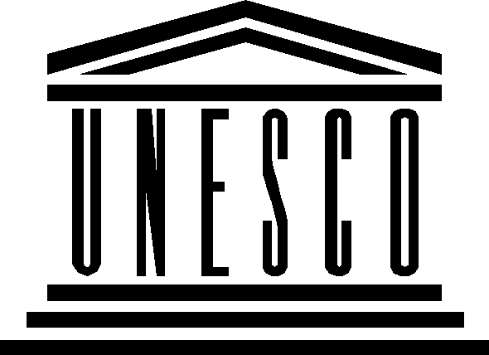 | 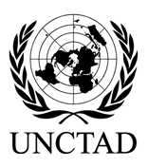 | 
OPEN CONSULTATIONS: WSIS FORUM 2010

Expression of interest

ITU Headquarters, Room H
10 February 2010, 14:30-18:00
Draft Agenda

- Opening ceremony
  - ITU, UNCTAD, UNESCO
- Briefing on interim results of the Open Consultation Process
  - Phase One: Online Discussion (UNESCO)
  - Phase Two: Submission of the Contributions (ITU)
- Open discussion
  - Topics
  - Other suggestions

