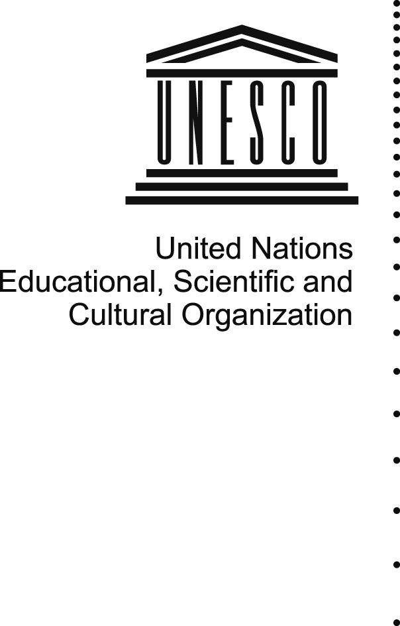
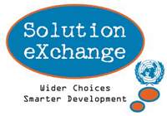

Agenda
2:30 – 3:15 | Plenary Session  UNESCO’s Commitment: Use of ICTs as an Enabler for Development (South Asian Perspective): Ms. Iskra Panevska, Adviser for Communication and Information, New Delhi Cluster Office  E- Governance in India: An Overview: Ministry of Communication and Information Technology, Government of India  Knowledge Management (UN Solution Exchange): Role in ICTs for Development: Mr Rajen Varada, Moderator and Resource Person, ICTD Community, UN Solution Exchange.
3:15-- 4:20 | Session 1- Introductory Session to Policy Issues , Challenges and Achievements  Introduction and Background to Session: Ms Gitanjali Sah , Research Associate, ICTD Community, UN Solution Exchange  - E-Governance in India: Presentation of Case Studies: Department of Information Technology, Ministry of Communication and Information Technology, Government of India  - Website & Content Accessibility: Developing Countries DAISY Consortium.  - Emerging Technologies for Development in India: Presentation from Private Sector
4:20 – 5:00 | Session 2 -Interactive Session with Expert Guest Panelists: Discussion and Experience Sharing  Session Moderator : Ms. Iskra Panevska, Adviser for Communication and Information, New Delhi Cluster Office  - E Governance in India  - Website & Content Accessibility  - Emerging Technologies for Development in India  Guest panelists will include experts from the Government, Academia, Civil Society and Corporate Sector.
5:00 – 5:30 | Presentation of Outcomes from each session  Conclusion
ICTs for Development in India: Opportunities and Challenges
By UNESCO, Communication and Information Unit: India
21 May 2009, 14:30 - 17:30
ITU Headquarters, Room B1

For further details please contact Mr. Rajen Varada r.varada@unesco.org and Ms. Gitanjali Sah g.sah@unesco.org

