
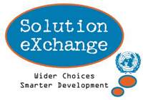
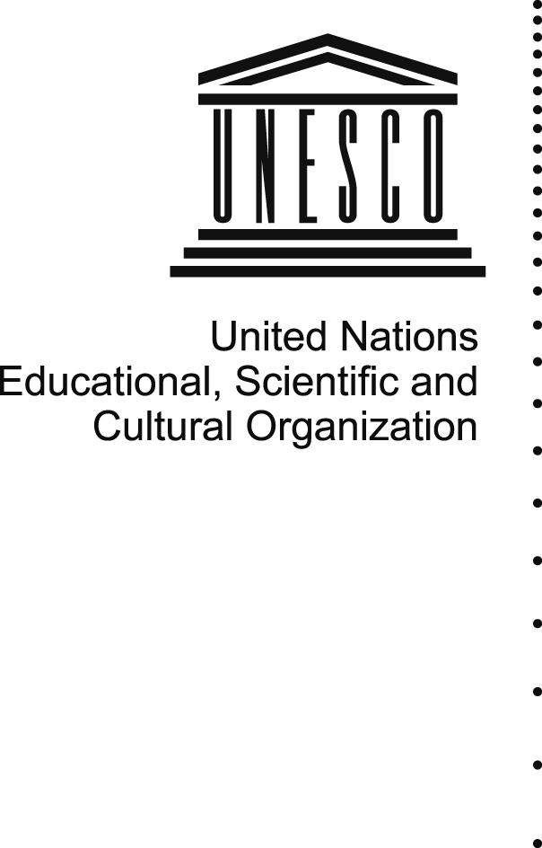
PRESS NOTE

India has taken a long stride in recent years in all relevant areas of Information and Communication Technology, including its adoption, implementation, human capacity building and citizen-centric governance. ICT has been institutionalised as an enabler to reach the so-far un-reached or under-reached hinterland, for the purpose of governance and service delivery. Government of India has taken up a large number of new initiatives in ICT which are expected to result in a direct and positive outcome for inclusive development for the large weaker sections of the communities, through empowerment, better livelihood and employment generation. ICT has thus been taken as the most effective tool to enable the under-privileged sections of the society to get into the main stream of development.

Achievement of India in the area of ICT has already earned recognition of the entire world. In order to look inwards now, significant resources have been mobilised in recent years to proliferate ICT education and education through ICT at all levels of structured learning. National Knowledge Network is being built in phases, to connect all premier academic and research institutes in India so that innovative research outputs are shared more effectively. Large converged secure wide area networks are being established all across the country to facilitate the government-to-government and government-to-citizen services and vice-versa. Implementation of a comprehensive multi-billion dollar National e-Governance Plan is underway with around 30 Mission Mode Projects across the central and the state governments. An all-encompassing citizen service delivery scheme of setting up more than 100,000 Telecentres with associated state-level Data Centres one in each of 35 States and Union Territories, would create world’s largest league of broadband-enabled service delivery outlets, located in one of every sixth villages of six hundred thousand villages in the country. While formulating the developmental projects with significant ICT-enabling, adequate care has been taken to address the issues related to achieving the MDG goals

India is thus committed to make best use of ICT to provide information and services to its people which leads to knowledge and knowledge leading to empowerment for better choice of the lives of its citizens

INDIA SESSION AT WSIS 2009
A session on ICTs for Development in India: Opportunities and Challenges will be held on the 21st of May 2009 from 14:30hrs - 17:30hrs. An Indian delegation comprising of the Government of India, UNESCO, Academicians and Civil Society Organizations will provide an overview of the ICTD and e Governance initiatives in India.

The DIT, Government of India will provide an overview of its National e Governance Plan. The session will discuss Accessibility, Content and Technologies with specific
context to the opportunities and challenges .

Various programmes and projects of the Government, UNESCO and Civil Society Organizations aim at leveraging the Millennium Development Goals (MDGs) through ICT tools, case studies from the grassroot focussing on Education, Livelihood and Health will be highlighted in the session .

___________________________________________________________

