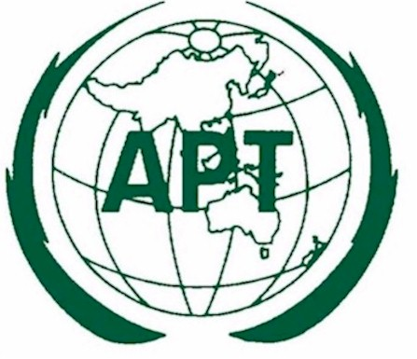 | APT- ITU MEETING ON  “ROLE OF ICT FOR DISASTER REDUCTION”  Bangkok, Thailand  28 February 2005

THE ROLE OF ICT FOR DISASTER WARNING AND RELIEF

Introduction

- The tsunami triggered by the recent 26 December 2004 huge earthquake off the coast of Sumatra in the Indian Ocean brought death and destruction on an unprecedented scale in a moment of time. We would like to express our sympathy and condolences to the disaster victims and afflicted areas.

- This catastrophe moved APT Members to come together to learn from this experience and to exchange views on what role ICT plays in mitigating the effects of such disasters. The members also shared recognition of the importance of the role of ICT.

- APT Members, through the exchange of opinions expressed at the meeting, affirmed that ICT plays an important role in 1) early disaster prediction, 2) communicating and dissiminating disaster information to residents as promptly as possible, and 3) ensuring a speedy communication system after a disaster occurs, as well as recognizing the importance of the diffusion of disaster relief telecommunications system in the Asia-Pacific region.

Summary of views and experiences from disaster events

- When disaster events occur getting the best out of high technology based telecommunication systems and infrastructure requires national, regional and international cooperation.

- The occurrence of disaster events cannot be prevented but their impact can be reduced by preparing appropriate advance operational plans, establishing warning systems, training emergency response personnel, educating citizens and testing emergency procedures.

- Systems for emergency warning and disaster relief need to make use of existing telecommunication and radiocommunication systems as well as new applications of existing broadcasting, amateur, mobile, satellite and fixed services in setting up warning systems and to provide information response systems.

- Responses to large disaster events are likely to involve a large number of relief agencies and relief teams which create severe pressure on requirements for interoperability and cooperation including frequency coordination of radiocommunication systems. Harmonised frequency use has been identified as one approach that leads to improved interoperability.

Attention was also drawn to the relevant activities within the three sectors of the ITU and APT programmes. The need for member countries to participate actively in the studies currently underway on public protection and disaster relief within the ITU and the APT was emphasised.

The way forward

Based on this recognition and experiences the meeting confirmed the following:

- Recognizing that ICT can play a significant role in disaster management including communicating and transmitting information for disaster relief, early warning, risk reduction, etc. to residents as well as gathering information necessary for disaster relief and reconstruction, member countries are urged to promote actively the utilization of ICT in case of disaster, such as strengthening the existing mechanism of a disaster relief telecommunication network/system and developing new systems including, in particular, the wireless communications system for disaster relief, which is useful in case of a disaster.

- Acknowledging the importance of cooperation for disaster relief between national and local governments, disaster management using ICT including developing a disaster relief telecommunication network system that enables smooth information transmission among the central government, disaster prevention-related agencies, local municipal entities, and hospitals, schools and other public institutions as well as developing a disaster relief management mechanism under related organizations needs to be pursued vigorously.

- Recognizing the importance of cooperation among the member countries to work together to tackle disaster management in the Asia Pacific region, as many opportunities as possible need to be provided to enable APT members to exchange views on disaster relief telecommunications systems and share information and experiences among the member countries.

- Building a disaster relief telecommunications system appropriate to the characteristics of each country, positive measures need to be taken to help member countries such as promoting human resources development through the implementation of training courses and providing support in the construction of a system by dispatching technical experts.

- Taking into account the effectiveness of ICT for disaster relief, cooperation among the members for sharing information on regional and international level needs to be further promoted.

- Recognising that telecommunications systems must be accompanied by a high level of community awareness in order to stimulate a culture of disaster resilience, efforts to develop disaster relief telecommunication systems that are integrated into the broader process of developing and strengthening risk reduction institutions and capacities at all levels, in particular at the community level should be promoted.

- Establishing appropriate technical standards and recommendations for disaster early warning and relief systems, immediate initiatives to foster the relevant APT work programmes at the regional level and the ITU process at the global level should be taken.

