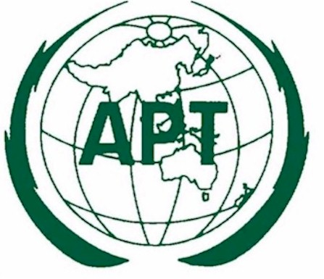 | APT-ITU MEETING ON  ROLE OF ICT FOR DISASTER REDUCTION  28 February 2005, BANGKOK, THAILAND

THE ROLE OF ICT FOR DISASTER WARNING AND RELIEF

On behalf of Asia-Pacific Telecommunity and ITU, I am very glad to present the outcome of a WSIS regional thematic meeting on “Role of ICT for disaster reduction”, which was co-organized by APT and ITU on the 28th of February 2005 at Bangkok, with kind support from the Ministry of ICT, Thailand.

As we all are aware and experiencing, various disasters are occurring in many countries and regions - beyond national borders and regardless of haves and have-nots. One of the main and recent disasters – i.e., the Tsunami triggered on the 26th of December 2004 by huge earthquake at the coast of Sumatra in the Indian Ocean brought death and destruction on an unprecedented scale.

Recognizing the possible role of ICT to reduce disasters, experiences shared at the Meeting include:

- Systems for emergency warning and disaster relief need to make use of existing telecommunication and radiocommunication systems as well as new applications of existing broadcasting, amateur, mobile, satellite and fixed services in setting up warning systems and to provide information response systems.

- Responses to large disaster events are likely to involve a large number of relief agencies and relief teams, which create severe pressure on requirements for interoperability and cooperation including frequency coordination of radiocommunication systems. Here, harmonized frequency use has been identified as one approach that leads to improve interoperability.

- Attention was also drawn to the relevant activities within the three Sectors of the ITU and APT programmes. The need for member countries to participate actively in the studies currently underway on public protection and disaster relief within the ITU and the APT was emphasized.

Having affirmed that ICT plays an important role in 1) early disaster prediction; 2) communicating and disseminating disaster information to residents as promptly as possible; and 3) ensuring a speedy communication system after a disaster occurs, in addition to the importance of the diffusion of disaster relief telecommunication system in the Asia-Pacific region, the Meeting has adopted seven major ways forward to reduce such disasters particularly through using ICTs.

In order to save time, I will highlight several points as followings, since the full report is available at both the WSIS website and hard copy.

- Recognizing that ICT can play a significant role in disaster management, member countries are urged to promote actively the utilization of ICT in case of disaster, such as strengthening the existing mechanism of a disaster relief telecommunication network/system and developing new systems, in particular, the wireless communication system.

- Acknowledging the importance of cooperation for disaster relief between national and local governments, disaster relief management using ICT within all the related organizations needs to be pursued vigorously.

- Positive measures such as promoting human resources development through the implementation of training courses and providing support in the construction of a system by dispatching technical experts need to be taken in order to help member countries.

- Efforts should be made to develop disaster relief telecommunication systems integrated into the broader process of developing and strengthening risk reduction institutions and capacities at all levels, in particular at the community level.

- Participants have also agreed that immediate initiatives should be taken to foster the relevant APT work programmes at the regional level and the ITU process at the global level for appropriate technical standards and recommendations concerning disaster early warning and relief systems.

While sending our sincere condolences to all the victims and their families from a series of the recent disasters such as Tsunami in the Indian Ocean, Hurricane Katrina, Typhoon Nabi etc., we wish these recommendations to be reflected at the outcomes of 2nd WSIS in order to reduce such disasters through using ICT at local, national, regional and global levels in the future.

Thank you very much for your kind attention.

